*Rezaul Haider, Karun Joseph*

*CEE6110: Final project Progress report*

**Back-end cyberinfrastructure for continuous real-time residential water use monitoring**

Rezaul Haider**,** Karun Joseph

Introduction:

Significant reduction in household water consumption could be achieved by understanding its use patterns and frequencies. Recent advancements in sensing technologies and inexpensive web services make it possible for continuous real-time sensing. This project aims to build a back-end cyberinfrastructure for real time water use data storage and analysis.

Progress:

(All code reside here in GitHub - <https://github.com/karunmj/ciws-campus-server>)

1. Set up back-end server

A backend Linux server was created as an EC2 instance with Amazon Web Services.

1. Prototyped RESTFul API framework

Backend services will be exposed as RESTful API endpoints. Bottle was chosen as the Python web framework and a template web app was created.

1. Sketched logical data model for water use time series

Currently, the server is set to handle synchronous requests and the sensor node makes a measurement every second. In order to avoid server being overloaded with requests, a design decision has been made to transmit data packets from the sensor node every minute instead of every second. Each data packet would comprise of 60 data values that were measured within a minute. Every data value would have a timestamp recorded in UTC, local time zone offset and daylight savings time indicator. A relational type database has been chosen to design the logical data model. Four entities (“sites”, “timeseries”, “variables” and “datavalues”) and their attributes were identified. Fig. 1 shows the entity-relationship diagram.

1. Implemented physical data model in MySQL

MySQL Workbench’s forward engineer tool was used to generate a SQL script from the logical data model on a local machine. This script was then run on the Linux server to create a physical data model.

1. Implemented RESTful API endpoints for writing and reading water usage time series

Simple endpoints for writing and reading water use data were created.

1. Database handler functions for writing, reading water usage time series

Simple database handler functions to write and read data were created using PyMySQL.

Future work:

1. Bulk inserting of data values from a time series into the datavalues table
2. End to end testing with two Raspberry Pis as clients
3. SQL based querying for water use analysis
4. Simple website for reading water usage time series

Appendix A: Figures

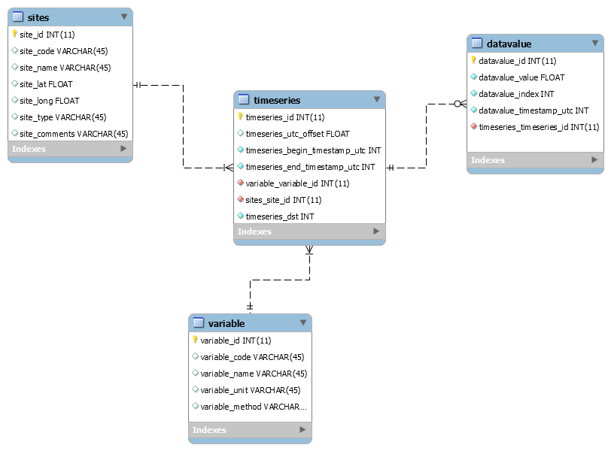

Fig 1: Entity Relationship diagram