1. Module 2

*2.1 Various processes by which runoff is generated*

Overland flow and shallow interflow processes that take water to a stream within a time scale of a day are referred to as runoff. The major inputs to runoff are rainfall and water stored below surface. Various mechanisms that generate runoff include infiltration excess overland flow (Horton overland flow), partial area infiltration excess overland flow, saturation excess overland flow, subsurface stormflow and perched subsurface stormflow. Each of these mechanisms has a different response with regard to rainfall and other factors such as soil, climate, geology, vegetation, land use, topography and geographic locations, and can contribute to runoff differently. Infiltration excess, saturation excess and groundwater flow pathways are some of the main processes involved in runoff generation. Infiltrated water enters soil where it contributes to interflow, and percolates to deeper groundwater. The quantity of water in soil affects variable source area involved in saturation overland flow. The deeper groundwater contributes to base flow and affects interflow through groundwater rise.

*2.2 Mechanisms that cause same quantity of precipitation falling in different watersheds to result in different amount of streamflow*

Factors such as soil, climate, geology, vegetation, land use, topography and geographic location are important runoff influencing factors in addition to rainfall. These factors could vary across different watersheds and hillslopes. As a result, in spite of similar precipitation falling, these watersheds could experience different runoff quantities. For example, spatial variability in soil properties can cause only a small part of a watershed to contribute to infiltration excess runoff, referred to as partial infiltration excess area. Vegetation is another example wherein it protects soil from rain packing and dispersal and can reduce infiltration excess runoff. Above mentioned mechanisms such as overland, saturation and subsurface flow could lead to different runoff quantities for similar rainfall events

*2.3 Reasons for same quantity of precipitation falling in the same watershed at different times of year causing different amounts of streamflow*

Climate is one factor that could change temporally for a watershed. Changing climate can affect soil properties, vegetation and others which could lead to different runoff quantities in a year. For example, during the cold weather, the soil could freeze and have reduced infiltration capacity. The water table level and soil moisture status, also called antecedent conditions, could also change during a year, causing different runoff mechanisms to occur at different times of a year. As a result, conditions before a storm and surface hydrologic processes could alter runoff generation mechanisms.

*2.4 Storm intensity and duration of precipitation’s effects on stormflow amounts in different watersheds*

Higher storm intensity can compete with infiltration rate of soil which when exceeded could lead to infiltration excess overland flow. A soil has a maximum limiting rate at which it can absorb surface water input. During a higher storm event, this surface water input could exceed the infiltration capacity of the soil and cause excess water to accumulate in small on-surface depressions. With continued surface water input, such depressions could fill to capacity and overflow leading to surface detention. Infiltration capacity also declines during a high intensity storm due to soil pores being filled with water reducing capillary forces that draw water into pores. Longer precipitation duration could cause saturation excess overland flow. It occurs in locations where infiltrating water completely saturates the soil profile until there is no more space for water infiltration. The water table could rise, referred to as saturation from below, leading to overland flow runoff. Continuing rain could also cause return flow which happens when water table has risen to the surface over lower part of a hillslope and saturated area expands to uphill.

1. Module 4

4.7



(please see attached handwritten notes for solution)

4.8



(please see attached handwritten notes for solution)

4.10

*Grain size distribution curve for the given soil sieve analysis*

**

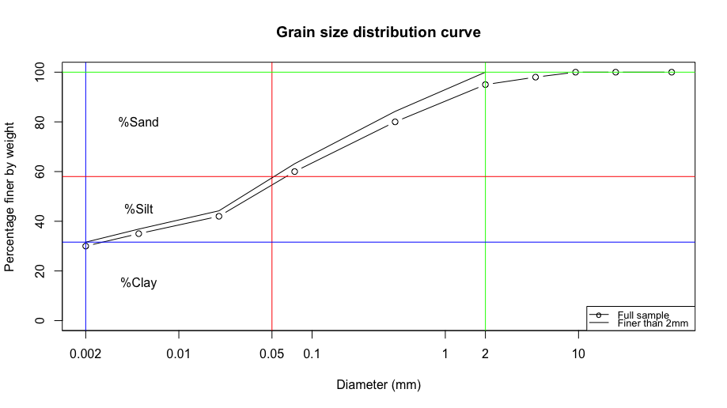

|  |  |  |
| --- | --- | --- |
| Sand percentage | Silt percentage | Clay percentage |
| 42 | 26.4 | 31.6 |

From soil texture triangle, the given soil is of type clay loom

4.11



(please see attached handwritten notes for solution)