1. Chapter 6 of the online Rainfall Runoff Process module

Finished online

1. ArcGIS exercise
2. Report the contributing area draining to the outlet location in number of cells, square kilometers and square miles. Report the area of a single grid cell. Compare your result in square miles to the USGS drainage area value for this site.

Contributing area in number of cells: 5581587

Contributing area in square kilometers: 558.16

Contributing area in square miles: 215.51

Contributing area in square miles from USGS: 214

1. Prepare a table that reports for the 9 stream links in the Spawn Creek tributary of the stream network the following attributes:
   1. Link number
   2. Downstream link number
   3. Upstream link number 1
   4. Upstream link number 2
   5. Downstream contributing area
   6. Length
   7. Identifier of corresponding watershed (WSNO)

|  |  |  |  |  |  |  |
| --- | --- | --- | --- | --- | --- | --- |
| Link number | DS link number | US link number 1 | US link number 2 | DS contributing area | Length | ID of corresponding watershed |
| 349 | 357 | 212 | 21 | 14634800 | 62.4 | 349 |
| 21 | 349 | na | na | 1008000 | 124.9 | 21 |
| 212 | 349 | 204 | 132 | 13619300 | 1207.8 | 212 |
| 132 | 212 | na | na | 1070300 | 449.7 | 132 |
| 204 | 212 | 196 | 140 | 11544600 | 152.4 | 204 |
| 140 | 204 | na | na | 1989000 | 1183.6 | 140 |
| 196 | 204 | 92 | 100 | 9525200 | 797.4 | 196 |
| 92 | 196 | na | na | 1330900 | 1072.3 | 92 |
| 100 | 196 | na | na | 7199200 | 4335.6 | 100 |

1. Open the attribute table of loganw and identify the count (number of grid cells) of the 9 Spawn Creek subwatersheds. Based on this count calculate area of each subwatershed and reconcile your values with contributing area values in the table from the stream network.

|  |  |  |
| --- | --- | --- |
| Link Number/ OID | Water shed area (sq metres) | Difference from DS contributing are |
| 349 | 14634800 | 0 |
| 21 | 1008000 | 0 |
| 212 | 13619300 | 0 |
| 132 | 1070300 | 0 |
| 204 | 11544600 | 0 |
| 140 | 1989000 | 0 |
| 196 | 9525200 | 0 |
| 92 | 1330900 | 0 |
| 100 | 7199200 | 0 |

1. Prepare a diagram that shows, based on your answers to 2 and 3, how connectivity between subwatersheds, stream links and upstream and downstream links is encoded.

Find handwritten notes attached

5. Report the following for the Logan River

- mean annual discharge in cfs: 227.1167

- mean annual runoff (discharge per unit area) in mm: 365.92

- Minimum, maximum and mean of mean annual precipitation over the Logan River watershed from PRISM in mm

|  |  |  |
| --- | --- | --- |
| Minimum | Maximum | Mean |
| 583.04 | 1351.37 | 941.5 |

- Runoff ratio for the Logan River: 0.389

1. Report the contributing area draining to the outlet location in number of cells and square kilometers. Report the area of a single grid cell.

Contributing area in number of cells: 146335

Contributing area in sq. kilometers: 14.6335

Area of single grid cell: 100 sq. meters

1. Report the value of D-Infinity contributing area at this location. Reconcile and explain the values of D8 contributing area and D-Infinity contributing area in terms of grid cell size.

D-Infinity contributing area at outlet in meters: 1407637

D8 contributing area in sq. meters: 14633500

After reconciling, multiplying D-Infinity by 10: 14076370

D8 and D-Infinity have slightly different values due to the differences in the respective methods

1. A histogram of wetness index distribution ln(a/S) for Spawn Creek.
2. Report the value of the TOPMODEL parameters λ_bar and D_bar and for Spawn Creek and the conditions given.

λ_bar: 6.294

D_bar: 0.117

1. A neatly labeled layout map showing the soil moisture deficit for these conditions.

(Refer to Fig. 1)

11. The area and volume of runoff generated from flat areas for these conditions

Area: 1800 sq. meters (number of grid cells with zero slope is 18, with each cell measuring 100 sq meters

Volume: 45 cubic meters (1800sq. meters * 25mm)

12. The area and volume of runoff generated from saturated areas for these condition

Area: 601400 sq. meters (obtained by running ("SpawnSMD.tif" <= 0) to find number of cells that are saturated and multiplying by 100)

Volume: 15035 cubic meters (601400*0.025)

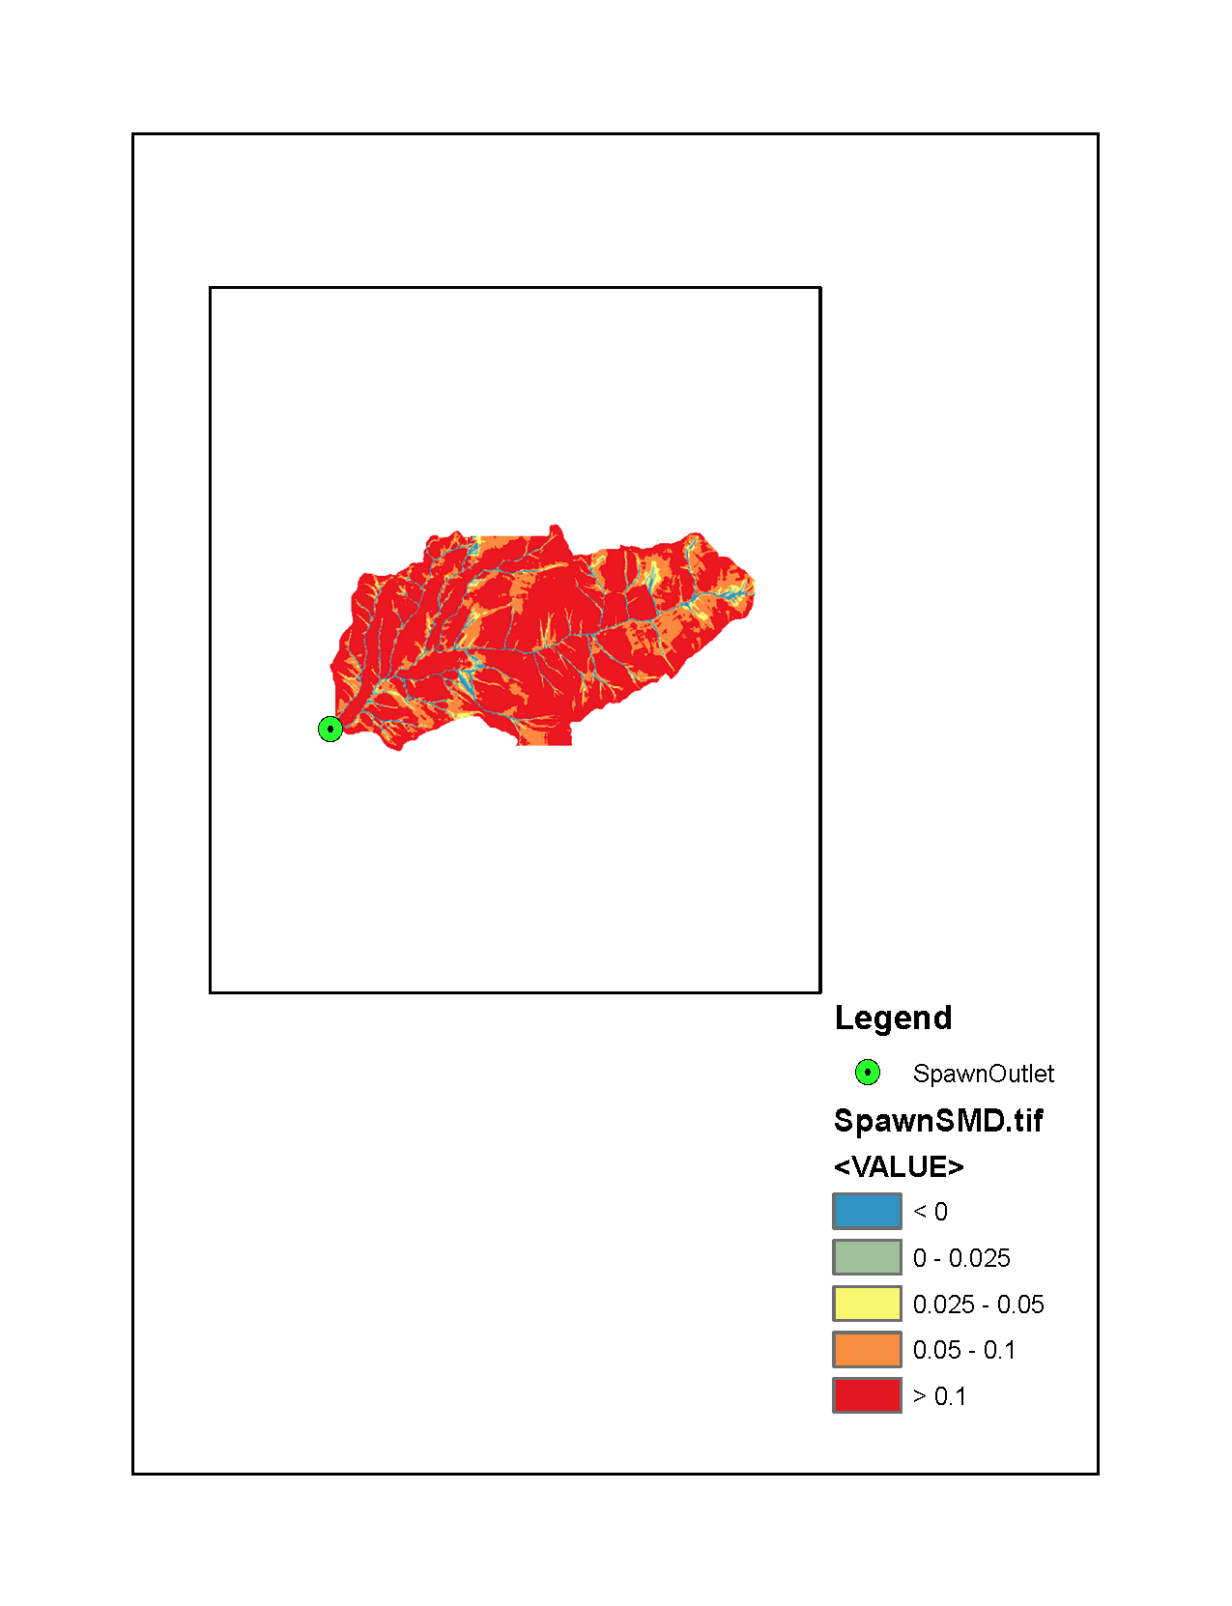

Fig 1: Soil moisture deficit

13. The area and volume of runoff generated from areas that will saturate for these conditions

Area: 254000 sq. meters (obtained by running ("smdwillsat.tif" >= 0)& ("smdwillsat.tif" < 0.0.25) to find number of cells and multiplying by 100)

Average smdwillsat subtracted from 0.025 gives 0.0113

Volume: 2870.2 cubic meters (254000*0.0113)

14. The total volume and per unit area depth of runoff generated for these conditions

Volume: 17950.2 cubic meters (2870.2 + 15035 + 45)

Per unit area depth: 1.23mm (17950.2/14633500

15. The runoff ratio from this storm with these conditions.

Runoff ratio: 0.0492 (1.23/25)