I have uploaded the excel worksheet and python script for plotting to canvas.

1. Chow 7.2.2

Response to 2 and 3 unit input were calculated by multiplying unit response function with 2 and 3 respectively. The response to both 2 and 3 units was obtained by summing 2 inputs’ output and 3 inputs’ output delayed by 1 unit.

|  |  |  |
| --- | --- | --- |
| Output with 2 unit inputs | Output with 3 unit inputs | Output with 2 units in first time interval, followed by 3 units |
| 0.54 | 0.81 | 0.54 |
| 0.72 | 1.08 | 1.53 |
| 0.36 | 0.54 | 1.44 |
| 0.18 | 0.27 | 0.72 |
| 0.1 | 0.15 | 0.37 |
| 0.06 | 0.09 | 0.21 |
| 0.02 | 0.03 | 0.11 |
| 0.02 | 0.03 | 0.05 |
|  |  | 0.03 |

1. Chow 7.4.5

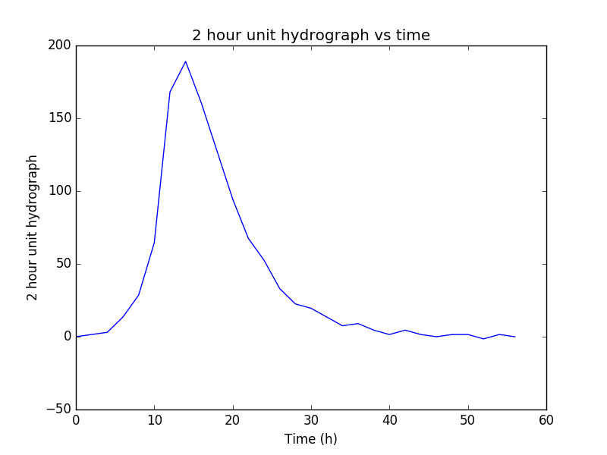

2 hour unit hydrograph was obtained using deconvolution which is plotted above.

1. Chow 7.5.3

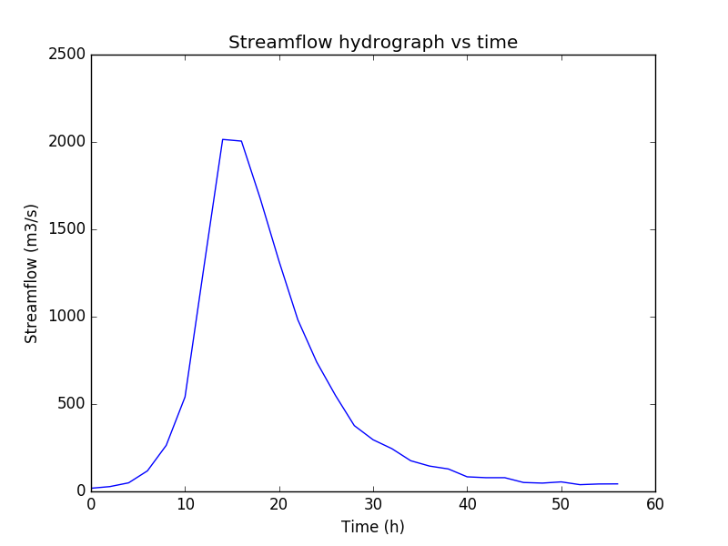

2 hour unit hydrograph from previous problem is used to obtain streamflow hydrograph which is plotted above.

1. Chow 7.6.2

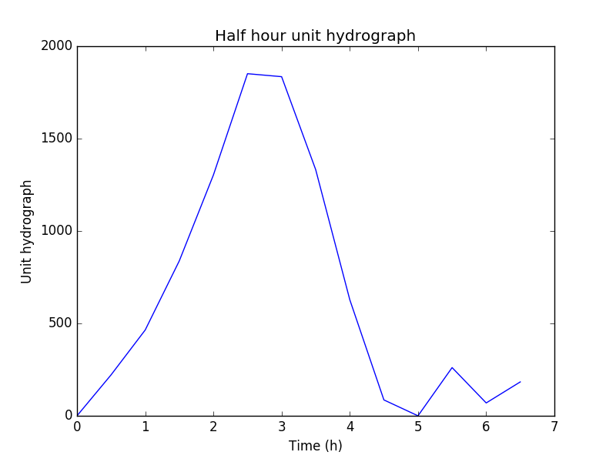

1. Using Chow 7.4.5, derive two-hour unit hydrograph using least squares, linear programming and compares results obtained from deconvolution

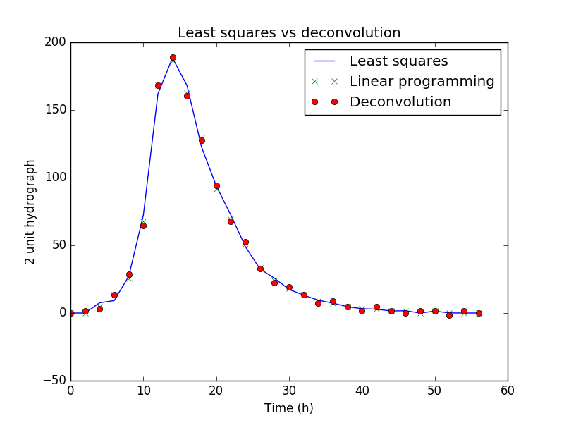

It looks like least squares, linear programming and deconvolution have similar results

1. Chow 7.7.2

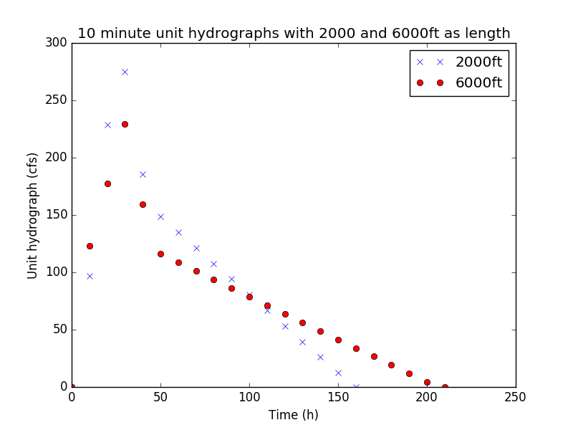

1. Chow 7.7.3

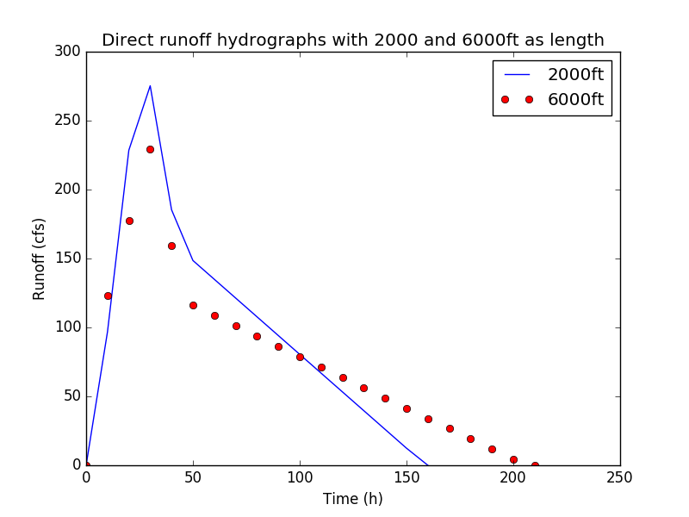

1. Chow 7.8.2

