**Physical Hydrology questions**

Objective: This question will evaluate the understanding of student of water balance and storage yield.

1. Compute the active storage capacity of a reservoir to supply a constant maximum annual yield, given the following sequence of annual flows: {8, 4, 6, 2, 4, 6}. Also, point out at which periods the reservoir will be full and empty considering the computed storage capacity.

Assuming the annual inflow sequent repeats, the maximum constant yield possible (without losses) = average annual inflow = (8+4+6+2+4+6)/6=5.

Solution to 1. The following table shows the computations of  in each period.

,

|  |  |  |  |
| --- | --- | --- | --- |
| Period, *t* | Release, | Inflow, |  |
| 1 | 5 | 8 | 0 |
| 2 | 5 | 4 | 1 |
| 3 | 5 | 6 | 0 |
| 4 | 5 | 2 | 3 |
| 5 | 5 | 4 | 4(maximum) |
| 6 | 5 | 6 | 3 |
| 1(repeating) | 5 | 8 | 0 |

In this example, computations can stop after period 1 in the second cycle as the value of  for period 1 is the same (=0) as that for the period 1 in the earlier cycle. Required active storage capacity is the maximum value of , i.e., 4.

With this capacity, the reservoir will be full at the end of the first and third periods and will be empty at the end of the fifth period.

1. Assume a year has two distinct seasons, wet and dry. 80% of annual flow occurs in the wet season each year, and 80% of annual yield is demanded in the dry season each year. Determine the percentage increase in the required storage capacity compared to the previous question. Use the sequent peak method, neglecting evaporation and seepage loss.

Inflow in the wet season = 0.8 (annul flow) each year, and inflow in the dry season = 0.2 (annual flow) each year.

Demand in the wet season = 0.2 (5) = 1 each year, and demand in the dry season = 0.8 (5) = 4 each year.

Sequent peak method is applied to the 6-year (12 seasons) sequence. The following table shows the computations.

,

|  |  |  |  |
| --- | --- | --- | --- |
| Period, *t* | Release, | Inflow, |  |
| 1 Wet | 1 | 6.4 | 0.0 |
| Dry | 4 | 1.6 | 2.4 |
| 2 Wet | 1 | 3.2 | 0.2 |
| Dry | 4 | 0.8 | 3.4 |
| 3 Wet | 1 | 4.8 | 0.0 |
| Dry | 4 | 1.2 | 2.8 |
| 4 Wet | 1 | 1.6 | 2.2 |
| Dry | 4 | 0.4 | 5.8 |
| 5 Wet | 1 | 3.2 | 3.6 |
| Dry | 4 | 0.8 | 6.8(maximum) |
| 6 Wet | 1 | 4.8 | 3.0 |
| Dry | 4 | 1.2 | 5.8 |
| 1 Wet | 1 |  | 0.4 |
| Dry | 4 |  | 2.8 |
| 2 Wet | 1 |  | 0.6 |
| Dry | 4 |  | 3.8 |
| 3 Wet | 1 |  | 0 (is the same as previous period 3) |

The required storage capacity is max {} = 6.8, and increase of 2.8 over the case in section 1, which is an increase of (6.8-4.0)/4=0.7 or 70%.

This example clearly shows that the capacity requirement increases when the variations in inflow and demands within the year periods are considered, rather that when the capacity is computed based on the annual values alone.

THIS EXAMPLE WAS ADOPTED FROM:

Vedula, S. and Mujumdar, P.P. (2006). “Water resources systems; Modelling techniques and analysis.” Second reprint, Tata McGraw-Hill Publishing Company Limited., New Delhi, India.

Objective: these questions cover some of the objectives of runoff generation and water in soil as provided in the Workbook chapter 2 and 3.

1. This figure is adopted from spatial patterns in catchment hydrology book (Grayson and Blöschl, 2000) which illustrates a soil-cross section.

<http://www.hydro.tuwien.ac.at/uploads/media/Chapter3_02.pdf>.

Describe the hydrologic process and the condition at which this process occur in the nature.

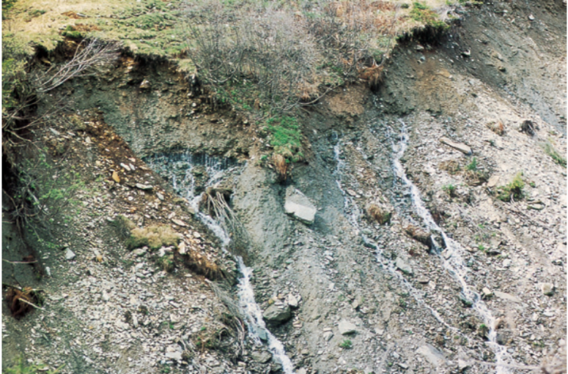

In the above soil-cross section figure, subsurface flow (lateral subsurface flow) is occurring. This happens when the infiltrated water follows subsurface pathways that take it to the stream relatively quickly. In fact, this figure clearly depicts the preferential pathways in which subsurface flow occurs.

Label the process – that you recognize from the previous part – in the below picture.



Subsurface flow

1. Which one of the following does not directly influence the rate of infiltration? (choose all that apply)
2. The physical characteristics of the soil
3. Land use
4. Moisture content of the soil
5. Soil temperature
6. Precipitation type
7. Rainfall intensity
8. Size of watershed