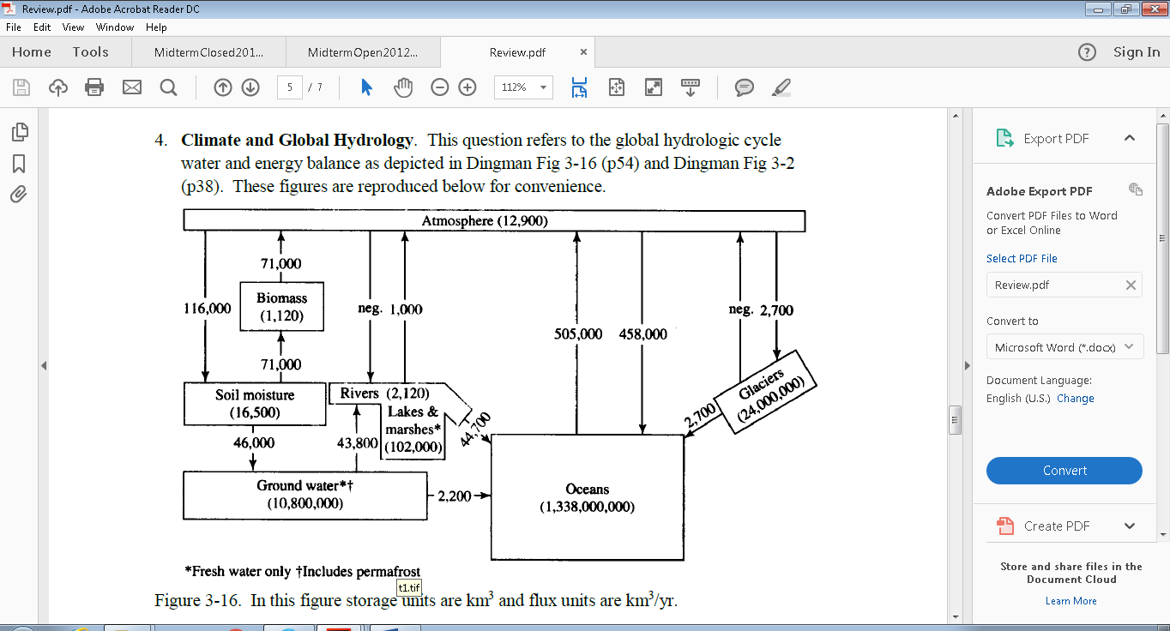

In this question it is required to

calculate the average annual evaporation in Land= 71,000/area of land =Km/year

Volume of evaporation = 72000 km3/yr (I included rivers and lakes)

Area = 149 x 106 km2

Depth = 72000/149000000 = 0.000483 km = 0.48 m

calculate the average annual evaporation in Ocean= 505,000/area of Ocean =Km/year

Yes: 505000/361000000 = 0.00139 km/yr = 1.39 m/yr

Then for the land area latent heat flux = 1000*2.45*10^6*Evaporation from Land

Latent heat flux.





This is per year

Putting on a per second basis $1.17 x {10}^{9}/$

Also can calculate heat flux from ocean

From the ocean.





This is per year

Putting on a per second basis

**Is the solution right??**

My question when ask to compare the net heat flux from the balance of the earth with the values that I calculated

I add the latent heat from the land to the ocean = **145 w/m2**

It is not right to add 37+108 -> 145 as these are per unit area fluxes that apply to a different area.

From the balance of the earth net latent heat flux is 24% of 1367 =**328 W/m2**

Solar flux is 1367 W/m2. This flux per unit area is measured over a surface perpendicular to the direction of the light from the sun. This it is over the circular disk area of the earth that intercepts sunlight, an area of $πR^{2}$ where R is the earth radius. Fluxes calculated from the water mass balance are over the spherical area of the earth, $4πR^{2}$. The solar flux when expressed per unit area over the spherical area of the earth is 1367/4 = 342 W/m2. 24% of this is 82 W/m2. If you take an area average of the values calculated above, you get:

86 W/m2 is close to 82 W/m2

**Are my calculation is wrong or right? There are huge difference between them??**

Also in the question

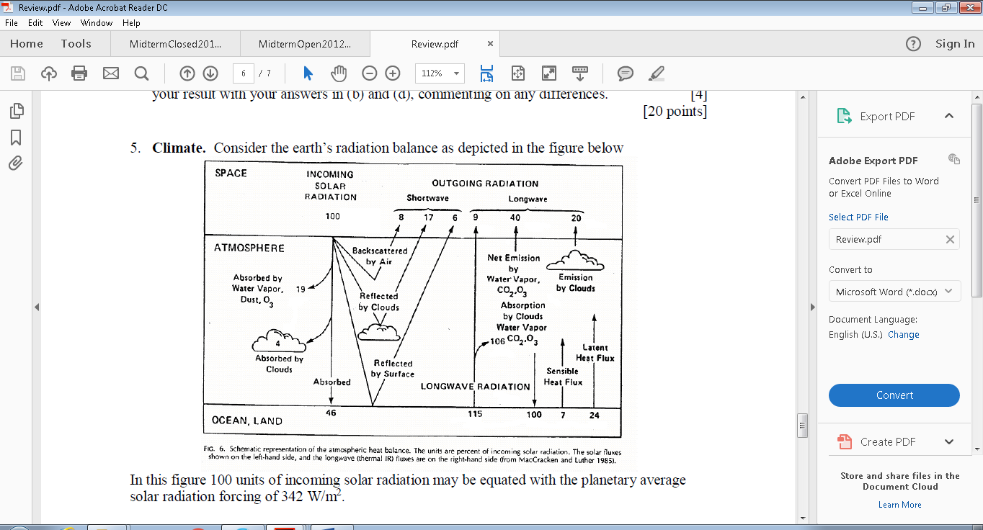

**Is the solar radiation in this case is 342 w/m2 not 1367 w/m2??? What is the different between these values?**

The explanation is the same as above. 1367 is the disk area and 342 the spherical area.

**Also I don’t know how to calculate the average precipitation??**

By mass balance over the planet P = E.





From this you can get E and then P