All code, plots reside here:

<https://github.com/karunmj/usu-coursework/tree/master/cs5660datasc/hw/hw2>

Data collection involved using request and beautiful soup libraries to get UFO data for circles, triangles and fireball shape sightings in the form of a Pandas data frame object in Python. The column labels include date of sighting, time of sighting, city, state, shape, duration, summary and posted date.

Data preprocessing involved including sighting between 1/1/2005 and 9/22/2016, representing duration of sighting in seconds and sightings in either of the 50 (+1 by including DC) states of US.

1. Box plot of duration of UFO sightings of each shape

(not done)

1. Time series figure with the number of sightings per year (one line per shape)

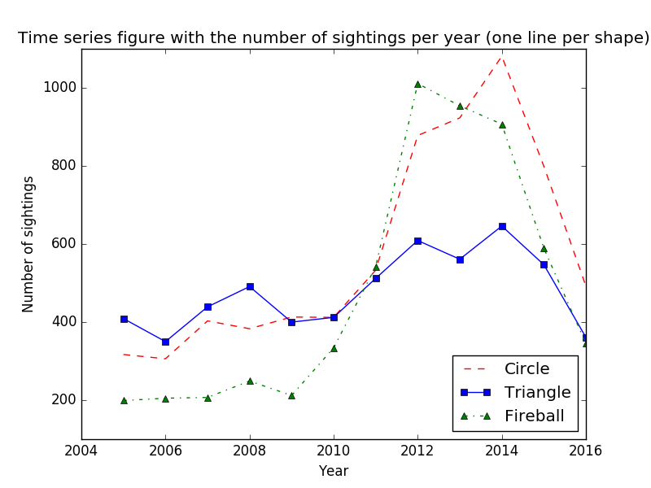

1. Bar chart for sightings of:
   1. Absolute numbers by state

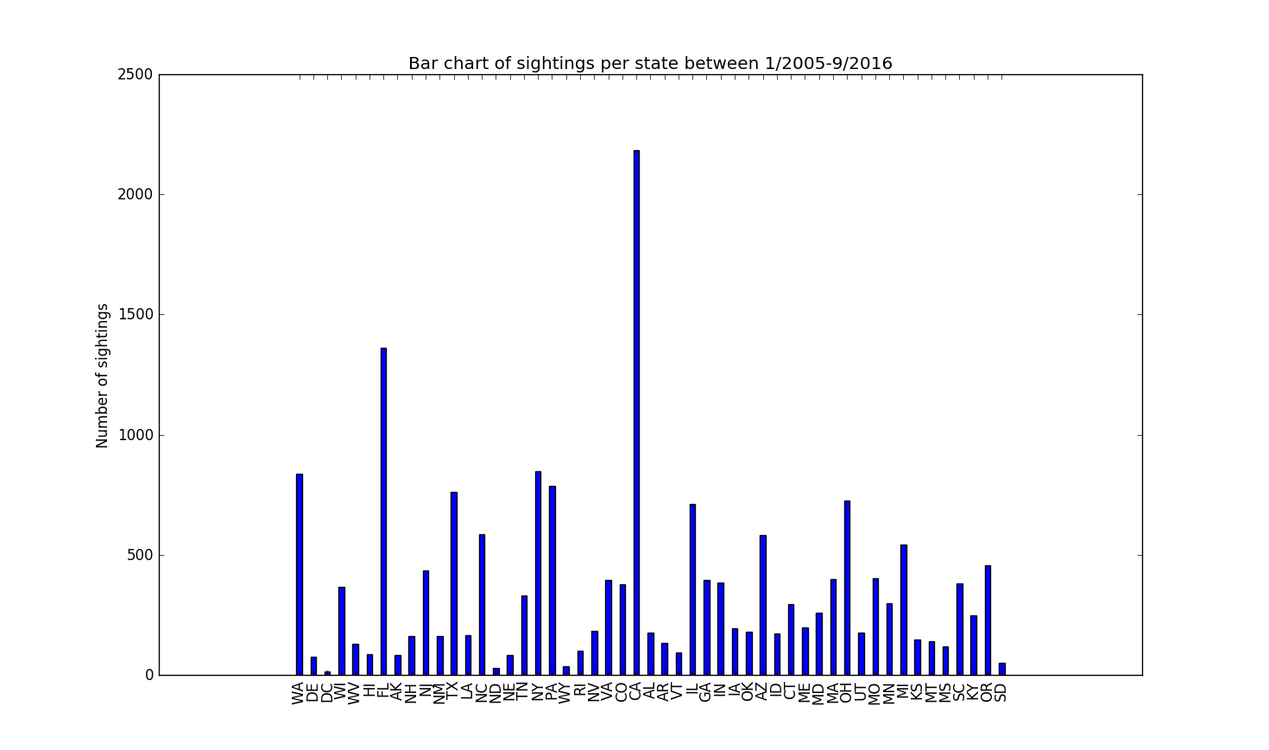

* 1. Normalized numbers, based on state population, by state

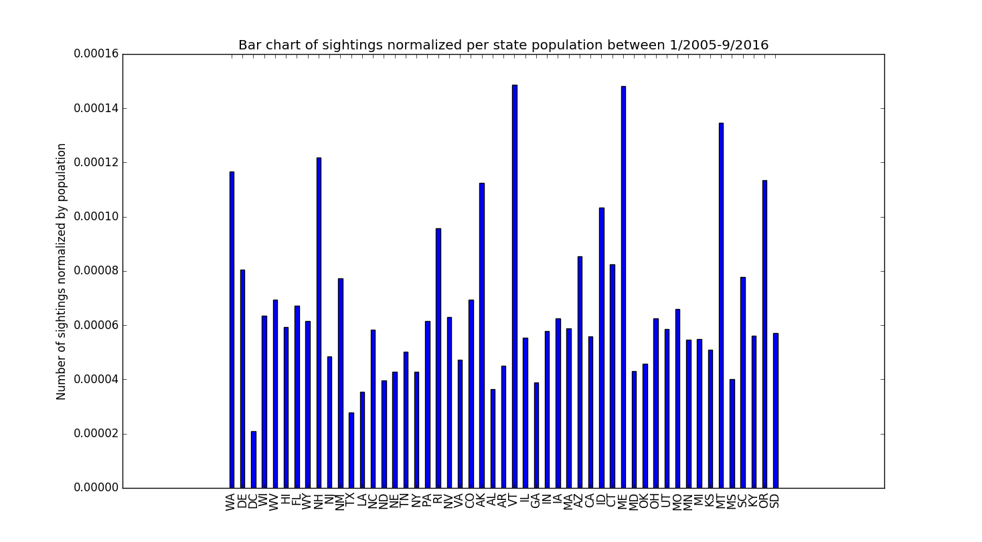

1. Normalized sightings by state population visualized on a map