|  |  |
| --- | --- |
| **Ex:No:6** | **Web Page Creation** |
| **Date:** |

**Aim:**

**Procedure:**

**Program:**

**Post method:**

var http=require("http");

var querystring=require("querystring");

var qs,name,email;

function onRequest(req,res)

{

var data1='';

req.on('data',function(chunk)

{

console.log(chunk);

data1+=chunk;

console.log("data string format"+data1);

});

req.on('end',function()

{

qs=querystring.parse(data1);

console.log(qs);

name=qs['uname'];

email=qs['email']

res.write("<h1>hello"+name+"<br>Your Email:"+email+"</h1>");

res.end();

});

}

http.createServer(onRequest).listen(4300);

console.log('server has started')

**Get method:**

var http=require("http");

var url=require("url");

var querystring=require("querystring");

function onRequest(req,res)

{

var path=url.parse(req.url).pathname;

console.log('Request for '+path+'received');

var query=url.parse(req.url).query;

console.log(query);

var name=querystring.parse(query)["uname"];

var email=querystring.parse(query)["email"];

var pswd=querystring.parse(query)["pswd"];

res.write("<h1>Welcome "+name+"<br>your email id:"+email+"<br>Password:"+pswd+"</h1>");

res.end();

}

http.createServer(onRequest).listen(2222);

console.log('server has started');

**Html.login:**

<html>

<head>

<title>SignUp</title>

<meta charset="utf-8">

<meta name="viewport" content="width=device-width, initial-scale=1">

<link href="https://cdn.jsdelivr.net/npm/bootstrap@5.2.1/dist/css/bootstrap.min.css"

rel="stylesheet">

<script

src="https://cdn.jsdelivr.net/npm/bootstrap@5.2.1/dist/js/bootstrap.bundle.min.js">

</script>

<style>

body {

background-image: url('car2.jpg');

background-repeat: no-repeat;

background-size: 100% 100%;

font-family: Arial, sans-serif;

background-color: #f1f1f1;

margin: 0;

display: flex;

justify-content: center;

align-items: center;

height: 100vh;

}

.form {

display: flex;

flex-direction: column;

}

.container {

background-color: #fff;

box-shadow: 0 0 10px rgba(0, 0, 0, 0.1);

padding: 20px;

border-radius: 5px;

}

h2{

text-align: center;

margin-bottom: 20px;

font-family: cursive;

}

label {

font-weight: bold;

}

input {

padding: 10px;

margin: 5px 0;

border: 1px solid #ccc;

border-radius: 3px;

}

button {

background-color: #4CAF50;

color: #fff;

border: none;

padding: 10px;

border-radius: 3px;

cursor: pointer;

position: center;

}

h2 {

text-align: center;

}

button:hover {

background-color: #45a049;

}

</style>

</head>

<body>

<div class="container mt-3">

<h2>sign up</h2>

<form action="http://localhost:4300/login"method="get">

<div class="mb-3 mt-3">

<label for="name">Username:</label>

<input type="text" class="form-control" id="uname" placeholder="Enter

username" name="uname">

</div>

<div class="mb-3">

<label for="email">Emailid:</label>

<input type="text" class="form-control" id="email" placeholder="Enter your

emailid" name="email">

</div>

<div class="mb-3">

<label for="pwd">Password:</label>

<input type="password" class="form-control" id="pwd" placeholder="Enter

password" name="pswd">

</div>

<button type="submit" class="btn btn-Outline-dark">Submit</button>

</form>

</div>

</body>

</html>

**Output:**

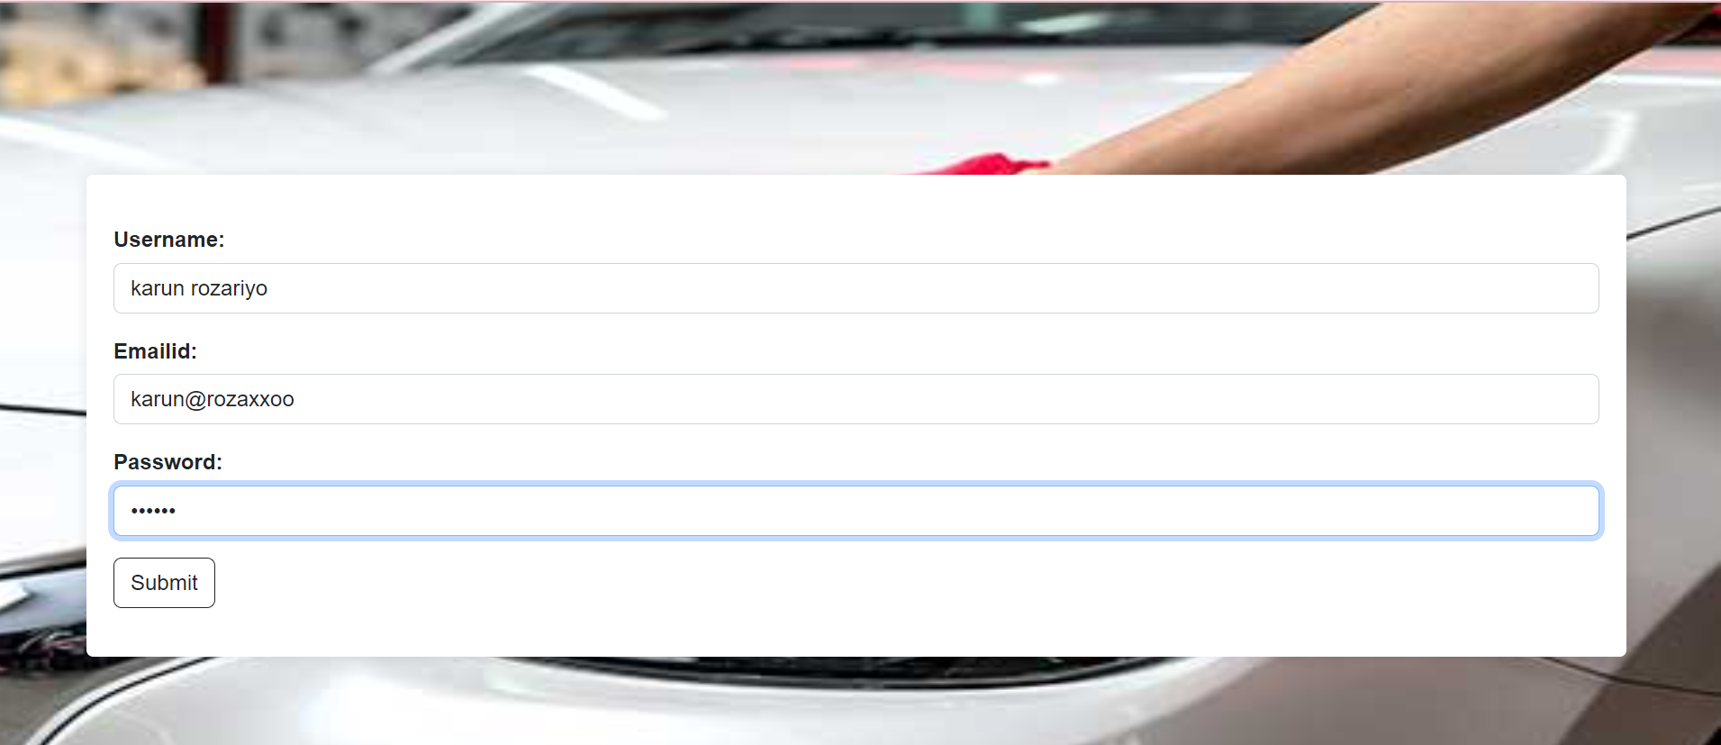



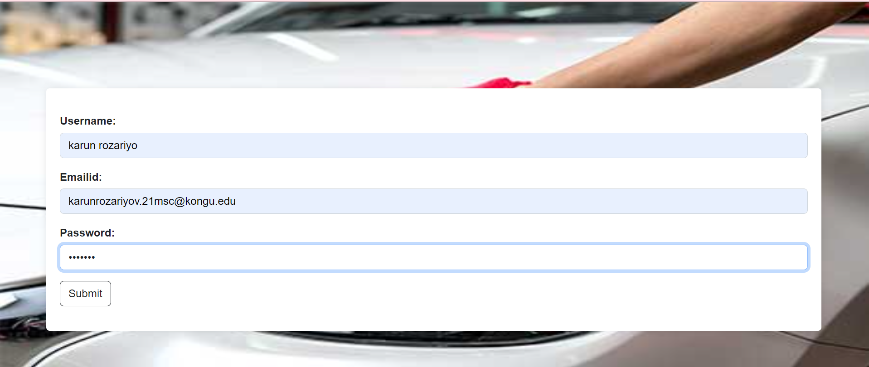

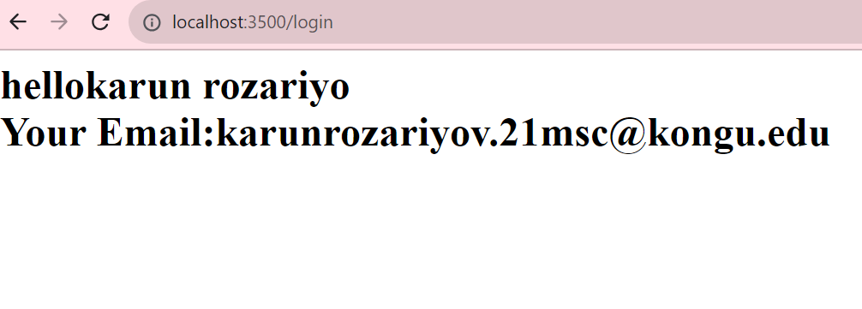

**Result**