|  |  |
| --- | --- |
| **Ex:No:7** | **Web Page Creation** |
| **Date:** |

**Aim:**

**Procedure:**

**Program:**

**Cal1.html**

<html>

<head>

<meta charset="UTF-8">

<meta name="viewport" content="width=device-width, initial-scale=1.0">

<title>Calculator</title>

<link href="https://cdn.jsdelivr.net/npm/bootstrap@5.3.0/dist/css/bootstrap.min.css" rel="stylesheet" integrity="sha384-

ggOyR0iXCbMQv3Xipma34MD+dH/1fQ784/j6cY/iJTQUOhcWr7x9JvoRxT2MZw1T" crossorigin="anonymous">

<style>

</style>

</head>

<body bgcolor="red">

<div class="container mt-3">

<n>

<div class="container mt-3">

<h2 ><center>Login</h2>

<form action="http://localhost:4000/res" method="post">

<center><input type="number" placeholder="Enter number 1" name="num1" required><br><br><center><input type="number" placeholder="Enter number 2" name="num2" required><br><br>

<center><label for="cal">Choose a Operation:</label><br><br>

<select name="calc" >

<option value="select">Select a operation</option> <option value="Addition">+</option>

<option value="Subtraction">-</option>

<option value="Multiplication">*</option>

<option value="Division">/</option>

<option value="Mod">%</option>

</select><br><br>

<button type="submit">Calculate</button></center>

</form>

</div>

</n>

</div>

</body>

</html><html>

<head>

<meta charset="UTF-8">

<meta name="viewport" content="width=device-width, initial-scale=1.0">

<title>Calculator</title>

<link href="https://cdn.jsdelivr.net/npm/bootstrap@5.3.0/dist/css/bootstrap.min.css" rel="stylesheet" integrity="sha384-

ggOyR0iXCbMQv3Xipma34MD+dH/1fQ784/j6cY/iJTQUOhcWr7x9JvoRxT2MZw1T" crossorigin="anonymous">

<style>

</style>

</head>

<body bgcolor="red">

<div class="container mt-3">

<n>

<div class="container mt-3">

<h2 ><center>Login</h2>

<form action="http://localhost:4000/res" method="post">

<center><input type="number" placeholder="Enter number 1" name="num1" required><br><br><center><input type="number" placeholder="Enter number 2" name="num2" required><br><br>

<center><label for="cal">Choose a Operation:</label><br><br>

<select name="calc" >

<option value="select">Select a operation</option> <option value="Addition">+</option>

<option value="Subtraction">-</option>

<option value="Multiplication">*</option>

<option value="Division">/</option>

<option value="Mod">%</option>

</select><br><br>

<button type="submit">Calculate</button></center>

</form>

</div>

</n>

</div>

</body>

</html>

**Cal2.js**

const http = require('http');

const url = require('url');

const fs = require('fs');

const path = require('path');

const querystring = require('querystring'); const calculator = require('./calc2');

var qs,name;

function onRequest(req,res)

{

let body = '';

req.on('data', (chunk) => {

body += chunk.toString();

});

req.on('end', () => {

const formData = querystring.parse(body); const x = parseFloat(formData.num1); const y = parseFloat(formData.num2); const operation = formData.calc;

if(operation=='Addition')

{res.write("<html><head><style> body{background-color:black; }h1{text- align:center;font-family:times new roman;color:blue;;}h2{text-align:center;font- size:30px;font-style:italic;color:white;}</style><body><br<br><h1>Operation Successful<br><br></h1><h2>Entered number 1: "+ x+"<br>Entered number 2: "+ y+"<br>Operation:"+operation+"<br>Result:"+calculator.add(x,y)+"<br></h2></body></ html>");

}

else if(operation=='Subtraction')

{

res.write("<html><head><style> body{background-color:black; }h1{text- align:center;font-family:times new roman;color:blue;;}h2{text-align:center;font- size:30px;font-style:italic;color:white;}</style><body><br<br><h1>Operation Successful<br><br></h1><h2>Entered number 1: "+ x+"<br>Entered number 2: "+ y+"<br>Operation:"+operation+"<br>Result:"+calculator.sub(x,y)+"<br></h2></body></ html>");

}

else if(operation=='Multiplication')

{

res.write("<html><head><style> body{background-color:black; }h1{text- align:center;font-family:times new roman;color:blue;;}h2{text-align:center;font- size:30px;font-style:italic;color:white;}</style><body><br<br><center><h1>Operation Successful<br><br></h1><h2>Entered number 1: "+ x+"<br>Entered number 2: "+ y+"<br>Operation:"+operation+"<br>Result:"+calculator.mul(x,y)+"<br></h2></body>< /html>");

}

else if(operation=='Division')

{

res.write("<html><head><style> body{background-color:black; }h1{text- align:center;font-family:times new roman;color:blue;;}h2{text-align:center;font- size:30px;font-style:italic;color:white;}</style><body><br<br><center><h1>Operation Successful<br><br></h1><h2>Entered number 1: "+ x+"<br>Entered number 2: "+ y+"<br>Operation:"+operation+"<br>Result:"+calculator.div(x,y)+"<br></h2></body></ html>");

}

else if(operation=='Mod')

{

res.write("<html><head><style> body{background-color:black; }h1{text- align:center;font-family:times new roman;color:blue;;}h2{text-align:center;font- size:30px;font-style:italic;color:white;}</style><body><br<br><center><h1>Operation Successful<br><br></h1><h2>Entered number 1: "+ x+"<br>Entered number 2: "+ y+"<br>Operation:"+operation+"<br>Result:"+calculator.modulo(x,y)+"<br></h2></bod y></html>");

}

res.end();

});

}

http.createServer(onRequest).listen(4000); console.log('server has started');

**Cal3.js**

exports.add=function(x,y)

{

return x+y;

}

exports.sub=function(x,y){

return x-y;

}

exports.mul=function(x,y)

{

return x*y;

}

exports.div=function(x,y)

{

return x/y;

}

exports.modulo=function(x,y) {

return x%y;

}

**Output:**

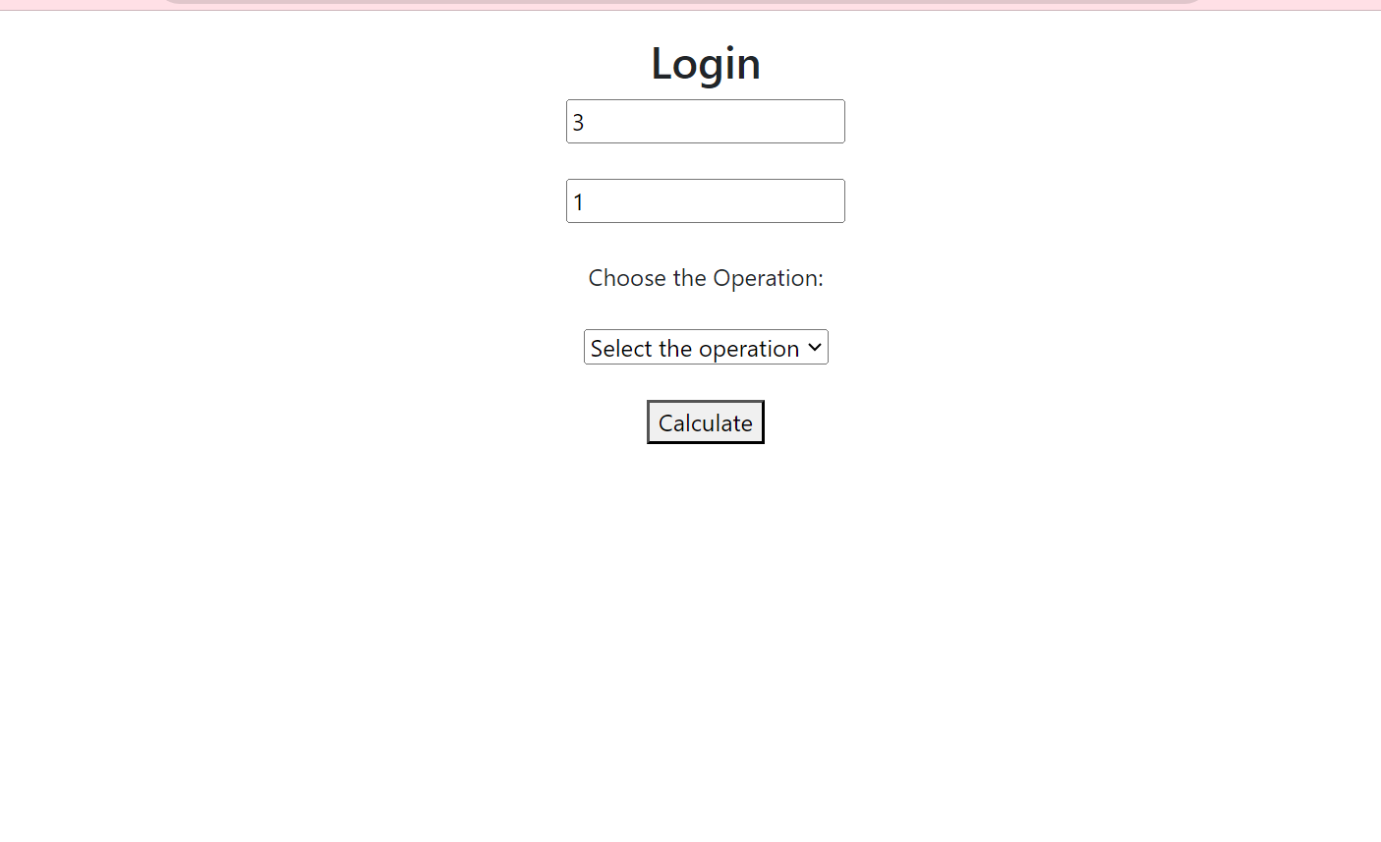

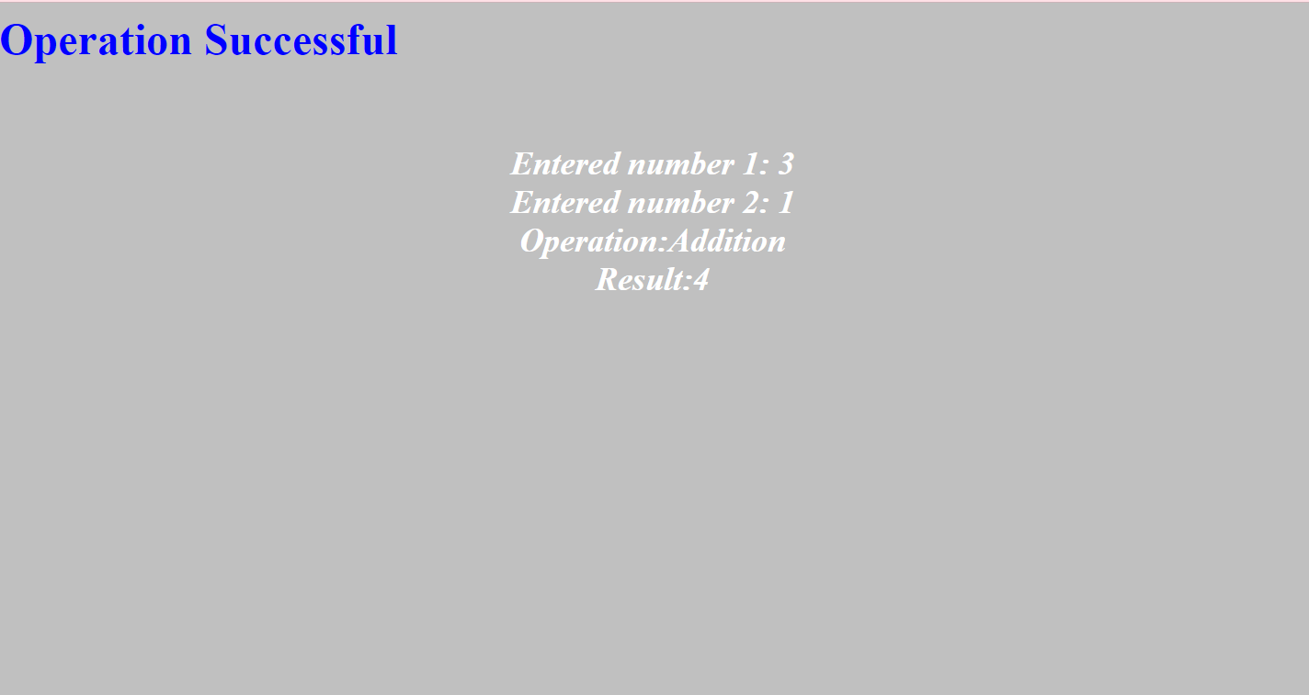

**Result**