PROJECT DESIGN
Project Title: Import Data using Transform Maps (Spreadsheet)

1. System Architecture
The project follows this data flow:
Spreadsheet → Import Set (Staging Table) → Transform Map → Employee Test Table → Reports and Dashboard
2. Source and Target Tables
- Source Table: Employee Import
- Target Table: Employee Test
3. Field Mapping
Source field | Target field
Employee ID | Employee ID
Employee Name | Employee Name
Email | Email
Department | Department
Location | Location

4. Design Screenshots
Phase 1: Prepare the sheets
- Open New Google Spreadsheet
- Create New Google Spreadsheet with sample data as shown below

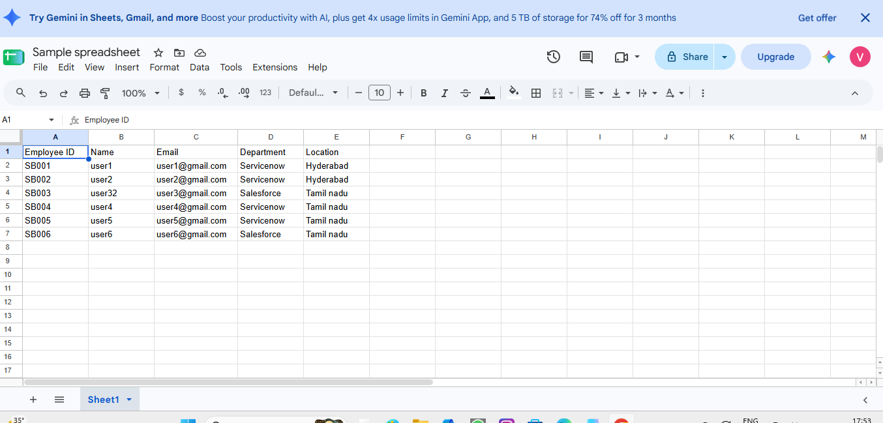
3.Download the spreadsheet as Sample Spreadsheet.xlsx format.
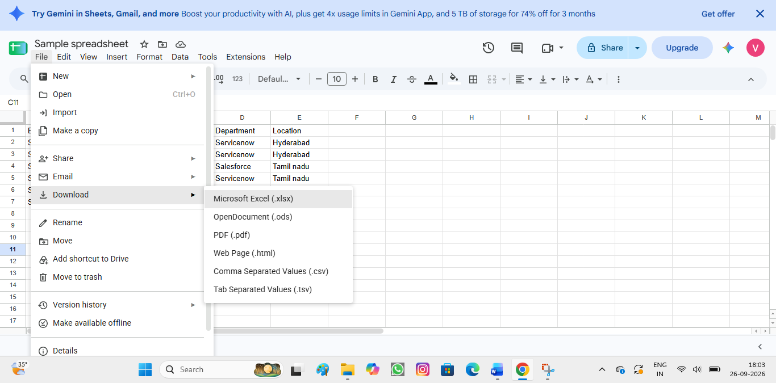
Phase 2: Create new Custom table
Navigation:
- Tables > Create New
- Label: Employee Test
- Name: u_employee_test
- Employee Name – Type: String
- Email – Type: String
- Department – Type: String
- Location – Type: String
- After creating all the required fields, click Save.

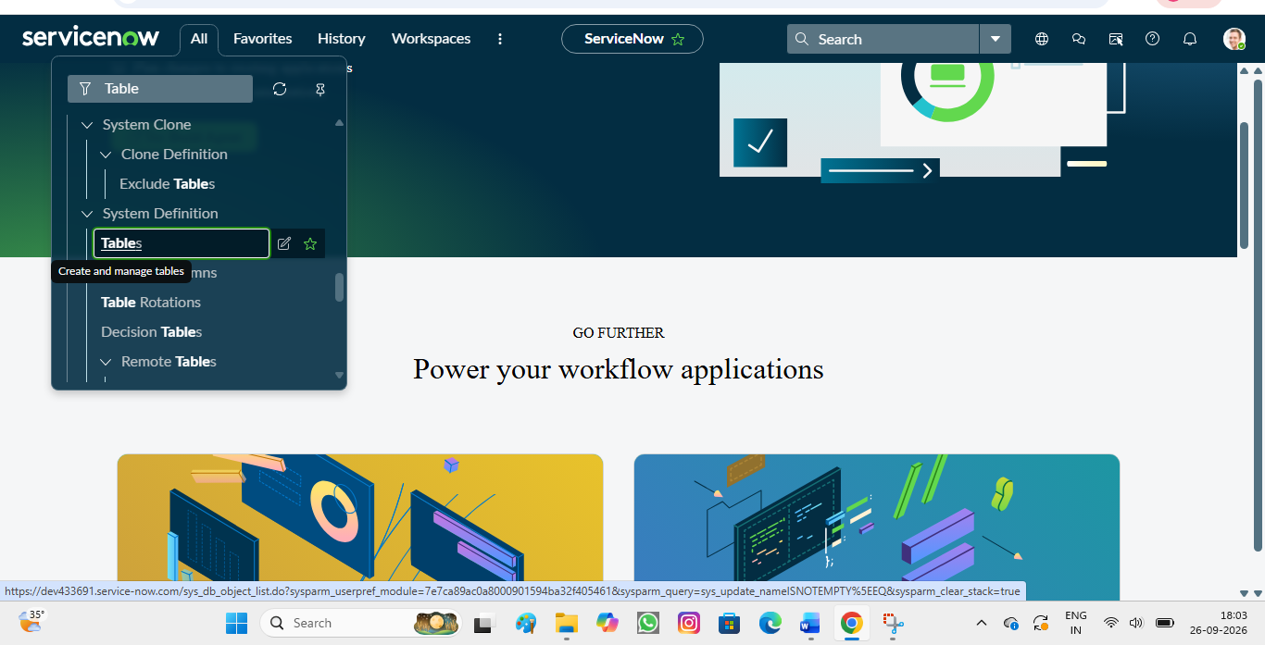
Phase 3: Import Set Table

- Navigation:
- In Application Navigator → Load Data

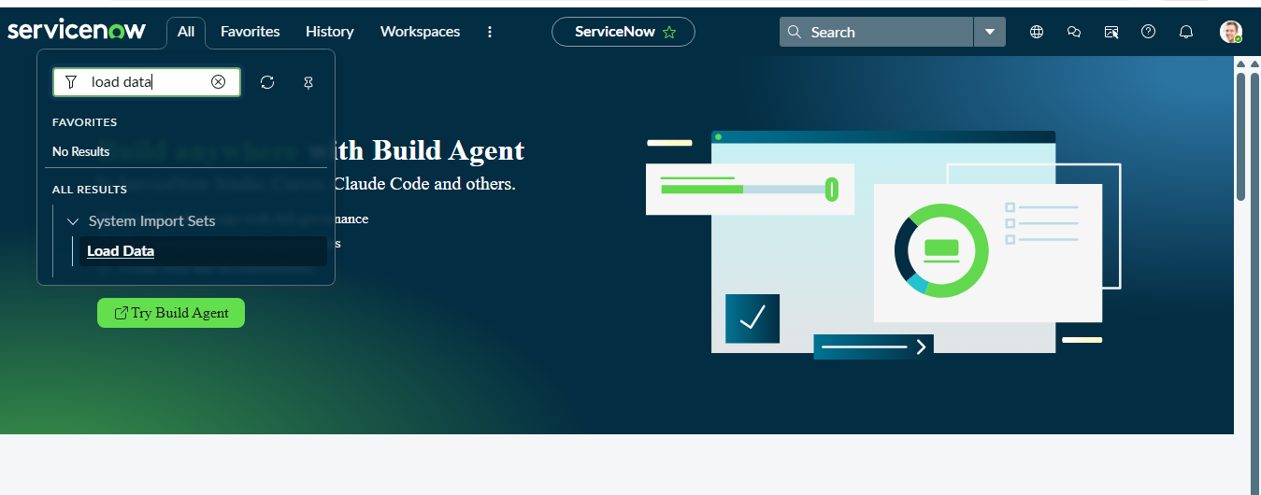
- Label: Employee Import
- Name: u_employee_import (auto populated)

- Click on Submit
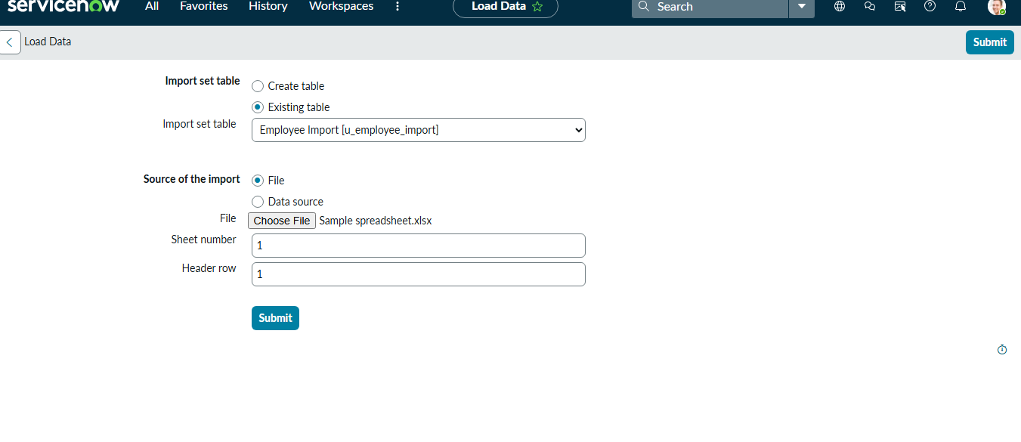
- Click on Submit

