PROJECT DEVELOPMENT
Project Title: Import Data using Transform Maps (Spreadsheet)

1. Introduction
This phase describes the implementation of the employee data import solution in ServiceNow.
2. Implementation Steps
Employee Spreadsheet
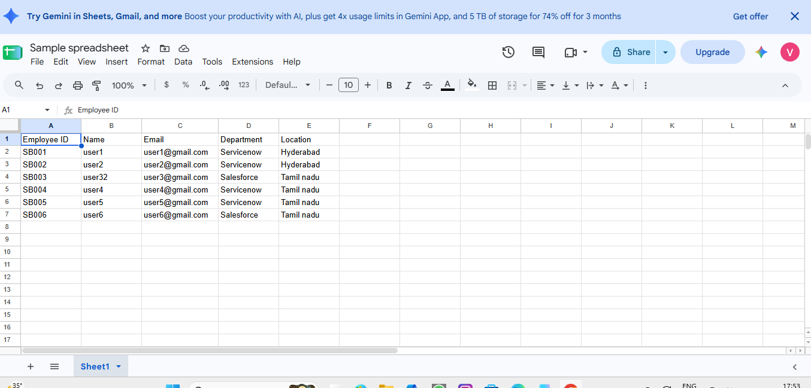
Employee Test Table
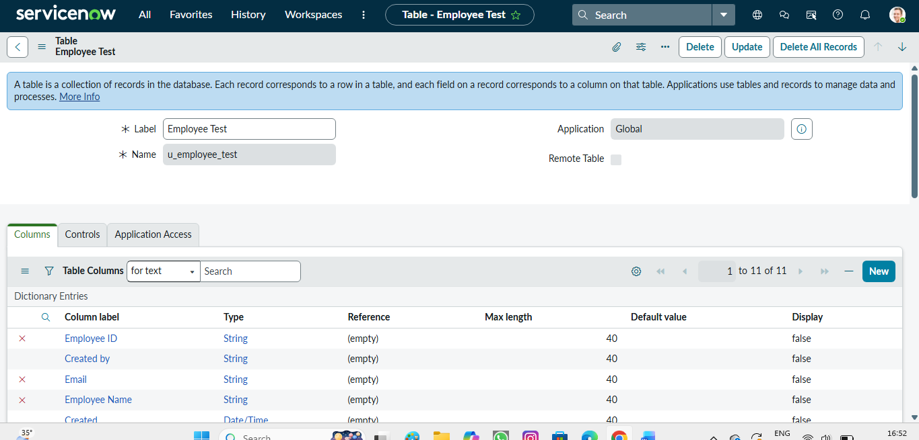
Employee Import staging table
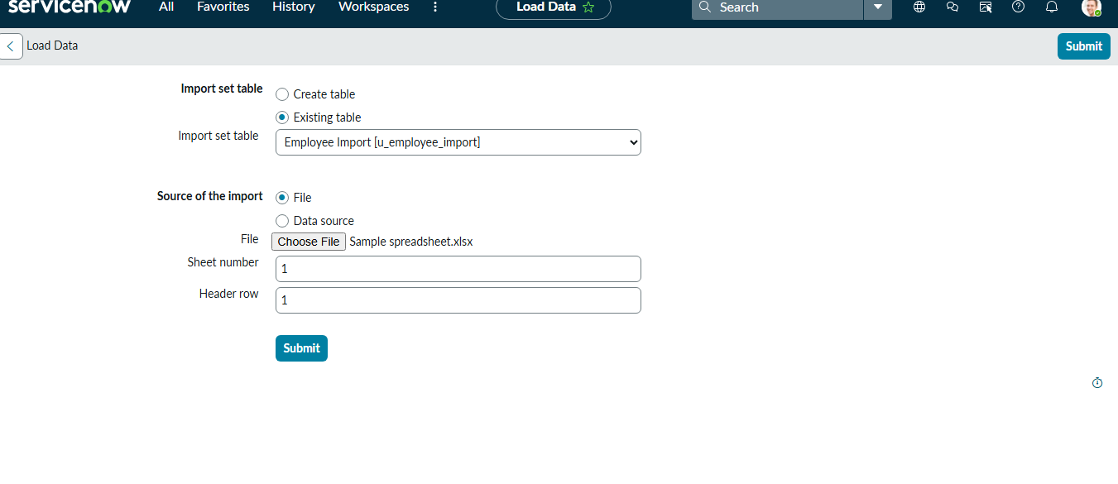
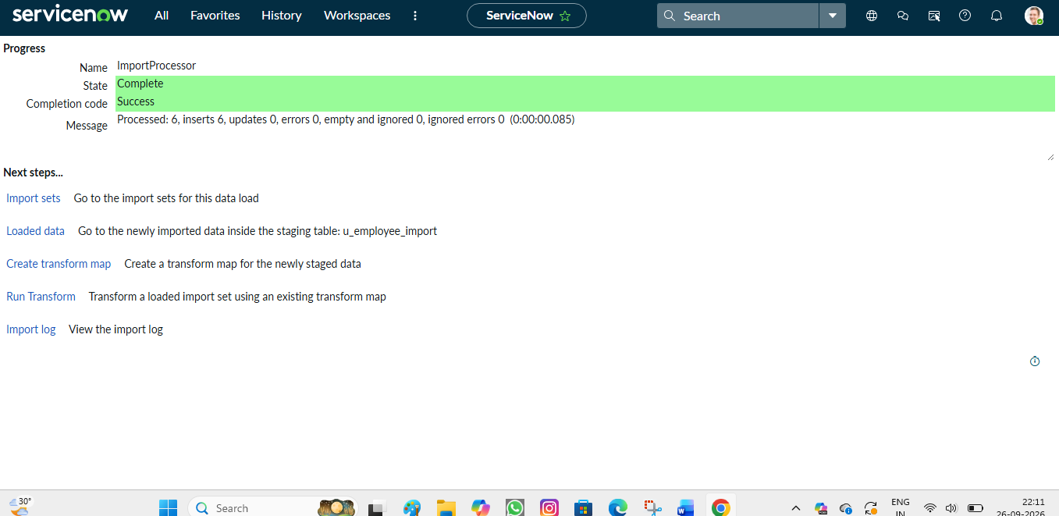
Transform Map creation
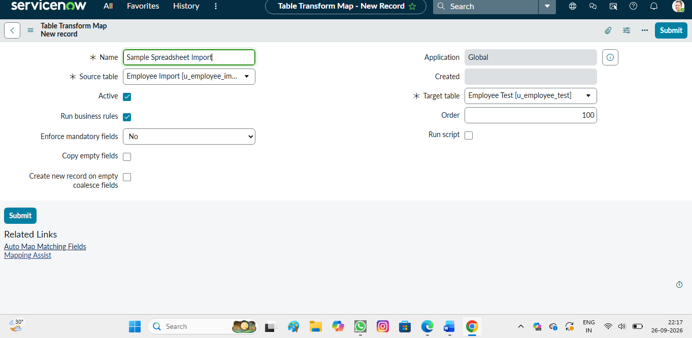
Field mapping and transformation
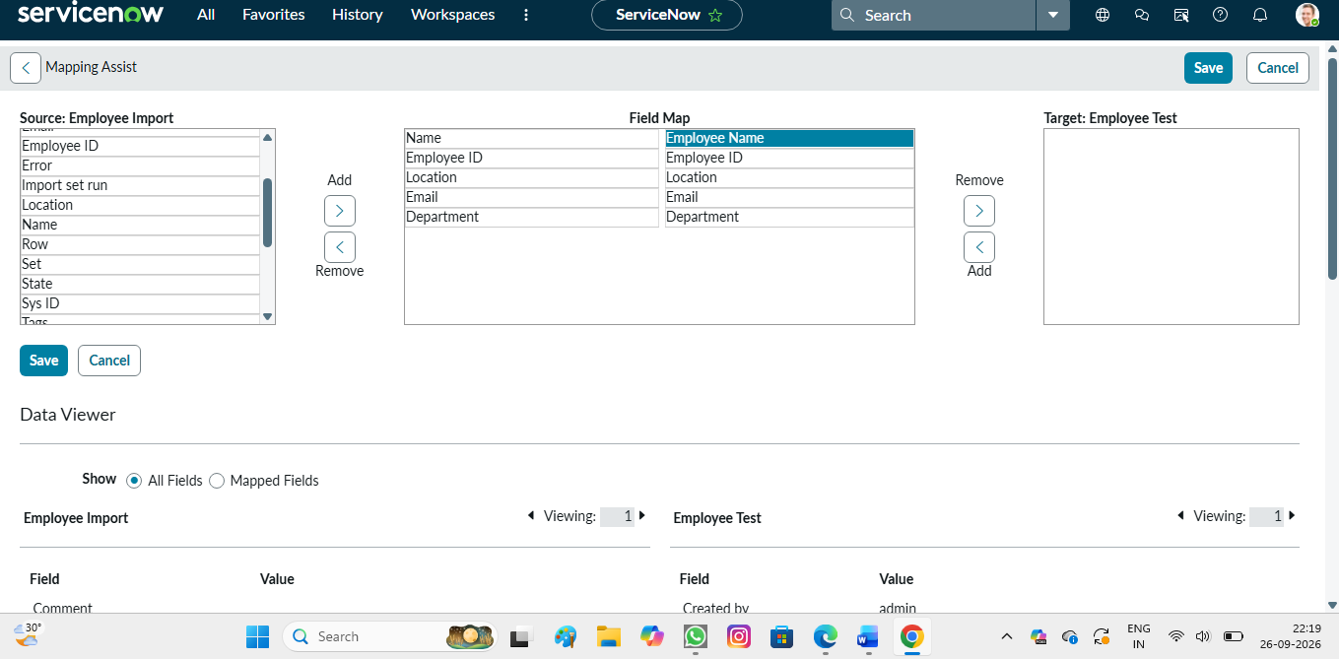
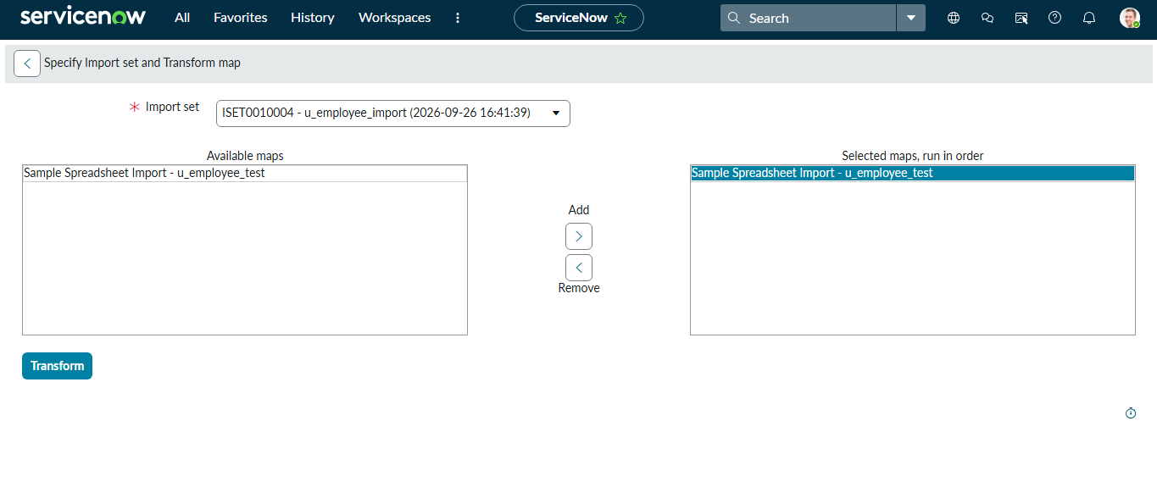
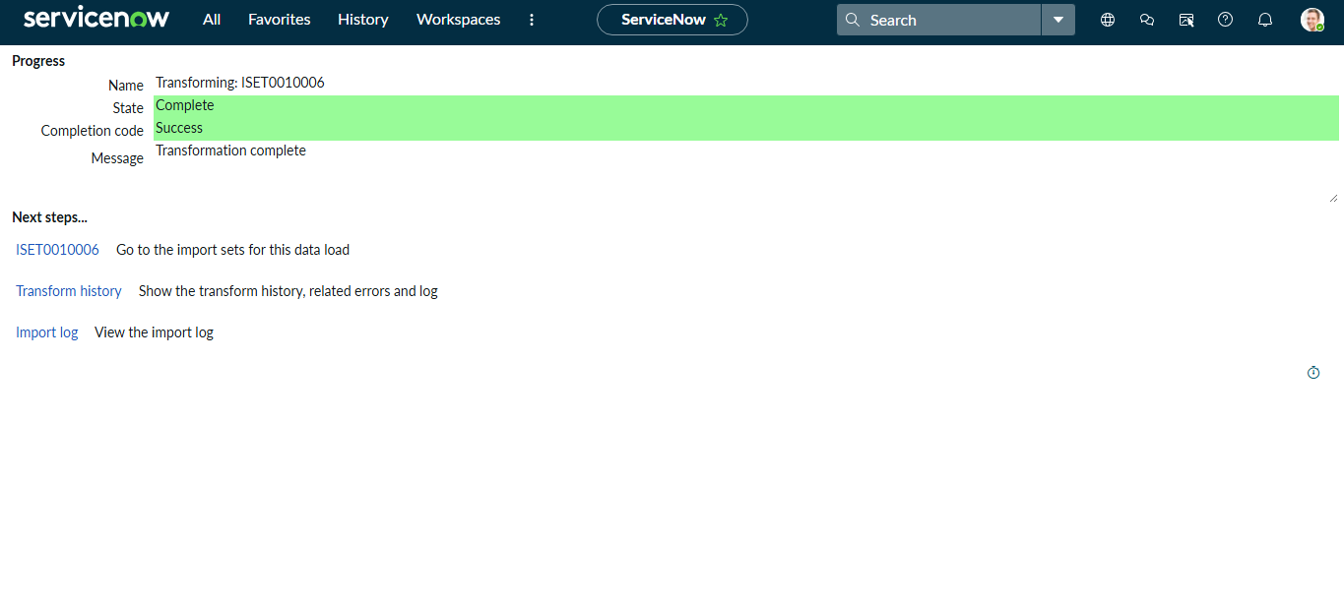
Employee records after import
