PROJECT TESTING
1. Testing Objective
To verify that employee data is imported correctly and duplicate records are prevented using Coalesce.
2. Test Cases
Test case | Expected result
Import new employee records | New records should be inserted
Import existing Employee IDs with modified details | Existing records should be updated
Import the same spreadsheet again | Duplicate records should not be created
Verify employee reports | Reports should display employee data
3. Testing Evidence
Coalesce enabled in Transform Map
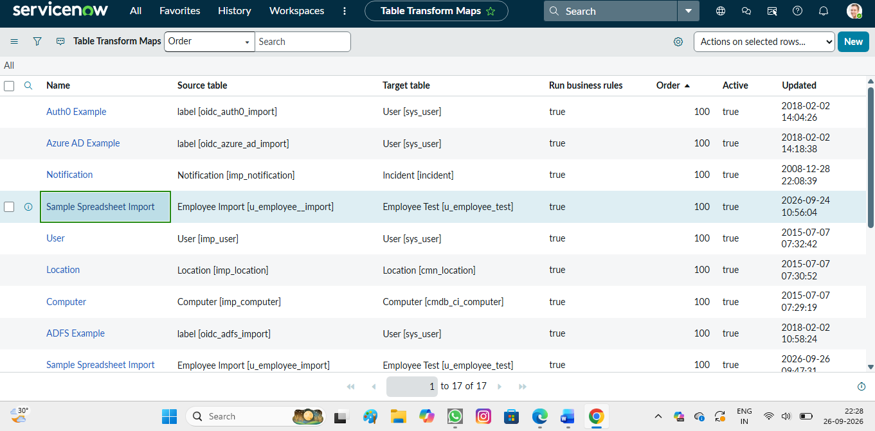
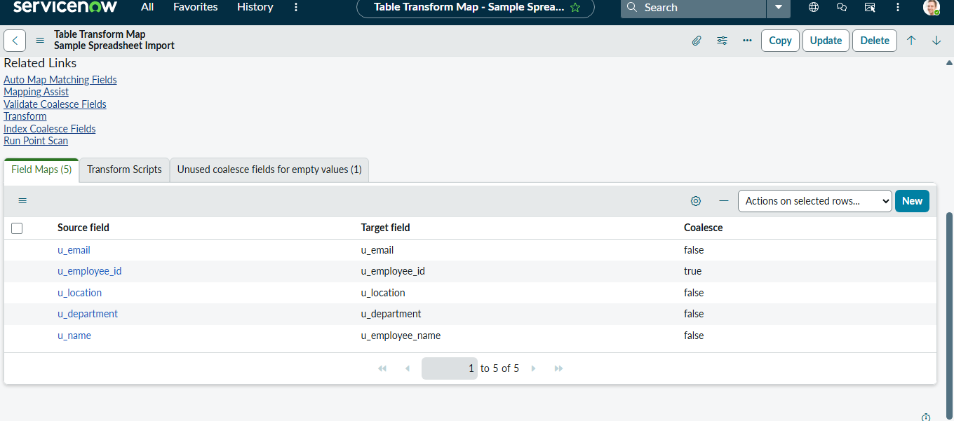
Import result showing inserted and updated records
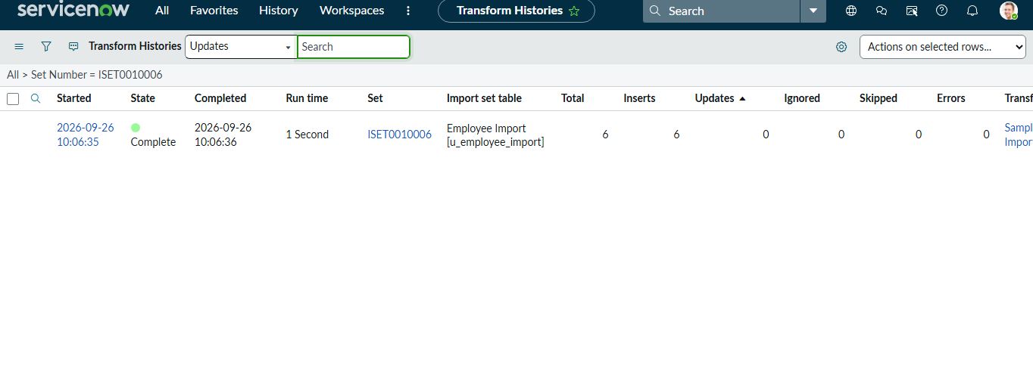
4. Testing Conclusion
The testing process verified that new employee records were inserted, existing records were updated using Coalesce, and repeated imports did not create duplicate records.

