Practical Questions

- write the query joining tables orders, orderdetails, products, customers, payments and produce the below output

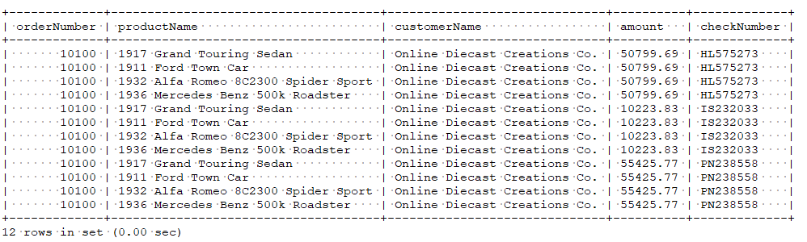

2) write the query to find the total paid amount for the order 10100

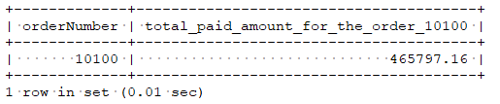
3) write the query to find all the checkNumber using which payment has done for the order 10100

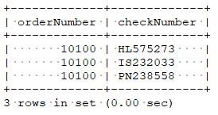

4) In the table products write the query to find least value in the column quantityInStock, and also the maximum value in

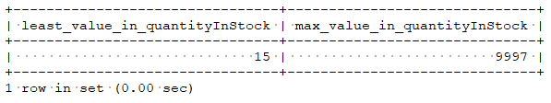
5) write the sql to join products , productlines using subquery and reproduce the below output

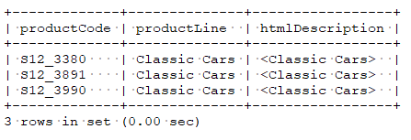
6) write the sql to find count of records in productliness where htmlDescription matches NULL;

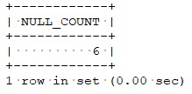

7) convert the date '2019-07-18 12:49:24' to the format 18-Jul-Thu

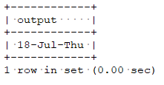

8) write a query to find 3rd highest amount in the table payments

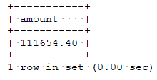

9) write a query to find contactFirstName in customers table that starts with 'C' and ends with 'a'

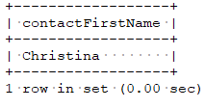

10) write a query to find a record in productlines that is not mapped to any record in products
