SQL Test Assessment:

Question No. 1

SELECT orders.orderNumber, products.productName, customers.customerName, payments.amount, payments.checkNumber
FROM orders INNER JOIN orderdetails
ON orders.orderNumber = orderdetails.orderNumber
INNER JOIN products ON orderdetails.productCode = products.productCode
INNER JOIN customers ON orders.customerNumber = customers.customerNumber
INNER JOIN payments ON payments.customerNumber = customers.customerNumber
WHERE orders.orderNumber=10100;

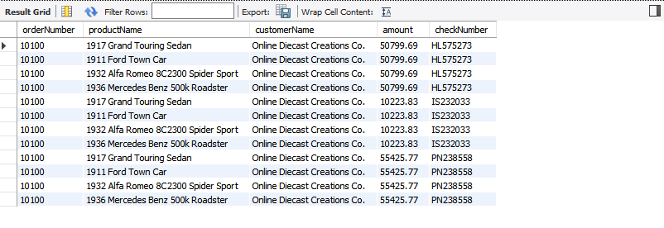
Question No. 2

SELECT orders.orderNumber, SUM(payments.amount) AS total_paid_amount_for_the_order_10100
FROM orders INNER JOIN orderdetails ON orders.orderNumber = orderdetails.orderNumber
INNER JOIN products ON orderdetails.productCode = products.productCode
INNER JOIN customers ON orders.customerNumber = customers.customerNumber
INNER JOIN payments ON payments.customerNumber = customers.customerNumber
WHERE orders.orderNumber=10100;

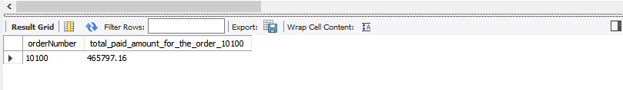

Question No. 3

SELECT DISTINCT orders.orderNumber, payments.checkNumber
FROM orders
INNER JOIN orderdetails ON orders.orderNumber = orderdetails.orderNumber
INNER JOIN products ON orderdetails.productCode = products.productCode
INNER JOIN customers ON orders.customerNumber = customers.customerNumber
INNER JOIN payments ON payments.customerNumber = customers.customerNumber
WHERE orders.orderNumber=10100;

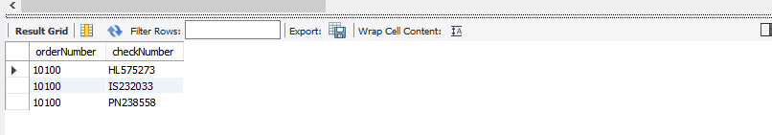

Question No. 4

SELECT MIN(quantityInStock) AS min_value_in_quantityInStock, MAX(quantityInStock) AS max_value_in_quantityInStock FROM products;

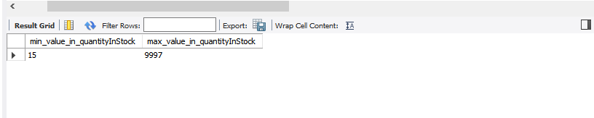

Question No. 5

SELECT products.productCode, products.productLine, productLines.htmlDescription
FROM products INNER JOIN productlines ON products.productLine=productlines.productLine
WHERE products.productLine=(SELECT productLine FROM productlines WHERE productLine='Classic Cars') AND (productCode='S12_3380' OR productCode='S12_3891' OR productCode='S12_3990') ;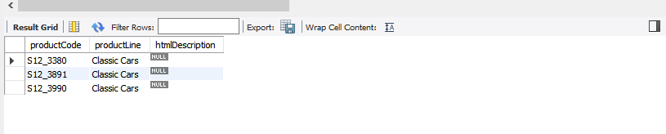

Question No. 6

SELECT count(htmlDescription) AS NULL_COUNT FROM productLines WHERE htmlDescription = NULL;

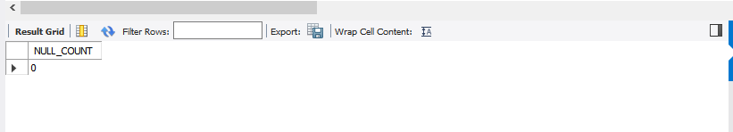

SELECT htmlDescription FROM productLines;

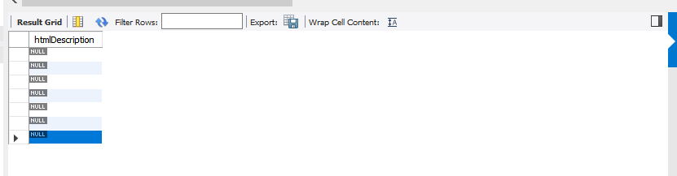

Question No. 7

SELECT date_format('2019-07-08','%e-%b-%a') AS output;

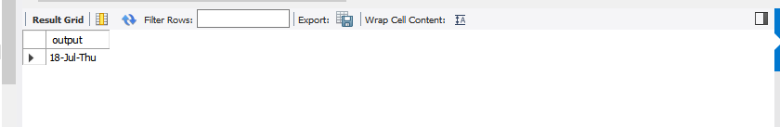

Question No. 8

SELECT amount FROM payments ORDER BY amount DESC LIMIT 2,1;

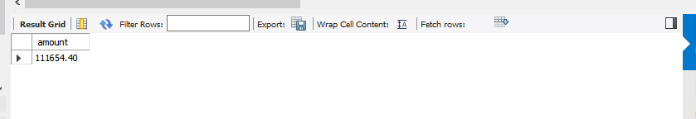

Question No. 9

SELECT contactFirstName FROM customers WHERE contactFirstName LIKE 'C%a ';

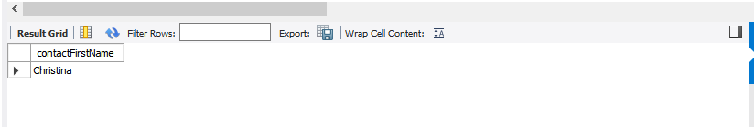

Question No. 10

SELECT * FROM productlines WHERE NOT EXISTS (SELECT * FROM products);

