**SQL Test Assessment:**

**Question No. 1**

**SELECT** orders.orderNumber, products.productName, customers.customerName, payments.amount, payments.checkNumber

**FROM** orders **INNER JOIN** orderdetails

**ON** orders.orderNumber = orderdetails.orderNumber

**INNER JOIN** products **ON** orderdetails.productCode = products.productCode

**INNER JOIN** customers **ON** orders.customerNumber = customers.customerNumber

**INNER JOIN** payments **ON** payments.customerNumber = customers.customerNumber

**WHERE** orders.orderNumber=10100**;**

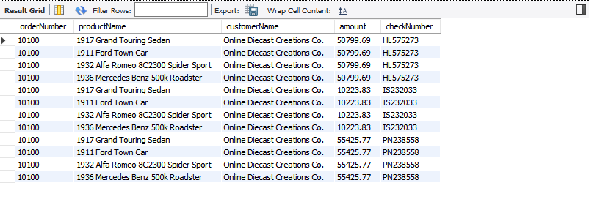

**Question No. 2**

**SELECT** orders.orderNumber, **SUM(payments.amount) AS** total_paid_amount_for_the_order_10100

**FROM** orders **INNER JOIN** orderdetails **ON** orders.orderNumber = orderdetails.orderNumber

**INNER JOIN** products **ON** orderdetails.productCode = products.productCode

**INNER JOIN** customers **ON** orders.customerNumber = customers.customerNumber

**INNER JOIN** payments **ON** payments.customerNumber = customers.customerNumber

**WHERE** orders.orderNumber=10100;

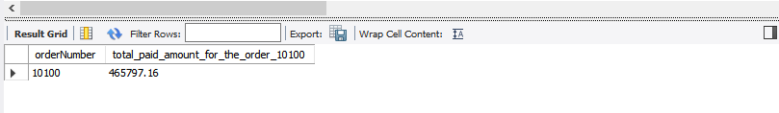

**Question No. 3**

**SELECT DISTINCT** orders.orderNumber, payments.checkNumber

**FROM** orders

**INNER JOIN** orderdetails **ON** orders.orderNumber = orderdetails.orderNumber

**INNER JOIN** products **ON** orderdetails.productCode = products.productCode

**INNER JOIN** customers **ON** orders.customerNumber = customers.customerNumber

**INNER JOIN** payments **ON** payments.customerNumber = customers.customerNumber

**WHERE** orders.orderNumber=10100;

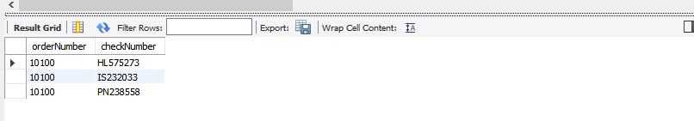

**Question No. 4**

**SELECT MIN**(quantityInStock) **AS** min_value_in_quantityInStock, **MAX**(quantityInStock) **AS** max_value_in_quantityInStock **FROM** products;

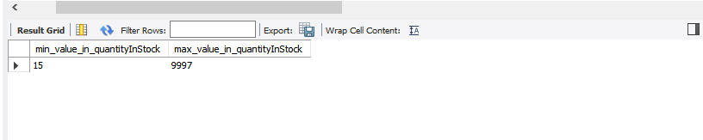

**Question No. 5**

**SELECT** products.productCode, products.productLine, productLines.htmlDescription

**FROM** products **INNER JOIN** productlines **ON** products.productLine=productlines.productLine

**WHERE** products.productLine=(**SELECT** productLine **FROM** productlines **WHERE** productLine='Classic Cars') **AND** (productCode='S12_3380' **OR** productCode='S12_3891' **OR** productCode='S12_3990') ;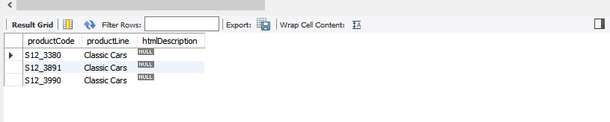

**Question No. 6**

**SELECT** count(htmlDescription) **AS NULL_COUNT FROM** productLines **WHERE** htmlDescription = **NULL**;

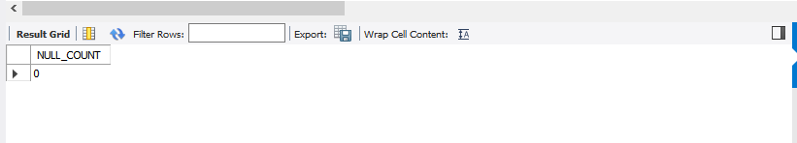

**SELECT** htmlDescription **FROM** productLines;

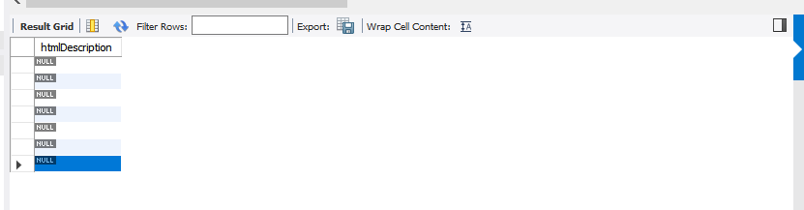

**Question No. 7**

**SELECT** **date_format**('2019-07-08','%e-%b-%a') **AS** output;

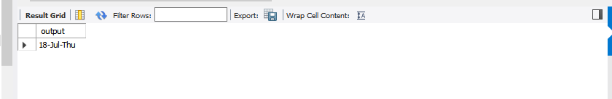

**Question No. 8**

**SELECT** amount **FROM** payments **ORDER BY** amount **DESC LIMIT** 2,1;

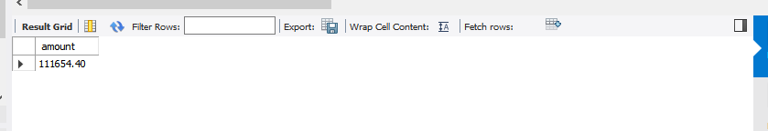

**Question No. 9**

**SELECT** contactFirstName **FROM** customers **WHERE** contactFirstName **LIKE** 'C%a ';

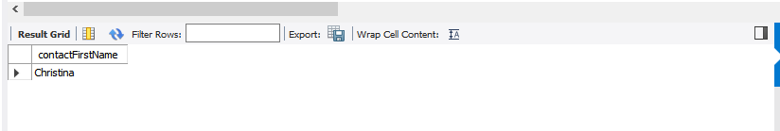

**Question No. 10**

**SELECT * FROM** productlines **WHERE NOT EXISTS** (**SELECT * FROM** products);

