context-engineering-studio

Where AI and humans build
business context, together.

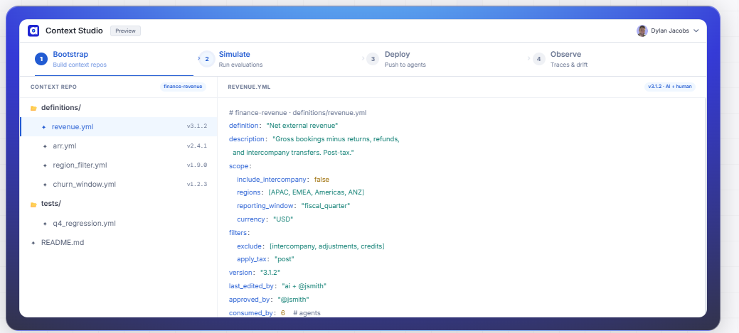

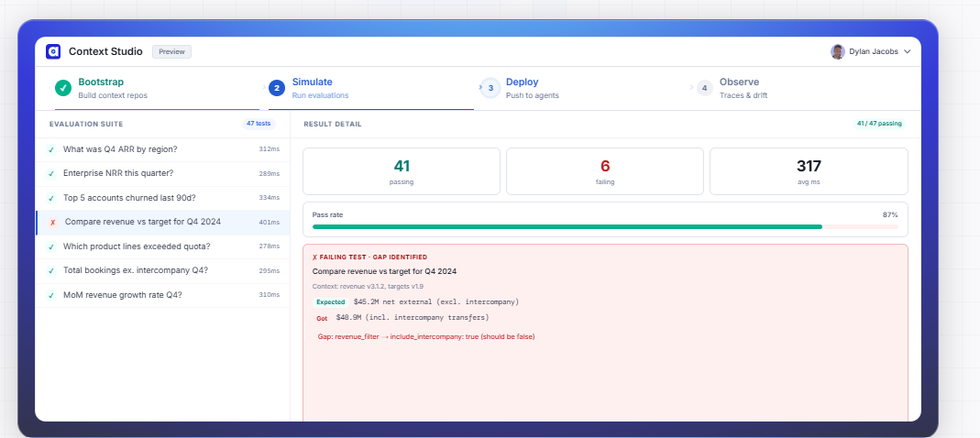

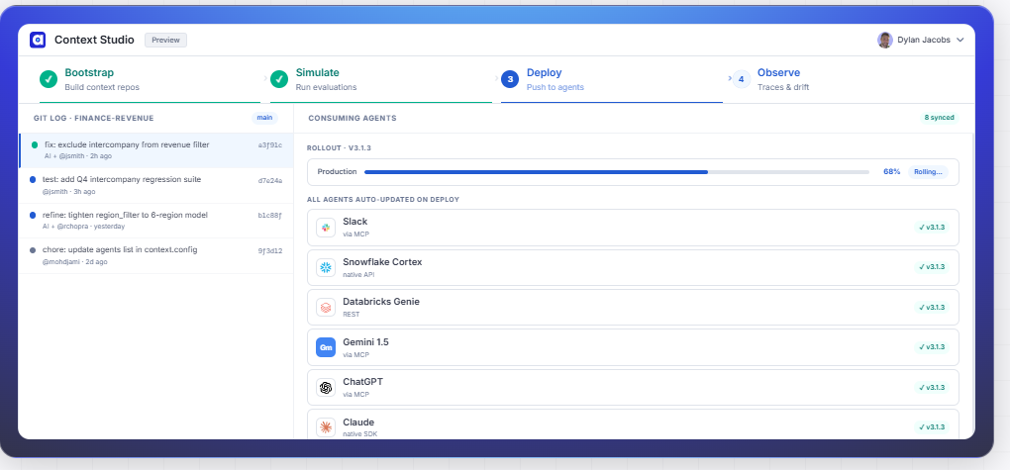

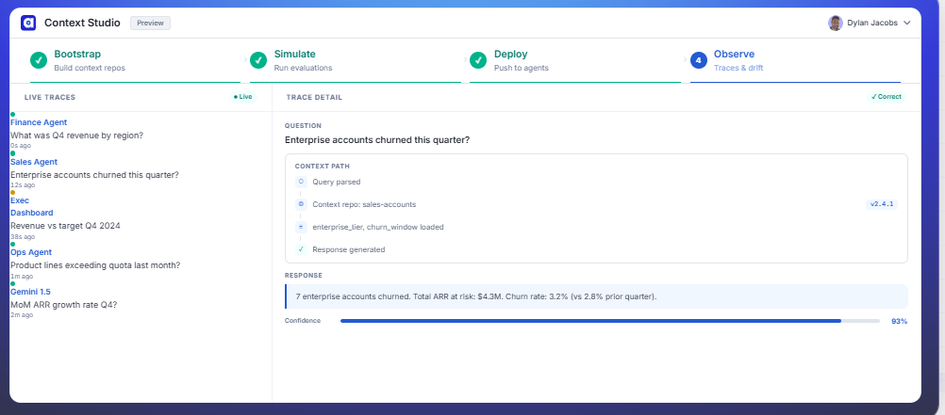

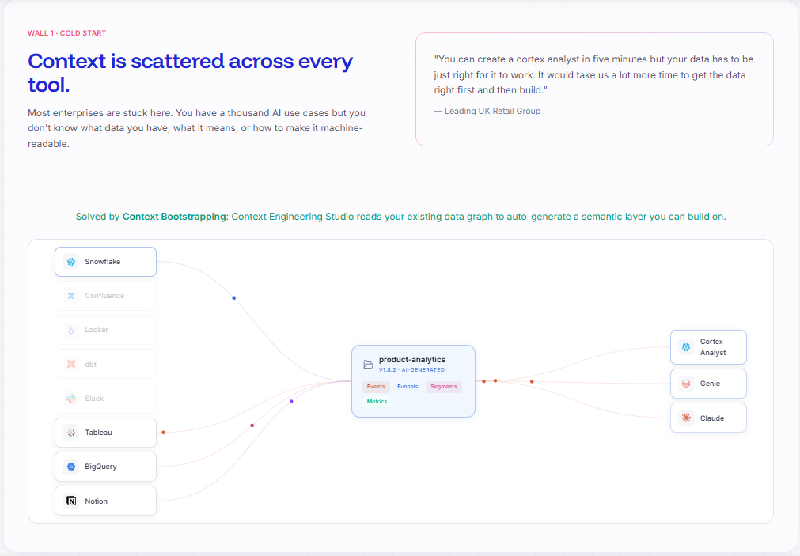

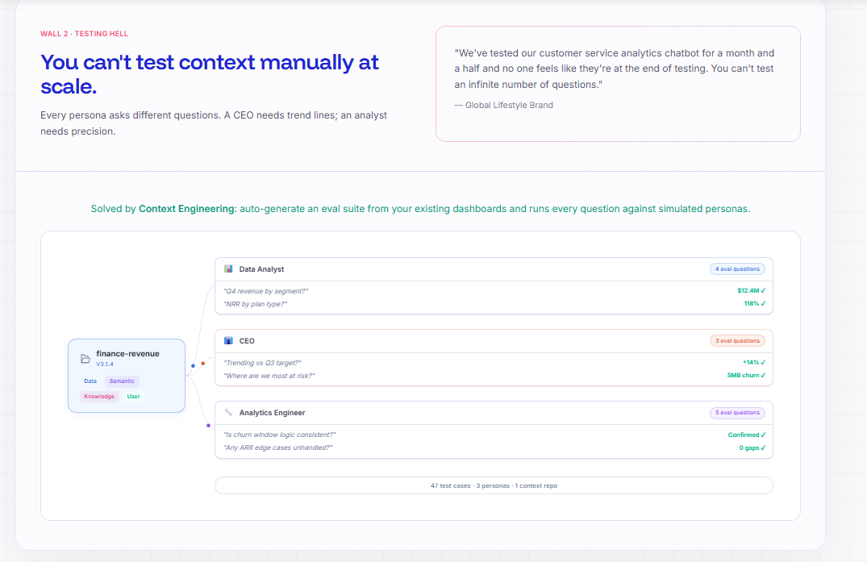

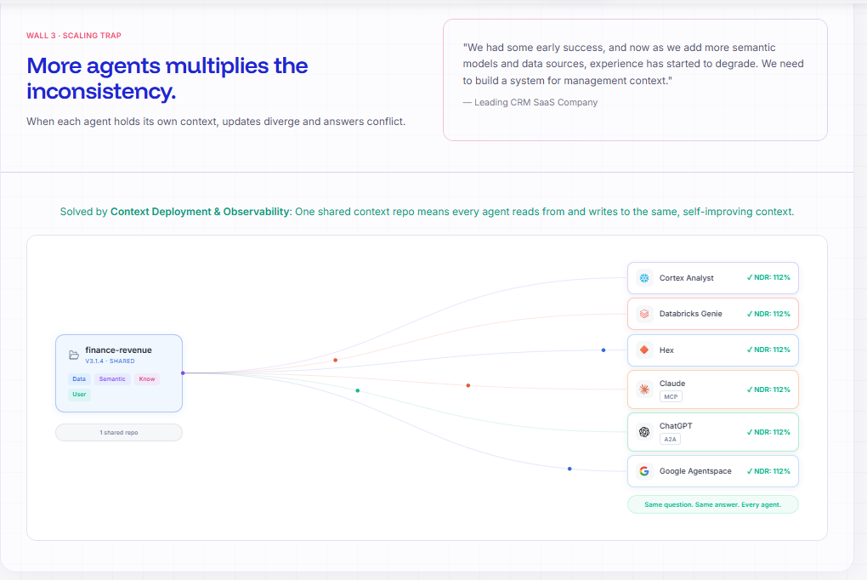

Context boostrapping :

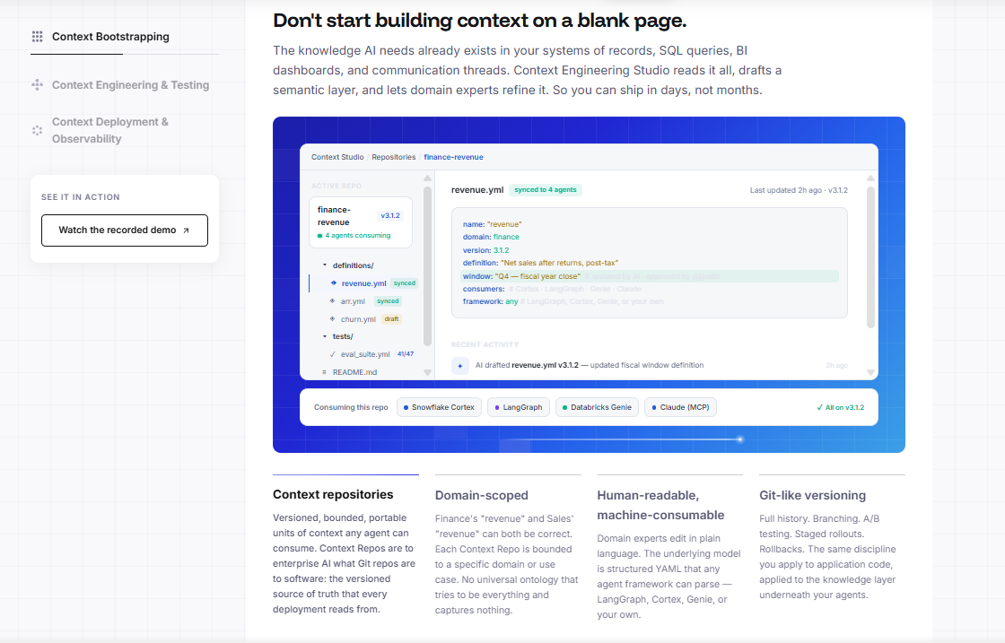

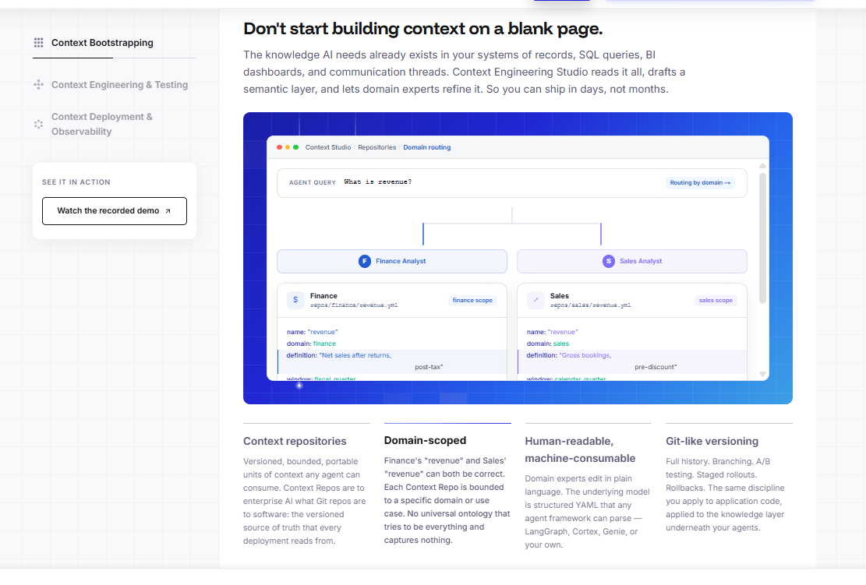

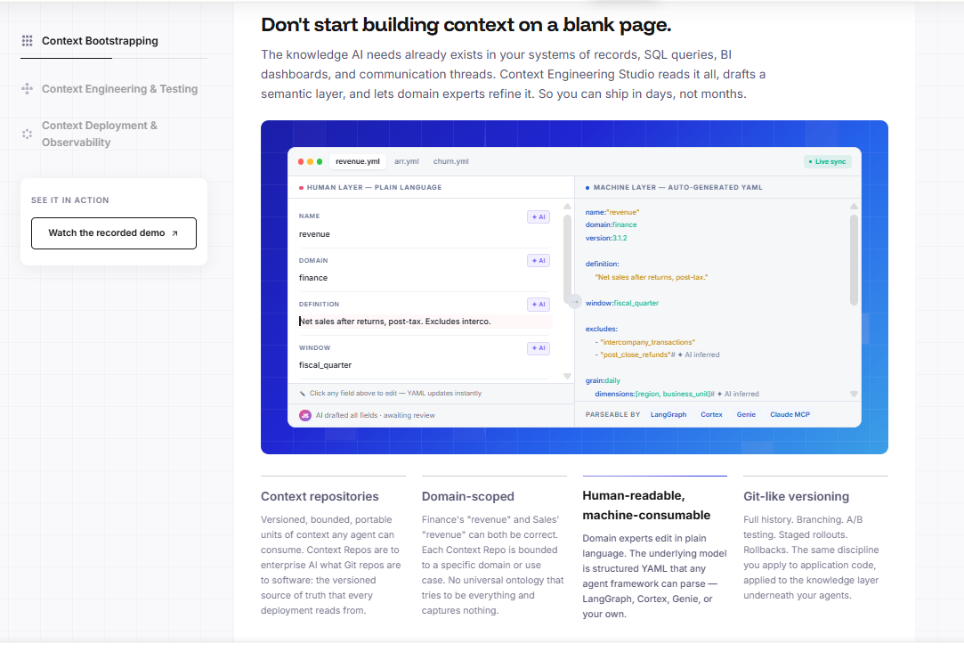
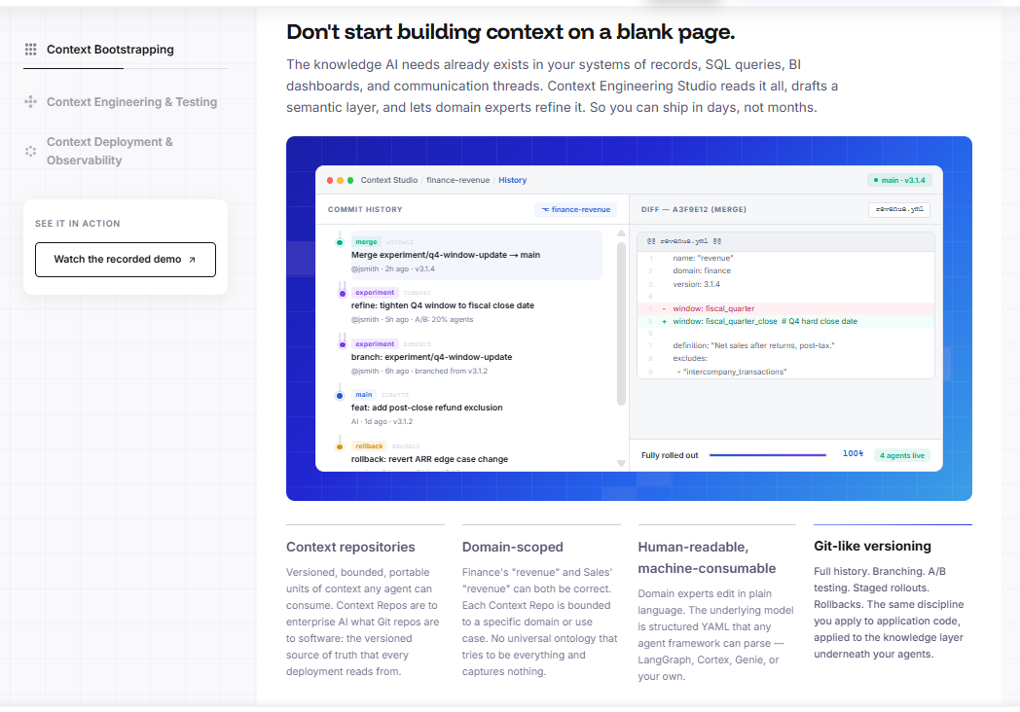
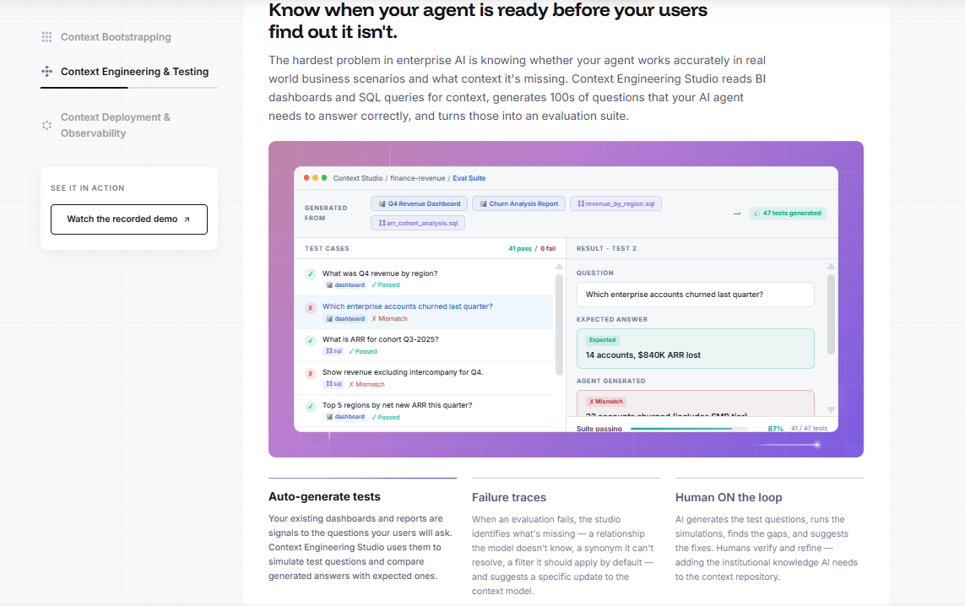

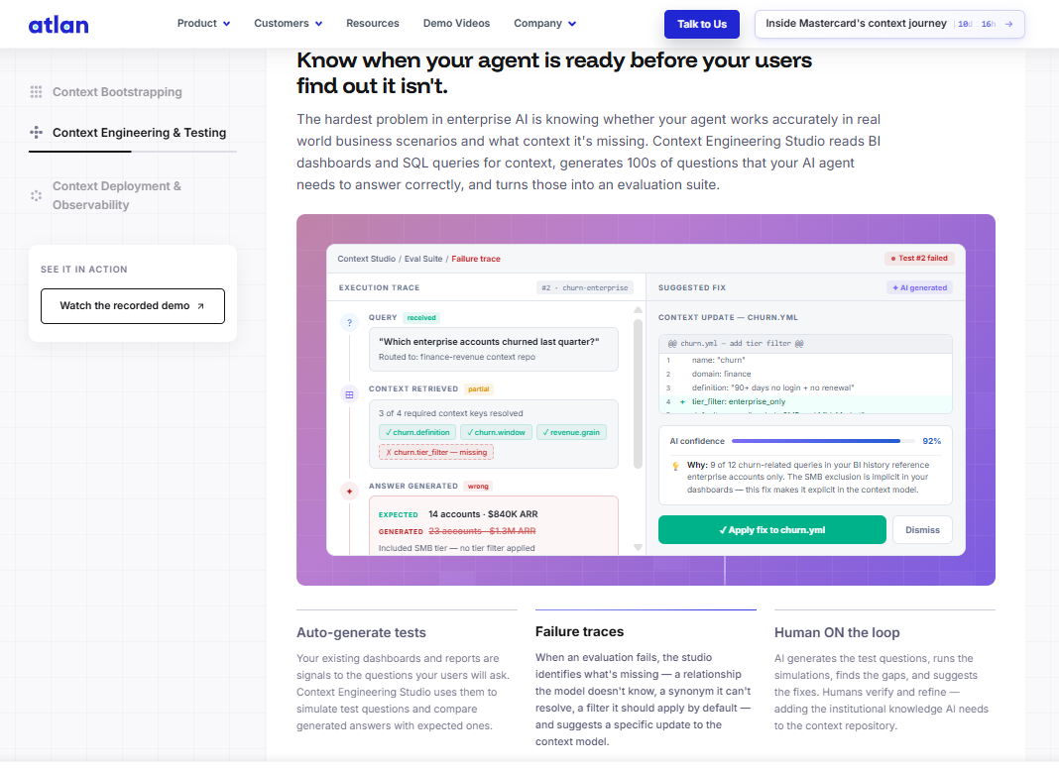

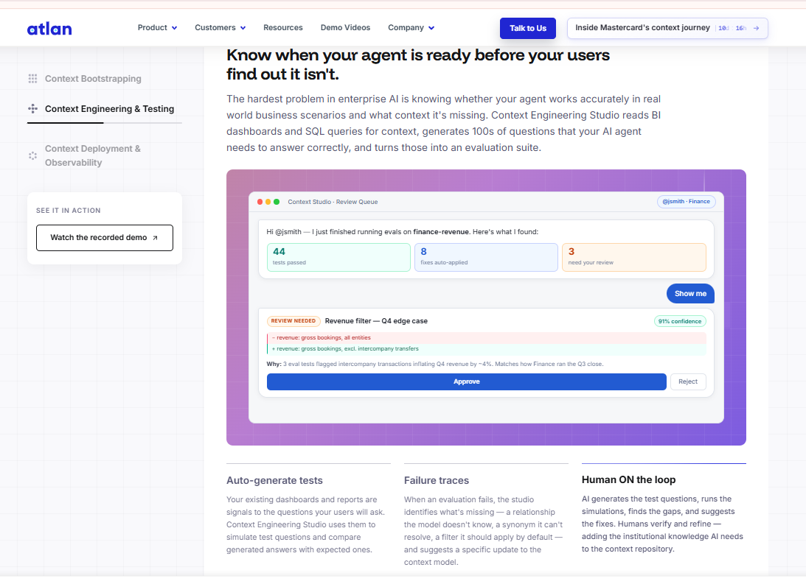

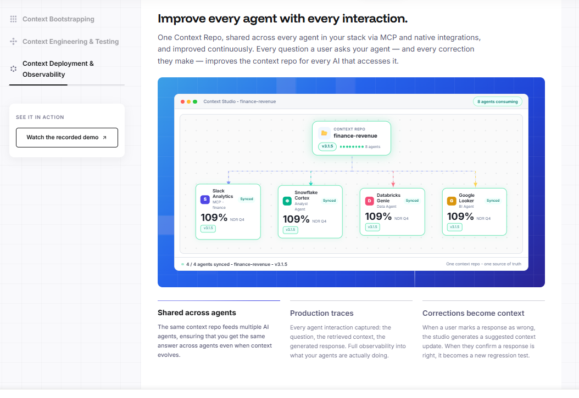

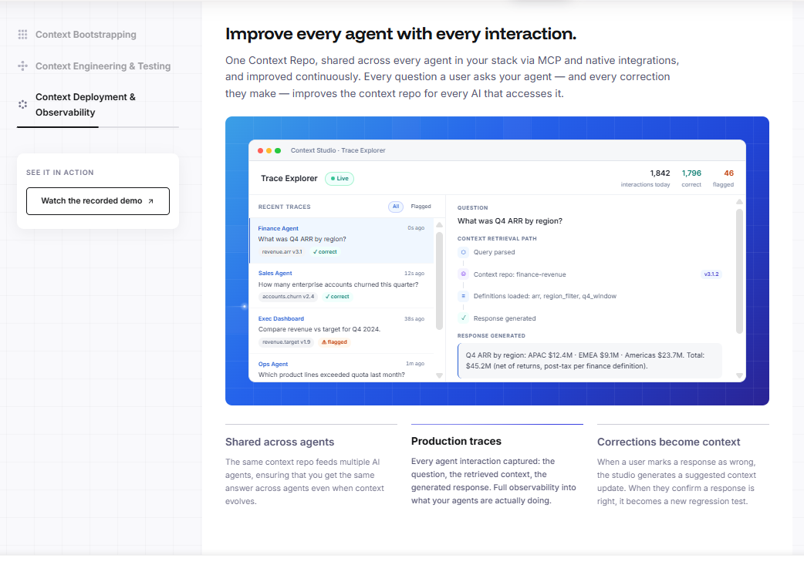

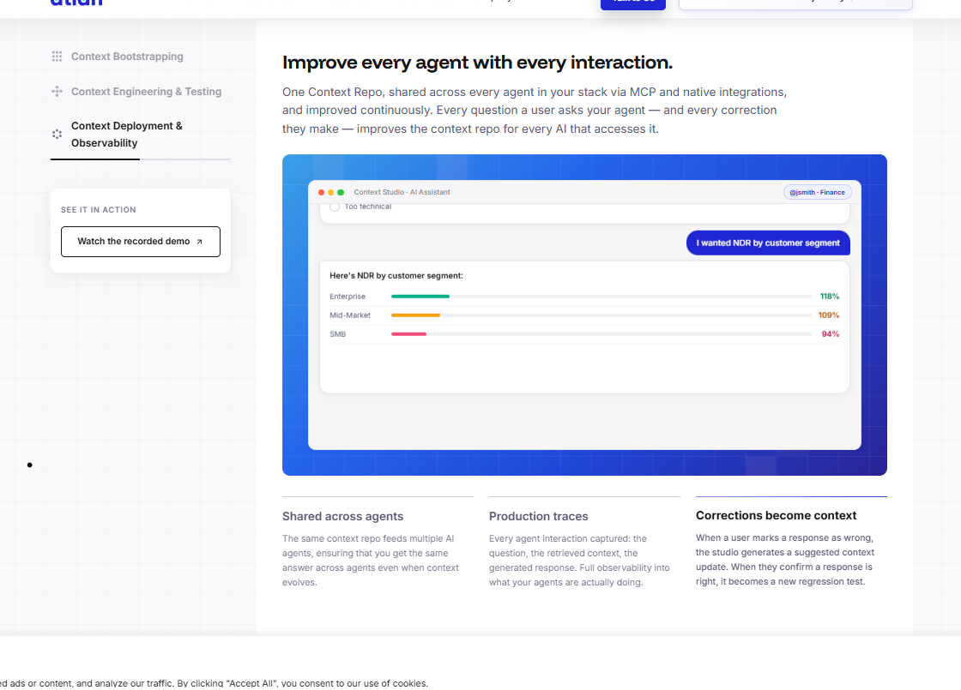

Context Engineering Studio is Atlan's AI-assisted workflow for building, testing, and deploying the context AI agents need to answer questions correctly. It combines specialist AI agents that bootstrap context from your existing metadata, human-in-the-loop workflows where domain experts fill gaps, automated evals that validate context before production, and a Context Repo that every AI agent in your ecosystem reads from through MCP. Context Engineering Studio is the engineering environment for the world model your AI runs on.
A semantic layer defines metrics and dimensions for BI tools. Context Engineering Studio goes further — it captures business logic, resolves definition conflicts across teams, documents edge cases, applies regional rules, and governs who owns each definition. The output is a versioned, model-agnostic Context Repo that any AI system reads through MCP, not locked to any single tool or vendor. A semantic layer answers "what does this metric mean." Context Engineering Studio answers "what does this metric mean, for which team, with which exceptions, and who certified it."
A Bounded Context Space is a scoped, versioned, governed environment inside Context Engineering Studio where domain experts do their part of context building. Each space is tied to a specific use case or business domain. Domain experts review AI-bootstrapped definitions, add business logic, resolve conflicts, and approve context for production — in plain language, with no SQL or YAML required. The boundary ensures that conflicting definitions from different teams are resolved deliberately, not silently overwritten.
Context Engineering Studio turns your existing dashboards, reports, and production queries into a test suite. Before any context ships, you run your AI agent against the actual questions your teams ask — surfacing gaps, wrong answers, and missing definitions before your users encounter them. Evals persist across versions, so every improvement is tested against the same benchmark. You would never push code to production without tests. Context Engineering Studio applies the same standard to the semantic layer your agents run on.
Context Repos are model-agnostic and expose context through the Model Context Protocol (MCP). Any AI agent or tool that supports MCP — including Snowflake Cortex Analyst, OpenAI models, Claude, Gemini, and custom-built agents — can read from the same shared Context Repo. You build context once. Every agent benefits. Not locked to Snowflake. Not locked to Databricks. Not locked to any AI vendor.
No. Context Engineering Studio complements existing semantic layers by adding the business context, governance, and conflict resolution they were not designed for. It reads from and enriches existing tools — bringing in definitions, ownership, and edge-case logic that improve the accuracy of any AI agent working on top of your data stack. If you already have a dbt semantic layer or a Snowflake Cortex model, Context Engineering Studio makes it more accurate, not redundant.

Context Agent s::

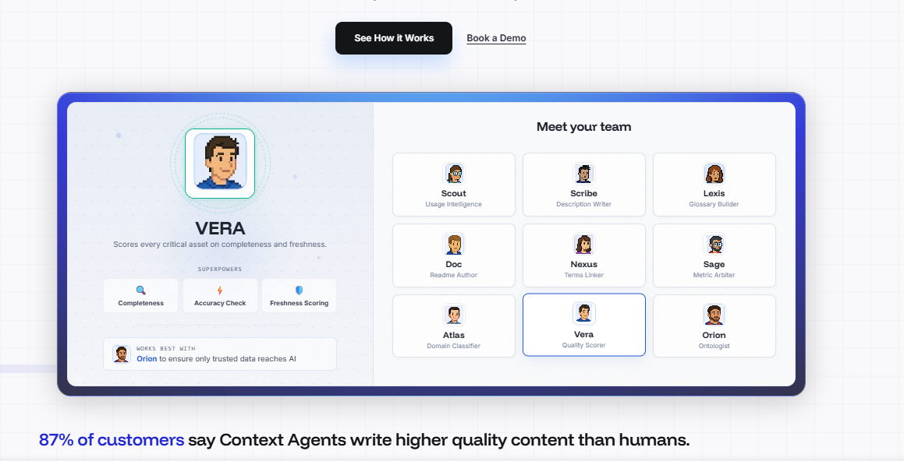

"We were stunned and perplexed by the quality of the content. How could the agents create such high-quality context from lineage, SQL, and dbt logic? It shows how much business information is hidden in metadata that we can't see with human eyes. But agents consume it all and organize it.

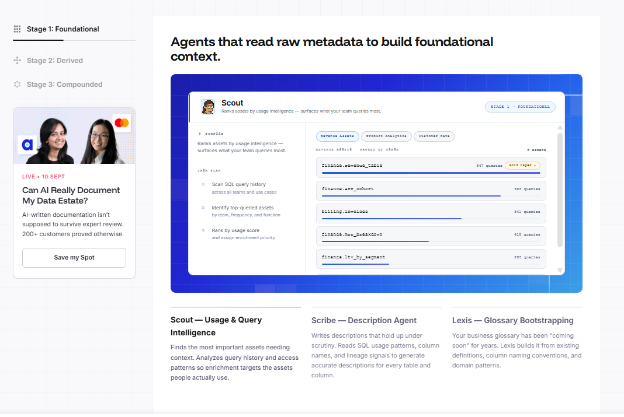

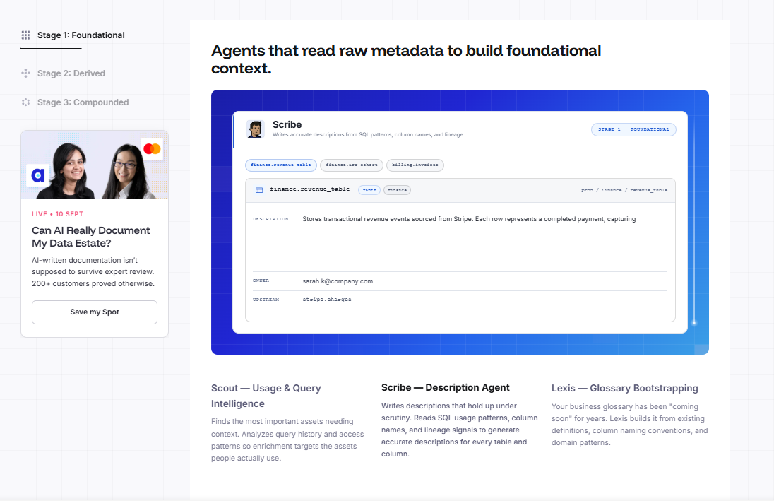

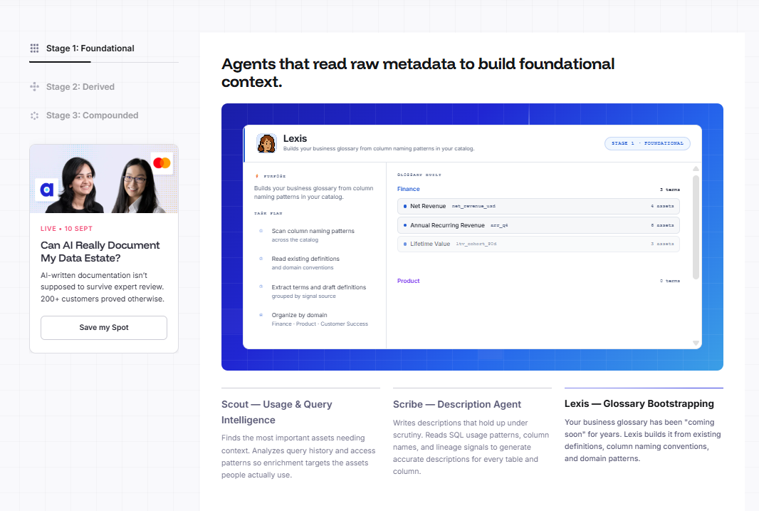

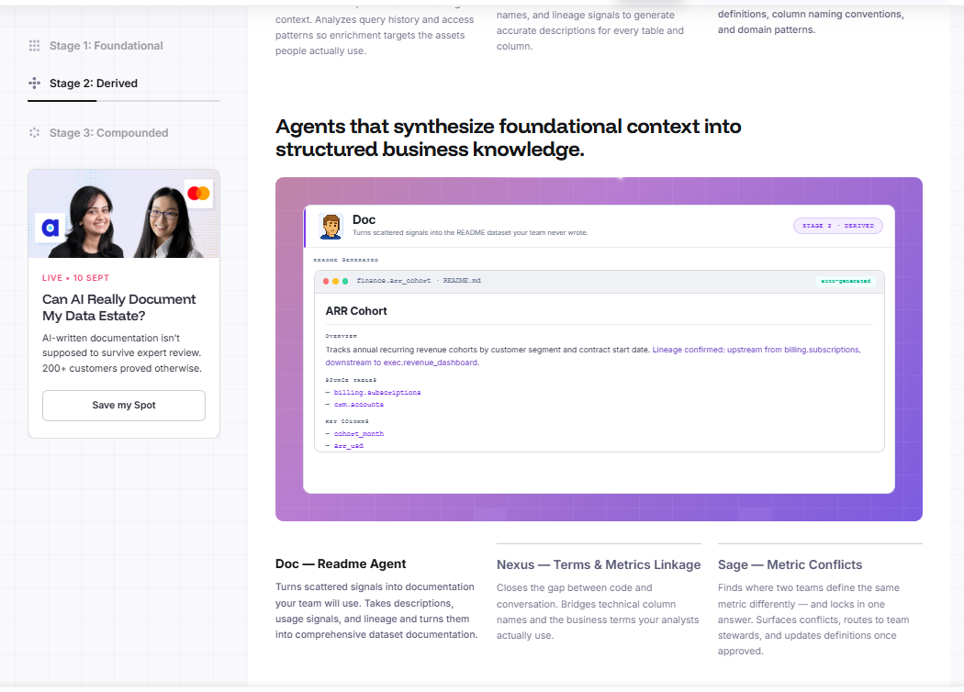

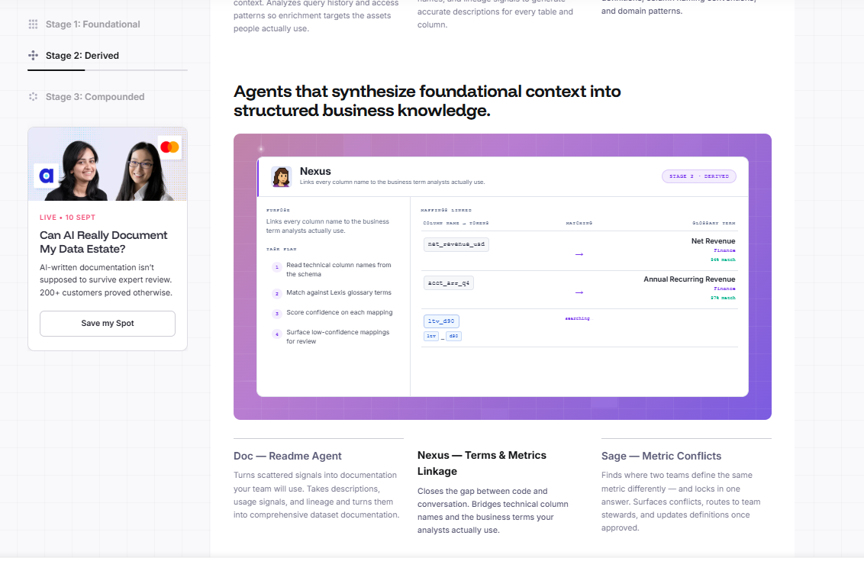

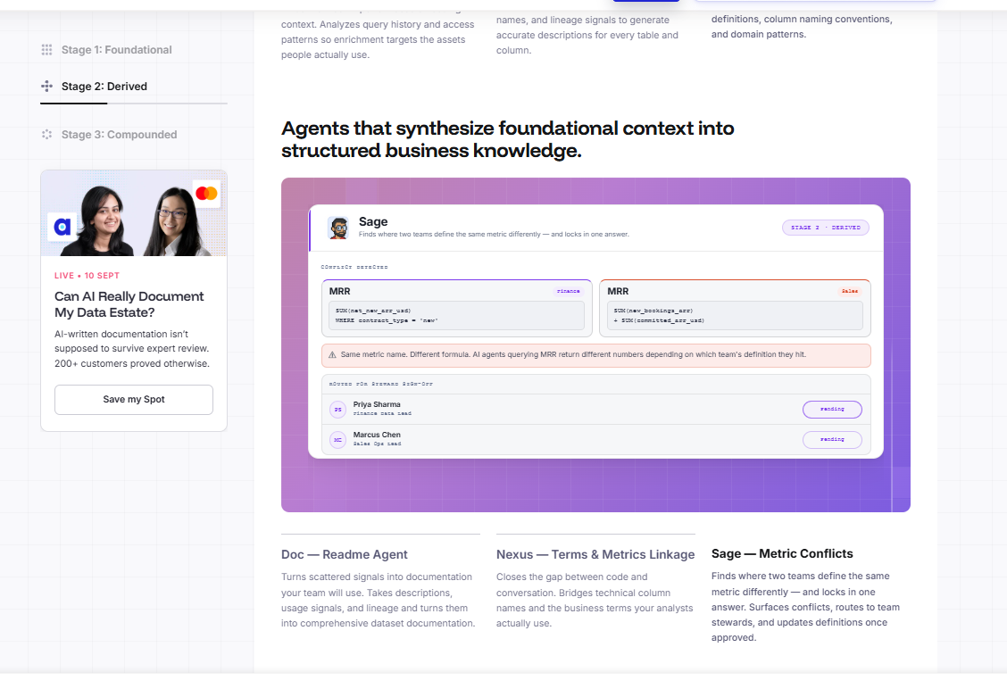

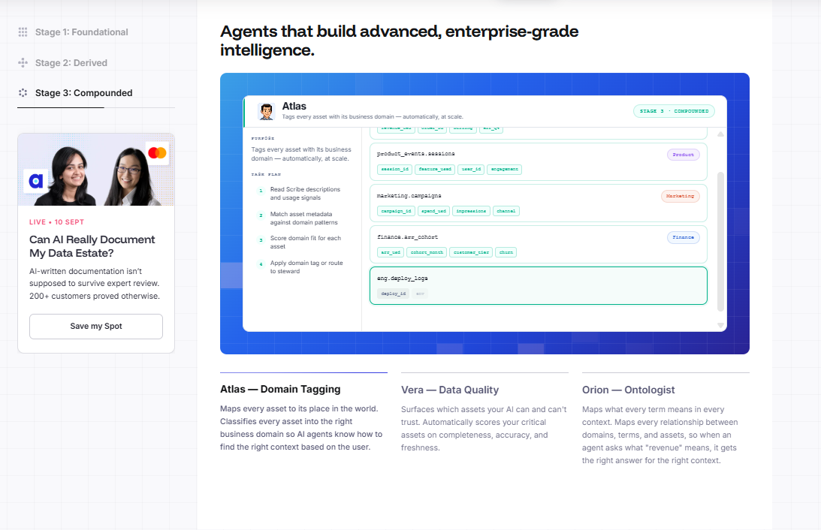

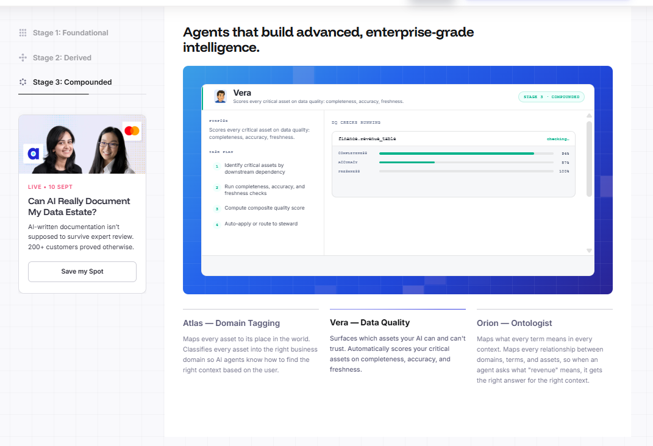

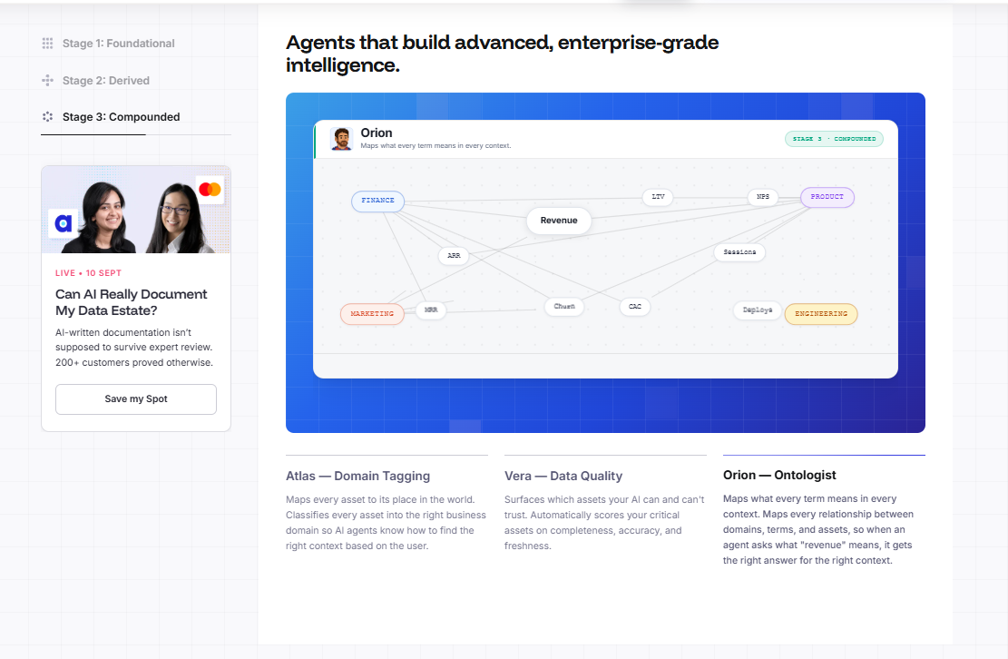

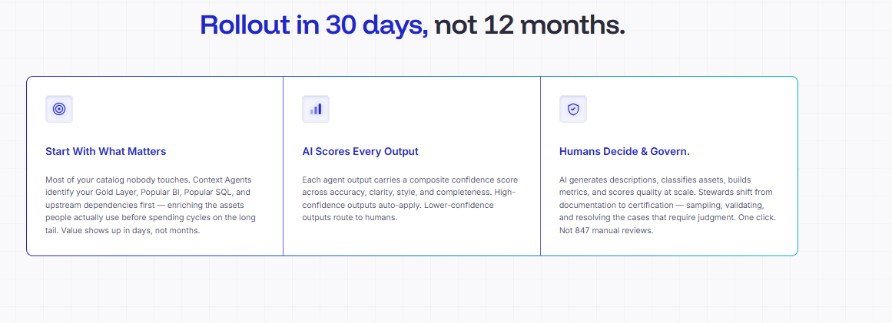

Months of work, done by lunch
"Without this context we would have spent months/years manually updating the metadata required for these efforts and would not let us move at the speed we can now."

Bernie Daley
Director of Data Management, Nelnet Servicing, LLC
"With single-digit hours of effort from our team, we were able to accomplish work that would have taken months for a larger team to finish — and realistically, we likely would not have ever started it."
Data Governance Leader
Consumer Packaged Goods (CPG)
"If we tried to map and document this data estate manually, it would have taken years for an entire team. I joked internally that I'd be ready to retire before we finished. Automation turned a multi-year hurdle into an immediate win."
Data Governance Leader
Financial Services
"Our pilot proved that automated context drafting makes our entire documentation process infinitely more efficient. The results show that it is significantly faster for our producers to review and fix an existing draft than to write one from scratch."
Data Engineering Leader
Retail & E-commerce
"This serves as an excellent accelerator to get critical governance conversations going across the company. It instantly provides rich content for our teams to discuss and refine, rather than leaving them staring at empty pages."
Data Architect
Energy & Utilities
"This completely jump-started the population of our descriptions, allowing us to permanently overcome the 'cold start' issue that stalls out most traditional enterprise governance initiatives."
Data Engineering Leader
Technology & SaaS
"The ability to quickly prefill initial descriptions and READMEs is extremely beneficial because taking that first manual step is always the most time-consuming. Once the baseline is established, you can focus human energy strictly on refining your highest-value assets."
Data Engineering Leader
Life Sciences & Healthcare
Context that captured the business DNA
"I expected boilerplate — instead, it inferred business context I never explicitly provided, correctly describing how an asset fit into our customer journey just from column names and lineage. That's when I realized this was knowledge synthesis, not just documentation."

Swatilekha Saha
Data Architect, DAT Freight & Analytics
"The output shifted from solid generic descriptions to something that felt like it had been written by someone who understands our business. That's the moment I stopped thinking about this as a time-saving tool and started seeing it as a strategic capability."

Izabela Wilczynska
Data Governance Manager, PayU
"It picked up on the nuance of our underlying database structures, successfully defining audit columns and system attributes that human stewards usually ignore out of fatigue. It proved we can move past line-by-line micromanagement."
Data Governance Leader
Insurance
"We have highly custom, specialized domain terminology that standard dictionaries completely miss. The system parsed our query behavior and accurately translated that unique jargon right out of the box, without heavy manual training."
Data Governance Leader
Travel & Hospitality
"Operating in heavy manufacturing means our data carries highly specific operational context. The agents interpreted and documented these industry-specific assets flawlessly, showing a deep understanding of our business logic without manual fine-tuning."
Data & Analytics Leader
Industrial Manufacturing
"The specialized documentation and structural context that the agents generated were surprisingly accurate. They captured our data architecture so cleanly that, with only a few minor corrections, they were completely production-ready."
Data Engineering Leader
Retail & E-commerce
"The depth of the context it pulled automatically was incredible. It successfully mapped out highly complex, specialized tables that are notoriously difficult to track manually, giving us a level of baseline precision we couldn't maintain on our own."
Data Governance Leader
Life Sciences & Healthcare
Surfaced business logic that was hidden in queries
"We were stunned with the quality of the content that was produced by these AI agents. We were perplexed. How could it create such high-quality context from lineage, from SQL logic, from dbt logic. It really shows how much business information is hidden in the metadata following a lineage that we simply cannot see with human eyes. But agents pick it up, consume it all, and spit it out in an organized way."

Kenneth Jebjerg
Head of Data Engineering
"The AI enables us to do things we wouldn't be able to do otherwise. I don't know if we would ever get to this level of quality with descriptions. Getting a consistent definition when different lines of business describe things differently? Everyone ends up learning more about the data than they knew."

Cody Brees
Data Governance Lead, The Bancorp
"This provided an exceptional opportunity to generate deep technical insights via SQL Intelligence that would be incredibly difficult and labor-intensive to gather manually across our core data pipelines."
Data & Analytics Leader
Retail & E-commerce
"We put the automated descriptions in front of our most rigorous enterprise data gatekeepers, and it cleared an 80% accuracy baseline immediately. It proved that automated context can meet the strict standards of a global corporate data office."
Data Governance Leader
Technology & SaaS
"Instead of just filling in blank text boxes, the system decodes the inner logic of our data through actual usage footprints. It turns documentation into a live, continuous feedback loop that evaluates our overall platform health."
Data Architect
Life Sciences & Healthcare
"By reverse-engineering raw query footprints, the system automatically captured the exact business questions our users naturally ask. It understands human intent far better than a static data dictionary ever could."
Data Governance Leader
Non-Profit & Education
"The natural language questions surfaced by the SQL Intelligence feature were a major milestone for us. Seeing the machine reverse-translate complex SQL queries back into clear, user-friendly business logic was highly impressive."
Data & Analytics Leader
Technology & SaaS
No more chasing busy analysts and engineers
"Once we showed this to our BI team, you could see the attitude shift — from 'another tool, more work' to excited to get in and start looking around. The instant value just changed everything."

Sayali Avalakki
BI & Analytics Lead, Brightspeed
"This system gives us an incredibly solid foundation to build our new data governance culture. By automatically generating initial context, it completely eliminates the 'blank page effect' that stops users from adopting tools."
Data Governance Leader
Your AI agents are flying blind.
Atlan gives them the context to act.

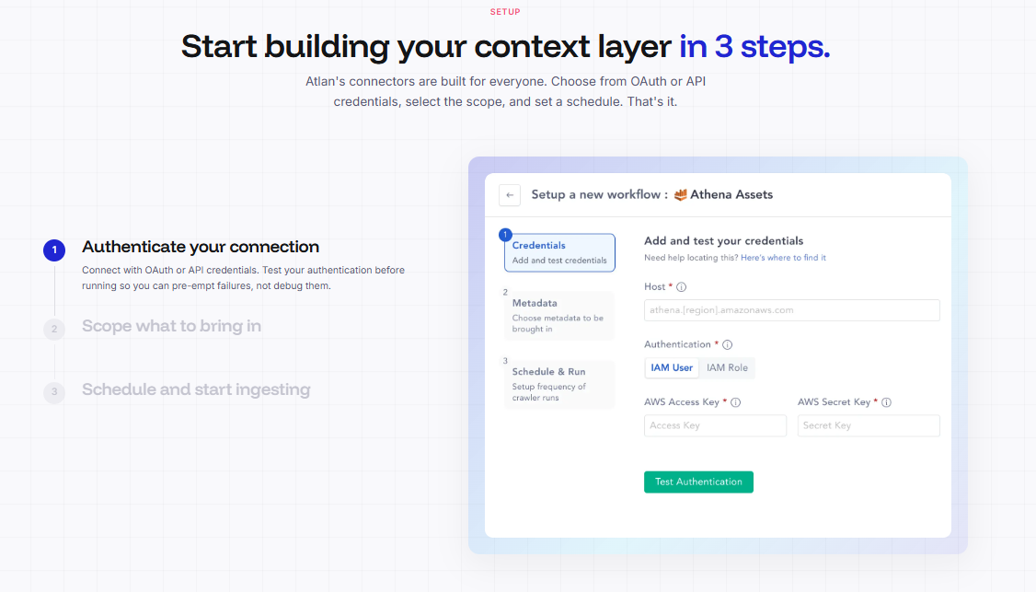
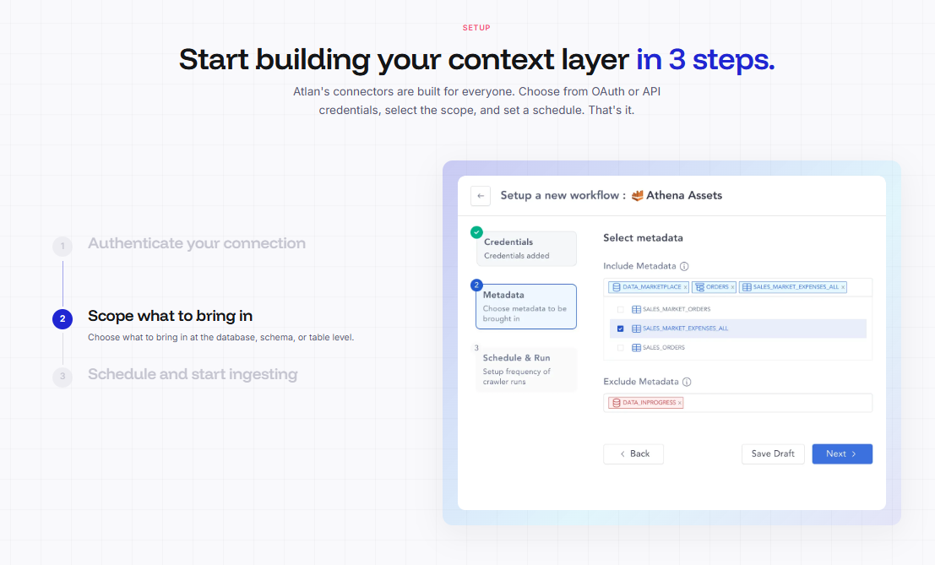

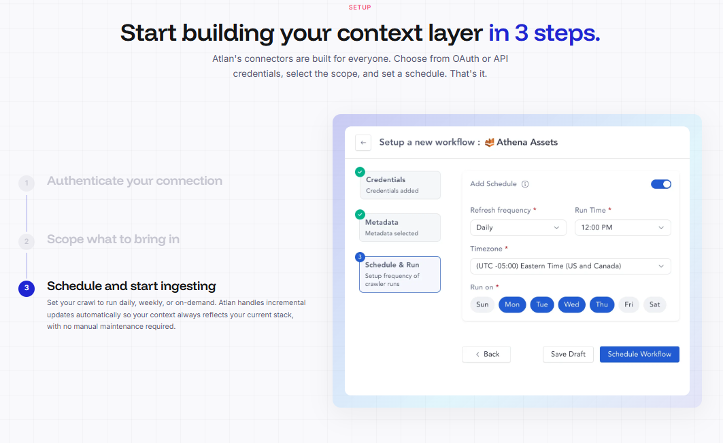

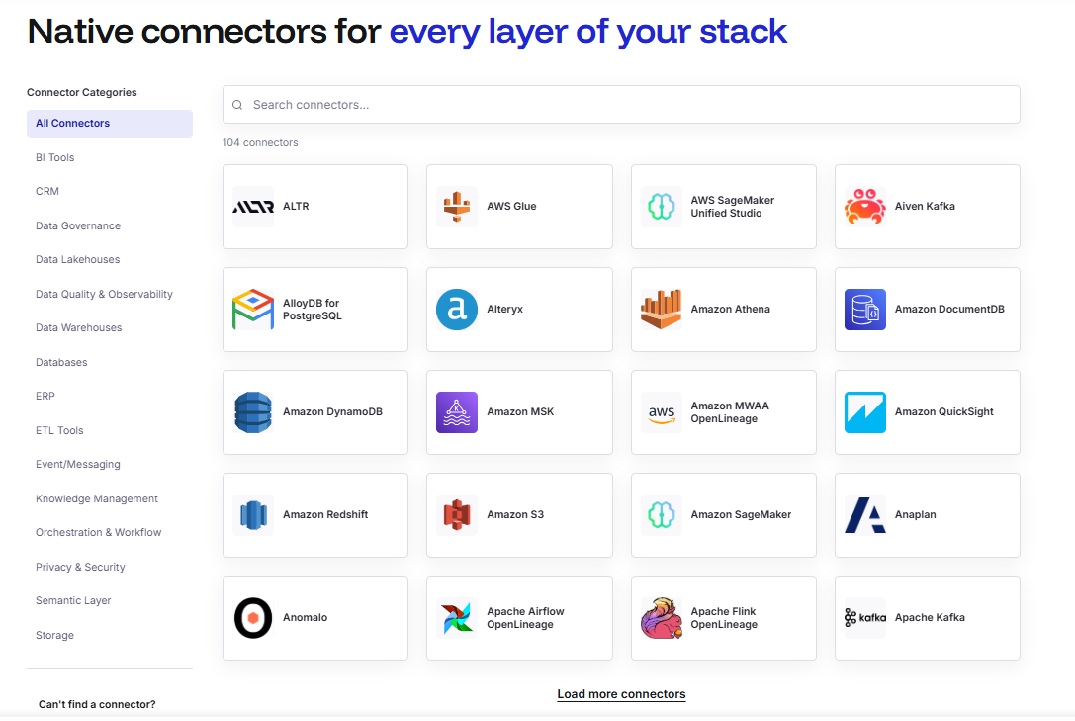

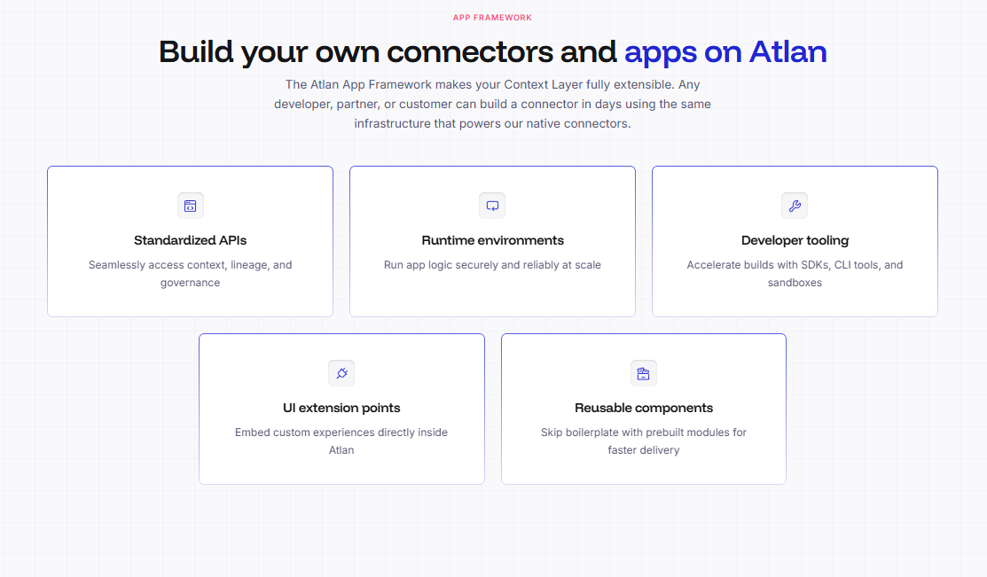
Data Lineage :

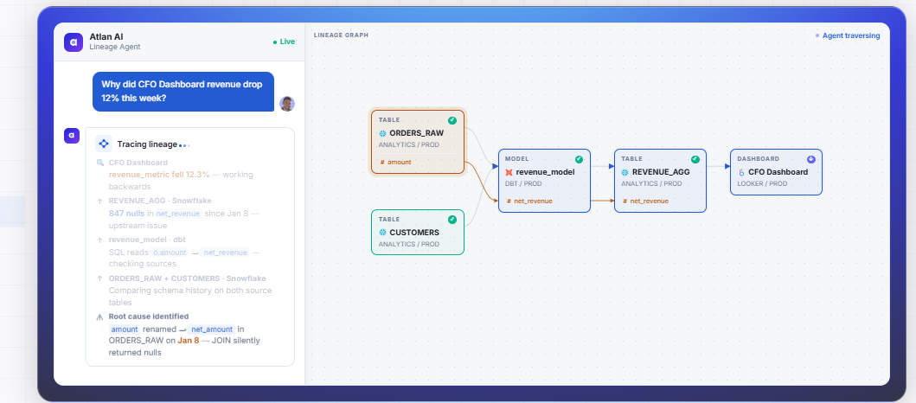

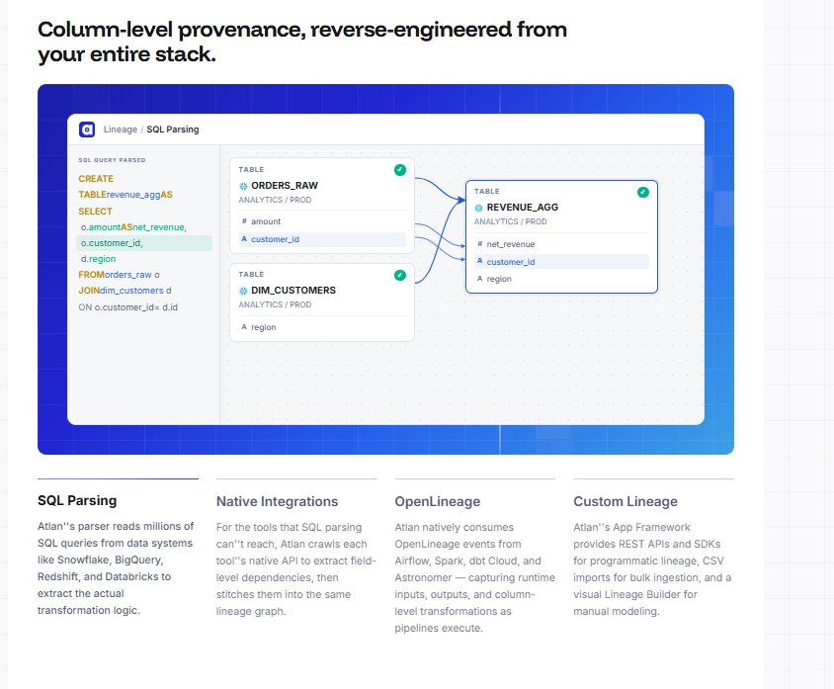

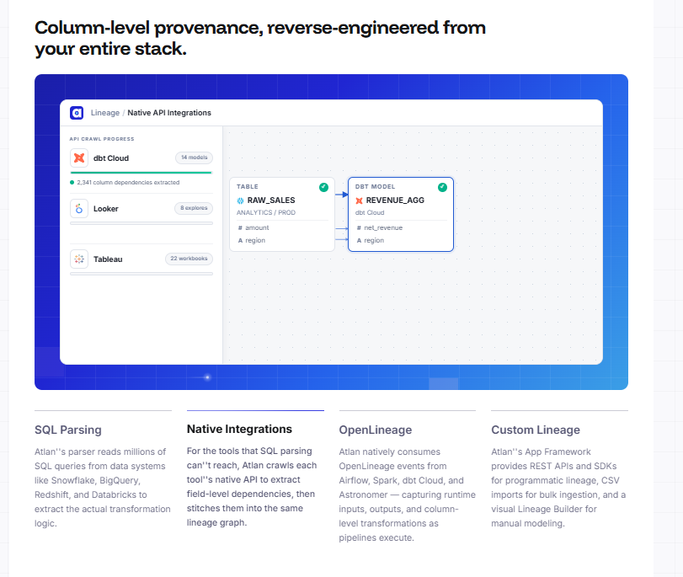

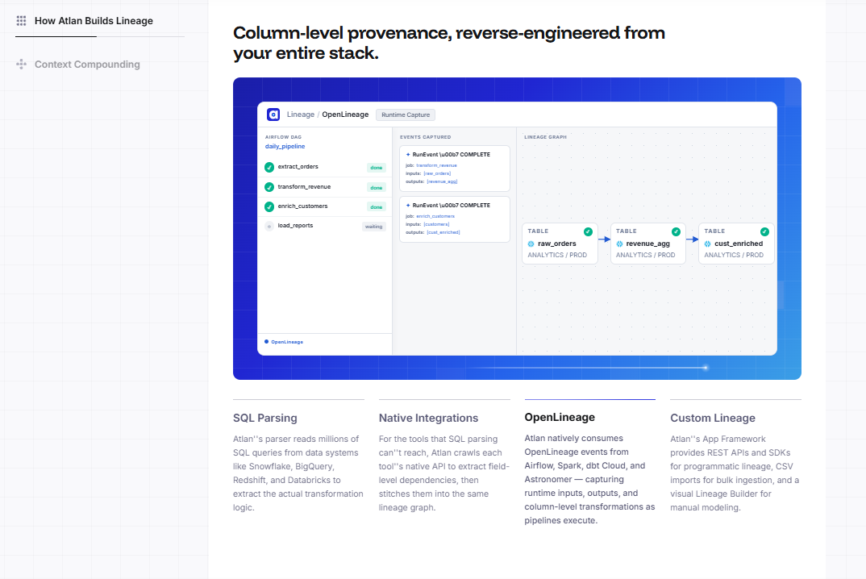

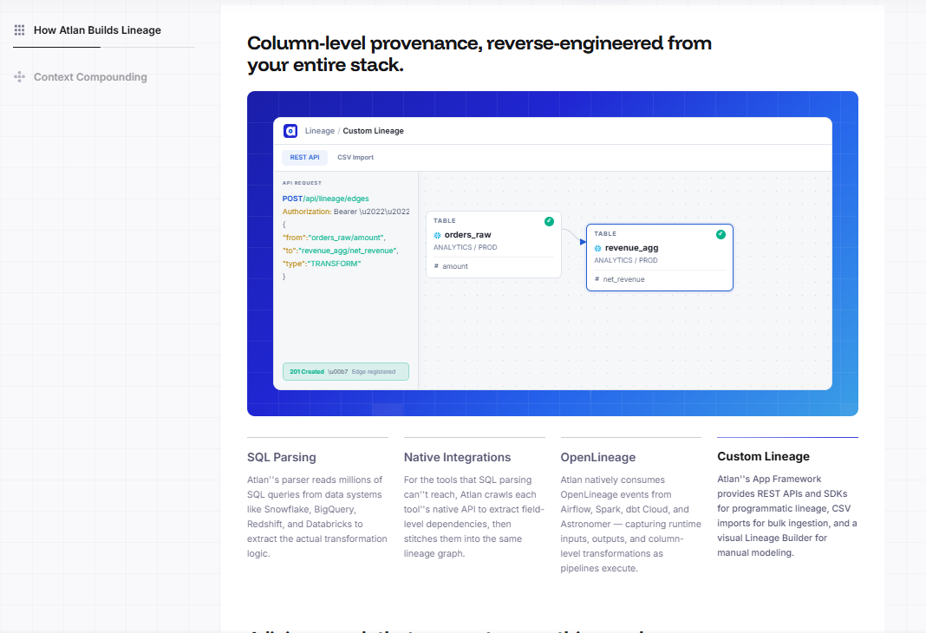

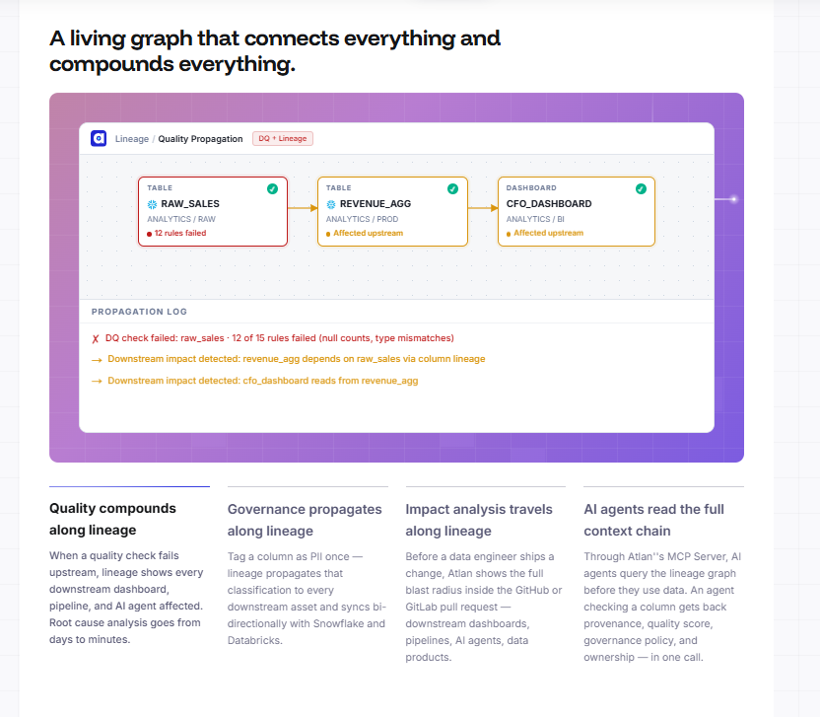

Everything you need to know about
data lineage with Atlan
How does Atlan build lineage across the enterprise data estate?
Four methods work together to build one unified graph. SQL parsing reads millions of queries from Snowflake, BigQuery, Redshift, and Databricks to extract transformation logic at the column level. Native integrations crawl each tool's API for pipelines SQL cannot reach. OpenLineage ingestion captures runtime inputs and outputs from Airflow, Spark, dbt Cloud, and Astronomer as they execute. Custom lineage APIs, SDKs, and a visual builder handle anything that falls outside those three. The result is a single, continuously updated lineage graph — automatically reverse-engineered, no manual mapping required.
How do AI agents query Atlan's lineage graph?
How does Atlan help trace AI answers back to source data?
What is the difference between table-level and column-level lineage?
How does governance propagate along the lineage graph?
How does impact analysis work before a schema change?

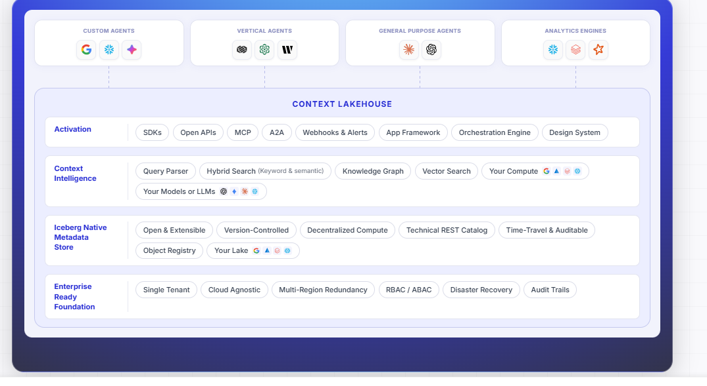

Analytics needed data infrastructure.
AI needs context infrastructure.
The data world built lakes, warehouses, and pipelines to tame data at scale. AI demands the same architectural investment — but for context.

Context at machine speed
Data needed fast pipelines. AI needs fast context. Agents query definitions, policies, and relationships thousands of times per hour — infrastructure built for human-speed access compounds into minutes of latency per run.

Context is big data
Data grew until you needed a data lake. Context is growing the same way. Every agent interaction creates observations, quality signals, usage patterns. Infrastructure that only reads collapses when agents write back at scale.

Context is relational
Data needed schemas. AI needs graphs. Agents traverse lineage chains, cross domain boundaries, and check governance policies in a single call. A flat index can't support that. You need a traversable map of the entire estate.

Context needs versioning
Data needed lineage. Context needs time travel. When an agent makes a mistake, you need to reconstruct exactly what context it saw and when. Without it, you can observe the output but never explain the reasoning.

Speaks every protocol AI agents use and every protocol humans already know.
Every interface an agent needs, and every interface a human already uses. From MCP for governed queries to SQL for analytics — Context Lakehouse meets your stack where it is.

Claudeclaude-3-7-sonnet
Atlan MCP
Is orders.revenue safe to use in my pipeline?

Atlan MCP—get_asset_context
asset:orders.revenue· include:quality, policies, lineage
certification
VERIFIED✓
quality_score
98.2%
classification
PII – Restricted⚠
lineage_depth
3 upstream · 7 downstream
owner
analytics-team
Yes — VERIFIED badge, quality 98.2% badge. Note: carries PII – Restricted — column masking is active, ensure your pipeline respects that policy.
ClaudeCursorWindsurfAny MCP client
Context before action · Zero hallucination on data
MCP — Model Context Protocol
What an asset means, whether it's trusted, and what policies apply — checked in a single call before anything executes.
A2A — Agent-to-Agent
Agents write observations, quality signals, and usage patterns back into the store — context compounds with every interaction.
SQL
Standard SQL over Iceberg — query metadata exactly as you query your data, with every engine your team already runs.
REST APIs & Graph APIs
Full programmatic access to the graph — build integrations, automate workflows, or pipe context into model training pipelines. Open by design.

Built for agents that read context, write it back, and traverse it at scale.
A knowledge graph for relationships and meaning. Iceberg-native file storage for scale and portability. Together, they give AI agents the richest possible context in the most open possible format.
orders.revenue
snp_c4d1
DB
2 columns added · revenue_net, revenue_adj
pipeline/dbt · Apr 3, 07:55
snp_f8a2↺
LN
+3 downstream nodes linked · lineage expanded
lineage-agent · Apr 3, 07:58
snp_f8a2↺
DQ
DQ score hit 98.2% · best ever recorded
dq-agent · Apr 3, 08:01
snp_f8a2↺
DQ
Quality score 91.3% → 95.7% · profiling complete
dq-agent · Mar 24, 08:30
snp_c4d1↺
TA
Trust score 71 → 89 · threshold cleared
trust-agent · Mar 24, 08:32
snp_c4d1↺
DB
revenue_raw column dropped · schema change
pipeline/dbt · Mar 17, 11:02
snp_b2e3↺
PA
PII-Restricted policy applied · auto-classified
policy-agent · Mar 17, 11:05
snp_b2e3↺
LN
+3 downstream assets linked to lineage graph
lineage-agent · Mar 17, 11:08
snp_b2e3↺
DB
Initial snapshot · baseline recorded
pipeline/dbt · Mar 3, 09:14
snp_a1b2↺
Knowledge graph
Everything an agent needs to understand an asset — domains, lineage, policies, quality scores — connected in a single traversable graph.
Iceberg-native storage
Apache Iceberg underneath: ACID transactions, schema evolution, time travel, and standard SQL from any compatible engine. Open and portable by default.
Vector-native AI search
Every asset stored with its vector embedding, so agents retrieve context by meaning, not keywords, across billions of assets.
Time travel
Every historical state is queryable, enabling point-in-time retrieval for compliance and full audit trails for GDPR, CCPA, and SOX.
Context Lakehouse
The world's first context store
engineered natively for AI.

Everything you need to know about
Context Lakehouse
What is the Context Lakehouse?
The Context Lakehouse is Atlan's knowledge architecture for storing, managing, and serving the context AI agents need to operate accurately at enterprise scale. It combines a knowledge graph for relationships and meaning, Iceberg-native file storage for portability and ACID guarantees, vector-native search for semantic retrieval, and full time-travel for compliance and audit. It is the store that every Atlan product reads from and writes to — and that any external agent can access via MCP, A2A, SQL, or API.
How is Context Lakehouse different from a data catalog?
A data catalog stores metadata for humans to browse. The Context Lakehouse is an active knowledge architecture designed for machine-speed access. The differences are structural: Iceberg-native storage means context is queryaWhat does "Iceberg-native" mean and why does it matter?
Iceberg-native means the Context Lakehouse stores all metadata in Apache Iceberg table format — the same open standard your best data already lives in. This gives you ACID transaction guarantees, schema evolution without breaking consumers, time travel for any historical state, and compatibility with every SQL engine your team already runs (Spark, Trino, DuckDB, Snowflake, BigQuery, Flink). It also means your context is stored in open formats you own and can query independently of Atlan. Your context is your IP — Iceberg-native ensures you can always access it.
ble with standard SQL from any engine. The knowledge graph means relationships are traversable at depth in under 100ms. Bidirectional writes mean agents improve context on every interaction. And vector-native search means retrieval is by meaning, not search bar. A catalog is a directory. A Context Lakehouse is infrastructure.

