ATLAN CONCEPT DEEP-DIVE
Seven Product Concepts, Mapped to Atlas
What Atlan built, why it matters, what AIDataAnalyst (Atlas) already has, and exactly what to build next

Playbooks · Context Lakehouse · Data Marketplace · Context Engineering Studio
Context Agents · Data Lineage · Connectors

Prepared for Balaji — AIDataAnalyst project
August 30, 2026

How this report was built
This report walks through seven pages Atlan (a data-catalog / “context layer” vendor) publishes at atlan.com: Applying Descriptions (Playbooks), Context Lakehouse, Data Marketplace, Context Engineering Studio, Context Agents, Data Lineage, and Connectors. For each page, the on-page copy, the FAQ text, and the embedded interactive demo were extracted directly from the rendered page in a live browser — not a static fetch — and a screenshot of the actual demo mock-up was captured; those screenshots appear inline below each section.
Every concept is then checked against the AIDataAnalyst (“Atlas”) codebase and its own internal documentation set — architecture principles, 21 module specs, and a 2026-08-30 delivery status matrix the project keeps deliberately honest about what is built versus planned. That status matrix is the source for every “what Atlas has today” claim below; where it says a capability is partial or pending, this report says so too, rather than rounding up.
HEADLINE FINDING
AIDataAnalyst already has a named module or working code path for all seven Atlan concepts — this is not a green-field gap. The project's own architecture docs already position it against Atlan explicitly (a deterministic control plane vs. a context-supply catalog). The real remaining gaps are narrow: connector breadth, a scheduled automation layer on top of bulk-action code that already exists, Looker BI lineage, and a conversational discovery surface for the marketplace.
CORRECTION — DATED 2026-08-30, SAME DAY AS THIS REPORT
The module specs and status matrix this report was written against had not yet caught up with Docs/60-delivery/03-tracker.md, which is updated more frequently and shows substantial same-day delivery. Three sections below have been corrected accordingly: Context Engineering Studio — change sets, the test harness, the diff view, and impact preview are now DONE (tracker rows ST-A1/A2/A3/A5); only the parameter-contract designer and Git binding remain. Data Lineage — view/procedure lineage is DONE (LN-2), and BI lineage is delivered for Tableau and Power BI (LN-4); only Looker and an edge_kind enum-consistency cleanup (ST-15) remain. Data Marketplace — the full Context Products/MCP stack (CX-1 through CX-6: server, maker-checker, per-read policy, consumption lineage, eligible tools, budgets) is DONE, not partial. The five genuinely still-open items from this report (a scheduled Playbook object, an open-table-format export, conversational marketplace search, a Slack/Teams surface, and a query-history-ranked documentation worklist) have been added to the tracker as AT-1 through AT-5.

Executive summary
Atlan's public positioning has shifted from “data catalog” to “the context layer for AI”: a metadata store (the Context Lakehouse) built on Apache Iceberg with a knowledge graph and vector search, fed by 104 connectors, enriched by nine specialized documentation agents (Context Agents), packaged for governed self-service (Data Marketplace), authored and tested through a Git-like workflow (Context Engineering Studio), automated in bulk through rule-based automations (Playbooks), and stitched together end-to-end by column-level Data Lineage. All seven ideas aim at the same problem: giving AI agents trustworthy, governed business context instead of raw schema.
Atlas is built around a different — and in several respects stronger — foundation for exactly that problem: a deterministic control plane where “models only propose, deterministic services decide” (ADR-0001), a single execution choke point so no code path reaches a source except through the query gateway (ADR-0004), and a value-free control plane so business data itself never crosses into logs, lineage, or the graph (ADR-0014). Atlan supplies context to agents and stops; Atlas evaluates policy on every read and keeps governing after the context leaves the platform. That contrast runs through this whole report — several sections below quote Atlas's own module specs making exactly this argument, unprompted, before this review ever started.
The table below maps all seven concepts to their Atlas counterpart in one place; each row is then expanded into its own section with a screenshot, the honest status, and prioritized next steps.
Atlan concept | Atlan's approach | Matching Atlas module(s) | Atlas status today
Playbooks  (Applying Descriptions) | Rule-based bulk metadata automation: filter → action → schedule, with conditional approval. | catalog_bulk_actions.py, classification_feed.py, ownership_rule (module 08) | Bulk actions exist as on-demand calls; no saved/scheduled trigger object yet
Context Lakehouse | Iceberg-native store: knowledge graph + vector search + time travel, BYOC, MCP/A2A/SQL/API access. | knowledge_graph.py, vector_store.py, fusion_ranking.py, Neo4j projection (module 10) | Graph + hybrid search implemented; no open-table-format layer, no BYOC, no time travel API
Data Marketplace | Self-service storefront: data products, conversational search, zero-touch access provisioning. | product_marketplace_api.py, Context Products CX-1..CX-6 (module 19) | MCP, per-read policy, consumption lineage, eligible tools, budgets all DONE; conversational search UI and Slack/Teams are the real remaining gap
Context Engineering  Studio | Bootstrap → Simulate → Deploy → Observe; Git-like Context Repos; auto-generated evals. | studio.py, studio_api.py, studio_test_harness.py (module 18) | Change sets, test harness, diff view, and impact preview all DONE (2026-08-30); only the parameter-contract designer and Git binding remain
Context Agents | 9 named agents (Scout, Scribe, Lexis, Doc, Nexus, Sage, Atlas, Vera, Orion) auto-documenting the catalog. | business_graph.py, semantic_inference.py, relationship_intelligence.py, data_quality.py | Deterministic-rules-plus-optional-model inference exists; not organized as scored named agents
Data Lineage | Column-level, 80–100+ systems; SQL parsing + OpenLineage + BI lineage + AI-answer traceability. | query_gateway.py, openlineage.py, dbt_artifacts.py, ai_decision_lineage.py (module 09) | Query, dbt, OpenLineage, view/procedure, and AI-decision lineage all DONE; only Looker (of 3 BI tools) and an edge_kind enum cleanup remain
Connectors | 104 native connectors: warehouses, DBs, BI, ETL, orchestration, quality tools — metadata-only. | connectors/ (postgres, sqlserver, oracle, bigquery, snowflake), fleet.py (module 02) | PostgreSQL implemented; 4 more in unverified beta; Databricks/Teradata/Db2 planned; no BI/ETL/quality connectors

1. Playbooks — Applying Descriptions
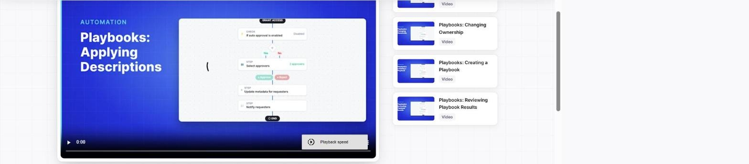
Atlan's Playbooks demo: a saved automation graph — Grant Access → Check auto-approval → Select approvers → Update metadata for requesters → Notify requesters.

What it is
Playbooks are Atlan's saved, reusable automations for bulk metadata changes. The captured demo walks through applying a consistent description to every column named “Order ID” across a Snowflake estate: define a filter (which assets qualify), an action (what changes), and a schedule (how often it re-runs) — the platform keeps re-applying it as new matching assets appear, with nobody needing to notice they exist first.
The flow shown is broader than a single action: it is an approval-gated pipeline (“Check if auto-approval is enabled” → “Select approvers” → “Update metadata for requesters” → “Notify requesters”), which makes a Playbook a small stateful workflow, not just a batch update.

Why it matters
The pitch targets the two failure modes of manual metadata work: it never keeps up with a growing warehouse, and different stewards word things inconsistently. A saved, scheduled rule fixes both — new matching columns get described the moment they appear, worded identically every time.

How Atlan built it
The design is a simple three-part contract — filter, action, schedule — composed visually as a flow graph with branching and multiple step types. Atlan's own page is light on backend detail beyond “operates within the Enterprise Data Graph”; the interesting decision is treating a bulk metadata change as a first-class, versioned, schedulable object rather than a one-off admin action.

What Atlas already has
Atlas already has every primitive this would be assembled from, just not wired into a saved/scheduled object yet. catalog_bulk_actions.py (“CT-1”) implements the planning half of bulk tag, classify, own, and certify actions as pure functions operating on already-fetched rows, bounded to 500 items per request (or a 10,000-row filter-scan cap), with an explicit partial-success contract — which items succeeded, which failed, and why.
classification_feed.py adds deterministic rule-based classification plus an authoritative external-feed override, with every classification decision recorded as evidence (rule-based vs. externally authoritative) — arguably a more auditable version of Atlan's filter logic.
Module 08 (Glossary and Stewardship) already has ownership_rule and bulk_stewardship_operation objects with reviewed, reusable pattern-based bulk application, running through the same maker-checker governance_review queue every other change in the platform uses — stricter by default than Atlan's optional “if auto-approval is enabled” branch.

The honest gap
STATUS PER ATLAS'S OWN 2026-08-30 TRACKER
Atlas's bulk actions are all synchronous, invoked directly through the API or portal — there is no persisted playbook object combining a filter, an action, and a recurring schedule that keeps re-running on its own. This isn't a line item marked Pending in the delivery tracker the way Studio is — it hasn't been scoped as its own deliverable at all yet, which makes it a clean, low-risk addition: it is composition of existing, already-governed primitives, not new governance machinery.

Recommended improvements
- Add a `playbook` domain object (module 08, or a thin new module) with a filter_spec (reusing the table/column matcher already in catalog_bulk_actions.py), an action_ref (tag / classify / own / certify / describe), a cron_schedule, and a maker-checker gate that reuses GovernanceReview — almost entirely composition, not new machinery.
- Drive scheduling through the existing Temporal workers (workflows/scheduler.py already runs fleet scans on a cadence) instead of standing up a second scheduler.
- Make approval conditional the way Atlan's demo does (“if auto-approval is enabled”) by adding a confidence/risk threshold below which a Playbook run auto-applies and above which it queues to the existing review path — this reuses classification-confidence fields Atlas already has rather than inventing new UX.
- Surface saved Playbooks and their run history in the Stewardship Control Center UI (ui/scripts/features/control-center.js) next to the existing bulk-ownership tooling, so stewards see one system rather than two.

2. Context Lakehouse
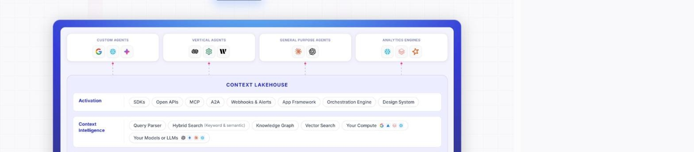
Atlan's Context Lakehouse architecture diagram: agents (custom, vertical, general-purpose, analytics) sit above an Activation layer (SDKs, MCP, A2A) and a Context Intelligence layer (query parser, hybrid search, knowledge graph, vector search).

What it is
The Context Lakehouse is Atlan's metadata store, pitched as four integrated layers: a knowledge graph (domains, lineage, policies, quality scores in one traversable graph), Iceberg-native storage (ACID transactions, schema evolution, standard SQL from any compatible engine), vector-native search (every asset embedded, so retrieval is by meaning, not keyword), and time travel (every historical state queryable for compliance replay). It speaks MCP, A2A (agent-to-agent bidirectional writes), SQL over Iceberg, and REST/Graph APIs with SDKs in Python, Java, Node.js, and Go, and supports bring-your-own-cloud storage (S3, GCS, ADLS) so a customer's own compute can query it directly.

Why it matters
Atlan's framing: “Analytics needed data infrastructure. AI needs context infrastructure.” Agents query definitions and policies “thousands of times per hour” (a latency problem human-speed catalogs weren't built for), traverse relationships and policy checks in a single call (a graph problem a flat index can't solve), and need to reconstruct exactly what context an agent saw on a past date for GDPR/CCPA/SOX audits (a versioning problem plain catalogs don't address).

How Atlan built it
The architecture is deliberately open-format: Apache Iceberg underneath means any Iceberg-compatible engine (Spark, Trino, DuckDB, Snowflake, BigQuery, Flink) can query context with standard SQL, and BYOC means the customer, not Atlan, owns where the bytes live. Atlan cites Gartner and Forrester leader placements and a Mastercard CDO quote (“configurable, intuitive, and able to scale to hundreds of millions of assets”) as third-party validation of this architecture specifically.

What Atlas already has
Module 10 (Knowledge Graph) already implements the graph layer: authoritative state in PostgreSQL projected into Neo4j via outbox/Kafka, bounded 1–4 hop traversal with explicit truncation reasons, and — a stricter guarantee than Atlan states anywhere — a hard contract that the graph exposes metadata and approved aggregate evidence only, never customer, account, or transaction values, so a screenshot of the graph explorer can never leak regulated data.
vector_store.py, vector_retrieval.py, embedding_provider.py, full_text_index.py, and fusion_ranking.py together already implement hybrid keyword-plus-semantic search — close to a line-for-line match to the “Hybrid Search (Keyword & semantic)” box in Atlan's own diagram above.
Atlas's own invariant (ADR-0003: “PostgreSQL is authoritative; everything else is a rebuildable projection”) is arguably a cleaner version of Atlan's “you own your context” pitch: the graph and vector projections can be deleted and rebuilt at any time and are never a second source of truth, whereas Atlan's Iceberg layer *is* positioned as a store of record.

The honest gap
STATUS PER ATLAS'S OWN 2026-08-30 TRACKER
No open-table-format (Iceberg or equivalent) layer exists — Atlas's metadata lives in PostgreSQL, Neo4j, and a vector store, none of it queryable by a customer's own Spark/Trino/DuckDB cluster the way Atlan markets. No BYOC option. No A2A-style write-back protocol. And no exposed time-travel API, even though the pieces already exist: module 09's AI decision lineage design already pins “semantic version and policy version” per agent decision — the data for point-in-time reconstruction is being captured, it just isn't queryable as a compliance replay feature yet.

Recommended improvements
- Expose the already-versioned semantic/policy pins (module 09, “Plan → semantic version and policy version pinned”) as a queryable time-travel API — this is API and presentation work on data Atlas already durably records, not a new capture mechanism.
- Evaluate landing a periodic export of catalog, lineage, and quality state into an open table format (Iceberg or Delta) so a bank's own compute can query context independently of Atlas — this also derisks the vendor-lock-in argument Atlas already uses against Atlan for query execution, applied symmetrically to itself.
- Add an A2A-style write-back path so agent runs can post observations (a confirmed answer, a corrected definition) into the graph as evidence, gated through the same maker-checker path bulk actions already use — mirrors Atlan's “context compounds with every interaction” loop without weakening governance.

3. Data Marketplace
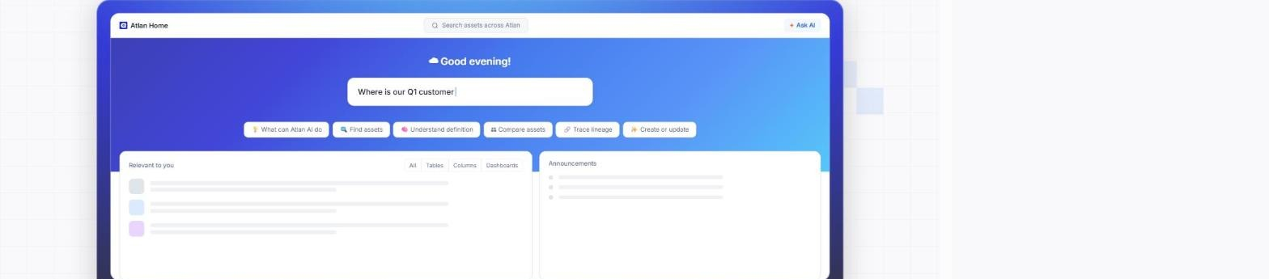
Atlan Home search: a conversational entry point (“Where is our Q1 customer…”) with quick actions for finding assets, understanding definitions, comparing assets, and tracing lineage.

What it is
Atlan's Data Marketplace is a self-service storefront layered over the catalog. Its unit of exchange is the data product: a curated, certified package of tables, dashboards, models, and metrics bundled with trust signals, ownership, lineage, and access controls, published once by a producer and evaluated/requested in one step by a consumer. Discovery is conversational (“What's our most trusted churn dataset?”) and personalized by role, and it embeds directly into Slack and Microsoft Teams.
Access governance is policy-attached-to-asset: classification-driven, domain-aware, enforced at the point of discovery, and — through an Immuta integration — provisioned with zero touch (masking, column-level restriction, ABAC) once approved, with Jira/ServiceNow issue auto-generation for enterprise IT workflows.

Why it matters
The stated problem is adoption: traditional catalogs are built for data teams, not the rest of the company — clunky search, jargon, no trust signals. A marketplace UX (plain-English search, product cards, one-click request) is meant to get non-technical users self-serving without two-week access-request queues.

How Atlan built it
The marketplace sits atop the Context Lakehouse and Enterprise Data Graph; policies travel with the asset (“when an asset changes, the policy changes with it”), and the same MCP server exposes the marketplace to IDE-based coding agents (Cursor, Copilot, Claude) so engineers can query it without leaving their editor.

What Atlas already has
product_marketplace_api.py already implements the core objects — DataProduct, DataProductVersion, DataProductPort, DataProductAccessRequest, DataProductRoleBinding, DataContractVersion — plus tenant-scoped portfolio analytics (usage, quality, lifecycle, and queue summaries), running through the same maker-checker (GovernanceReview) and entitlements.py path as every other governed change in the platform.
Context Products (module 19) already deliver Atlan's most differentiated idea — bounded, versioned, policy-gated context packages — and per the tracker's own rows CX-1 through CX-6, dated 2026-08-30, the whole stack is DONE: the MCP server (CX-1), maker-checker-published Context Products (CX-2), per-read policy evaluation (CX-3), consumption recorded as lineage (CX-4), role-filtered eligible-tool exposure with governed invocation (CX-5), and per-consumer rate limits/budgets (CX-6). This goes further than Atlan in one specific way the module spec calls out unprompted: Atlas evaluates policy on every read and records consumption as lineage, not just at the initial access grant — its own doc names this as the gap in every competitor's MCP server, Atlan included: “they authenticate, hand over context, and stop.”

The honest gap
STATUS PER ATLAS'S OWN 2026-08-30 TRACKER
No conversational / natural-language discovery surface (“Where is our Q1 customer churn?”) — Atlas's marketplace today is API- and portal-form driven, not chat-first. No Slack/Teams embedding. Workload identity for MCP consumers (CX-7) and BI-surface context injection (CX-8) are also still open. No zero-touch downstream policy push into the warehouse itself (a Snowflake/Databricks masking partner comparable to Immuta) — though this is consistent with Atlas's own design choice to keep enforcement in-band through its own gateway rather than delegate it to a third party.

Recommended improvements
- Add a conversational search entry point by routing marketplace/context-product questions through the existing governed-question pipeline (agent_orchestrator.py, module 13) instead of a tabular data source — “find me a certified churn dataset” gets the same screening, retrieval, and policy evaluation as an analytical question, largely a routing change rather than new infrastructure. (Tracked as AT-3.)
- Ship the Slack/Teams surface on top of the module 19 governed MCP/context-product read path already built, so a chat-based request still triggers per-read policy evaluation and lineage recording — a strictly stronger version of what Atlan ships today. (Tracked as AT-4.)
- Close CX-7 (workload identity for MCP consumers) and CX-8 (BI-surface context injection), both already TODO rows in the tracker, before positioning any of this externally.

4. Context Engineering Studio
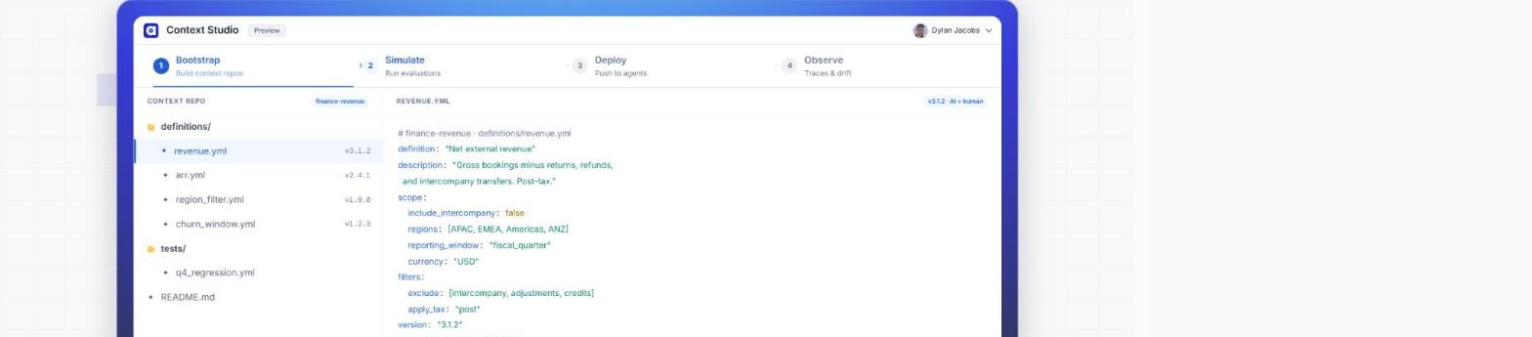
Context Studio's Bootstrap stage: a Git-like Context Repo (finance-revenue) with versioned YAML definitions (revenue.yml v3.1.2, AI + human authored) and a tests/ folder.

What it is
Context Engineering Studio is a four-stage workflow — Bootstrap, Simulate, Deploy, Observe — for building “Context Repos”: versioned, domain-scoped YAML definitions (e.g. finance-revenue/definitions/revenue.yml) that any MCP-speaking agent reads. Bootstrap auto-drafts a semantic layer from existing Snowflake/dbt/Looker/Confluence content; Simulate auto-generates dozens to hundreds of eval questions from real dashboards and SQL history, runs them, and produces failure traces identifying a missing relationship, an unresolved synonym, or a filter that should apply by default; Deploy pushes one repo to every consuming agent (Cortex, Genie, Claude via MCP) simultaneously; Observe captures production traces and turns user corrections into new regression tests.
A “Bounded Context Space” scopes this per domain (Finance's “revenue” and Sales' “revenue” can both be correct, separately), and the whole thing is explicitly “Human ON the loop”: AI drafts, tests, and proposes fixes; a human approves.

Why it matters
The framing targets what Atlan calls the AI Context Gap: cold start (context scattered across every tool, months to assemble by hand), testing hell (no visibility into whether an agent is accurate before production), and the scaling trap (a context fix in one place doesn't propagate everywhere it's used). Atlan cites “83% of AI pilots never reach production” and “49% fail from insufficient business context” as the reason this matters.

How Atlan built it
Context Repos get Git-like discipline — full history, branching, staged rollouts, rollbacks — over structured YAML that domain experts edit in plain language. The differentiating piece is the eval suite: it is generated from an organization's actual dashboards and SQL, not hand-written fixtures, so a failing test points at a specific missing piece of business logic rather than a generic accuracy score.

What Atlas already has
Module 18 (Studio) is explicitly scoped as Atlas's answer to this exact feature — its own spec states the comparison outright: “Snowflake ships Semantic Studio (AI-assisted IDE with Git integration); Atlan ships Context Engineering Studio... Atlas differentiates not by having a Studio but by what its objects do: Atlas semantic objects carry policy and compile into executable governed tools.”
As of 2026-08-30, most of that design is now built, not just specified: ST-A1 (change sets — grouping, base-version conflict detection, single-proposal submission), ST-A2 (the test harness — compilation, validation, fixture-execution against synthetic data, grain/join/regression checks), ST-A3 (a diff view), and ST-A5 (impact preview) are all DONE per Atlas's own delivery tracker, all landing the same day as this review.

The honest gap
STATUS PER ATLAS'S OWN 2026-08-30 TRACKER
Per the 2026-08-30 tracker, the two pieces still open are narrower than the module spec's full scope: ST-A4 (the parameter-contract designer) and ST-A6 (Git binding, with Atlas remaining authoritative) are still TODO. Change sets, the test harness, the diff view, and impact preview — the parts that do the actual work of catching a bad semantic change before it ships — are already live.

Recommended improvements
- Close ST-A4 next: a parameter-contract designer for the metrics/tools that already exist, so a semantic object's inputs are declared and validated the same way its outputs already are through ST-A2's test harness.
- Ship ST-A6 (Git binding) last, exactly as scoped: export/import with Atlas remaining authoritative, so a Git merge can never publish a semantic version without passing maker-checker. This is one place Atlan's own marketing is looser than Atlas's design — Atlan's Context Repos branch and version freely — so shipping it as designed is already a stricter product than the one being matched.
- Track delivery against the module 18 spec's own definition of done for the two remaining items rather than re-deriving requirements from scratch — the spec already lists every UI and API surface needed.

5. Context Agents
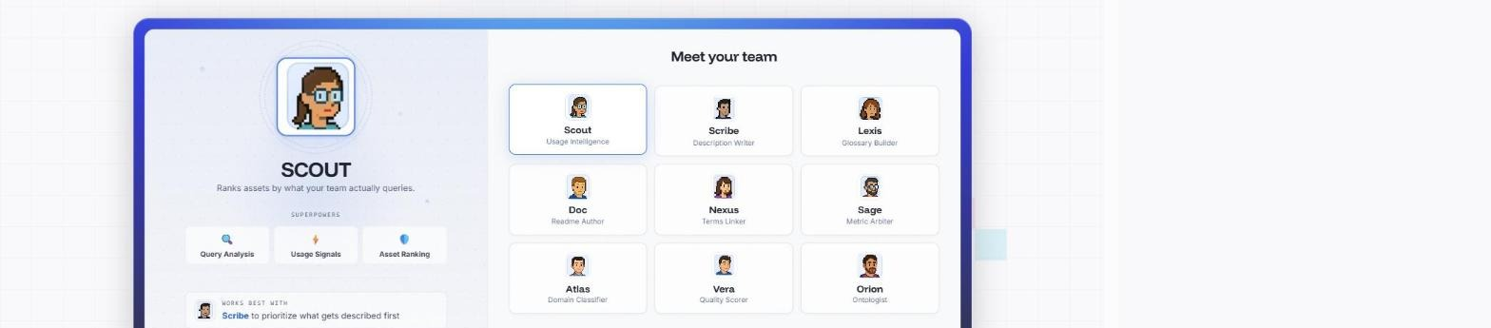
Atlan's nine Context Agents: Scout, Scribe, Lexis (foundational), Doc, Nexus, Sage (derived), Atlas, Vera, Orion (compounded) — Scout selected, showing its “Usage Intelligence” task plan.

What it is
Context Agents are nine named, specialized AI agents that auto-document a catalog, organized in three stages. Foundational: Scout ranks assets by real query history so enrichment targets what people actually use; Scribe writes descriptions from SQL patterns, column names, and lineage; Lexis bootstraps a business glossary from existing definitions and naming conventions. Derived: Doc synthesizes Stage 1 signals into full dataset READMEs; Nexus links technical column names to business terms; Sage finds and resolves metric-definition conflicts across teams. Compounded: Atlas classifies every asset into a business domain at scale; Vera scores data quality (completeness, accuracy, freshness); Orion maps relationships between domains, terms, and assets.
Every agent output carries a composite confidence score across accuracy, clarity, style, and completeness — high-confidence output auto-applies, lower-confidence output routes to a human steward.

Why it matters
Documentation is catalogued as the perennial unsolved problem — “AI needs more documentation than humans can write.” Atlan reports 90%+ acceptance and 350K+ AI-written descriptions applied, pitching “AI-ready in 30 days” by prioritizing the Gold Layer, popular BI, and popular SQL first rather than the whole estate at once.

How Atlan built it
The three stages are a pipeline, not nine independent tools: Scout's ranking feeds Scribe's priority queue, and Doc's README synthesizes Scribe, Nexus, and lineage output. Everything is grounded in the same signals module — “SQL usage patterns, column names, and lineage signals” — pulled from the Context Lakehouse rather than generated in isolation.

What Atlas already has
Atlas's “Business meaning” pipeline (business_graph.py, semantic_inference.py) is close to a direct match for Scribe, Lexis, Nexus, and Atlas combined: deterministic rules plus an optional approved model route infer candidate business domains, entities, descriptions, table roles, grain, synonyms, and analytical questions — with only metadata structure ever supplied to the model, and a human checker required to approve each proposal before it becomes authoritative (README: “a checker must approve each proposal before it becomes authoritative”).
relationship_intelligence.py, table_family_intelligence.py, and composite_key_inference.py map to Orion's ontology-mapping role. data_quality.py's deterministic baselines and durable incidents map to Vera, minus an AI-scored confidence layer. classification_feed.py's rule (“the external record always wins”) is a stricter, more auditable version of Sage's conflict arbitration.
The underlying invariant — ADR-0001, models only propose, deterministic services decide — is the same “human ON the loop” pattern Atlan describes, just enforced platform-wide rather than agent-by-agent.

The honest gap
STATUS PER ATLAS'S OWN 2026-08-30 TRACKER
Atlas's inference runs as one pipeline (“Business meaning”), not nine named, individually invokable, confidence-scored agents a steward can reason about separately (“Scout says these five tables are worth documenting first”). There is no query-history-driven prioritization step surfaced to stewards, even though the input data (query_gateway.py, consumption_lineage.py) already exists to build one. The approval gate is binary approve/reject per proposal, not graduated by a composite confidence score the way Atlan's auto-apply/route-to-human split works.

Recommended improvements
- Package the existing business-meaning inference as named, separately surfaced worklists (a usage-ranked queue, a description-drafts queue, a domain-classification queue) in the stewardship UI — same underlying pipeline, far better steward ergonomics, and purely a presentation change over code that already exists.
- Add a query-history ranking step ahead of description generation, built from data already captured in query_gateway.py and consumption_lineage.py, so stewards review the highest-usage undocumented tables first — Atlan's single most-cited efficiency win, and Atlas already has the input signal.
- Extend the maker-checker gate with a graduated confidence threshold (reusing the confidence patterns already present in composite_key_inference.py and classification_feed.py) so high-confidence proposals can auto-apply while ambiguous ones queue for review — turns today's binary gate into Atlan's graduated one without weakening it.

6. Data Lineage
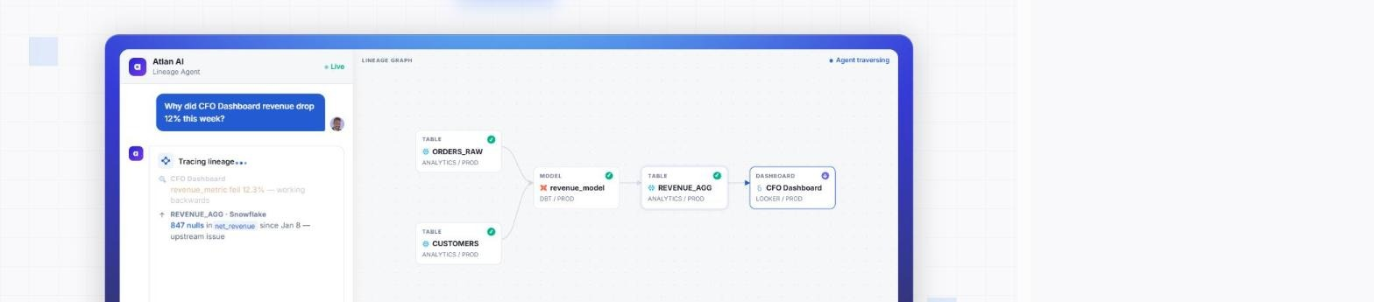
Atlan's Lineage Agent tracing “Why did CFO Dashboard revenue drop 12% this week?” backwards through REVENUE_AGG and revenue_model to a root cause in ORDERS_RAW.

What it is
Atlan's lineage is column-level across 80–100+ systems, built from four complementary ingestion methods: SQL parsing (reads executed queries to extract real transformation logic from Snowflake, BigQuery, Redshift, Databricks), native API crawling (for tools SQL parsing can't reach), OpenLineage ingestion (runtime events from Airflow, Spark, dbt Cloud, Astronomer), and custom lineage via REST APIs, SDKs, and a visual builder. On top of the graph it layers impact analysis (full blast radius surfaced inside a GitHub/GitLab pull request before a schema change merges), quality propagation (an upstream failure flags every downstream dashboard and agent), governance propagation (tag a column PII once, every downstream asset inherits it, synced bidirectionally with Snowflake/Databricks), and — the demoed hero feature — a Lineage Agent that root-causes a dashboard anomaly by walking the graph backwards to the exact upstream change that caused it.

Why it matters
The framing: “every tool in your stack produces its own metadata... none of them pass that context downstream. It leaks at every boundary.” Lineage is the connective tissue turning isolated per-tool metadata into one traceable chain — which is also what lets an AI agent's answer be traced back to the source data that produced it (“AI accountability”).

How Atlan built it
The four ingestion methods run in parallel and merge into one graph; through the MCP server, an agent pulls “the full context chain for a column” — origin, every transformation, quality checks, governance policy, and owner — in a single call before it acts on that column.

What Atlas already has
query_gateway.py's extract_column_lineage() already does real SQL-parse-based lineage — direct versus derived — on every executed statement; per module 09's own audit this is “real and the module's strongest part.” openlineage.py / openlineage_api.py ingest the same OpenLineage standard Atlan uses (Airflow, Spark, dbt Cloud, Astronomer). dbt_artifacts.py / dbt_api.py ingest dbt manifests for transformation lineage.
As of 2026-08-30, coverage is broader than the SQL-parse case alone: LN-2 (view- and stored-procedure-lineage parsing) is DONE, and LN-4 (BI-tool lineage) is delivered for Tableau and Power BI via bi_lineage.py / bi_api.py — only Looker remains. AI decision lineage — something Atlan has no equivalent for at all — is also DONE (LN-3 / AG-5, in ai_decision_lineage.py / ai_decision_lineage_api.py): not just “this column came from that column” but “this answer used this metric, at this semantic version, selected by this retrieval ranking, executed through this approved tool, under this policy version — and it declined to use that other table because its quality incident was open.” Atlas's own doc calls this whitespace no competitor models, because capturing a refusal as a first-class deterministic event requires the execution choke point and prompt-risk screening this platform already has — “a product whose agent simply runs cannot record what it declined to do, because it declines nothing.”

The honest gap
STATUS PER ATLAS'S OWN 2026-08-30 TRACKER
The remaining gaps are narrower than a first read of the module docs suggested. Looker is the only BI system left unconnected for lineage — Tableau and Power BI are already live. And the edge_kind enum (QUERY/VIEW/PROCEDURE/ETL/DBT/BI/AI_DECISION) is defined but not yet fully honored end-to-end: some write paths still emit SUGGESTED_RELATIONSHIP instead of the specific enum value, which is tracked as ST-15 and still TODO. No GitHub/GitLab PR-embedded impact analysis exists yet either.

Recommended improvements
- Close ST-15 (the edge_kind cleanup) first — the cheapest fix with the highest strategic payoff: wire the remaining write paths through to the specific QUERY / VIEW / PROCEDURE / AI_DECISION values the enum already defines, replacing the placeholder SUGGESTED_RELATIONSHIP wherever it still appears. This finishes a differentiator no competitor has, rather than chasing one they already do.
- Treat Looker as a connector-breadth problem, not a lineage-engine problem: once a Looker connector exists (see Connectors, next section), feed its extracted field references into the same bi_lineage.py model already serving Tableau and Power BI rather than building a second lineage engine.
- Add a lightweight PR-comment integration for impact analysis — module 10 already computes bounded impact in the knowledge graph, so this is an output-channel addition, not a new capability.

7. Connectors
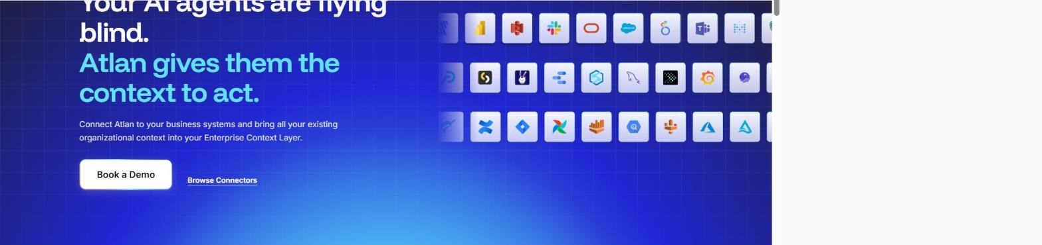
Atlan's connector grid: 104 native, metadata-only connectors spanning warehouses, databases, BI tools, ETL, orchestration, and data-quality tools.

What it is
Atlan ships 104 native connectors — data warehouses, databases, BI tools, ETL pipelines, orchestrators, quality tools, ERP, CRM, storage, and semantic layers — set up in three steps: authenticate (OAuth or API credentials, tested before running), scope (database/schema/table level), and schedule (daily, weekly, or on-demand, with automatic incremental updates after that). An open-source App SDK lets any developer, partner, or customer build a new connector in days on the same infrastructure that powers native ones. The page is explicit that connectors are metadata-only: “Atlan only reads context — schema names, table structures, column definitions, lineage relationships, ownership, and timestamps” — actual data rows never leave the source system.

Why it matters
Breadth is the moat for a context layer: an agent is only as good as the systems it can see into, and every unconnected system is a blind spot exactly where governance matters most (“Your AI agents are flying blind. Atlan gives them the context to act.”).

How Atlan built it
Each connector category (warehouses, databases, BI, ETL, orchestration, quality, etc.) exposes the same context shape into one Enterprise Data Graph — structural context, relationship-level lineage, and operational context (row counts, timestamps) — so a newly connected tool is immediately usable by every downstream feature (Context Agents, Data Lineage, marketplace discovery) without bespoke integration work per feature.

What Atlas already has
Module 02 (Connectivity) is explicitly designed around capability negotiation: capability flags are derived from certification results, never hand-declared, which the module's own spec frames as a direct differentiator against “vendors whose connector lists overstate depth” — a pointed, if implicit, contrast with a marketing page that leads with a connector count.
PostgreSQL is fully implemented and certified (discovery, read-only execution, EXPLAIN cost, timeouts, bounded profiling, deterministic per-source conformance evidence). SQL Server, Oracle, BigQuery, and Snowflake all have real native adapters already written — discovery, EXPLAIN-based cost estimation, bounded profiling — currently BETA and unverified against a live source per the tracker. A connector-certification pipeline (immutable certification runs scoring implementation, secret handling, connection, hierarchy capability, and inventory) already exists as a control-plane concept Atlan has no equivalent of: Atlan lists a connector as live or not; Atlas scores and evidences what “live” actually proves.

The honest gap
STATUS PER ATLAS'S OWN 2026-08-30 TRACKER
5 connectors built or in beta versus Atlan's 104. Databricks, Teradata, and Db2 are visibly PLANNED with no native pull adapter yet (canonical push ingestion only). And Atlas has zero BI-tool, ETL-tool, orchestrator, or data-quality-tool connectors — an entire category of Atlan's matrix (Tableau, Power BI, Looker, Fivetran, Airflow, Monte Carlo, and similar) is out of scope today, which is also exactly why BI lineage (previous section) is blocked at the source.

Recommended improvements
- Live-verify Oracle, BigQuery, and Snowflake against real accounts — already flagged P1 in the tracker — before adding new connector types. Finishing what's started is cheaper than starting more, and the certification pipeline exists specifically to prove it once done.
- Prioritize one BI-tool connector (Looker or Power BI) specifically to unblock BI lineage, rather than treating connector breadth and lineage breadth as separate backlog items — they are the same gap seen from two different module docs.
- Publish the honest capability/maturity matrix module 02 already builds as a customer-facing page, the way Atlan publishes its connector count — turns an internal differentiator (“we tell you what's actually proven, not just listed”) into a visible artifact instead of leaving it inside the docs tree.
- Consider a thin, sandboxed connector SDK modeled on Atlan's App Framework only after the native fleet is deeper — an SDK multiplies coverage fastest once there is a stable certification contract for third parties to target; building it too early just multiplies uncertified connectors.

Consolidated roadmap
Pulling every recommendation above into one prioritized list. P0 items are the cheapest, highest-leverage fixes (finishing something already mostly built, or wiring existing data through an existing gap). P1 items are scoped, medium-effort builds the project's own documentation has already designed. P2 items are longer-horizon or lower-urgency investments.
Priority | Concept | Recommended action | Where it lands in Atlas
P0 | Data Lineage | Close ST-15: wire the remaining write paths through to the specific QUERY/VIEW/PROCEDURE/AI_DECISION edge_kind values instead of the placeholder SUGGESTED_RELATIONSHIP. | src/aida/query_gateway.py, agent_orchestrator.py, module 09, tracker ST-15
P0 | Connectors | Live-verify Oracle, BigQuery, and Snowflake adapters against real accounts before adding new connector types. | src/aida/connectors/, module 02 (already P1 in tracker)
P0 | Context Agents | Surface the existing Business Meaning pipeline as a query-history-ranked worklist so stewards see what to document first. | business_graph.py, query_gateway.py, consumption_lineage.py (tracked as AT-5)
P1 | Context Engineering Studio | Close ST-A4: build the parameter-contract designer, the one authoring surface not yet covered by the now-complete change-set/test-harness/diff-view/impact-preview stack. | studio.py / studio_api.py, module 18, tracker ST-A4
P1 | Playbooks | Add a saved, scheduled `playbook` object (filter + action + schedule) on top of existing bulk-action code, run via Temporal. | catalog_bulk_actions.py, classification_feed.py, workflows/scheduler.py (tracked as AT-1)
P1 | Data Marketplace | Route marketplace/context-product questions through the governed agent pipeline for conversational search. | product_marketplace_api.py, agent_orchestrator.py, module 19 (tracked as AT-3)
P1 | Connectors | Ship a Looker connector — the one BI system left unconnected — to unblock full BI lineage at the source; Tableau and Power BI are already live. | src/aida/connectors/, module 02, bi_lineage.py
P2 | Context Engineering Studio | Ship ST-A6: Git binding with Atlas remaining authoritative over any Git-sourced change. | module 18 §8, tracker ST-A6
P2 | Data Marketplace | Ship the Slack/Teams surface on the already-governed module 19 read path, with the same per-read policy check and lineage recording as an MCP read. | module 19 (tracked as AT-4)
P2 | Context Lakehouse | Expose pinned semantic/policy versions as a queryable time-travel / compliance-replay API. | module 09 AI decision lineage, module 10
P2 | Context Lakehouse | Evaluate an open-table-format export (Iceberg/Delta) of catalog + lineage + quality state for customer-owned compute. | module 10, new export path (tracked as AT-2)
P2 | Connectors | Publish the honest connector capability/maturity matrix externally as a customer-facing artifact. | module 02 capability matrix

Sources
Atlan product pages (fetched and rendered 2026-08-30):
- atlan.com/demos/applying-descriptions-playbooks
- atlan.com/context-lakehouse
- atlan.com/data-marketplace
- atlan.com/context-engineering-studio
- atlan.com/context-agents
- atlan.com/data-lineage
- atlan.com/connectors

AIDataAnalyst (Atlas) internal documentation referenced:
- README.md — project overview and quick start
- Docs/60-delivery/00-status.md — 2026-08-30 delivery status matrix (source for every “what Atlas has today” claim)
- Docs/20-modules/02-connectivity.md, 08-glossary-and-stewardship.md, 09-lineage.md, 10-knowledge-graph.md, 13-agent-runtime.md, 18-studio.md, 19-context-products-and-mcp.md
- Docs/_superseded/20-atlan-analysis.md — prior internal Atlan competitive analysis
- Source files: src/aida/catalog_bulk_actions.py, classification_feed.py, product_marketplace_api.py, query_gateway.py, openlineage.py, dbt_artifacts.py, business_graph.py, semantic_inference.py, connectors/*

