1. Write a Python program to print "Hello Python"?

Ans:

**Code:**

print("Hello Python")

**Sample I/O:**

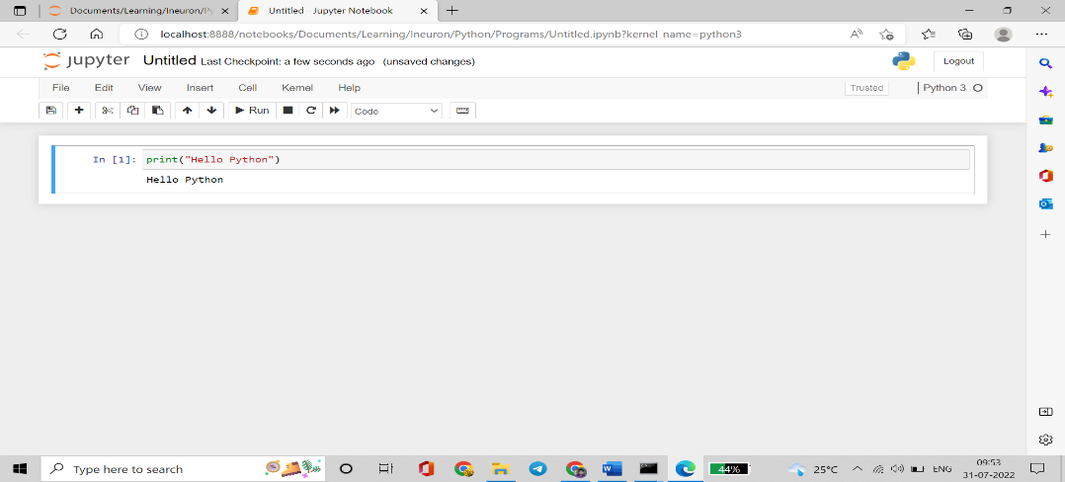

1. Write a Python program to do arithmetical operations addition and division.?

Ans:

**Code:**

a = int(input("Enter number1: "))

b = int(input("Enter number2: "))

print(f"Addition of {a} and {b} is {a+b}")

print(f"Division of {a} and {b} is {a/b}")

**Sample I/O:**

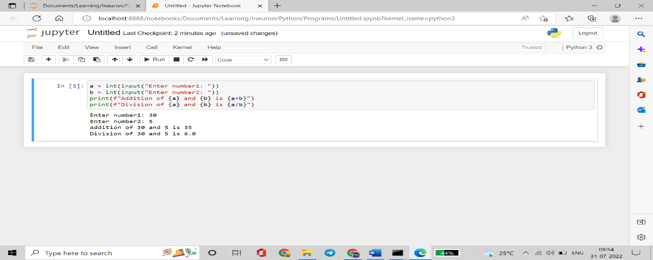

1. Write a Python program to find the area of a triangle?

Ans:

**Code:**

b = int(input("Enter value of breadth: "))

h = int(input("Enter value of height: "))

print(f"Area of triangle with breadth = {b} and height = {h} is {(1/2)*b*h}")

**Sample I/O:**

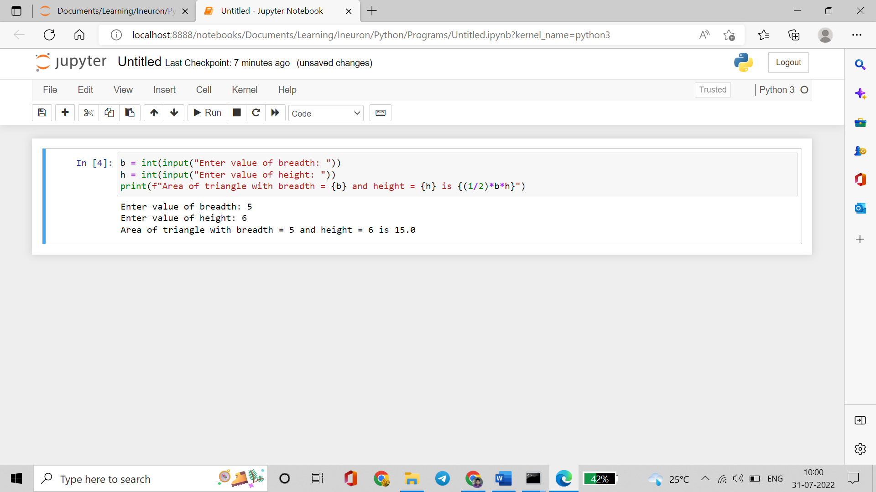

1. Write a Python program to swap two variables?

Ans:

**Code:**

num1 = int(input("Enter number1: "))

num2 = int(input("Enter number2: "))

print(f"Before swap, the values of variables num1 and num2 are {num1}, {num2}")

num1,num2 = num2, num1

print(f"After swap, the values of variables num1 and num2 are {num1}, {num2}")

**Sample I/O:**

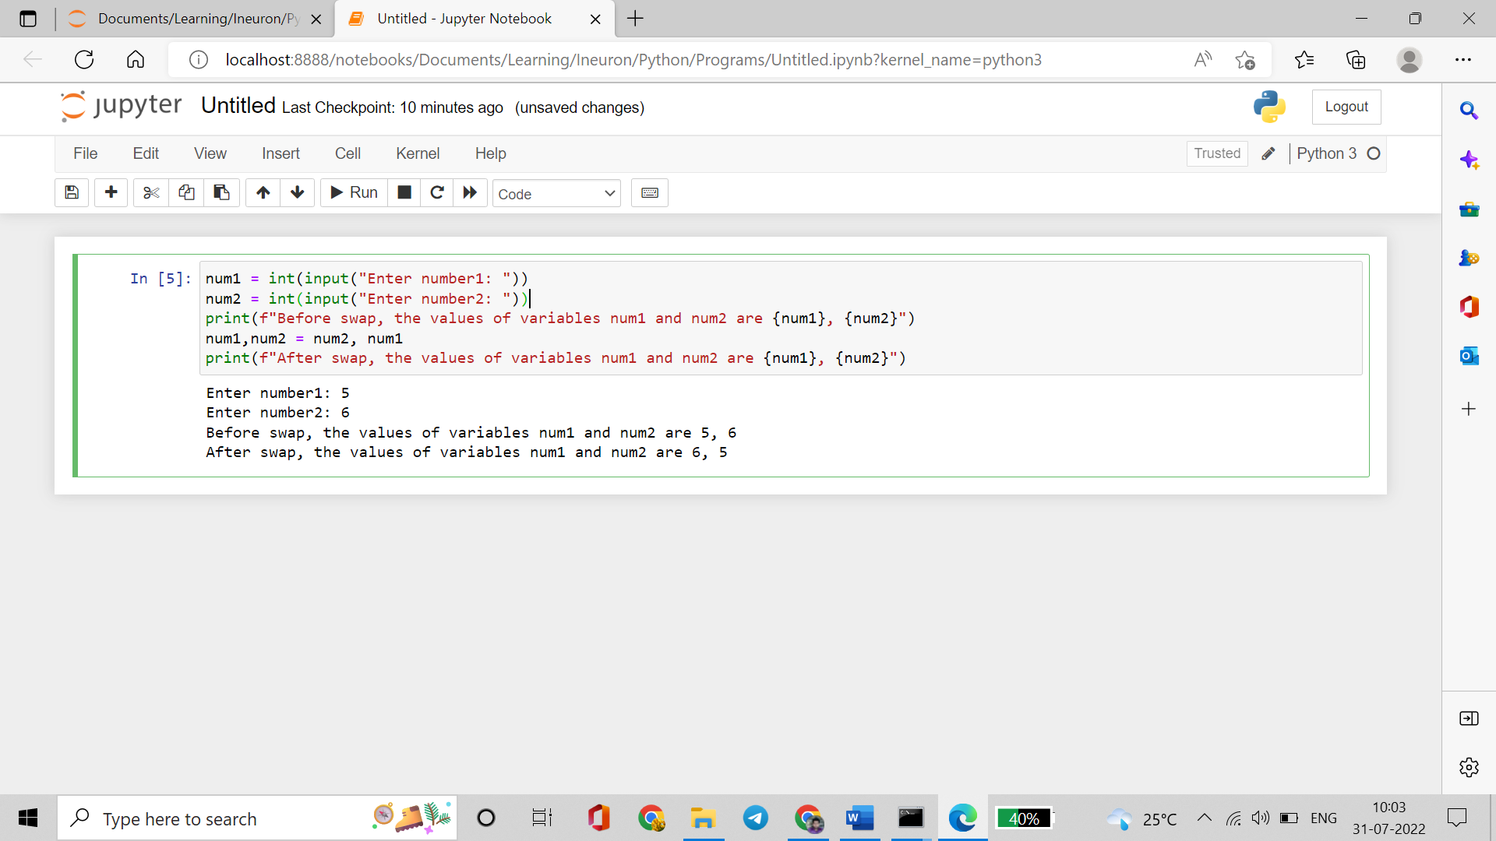

1. Write a Python program to generate a random number?

Ans:

**Code:**

import random

print(random.randint(1,1000))

**Sample I/O:**

