1. What each LangGraph term means: in plain English
LangGraph has six building blocks. Everything in Karya maps to one of them. Here is what each one is, with no jargon.

Term | What it is | Analogy | Karya example
Node | An async function that receives the full conversation state, does its job, and hands back only the fields it changed | A specialist team member who reads the full brief, does their work, writes their section, and passes it on | memory_agent_node :reads the user's message, extracts KB fields, updates the knowledge base
Tool | A specific capability a node can call :an LLM, a database query, an API call, or a calculation | A tool in a toolbox that a team member picks up to do part of their job | extraction_llm :the Haiku LLM call the Memory Agent uses to pull structured data from user messages
Hook | A before/after callback that fires automatically around every node :the node never knows it's there | Quality control and timekeeping that happens without the specialist needing to think about it | rate_limit_hook :checks if the user has exceeded their daily turn quota before any node runs
Checkpointer | Automatically saves the full conversation state after every node :enables pausing and resuming | A recorder that takes a full snapshot after every step so you can always rewind or resume | AsyncPostgresSaver :saves full state after every turn so HITL approvals can pause and resume
Store | A persistent key-value memory that survives across separate conversations | A filing cabinet that team members can read from and write to across multiple meetings | AsyncPostgresStore :holds the user KB so it persists even when a new chat session starts
Connector | A configured connection to an external service :API key wired up and ready to use | A phone line to an external service already set up and authenticated | Anthropic API connector :wired once in config.py, used by all LLM tool calls
Script | A standalone utility that runs outside the graph to set up, seed data, or run evaluations | Prep work done before the meeting starts :printing the agenda, setting up the room | seed_catalogue.py :loads all 31 projects into the database before the graph runs

The one rule that governs everything
Nodes talk to each other only through shared state :never directly. Node A writes fields to the state. The graph router reads state and decides which Node B runs next. Node B reads what A wrote. That is the entire coordination mechanism.

2. The full system :one page
The Karya GTM Advisor guides a business user through 5 phases. Each phase is owned by a node. Nodes hand off to each other through a shared state object and conditional routers. The diagram below shows every node, what triggers it, and where it goes next.
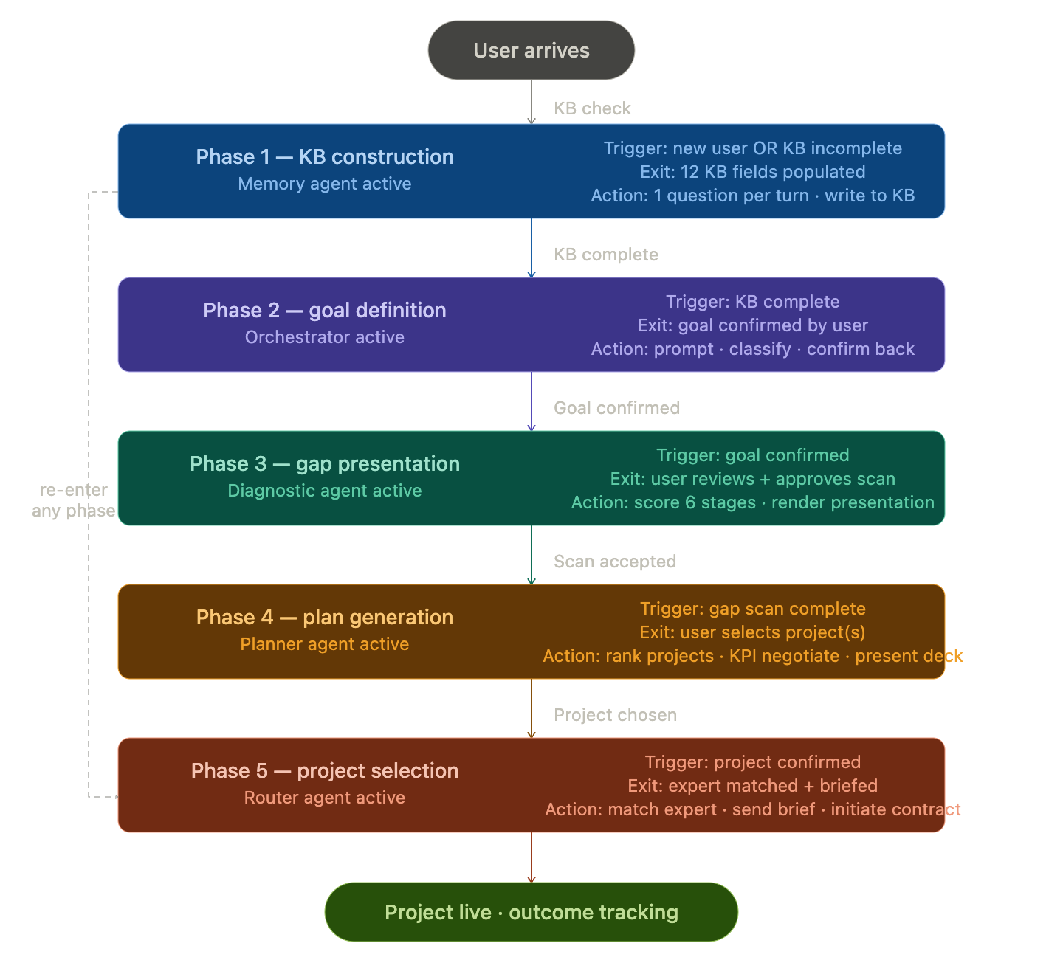

Phase 1 :KB Construction
Who you are, what you sell, who you sell to, how you sell today

Node | Trigger | Output
memory_agent_node | New user enters  OR kb_completeness < 35%  OR orchestrator says next_action = 'ask_field' | Updated user KB (47 fields)  Ranked ask-queue (which field to ask next)  Confidence-scored field log entry
Also triggers | If company.url is newly provided → url_scan_tool fires asynchronously in the background (does not block the response)

Phase 2 :Goal Definition
What outcome the user wants in the next 90 days

Node | Trigger | Output
orchestrator_node | KB completeness ≥ 35%  Runs every turn :always after memory_agent | Conversational response to user  next_action signal (routes to next node)  Phase updated in state

Phase 3 :Gap Presentation
Score the user's GTM motion across 6 funnel stages

Node | Trigger | Output
diagnostic_agent_node | User's primary goal is confirmed  orchestrator sets next_action = 'run_diagnostic' | 6 stage scores (0–10 each)  Gap signals per stage (evidence)  Assessment ID stored in state
→ Always goes directly to planner_agent_node next | 6 stages scored: Awareness, Discovery, Connect, Qualify, Convert, Retain | Gap scores written into user KB  Assessment record saved to Store

Phase 4 :Plan Generation
Build the prioritised 30-60-90 day project plan

Node | Trigger | Output
planner_agent_node | Runs immediately after diagnostic_agent_node  Also runs if user changes their goal (re-plan) | 30-60-90 day project plan (6–8 projects)  One-line diagnosis  3 negotiable KPIs (2 quantitative + 1 qualitative)
→ Always goes to orchestrator_node next (to present plan) | Reads project catalogue from Store  Filters by budget tier + gap priority | Plan record saved to Store  plan_id written to state

Phase 5 :Project Selection & Expert Match
Match confirmed project to fractional expert, negotiate KPIs

Node | Trigger | Output
router_agent_node | User selects a project from the plan  orchestrator sets next_action = 'run_router' | Expert matched from registry  Project brief generated (filtered :no sensitive financials)  HITL gate created (status: pending)
human_gate_node | Always runs after router_agent_node  Graph PAUSES here :frontend renders approval UI  Resumes when human acts | Gate status: approved → goes to orchestrator  Gate status: rejected → goes back to router_agent  Gate status: escalated → goes to END (admin)

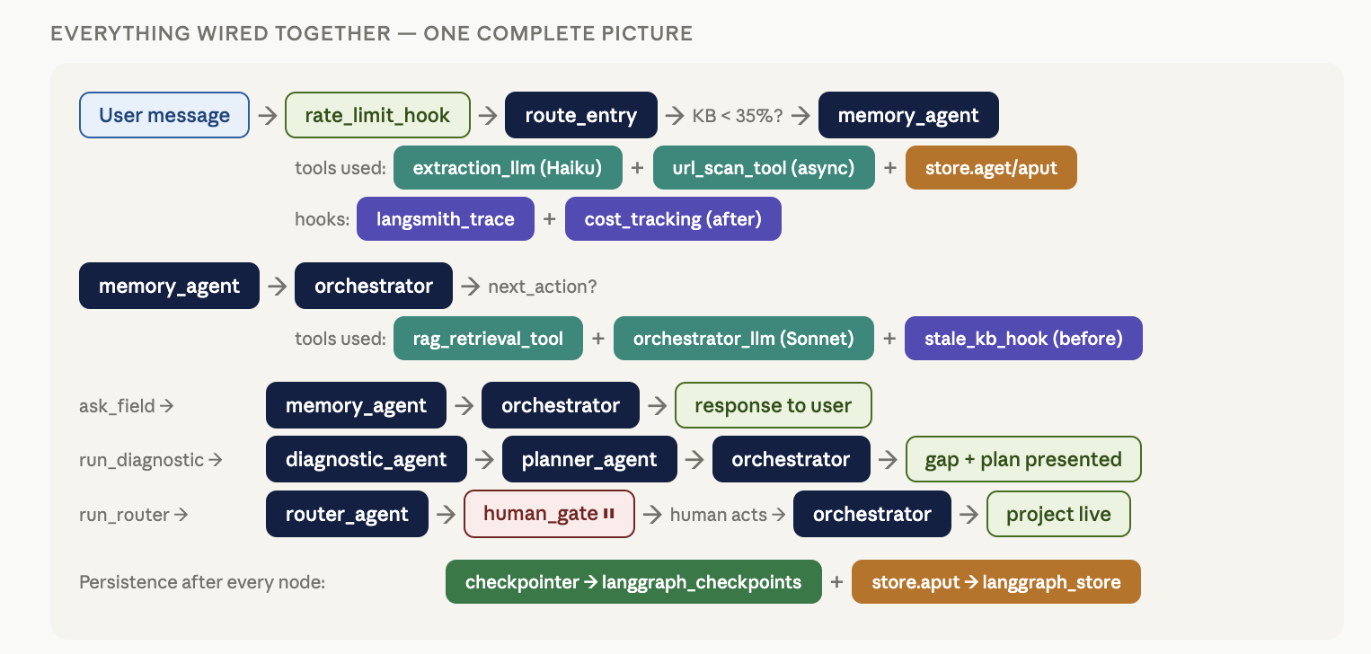

3. Nodes :the 6 agent functions
Every node has the same shape: it receives the full conversation state, does its specific job using tools, and returns only the fields it changed. LangGraph merges those changes back into the shared state.

Node 1 of 6 · memory_agent_node
Phase 1 · Sprint 1

Role: The KB builder. Runs on every turn to extract structured information from the user's messages and maintain the 47-field knowledge base.

Reads from state | current_user_input :the user's message this turn  kb :current knowledge base (47 fields, 6 blocks)  ask_queue :ranked list of missing fields  messages :last 3 conversation turns (for extraction context)  url_scan_result :if a URL was scanned asynchronously last turn
Writes to state | kb :updated with any newly extracted field values  kb_completeness :recalculated (0–100%)  kb_field_log :one entry per field written (source + confidence)  ask_queue :fully rebuilt and re-ranked by priority  next_field_to_ask :head of the queue (what to ask next turn)  url_scan_pending :true if URL scan was just triggered  agent_calls :one cost/latency record appended
Tools it calls | extraction_llm :lightweight LLM (Haiku) call that reads the user message and returns only changed KB field values  url_scan_tool :async background call that fetches and analyses the company URL (fires once, does not block response)  Store read/write :loads KB at start of turn, saves updated KB at end
Skills & logic | Confidence scoring :every extracted value gets a score 0–1. Values below 0.60 are discarded before writing  Source priority :never overwrites a field the user explicitly stated with an inferred value  Ask-queue rebuild :recomputes priority scores for every missing field after each write. Formula: tier weight + unlock bonus + inference bonus + RAG bonus - recency penalty  Completeness gating :KB completeness score gates phase transitions. Phase 1→2 requires ≥35%.
Always goes to | orchestrator_node (always :extraction is background work; orchestrator generates the response)

Node 2 of 6 · orchestrator_node
Phase 1 · Sprint 1

Role: The conversational core. Runs every turn. Assembles context, calls the main LLM, generates the user-facing response, and decides what happens next via the next_action signal.

Reads from state | Everything: kb, phase, ask_queue, next_field_to_ask, gap_scores, plan_id, plan_projects, plan_kpis, messages, selected_project_slug, active_gate
Writes to state | messages :appends both the user message and the assistant response  assistant_response :the text sent to the user  phase :updated if a phase transition condition is met  phase_history :one entry appended if phase changed  next_action :the routing signal that controls what runs next  turn_index :incremented by 1  agent_calls :one cost/latency record appended
Tools it calls | rag_retrieval_tool :semantic search of the GTM knowledge base, returns top-5 relevant chunks to inject into context  orchestrator_llm :the main Sonnet LLM call that generates the conversational response
Skills & logic | Context assembly :compresses the user KB to fit within a 600-token budget, retrieves relevant RAG chunks, assembles a 7-block system prompt (Role + Phase + KB + Gaps + Next Field + RAG + Constraints)  Phase transition detection :checks conditions for advancing the phase (completeness score, goal confirmed, gap scored, plan presented, project selected)  next_action computation :sets the routing signal: ask_field | run_diagnostic | run_planner | run_router | await_human | respond  One question per turn :the system prompt hard-constrains the model to ask at most one question per response  Deflection handling :after 2 failed attempts to ask a field, names the dependency explicitly
Always goes to | Conditional: routes via next_action to memory_agent | diagnostic_agent | planner_agent | router_agent | human_gate | END

Node 3 of 6 · diagnostic_agent_node
Phase 2 · Sprint 2

Role: The GTM analyst. Scores the user's business across 6 funnel stages using the full knowledge base and GTM benchmark context retrieved from the knowledge base.

Reads from state | kb :all 6 blocks (company, icp, gtm_motion, goals, constraints)  gap_assessment_id :checks if already scored this session (idempotent :will not re-score)
Writes to state | kb.gap_scores :6 stage scores (0–10 each) + overall average + metadata  gap_assessment_id :UUID of the assessment record  gap_signals :list of evidence items per stage (what was detected, why it scored low/high)  gap_presentation_ready :set to True  agent_calls :one cost/latency record appended
Tools it calls | rag_retrieval_tool :retrieves GTM benchmark content for each stage (what good looks like)  scoring_llm :Sonnet call at temperature 0 that scores all 6 stages and returns structured JSON with scores, signals, and recommended project categories
Skills & logic | 6-stage scoring rubric :Awareness (content, podcast, community, SEO), Discovery (website, GEO, AI chat), Connect (outbound list, email, voice, LinkedIn, intent), Qualify (framework, demo prep, post-call CRM), Convert (case studies, coaching, win-loss), Retain (NPS, upsell, referral, community)  Signal detection :per stage, identifies specific gap signals (e.g. 'no cold email infrastructure') and positive signals  Score impact :each signal is tagged with how much it affected the score  Idempotency :if gap_assessment_id is already set, skips re-scoring
Always goes to | planner_agent_node (always :diagnostic always feeds directly into plan generation)

Node 4 of 6 · planner_agent_node
Phase 3 · Sprint 3

Role: The GTM strategist. Reads the gap assessment and project catalogue to build a prioritised, personalised 30-60-90 day project plan with 3 negotiable KPIs.

Reads from state | kb :full knowledge base including gap_scores  gap_assessment_id :to load full assessment from Store  Store: ('gap_assessments', user_id) :full assessment record with scores and signals  Store: ('shared', 'platform') 'project_catalogue' :all 31 available projects
Writes to state | plan_id :UUID of the generated plan  plan_projects :list of 6–8 projects with phase (30/60/90), priority rank, personalised rationale, and expected output  plan_diagnosis :one-line root cause statement  plan_kpis :3 KPIs (negotiated=False until human approves)  plan_presented :set to False (orchestrator presents to user next turn)  agent_calls :one cost/latency record appended
Tools it calls | project_catalogue_search :reads and filters the project catalogue from Store by segment, difficulty, and budget tier  planning_llm :Sonnet call at temperature 0.3 that selects projects, assigns phases, generates personalised rationale and KPIs
Skills & logic | Budget filtering :under $3K/month: max 2 projects. $3–5K: max 5. Over $5K: max 8  Dependency ordering :Phase 30 projects must have no unresolved dependencies (e.g. Contact Intelligence before Email Engine)  Personalisation :rationale and expected output must reference the user's specific context (their industry, deal size, channel, gap scores) :not generic descriptions  3-KPI rule :exactly 3 KPIs: 2 quantitative (measurable numbers) + 1 qualitative (team/customer experience outcome)  Phase logic :Phase 30 = foundation only, Phase 60 = first motion and first results, Phase 90 = compound and scale
Always goes to | orchestrator_node (to present the plan to the user)

Node 5 of 6 · router_agent_node
Phase 4 :also runs after Phase 3 · Sprint 4

Role: The expert matcher. When a user selects a project, matches them to the best available fractional expert, generates a filtered project brief, and creates the HITL approval gate.

Reads from state | selected_project_slug :which project the user chose  kb :for brief generation (filtered :sensitive financials excluded)  plan_kpis :the 3 KPIs to be negotiated  plan_id :to link the assignment to the plan  Store: ('shared', 'platform') 'expert_registry' :all experts + availability
Writes to state | matched_expert_id :UUID of the best available expert  assignment_id :UUID of the project assignment record  brief_id :UUID of the expert brief  active_gate :HITL gate object: {gate_type, status:'pending', required_actor:'user'}  agent_calls :one cost/latency record appended
Tools it calls | expert_match_tool :filters expert registry (availability + capacity), scores by segment match + NPS, returns best expert. No LLM needed :rule-based matching  Store writes :saves assignment record and filtered brief to Store namespaces
Skills & logic | Expert matching algorithm :Filter: availability='available', active=True, active_slots < capacity_slots. Score: segment_match × 100 + nps_score. Sort descending, take top.  Brief filtering :expert brief includes: company name/stage, ICP summary, primary goal, what is working, KPIs, budget range. Excludes: ARR, avg deal size, funding details. Privacy decision :not an oversight.  Gate creation :sets active_gate with status='pending' which triggers the HITL interrupt in human_gate_node  Fallback :if no experts available: sets escalated=True, notifies admin
Always goes to | human_gate_node (always :expert matching always requires human KPI approval)

Node 6 of 6 · human_gate_node
Phase 5 · Sprint 4

Role: The human checkpoint. The graph PAUSES before this node runs. The frontend renders the approval UI. The human acts. The graph resumes with the human's decision.

Reads from state | active_gate :reads status field: 'pending' (first pass) or 'approved'/'rejected'/'escalated' (after human acts)  assignment_id :to update assignment status on approval
Writes to state | active_gate :status updated to resolved value  gate_history :one entry appended (audit trail)
Tools it calls | Store write :updates assignment status to 'expert_accepted' when gate is approved
Skills & logic | interrupt_before pattern :the graph is compiled with interrupt_before=['human_gate']. The platform PAUSES before this node, returns state to the API, the frontend renders the UI, and the human's decision is written back via update_state() before the graph resumes via invoke(None)  3 gate types :kpi_negotiation (required_actor: user), expert_match (required_actor: expert), project_launch (required_actor: user)  SLA enforcement :background script marks gates as 'escalated' if deadline_at passes with no response  Routing on resume :approved → orchestrator (confirm to user), rejected → router_agent (re-negotiate), escalated → END (admin handles)
Always goes to | Conditional on active_gate.status: orchestrator_node (approved) | router_agent (rejected) | END (escalated)

4. Tools :the 8 callable capabilities
Tools are specific capabilities that nodes invoke to do a job. They are not agents :they do not make decisions. They execute one task and return a result. A node can call multiple tools in sequence. Tools are plain functions, not separate processes.

Tool | Type | Called by node | Model / service | What it does
extraction_llm | LLM call | memory_agent | claude-haiku-4-5 temp=0 | Reads user message + last 3 turns + current KB. Returns only changed field values with confidence scores. Fast (~400ms), cheap (~$0.002). Returns empty dict if nothing extractable.
orchestrator_llm | LLM call | orchestrator | claude-sonnet-4-6 temp=0.7 | Generates the conversational response. Receives 7-block assembled system prompt (~1,550 tokens) + last 8 turns of chat history. Streamed to user.
rag_retrieval_tool | Vector search | orchestrator, diagnostic | pgvector + text-embedding-3-small | Embeds a query, searches the GTM knowledge base using vector similarity, returns top-5 most relevant content chunks. Falls back to empty list if DB unavailable.
scoring_llm | LLM call | diagnostic_agent | claude-sonnet-4-6 temp=0 | Scores all 6 GTM stages from the KB snapshot + benchmark context. Returns structured JSON: one score + signal list + project recommendations per stage. Temperature=0 for consistency.
project_catalogue_search | Store read | planner_agent | No LLM :rule-based filter | Reads the project catalogue from Store. Filters by: active=True, budget tier, segment match to gap stages. Returns ranked list of eligible projects. No model call needed.
planning_llm | LLM call | planner_agent | claude-sonnet-4-6 temp=0.3 | Selects 6–8 projects from the filtered catalogue, assigns each to Phase 30/60/90, writes personalised rationale for each, generates exactly 3 KPIs. Returns structured JSON plan.
expert_match_tool | Store read | router_agent | No LLM :scoring algorithm | Loads expert registry from Store. Filters: availability='available', active_slots < capacity_slots. Scores: segment_match × 100 + nps_score. Returns best matching expert.
url_scan_tool | HTTP + LLM | memory_agent (async) | Jina Reader API + claude-haiku-4-5 | Fetches company URL via Jina (returns clean markdown). Haiku extracts KB fields from page content. Runs asynchronously :does not block the turn. Writes result to Store for pickup next turn.

5. Skills :the logic and capabilities inside each node
Skills are not a LangGraph primitive. They are the domain-specific logic baked into each node's implementation :the rules, algorithms, and decision-making capabilities that make each node intelligent rather than just an LLM wrapper.

Skills: memory_agent_node
Confidence scoring
Every value extracted from a user message is assigned a confidence score from 0.0 to 1.0. A direct answer to a question scores 0.95+. A clearly implied value scores 0.75–0.85. An uncertain inference scores below 0.60. Values below 0.60 are discarded before writing :they are too speculative to act on.

Source priority
Every field write is tagged with its source: user_explicit, user_correction, url_scan, or inferred. A field set by user_explicit can only be overwritten by user_correction. An inferred value can never silently replace something the user stated directly.

Ask-queue priority scoring
After every KB write, all missing fields are scored and ranked. Score = tier_weight (P0=1000, P1=100, P2=10, P3=1) + unlock_bonus (50 per downstream field this fills) + inference_bonus (30 if enables inferences) + RAG_bonus (20 if improves search quality) - recency_penalty (15 if asked in last 3 turns). Only the top-ranked field is passed to the orchestrator.

Completeness gating
KB completeness is a 0–100 score computed from required field weights. Phase transitions require minimum completeness: Phase 1→2 needs 35%, Phase 2→3 needs 42%, Phase 3→4 needs 55%, Phase 4→5 needs 60%, Phase 5→active needs 65%.

URL scan merge
When a URL scan result arrives in Store (from the previous turn's async background call), the memory agent merges the inferred fields at confidence 0.65, then surfaces them to the user for confirmation before writing to the KB.

Deflection handling
If a field has been asked 2 times without answer, the orchestrator is instructed to ask once more with different phrasing. After 3 failed attempts on a P0 field, the orchestrator explicitly names the dependency: 'I need your monthly budget before I can build the plan.'

Skills: orchestrator_node
Context assembly
Each turn, the orchestrator assembles a 7-block system prompt within a 1,600-token budget. Block 1: Role and tone (~250 tokens). Block 2: Current phase and allowed actions (~50). Block 3: Compressed user KB :populated fields only (~600). Block 4: Missing required fields ranked by priority (~100). Block 5: Next field to ask from queue (~50). Block 6: RAG chunks :top 5 from GTM knowledge base (~400). Block 7: Constraints and output rules (~100).

Phase transition detection
After generating the response, the orchestrator checks whether the current phase's exit condition has been met. Conditions: KB completeness threshold passed, goal confirmed by user language, gap_assessment_id set, plan_presented flag flipped, project selected by user. Phase advances forward only :never regresses (except on goal change).

next_action computation
The orchestrator sets next_action to one of 6 values that control the graph's routing: ask_field (KB incomplete), run_diagnostic (goal confirmed), run_planner (gap scored), run_router (project selected), await_human (HITL gate active), respond (no downstream action needed).

One-question discipline
The system prompt hard-constrains the model: ask at most ONE question per response. The next field to ask is injected as a soft instruction :the model decides whether to ask it naturally or defer to a more topically coherent turn.

RAG query construction
The RAG query is built from the current state. Phase 1–2: GTM best practices + company stage + industries. Phase 3: gap analysis + goal type. Phase 4: project plan + goal type + budget. Phase 5: specific project slug. Different phases retrieve different content from the same knowledge base.

Skills: diagnostic_agent_node
6-stage scoring rubric
Each stage has a defined set of signals. Awareness: consistent content publishing, podcast/audio, community presence, SEO strategy, brand voice consistency. Discovery: website conversion, GEO/AI citation presence, AI chat qualification, organic SEO content. Connect: enriched outbound list, email infrastructure, voice AI, LinkedIn selling, intent signal monitoring, ABM. Qualify: structured qualification framework, pre-demo research, post-call CRM intelligence. Convert: case studies, sales coaching, win/loss analysis, proposal personalisation. Retain: NPS programme, structured upsell motion, referral programme, community engagement.

Signal-to-score mapping
Detected signals are tagged as: missing_field (no evidence this exists), low_value (exists but underperforming), contradictory (signals conflict), or positive (strength). Each signal carries a score_impact value :how much it moved the stage score up or down.

Idempotency
If gap_assessment_id is already set in state, the diagnostic agent skips re-scoring. This prevents double-billing and ensures the plan is always generated from one consistent assessment. A goal change nullifies gap_assessment_id and forces a fresh diagnostic run.

Skills: planner_agent_node
Budget-based project cap
Budget tier determines the maximum number of projects: under $3K/month → max 2 projects total. $3–5K/month → max 5 projects. Over $5K/month → max 8 projects. This cap is enforced in both the system prompt and in code validation before the plan is returned.

Phase sequencing rules
Phase 30 (Days 1–30) = foundation only :data infrastructure, research, and tooling that other projects depend on. Phase 60 (Days 31–60) = first motion and first measurable results. Phase 90 (Days 61–90) = compounding and scaling what is working. Dependencies are checked: a project cannot be in Phase 30 if it has a dependency on another Phase 30 project.

Personalisation requirement
The rationale and expected_output for each project must reference the user's specific context. 'Build an enriched contact list of 5,000 VP Operations contacts in UK logistics' not 'Build a contact list.' The planning LLM is explicitly instructed: do not use generic project descriptions.

3-KPI rule
Exactly 3 KPIs: 2 quantitative (measurable numbers :meetings booked, pipeline generated, NRR improvement) and 1 qualitative (team or customer experience outcome :'sales team rates lead quality >7/10'). These are the outcome anchors for the platform's outcome-based pricing.

Skills: router_agent_node
Expert matching algorithm
Step 1: Filter experts to only those with availability='available', active=True, and active_slots < capacity_slots. Step 2: Score each remaining expert: segment_match (does the expert's segment_tags list include the project's segment? Yes = 100 points) + nps_score (0–10). Step 3: Sort descending. Step 4: Return the top expert. No LLM involved :pure deterministic logic.

Brief privacy filtering
The expert brief is intentionally filtered. What the expert sees: company name, company stage, ICP summary (buyer title, industries, geography), primary goal, what is currently working, agreed KPIs, budget range. What the expert does NOT see: ARR, average deal size, funding amount, full constraint details. Experts need enough context to do the work :not the user's financial profile.

HITL gate creation
The router creates an active_gate object in state: { gate_type: 'kpi_negotiation', status: 'pending', required_actor: 'user', deadline_at: 72 hours from now }. Setting status to 'pending' triggers the graph to route to human_gate_node, where interrupt_before will pause execution.

No-expert fallback
If no expert passes the availability and capacity filters: set matched_expert_id = None, set active_gate.status = 'escalated', add notes explaining no expert is available. The gate_sla_enforcer script notifies the admin to manually assign an expert.

Skills: human_gate_node
interrupt_before pattern
The graph is compiled with interrupt_before=['human_gate']. This means the LangGraph Platform pauses execution BEFORE human_gate_node runs. The full state is saved to the checkpointer. The API returns the state (including active_gate) to the caller. The frontend renders the appropriate approval UI. When the human acts, the frontend writes their decision back via update_state() and resumes via invoke(None).

Three gate types
kpi_negotiation (required_actor: user) :user reviews and approves/modifies the 3 KPIs before committing. expert_match (required_actor: expert) :the matched expert receives the brief and must accept or decline. project_launch (required_actor: user) :final confirmation of scope, KPIs, expert, and start date before the project goes live.

Routing on resolution
After the human acts and the graph resumes: approved routes to orchestrator_node (to confirm project activation to the user). rejected routes back to router_agent_node (to renegotiate or find a different expert). escalated routes to END (admin handles out of band).

6. Hooks :5 lifecycle callbacks
Hooks are wrapper functions applied around every node. Nodes never know hooks are there. Hooks handle cross-cutting concerns :rate limiting, cost tracking, error recovery :without polluting node logic. All 5 hooks are implemented in hooks.py and applied via a wrap_with_hooks() function at graph registration time.

Hook | Fires | Applied to | What it does
rate_limit_hook | Before node | Every node | Checks Redis for the user's daily turn count and daily cost accumulation. If either limit is exceeded for their tier (Free: 20 turns/day, Starter: 100 turns/day, all tiers: $5/day cost cap), raises an error that the Platform catches and returns as a 429 response :the node does not run.
cost_tracking_hook | After node | Every node | Reads the agent_calls records appended to state this turn. Calculates cost from token counts × model pricing rates. Writes to: (1) Redis daily cost accumulator (for rate limiting checks), (2) agent_call_log Postgres table (for billing and analytics). Never blocks :runs silently after the response is sent.
langsmith_trace_hook | Before + after | Every node (automatic) | LangSmith tracing is enabled by setting LANGSMITH_TRACING=true in environment. Each graph run becomes one LangSmith trace. Each node becomes one span. Each LLM call within a node becomes a child span. The hook adds custom metadata tags to each span: user_id, session_id, phase, kb_completeness :enabling filtered debugging in the LangSmith UI.
stale_kb_hook | Before node | orchestrator only | Checks kb_field_log for fields not updated in over 60 days (GTM motion fields) or 90 days (financial fields). If stale fields are detected, adds a stale_field_paths list to state. The orchestrator's system prompt is extended with: 'These fields may be outdated :if relevant to the conversation, gently verify with the user.' Prevents stale plans.
error_recovery_hook | On exception | Every node | Wraps every node in try/except. LLM API timeout: retry once after 2 seconds. JSON parse failure from any LLM tool: return an empty/default result and continue :never crash on a parse error. Postgres unavailable: serve the Redis-cached KB snapshot instead (+200ms latency). After 3 consecutive retries on the same node: route to END with a user-facing error message. Writes last_error and retry_count to state.

7. Connectors :6 external services
Connectors are external services the graph depends on. Each is configured once in config.py and used by multiple nodes and tools. Each has a defined fallback so the system degrades gracefully if any one connector is unavailable.

Connector | What it provides | Environment variable | Used by | Fallback if unavailable
Anthropic API | All LLM calls :Haiku for extraction, Sonnet for orchestration, diagnostic, and planning | ANTHROPIC_API_KEY | All 4 LLM tools | Retry once after 2s → user-facing 'thinking' message → error if second attempt fails
Postgres + pgvector | Checkpointer (session state) + Store (cross-session KB) + RAG vector search (GTM knowledge base) | POSTGRES_URL | All nodes via LangGraph primitives + rag_retrieval_tool | Redis KB snapshot for reads. Queue writes for retry. RAG returns empty list (orchestrator uses static context).
Redis | Session cache (last 8 turns), rate limiting token bucket per user, daily cost accumulator | REDIS_URL | rate_limit_hook, cost_tracking_hook, all nodes (cache reads) | Rebuild session cache from Postgres conversation_turns (+200ms). Rate limiting temporarily disabled.
LangSmith | Distributed tracing :one trace per graph run, one span per node, child spans per LLM call | LANGSMITH_API_KEY + LANGSMITH_TRACING=true | Auto-enabled via environment variable :no code changes needed | Log to stdout. Application continues normally :tracing is observability only.
Jina Reader API | Converts a company URL to clean markdown for the URL scan tool. No API key required for basic use. | None (public endpoint) | url_scan_tool only | Skip the scan. Write empty result to Store. Memory agent handles gracefully next turn. Retry in next session.
Async job queue (BullMQ or Inngest) | Background jobs: URL scan, expert email notification, SLA deadline enforcement for HITL gates | QUEUE_URL | memory_agent (url scan job), router_agent (expert notify job) | For MVP: use asyncio.create_task() for URL scans (no queue needed). Expert notifications sent via direct email. SLA enforcement via hourly cron.

8. Scripts :7 setup and operations scripts
Scripts run outside the LangGraph graph. They prepare the infrastructure the graph depends on. Run them in the order shown below before the first deployment.

Script | Run when | Needs | What it does
setup_db.py | Once before first deploy | POSTGRES_URL | Creates all database tables (full schema from the Database Schema document). Enables the pgvector extension. Calls checkpointer.setup() and store.setup() to create LangGraph's internal tables (langgraph_checkpoints, langgraph_store). Creates the IVFFlat vector indexes on embedding columns. Creates one Postgres database role per agent with column-level write permissions :enforcing row-level security.
seed_gtm_kb.py | Once + on content updates | POSTGRES_URL + ANTHROPIC_API_KEY | Loads GTM knowledge base content from structured content files (stage definitions, benchmark data, gap signal library, best-practice playbooks). Chunks content into ~300-token passages. Generates embeddings using text-embedding-3-small. Upserts into the gtm_knowledge_base table using a stable chunk_id as deduplication key :re-running is safe.
seed_catalogue.py | Once + on project updates | POSTGRES_URL + ANTHROPIC_API_KEY | Loads all 31 project definitions from a structured data file. Generates embeddings from each project's title + description + subjects. Upserts into the project_catalogue database table. Also writes the full catalogue to the LangGraph Store at namespace ('shared','platform') key 'project_catalogue' :which is what planner_agent_node reads at runtime.
seed_experts.py | On expert roster changes | POSTGRES_URL + ANTHROPIC_API_KEY | Loads expert profiles from a data file (name, skills, segment tags, availability, capacity). Generates embeddings from each expert's headline + skill tags. Upserts into the expert_registry database table. Also writes to Store: ('shared','platform') key 'expert_registry' :which is what router_agent_node reads at runtime. Also recomputes active_slots from open assignments.
run_evals.py | Before every deployment | POSTGRES_URL + ANTHROPIC_API_KEY | Runs agent-level evaluation suites. Memory Agent: 50 test user messages → checks extraction accuracy (target: >90% of fields correctly populated). Diagnostic Agent: 20 KB snapshots scored by the agent vs expert-assigned scores (target: RMSE < 1.0 point). Planner Agent: 10 test scenarios → checks correct project selection and phase assignment. Fails the CI/CD pipeline if any agent drops below its threshold.
cost_report.py | Daily cron (midnight) | POSTGRES_URL + SLACK_WEBHOOK | Reads yesterday's agent_call_log records. Aggregates cost by user_id, agent_name, model, and date. Writes a cost_summary record. Sends a Slack alert if: any single user exceeded $5 yesterday, or total platform daily spend exceeded the budget cap. This is the primary input to the billing system.
gate_sla_enforcer.py | Hourly cron | POSTGRES_URL + notification system | Queries the human_approval_gates table for records where status='pending' and deadline_at has passed. Updates those records to status='escalated'. Sends notifications to the admin. For expert acceptance gates specifically: if the primary expert has not responded within 24 hours, runs the expert_match_tool logic to find a backup expert and generates a new brief for them.

Run order :first deployment
- Step 1 :setup_db.py (tables + roles + indexes)
- Step 2 :seed_gtm_kb.py (knowledge base chunks + embeddings)
- Step 3 :seed_catalogue.py (31 projects + embeddings → DB + Store)
- Step 4 :seed_experts.py (expert registry → DB + Store)
- Step 5 :run_evals.py (validate all agents pass thresholds)
- Step 6 :langgraph dev (start local development server on port 8123)

9. Build sequence: what to build in what order
Build the data and state layer before the agent layer. Every agent decision depends on reading from a well-structured knowledge base. Getting the schema right first means you instrument once, not twice.

Sprint | Duration | What to build | Milestone :how you know it works
Sprint 0 | 1 week | Finalise KaryaState TypedDict in state.py. Define FIELD_REGISTRY in kb_schema.py (all 47 fields with tier, weight, unlock_count, phase_gate). Design the database schema. Set up Postgres + pgvector + Redis. Choose LangSmith project. Write no node code yet. | state.py is finalised and agreed. DB schema is applied via setup_db.py. All environment variables are set. Team has agreed on all 'decisions already made' from Section 10.
Sprint 1 | 2 weeks | setup_db.py (run once). memory_agent_node + extraction_llm + url_scan_tool. orchestrator_node + rag_retrieval_tool + orchestrator_llm. graph.py with these 2 nodes + route_entry + route_after_orchestrator. hooks.py with error_recovery + langsmith_trace. seed_gtm_kb.py with at least 20 chunks. | A conversation correctly populates user_kb from chat input. Completeness score updates after each turn. Ask-queue prioritises correctly (P0 fields asked before P2). URL scan fires async on URL input. LangSmith shows traces.
Sprint 2 | 2 weeks | Expand seed_gtm_kb.py to full content (50+ chunks covering all 6 stages + benchmarks). Implement diagnostic_agent_node + scoring_llm. Expand graph.py to register diagnostic_agent. Update route_after_orchestrator to handle 'run_diagnostic'. Add stale_kb_hook to hooks.py. | A complete user_kb (completeness >42%) produces a scored gap assessment with evidence signals per stage. RAG retrieval returns relevant benchmark chunks. Scores match what a human expert would assign within 1 point.
Sprint 3 | 2 weeks | seed_catalogue.py (all 31 projects + embeddings). project_catalogue_search tool. planner_agent_node + planning_llm + planning logic (budget filter, dependency ordering, personalised rationale). Update graph.py. | A gap assessment produces a personalised 30-60-90 plan. Projects are correctly phased. Rationale references the user's specific context. KPIs are generated as 2 quantitative + 1 qualitative.
Sprint 4 | 2 weeks | seed_experts.py. expert_match_tool. router_agent_node (matching + filtered brief). human_gate_node (interrupt_before pattern). gate_sla_enforcer.py. Update graph.py with router + human_gate + route_after_human_gate. | Project selection → expert matched → brief generated → graph PAUSES at human_gate → frontend can read active_gate → update_state sets gate to approved → invoke(None) resumes → orchestrator confirms to user. Expert notified.
Sprint 5 | 2 weeks | rate_limit_hook + cost_tracking_hook (Redis token bucket). run_evals.py (all 3 eval suites). cost_report.py. All 5 hooks wired via wrap_with_hooks(). Load test at 10x expected volume. Review LangSmith traces for quality issues. | All agents pass eval thresholds. Cost per session is measured and below budget cap. Rate limiting works (429 response when exceeded). System handles 10x load without degradation. Ready for beta users.
Sprint 6+ | Ongoing | Add specialist agents one at a time: each gets its own node + tool + eval suite before activation. Expert portal (replaces email MVP for expert communication). Multi-user / org support if required. | Each specialist agent passes its own eval suite before going live. No specialist agent runs automated outbound (LinkedIn, voice, email) without a human approval gate.

10. Decisions already made :do not revisit
These decisions have downstream architectural implications. Changing any of them requires a full impact assessment across multiple files and potentially a database migration.

Decision | Why it is locked
Two LLM calls per turn :not one | Haiku for extraction (cheap, deterministic, temperature=0) and Sonnet for the conversation (warm, temperature=0.7). Separating them means extraction failures never corrupt the response, and model costs can be optimised independently.
Confidence floor = 0.60 before any KB write | Below 0.60 the model is speculating. Writing speculative values to the KB corrupts the diagnostic scores and plan downstream. The floor prevents compound errors from accumulating across turns.
Never overwrite user_explicit with inferred | Source priority hierarchy: user_correction beats user_explicit beats url_scan beats inferred. A user who stated their deal size cannot have it silently changed by an inference. Trust the user's own words above all else.
Ask-queue rebuilt from scratch every turn | A cached queue becomes stale if the KB changes mid-session. Rebuilding ensures priority scores always reflect the current KB state. The cost is negligible (pure Python computation).
interrupt_before for HITL :not sleep or polling | This is the only correct LangGraph HITL pattern. Sleep loops block threads. Polling hammers the database. interrupt_before + update_state + invoke(None) is the platform-native approach and the only one that works at scale.
Checkpointer AND Store :both required | Checkpointer = within-session state (required for HITL resume). Store = cross-session data (required for KB continuity). They serve different purposes. Removing either one breaks a core platform capability.
Expert brief filters out sensitive financial fields | Experts see: company stage, ICP summary, primary goal, what is working, KPIs, budget range. Experts do not see: ARR, average deal size, funding amount. This is a deliberate privacy design decision, not an oversight.
One Postgres role per agent :not a shared superuser | Postgres Row-Level Security only works if each agent has its own role with scoped permissions. A shared superuser bypasses all RLS and eliminates the security model entirely.
Prompts in a versioned database table :not hardcoded | Hardcoded prompts require a code deploy for every prompt change and break in-flight sessions. A prompts table enables A/B testing, version pinning per session, and zero-downtime updates.
Goal change resets Phases 3 and 4 | If the user changes their primary goal, the gap scores and plan were computed against the old goal and are now wrong. gap_assessment_id and plan_id must be cleared and both agents must re-run against the new goal.
Jina Reader for URL scan :not raw HTTP fetch | Raw HTTP returns full HTML including scripts, ads, and navigation menus. Jina returns clean markdown. LLM extraction accuracy is substantially higher on clean markdown. The prompt injection surface is also smaller.
pgvector for RAG at launch :not a separate vector service | pgvector collocates vector search with the primary database, eliminating a separate service dependency for the MVP. Migrate to Pinecone when the knowledge base exceeds 50,000 chunks or query latency exceeds 100ms.

