Exercise 1.

Problem Statement:

Modify the table Associate_Status to include following two columns:

Column Name: Batch_Id

Details: Batch Id from batch_Info

Data Types: Character

Size: 20

Column Name: Trainer_Id

Details: Trainer Id from trainer_Info

Data Types: Character

Size: 20

Ans.

ALTER TABLE Associate_Status

ADD CONSTRAINT FOREIGN KEY (Batch_Id) REFERENCES Batch_Info (Batch_Id);

ALTER TABLE Associate_Status

ADD CONSTRAINT FOREIGN KEY (Trainer_Id) REFERENCES Trainer_Info (Trainer_Id);

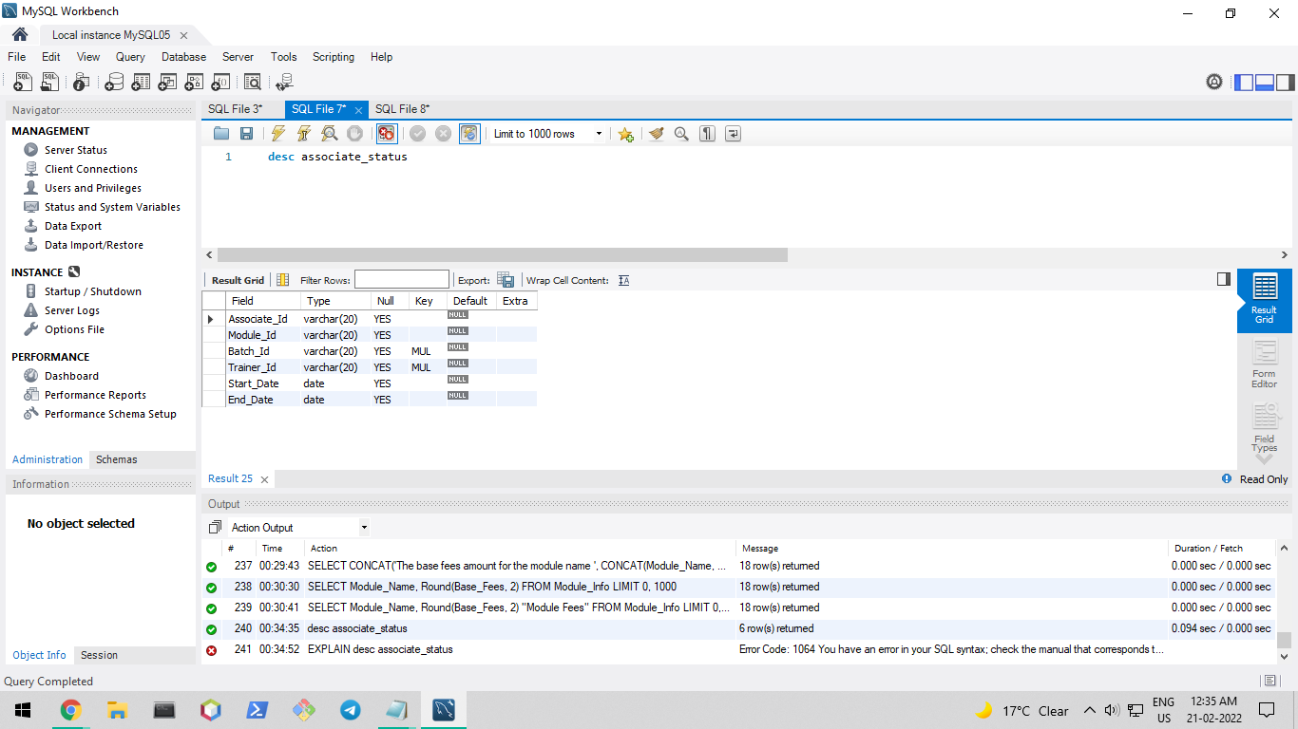

Problem Statement:

Modify two columns data types of the table Associate_Status as follow

Start_Date

Desired Type: Date

End_Date

Desired Type: Date

Deliverables Expected:

New Columns in batch_Info & trainer_Info & changed column data types

Ans.

ALTER TABLE Associate_Status

MODIFY Start_Date date;

ALTER TABLE Associate_Status

MODIFY End_Date date;



Exercise 2.

Problem Statement:

Insert below details into table:

Ans.

/*Step 1. Copy the date into an editor and save with "txt" extension.

Step 2. Run the following commands to load data into the table.

P.S: Question_Text column in Questions table has been enclose in "" for ease of loading.*/

LOAD DATA INFILE 'C:/ProgramData/MySQL/MySQL Server 8.0/Uploads/Trainer_Info.txt'

INTO TABLE Trainer_Info

FIELDS TERMINATED BY ','

LINES TERMINATED BY '\n'

IGNORE 1 ROWS;

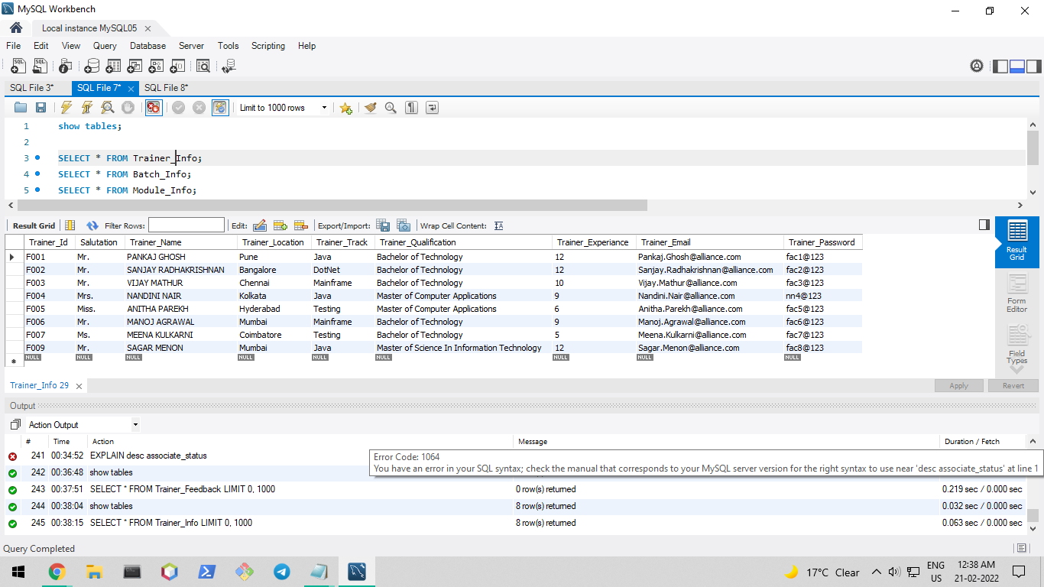

LOAD DATA INFILE 'C:/ProgramData/MySQL/MySQL Server 8.0/Uploads/Batch_Info.txt'

INTO TABLE Batch_Info

FIELDS TERMINATED BY ','

LINES TERMINATED BY '\n'

IGNORE 1 ROWS;

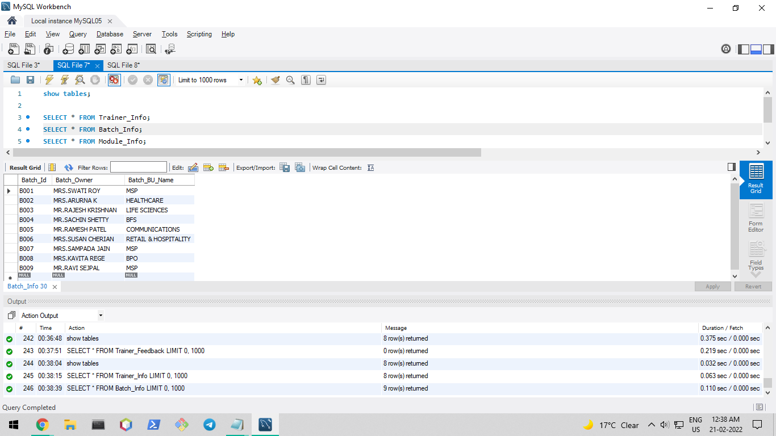

LOAD DATA INFILE 'C:/ProgramData/MySQL/MySQL Server 8.0/Uploads/Module_Info.txt'

INTO TABLE Module_Info

FIELDS TERMINATED BY ','

LINES TERMINATED BY '\n'

IGNORE 1 ROWS;

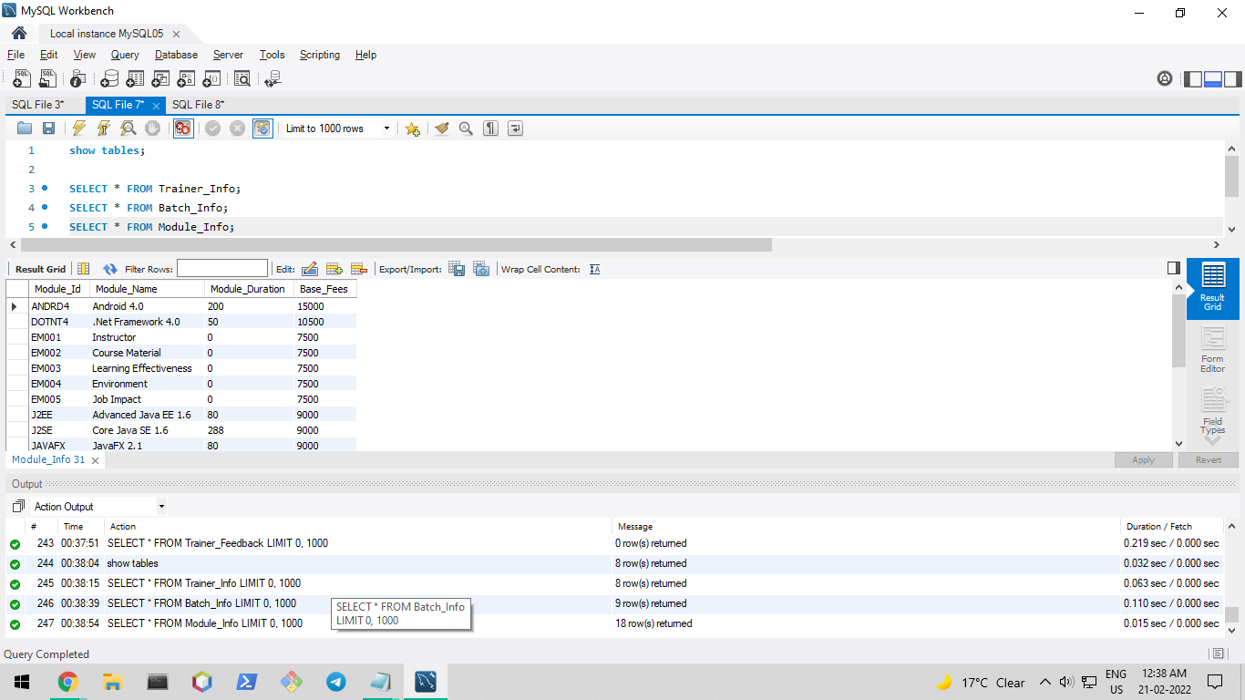

LOAD DATA INFILE 'C:/ProgramData/MySQL/MySQL Server 8.0/Uploads/Associate_Info.txt'

INTO TABLE Associate_Info

FIELDS TERMINATED BY ','

LINES TERMINATED BY '\n'

IGNORE 1 ROWS;

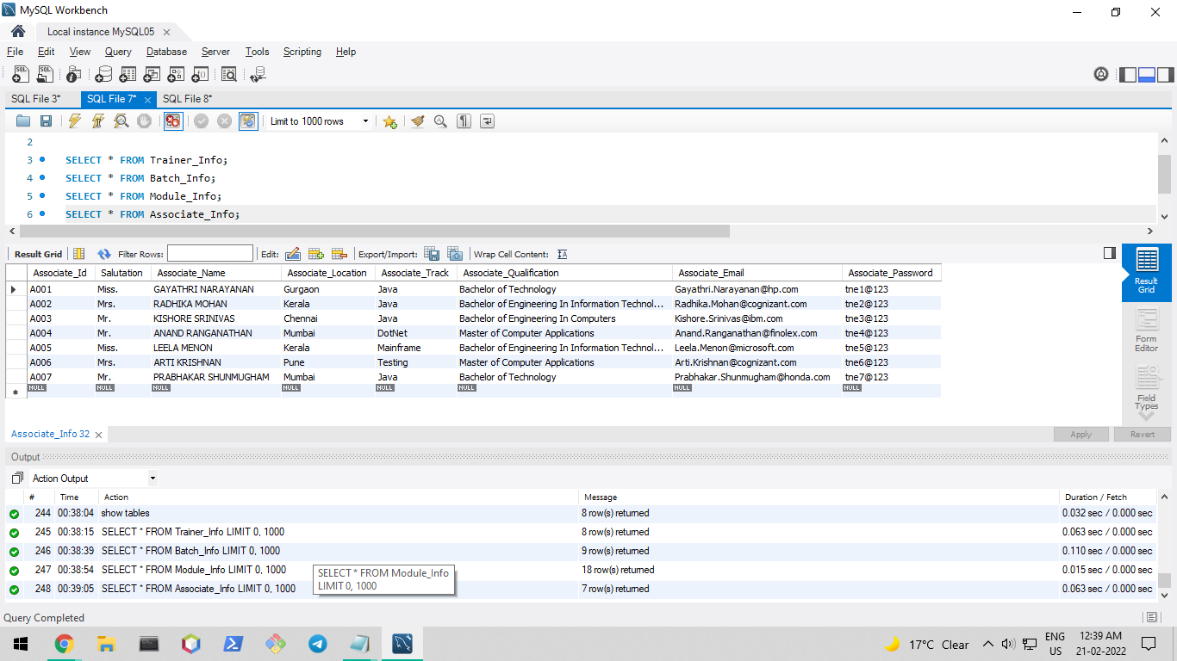

LOAD DATA INFILE 'C:/ProgramData/MySQL/MySQL Server 8.0/Uploads/Questions.txt'

INTO TABLE Questions

FIELDS TERMINATED BY ','

ENCLOSED BY '"'

LINES TERMINATED BY '\r\n'

IGNORE 1 ROWS;

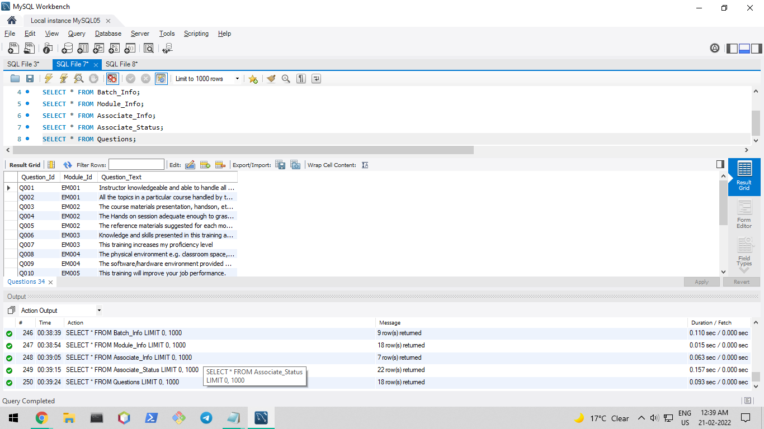

LOAD DATA INFILE 'C:/ProgramData/MySQL/MySQL Server 8.0/Uploads/Associate_Status.txt'

INTO TABLE Associate_Status

FIELDS TERMINATED BY ','

LINES TERMINATED BY '\n'

IGNORE 1 ROWS;

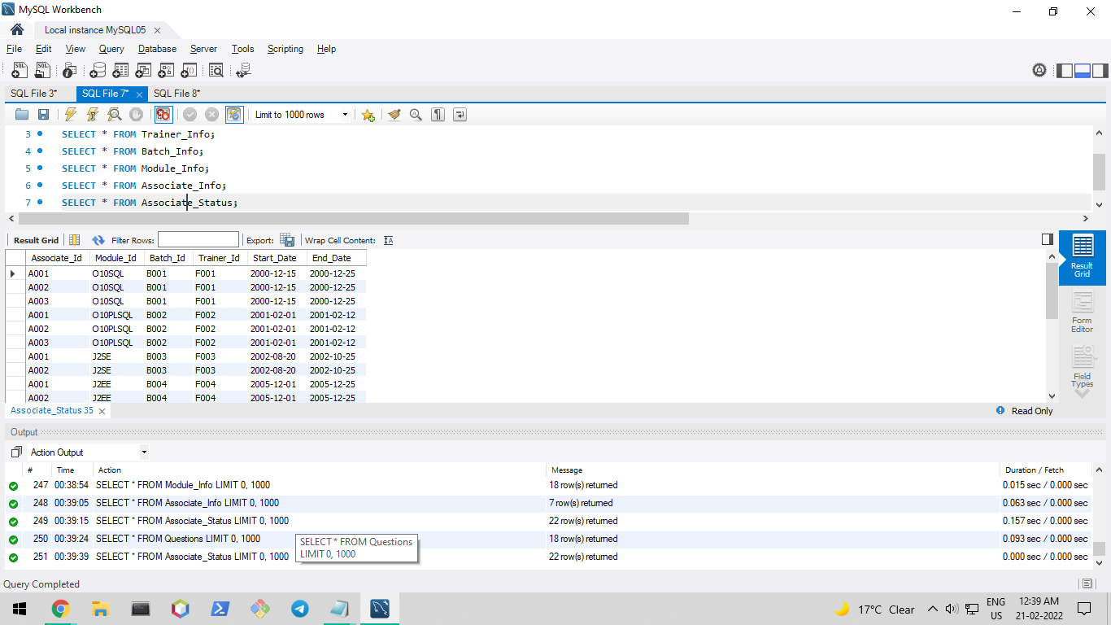

Exercise 2.1

Problem Statement:

Change the password of trainer F004 from fac4@123 to nn4@123

Deliverables Expected:

Updated password of trainer F004

Ans.

UPDATE Trainer_Info

SET Trainer_Password = 'nn4@123'

WHERE Trainer_Id = 'F004';

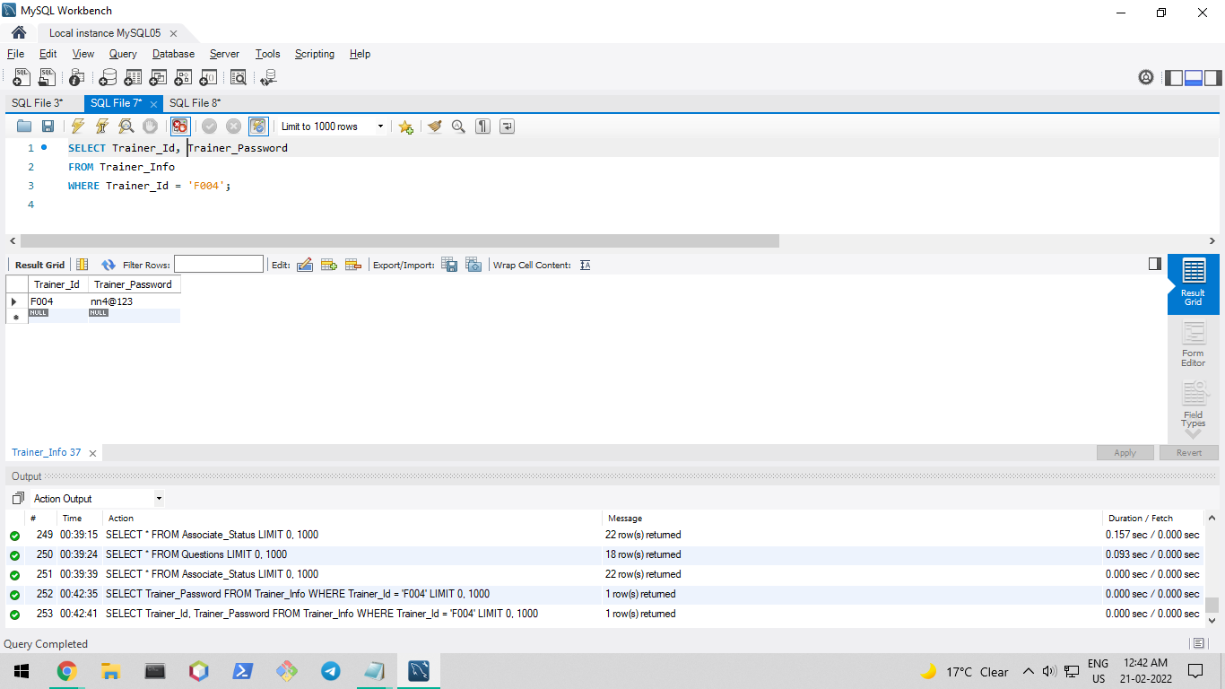

Problem Statement:

Remove following record form associate_status table

A003,J2EE,B004,F004,2005-12-1,2005-12-25

Deliverables Expected:

Removed record from associate status.

Ans.

DELETE FROM Associate_Status

WHERE Associate_Id = 'A003'

and Module_Id = 'J2EE'

and Batch_Id = 'B004'

and Trainer_Id = 'F004'

and Start_Date = '2005-12-01'

and End_Date = '2005-12-25';

Problem Statement:

Fetch first five trainers who have maximum years of experience & display there details.

Deliverables Expected:

Top five experience trainers.

Ans.

SELECT *

FROM Trainer_Info

ORDER BY Trainer_Experiance DESC

LIMIT 5;

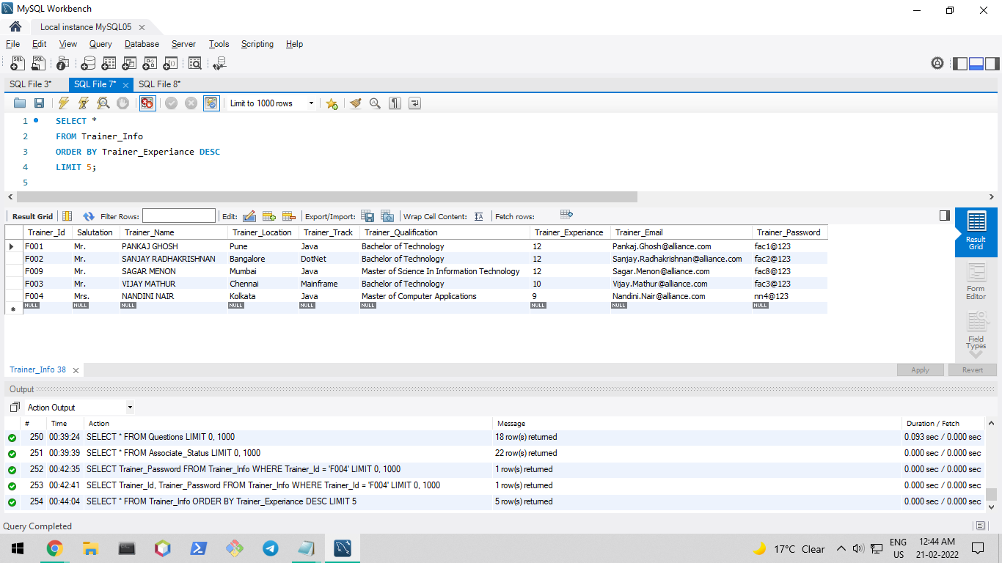

Problem Statement:

Begin transaction & insert below to records into Login_Details

'U001' Admin1@123

'U002' Admin2@123

Perform rollback operation & verify whether any records are inserted in table or not.

Ans.

#To insert data:

INSERT INTO Login_Details VALUES ('U001', 'Admin1@123'), ('U002', 'Admin2@123');

#To check if data is inserted:

SELECT * FROM Login_Details;

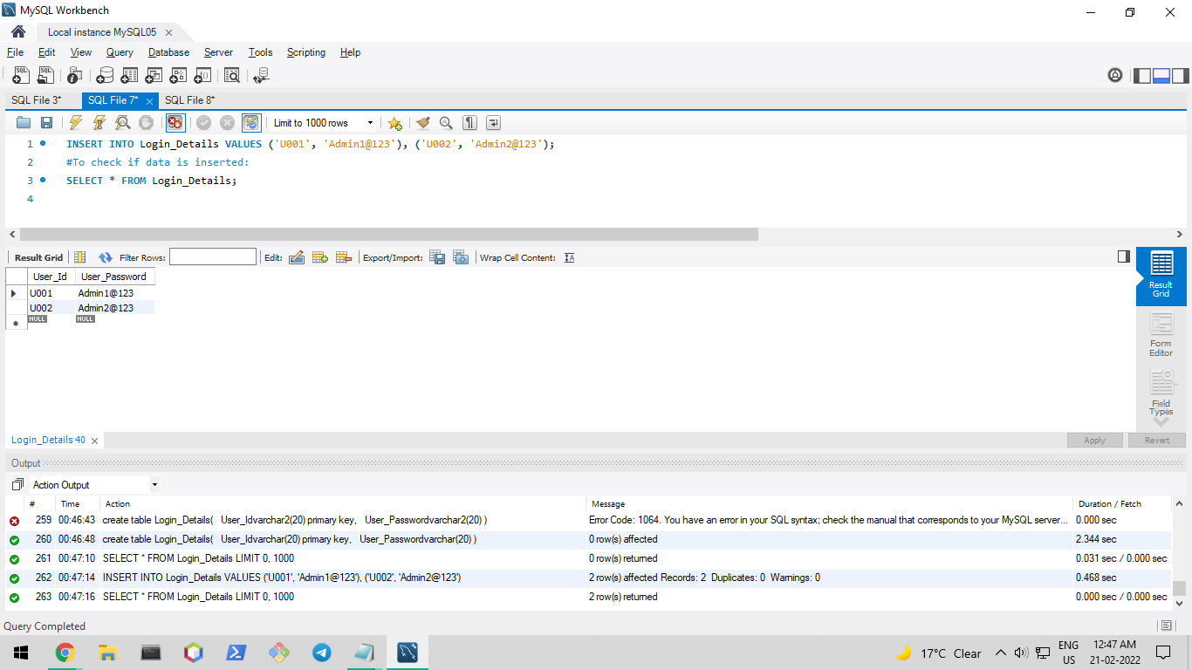

#To rollback

rollback;

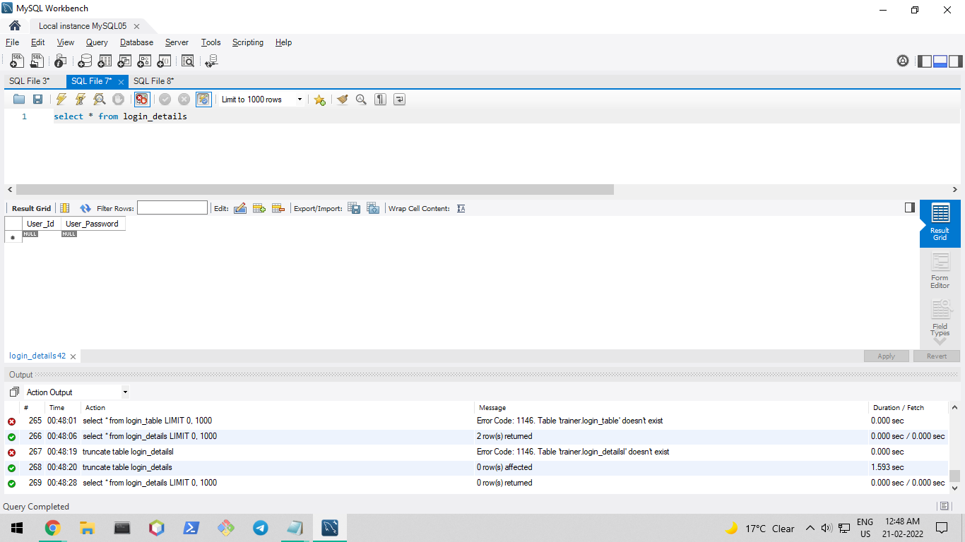

#If data has not been committed then Login_Details is empty after rollback.

Problem Statement:

Create a dummy user in database. Grant create & select table privilege to him/her.

Repeat the above all queries using login credentials of newly created user.

Revoke the privilege assigned to this newly created user.

Ans.

#create user

CREATE USER 'newuser'@'localhost' IDENTIFIED BY 'password';

#grant all priveleges on Trainer Database

GRANT ALL PRIVILEGES ON Trainer.* TO 'newuser'@'localhost';

#view grants for newuser

SHOW GRANTS FOR 'newuser'@'localhost';

#revoke all priveleges

REVOKE ALL PRIVILEGES ON Trainer.* FROM 'newuser'@'localhost';

#drop newuser

DROP USER 'newuser'@'localhost';

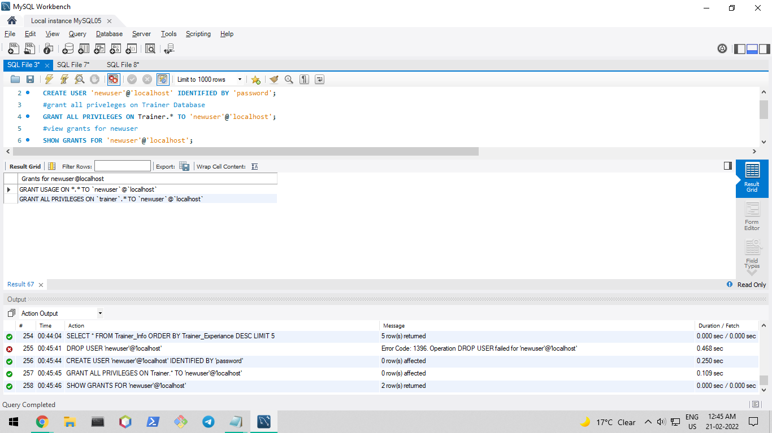

Problem Statement:

Remove table Login_Details from database.

Ans.

DROP TABLE Login_Details;