Hands-on Exercise: MySQL Operators

Problem # 1:

Write a query which fetches and displays all the trainers who don’t have an email.

Ans.

SELECT Trainer_Name

FROM Trainer_Info

WHERE Trainer_Email IS NULL;

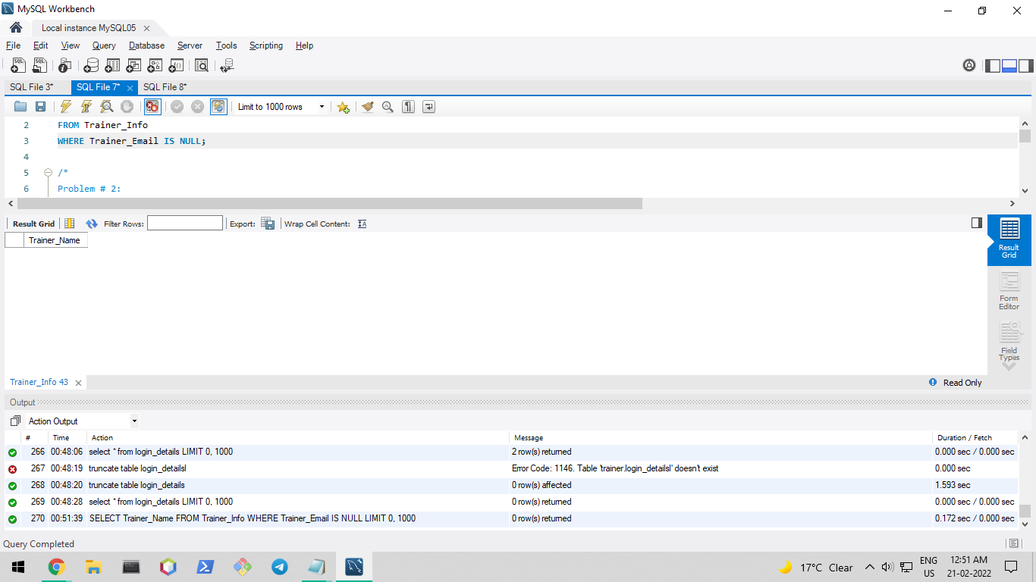

Problem # 2:

Write a query which displays the id, name, track and location of all trainers who has Experience > 4 years.

Ans.

SELECT Trainer_Id, Trainer_Name, Trainer_Track, Trainer_Location

FROM Trainer_Info

WHERE Trainer_Experiance > 4;

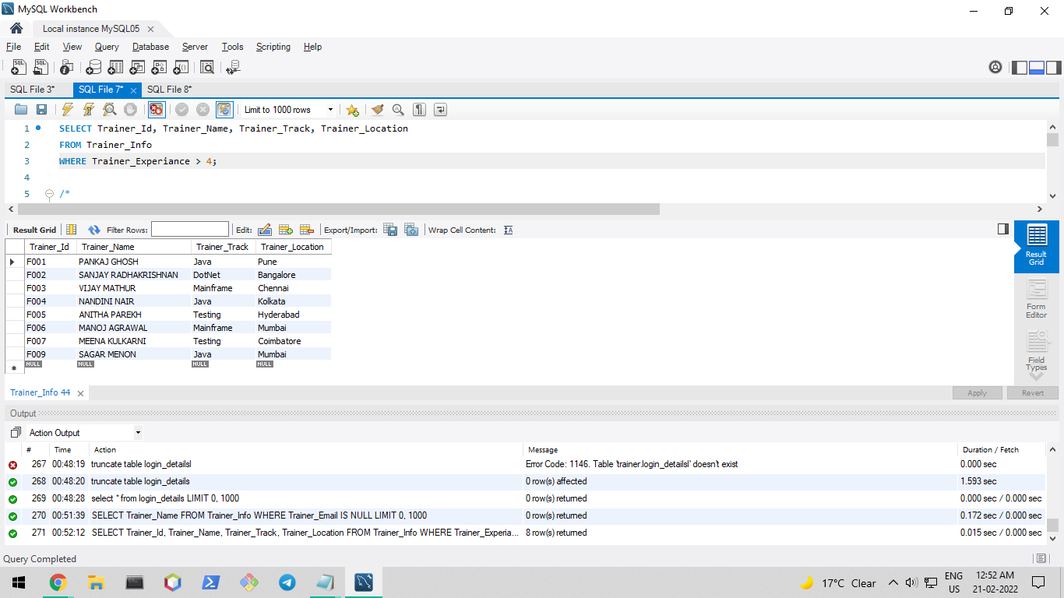

Problem # 3: Select all the modules whose duration > 200.

Ans.

SELECT *

FROM Module_Info

WHERE Module_Duration > 200;

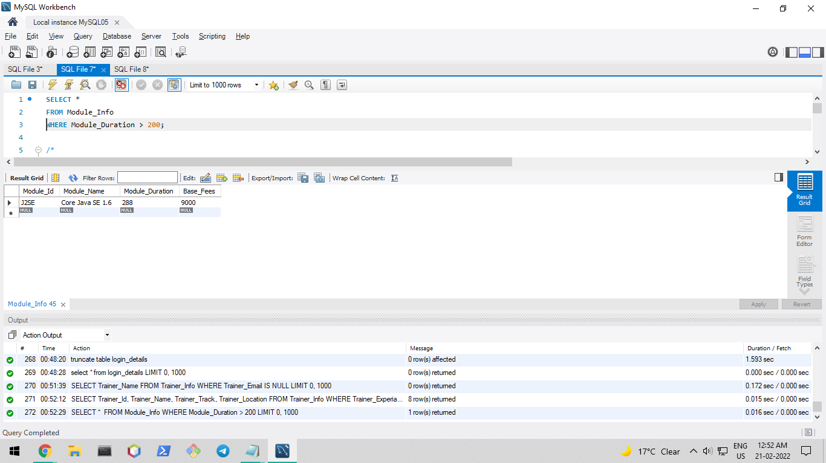

Problem # 4: Display the trainer Id, trainer name whose trainer qualification is not ‘Bachelor of Technology’.

Ans.

SELECT Trainer_Id, Trainer_Name

FROM Trainer_Info

WHERE Trainer_Qualification = 'Bachelor of Technology';

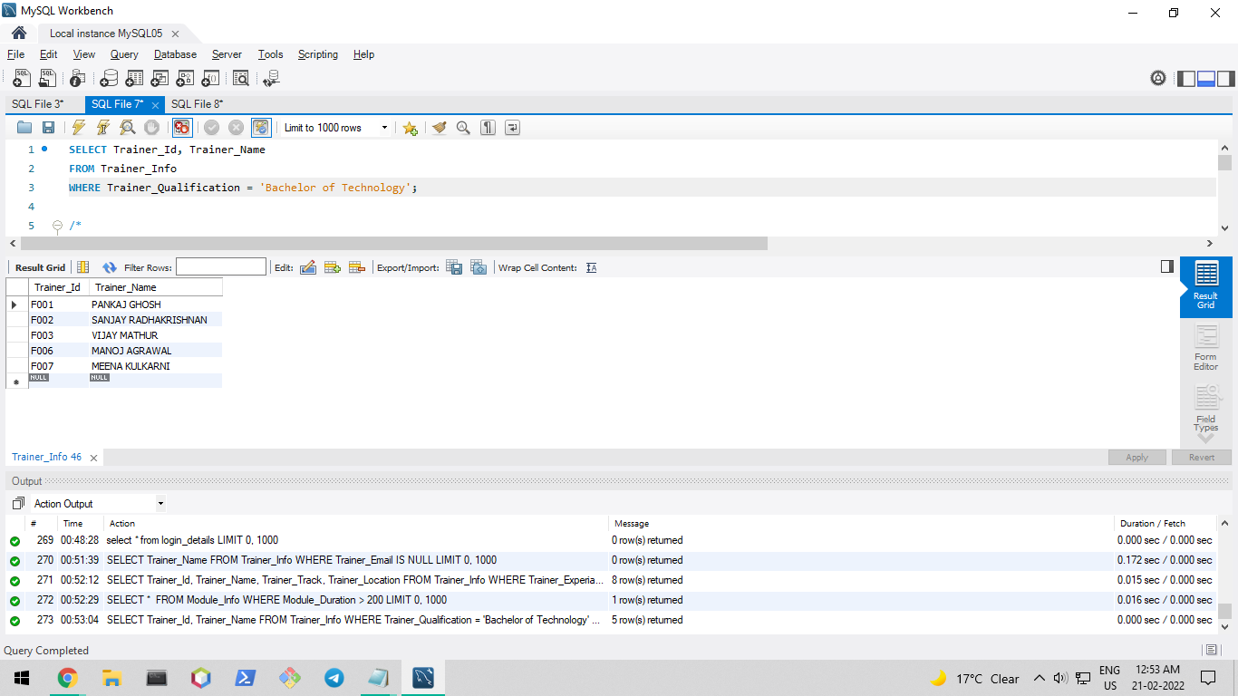

Problem # 5:

Select all the modules whose duration is in the range 200 and 300.

Ans.

SELECT *

FROM Module_Info

WHERE Module_Duration between 200 and 300;

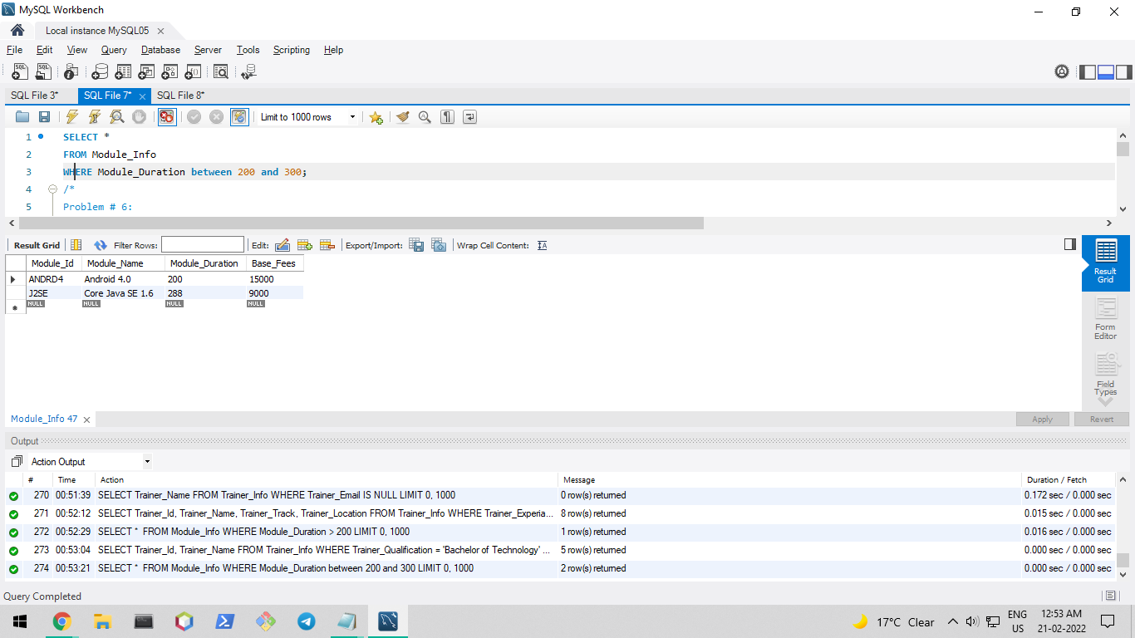

Problem # 6:

Display the trainer Id, trainer name whose first name starts with ‘M’.

Ans.

SELECT Trainer_Id, Trainer_Name

FROM Trainer_Info

WHERE Trainer_Name LIKE 'M%';

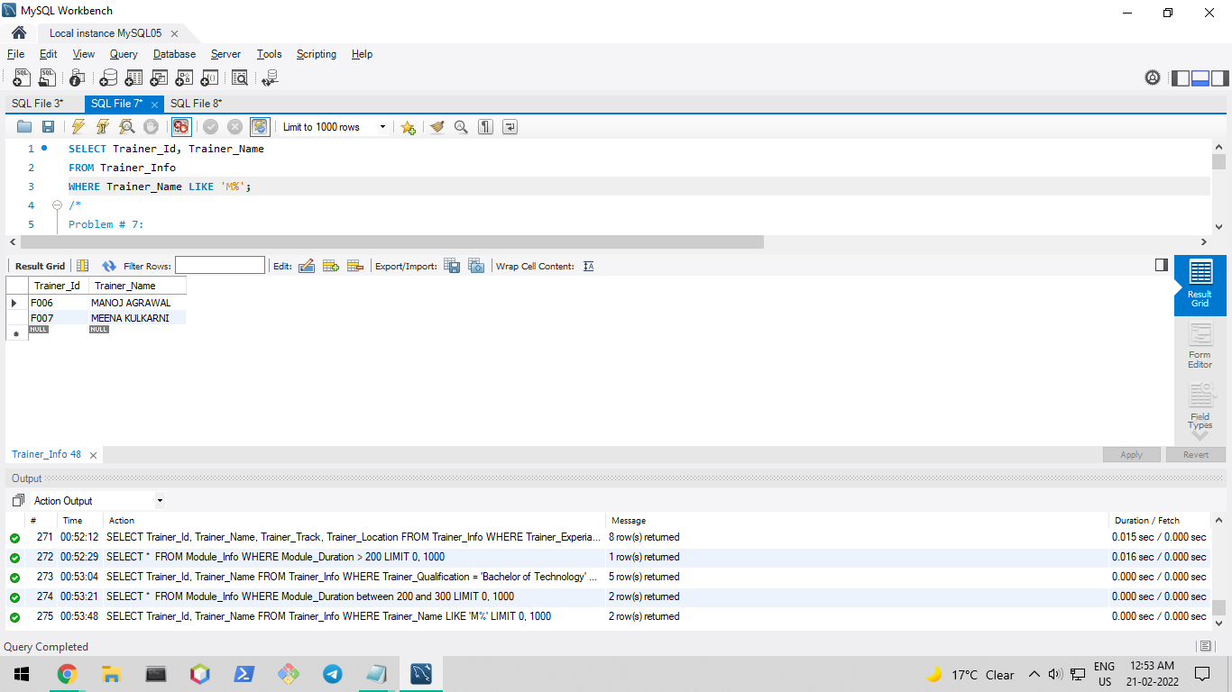

Problem # 7:

Display the trainer Id, trainer name whose first name has a character ‘O’

Ans.

SELECT Trainer_Id, Trainer_Name

FROM Trainer_Info

WHERE Trainer_Name LIKE '%O%';

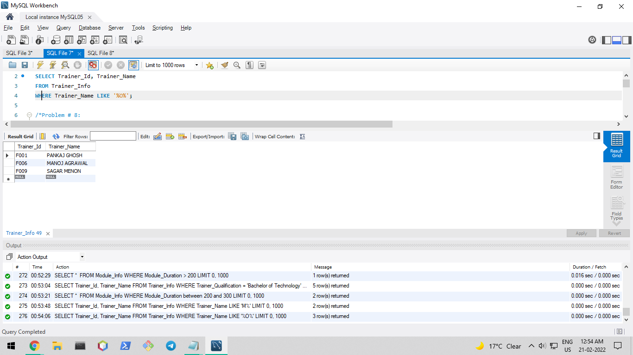

Problem # 8:

Display the names of all the modules where the module name is not null.

Ans.

SELECT Module_Name

FROM Module_Info

WHERE Module_Name IS NOT NULL;

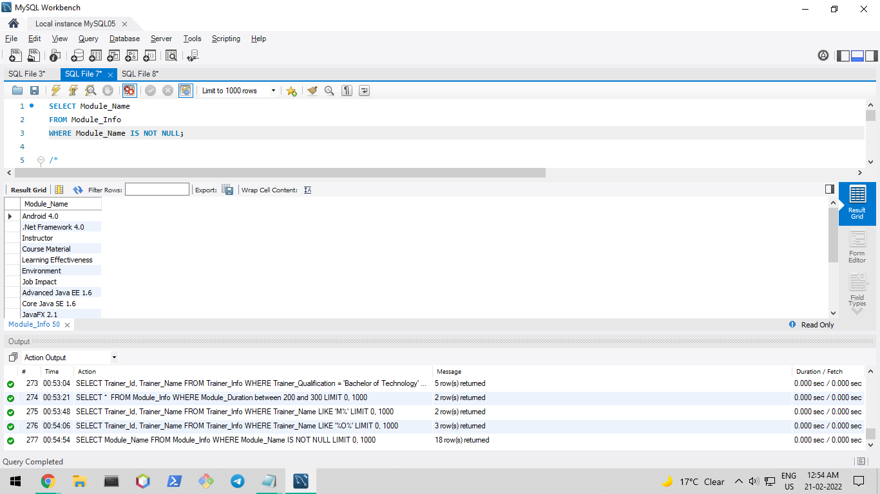

Hands-on Exercise: MySQL Function

Problem 1: Develop a query which will display the module name and module Infra fees of the entire module. The infra fee should be rounded to 2 decimal point.

Ans.

SELECT Module_Name, Round(Base_Fees, 2) "Module Fees"

FROM Module_Info;

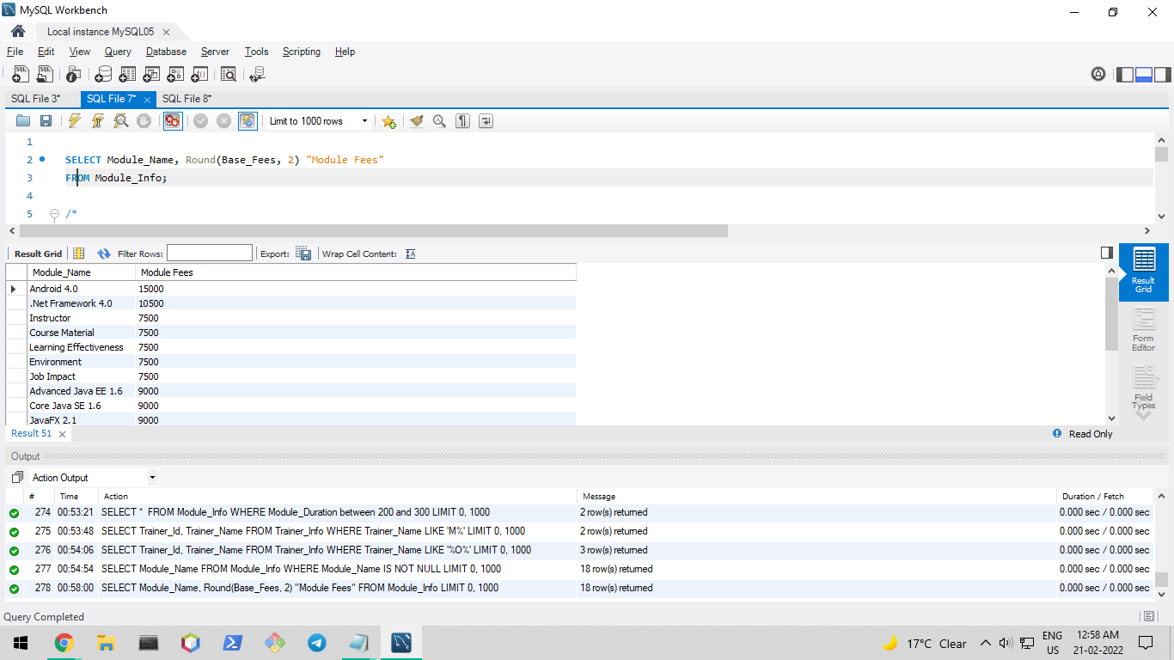

Problem 2: Develop a query which will list all the module id and module names in Module_Info table where in the first letter should be capital letter.

Ans.

SELECT Module_Id, CONCAT(UCASE(LEFT(Module_Name, 1)), SUBSTRING(Module_Name, 2)) "Module_Name"

FROM Module_info;

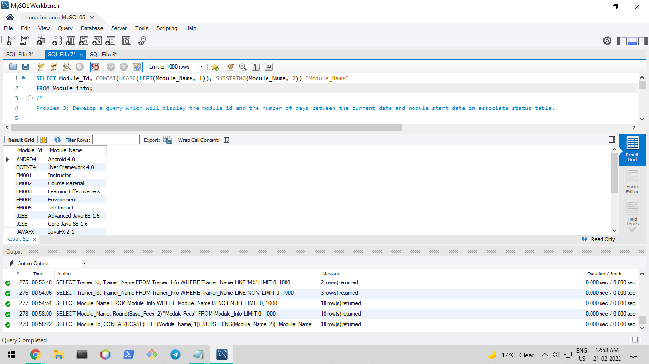

Problem 3: Develop a query which will display the module id and the number of days between the current date and module start date in associate_status table.

Ans.

SELECT Module_Id, DATEDIFF(CURDATE(), Start_Date)

FROM Associate_Status;

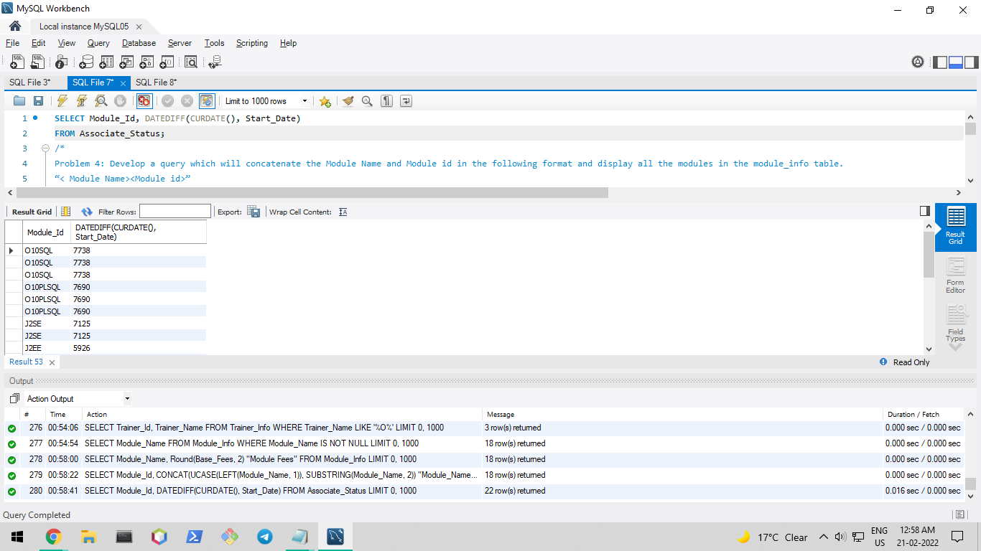

Problem 4: Develop a query which will concatenate the Module Name and Module id in the following format and display all the modules in the module_info table.

“< Module Name><Module id>”

Ans.

SELECT CONCAT(Module_Name,CONCAT(' ',Module_Id)) "Module Info"

FROM Module_Info;

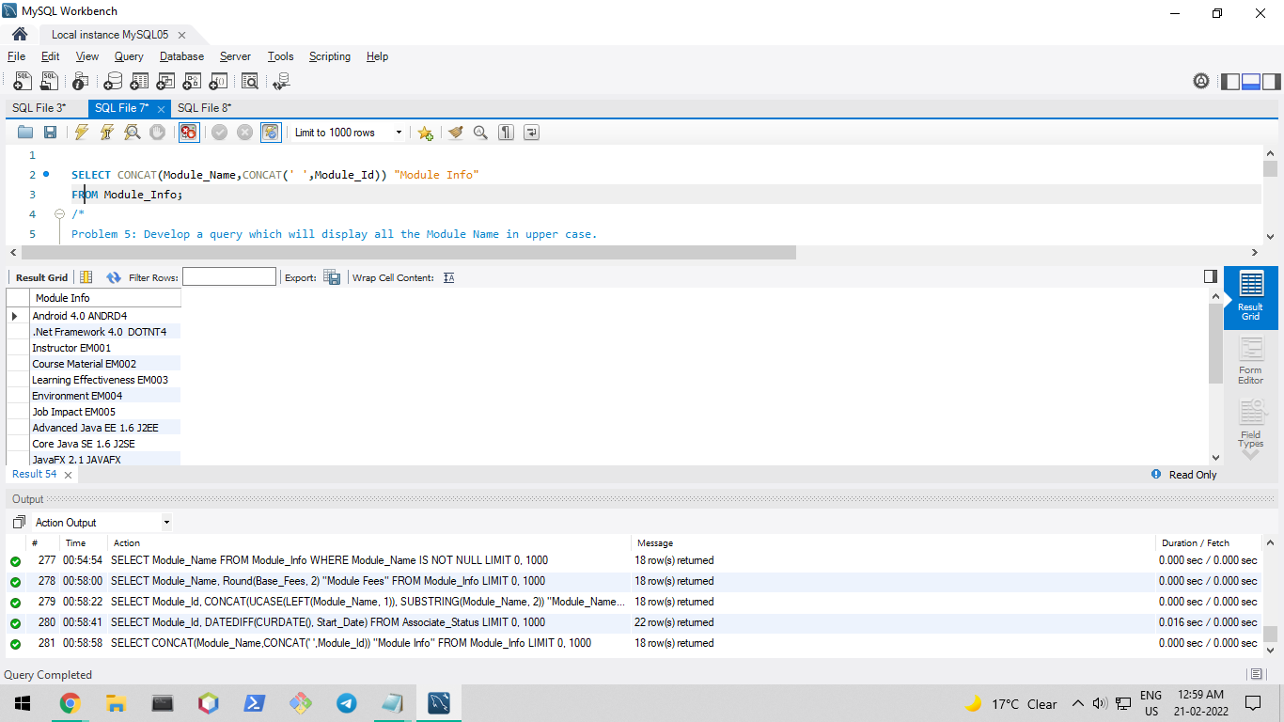

Problem 5: Develop a query which will display all the Module Name in upper case.

Ans.

SELECT UCASE(Module_Name)

FROM Module_Info;

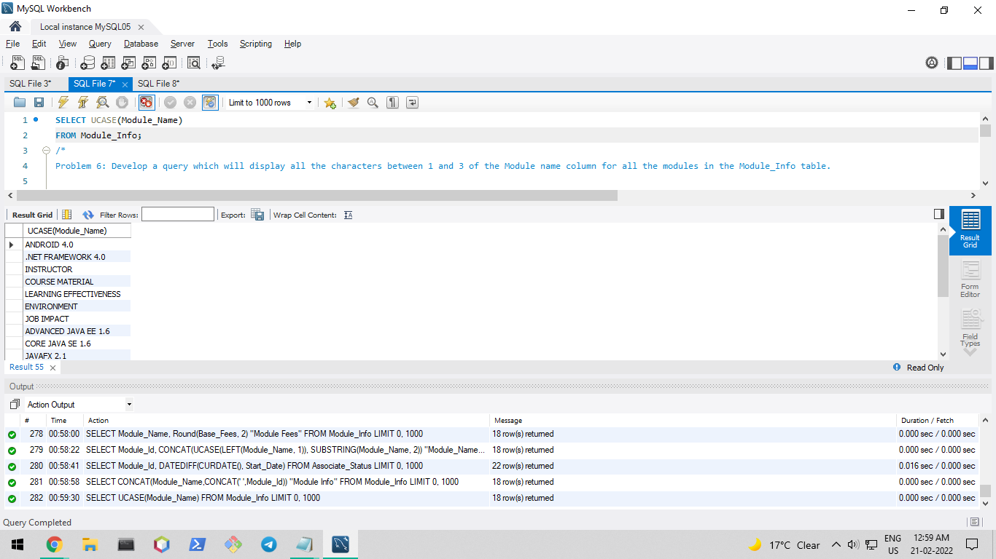

Problem 6: Develop a query which will display all the characters between 1 and 3 of the Module name column for all the modules in the Module_Info table.

Ans.

SELECT SUBSTR(Module_Name, 1, 3) "Module Name"

FROM Module_Info;

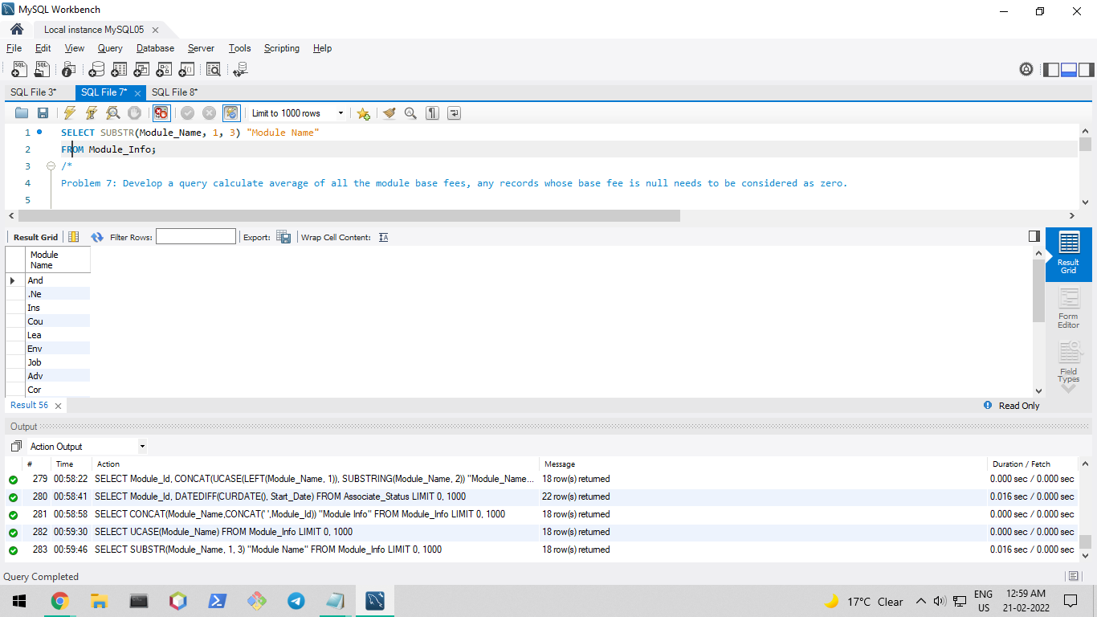

Problem 7: Develop a query calculate average of all the module base fees, any records whose base fee is null needs to be considered as zero.

Ans.

SELECT AVG(Base_Fees) "Average Fees"

FROM Module_Info;

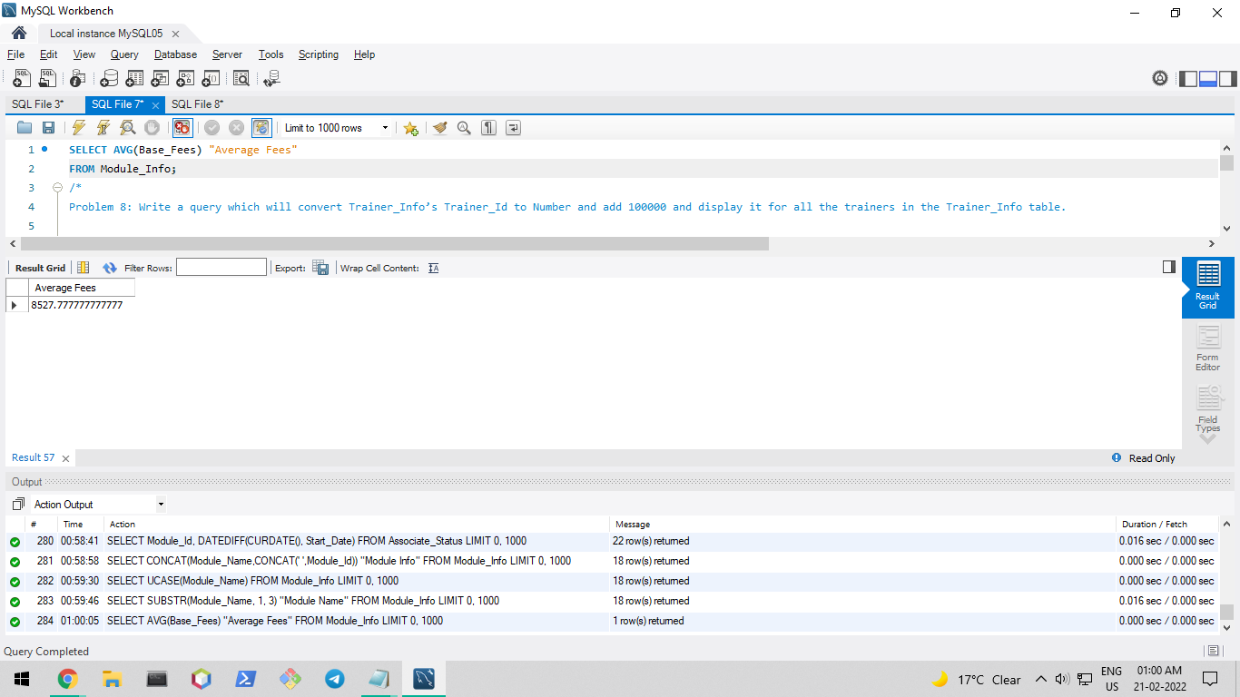

Problem 8: Write a query which will convert Trainer_Info’s Trainer_Id to Number and add 100000 and display it for all the trainers in the Trainer_Info table.

Ans.

SELECT (100000 + CAST(SUBSTR(Trainer_Id, 2) AS UNSIGNED))

FROM Trainer_Info;

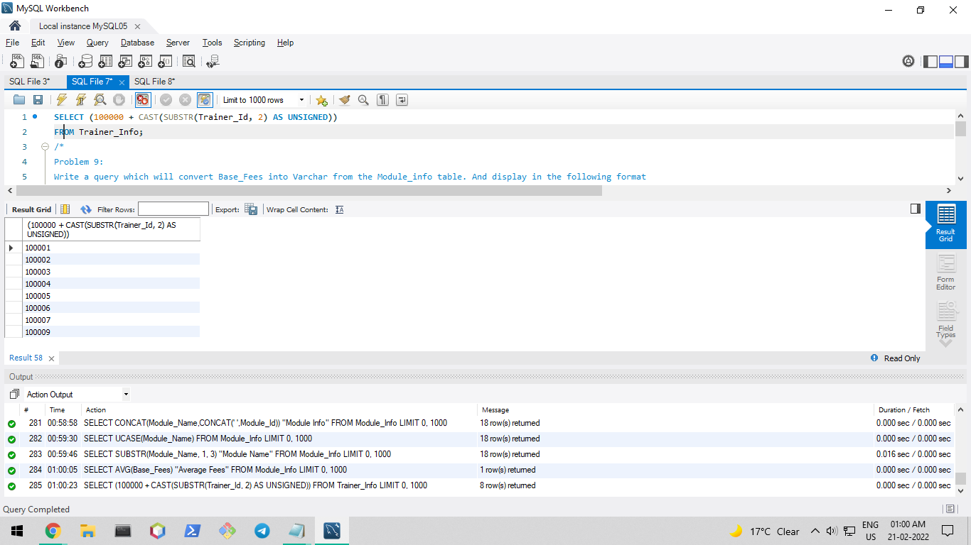

Problem 9:

Write a query which will convert Base_Fees into Varchar from the Module_info table. And display in the following format

‘The Base Fees Amount for the module name’ <Module Name>’ is ’<Base Fees>

Ans.

SELECT CONCAT('The base fees amount for the module name ', CONCAT(Module_Name, CONCAT(' is ', Base_Fees))) "Module Fees"

FROM Module_Info;

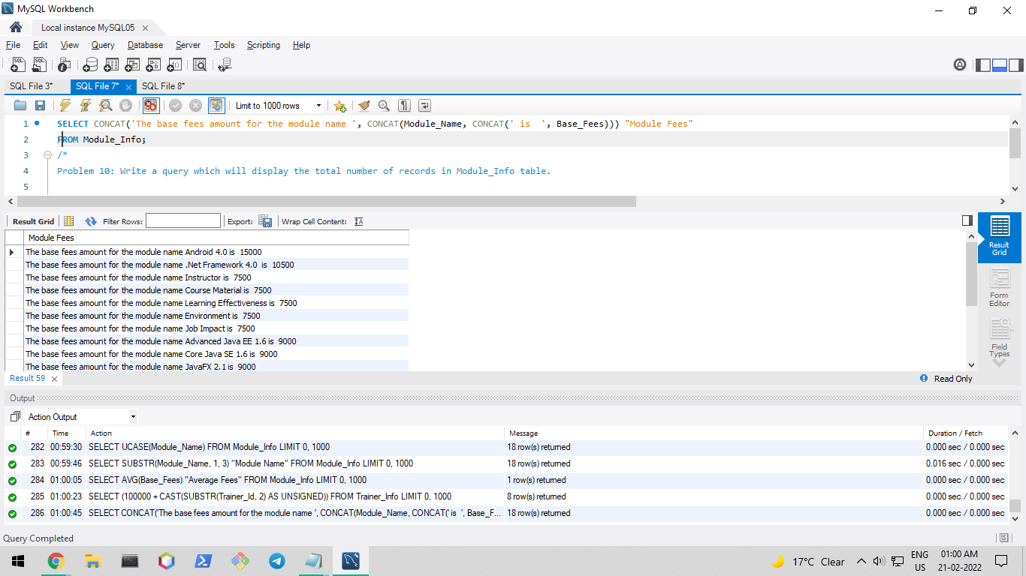

Problem 10: Write a query which will display the total number of records in Module_Info table.

Ans.

SELECT COUNT(*) "Number of Modules"

FROM Module_Info;

