Assesment3_Subqueries & Joins

Subqueries

Exercise 1

Problem Statement:

Write a query to display trainer IDs for all associates whose names contain the letter 'i'. Note: Use sub-query to achieve this.

Ans:

SELECT trainer_id

FROM trainer_info

WHERE trainer_name IN (SELECT trainer_name

FROM trainer_info WHERE trainer_name LIKE '%i%');

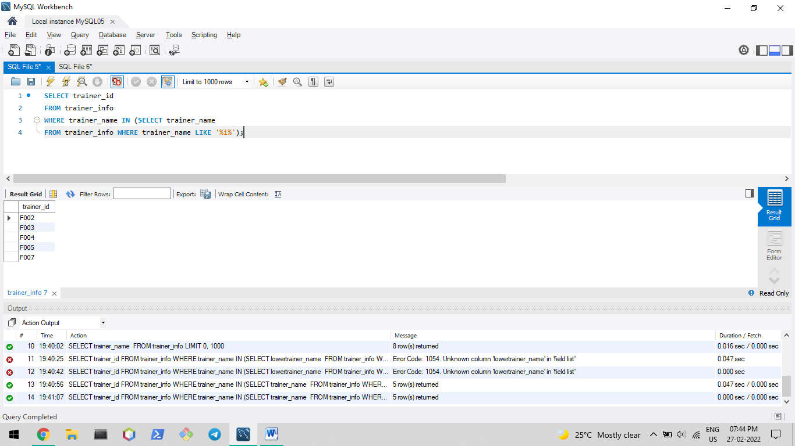

Problem Statement:

Write a query to display trainer IDs for all associates whose names do not contain the letter 'i'.

Ans:

SELECT trainer_id

FROM trainer_info

WHERE trainer_name IN (SELECT trainer_name

FROM trainer_info WHERE trainer_name NOT LIKE '%i%');

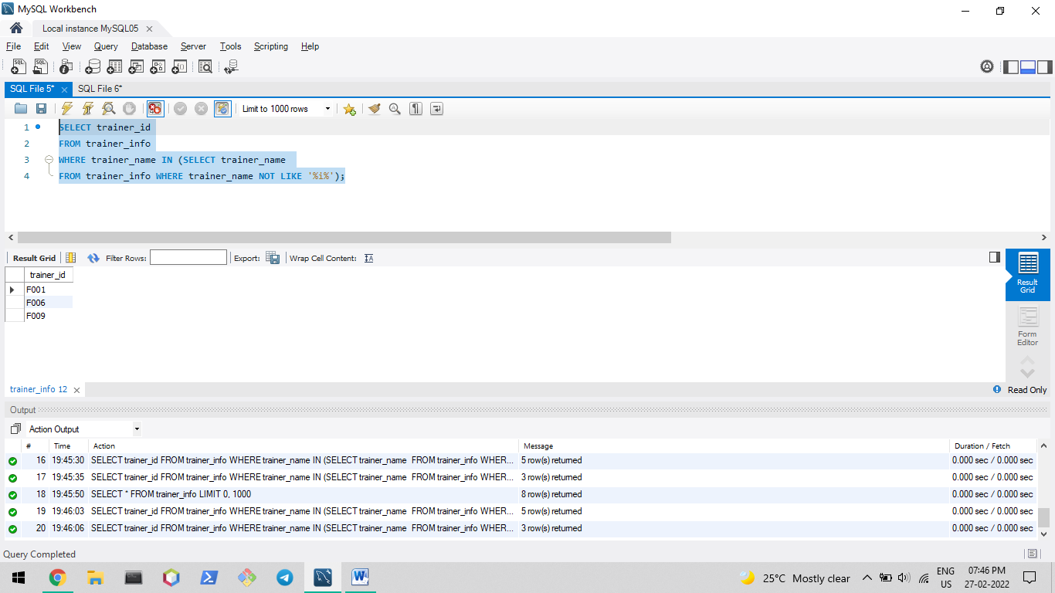

Problem Statement:

Write a query to display trainer ID and trainer rating for the trainers who handled J2EE module. Hint: Use trainer_feedback and associate status tables.

Ans:

SELECT trainer_id, trainer_rating

FROM trainer_feedback

WHERE module_id = "J2EE";

Exercise 2

Following commands were used to create student table and add data to it to perform the given queries:

CREATE TABLE student(

registration_id varchar(4) primary key,

student_name varchar(100),

subject_name varchar(100),

marks integer

);

INSERT INTO student VALUES ("S001", "Sambodhi Baid", "EI05IP", 94);

INSERT INTO student VALUES ("S002", "Madhurima Y.", "TS02IP", 98);

INSERT INTO student VALUES ("S003", "Shravya B.", "EI05IP", 96);

INSERT INTO student VALUES ("S004", "Mohd. Shahbaz", "UP07IP", 80);

INSERT INTO student VALUES ("S005", "Sumi Batra", "DL01IP", 75);

INSERT INTO student VALUES ("S006", "Amrita Dev", "DL01IP", 94);

Problem Statement:

Write a query to pick up the maximum marks secured in the subject “EI05IP” and display the student name and registration number of the student who has secured it.

Ans:

SELECT registration_id, student_name

FROM student

WHERE marks = (SELECT MAX(marks)

FROM student

WHERE subject_name = 'EI05IP')

AND subject_name = 'EI05IP';

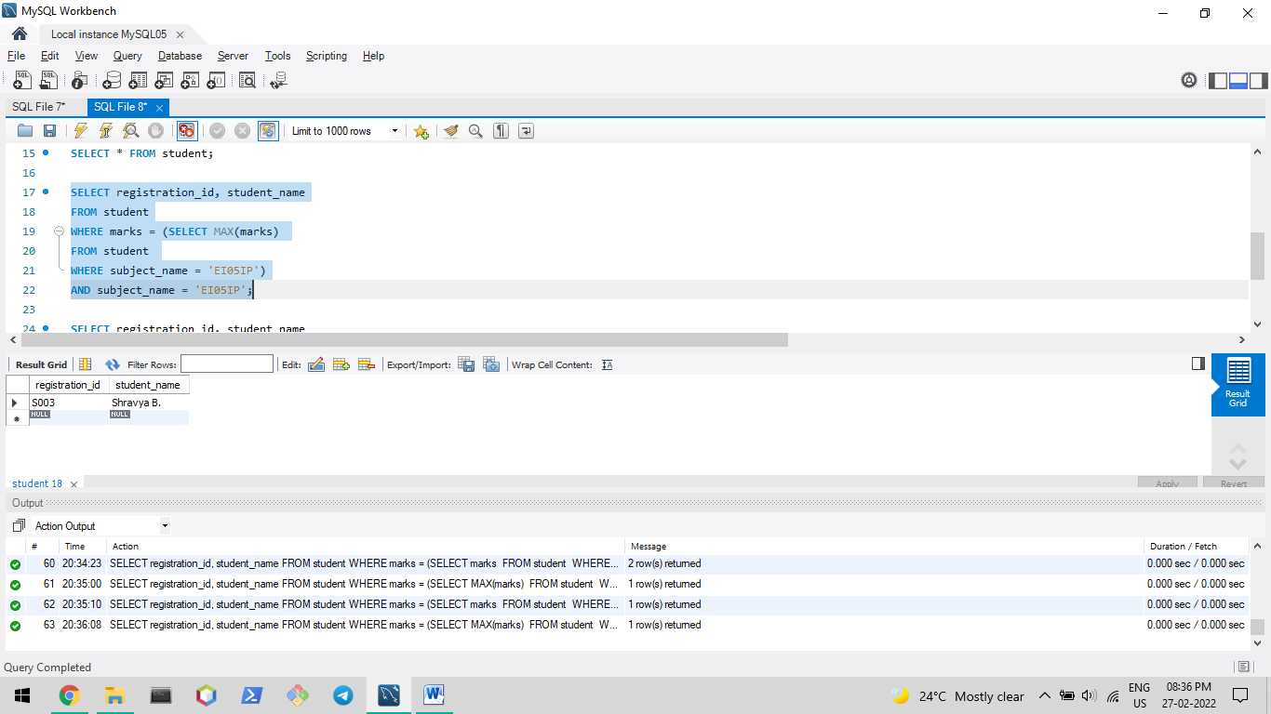

Problem Statement:

Write a query to display the student name and registration number of the student who has secured second highest marks in the subject El05lP subject.

Ans:

SELECT registration_id, student_name

FROM student

WHERE marks = (SELECT marks

FROM student

WHERE subject_name = 'EI05IP'

ORDER BY marks DESC LIMIT 1, 1)

AND subject_name = 'EI05IP';

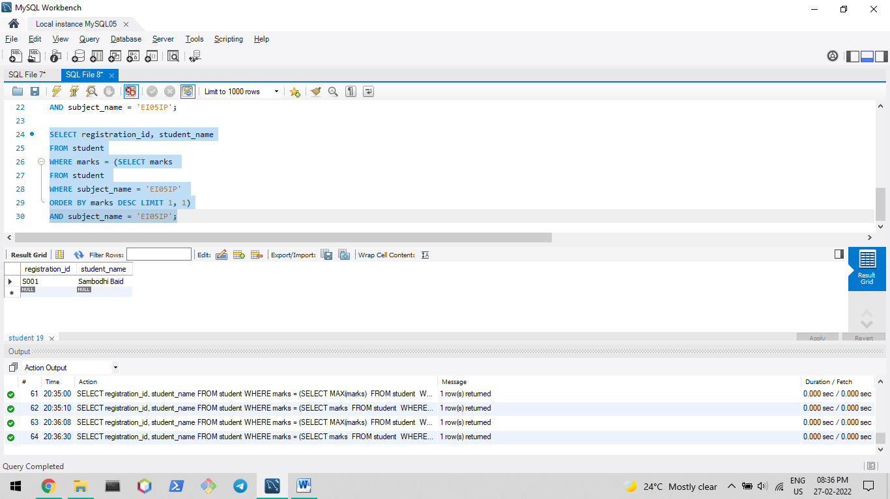

Joins

Exercise 1

Problem Statement:

Write a query to display trainer_id and batch_id details in such a way that we get all possible combinations of trainer IDs and batch IDs.

Hint: Use Trainer_Info and Batch_Info tables.

Ans:

SELECT t.trainer_id, b.batch_id

FROM trainer_info t,

batch_info b;

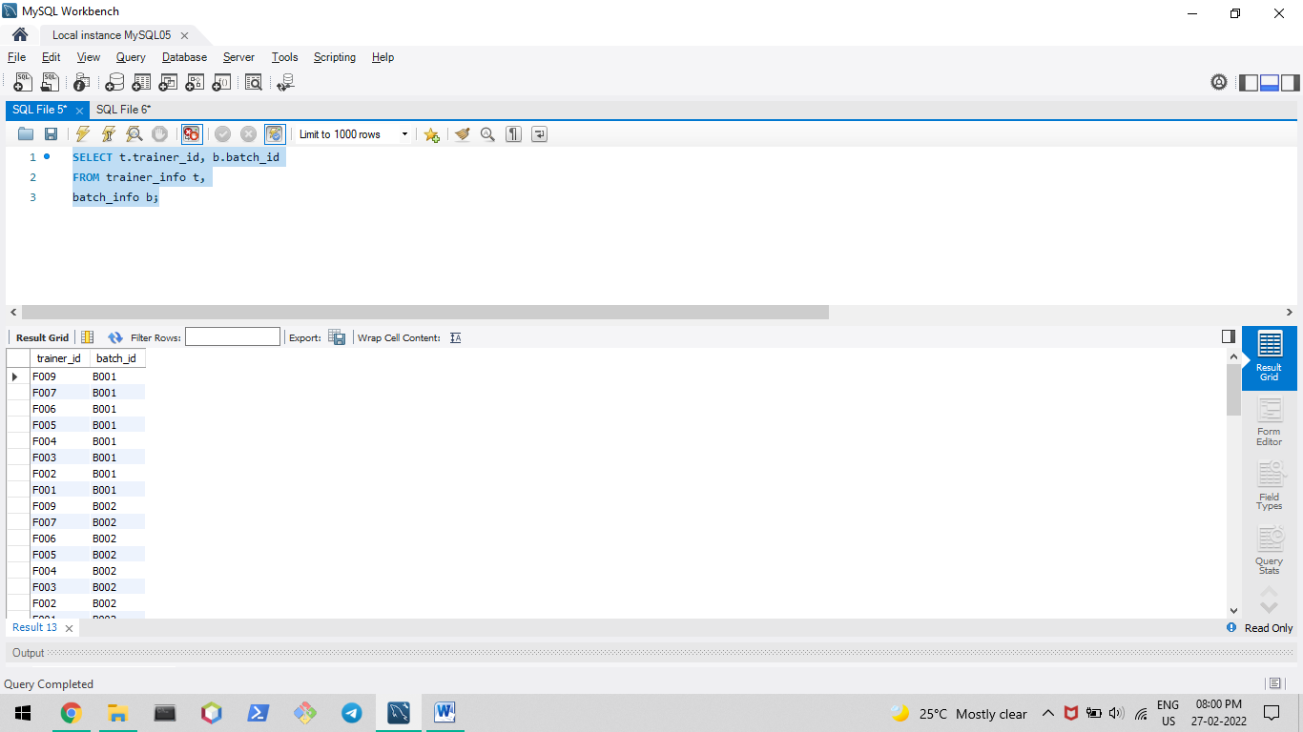

(large output)

Problem Statement:

Write a query to display the records from all columns of tables associate_status and batch_info, wherever the batch_id in the two tables matches.

Ans:

SELECT *

FROM associate_status a

JOIN batch_info b

ON a.batch_id = b.batch_id;

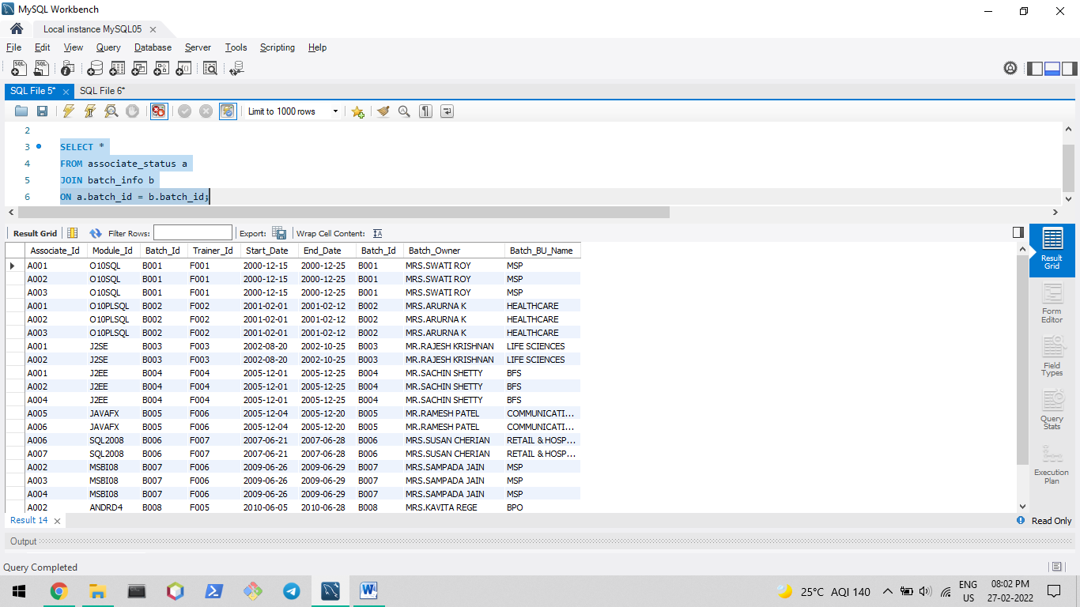

Problem Statement:

Write a query to display the associate IDs of the associates tagged to trainers and all the trainer IDs irrespective of whether there are any associates tagged to them or not. Hint: Use associate_status and trainer_info tables.

Note: Use Left Outer Join

Ans:

SELECT a.associate_id, t.trainer_id

FROM trainer_info t

LEFT OUTER JOIN associate_status a

ON t.trainer_id = a.trainer_id;

