Creating Django Project
Step-1
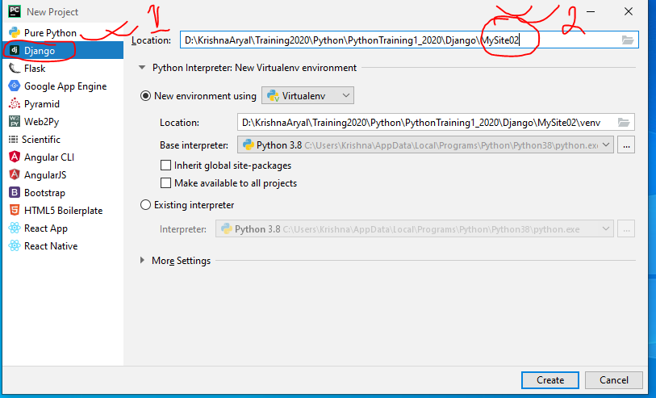
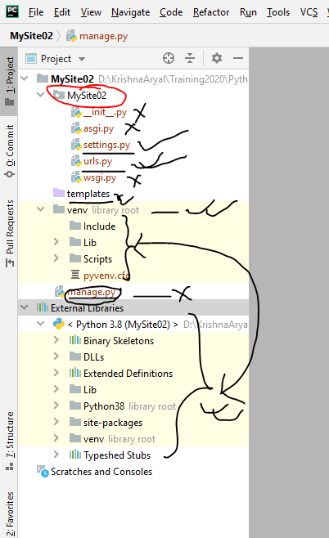
Step-2: Exploring Project
Website Browse
Step-1
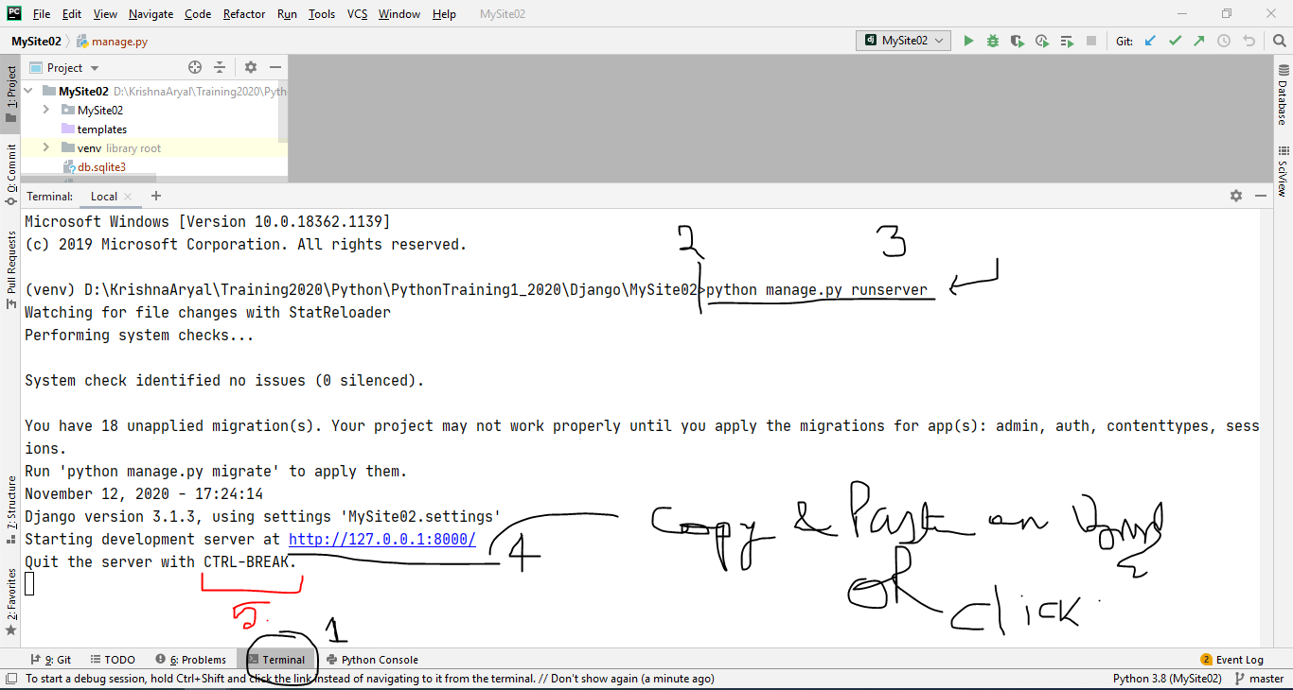
Step-2
- Tools (Menu) -> Run Manage.py Task (Ctrl + Alt + R)
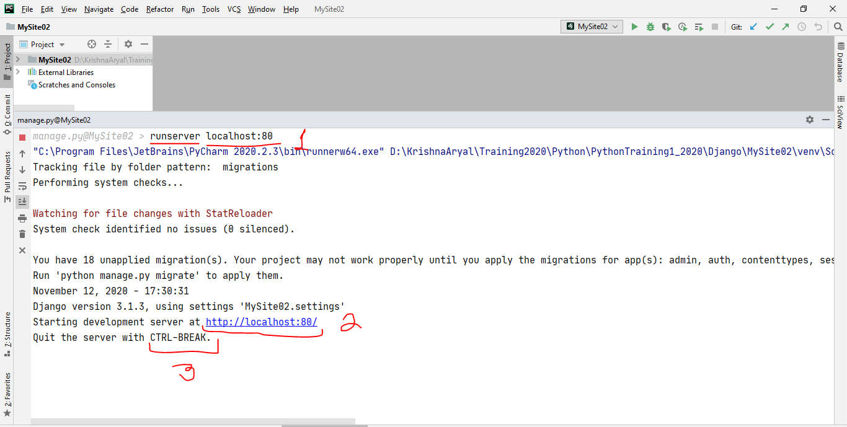
Custom View
1. Create views.py file
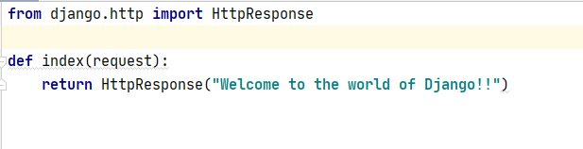
- Update urls.py
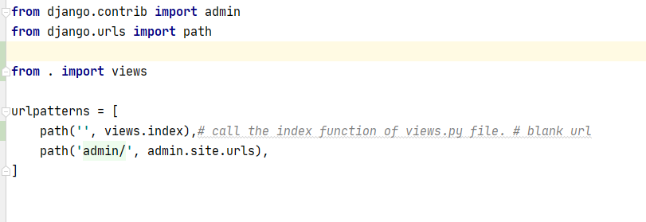
Apps
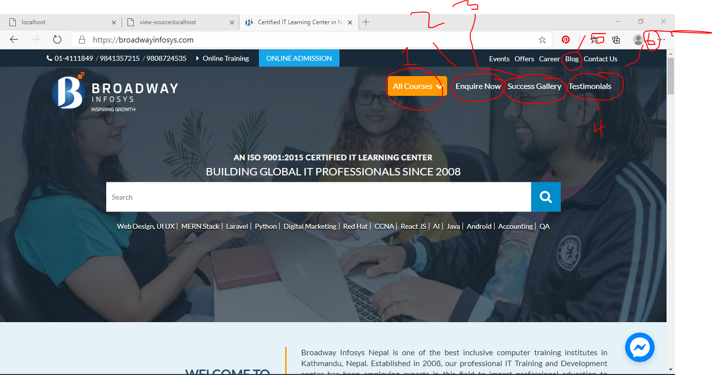
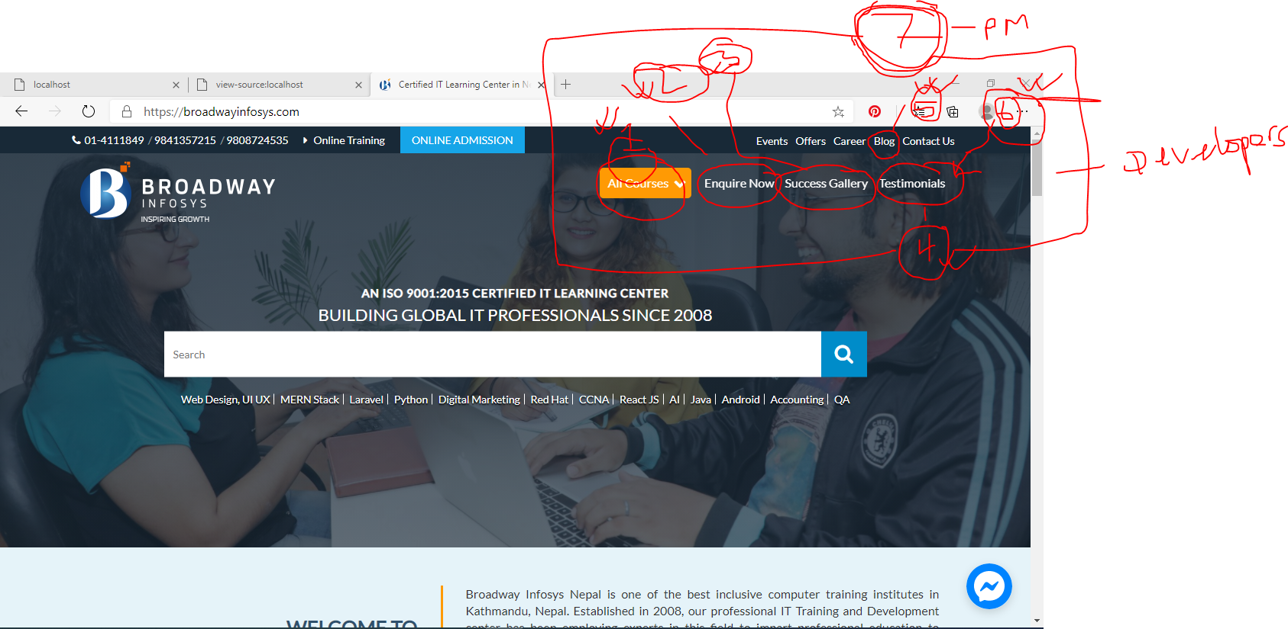
Creating app in Project
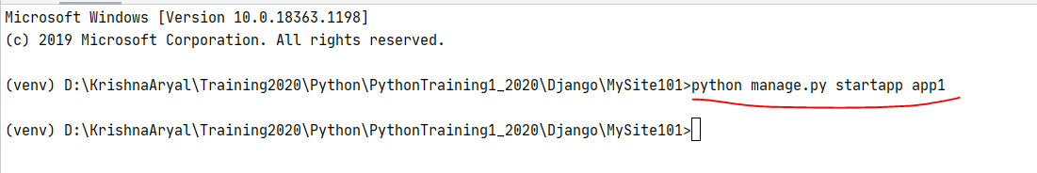
Links
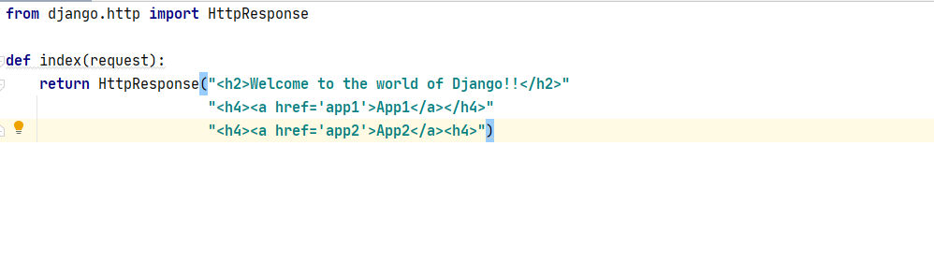
References:
https://docs.djangoproject.com/en/3.1/

