|  |
| --- |
| **WorldView EcoTours**  **Data Management Proposal** |
| Team #6 Databoss  Milestone 3 |

|  |
| --- |
| **CIS3400**  Simon Wang, (Swang1093@gmail.com)  Kary Huang, (Karyh8023@gmail.com)  Atikur Rahman, (mb.2030yahoo.com)  Wenyi Chen, (cwy-1991@hotmail.com)  4-19-2016 |

**Table of Contents**

1. WVET Data Management Plan 2

WVET’s Business Processes 2

WVET’s Database System and Management Practices 2

How We Can Help 3

Required Information Items 3

How Our System Works 4

Summary 4

2. WVET Entity Relationship Diagram (ERD) 5

3. WVET Relational Model and Normalization 6

Normalized Relations 6

Why Third Normal Form 6

Functional Dependencies 6

4. Database Preview 7

Relationship window 7

Assignment table – Design view 8

Customer table – Design view 9

Employee table – Design view 10

Package table – Design view 11

Reservation table – Design view 12

Tour table – Design view 13

# WVET Data Management Plan

## WVET’s Business Processes

WVET is a tour-guiding company with a simple business model – generating revenue through the sale of services (in the form of tours and tour packages). Because the owners are primarily focused on increasing sales, they have limited time and resources to dedicate towards database management. WVET’s current data management practices include using hardcopy binders to keep their customers’ data, which is disadvantageous in retrieving and manipulating information. We are confident that a more modern database management system will help WVET improve its operating efficiency and managerial analysis.

## WVET’s Database System and Management Practices

WVET currently keeps information in hardcopy binders. This makes the information much more difficult to retrieve, analyze and far more susceptible to loss. This risk increases as the business grows and the amount of customers and sales (and therefore, data) increases. It takes a large amount of time to go through the books and papers for every new transaction, updates or cancellations on transactions, as well as modifications on customer information. Nowadays, the use of digital Database Management Systems (DBMS) is very common for all kinds of data storage, control, manipulation, and retrieval, and the usage of digital DBMS can greatly improve a company’s operational efficiency.

## How We Can Help

Databoss plans to help WVET improve their business operations by improving and automating their database management. We will first map their data in an Entity-relationship Diagram (ERD), which is a data modeling technique that helps define business processes and can be used as the foundation for a relational database. We will create easy-to-read tables for tracking sales. For convenience and readability, we aim to identify and separate unnecessary fields if possible. In doing so, we will be able to decrease the time required for WVET to retrieve their data, the time spent correcting inaccurate data and present the data in a much more readable format.

## Required Information Items

The information items we will require will include the entity classes, such as PACKAGE, CUSTOMER and EMPLOYEE. With this information, we as the database designers will identify the relationships between each entity. By identifying and understanding the relationships, we will be able to create composite entities if necessary in order to resolve many to many relationships. This will allow WVET to track things such as individual sales of packages, providing a single table which contains information regarding the package, the customer, the tours included and more. Additionally, we will require the attributes or “field names” that WVET would like to keep track of. This will allow us to fill the column fields of the relationship tables with information that is useful to the managerial analysis and decision-making processes of WVET.

## How Our System Works

Databoss will introduce a far more efficient and up-to-date data management system to WVET in the form of a relational database. This will allow WVET executives to focus on the selling side of their business, without having to worry about tedious, manual management of their data. The automated database will allow for better managerial analysis and decision-making by simplifying and automating retrieval and data queries. Automated calculations and queries leave less potential for human-error, improving the accuracy of the data. This new proposed system will increase the operational efficiency of WVET by allowing for easier data access, data entry and retrieval. In addition, it will save physical space, time and money. As we know, these days a ten kilobyte digital file can contain the same amount of information as an entire page of written information. For the same amount of information, WVET will only need hard drives for data storage instead of physical space. Therefore, the automated system will be less susceptible to information loss, as it is far harder to lose data in the cloud than it is to lose a physical piece of paper. It will also be much easier to fix inaccurate data. Furthermore, our proposed system will protect the information’s privacy by allowing for different levels of access depending on the users requiring access to the data.

## Summary

We believe that WVET will benefit significantly by updating its database management system. By going digital, WVET will be able to take advantage of the capabilities of modern computers. Operational efficiency will increase as data retrieval and data entry will be simplified. Calculations will be automated, leading to an increase in data accuracy. Automated queries allow for better and easier managerial analysis and decision making. The data is safe and protected as different users can have different levels of access to the information. It is also less susceptible to loss as digital data can be easily backed up on to multiple hard drives. In the long run, WVET will save money by spending far less time on managing its data.

2. WVET Entity Relationship Diagram (ERD)

# 3. WVET Relational Model and Normalization

## Normalized Relations

CUSTOMER (**CustID**, FirstName, LastName, DOB, City, State, Phone, Email)

PACKAGE (**PackageID**, PackageName, Length, SingleSupplement, Price, Destination, Country)

TOUR (**TourID**, ***PackageID***, DepartureDate, ReturnDate)

EMPLOYEE (**Empl_ID**, FirstName, LastName, Location, Driver_Y/N, Guide_Y/N)

ASSIGNMENT (**AssignID**, ***Empl_ID, TourID,*** Role_D/G)

RESERVATION (**RsvNum**, ***CustID****,* ***TourID***, ***Roommate,*** Deposit, RsvDate)

## Why Third Normal Form

This relation was already in second normal form as each entity only has one primary key, therefore there could not have been any partial dependencies. For example, in CUSTOMER, FirstName, LastName, Gender, DOB, Address, Phone and Email only dependence on CustID. In addition, there are no transitive dependences, therefore it is currently in third normal form. 3NF pays handsome dividends by ensuring there is no data duplication, which in turn makes queries run much more efficiently and reduces the amount of storage required.

## Functional Dependencies

**CustID** -> FirstName, LastName, DOB, City, State, Phone, Email

**PackID** -> PackageName, Length, SingleSupplement, Price, Destination, Country

**Empl_ID** -> FirstName, LastName, Location, Driver_Y/N, Guide_Y/N

**Empl_ID, TourID**-> Role_D/G

**TourID** -> DepartureDate, ReturnDate

**RsvNum** -> Deposit, RsvDate

**CustID, RsvNum** -> Roommate

# 4. Normalized Data – attached as Excel document

# 5. Database Overview

## Relationship window

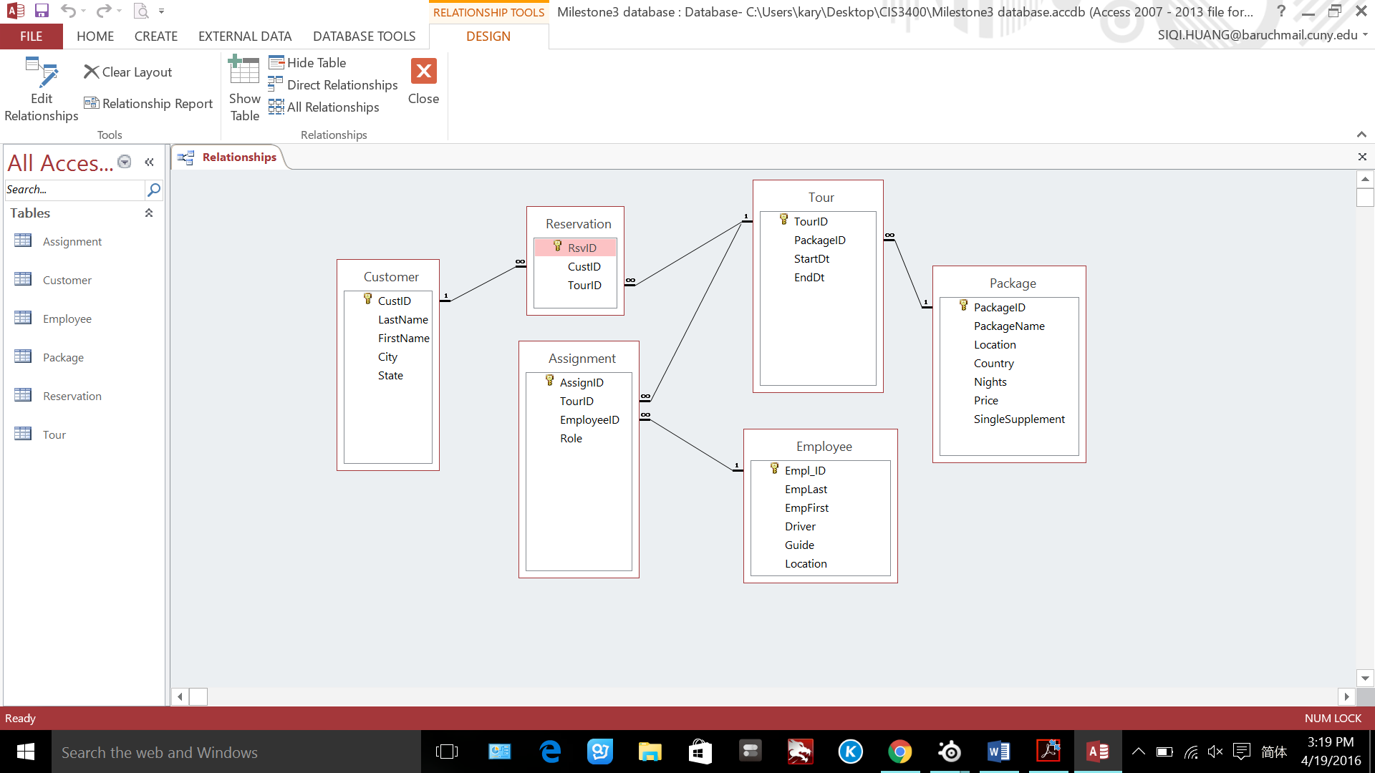

Assignment table – Design view

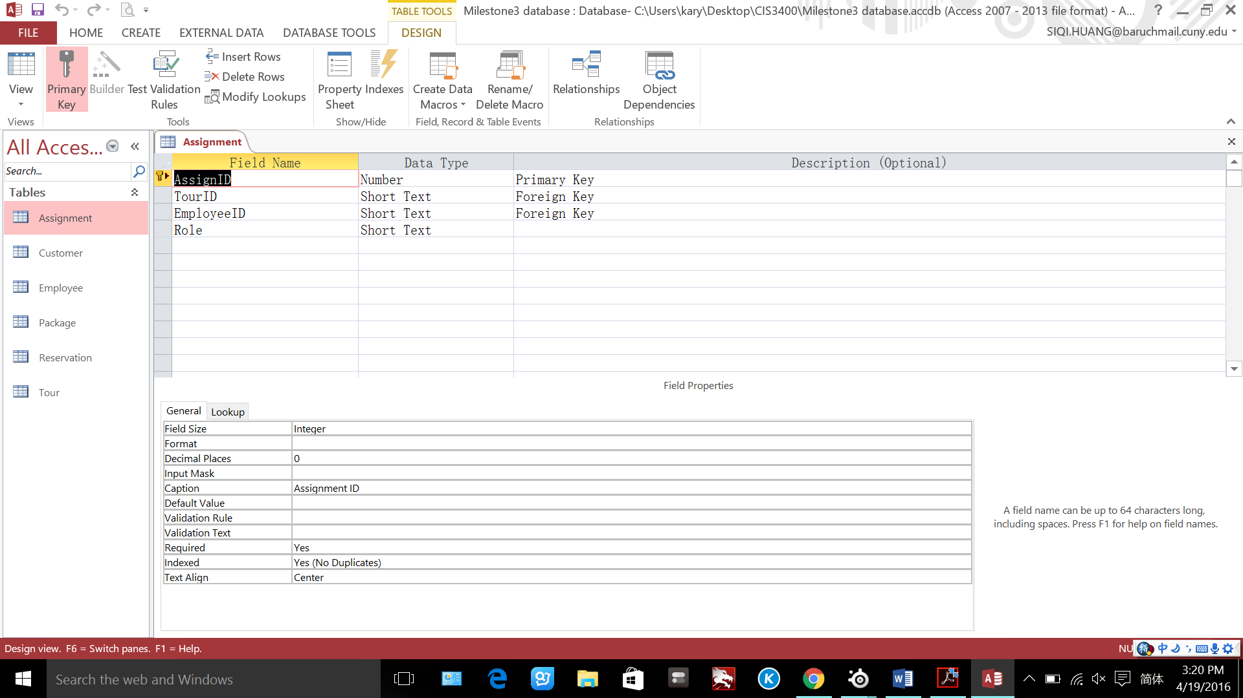

## **Customer table – Design view**

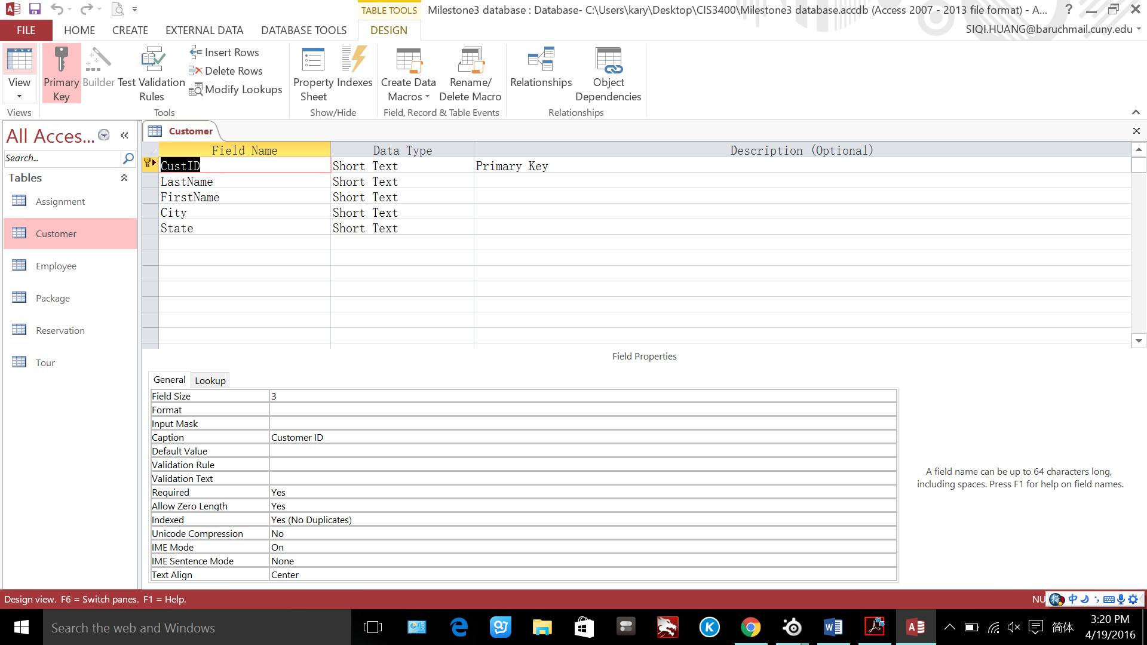

Employee table – Design view

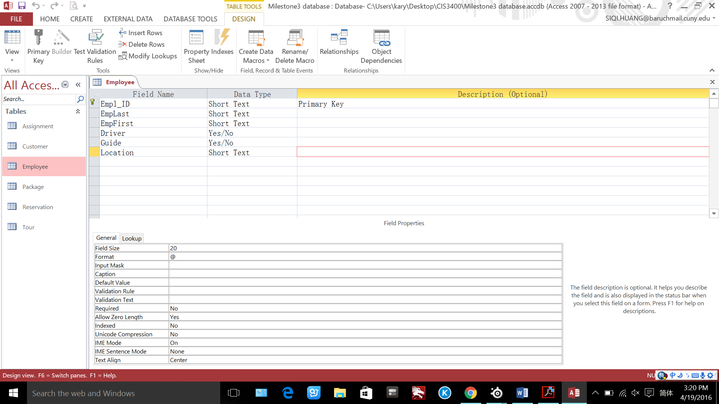

Package table – Design view

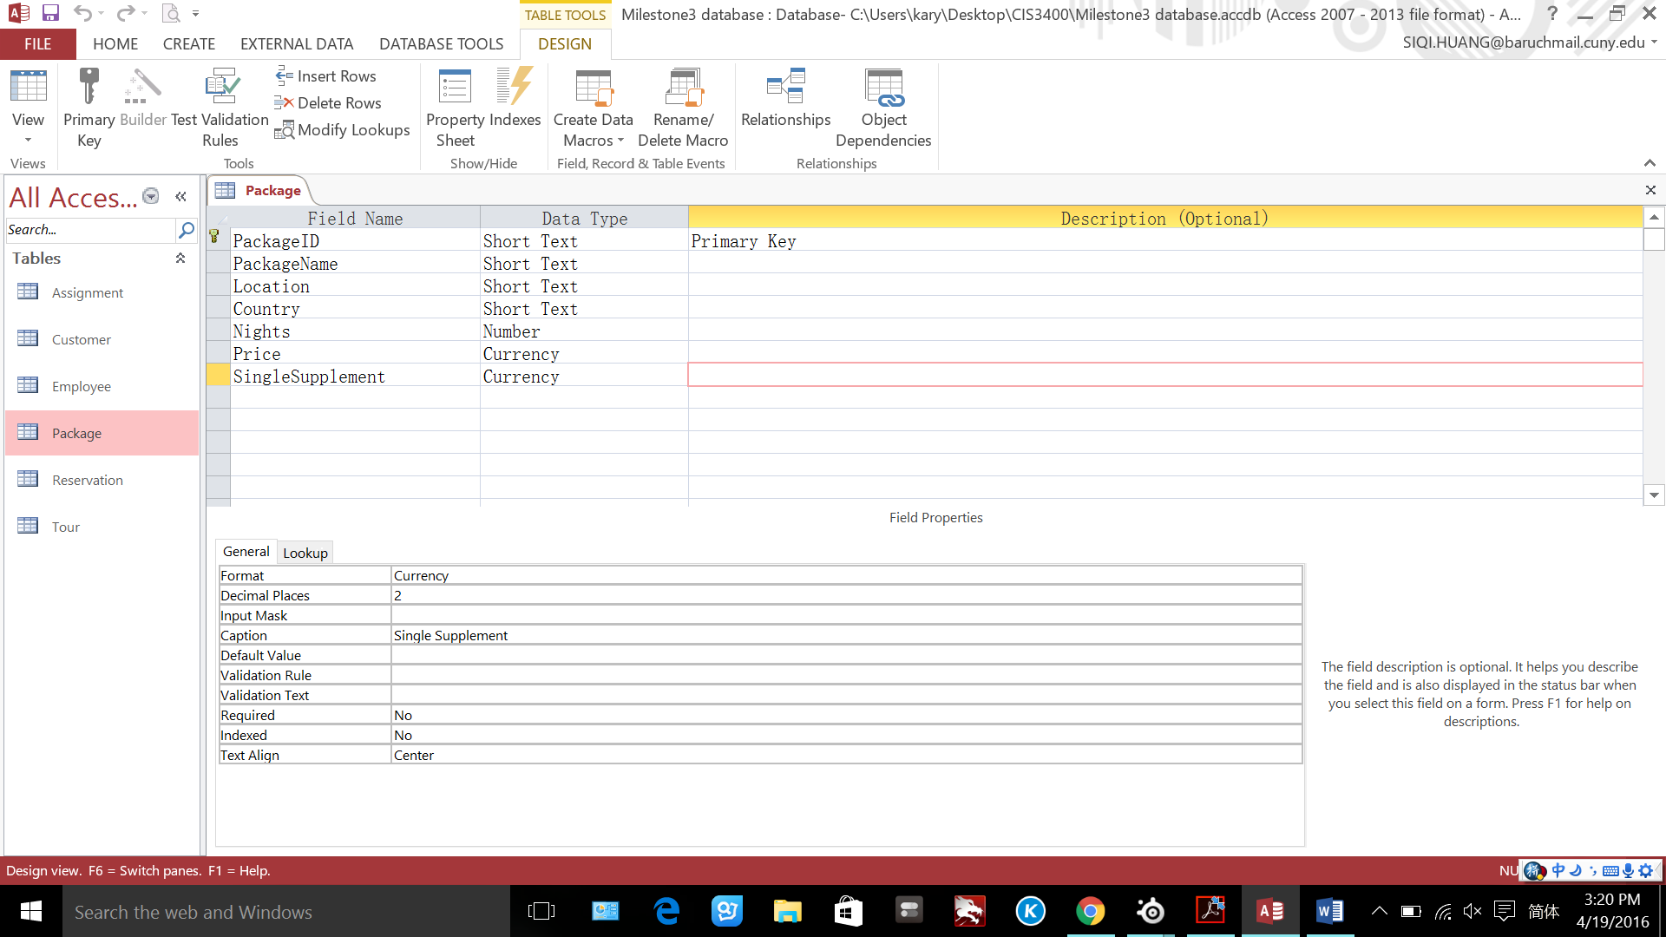

Reservation table – Design view

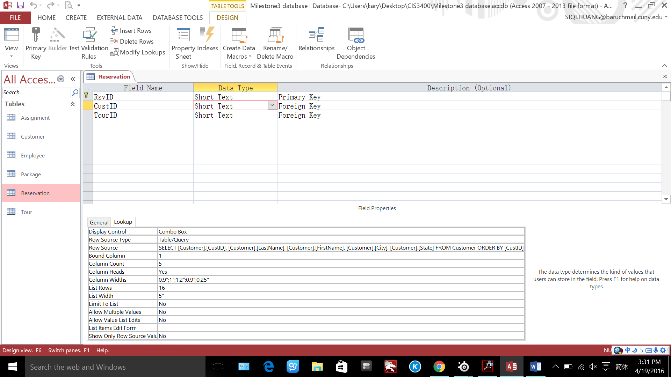

## **Tour table – Design view**

