ESRG vs SRG: Example Slices per Specific Objective
Every example is a slice of the BRISC 2025 test split, re-run with the study's frozen parameters. The DSC under each image equals the value recorded in outputs/evaluation/raw_results.csv (checked to 0.001 when the images were produced). Red fill is the predicted mask; the green outline is the radiologist ground truth.
Reproducing an example. Load the file named in each heading. Click positions are (row, col), 0-based, at the 512 px working scale, as in the GUI Seeds panel. Use Manual Seeding for SRG and Automated Seeding for ESRG (Objective 1); the Objective 2 ESRG image uses the same click as the first SRG image.
Selection note. These are best cases, chosen where ESRG reached DSC of at least 0.80 and SRG stayed low. They are not typical results. Over all 954 sampled slices the automatic-seeding means are DSC 0.148 for SRG and 0.319 for ESRG, ESRG scored more than 0.05 DSC below SRG on 44 slices, and when the automatic seed lands off the tumor ESRG averages only 0.025 (531 slices), as in the glioma slice you tested in the GUI.

Objective 1: Automatic seed selection
Problem: with manual seeding the result of the original SRG depends on where the operator clicks, so results are inconsistent (Section 3.4.1).
Shown: the original SRG from three different operator clicks inside the tumor, against ESRG with automatic seeding (no click needed).

Example 1.1: brisc2025_test_00287_me_ax_t1.jpg
meningioma, axial, test split; ground-truth area 28154 px.
ORIGINAL (brisc2025_test_00287_me_ax_t1.jpg):
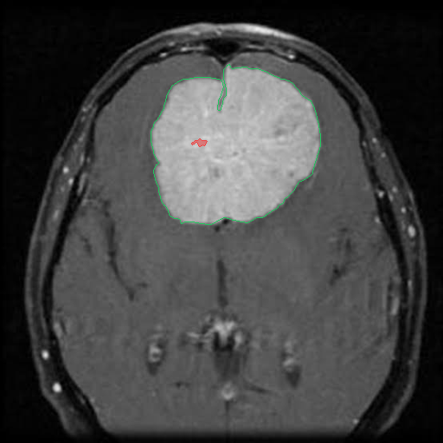  SRG, operator click 1  DSC: 0.007  click (row 166, col 231) | 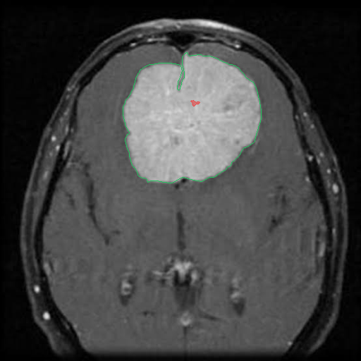  SRG, operator click 2  DSC: 0.004  click (row 147, col 275) | 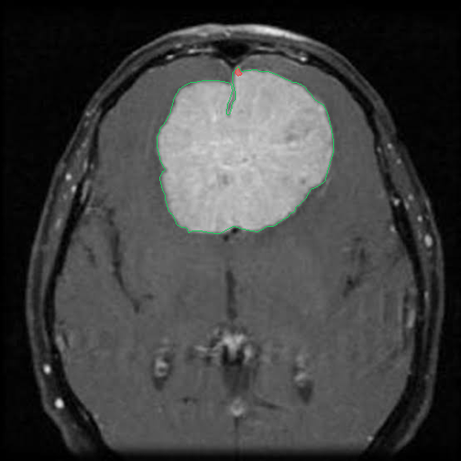  SRG, operator click 3  DSC: 0.004  click (row 81, col 264)
ENHANCED (brisc2025_test_00287_me_ax_t1.jpg):
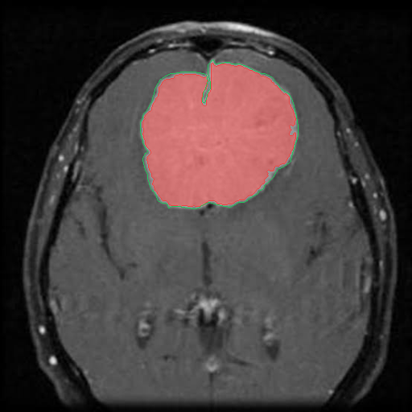
ESRG, automatic seed
DSC: 0.961
automatic seed

Example 1.2: brisc2025_test_00871_pi_co_t1.jpg
pituitary, coronal, test split; ground-truth area 6705 px.
ORIGINAL (brisc2025_test_00871_pi_co_t1.jpg):
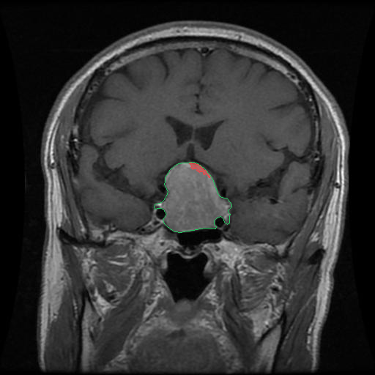  SRG, operator click 1  DSC: 0.060  click (row 232, col 272) | 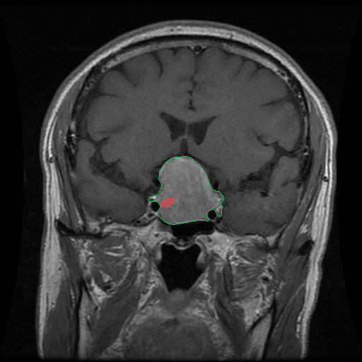  SRG, operator click 2  DSC: 0.048  click (row 287, col 234) | 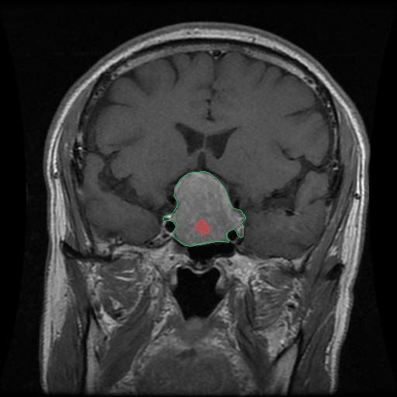  SRG, operator click 3  DSC: 0.071  click (row 287, col 261)
ENHANCED (brisc2025_test_00871_pi_co_t1.jpg):
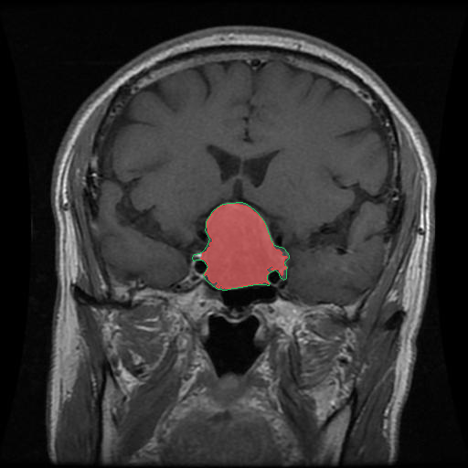
ESRG, automatic seed
DSC: 0.948
automatic seed

Example 1.3: brisc2025_test_00110_gl_co_t1.jpg
glioma, coronal, test split; ground-truth area 5666 px.
ORIGINAL (brisc2025_test_00110_gl_co_t1.jpg):
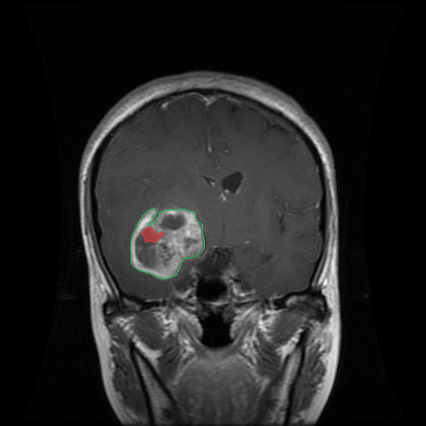  SRG, operator click 1  DSC: 0.105  click (row 285, col 183) | 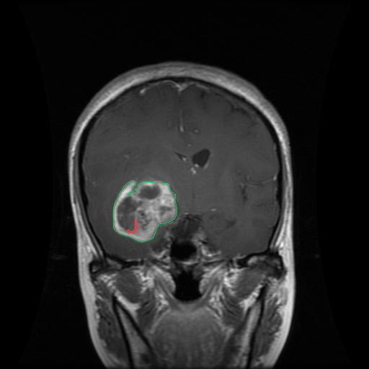  SRG, operator click 2  DSC: 0.038  click (row 321, col 178) | 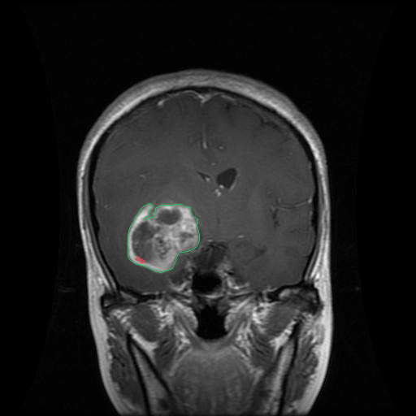  SRG, operator click 3  DSC: 0.018  click (row 321, col 174)
ENHANCED (brisc2025_test_00110_gl_co_t1.jpg):
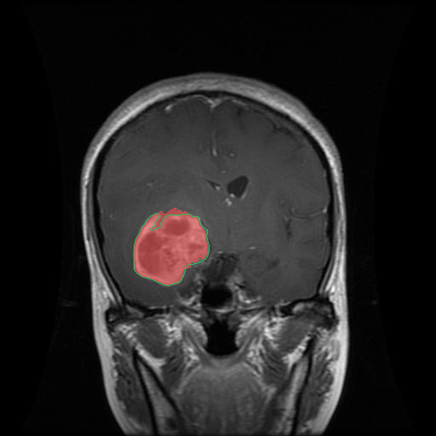
ESRG, automatic seed
DSC: 0.944
automatic seed

Objective 2: Log-domain transformation (undersegmentation)
Problem: the original SRG assumes uniform brightness across the image, causing undersegmentation (Section 3.4.2).
Shown: the original SRG from three different operator clicks, against ESRG from the same first click, so only the growing method differs.

Example 2.1: brisc2025_test_00407_me_co_t1.jpg
meningioma, coronal, test split; ground-truth area 5631 px.
ORIGINAL (brisc2025_test_00407_me_co_t1.jpg):
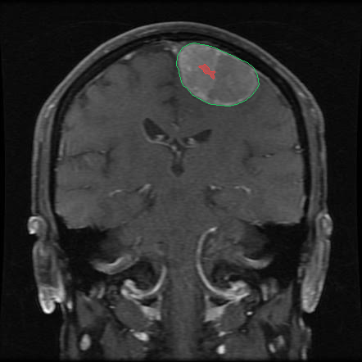  SRG, operator click 1  DSC: 0.052  click (row 87, col 251) | 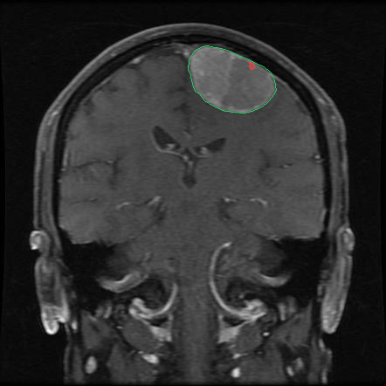  SRG, operator click 2  DSC: 0.017  click (row 76, col 288) | 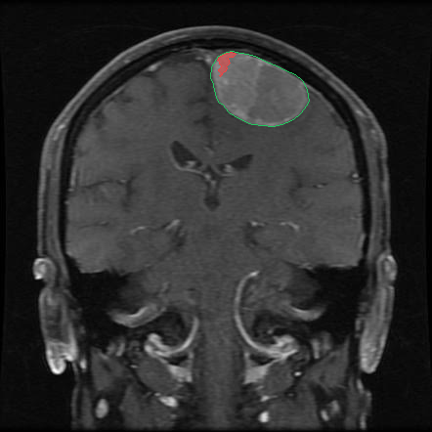  SRG, operator click 3  DSC: 0.078  click (row 64, col 232)
ENHANCED (brisc2025_test_00407_me_co_t1.jpg):
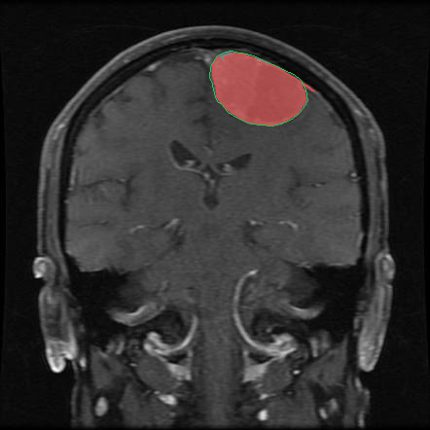
ESRG, operator click 1
DSC: 0.957
click (row 87, col 251)

Example 2.2: brisc2025_test_00717_pi_ax_t1.jpg
pituitary, axial, test split; ground-truth area 4654 px.
ORIGINAL (brisc2025_test_00717_pi_ax_t1.jpg):
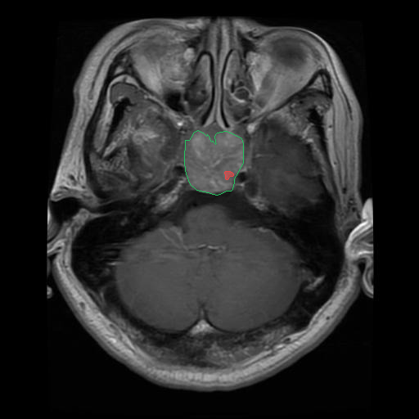  SRG, operator click 1  DSC: 0.038  click (row 213, col 280) | 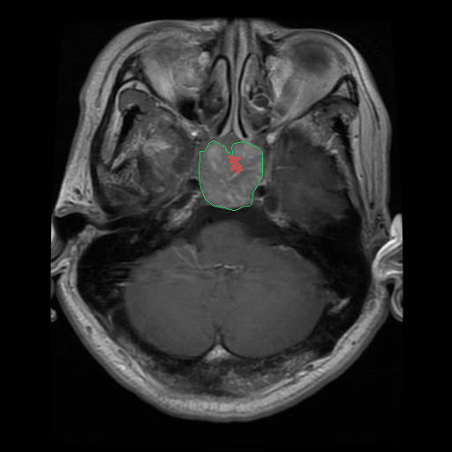  SRG, operator click 2  DSC: 0.077  click (row 191, col 271) | 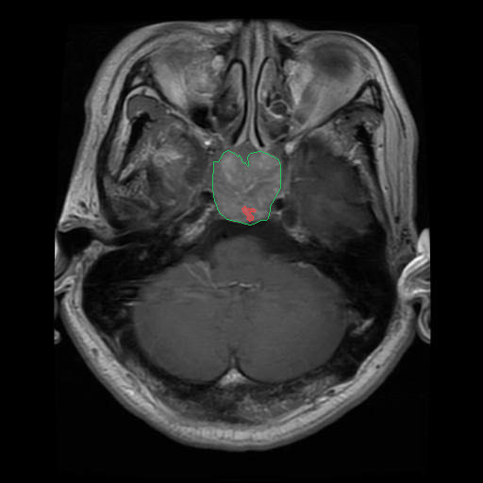  SRG, operator click 3  DSC: 0.055  click (row 223, col 263)
ENHANCED (brisc2025_test_00717_pi_ax_t1.jpg):
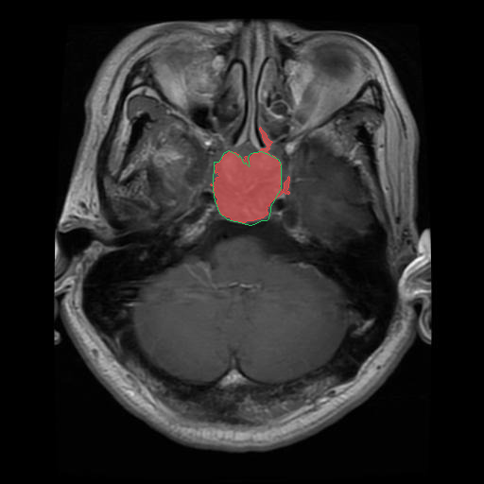
ESRG, operator click 1
DSC: 0.925
click (row 213, col 280)

Example 2.3: brisc2025_test_00019_gl_ax_t1.jpg
glioma, axial, test split; ground-truth area 10811 px.
ORIGINAL (brisc2025_test_00019_gl_ax_t1.jpg):
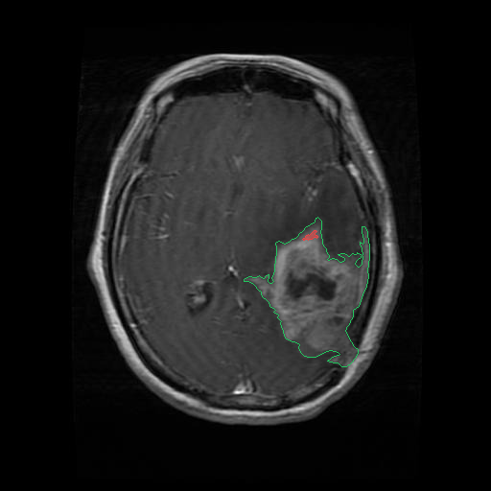  SRG, operator click 1  DSC: 0.017  click (row 247, col 321) | 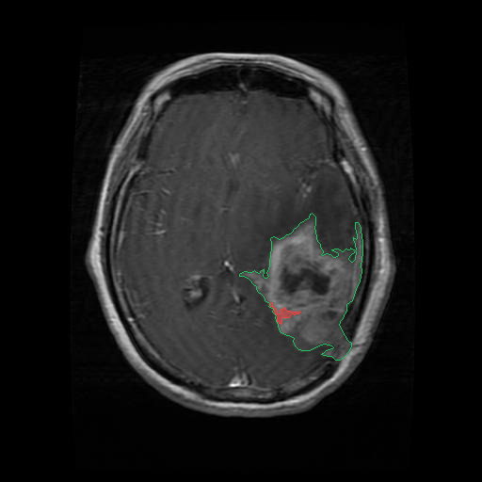  SRG, operator click 2  DSC: 0.043  click (row 334, col 301) | 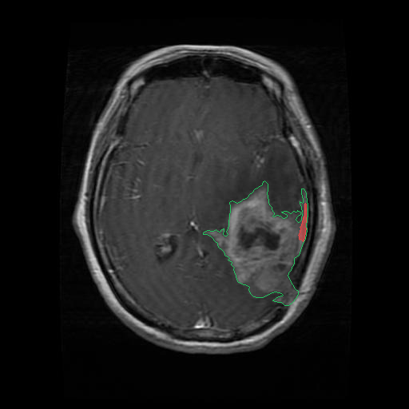  SRG, operator click 3  DSC: 0.048  click (row 294, col 376)
ENHANCED (brisc2025_test_00019_gl_ax_t1.jpg):
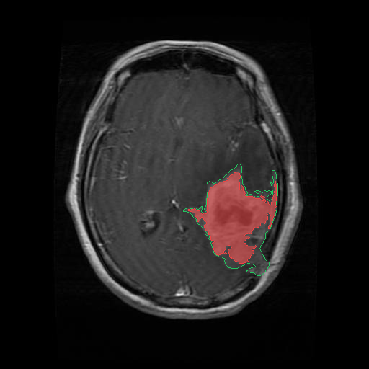
ESRG, operator click 1
DSC: 0.824
click (row 247, col 321)

Objective 3: Adaptive stopping criterion (boundary leakage)
Problem: region growing without a stopping rule leaks across weak boundaries (Section 3.4.3).
Shown: because the original SRG undersegments on this data instead of leaking (precision ≈ 0.99), the stopping criterion is shown by ablation. The same planted seed (one click at the deepest tumor pixel) is run with SRG, with ESRG with the stopping criterion turned off, and with full ESRG.

Example 3.1: brisc2025_test_00523_me_sa_t1.jpg
meningioma, sagittal, test split; ground-truth area 1768 px.
ORIGINAL vs ABLATION vs ENHANCED (brisc2025_test_00523_me_sa_t1.jpg); seed click (row 281, col 328):
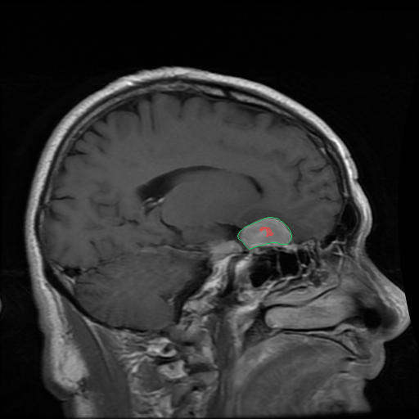  SRG, planted seed  DSC: 0.101  precision 1.000, recall 0.053 | 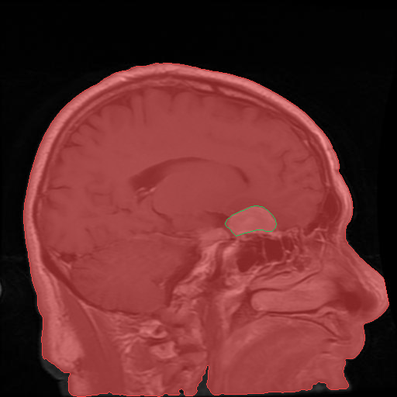  ESRG, stopping criterion OFF  DSC: 0.022  precision 0.011, recall 1.000 | 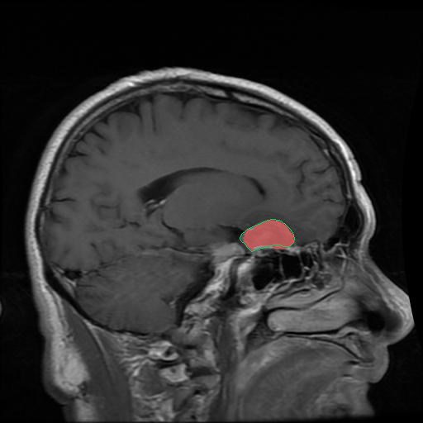  ESRG, full (stopping criterion ON)  DSC: 0.895  precision 0.965, recall 0.834

Example 3.2: brisc2025_test_00743_pi_ax_t1.jpg
pituitary, axial, test split; ground-truth area 3681 px.
ORIGINAL vs ABLATION vs ENHANCED (brisc2025_test_00743_pi_ax_t1.jpg); seed click (row 216, col 240):
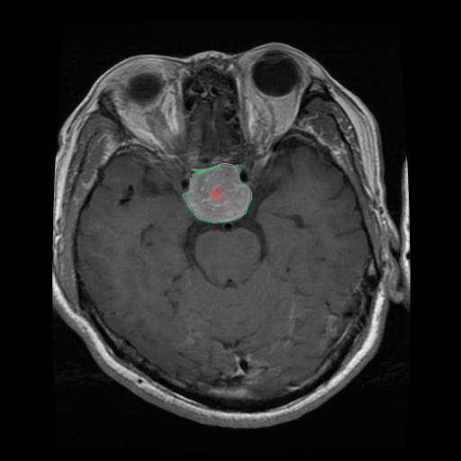  SRG, planted seed  DSC: 0.050  precision 1.000, recall 0.026 | 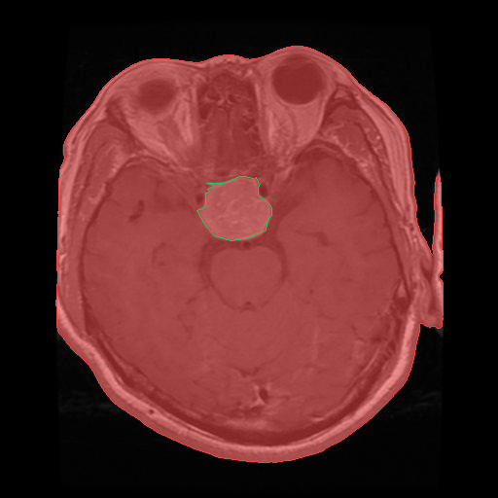  ESRG, stopping criterion OFF  DSC: 0.053  precision 0.027, recall 1.000 | 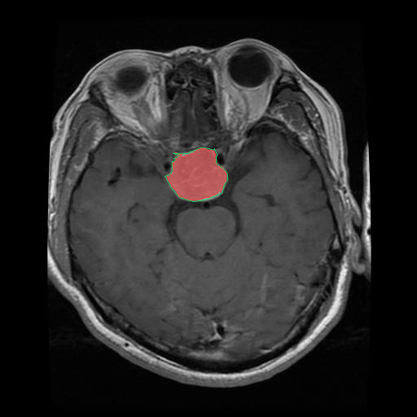  ESRG, full (stopping criterion ON)  DSC: 0.957  precision 0.997, recall 0.920

Example 3.3: brisc2025_test_00248_gl_sa_t1.jpg
glioma, sagittal, test split; ground-truth area 1995 px.
ORIGINAL vs ABLATION vs ENHANCED (brisc2025_test_00248_gl_sa_t1.jpg); seed click (row 158, col 261):
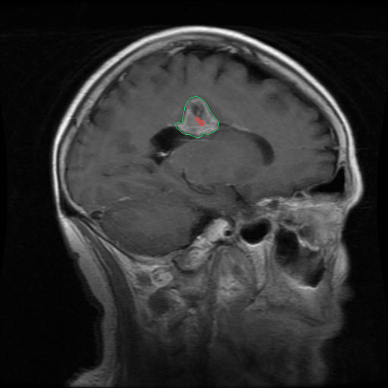  SRG, planted seed  DSC: 0.073  precision 1.000, recall 0.038 | 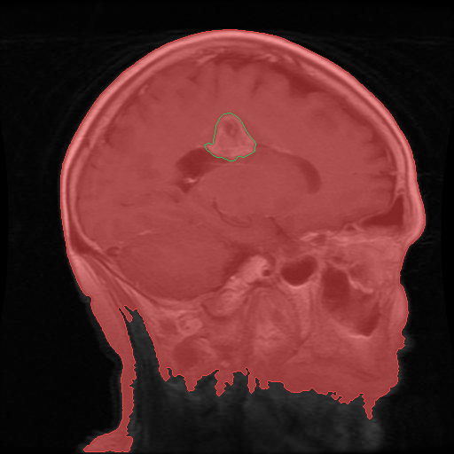  ESRG, stopping criterion OFF  DSC: 0.029  precision 0.015, recall 1.000 | 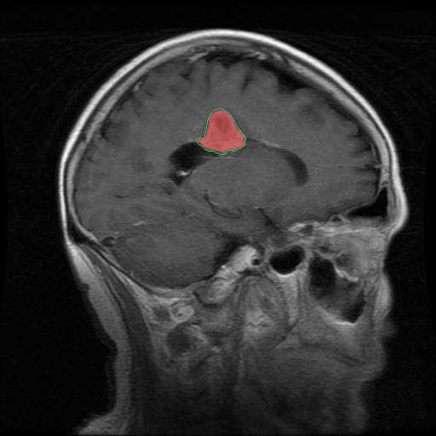  ESRG, full (stopping criterion ON)  DSC: 0.891  precision 1.000, recall 0.804

Summary for counter-checking
Obj. | Image file | Tumor / plane | Original / ablation DSC | ESRG DSC
1 | brisc2025_test_00287_me_ax_t1.jpg | meningioma / axial | 0.007, 0.004, 0.004 | 0.961
1 | brisc2025_test_00871_pi_co_t1.jpg | pituitary / coronal | 0.060, 0.048, 0.071 | 0.948
1 | brisc2025_test_00110_gl_co_t1.jpg | glioma / coronal | 0.105, 0.038, 0.018 | 0.944
2 | brisc2025_test_00407_me_co_t1.jpg | meningioma / coronal | 0.052, 0.017, 0.078 | 0.957
2 | brisc2025_test_00717_pi_ax_t1.jpg | pituitary / axial | 0.038, 0.077, 0.055 | 0.925
2 | brisc2025_test_00019_gl_ax_t1.jpg | glioma / axial | 0.017, 0.043, 0.048 | 0.824
3 | brisc2025_test_00523_me_sa_t1.jpg | meningioma / sagittal | 0.101, 0.022 | 0.895
3 | brisc2025_test_00743_pi_ax_t1.jpg | pituitary / axial | 0.050, 0.053 | 0.957
3 | brisc2025_test_00248_gl_sa_t1.jpg | glioma / sagittal | 0.073, 0.029 | 0.891

Objective 3 original / ablation DSC lists SRG first, then ESRG with the stopping criterion off.

