Chapter Four

RESULTS AND DISCUSSION

4.1 General Results
This chapter presents the evaluation of the Enhanced Seeded Region Growing (ESRG) algorithm against the original Seeded Region Growing (SRG) algorithm of Adams and Bischof (1994), which serves as the baseline control. The evaluation follows the three aspects that Udupa et al. (2006) identify for judging a segmentation method: its accuracy (how closely the result matches the ground truth), its precision in the sense of reproducibility (whether the same image always yields the same result), and its efficiency (the time it takes). The dataset and sampling design, the experimental configurations, the evaluation metrics, and the statistical tests are described in Chapter 3 (Sections 3.1 to 3.1.2, Tables 3.1 to 3.5) and are not repeated here.
The results are organized by the three specific objectives of the study: to provide an automatic seed selection option through Multi-Level Otsu Thresholding with connected-component filtering, evaluated by the seed hit rate and the variability between operators; to minimize undersegmentation by replacing the global-mean difference with a local difference measure computed in the log domain, making the criterion insensitive to multiplicative bias, evaluated by recall; and to decrease boundary leakage by integrating a stopping criterion that adapts to the intensity variability of the growing region, supported with a global drift guard, evaluated by precision, the leakage rate, and HD95. Overall delineation is summarized by the Dice Similarity Coefficient (DSC) and the success rate, and efficiency by the processing time per slice. All 21,942 runs (954 slices × 23 configurations) were produced by the automated evaluation pipeline, and none ended in an error; the per-slice results of every evaluation are listed in Appendices B to H.
Because the Shapiro–Wilk test rejected the normality of every paired difference (W = .389 to .960, all p < .001), configurations are compared with the Wilcoxon signed-rank test and paired rates with the exact McNemar test, as specified in Section 3.1.2. With 954 paired slices almost every difference is statistically significant, so the tables report the effect size r = Z/√N (Section 3.1.2), where |r| near .1, .3, and .5 indicates a small, medium, and large effect. The tables of Sections 4.2.1 to 4.2.3 add an Interpretation column that states, for each comparison, whether the Holm-adjusted p value is below .05 (significant), the size of the effect, and which configuration the result favors. Means and medians are reported without standard deviations because per-slice DSC is bounded and bimodal (Figure 4.1); the standard deviations, test statistics, and confidence intervals of every comparison are given in the appendix workbooks.

4.1.1 Overall Performance
Table 4.1 compares the two algorithms under automatic seeding, which is how the system operates without user input.
Table 4.1
Overall Performance of the Baseline and Enhanced Algorithm Under Automatic Seeding
 | SRG |  | ESRG
Metric | M | Mdn | M | Mdn | p | r
DSC | 0.148 | 0.000 | 0.319 | 0.052 | < .001 | .56
Precision | 0.442 | 0.000 | 0.386 | 0.028 | < .001 | −.13
Recall | 0.097 | 0.000 | 0.420 | 0.399 | < .001 | .64
HD95 (px) | 116.02 | 102.46 | 128.48 | 135.13 | .448 | −.02
Success rate (DSC ≥ 0.70) | 1.7% | — | 29.4% | — | < .001 | —
Leakage rate (|M| > 2|G|) | 1.5% | — | 27.5% | — | < .001 | —
Note. N = 954 paired slices under automatic seeding. p is from the Wilcoxon signed-rank test, or the exact McNemar test for the two rates, Holm-adjusted over the metrics of the comparison; r = Z/√N (Section 3.1.2) is positive when ESRG scored higher, an improvement for every metric except HD95, where lower is better. HD95 of an empty prediction is set to the image diagonal (Table 3.3; 11 ESRG slices). IoU, ASSD, standard deviations, and test statistics are given in Appendix F.
Under automatic seeding, mean DSC is 0.148 for SRG and 0.319 for ESRG (r = .56, p < .001), a large effect. The largest change is in recall, from 0.097 to 0.420 (r = .64, p < .001). The share of successfully segmented slices is 1.7% for SRG and 29.4% for ESRG: ESRG succeeded on 272 slices on which SRG failed, and the reverse happened on 8 (p < .001). Mean precision is 0.442 for SRG and 0.386 for ESRG (r = −.13, p < .001), and the leakage rate is 1.5% against 27.5% (p < .001). The enhanced algorithm is therefore significantly better at delineating the tumor, and the gain comes mainly from recall: it recovers about four times as much of the tumor. The lower precision and higher leakage rate do not mean that the baseline controls leakage better. Its background seeds surround the tumor seed and claim the neighboring tissue first, so its tumor region rarely grows: its median area is only 0.17 times the true tumor area under automatic seeding, against 0.82 for ESRG. The baseline avoids leakage by severely undersegmenting. Moreover, 210 of the 262 slices on which ESRG leaked (80.2%) started from a seed that was not entirely inside the tumor, so the region grew in the wrong tissue from the outset. On the 412 slices whose automatic seed hit the tumor, which both algorithms share, ESRG reaches a mean DSC of 0.707 against 0.335 and a mean recall of 0.727 against 0.216 (r = .85, p < .001). HD95 does not differ significantly (p = .448): both algorithms start from the same seed, so on the slices where that seed misses the tumor both boundaries are far from the true one, whichever algorithm grows the region. Sections 4.2.1 and 4.2.3 separate the contribution of seed placement from that of growth.
Table 4.2
Overall Performance of the Baseline and Enhanced Algorithm Under Planted Seeding
 | SRG |  | ESRG
Metric | M | Mdn | M | Mdn | p | r
DSC | 0.148 | 0.086 | 0.387 | 0.338 | < .001 | .53
Precision | 0.998 | 1.000 | 0.860 | 1.000 | < .001 | −.42
Recall | 0.092 | 0.045 | 0.416 | 0.376 | < .001 | .64
HD95 (px) | 43.08 | 38.37 | 54.72 | 28.35 | < .001 | −.16
Success rate (DSC ≥ 0.70) | 2.0% | — | 23.5% | — | < .001 | —
Leakage rate (|M| > 2|G|) | 0.0% | — | 14.4% | — | < .001 | —
Note. N = 954 paired slices under a seed planted inside the tumor. p is from the Wilcoxon signed-rank test, or the exact McNemar test for the two rates, Holm-adjusted over the metrics of the comparison; r = Z/√N (Section 3.1.2) is positive when ESRG scored higher, an improvement for every metric except HD95, where lower is better. HD95 of an empty prediction is set to the image diagonal (Table 3.3; 0 ESRG slices). IoU, ASSD, standard deviations, and test statistics are given in Appendix F.
Table 4.2 repeats the comparison with the seed planted inside the tumor on every slice, which isolates the region-growing procedure. Mean DSC is 0.148 for SRG and 0.387 for ESRG (r = .53, p < .001), and mean recall 0.092 against 0.416 (r = .64, p < .001). Mean precision is 0.998 for SRG and 0.860 for ESRG (r = −.42, p < .001), and median HD95 is 38.37 against 28.35 pixels (r = −.16, p < .001). With a correctly placed seed, the enhanced algorithm again delineates the tumor significantly better, with a large effect on DSC and recall. The baseline’s near-perfect precision reflects how little it grows: its median predicted area is 0.045 times the tumor area, so almost everything it absorbs is tumor but it misses most of the tumor. ESRG trades a moderate loss of mean precision (median 1.000) for a fourfold gain in recall, and its boundary lies closer to the true boundary on most slices (median HD95 28.35 against 38.37 pixels). Its mean HD95 is higher than its median because the 14.4% of slices that leak have large boundary errors.
Figure 4.1
Distribution of Per-Slice DSC for the Baseline and Enhanced Algorithm
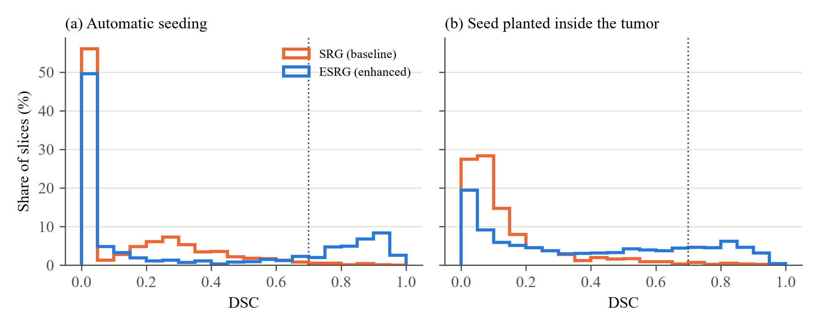
Note. Each curve is a histogram of the per-slice DSC of one configuration in bins of width 0.05, expressed as the percentage of the 954 sampled slices. The dotted line marks the success threshold of 0.70 (Table 3.3).
Figure 4.1 shows why medians and success rates are reported alongside means. Under automatic seeding, 43.4% of ESRG slices and 54.5% of SRG slices have a DSC of exactly zero, the slices on which the seed missed the tumor. ESRG then has a second cluster between 0.8 and 0.95, the slices on which its seed hit, whereas the baseline has almost no slice above 0.6. With a planted seed the zeros disappear for both algorithms (0.0% and 0.0%); ESRG spreads across the whole range while the baseline stays concentrated below 0.2. Because the distribution is bimodal, a mean summarizes it poorly, which is why medians, success rates, and rank-based tests are used throughout (Maier-Hein et al., 2024; Reinke et al., 2024).
Two checks confirm that these figures are not artifacts of the sampling design. Re-weighting the strata to their population shares (Section 3.1.1) changes no mean DSC, recall, or precision by more than 0.018, so the equal allocation does not distort the overall results. Slices drawn from the training split, on which the seed-ranking weights were tuned, did not score differently from test-split slices: under automatic seeding the mean DSC of ESRG is 0.313 on training slices (n = 791) and 0.349 on test slices (n = 163; Mann–Whitney p = .062), and with a planted seed 0.378 against 0.432 (p = .082). The training-split slices therefore show no advantage; if anything they score slightly lower, so the tuning of three ranking weights on that split did not inflate the results, and pooling the splits to reach the required sample size did not bias the evaluation in favor of the method.

4.2 Results per Objective

4.2.1 Objective 1: Automatic Seed Selection
The first problem is that the original algorithm relies on manual seed selection, so its output depends on where an operator places the seed (Adams & Bischof, 1994). The first objective is to provide an automatic seed selection option through Multi-Level Otsu Thresholding with connected-component filtering: multi-level Otsu thresholding isolates the brightest interior tissue, the connected components near the head outline are removed by the clearance filter, the remaining components are ranked, and the distance-transform core of the top-ranked component becomes the seed (Section 3.4.1). Two questions follow: whether the automatic seed lands in the tumor, and whether automation removes the dependence on the operator.
Table 4.3
Seed Hit Rate of the Automated Seed Selection
Group | No candidate | Hits / N_{S} | SHR | 95% CI | Distance Mdn, px | Interpretation
By tumor class
Glioma | 0 | 49 / 318 | 15.4% | [11.9, 19.8] | 107.4
Meningioma | 11 | 231 / 307 | 75.2% | [70.1, 79.7] | 0.0
Pituitary | 0 | 132 / 318 | 41.5% | [36.2, 47.0] | 44.1
All slices | 11 | 412 / 943 | 43.7% | [40.6, 46.9] | 42.0 | Class differences: Significant
By imaging plane
Axial | 8 | 138 / 310 | 44.5% | [39.1, 50.1] | 32.6
Coronal | 0 | 165 / 318 | 51.9% | [46.4, 57.3] | 0.0
Sagittal | 3 | 109 / 315 | 34.6% | [29.6, 40.0] | 81.5 | Plane differences: Significant
Note. Configuration A_ESRG; each class and each plane holds 318 slices. A hit is a slice whose whole seed core lies inside the tumor (Table 3.3); N_{S} counts the slices that received a seed, and “No candidate” those for which the selector reported no tumor instead of guessing. The 95% CI is the Wilson score interval (Section 3.1.2). Distance is the seed distance (Table 3.3), 0 when the seed centroid lies inside the tumor. Class differences: χ²(2, N = 943) = 228.25, p < .001, Cramér’s V = .49; plane differences: χ²(2, N = 943) = 19.34, p < .001, V = .14.
Figure 4.2
Seed Hit Rate of the Automated Seed Selection by Tumor Class and Imaging Plane
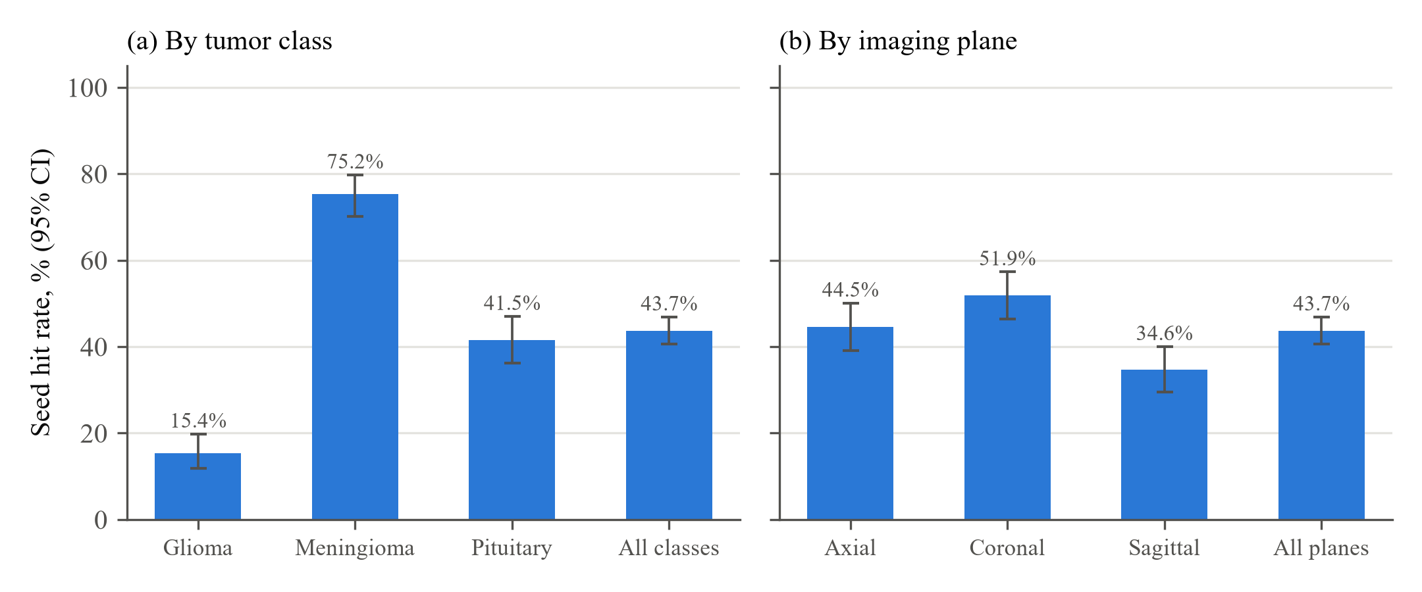
Note. Bars are the seed hit rates of Table 4.3; error bars are Wilson 95% confidence intervals (Section 3.1.2).
Table 4.3 and Figure 4.2 show that the automatic seed lies entirely inside the tumor on 412 of 943 seeded slices, a seed hit rate of 43.7% (95% CI [40.6, 46.9]); on 11 slices the selector reported no tumor candidate instead of guessing. Reliability depends strongly on the tumor class (χ²(2) = 228.25, p < .001, Cramér’s V = .49, a large association). The seed hits 75.2% of meningiomas, whose bright, compact, well-circumscribed enhancement places them clearly in the highest interior intensity class, consistent with intensity-based seeding results in the literature (Biratu et al., 2021); its median seed distance is 0.0 pixels, that is, the seed centroid lies inside the tumor. Reliability is lower for pituitary tumors (41.5%), which sit centrally among normal structures of similar brightness, and lowest for gliomas (15.4%, median distance 107.4 pixels), whose heterogeneous, often weakly enhancing tissue is frequently not the brightest structure in the head (Tohka, 2014). The imaging plane matters much less (χ²(2) = 19.34, p < .001, V = .14, a small association): coronal slices give the highest rate (51.9%) and sagittal slices the lowest (34.6%). When the seed misses, it usually lands on a different structure altogether rather than just outside the tumor edge, as the large seed distances show.
The seed outcome decides the result. When the seed lands in the tumor (412 slices), ESRG reaches a median DSC of 0.814 and succeeds on 67.7% of slices; when it misses or no seed is produced (542 slices), the median DSC is 0.000 and 0.2% succeed (Mann–Whitney p < .001, rank-biserial r = .98). Of the 262 slices on which ESRG leaked under automatic seeding, 210 started from a seed that was not entirely inside the tumor, so most leakage under automatic seeding is a consequence of a misplaced seed rather than of the stopping criterion.
Table 4.4
Variability of the Result Across Five Simulated Operators
 | Within-slice SD of DSC |  | Inconsistency rate
Tumor class | SRG | ESRG | SRG | ESRG | Interpretation of the SD
Glioma | 0.042 | 0.177 | 0.9% | 25.2% | Significant, large effect; favors SRG (smaller SD)
Meningioma | 0.044 | 0.229 | 0.9% | 68.9% | Significant, large effect; favors SRG (smaller SD)
Pituitary | 0.066 | 0.262 | 2.2% | 56.0% | Significant, large effect; favors SRG (smaller SD)
All classes | 0.051 | 0.223 | 1.4% | 50.0% | Significant, large effect; favors SRG (smaller SD)
Note. Each slice was segmented from five simulated operator clicks at random tumor pixels (Section 3.1). The within-slice SD is the standard deviation of the five DSC values of a slice, averaged over slices; the inconsistency rate is the share of slices on which some clicks succeed (DSC ≥ 0.70) and others fail. The automatic seed is deterministic, so both measures are zero under automatic seeding.
Figure 4.3
Within-Slice Variability of DSC Across Five Simulated Operators
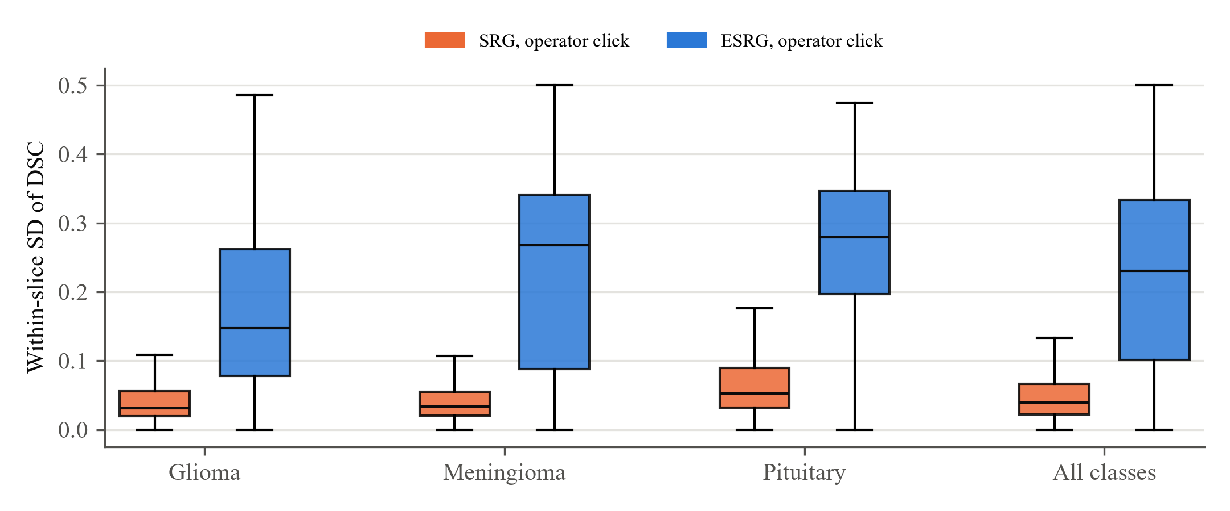
Note. Boxes show the distribution over slices of the within-slice standard deviation of DSC; whiskers extend to 1.5 interquartile ranges, outliers are not drawn. The automatic seed has a within-slice standard deviation of zero on every slice.
Table 4.4 and Figure 4.3 address the consistency that Objective 1 targets. With five equally valid operator clicks inside the same tumor, the DSC of the original algorithm varies with a mean within-slice SD of 0.051, and that of the enhanced grower with 0.223. On 50.0% of slices, whether the enhanced grower succeeded depended on which operator clicked, and on 1.4% for the baseline. The automatic seed, in contrast, produced identical masks in both independent runs on 180 of 180 slices for ESRG and 180 of 180 for SRG, so its within-slice variability and inconsistency rate are zero. Two findings follow. First, the original algorithm appears consistent only because it consistently undersegments: its mean DSC over the five operators is 0.122, so its results cannot vary much. Second, the enhanced grower is far more sensitive to where the seed is placed (p < .001, r = .82): because its stopping bound is derived from the statistics of the seed region (Equations 3.9 and 3.10), a click on a slightly brighter or more heterogeneous part of the tumor produces a different bound and a different result. This confirms the problem stated for Objective 1, that manual seeding makes the output depend on the operator (Adams & Bischof, 1994; Fan et al., 2005), and it is exactly the variability that the automated seed removes: with no operator input, the same slice always yields the same seed and the same mask. The cost of automation is measured by comparing the automatic result with the average of the five operator results for the same grower. Over all slices the operators do better (mean DSC 0.374 against 0.319; p < .001, r = −.17), but this difference comes from glioma (0.217 against 0.098, p < .001), where the automatic seed seldom reaches the tumor. For meningioma (0.556 against 0.550, p = .290) and pituitary tumors (0.350 against 0.310, p = .066), the automatic seed performs as well as the average operator who clicks correctly inside the tumor, without any operator input and with no variability. The automatic seed also outperforms the original algorithm seeded by an operator (r = .28, p < .001).
Table 4.5
Failure Attribution of the Enhanced Algorithm Under Automatic Seeding (Experiment E5)
Bucket | Glioma | Meningioma | Pituitary | All classes
C – Seed chose wrong structure (Stage 5) | 87 (27.4%) | 60 (18.9%) | 131 (41.2%) | 278 (29.1%)
G – Success | 15 (4.7%) | 175 (55.0%) | 86 (27.0%) | 276 (28.9%)
B – Tumor absent from candidates (Stage 4) | 184 (57.9%) | 15 (4.7%) | 42 (13.2%) | 241 (25.3%)
E – Growth undersegmented (Stage 6 measure) | 12 (3.8%) | 25 (7.9%) | 38 (11.9%) | 75 (7.9%)
D – Growth leaked (Stage 6 stopping) | 16 (5.0%) | 25 (7.9%) | 9 (2.8%) | 50 (5.2%)
A – Head mask lost tumor (Stage 2) | 3 (0.9%) | 3 (0.9%) | 12 (3.8%) | 18 (1.9%)
X – False no-candidate flag | 0 (0.0%) | 11 (3.5%) | 0 (0.0%) | 11 (1.2%)
F – Post-processing hurt result (Stage 7) | 1 (0.3%) | 4 (1.3%) | 0 (0.0%) | 5 (0.5%)
Total | 318 | 318 | 318 | 954
Note. Number (and percentage) of slices in each bucket. Each slice is assigned to the first gate it fails, in the order of Table 3.4. Class differences in the distribution over G, B, C, and the remaining buckets: χ²(6, N = 954) = 385.89, p < .001, V = .45.
Table 4.5 locates the remaining failures of the automatic pipeline by assigning each slice to the first stage it fails (Table 3.4). Successful slices (bucket G) make up 28.9% of the sample. Most failures occur before region growing begins: on 29.1% of slices a candidate containing the tumor existed but a different structure was ranked first (C), and on 25.3% the tumor never entered the highest intensity class (B). Together with the false no-candidate flags (X), seeding accounts for 55.6% of slices, whereas leakage (D) and undersegmentation (E) during growth account for only 13.1%. The pattern differs by class (χ²(6) = 385.89, p < .001, V = .45). For gliomas the dominant failure is B (57.9%): weakly enhancing tumor tissue falls below the uppermost Otsu threshold. For pituitary tumors it is C (41.2%): the tumor is a candidate, but a brighter neighboring structure is ranked above it. For meningioma, 55.0% of slices succeed. The automated seed selection is therefore the component that limits the fully automatic pipeline, and the manual seeding option remains necessary for pituitary tumors and gliomas.

4.2.2 Objective 2: Minimization of Undersegmentation
The second problem is that the original algorithm evaluates each candidate pixel against the mean of the entire region rather than its local neighborhood, so it implicitly assumes that the region is intensity-homogeneous; under MRI intensity non-uniformity, pixels of the same tissue deviate from that global mean and are left out, causing undersegmentation. In this study, undersegmentation is the failure of region growing to cover the full extent of the tumor, so that part of the ground-truth tumor is left outside the segmented region even though the seed lies inside it; it is measured by recall (Table 3.3). The second objective is to minimize undersegmentation by replacing the global-mean difference with a local difference measure computed in the log domain, making the criterion insensitive to multiplicative bias: each candidate is compared with the nearby absorbed pixels (Equation 3.8) on the log-intensity scale (Equation 3.6). To exclude the influence of seed placement, the seed is planted inside the tumor, and the full enhanced grower is compared with the baseline and with two ablated versions: one with the global measure restored, and one with the log transform switched off.
Table 4.6
Recall of the Baseline, the Ablated Variants, and the Full Enhanced Algorithm With a Planted Seed
Configuration | Glioma | Meningioma | Pituitary | All classes | Interpretation
Recall M
SRG (baseline) | 0.078 | 0.069 | 0.128 | 0.092
ESRG, global measure | 0.187 | 0.168 | 0.116 | 0.157
ESRG, log transform off | 0.398 | 0.325 | 0.252 | 0.325
ESRG (full) | 0.439 | 0.506 | 0.304 | 0.416
Full ESRG vs. reference, r
SRG (baseline) | .60 | .79 | .46 | .64 | Significant, large effect; favors full ESRG
ESRG, global measure | .75 | .83 | .78 | .79 | Significant, large effect; favors full ESRG
ESRG, log transform off | .22 | .58 | .36 | .40 | Significant, medium effect; favors full ESRG
Note. Recall (Table 3.3) is the share of the true tumor recovered. All four configurations start from the same planted click, so each difference is due to the growing procedure alone. r is the effect size of the Wilcoxon signed-rank test of full ESRG against the named configuration (positive = full ESRG recovered more); after Holm adjustment over the three comparisons within each class, every p is < .001.
Table 4.6 shows that the full enhanced grower recovers a mean 0.416 of the tumor, against 0.092 for the baseline (r = .64, p < .001). In other words, the share of the tumor left unsegmented falls from 90.8% to 58.4%. The ablations isolate the two parts of the enhancement. Restoring the global measure lowers mean recall to 0.157 (r = .79, p < .001), and switching off the log transform lowers it to 0.325 (r = .40, p < .001). The local comparison is the larger of the two contributions: with everything else held fixed, it improved recall on 786 slices and lowered it on 44, a large effect in every class. The log transform adds a medium effect (540 slices improved, 242 worse), and it does so without a loss of precision (0.861 without it against 0.860 with it, p = .424), raising mean DSC from 0.275 to 0.387. In the log domain the tolerance σ_{A} is effectively relative to the intensity level, so the same bound admits proportionally similar variations at any brightness. The local measure costs some precision (0.957 to 0.860), but its recall gain is far larger and mean DSC doubles, from 0.193 to 0.387. The share of slices on which at least half of the tumor is recovered rises from 2.5% for the baseline to 40.5%. This directly addresses the second problem: replacing the global-mean difference with a local comparison in the log domain substantially reduces undersegmentation (Akram et al., 2017; Li et al., 2011). Recall nevertheless remains moderate in absolute terms, lowest for pituitary tumors (0.304). Growth ended at the maximum of four passes on 796 of the 954 planted slices (83.4%), so the region was usually still growing when the pass limit was reached, and the small purified seed yields a tight initial bound (Table 4.10).
Table 4.7
Recall With and Without a Synthetic 40% Bias Field
Configuration | Recall M, no bias | Recall M, bias field | Change | p | Interpretation
SRG | 0.092 | 0.092 | +0.000 | .726 | Not significant
ESRG, global measure | 0.157 | 0.160 | +0.003 | < .001 | Significant, small effect; recall higher with the field
ESRG, log off | 0.325 | 0.318 | −0.007 | .726 | Not significant
ESRG (full) | 0.416 | 0.415 | −0.001 | .726 | Not significant
SRG + N4 | — | 0.092 | — | — | —
Note. Same slices and planted seeds; only the bias field of Section 3.1 differs. Each configuration is compared with itself without the field (Wilcoxon signed-rank test, Holm-adjusted over the four configurations). N4 was applied only under the field; against plain SRG on the biased slices, p = .159.
Table 4.7 tests the insensitivity to multiplicative bias that the log-domain measure is designed to provide. With the 40% field, the mean recall of full ESRG changes from 0.416 to 0.415 (p = .726), and that of the baseline from 0.092 to 0.092 (p = .726). Full ESRG on biased slices still recovers far more of the tumor than SRG with N4 correction (0.415 against 0.092; r = .64, p < .001). Neither full ESRG, nor ESRG without the log transform, nor the baseline changed significantly under the field (Holm-adjusted p = .726 or above); individual slices moved by a mean of 0.048 in recall for full ESRG, but in both directions. Only the global-measure variant changed significantly, by 0.003 (p < .001), a statistically detectable but practically negligible amount, and N4 correction did not change the baseline (p = .159). The field used here is smooth: across a tumor of median size (about 65 pixels in diameter) it changes the intensity by only about 3.6%, which is small compared with the natural heterogeneity of the tumor. The experiment therefore shows that ESRG is robust to a field of this size, rather than that the baseline is harmed by it; the gains of Objective 2 in Table 4.6 appear on the original slices and come from comparing each pixel with its own neighborhood on a relative scale.

4.2.3 Objective 3: Decrease of Boundary Leakage
The third problem is that the original algorithm absorbs the next candidate pixel from the sequentially sorted list unconditionally, so growth crosses weak boundaries and floods the surrounding tissue. The third objective is to decrease boundary leakage by integrating a stopping criterion that adapts to the intensity variability of the growing region, supported with a global drift guard: a pixel is absorbed only while its local difference stays within a bound proportional to the region’s own standard deviation, and a global drift guard rejects pixels that stray too far from the region mean, with both bounds frozen within each pass (Equations 3.9 to 3.11). To isolate the criterion, the enhanced grower was run with and without it from the same planted seed; without it, pixels are absorbed unconditionally, as in the original algorithm.
Table 4.8
Precision and Leakage Rate With and Without the Adaptive Stopping Criterion
 | Precision M |  |  | Leakage rate
Tumor class | No stopping | Adaptive | r | No stopping | Adaptive | Interpretation
Glioma | 0.050 | 0.676 | .86 | 99.4% | 34.3% | Precision: Significant, large effect; leakage: Significant
Meningioma | 0.085 | 0.949 | .86 | 96.5% | 4.4% | Precision: Significant, large effect; leakage: Significant
Pituitary | 0.053 | 0.953 | .85 | 96.5% | 4.4% | Precision: Significant, large effect; leakage: Significant
All classes | 0.063 | 0.860 | .86 | 97.5% | 14.4% | Precision: Significant, large effect; leakage: Significant
Note. Both configurations use the local log-domain measure and the same planted seed; only the stopping criterion differs. Precision (Table 3.3) was compared with the Wilcoxon signed-rank test and the leakage rate (Table 3.3; predicted area more than twice the true area) with the exact McNemar test; every p is < .001.
Figure 4.4
Leakage Rate With and Without the Adaptive Stopping Criterion
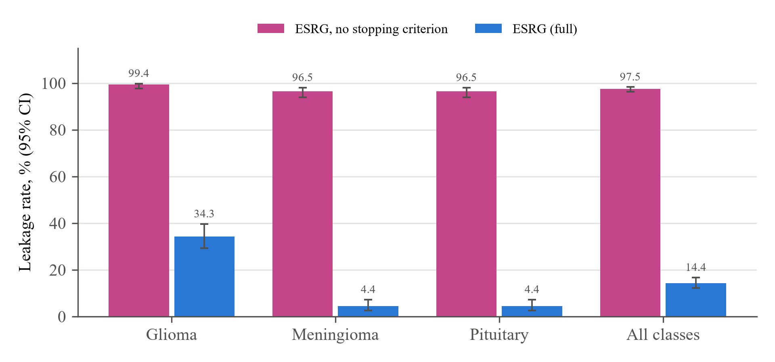
Note. Planted seed. A slice leaks when its predicted area exceeds twice the ground-truth area (Table 3.3). Error bars are Wilson 95% confidence intervals.
Table 4.8 and Figure 4.4 show the effect of the stopping criterion. Without it, the region leaks on 97.5% of slices, its median area is 37.00 times the true tumor area, and mean precision is 0.063. With it, the leakage rate falls to 14.4% and the median area ratio to 0.38: the criterion removed the leak on 793 slices and introduced it on none (p < .001). Mean precision rises to 0.860 (r = .86, p < .001). The improvement in precision is large and significant in every class (r from .85 to .86). The median precision with the criterion is 1.000, meaning that on most slices every absorbed pixel is tumor. The criterion also raises mean DSC from 0.073 to 0.387, although recall falls from 0.976 to 0.416, because unconditional growth covers the tumor only by covering the whole head. This directly addresses the third problem: the adaptive stopping criterion and its drift guard prevent the flooding caused by unconditional absorption, in the same way that confidence-connected region growing bounds a region by its own statistics (Insight Software Consortium, n.d.). Leakage is not eliminated. Glioma remains the most affected class (34.3% leakage, mean precision 0.676), because its infiltrative margin has no sharp intensity step at which the bound can stop growth. The baseline shows no leakage with a planted seed (0.0%), but, as noted in Section 4.1.1, it achieves this by stopping far inside the tumor (median area ratio 0.045).
Table 4.9
HD95 of the Baseline, the Enhanced Algorithm Without Stopping, and the Full Enhanced Algorithm
 | HD95 Mdn [IQR], pixels
Tumor class | SRG | ESRG, no stopping | ESRG (full) | Interpretation
Glioma | 45.8 [29.6, 66.1] | 254.8 [211.0, 294.0] | 58.3 [30.7, 156.1] | Significant vs. SRG (medium effect, favors SRG); significant vs. no stopping (large effect, favors full ESRG)
Meningioma | 42.5 [29.9, 53.9] | 252.0 [216.3, 307.0] | 19.8 [11.4, 34.5] | Significant vs. SRG (large effect, favors full ESRG); significant vs. no stopping (large effect, favors full ESRG)
Pituitary | 30.5 [21.8, 42.2] | 248.6 [229.9, 266.8] | 23.4 [15.7, 37.1] | Significant vs. SRG (small effect, favors full ESRG); significant vs. no stopping (large effect, favors full ESRG)
All classes | 38.4 [26.1, 53.1] | 250.3 [222.0, 284.2] | 28.3 [16.0, 55.1] | Significant vs. SRG (small effect, favors full ESRG); significant vs. no stopping (large effect, favors full ESRG)
Note. Planted seed. HD95 (Table 3.3) in pixels at the working resolution; lower is better. Full ESRG was compared with each reference by the Wilcoxon signed-rank test, Holm-adjusted within each row; every p is < .001. Full ESRG has the smaller HD95 against both references in every class except against SRG for glioma. ASSD gives the same pattern (Appendix E).
Table 4.9 evaluates the boundary itself. The median HD95 of full ESRG is 28.35 pixels, against 250.28 without the stopping criterion (r = −.85, p < .001) and 38.37 for the baseline (r = −.16, p < .001). Without the stopping criterion the boundary lies, at its 95th percentile, a median of 250 pixels from the true boundary, about half the width of a 512-pixel slice, so the criterion reduces the boundary error by roughly an order of magnitude. Against the baseline, the full enhanced algorithm places the boundary closer on most slices overall; by class, it is clearly better for meningioma (median HD95 19.84 against 42.49 pixels) and pituitary tumors (23.45 against 30.48), but worse for glioma (58.28 against 45.77), where the slices that leak carry their boundary into the surrounding tissue. A boundary metric is needed to see this, since overlap metrics alone do not reveal where the errors lie (Reinke et al., 2024; Taha & Hanbury, 2015).
Table 4.10
Effect of Seed Purification on the Enhanced Algorithm With a Planted Seed
Metric | Click disk | Purified core | r | Interpretation
DSC | 0.486 | 0.387 | −.46 | Significant, medium effect; favors the click disk
Recall | 0.659 | 0.416 | −.76 | Significant, large effect; favors the click disk
Precision | 0.701 | 0.860 | .55 | Significant, large effect; favors the purified core
Success rate (DSC ≥ 0.70) | 36.5% | 23.5% | — | Significant; favors the click disk
Leakage rate (|M| > 2|G|) | 30.5% | 14.4% | — | Significant; favors the purified core
Note. Means and rates of P_ESRG_nopurify (the click disk used directly) and P_ESRG (the disk reduced to its core, the default in manual mode). r is positive when the purified core scored higher (Wilcoxon signed-rank test; rates: exact McNemar test); after Holm adjustment, every p is < .001.
Table 4.10 examines the seed size, which sets the first stopping bound. Purifying the planted click shrinks it from a median of 29 to 5 pixels, and its initial σ_{A} from 0.0447 to 0.0253; on 39.4% of slices the noise floor, not the seed, then sets the bound. A seed of a few pixels has a very small spread, so the resulting bound is tight and growth stops before the tumor edge. Purification halves the leakage rate (30.5% to 14.4%) and raises precision (0.701 to 0.860), but it lowers recall (0.659 to 0.416) and mean DSC (0.486 to 0.387); the larger click disk gives a looser bound that reaches further (success 36.5% against 23.5%) but leaks more often. The seed size therefore controls the balance between the two growth objectives: purification favors Objective 3, and the unpurified disk favors Objective 2.

4.2.4 Overall Delineation Quality and Class-Dependent Performance
Combining the three enhancements, Table 4.11 reports the median DSC by tumor class for both algorithms under both seeding conditions, with the share of successfully segmented slices.
Table 4.11
Dice Similarity Coefficient by Tumor Class
 | Automatic seed |  |  | Planted seed
Tumor class | SRG | ESRG | r | SRG | ESRG | r
Glioma | 0.000 (0.6%) | 0.000 (5.0%) | .38 | 0.075 (1.6%) | 0.127 (6.3%) | .27
Meningioma | 0.230 (1.6%) | 0.759 (56.0%) | .71 | 0.068 (0.9%) | 0.663 (46.5%) | .77
Pituitary | 0.000 (2.8%) | 0.000 (27.0%) | .52 | 0.133 (3.5%) | 0.351 (17.6%) | .41
All classes | 0.000 (1.7%) | 0.052 (29.4%) | .56 | 0.086 (2.0%) | 0.338 (23.5%) | .53
Note. Values are the median DSC with the success rate (DSC ≥ 0.70) in parentheses. r = Z/√N (Section 3.1.2) is the effect size of the Wilcoxon signed-rank test of ESRG against SRG under the same seeding; after Holm adjustment over the three classes every p is < .001. DSC of ESRG differs across classes under automatic seeding, H(2) = 185.09, p < .001, and planted seeding, H(2) = 172.07, p < .001 (Kruskal–Wallis).
Table 4.11 shows three distinct outcomes. Meningioma is delineated reliably and automatically: its median DSC improves from 0.230 to 0.759 (p < .001, r = .71), and 56.0% of slices are segmented successfully without any user input. Pituitary tumors improve significantly (p < .001), and their success rate rises from 2.8% to 27.0%, but their median DSC under automatic seeding stays at 0.000 because the seed lands in the tumor on 41.5% of slices; with a planted seed their median rises to 0.351, so for these tumors the manual seeding mode is the practical option. Glioma is the most difficult class: the enhanced algorithm is significantly better under both seeding conditions, but its median DSC remains low (0.000 automatic, 0.127 planted). The heterogeneous, infiltrative appearance of glioma provides no sharp boundary for an intensity-based method to follow, which limits both recall and precision. The tumor class explains a substantial share of the variation in DSC (ε² = .19 under automatic and .18 under planted seeding).
By imaging plane (Appendix F), the plane has a statistically significant but small effect under automatic seeding (ε² = .02) and no significant effect with a planted seed (p = .616). The plane therefore affects where the automatic seed lands rather than how the region grows. The clearest example is automatic seeding of pituitary tumors, whose coronal slices reach a median DSC of 0.465 against 0.000 on axial and 0.000 on sagittal slices, in line with the higher coronal seed hit rate: the pituitary gland is easier to separate from neighboring bright structures on coronal views.
Table 4.12
Contribution of Each Enhancement With a Planted Seed
Configuration | DSC M | Success | Leakage | Mean rank | r vs. full
ESRG (full) | 0.387 | 23.5% | 14.4% | 1.70 | —
Global measure | 0.193 | 3.0% | 4.1% | 2.72 | .63
Log transform off | 0.275 | 13.8% | 14.0% | 2.38 | .43
No stopping criterion | 0.073 | 0.3% | 97.5% | 3.20 | .73
SRG (baseline) | 0.148 | 2.0% | 0.0% | — | —
Note. Same planted seeds in every row; each ablated configuration removes exactly one enhancement. Mean rank is the average DSC rank among the four ESRG configurations (1 = best) from the Friedman test: χ²(3, N = 954) = 714.39, p < .001, Kendall’s W = .25 (Section 3.1.2). r compares DSC with full ESRG (positive = full ESRG higher); after Holm adjustment, every p is < .001. The baseline is listed for reference only.
Table 4.12 summarizes the ablation. The four ESRG configurations differ significantly (χ²(3, N = 954) = 714.39, p < .001, Kendall’s W = .25), and full ESRG has the best mean rank (1.70). Removing any single enhancement lowers DSC significantly. The largest loss comes from removing the stopping criterion (mean DSC 0.073), followed by restoring the global measure (0.193) and switching off the log transform (0.275). The enhancements are complementary: the local log-domain measure lets the region reach the tumor boundary, and the stopping criterion keeps it from crossing it.

4.2.5 Computational Efficiency
Table 4.13
Processing Time per Slice Under Automatic Seeding
Tumor class | SRG Mdn, s | ESRG Mdn, s | Reduction | r
Glioma | 14.57 | 8.69 | 40.4% | −.64
Meningioma | 10.76 | 6.43 | 40.2% | −.71
Pituitary | 3.48 | 1.68 | 51.7% | −.86
All classes | 10.76 | 5.73 | 46.7% | −.68
Note. N = 180 slices (20 per stratum) timed in the sequential pass of Section 3.1.2. Reduction is 1 − Mdn_{ESRG}/Mdn_{SRG}; a negative r means ESRG was faster (Wilcoxon signed-rank test); after Holm adjustment over the three classes, every p is < .001. Means and standard deviations are given in Appendix G.
Table 4.13 shows the processing time measured in the sequential timing pass. The median time per slice is 10.76 s for SRG and 5.73 s for ESRG (p < .001, r = −.68), a 46.7% reduction; ESRG was faster on 86.7% of slices. The enhanced algorithm is therefore faster as well as more accurate. The baseline partitions the whole head among hundreds of background seeds, whereas ESRG grows a single region and stops at its boundary. By class, ESRG takes longest on glioma slices (median 8.69 s), where weak margins let the region grow larger before the bound halts it. Running first or second made no material difference (mean 6.33 against 6.34 s for ESRG and 9.82 against 9.87 s for SRG), so the alternation removed any warm-cache advantage. At a median of 5.73 s per slice on a laptop CPU without a GPU, running on battery power, the enhanced algorithm is fast enough for interactive use.
Table 4.14
Mean Processing Time per Pipeline Stage
Stage | SRG M, s | ESRG M, s
1 · Input | 0.006 | 0.006
2 · Head mask | 1.757 | 1.745
3 · Log domain | 0.006 | 0.006
4–5 · Seed selection | 2.614 | 2.606
6 · Region growing | 5.350 | 1.858
7 · Post-processing | 0.045 | 0.043
Note. Same sequential pass as Table 4.13. Stages 1–5 are shared by both algorithms, so their times differ only by measurement noise; the difference in total time comes from Stage 6.
Table 4.14 shows where the time goes. Stages 1 to 5 are identical for both algorithms; the difference lies in region growing, which takes a mean 5.35 s for SRG and 1.86 s for ESRG. The most expensive shared stage is seed selection (2.61 s), which ranks every candidate component; it is also the stage that limits accuracy under automatic seeding, so it is the natural target for further optimization.

4.3 Summary of Findings
Table 4.15 summarizes the evaluation per objective. Each objective is judged by the metric that measures its problem directly, against the configuration without the corresponding enhancement.
Table 4.15
Summary of the Evaluation per Objective
Metric | Without enhancement | ESRG | Effect | Table
Objective 1: automatic seed selection
Seed hit rate | No automatic seed | 43.7% | 95% CI [40.6, 46.9] | 4.3
Within-slice SD of DSC | 0.223 (operator) | 0.000 (automatic) | Deterministic | 4.4
Objective 2: undersegmentation (planted seed)
Recall M, baseline vs. ESRG | 0.092 | 0.416 | r = .64 | 4.6
Recall M, global vs. local measure | 0.157 | 0.416 | r = .79 | 4.6
Recall M, log off vs. on | 0.325 | 0.416 | r = .40 | 4.6
Objective 3: boundary leakage (planted seed)
Precision M, no stopping vs. adaptive | 0.063 | 0.860 | r = .86 | 4.8
Leakage rate, no stopping vs. adaptive | 97.5% | 14.4% | McNemar | 4.8
Overall (automatic seed) and efficiency
DSC M | 0.148 | 0.319 | r = .56 | 4.1
Success rate | 1.7% | 29.4% | McNemar | 4.1
Time per slice, Mdn | 10.76 s | 5.73 s | r = −.68 | 4.13
Note. “Without enhancement” is the configuration lacking the enhancement (the baseline SRG, or ESRG with one enhancement removed); for the within-slice SD it is the enhanced grower seeded by an operator. Objectives 2 and 3 are measured with a planted seed so that seed placement does not affect them. r is from the Wilcoxon signed-rank test and rates from the exact McNemar test; every p is < .001.
Objective 1 is met in the sense intended: multi-level Otsu thresholding with connected-component filtering now provides an automatic, deterministic seed that removes the dependence on the operator, which the evaluation showed to be substantial for the enhanced grower (inconsistent outcome on 50.0% of slices). Its seed hit rate of 43.7% is high for meningioma and low for glioma, so automatic seeding is dependable for well-circumscribed tumors while the manual option remains necessary for the others. Objective 2 is met: the local log-domain measure raises recall from 0.092 to 0.416 with a planted seed, and both of its parts contribute significantly. Objective 3 is met: the stopping criterion, which adapts to the intensity variability of the growing region and is supported by the global drift guard, lowers the leakage rate from 97.5% to 14.4% and raises precision from 0.063 to 0.860. Combined, the enhancements more than double the mean DSC of the original algorithm under automatic seeding (0.148 to 0.319) and with a planted seed (0.148 to 0.387). The remaining errors are concentrated in seed selection for pituitary tumors and gliomas and in the weak margins of gliomas.

References Added in Chapter 4
Fan, J., Zeng, G., Body, M., & Hacid, M.-S. (2005). Seeded region growing: An extensive and comparative study. Pattern Recognition Letters, 26(8), 1139–1156. https://doi.org/10.1016/j.patrec.2004.10.010
Reinke, A., Tizabi, M. D., Baumgartner, M., Eisenmann, M., Heckmann-Nötzel, D., Kavur, A. E., … Maier-Hein, L. (2024). Understanding metric-related pitfalls in image analysis validation. Nature Methods, 21(2), 182–194. https://doi.org/10.1038/s41592-023-02150-0
Udupa, J. K., LeBlanc, V. R., Zhuge, Y., Imielinska, C., Schmidt, H., Currie, L. M., Hirsch, B. E., & Woodburn, J. (2006). A framework for evaluating image segmentation algorithms. Computerized Medical Imaging and Graphics, 30(2), 75–87. https://doi.org/10.1016/j.compmedimag.2005.12.001

