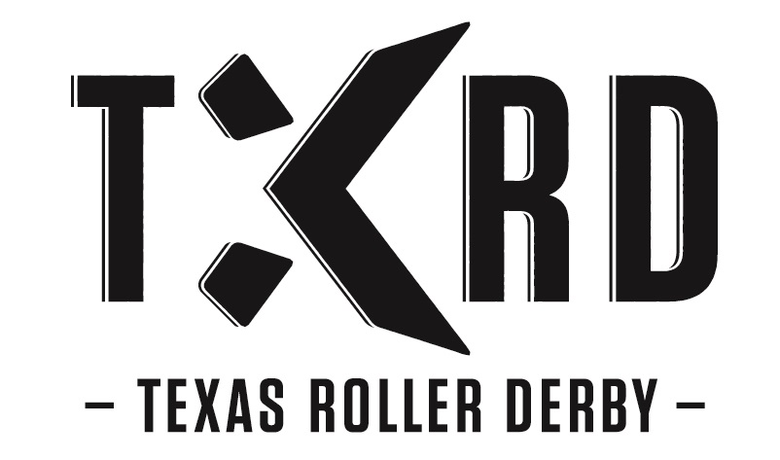

SKATE OF THE UNION
2014
Table of Contents
About the Skate of the Union 5
TXRD Oral History 6
TXRD Roll Out! 16
TXRD Slang- Know the talk! 17
Welcome to Membership! 18
Oh, To Be a Rollergirl 18
Production Crew 19
Non-Skater Members 19

Section 1 - Bouting Requirements 20
Practices 20
Draft Protocol 21
Teams & Special Ops 22
Playoffs and the Calvello Cup 23

Section 2 - Membership Requirements 24
Mission Statement, Vision Statement, and League Goals 24
1. Some Definitions 24
2. How is our company set up? 25
3. Who runs this shit? 25
4. How you Become a Member: 26
4.1 Skaters 26
4.2 Non-Skater Member (NSM) 26
4.3 Production 27
5. Your Rights as a Member 27
6. How you Maintain Membership aka, Staying in Good Standing 28
6.1 Member Requirements 28
6.2 Skater-Specific Requirements 29
6.3 Production-Specific Requirements 29
7. What to Do When Somebody is Really Fucking Up 30
7.1 Personal Issues 30
7.2 Penalty Process 30
7.3 Types of Penalties 30
7.4 Major Penalty Dispensation 31
7.5 Penalty Consequences 31
8. Need time off? 32
8.1 Sabbaticals 32
8.2 Military Leave 32
8.3 New Kid on the Block Leave 32
9. What If I get hurt? 32
9.1 Injured Leave of Absence 32
9.2 Accident Medical Coverage Policy 33
10. How to Leave TXRD 33
10.1 Voluntary Retirement 33
10.2 Involuntary Removal 33
11. If you just want to quit skating 33
12. If you Want to return to membership 33
13. Involvement as a Non-Member/Privileges of Retirees 34
14. If someone would like to help TXRD without becoming a member 34
15. How do you keep in touch with everyone? 34
16. How does the league make money? 36
17. How do you make money as a business owner? 36
18. What if someone wants to hire you? 37
18.1 Endorsement Schedule 38
19. Innovations and Propriety Rights Agreement 38

Appendix I - TXRD Texas Roller Derby Rules and Policies 2012 Season 39
Appendix II - Skater Membership Forms 48
·Waiver and Release of Liability 49
·TXRD equipment agreement 50
·Confidentiality and Non-Disclosure Agreement 51
·Name and Likeness Release 54
·Innovations and Proprietary Rights Assignment Agreement 55
·Exclusive Membership Agreement 59
·TXRD Member Information Sheet 60
·TXRD Rules/Policies of the Game Agreement 61
Appendix III - Strategic Plan 62
Appendix IV - Regulations 116

About the Skate of the Union

This is your TXRD Bible and membership book. The information in this book is confidential and is to be read and used by members only! Do not keep the Skate of the Union as a coffee table book or open for anyone to pick up. TXRD has worked very hard to gather the information provided herein, and it’s not meant to be distributed freely.

This contains a little something for everyone. History, fun facts, rules, and most of all business answers. If you want to understand how Four on the Floor, LLC (the legal name of TXRD’s company) is organized and works, check here. If you can’t remember all your responsibilities and rights as an owner of the company, keep reading!

Our business, legally and procedurally, is made up of a few Big Documents. The Amended and Restated Regulations of Four on the Floor, LLC, (the Regulations) our legal corporate document, (the “bones” of our company, and what we fall back on for reference) will not be altered unless our lawyer tells us it’s a good idea. We also have the Skate of the Union, which fills out the “flesh” of our company with procedures on top of the bones, and puts the Regulations into common language, not legalese. Within the SOTU is a section on Good Standing, which amends Schedule C of our Regulations. The Good Standing requirments may be changed from time to time with input from the Board and/or league as a whole. Our final Big Document is the Operations Manual, which lists all league jobs, the duties they perform, and how they relate to one another. This 2011 SOTU is attempting to bring all those documents together in a way that will make all Members aware of their rights and abilities, and give greater understanding in the future of how our business is properly run.

Please refer to the Skate of the Union for official TXRD information. Most of your answers will be found here. If you have further questions, contact the Secretary of Skate at info@txrd.com.
TXRD Oral History
(*subject to interpretation and slacking brain cells)

Round One by La Muerta
Devil Dan came to town in December of 2000. He started asking girls to be superstars in his multimedia show featuring a banked track and video screens and bands. We would be the showcase for the bands and skate around them.

He put up posters for recruitment and collected sponsorship money from different bars. We all met at Casino el Camino on a hazy Sunday afternoon , January 21, 2001. There were 50+ girls, so in one night we organized teams according to where we all liked to drink the most (two Emo's teams and two Casino teams) and assigned team captains who would name the teams and think of costumes. After a very freaky kickoff/fundraiser in March of 2001, Devil Dan skipped town with whatever funds we had.

We team captains Nancy Love (Hellcats), Anya Jack (Rhinestones), April Ritzenthaler (Putas) and Amanda Hardison (Holy Rollers) decided with the help of Heather Burdick (secretary) and Laurie Rourke (bossy best friend to secretary) to continue and work on creating our own roller derby game. We quickly named ourselves Bad Girl, Good Woman Productions and promptly had the logo designed. Well, I say promptly, which in BGGW terms means 28 hours of discussions, 18 drafts, 3 lost copies, versions with and without nipple, and finally computer paper iron-ons for everyone!

We had our first fundraiser at a bowling alley mid-May and began making plans for All-Girl Roller Derby Entertainment World Domination. When Anya brought in a business consultant with dubious credentials, Laurie and Amanda promptly quit and Heather took over as team captain of the Holy Rollers, and the four of us became known as the She-E-O’s.

Practice was haphazard and mostly consisted of each captain calling and thoureatening their members continuously and no skating rink letting us have sanctioned practice. We must have sounded too rough over the phone, so we didn't let Nancy call anymore. Finally, in late summer of 2001 Skateworld allowed us to have regular practices there—on Saturday at 8 a.m.! Pretty rough for us bar girls. Our system of dues ($25 a month) was instituted at this point to pay for the practice space and lessons, which cost $600 to $800 per month.

At this point we still had over 60 girls on four teams, and we needed a firm structure. We had a huge league meeting on September 9, 2001 at which we assigned committee managers, members, and duties and passed out a bunch of patches. (These patches, I'm sure, bankrupted our already dwindling funds.) This was our great achievement! We were all working together and had delegated responsibility to lots of willing girls, and the world was great! Oh, yeah, then the world blew up two days later. Needless to say, everyone's spirits were pretty low, and commitment levels were negligible into the following spring.

We had another recruitment in the spring of 2002 and picked up most of the old-timers you see today in this league - Lunatic, Loca, Horrorshow, Miss Conduct, Hell's Belle, and Cherry Chainsaw. We realized at this point it was now or never, and the documentary "Texas Rollergirls" was being filmed, so we had to put out for them. A year and a half after our inception we held our first bout, an exhibition, on Sunday, June 23, 2002. The Converters played and admission was free. We had 275 of our closest friends and family in attendance, free beer in the cafeteria area only. BGGW—Texas Rollergirl shirts were sold, and we did it all with (drum-roll), NO production manager! I still am amazed that we pulled it off with no real outside help, especially since all four teams skated! Ahh, DIY at it's finest.

Our second game and rest of the season were moved to Playland amidst much controversy and fighting. A couple skaters quit but quickly returned when our attendance went up every game. In June, we had a crowd of 275; August was 600; September 1000. October saw 1200 fans, which was our maximum, and we stayed maxed out. We found our home at Playland, but it was very expensive and restrictive, which made it necessary to continually have fund-raisers.

A note on production and themes: none of us were very good skaters. It wasn't fast and furious like it is now. We were afraid of using the words "roller derby" (roller derby was seen as banked track only), so we changed it to “roller derby entertainment.” With this idea came the penalty wheel and spank alley. This also brought the idea of processions with the team intros and cheerleaders and crowd interactions and masked skaters breaking into other team's jams, etc. We're better skaters now, but the crowd still loves it!

Funny Facts of BGGW History
Our committee list for Sept 2001:
1. Fashion / Merch
2. Promotions
3. Marketing
4. High tech / Image
5. Rules / Choreography
Our first penalty list:
1. Mandatory karaoke
2. Spin penalty wheel
3. Wear boxing gloves for jam
4. Touch toes 2 minutes
5. Most fouls dates highest bidder
6. Makeover box
7. Hose down
8. Shaving cream shirt

Poem by La Muerta (published in the NY Times in December 2008)
Devil Dan was a man.
A man with a plan.
A man with a vision.
A man with a dream.
He wanted to make us superstars.
He told me I'd be
a roller derby queen.
So he got excited
and he got bold,
he put up posters
and soon we were told
to meet at Casino, Sunday at 4.
I thought I'd be
the only girl through the door.
Well, apparently
so did Dan.
But being a man
faced by 50 tough women
he stood by his plan,
he explained his vision.
We broke into teams
by an easy means.
We're girls of bad habits - the Holy Rollers grabbed it.
We're girls who fight - the Hellcats - right!
We're girls who roam - so came the Rhinestones.
And of course we're all whores - Need I say more?
This went on for a while,
and he promised great style
but no substance arose
from his grandiose pose.
Where was the money that those bars gave us?
For costumes, for bands?
Oh, wait!
Maybe someone should train us!
So he dismissed himself
in a spectacular way,
no trouble to us,
nevermore, not today.
But I'm thankful to Dan
and his vision so bright.
He stacked wood for the fire,
but we girls made it light.

Round Two by Chola
With the league growing so quickly and La Muerta stepping off the board, the remaining She-E-O’s enlisted the help of a business consultant with valid experience and the willingness to help for free, Stuart Thomajan. Little did he know that shortly after he agreed, the league would be on the brink of the biggest drama yet: a split. The league had just had a huge recruitment in December ’02 that brought in lots of girls, including: Holly Peño, Chola, Varuca Assault, Suzy Homewrecker, and Jenacide. The girls listed were all chosen to be Putas with Lunatic as the Captain and are now known as the Original Puta Posse. We Putas had no idea that there was some serious contention between the leaders of the other teams and the She-E-O’s over what the corporate structure would be, among other things

After the split, most of the girls followed their captains. The Putas and a handful of others decided to stay with the She-E-O’s and BGGW; the rest left and created Texas Rollergirls. So there we stood: the She-E-O’s, 12 Putas, Cherry, Stuart, and Clownsnack with little money, and no venue to practice or play. The Putas were forced to split and recreate the teams. Cha Cha, Chola, Hell’s Belle, Holly Peño and Jenacide remained Putas; Loca and Feisty became Rhinestones; Horror Show and Varuca became Holy Rollers; and Lunatic became a Hellcat. Using the “one foot in front of the other” method, we soon recruited new girls (Ruby Sioux, Sister Mary Jane, Witch Baby, Lux, Helena Handbasket, Smarty Pants, Guera, Mighty Aphourodite, and Hades Lady among others), re-established structure, and started practicing at Skateworld. Soon thereafter, we were rejoined by Miss Conduct.

With the help of Stuart and the She-E-O’s, we purchased the banked track and held bouts in Killeen and at the Travis County Expo Center. BGGW didn’t roll off the tongue, and we needed a new way to define us as rollergirls, so we had a league vote and changed it to TXRD—Lonestar Rollergirls. Texas Roller Derby (TXRD) was to become our umbrella when we started to expand into other leagues and Lonestar Rollergirls would describe us as the girls who skate in Austin. Once the league regained ground, the She-E-O’s left as leaders, and new board members were elected. The rest is history.

The She-E-O’s put in so much with little to no reward. The spirit of the She-E-O’s still lives on-determination against all odds, mind-blowing creativity and the need above all to have fun with girlfriends. We should all remember that if it wasn’t for the work and brilliance of these ladies, there wouldn’t be all-girl roller derby as the world knows it today.

Round Three by Chola
Shortly after we purchased the banked track, we got a random email from an angel that would change the way we saw our new banked-track sport and how we trained. His name was Greg Rollie (aka G-Spot). Greg was a roller derby veteran who skated for the old school roller derby and was still such a fan that he had built his own banked track in his back yard! He had contacted us simply to ask if we would let him skate on our track, but little did he know that we would rope him into being our main trainer, a ref, and a mentor. Greg taught us to block, assist and fight in ways we had never seen or even considered. He showed us footage from the old school days of roller derby and instilled in our league the idea of showmanship. He reminded us every practice that this game isn’t supposed to be one long match race—it should and HAS to be more. More importantly, he showed and taught us that above all else, we were there to have FUN and not to take the game and the competition too seriously. Greg was also the person who introduced us to the legend Ann Calvello. Greg and Ann were close friends, and I like to think he saw a lot of her in our new generation of roller derby. When it came time to name our championship bout, it was Greg who offered the idea to name it after Calvello.

Cherry Chainsaw was the first lady from TXRD to meet Ann. She went and visited her and got video footage of Ann presenting the Calvello Cup to the winning team to be seen at the bout. We kept in touch with Ann throughout the years, sending cards and calling her, always hoping that one day she would be at a championship bout named in her honor. The fateful day finally came in 2005 during the taping of the A&E series “Rollergirls”. She traveled with her trusted and awesome partner Billy. It was during this visit that we had a viewing of her documentary, Demon of the Derby, and she declared that her visit to Austin was her proudest moment in her derby career. There is too much about Ann to write about in this article, so you will have to do your own homework, but the most important thing was that she stood for style, strength, and cooperation. She was hard as nails and didn’t take shit from anyone, but she told to us over and over again that our sport and league would only last if we stuck together. I personally consider her lesson to mean “League First.” Even if you are on a team or committee, you should always put the LEAGUE FIRST because we have to stick together as a league to make this work.

Round Four by Mz. Behavin’
March 14, 2006 was the fateful day when our beloved Queen of Mean, Ann Calvello, passed. Those of us with the league during the 2005 season were fortunate to have met the feisty lioness. She was an absolutely amazing lady who not only reminded us to keep our friendships tight, but also to keep our tickets up! Tickets, by the way, meaning breasts because in the words of Ann Calvello, “Those tickets are what get people’s butts in the seats!”

Throughout the years we have experienced our ups and downs. Amongst the ambiguity have been the constant moves from warehouse to warehouse. We began our banked track journey at a warehouse on Decker Lane then moved to a second location on Tillery. Our next move would be a great one! A&E came to town and proposed the filming of our league. They hooked us up with a warehouse at the old airport in an airplane hanger. It had huge sliding doors that, when opened at night for practices, gave us an amazing view of downtown Austin. Amongst the perks of A&E was free rent for the season, a production setup with movie set lights, and an amazing sound system. As some would say, the whole works, the whole nine yards! If there was a downside to the filming of our A&E series, some might have to say that it was definitely hard getting used to having cameras at every practice and special event. For others it may have been losing anonymity and becoming nationally recognized. Rollerball 2005 was on a different level as well. We had free food, free booze, and a luxury bus ride to and from the event. It was quite a crazy, amazing evening that summarized and marked the ending to our 2005 season!

All in all, the experience that A&E brought to our league has been one that we have all learned from. It has been an experience that we continue to build from, and with the filming over, it became time for things to get back to normal, or so we thought. In 2006 we moved into a new warehouse on the north side, The Crockett Center. This location fit our grassroots budget. We were now paying our own rent again. A&E was no longer filming, but the show, Rollergirls, had served to skyrocket our attendance! At our first bout in 2006 we had to turn away an estimated 500 people because we ran out of space in the warehouse. It was absolutely insane! Those of us there for that season kickoff will never forget the feeling we had that night. The crowd roared and the game was so much more intense with a wall-to-wall, jam-packed room. We quickly realized that the show was going to be a big boost to our league.

Before we knew it, leagues were popping up all over the place, and not only in the U.S., but internationally as well. It was the most amazing feeling to know that we were responsible for it all. We were the role models and encouragement that led to 180-plus leagues worldwide, and that number continues to grow!

Given the success that roller derby appeared to have across the nation, we thought we had it made. From there on out, we would have tons of money, tons of fans, and no problems. Little did we know that we would quickly go from instant fame to facing some devastating developments with our 2006 season plans.

What happened?

Round Five by Maya Mayhem
Simply put in one word, business. We are an independent business that suddenly gained national attention because of our unique nature and appeal. Along with national attention came local attention. Soon after, we encountered an obstacle that would impede the normal production of our events. This hindrance came early in our 2006 season when we discovered our new landlords at the Crockett Center had lied about the Certificate of Occupancy. The space was rated for retail sales only, not for assembly, which we need to have events! We were shut down by the Fire Department, but the board, consisting of La Muerta, Hades Lady, Patty Hurts, Chola and Doc made such a stink to the City (Mayor, Council, and anyone else that would listen when April accosted them in City Hall ☺) that the City Manager, Toby Futrell, gave us the Austin Convention Center to use and practice in for the entire season, at a huge discount! This move appealed to some league members and not so much to others. Regardless of each personal opinion within the league, the financial effect of this situation was detrimental. Our financial responsibilities increased dramatically from having one privately leased location for practice space and one leased location for our regularly scheduled season. Within this move we also lost profits in liquor sales at the Convention Center (nearly 1/3 of our income), as Aramark is the sole provider of concessions. Determined to overcome this obstacle, the league continued to have a successful turnout in 2006 at the Austin Convention Center. People from all over the country came in to Austin, Texas simply to see a TXRD bout. The public responded in attendance at the bouts and via virtual support on the message boards at TXRD.com. This online surge of visitors to our website gave way to our very own fan base known as the Board Whores. They are a group of dedicated fans who come together on the message boards to talk about TXRD! They are an enthusiastic group of people who support what we do and appreciate our sport and business to the fullest. They are people from within local city limits, across the nation, over seas and some so unique, it’s questionable as to whether or not they are from this planet. A group that very much resembles our own league!

In that respect, business as usually continued with our 2006 tryouts. Our 2006 class required two days to evaluate every girl that signed up. An estimated 90 girls tried out and the talent was promising, bringing in skaters like Rocky Casbah, Dixie Sanchez, Purr Ana, Maya Mayhem, and Hottie Smoochalottie. As with any new class these are the skaters that are looked to for new refreshing ideas. In order to ensure the commitment level of this new class the Training Team decided to run the girls through a three month training course. The new implication of a three-month training period allowed the new girls to develop their skills before their debut bout.

When the 2007 season commenced, it was a nail biting series from start to finish. People raved about the Hellcats, a powerful team composed primarily of new girls. People raved about Cherry Bomb rookie sensation, Rocky Casbah, and held tight to see who would ultimately be in the 2007 Calvello Cup Championship. In the end it was a Putas del Fuego vs. Holy Roller Cup. The Holy Rollers came out on top, but the entire 2007 season raised the bar on skill level and athleticism.

TXRD continues to keep a strong faith and believe in what we do and what roller derby stands for. We are a seasoned league that has encountered and prevailed against a series of obstacles. We continue to learn and grow and develop from these struggles and most importantly each other. Looking to the future, we understand that the only way to keep our business strong is to put in the hard work and time. We realize that the glory of the A&E days was sweet and promising but short-lived. The need and focus on driving us to success once again is dependent on each and every one of us.

How will this be done?
How will TXRD stabilize the business that we’ve created out of roller derby and ultimately meet our corporate goals?

In October of 2007, the Board of Directors in office, Varuca Assault, Maya Mayhem, Mz. Behavin’, and Stoli Rocks put their efforts together and finalized a long-time goal of establishing the TXRD Operations Manual, a manual that details job descriptions within the league and enables members to enter into management roles with an understanding of the responsibilities involved. The obvious step towards accomplishing our corporate goals will require committed involvement from each member. Each effort made by our members counts and defines this organization. Therefore, our internal structure requires guidelines that can measure and account for the contributions made by all. Leaders in office will continuously put efforts in place that help move this league forth productively. Establishing an internal structure in which members can easily enter, understand and impact the business is imperative to our success. By developing empowering opportunities for each league member we can attain our vision. We can and will reach the worldwide domination that we’ve always talked about, but it will take this league’s work and commitment. We’ve come too far, worked too hard, and created too many friendships to let this slip away. We can prevail. We will prevail. Our empire will continue to grow, and roller derby can take over the world.

Round Six by Honey Homicide
The 2008 season was rough at first, but it turned out to be one of the most successful ones in our league’s history. In the offseason between ’07 and ’08, we voted to return to our original season scheduling. For those who don’t know, back in the day, our season ran from February to about November, with bouts every three weeks and every team playing each other twice (we only had the four original teams then). For the 2005 season, when we filmed Rollergirls, the show’s producers condensed our season to last from January to July, with each team playing every two weeks. Our season was even more squished than it would have been because we introduced the fifth TXRD team, the Cherry Bombs (destroy!), that same season.

The return to the original season schedule had its good points and bad points. On the good side, bouting every three weeks made the season much easier on the managers and production crew and, really, the league in general. Everything was much more relaxed because you weren’t staring another bout in the face right after you recovered from the previous one. Also, we weren’t bouting during the holidays, which has always been problematic both for bout attendance and for skaters’ practice attendance. People are out of town, college kids are home for the holidays, and everyone just has other shit going on.

On the bad side was the fact that our offseason that year ended up lasting six months. We were strapped for cash in a bad way. However, we pulled it off, thanks in a big way to our special events crew. They had endless fundraisers for the league, and we stayed afloat. Also, though the long offseason was a nice break, six months is a long time to go without skating or really seeing each other, and we became a little disjointed and out of shape.

But we came back with a bang, bitches! We sold out the Palmer Events Center for All-Scar Army v. Holy Rollers season opener. We even had to turn people away. The whole place was hot as fuck, and the crowd was hopped-up six ways from breakfast. The bout was so intense that even though I tried to get ejected, I just couldn’t.

Though we didn’t sell out any more bouts in ’08, we had great attendance, and our game changed a lot. It continued to get faster and faster, a change which had good and bad points, too. The game got a lot more interesting in a lot of ways because of the speed, and the strategies changed a lot. Where we used to always put heavy hitters in the back of the pack, we began loading the front of the pack, so the pivots got even more action than usual. The defensive lines were amazing that season; I’ve never seen such strong blocking lineups in my entire derby career.

The drawbacks to all these changes are a matter of opinion, but I’m the one writing this round, so deal with it. The blocking was so good and the packs were so fast that the jammers had a hard time putting points on the board, so the game scores became insanely low. For the Calvello Cup, the final score was 18-14. Some folks feel that the low scores make for exciting games, but I feel personally that it makes the games a little dull. The bouts certainly weren’t dull while we were playing—the hitting was so hard and fast that everything became a blur. The only problem was that the intensity didn’t translate very well to the audience.

Though we were really competitive in ’08, we still managed to have some fun, and there were quite a few surprises. The Putas ended up losing half their lineup at the end of ’07, and they drafted six rookies to make up the difference. They took it in stride that they weren’t gonna have a cup-tastic season, so they instituted Project Mayhem, which basically consisted of causing utter pandemonium out on the track. You could tell they were having just a shit-ton of fun out there. My personal favorite part of the Project was when they were playing the Hellcats. Curly Suicide came up to the line in one of the last jams, and every one of the Putas on the track just went after her—illegally, of course! She didn’t go down without a fight, but she did go down. All the Putas went to the penalty box, and the game ended with time left on the clock.

Another surprise was the biggest upset in TXRD history: the Rhinestone victory against the Holy Rollers.

So the Rollers are all set to go to the championship, having beaten the other favorites for the Cup, the Cherry Bombs and Hellcats. Their final game of the regular season is against the Rhinestone Cowgirls, who have only retained three—yes, that’s three—skaters from their previous year’s roster. They had nine rookies skating for them all in all. The best part about the Rhinestone victory was that they used the Holy Rollers’ own defensive tactics against them, and they did it really well. The game was close, but absolutely nobody had expected the Rhinestones to come out on top. Congrats to them! I think we’ll see great things from that team next season.

The best part about the ’08 was that, for the first time since the show, we came into the offseason not having to worry about how we were going to get by. We had enough money in the bank that we actually got to decide what to spend it on, not closely calculate how much more we’d need to continue to keep our space. I, for one, was really proud of how well we did, and I know we’ll continue to kick ass in ’09.

Round Seven by Honey Homicide
2009 continued much in the vein of the last few seasons. We had all of our bouts at the Austin Convention Center and continued working hard to make our bouts happen. While we weren’t as financially successful as we were in ’08, we had about 2800 people at our Calvello Cup and ended up coming into the offseason financially stable. Our games were all very exciting due mostly to a new 20-foot rule that allowed some of the teams to create pretty effective strategies that damn near put a stop to Runaway Pussy.

The thing that stood out most to me in the 2009 season, though, is the widening chasm between the teams. I’m not as much of a derby geezer as some of the old bitches around, but as I go into my sixth season with TXRD, I pause to reflect on what has gone down in the last few years. As I read over the previous rounds of our history, it occurs to me that as we grow, we become more organized within our business and, at the same time, a little less convivial with each other. I think there are definitely more than a few contributing factors here.

The first is that most of us work really hard. Derby can be a second full-time job, but even the girls who aren’t so involved in the business are required to make eight practices a month, a change we instated a few years back. I’m not saying that I don’t think upping practice requirements was a bad idea, but fitting derby into your schedule twice a week is sometimes difficult, especially when you’re required to attend team practice to boot.

We’ve also seen the slow death of one of our time-honored traditions: the Last Supper. As we bring in more athletic girls, we have developed a distaste for partying at someone’s house two days before a game lest it affect our performance. I’m not confident that the Last Suppers will resurface in the 2010 season since we will have most of our games on Saturdays (a good move on our part, departure from tradition notwithstanding).

Another reason might be that we’ve gotten really competitive with each other, a fact that divides the teams socially and doesn’t allow much of a level playing field in our games since some skaters have a hard time giving away their knowledge to girls on other teams. When I started, we didn’t really have enough girls to make permanent teams—Sister Mary Jane, the Holy Roller legend, even had a skater name on each of the four teams, my favorite of which was her Hellcat [actually it was her Puta name - edit by La Muerta] name, Anita Toke. Some people may also remember Chola’s experiences as a Rhinestone Cowgirl (the Rhinestone fans made a huge cardboard cutout of an old photo of her in a Cowgirl uniform for the ’06 Cup) and as “AlternaToe,” which we called her after she donned Luna’s Hellcat uniform one game in the ’04 season after Luna was injured. (Luna used to have really intense camel toe.)

I’m going back a ways as I say this, even though my focus should primarily be the 2008 season. In order to talk about the subject at hand, though, ancient history is essential. My training class filled the rosters in 2005 and saw the end of sharing skaters. I don’t know if it was easier back then to know everyone because there were fewer girls or because we were all working together to make the game on the track a success (as opposed to our constantly-shifting focus to the making the business side a success), but I don’t think girls coming into the league get to know girls on other teams very well. I personally think we draft too early. Thus, you don’t really get a chance to know anybody but bitches on your team, bitches you directly work with in the business, and bitches in your new girl class. It makes me a little sad, but it’s an inarguable fact that the division I’m describing exists. The proof is in the pudding: a look around at a league meeting (or any league event, for that matter) will validate my point here.

That’s not to say that we have lost all of our sense of fun or anything; quite the contrary. We still fight and fuck with each other and talk shit on a pretty regular basis. Some of us had the opportunity to go play in Corpus with Hurricane Alley Roller Derby, who had gone through a split and were short on girls. When I went, it felt like I got back to my roots: a shitty venue with shitty air conditioning in a shitty part of town. The experience was Decker-rific. HARD had no rule set, but they loved to fight and had a kickass penalty wheel that included a dance-off. We also got back to our roots by playing an expo game in Snyder, Texas. Girls did some excellent planned plays, and though the competitive edge was still there, the spirit of showmanship was very much in evidence in a way that it hadn’t been in years.

So I guess the point of my historical ramblings here comes down to two pieces of very unsolicited advice. The first piece is, to keep our league as fun as it’s been in the past, honor our history by going out and getting wasted with a girl you’ve never really talked to before. Make some fuzzy memories over shots of tequila. Remember, there is no occasion which cannot have an afterparty. My second recommendation is that you give away your secrets in all aspects of derby. Bequeath to your successors in the business all the things you’ve learned in your stint as manager/board member/production member. More importantly, assist a shitty skater. If you give away all your derby tricks to other girls, it not only helps the league but also makes you stay on top of your own game and learn new tricks yourself. There is no room for plateaus in this league; we need to up our game and up our duckets as often as possible, and the responsibility is nobody’s but ours.

Round 8 by Honey Homicide
We kicked so much ass this year it was ridiculous! Due to the release of Whip It in October of 2009, our season opener was an absolute riot, and we continued to have an unprecedented number of attendees for most of the season. Even with all this publicity, we continued to reach out to new markets by advertising in college newspapers and on the backs of taxis. We made an appearance in Pride’s big gay parade again, and we built a new (and completely badass) web site. Production got our track build times down to an excellently efficient minimum, and with the purchase of Dixie’s Magic Box, media really got down to business with the web cast.

The game itself was excellent. Though we’ve been slipping on our fighting skills (something I hope we’ll work on in 2011), we really stepped up our training strategies, and as a result, we saw a smaller number of injuries than ever along with some amazing play during game time. The season ended with another Hellcat/Cherry Bomb Calvello Cup—only this time, the Bombs won their first championship title ever!

We also traveled a good deal this season, playing flat and banked bouts with teams around Houston and Corpus. The travel team especially really worked hard this year: they ruffled the hell out of LA’s feathers by very nearly beating them in the third Battle on the Bank tournament.
We really got our shit on lock this season with regard to the business side. We were more organized than ever, and aside from some minor mistakes and tiffs, we cooperated better and accomplished more than last year. We grossed about 300 grand this year and actually had the problem of having too much money come tax time. That’s a great problem to have.

We also locked down a deal with KCWX, a station that reaches San Antonio, Austin, Fredericksburg, Waco, and a lot of other places, to televise our games in the 2011 season. Their vision of what the show will be like seems to very much fall in line with what we want the world to see, and I hope that this partnership will prove to be the media break we’ve been looking for.

A big problem that I saw this year was a labor shortage. This has been an issue for some time, but it gets worse and worse every season. Back in the day, there were always people running against each other, vying for manager and positions. This year, we had a hard time getting enough people to put a name beside each position on the manager election ballot. We’ve been filling board and manager slots late because no one will step up. When there’s no one to do the jobs, it makes the folks who are shouldering the work load even more stressed, which is detrimental to our business.

I feel the need to say here that a board, manager, or committee position isn’t the end of the world, and sometimes work can be pretty slow. When we asked for board nominations this season, I heard someone say, “Yeah, throw somebody under the bus!” It’s not like that, folks. Running a business may be stressful at times, but it is exceptionally rewarding when you come to a bout, see 2,000 people enjoying themselves and know you had a hand in it. Plus, if you’re interested in something that has nothing to do with your career, you can learn the ropes and maybe even find a vocation that is completely different from what you currently do.

Another trend that I see is over-standardization. This one’s a double-edged sword. We make rules and regulations so that things are fair, but sometimes we go too far with them. Sometimes we forget that this isn’t a professional sport or a Forbes 500 company; this is roller derby. In our effort to make everything fair, we sometimes alienate people by being too strict and making rules that sound good in theory but make things too complicated in reality.

We have identified this problem and are doing our best to simplify things, though. I’m very proud of a system La Muerta came up with and the board perfected (we hope). Instead of having a bunch of weird rules that are hard to track and enforce, we started, and the league voted in, a points system for membership. So, no matter what your situation in life or in a time frame, you can stay in good standing with the league by doing a small number of tasks if that’s all you can do. The great thing about it is that it also tracks effort, so in the event that we have a distribution, we can do it the way the corporate documents indicate that we should.

So, to sum up: we have our problems, but they’re completely manageable. We did an amazing job this season, and we should be extremely pleased with ourselves.

Round 9 by Honey Homicide
2011 came and went, as years are wont to do. We had a spectacularly successful tenth-anniversary season, which we kicked off with a very well-received game that showcased two all-star teams instead of one. The Rhinestones won their first Calvello Cup in six years. We brought in new girls and said goodbye to those who were ready to leave. We played travel bouts all over the place and participated in Battle on the Bank in Arizona. We made so much money again that we had the problem of figuring out what to do with it.

We landed a new training facility, a guaranteed five-year home. After putting the dream of owning a practice space that doubled as a game space on the back burner, finding our current warehouse felt good. It felt like we had a real home at last, somewhere we could go to plot our successes and pick each other up after our failures—and also a place where we could have a kickass Rollerball without being worried about anyone getting thrown out.

We also decided to build a new track. Grandma has certainly seen her better days. She will be missed, although she undeniably had a good run. The new track isn’t finished yet as of this writing, but I’ve seen her in pieces. She looks spectacular.

But there was division and darkness as well, as exist in all aspects of life. The social chasms between the teams continue to widen as they have over the last few years, as has the rift between non-skating members and the skaters. We conducted an internal audit and found that the number-one problem in TXRD’s business dealings is internal personal conflict. Maybe we got too big. Maybe we forgot how to listen to each other. Maybe we’ve been too successful and have become spoiled. Maybe we’ve just changed completely as a league and a game from what we were when we started. Maybe we’re fighting too hard for a group identity. Any way you slice it, the focus in the future needs to be the ties that bind us, not the differences of opinion and culture that separate us. We will only function at our highest and most spectacular capacity when all of our attention is undivided by personal conflict and turned instead toward our goals.

I also got the feeling many times this season that an alarming number of folks feel like they volunteer for or just plain belong to the league. You do not belong to TXRD. You own TXRD. So take ownership of it. Every day when you walk into the warehouse to practice, every great night you go out on the town and just laugh your ass off with your fellow league members, and most certainly every time you walk into a game and see all those people having the times of their lives, you should be able to say to yourself, “I made this happen. This is mine.” If you can’t, you might want to re-evaluate the reason that you’re playing roller derby and not another, more traditional sport.

2011 was, on a personal level, my seventh and final year with TXRD. To no one’s surprise, I wrote a farewell address to the league as I had a lot of advice and experiences that I wanted to share with everyone, not just one or two people I happened to see when I was thinking of it. I have copied the meat of the address here for everyone who is or will be a member of TXRD—why else do we have a history section but to keep a record of the awesome ideas we had? I don’t know about anybody else, but I think it’s pretty fucking good.
- Be good to one another. Forgive each other. Know your fellow league member’s faults and love them anyway. Accept everything about people, not just the parts you want to see. The best advice anyone ever gave the league (thanks, Muerta) was that we should try to be kinder to each other. I very much took that advice to heart even though I’m sure everyone can tell that it’s something I’m still working on. I’ve tried to use it in my real life as well as my derby life.
- Remember who you are. We create alter egos for ourselves when we become skaters, and sometimes they allow us to act in a way that we never would in real life, which can be a good thing. Our alter egos give us confidence and put us on the path to defining ourselves as women. Unfortunately, they may also give us permission to act like real pieces of shit sometimes.
- I came to that realization a few years ago. I was having a really hard time in the league and was seriously considering quitting. I walked into my closet one day and had a kind of fit. I tore all of my derby shirts and derby-related outfits off their hangers, threw them on the floor, and took a look at what was left. It wasn’t much, and I came to the conclusion immediately that Honey Homicide was taking over my entire being. I was angry and frustrated and not communicating well; I was utterly lost and out of touch with who I really was. So I dug deep and found myself again. I brought Natalie Schiro to derby instead of letting Honey Homicide bleed into the rest of my life. If you were around in 2009 and noticed a change in me, that fit was responsible for it.
- The issue of alter egos goes both ways—not only can you lose yourself in your own, but you can limit your concept of another person by identifying them only by their alter ego. Don’t ever forget that you’re bouting with a person with thoughts and worth and feelings, a breakable and fallible human being, not an idea, not a machine, and certainly not an enemy. No matter what I’m doing, no matter how much I want to exercise my skills on the track or dominate my opponent, I never forget that I’m not playing against Anita Confess. That’s Pam Rogers, a friend and long-time cohort in plotting TXRD’s success. When I’m blocking against the obscenely skilled Kategory 5, no matter how much I want to stop her from passing me, I never forget that she is Katrine Nordstrom, a lady with a family and a foreigner who mixes up words much to my delight. When I’m blocking for Rocky Casbah, I’m not thinking about winning or how many points she’s scoring. I’m doing everything I can to protect and assist Kerri St. Aubin, a wonderfully flaky, loudly competitive, unapologetically bisexual Midwesterner.
- Don’t play injured. Ever.
- Being an aggressive skater is NOT about anger or hatred on the track. It’s about going to that primal, intuitive place inside you and opening it up in a way that you can control. When you’re desperate and angry, your judgment is clouded. Roller derby is Zen, and you need to find that still place within yourself where savagery and love coexist. You’ll be a better player for it.
You may be wondering what the fuck I’m talking about. How does a person spontaneously get to such a place? Well, your most primal urges are for food, water, comfort, and sex. Thinking about food distracts me from the game (I’m a feeder, right Glitter?), and I try my best not to get thirsty. I tend to think about sex to find my Zen place. Seriously. Sexuality is a powerful tool, one that draws people to us and draws us closer together. Whether you’ve ever thought about it or not, you are empowered by sex, so use it to your advantage.
But comfort is there, too. We have an intimacy with each other that stems from constantly being in each other’s personal space. Hitting each other renders us vulnerable because we’re putting the results of our primal urges on display, something women generally have been taught not to do. In letting go of our physical boundaries, we let each other in emotionally. This unorthodox intimacy is the tie that binds us. It’s what I will miss the most when I leave. It’s how we find comfort in each other. It’s also the reason that we could never have a real sexual harassment policy.
- I don’t care what your style is or your ideals are, always dress like a whore when you bout. If you don’t know how to dress like a whore and do it well, there are plenty of ladies in this league who can help you out. Using sex as a marketing tool does not discredit us. We are a new and better definition of sex appeal, something that at one time I didn’t even know that I knew.
Once, when I was fairly new to derby, I was walking through a mall and had one of the most wonderful experiences of my life. I looked at this poster of an allegedly attractive woman and saw it for what it really was: an illusion. Suddenly all my ingrained ideas of what a woman should be slid off of me like water. That is the embodiment of what we do. We take all the accepted rules about how women should look and act, throw them out the window, and make up our own. Outright rebellion against the accepted paragon of femininity is what makes us role models to younger women, and it’s what draws a lot of us to derby in the first place.
- Do not ever forget that you are an entertainer first and an athlete second. The rise of athleticism over entertainment in this league has made me nervous for a long time because the loss of entertainment will be our downfall. The shift towards total athleticism is picking up speed, and if we make our league purely athletic, we will lose our niche market and our success. There is another league right across the river who has been playing that style for much longer than we have and has perfected it. To emulate them is a poor business decision at best, and emulating other banked-track leagues and following instead of leading isn't the way to go, either. We aren't Denny's; we're the Omelettry. We should never want to hear someone say about us, "Oh, yeah; we've got one of those in our town." Our uniqueness is what makes us successful.
- If you care about TXRD as a successful business in perpetuity, you will do everything you can to make first-timers and old-timers alike want to come back to our games. Forget your fucking ego and your need to hold a championship title that we made up for ourselves. Getting a great crowd reaction will only further the satisfaction you get from playing. Plus, acting like a jackass is really fun.
- In the best interest of your business, keep the fighting; keep the penalty wheel; keep being a fantastically sore loser or a real douche of a winner; keep being ridiculous and fun and proud. The idea that showboating takes away from your athleticism is ludicrous. Look at Rocky. She is the embodiment of everything a TXRD—Lonestar Rollergirl should be on the track: a complete show-off and a badass, relentless player. Strive to be like her, and TXRD will last a long time.
- Socialize with people on other teams. I look around at league meetings and other events, and everyone is sectioned off with their teams. “League first” is a motto for a reason. Don’t let the division between the teams turn into a chasm.
Focus on being logical, not fair, in all you do. Make rules and policies work the way they’re supposed to work; make them serve the purpose that they were meant to serve without regard to who’s going to be upset or left out or get the better end of the deal. Shit isn’t fair sometimes. Accept it. Don’t make stupid rules and policies and decisions in the interest of standards and fairness—it gets in the way of function.

Round 10 by Dee Toxin

Wow, what a year TXRD has had! For the first time in a long time, we focused out energy internally, with a number of huge projects. Before the season began, we were very lucky to see the return of former Hellcat, Sindra Dee, who had recently returned from Manchester after completing a fancy business degree. She conducted a thorough review of our business, interviewing managers and BOD members, studying our finances, and examining the inner workings of our business. Based on all of this information, she composed a detailed strategic plan, covering the next several years. Fancy pants!

Based on Sindra's recommendations and our own experiences on the BOD during the season, we decided to completely revamp the infrastructure of our business. We re-named several BOD positions and re-aligned the manager and coordinator positions to make point allocation easier. Our new BOD positions became Production Director, HR Director, Performance Director, Marketing Director, and Business Director. We created several new positions in response to Sindra's findings, including a "Retention Manager" position to address the large amount of turnover in our business.

Our financial focus became ticket sales and training/space rental, and in order to meet our financial goals for the upcoming several seasons, we needed the help of a marketing firm to point us in the right direction. We spent a bunch of money to hire Greatest Common Factory to survey our audience and put together a marketing campaign. They proposed that we re-brand ourselves, so we became "Texas Roller Derby", with a new logo and everything. They brought in a famous sports photographer to truly capture how awesome we are, and designed an exciting new advertising campaign. We are being included in a traveling exhibit in the Smithsonian Museum and word on the street is that there will soon be a giant picture of Kategory 5's ass in the Austin airport. GCF did a lot of fantastic work for us, but it definitely came at a price. At the end of the season, we had spent a lot of money and hadn't seen as much return as we had hoped. We did anticipate our marketing campaign to affect tickets sales in 2013 more than 2012, so the plan for 2013 is to really focus on Marketing and PR to take advantage of everything that GCF has created for us.

On the performance side of our business, there was a lot of excitement this season! The Rhinestone Cowgirls won the Calvello Cup for the second consecutive year, after facing off against the Holy Rollers (Rock On, Rhinestones!). The first new girl class of 2012 was introduced into the league immediately after the draft, setting the tone for future new girl classes. These girls had several months to skate as Hired Gun$ before being eligible for the draft, helping teams to get to know them better and make more fitting draft choices. The strategy distastefully known as "Runaway Pussy" continued this season, again resulting in many low-scoring games, and a large amount of confusion in the audience, amongst the referees, and even with the skaters. But the league has continued to struggle with creating rules to prevent this strategy; in fear of introducing "stroller derby" to our game, teams voted to keep the pack and 20' rules mostly the same for another year.

Over the years, the league has struggled with finding our place in the larger roller derby community through interleague play. Some people dislike the idea of playing by different rule sets, and have chosen to ignore this part of our league all together. But the Travel Team has worked very hard over the last 6+ years, raising a lot of money, playing in bouts in a lot of different cities, and competing in national tournaments. This season, under the leadership of Cheapskate and Bloody Picka, the Travel Team jetted all over the place, from Houston to Colorado Springs to Seattle. The World Organization of Roller Derby (aka WORD), formed as a banked track interleague alliance between our league, LA, and San Diego back in 2008, was disintegrated, likely due to LA and SD's desire to take over the world of banked track roller derby by excluding the old school style of derby which they loathe so much. A new alliance was formed without us, including LA, SD, OC, the Arizona Derby Dames, and Tilted Thunder in Seattle. They named this group the "Roller Derby Coalition of Leagues" (aka RDCL) and made a website, a rule set, and declared itself the governing body over the Battle on the Bank tournaments that WE formed such a long time ago. We received a surprise invitation to participate in the 2012 BotB tournament, likely due to our friendly relationship with the host team, Tilted Thunder. We are wondering if this was our last year in the tournament, since RDCL has formed a ranking system to determine future tournament participants. Either way, it has been very sad to see banked track derby following the same direction as flat track derby has, becoming all sport and strategy with no purposeful focus on the entertainment aspect of the sport.

This year brought an end to my 3 years as a BOD member, and Muerta's 2.5 years. Over this time, our league has acquired a beautiful track ("The Stinger", which our amazing Production Crew built from scratch!), found a kickass training facility, was featured in a big Hollywood film ("Whip It"), signed a tv contract, introduced a membership point system that ensures that all members are contributing to our business, began a kickass marketing campaign, composed a detailed strategic plan, and earned a shit ton of money. Never underestimate the value of hardworking league members; having consistent BOD members, managers, and league members in general does wonders for the forward movement of our business.

So much has been accomplished since our league was born, I can't wait to see what the future holds for us.

TXRD Roll Out!
Fabulous league cheer/song written by the charming and creative Honey Homicide. Parts in regular text are yelled by everyone, except where teams or departments are indicated. Parts in bolded text are yelled by a leader, usually the senior league member present. The Roll Out is set to the beat of a four-count army march.

We’re the Lonestar Rollergirls,
The baddest bitches in the world
We work hard and play hard, too
We’ll bet we have more fun than you
Production…sound off!
[Production] Yeeeeeeeeeeah!
Putas…sound off!
[Putas] Putas, burn in hell!
Hellcats…sound off!
[Hellcats] Hell, yeah, Hellcats!
Rhinestones…sound off!
[Rhinestones] Yeeeeee-haaaaaaw!
Ho-ly Ro-llers!
[Holy Rollers] Motherfucking Holy Rollers!
Cherry Bombs…sound off!
[Cherry Bombs] 1-2-3 DESTROY!
Tonya Hardings, shout it loud!
[Tonya Hardings] Sleep with one eye open!
I love my league, and it loves me,
LIVE AND BLEED TXRD!

TXRD Slang- Know the talk!

Blood and Thunder: Practice drill in which all skaters take the track and proceed to knock the hell out of each other until only one skater remains standing.
Clawing/Swimming: A jammer pulling her way illegally through a tough pack, usually with the use of her hands.
Clothesline: Straight arm block against a player’s throat.
Cutting the Track: Crossing the infield to rejoin the pack after you fall.
Decker-rific: An adjective that describes any venue that’s kind of ghetto in a down-home kind of way. Stems from our first warehouse on Decker Lane, which had no windows, two bay doors (next to each other; not much ventilation), no stands except for a few rows of theatre seats (people had to bring chairs or stand up next to the track) and a whole lot of visceral charm.
Fishnet Burn: Similar to masonite burn, but with an attractive, semi-permanent fish-scale pattern, resulting from falling while wearing fishnet stockings.
Getting Railed: When a skater rams another skater up onto the outer track rail.
Give a Whip: An assist move in which a skater extends her arm and whips her jammer around the track, giving away all her momentum and speed.
Grandma: Our original track, which used to belong to the Bay City Bombers. She just might be older than you.
Jam: A single play in roller derby, lasting one minute or until the lead jammer calls it off.
Jammer: Scoring skater position designated by star on her helmet. Her object is to score one point per opposing player she laps.
Lead Jammer: The jammer in the lead and the only one that can call off a jam.
Over the Rail: Pushing or blocking a skater over the barrier rail onto the floor.
Over the Top: Overhand cheat move in arm wrestling.
OPP’s: Original Puta Posse - anyone who stayed with BGGW & the She-E-O’s after the “split” in April 2003. This was primarily the Putas (minus a couple of members), and plus Cherry Chainsaw, Miss Conduct, Houston, Clownsnack, Hunter, Wunda Mike and Tim Murphy. They voted to change the name to Texas Roller Derby Lonestar Rollergirls.
Pack: The majority of blockers on the track.
Pack It Up!: A yell to get the blockers and pivot closer together
Pivot: Defensive skater position designated by a stripe down the middle of her helmet who is known as the front pace-setter for the pack. She may take over the jammer position if her jammer passes her the jammer star.
Purple Heart Award: Awarded to the most heinous injury of the year, usually taken home by recipient of a broken bone.
Runaway Pussy: A group of skaters speeding away from the opposing jammer. Highly effective, but a bitch move that completely misses the point of a contact sport.
She-E-O’s: Mothers of the roller derby revival: Anya Jack, April Ritzenthaler, Heather Burdick and Nancy Haggerty.
Snake Drill: A practice drill in which all skaters skate single-file around the track, while a single jammer weaves through the entire line from back to front.
Solid: A great compliment about a skater’s stability and toughness. <She's solid.>
Spank Alley: Now the place where the judges sit. At one point was also a penalty that allowed the people in Spank Alley to smack skaters’ behinds with fly swatters when they’d been naughty. We jettisoned it in favor of point-loss penalties.
Speed Bump: Deliberate fall to trip several skaters on the opposing team at once.
Stich-n-Bitch: Team meeting where members get together to drink beer, work on uniforms, strategize, and basically … well, bitch.
Stinger: The name of our new practice track, built in 2012 and named for her yellow and black color (also the colors of our Production Crew).
Striding the Track: The best way to skate around the banked track to build up the most speed (four strides on the straightaways, three crossovers on the corners).
T-stop: dragging the back skate perpendicular to the front skate.
Takedowns: Any block that results in another player falling flat on the track.
Thunderdome: Where people go for roller derby mayhem and madness. Past Thunderdomes include Decker Lane, Tillery, the Crockett Center, and Burleson.
Track Rash or Masonite Burn: Stinging strawberry across buttocks and/or legs resulting from too-short skirts or shorts which allow exposed skin to hit the banked track. Accompanied by painful skin-against-SkateLite sound.
Welcome to Membership!

All members of the league are owners of the company. For HR tracking purposes, we delineate members as skaters, production crew, and non-skating members. But each have equal rights and fiscal responsibilities within the league.

Things to remember:

· Being a part of this league is something to be proud of and should be seen as a privilege. Never take it for granted.
· Commit or quit. When you can’t put in a 100%, consider taking a sabbatical to rejuvenate, or retiring and returning when life allows.
· We’re all here for the same reason.
· We are lucky to be surrounded by such bad ass chicks and rocking guys!
· As frustrated as you may get, your concerns and worries are manageable.
· You’re always representing TXRD, so act accordingly.
· Always speak positively of the league, its members, and derby in general, especially in public, which includes online.
· TXRD has an open door policy. Please feel free to express your concerns through the proper channels—usually through your skater reps.
· TXRD does have a drug and alcohol policy.
· ANY mention of our league should be praise regardless of what team or person featured. It is not in our company’s best interest to bad-mouth anyone to outsiders, no matter how upset you are.
· The best way to meet skaters is to attend practice and special events.
· Miscommunication, jealousy, and selfishness are dangerous to our league and should be avoided.
· This is YOUR league. All the money generated and spent is yours, so always be frugal.
· TXRD does have a dismissal policy.
· Don’t discuss things you aren’t certain about. Instead direct the questions/concerns to the proper department.
· Never accept an interview without permission from the Public Relations Department.
· Never discuss or accept a business contract of ANY sort without the input and permission of the Board of Directors. This includes appearances, hires and endorsements. All of these must go through the league so you get the full benefit of our legal and business knowledge!

Oh, To Be a Rollergirl

Statement of Sportswomanship:
Respect for the game and each other is key. Poor sportswomanship, malicious violence, and disregard for the rules and policies of TXRD will not be tolerated. Likewise, malicious gossip, personal insults (including anything regarding race, religion, sexuality, body type, and more), blatant disrespect towards another league member, and any other petty behavior that does not resemble sisterhood will not be tolerated. This type of behavior will result in a penalty, and/or possible expulsion from the league. Attempts to “poison the well” or sour another member’s opinion of a person, rule, or situation negatively will not be tolerated. The membership of TXRD will not allow any one member to ruin the sisterhood and camaraderie that we as a whole are here to promote.
We expect you to self-correct and apologize from the heart when you’ve offended another, and we also expect that you will forgive each other and move on. Read further below in number 7 for details of getting aid from the Skater Reps in this regard.

******************

Being a rollergirl is hard work but very rewarding. You get great exercise, great friends and really good parties all rolled up in one. Having a blast is what it’s all about! But it’s always important to remember that when you are wearing TXRD apparel, acting as a league spokesperson or attending a TXRD function, you are representing the league. This is your league, and it’s up to all of us to maintain its integrity and longevity. Remember, you are an OWNER of this league!

Whether you know it or not, people you don’t know may know who you are. Don’t disrespect your team and league by doing, writing and/or saying things to the detriment of the league’s reputation. Even an off-the-cuff remark made at a bar can be overheard and spread. A general rule of thumb is if you don’t want it printed, don’t say it! League business and discussion should stay in the family.

Fighting: We love to hurt the ones we love.

Everyone will be asked at some point in time if our fighting is fake or choreographed. No! We are competitive girls who hate to lose, and some could say we have a temper. This temper flares up in our bouts, and we fight! But we don't fight to kill. We mostly fight to show dominance and to shock the opponent. It can be compared to sisters/brothers; you love each other and they are the ones who know how to push your buttons. Hence your sisters are the ones you feel most comfortable beating the crap out of, but you don't necessarily want to break their bones.

We are a family and everyone should watch out for each others’ well-being... but fighting with your sisters is fucking fun!

Production Crew - the peeps who make the bout happen

The Production Crew, as you know are mostly men, but don’t worry, they let women in too! TXRD has been and always will be gender integrated in our membership, although skating on teams is limited to women. We have always relied on our Production Crew to get the track up, and they have never let us down, no matter what crazy thing we’ve gotten ourselves into! If we want to move to another city, they pack it up, drive it, load it out, put it up, drink some beers and enjoy the game, and do it all in reverse. Yes, if you have helped with any of this, you know it’s an effort with both skaters and production, but we are inter-dependent on each other, and like it that way!

As a member of the Production Crew (technically a Non-Skater Member per our Regulations), you are an equal member in the business. Your specific membership requirements are spelled out in Section 2 - Membership Requirements. But basically, for all bouts you load the track, build it, tear it down, and load it out. Also, the Production Manager (part of the Crew) will have off-season projects on the track and warehouse that you’ll help with like track painting and maintenance. Skaters and NSMs will be assigned to help at various times, but you are who we rely on to get the job done. You have never failed, and never will - the commitment of the Production Crew runs too deep! Take pride in this - you are the first Crew in the country, the best, and the funnest. Every year you prove your dedication time after time. You make the tracks safer and the builds quicker, and care for injured skaters. Never forget that you too are warriors!

Non-Skater Members

Non-Skater Members (NSM) are those who don’t fall into skating or Production categories (note: technically, per our Regulations, anyone who doesn't skate is an NSM). They are another important part of the business of the league, and usually bring specialized knowledge or skills to a certain department, for example, referees. Sometimes skaters stop skating in bouts and want to stick around - you can do this if you take a league job and can fulfill all Membership Points Requirements. If a person wants to join (or return from retirement) as a NSM they will be considered if they can fill a job that requires a specialized skill. If a non-member wants a job that may take away the ability to earn points from a current member, then HR and the Board will consider that in whether or not they accept the application for membership. Remember, all NSM’s are expected to fulfill Good Standing requirements, with the exception of our founders, Nancy, Heather, Anya and April (Reg. Art. 5.15).

Section 1 - Bouting Requirements

General Practice Guidelines
· Practices are provided by the Training Team continuously throughout week.
· Be on time. Current practice times are listed on the home page of the Yahoo! group.
· Wear clothing that covers skin. Track rash is a bitch!
· Don’t wear strong perfume. Patchouli could start a fight. Deodorant is highly recommended.
· Realize that jewelry could be very dangerous. You wouldn’t be the first to have a piercing yanked. Ouch!
· If you must to take a short break (for injury or any other emergency), don’t stop on the straight-aways. Go to the middle.
· If you plan on taking a long break, don’t be a bad influence. Get completely off the track (don’t stay in the center).
· Pay attention to the trainer’s instruction. Not listening to her is disrespectful and wastes time. There will always be time for chat and fun, but the main purpose is to improve our skills.
· Trainers are providing a service. If a skater is overtly disrespectful or disrupts/distracts from the trainer’s lesson, the trainer has the right to ask the skater to leave.

1. Practices:
a. The practice schedule is determined by the Internal Training Manager after consulting with the trainers and captains/co-captains. It is published on the front page of the Yahoo! group.
b. Each skater is required to attend a minimum of 8 practices in the calendar month preceding a bout in order to be eligible to skate in it.
i. Skaters are allowed 2 Training Team exceptions per season to the 8 practice requirement rule. Skaters requesting an exception must submit an exception request form (which can be found on the front page of the Yahoo group or may be emailed by the training secretary) by midnight on the last day of the month.
1. The Training Secretary manages these requests and submits them to the voting members of the Training Team. There are two voting members from each of the five teams and the alternate squad. Any ties are broken by a vote from the Internal Training Manager.
ii. Choice of an alternate for a bout is determined by the captain and co-captain of a bouting team, provided the alternate is in good standing with both Human Resources and Training (refer to the Operations Manual for more details). Alternates are highly encouraged to attend both bout practices the week before a game. The Captain/Co-captain is responsible for communicating this change to referees and announcers no less than 24 hours before a bout. Delays may result in program omissions. Emails to bouts@txrd.com AND refs@txrd.com will suffice.
iii. Skaters are responsible for logging their attendance in the attendance notebook
c. Each team has their own team practice which is considered closed unless they open it to the league. Only two closed team practices a month may count toward practice credit, for all skaters (i.e. bouting teams and the alternate squad).
d. A team may declare their practice open to the league provided that they do so with 24 hours notice via emails to all teams for the sake of both skaters and the Attendance Manager.
i. Teams or individuals invited to skate at another team’s practice will receive team practice credit unless the practice is open to the whole league. The monthly closed-practice limits still apply.
e. Open league practices are scheduled throughout the week, including two weekly bouting practices. These are open to all except the bout practices the week before a bout, which are then open only to members of the bouting teams and alternates. During these times, off-track practices for the non-bouting teams will be arranged at the Internal Training Manager’s discretion.
f. In order to receive practice credit, a trainer must be present at a practice. Special cases (including out of town practices) may be cleared through the Internal Training Manager.
g. In order to receive practice credit, a skater must be present for at least ¾ of a practice.
h. Practice credit may be revoked by a trainer at her discretion. The trainer must notify the skater, the team captain, and the Internal Training Manager within 48 hours if she is revoking any skater’s practice credit. The skater can contest the revocation within 48 hours. The Internal Training Manager has final discretion in any attendance disputes.
i. Skaters are not allowed to skate in a practice while they are under the influence of drugs or alcohol.
j. Protective gear (helmet, elbow pads, knee pads, and wrist guards) must be worn at all times while skating for TXRD. Mouth guards are strongly recommended but not required.
k. All teams are self-regulating in terms of bout play and benching.

2. Draft Protocol:
A Draft is typically held during the offseason. An additional Draft may be held at midseason, depending on the needs of the league as determined by the Board of Directors.

Note that Draft protocol may change according to gentlewomen’s agreement by Captains.

- Team Captains (including the alternate squad) will provide the Performance Director and Draft Coordinator with their current roster 2 weeks prior to the Draft date. This roster includes retiring or dismissed skaters, skaters who have been released by the team into the draft pool, skaters who have chosen to join the draft pool, returning retired skaters (including those who have been NSMs or league members during the interim between drafts), and skaters switching teams, 2 weeks before the Draft.
- Returning retired skaters or NSMs must submit a request to the Training Team and Human Resources in order to return to skating status and have their eligibility to bout verified. They must follow the procedures outlined in the “If You Want to Return to Membership” section of this document. Returning retired skaters may return to any team without being entered into the general draft pool, as long as they are included on a team's roster by the roster due date
- Teams, including the alternate squad, may only admit skaters on the roster due date.
- Teams wishing to release a skater, or skaters wishing to switch teams, must give written notice to the Draft Coordinator and HR Department no later than 30 days before the Draft.
- In order for a team to release a current member of their team into the draft pool, the team must ensure that at least a majority of the team are in favor of that decision. The team reserves the right to determine their own process, provided that all members have an equal say.
- The draft pool consists of all eligible current or returning alternates, skaters recently admitted to the league, returning retired skaters who were not included on a bouting team’s roster, skaters who have been released from their team, and any member of a bouting team who elects to put herself into the Draft.
- Draft pick order is determined by each team’s loss-win record from the previous season for both offseason and midseason drafts, with the team with the most losses drafting first and the champions last. In the event that two teams have the same loss-win ratio, the team that lost in the game between those two teams precedes the other.
- Returning retired skaters and skaters switching to other teams do not count against a team’s draft pick order, as long as they are included on the team's roster by the roster due date. Those skaters are effectively absorbed onto the roster.
- If a skater opts out of the Draft, that skater will not be eligible to skate in regular season bouts [until the next Draft].
- Only the Draft Coordinator, bouting team captains and co-captains (not including the alternate squad captains), and the
HR Director may attend the Draft.
- Teams are not required to fill their rosters.
- While the Draft is still in session, trades of newly drafted skaters are permissible between teams after the final round of draft is complete. Trades are considered final at the end of the Draft.

3. Home Teams:
• Hellcats – 50’s style vixens who love their hotrods and switchblades
• Pink with black accent uniforms
• Founded by She-E-O Iron Maiden (Nancy Haggerty)
• ’02 & ’09 Calvello Cup Champs
• Holy Rollers - Baddest bullies in the Sacred Heart Schoolyard
• Blue and green plaid skirts, white shirt uniform
• Founded by Amanda Hardison, former casino waitress, taken over by Sugar (later MisInformation) aka She-E-O Heather Burdick. Amanda just liked the name and attitude – no one saw the sexploitation movie Unholy Rollers for a year after it was created.
• Featured as the villains in the Drew Barrymore/Ellen Page film Whip It!
• ’04, ’07, & ‘08 Calvello Cup Champs
• Rhinestone Cowgirls – Texas fillies offering up the best in country-fried violence
• Blue jean bottoms, western red tops uniform
• Founded by Hot Lips Dolly (Anya Jack)
• ’03, ‘05, ’11, and ‘12 Calvello Cup Champs
• Putas del Fuego – Toughest cholas in the barrio
• Black with red and flame accent uniform
• Founded by La Muerta (April Ritzenthaler) with help naming from Mio at Casino el Camino
• The only team to stay with BGGW after the “split” (anyone who stayed is now called the OPP’s -Original Puta Posse)
• ‘06 Calvello Cup Champs
• Cherry Bombs – Ruthless Rock ‘n Roll misfits running amok!
• Lime green with black and burgundy accent uniform
• Founded in ’05 by Cherry Chainsaw (Olivia Vernon) with the bad asses of the movie Rock ‘n Roll High School as inspiration
• ’10 Calvello Cup Champs

4. Special Ops:
• All-Scar Army – The all-star team voted on by the league.
• Camouflage outfits
• Girls chosen based on attendance, attitude and skill as the “best of” TXRD skaters for any given year, regardless of team affiliation.*
• An exposition All-Scar team is chosen to play an expo bout against the previous season’s Calvello Cup Champions to kick off each season.
• When the league is presented with the opportunity to travel for games, the traveling group may opt to use the moniker of All Scar Army in name only. This group will not be governed by the regulations/guidelines listed here.
• Nationally undefeated until the Battle of the Bank hosted by the Los Angeles Derby Dolls in 2008
*Note: Skaters who have been disqualified from participating in a bout by either Training Team or HR the previous season will be ineligible for the All-Scar Army.

• Alternate Squad– (name may change with each group)
• Teal and black
• Founded by each new group of TXRD skating members
• Dugout Dolls- 2004
• Team Bling – 2005
• New Rebrutes – 2006
• Tonya Hardings – 2007
• Track Daniels – 2008
• Tonya Hardings- 2009 and 2010
• Hired Gun$ - 2011 and 2012

5. Playoffs and the Calvello Cup

During the season, teams compete for a spot in the Playoffs and/or Championship game, named the Calvello Cup.

Playoff Policy:

The team with the best ranking at the end of the regular season will automatically go to the championship.
a. If there is a tie for best ranking, the tie breaker policy will be applied.
b. The second- and third-ranked teams will compete in a playoff bout. The winner advances on to the championship.
c. The number and format of the playoff games may be changed to suit the scheduling needs of the league

Tie Breaker Policy:

If at the end of the season two or more teams are tied to go to the championship, the method of determining who will advance will be based on each team’s win-loss record.
a. If each team that is tied played each other once, the team that won between the two will advance to the championship.
- If each team tied played each other twice and each team won one game each, the team with the most points from all
bouts for the season will advance to the championship
- If there is a three or four way tie, or other situation where clear rankings are not possible, the team with the most points in
losing games is the higher ranked team.
Section 2 - Membership

Mission Statement: TXRD—Lonestar Rollergirls, or our legal partnership of Four on the Floor, LLC, exists and operates to:
Provide unique and quality entertainment which generates sufficient income to sustain and perpetuate TXRD bouts
Promote the sport of roller derby in Austin and beyond
Ensure the safety and continued skill development of the skaters
Support the empowerment and development of our members

Vision Statement: To be a strong, self-sustaining organization that enriches the lives of its members and enhances the spirit of its community through our shared passion for the sport of roller derby, our dedication to personal empowerment, and our unyielding commitment to having fun!

League Goals (from league vote in 2008, and re-affirmed in December 2011):
These may change periodically, and may be altered by the Board, and/or a league vote to reflect new knowledge, opportunities
or directions. Goals are part of the Mission Statement, and may be altered from time to time.

- Be financially stable.

- Foster the growth of roller derby communities, both TXRD and worldwide.

- Maintain excellent internal communications & interdepartmental cooperation.

- Keep a high profile for TXRD in the Austin community by participating in charitable events and other marketing/PR opportunities.

- Perpetuate TXRD as entertainment; leverage our fame as “Rollergirls” to generate awareness of and interest in the sport of roller derby.

- Maintain a strong presence in the Austin community by participating in charitable events and other marketing/PR opportunities.

- Secure a home as both practice and performance space.

- Develop the athletic and performance skills of our skaters while ensuring their safety.

- Foster positive, healthy relationships between TXRD league members. Keep TXRD membership fun!

1. Some Definitions:
• “TXRD” - Texas Roller Derby Lonestar Rollergirls, our working, trademarked league name voted in 2003, and interchangeable with Four on the Floor, LLC (our Company registered with the State of Texas) in this document.
• “Regulations” - Amended and Restated Regulations of Four on the Floor, LLC, attached as Appendix I.
• “Membership Interest” -the amount of $10 and any rights you hold as a TXRD member. The list of who holds Membership Interest is Schedule A of the Regulations, which is amended by HR’s current membership files.
• “Effort Hours” - actual clock hours of time you spend doing TXRD business; now being tracked as an average through our Membership Points system.
• “Membership Ratio” - Schedule B of the Regulations - our way of calculating distributions of profit to members, based on Effort Hours and Tenure in TXRD.
• “Skater” - Skater Member, as per Reg Art 5.14 Must participate in 6 practices over 30 days before being admitted to membership, unless that requirement is waived by the Board. A skater must participate in regular season bouts during the season in order to maintain skating status.
• “NSM” - Non-Skater Member. A delineation for any member who is not a Skater Member. (For the purpose of clarity, the NSMs are tracked by HR as a group that does not include the Production Crew.) In order to be a NSM you must remain in Good Standing through meeting all Membership Points requirements, which includes having a league job. NSMs may simply be admitted to Membership by the Board.
• “Production” - a Member who is on the Production Crew (technically also a Non-Skater Member). Admitted traditionally after 3 months of work, an open position on the Production Crew, and the approval of the Production Manager, and vote by the league. May simply be admitted to Membership by the Board after one month with 2 work days.
• “Good Standing” -means that a Member is in compliance with the requirements set forth in Schedule C of our Regulations, as amended from time to time by the Board, and noted here in the SOTU as “How you Maintain Membership aka, staying in Good Standing.” Receiving a Major Penalty automatically affects Good Standing.
• “Purchase Option” - If at any time, a Member fails to be in Good Standing, their Membership Interest is subject to being repurchased for the original $10 investment, without notice, at the discretion of the Board. (Reg. Art. 9.2)
• “C4” = Captains Council on the Code of Conduct. C4 was created by the Board in April 2008 to serve as a ‘jury of peers‘ in the event of controversial league member penalties. Its function has been refined somewhat to be an appeals court for penalties, or to give out Major Penalty consequences. It is comprised of Captains and Co-Captains of each of the six teams, along with a representative from Production and the NSM’s, based on their numbers (e.g. 6 production crew = 1 representative or 12 nsm’s = 2 reps).

2. How is our company set up?
When the four founders (Nancy, Anya, Heather, April) originally started the league in Spring of 2001, we were a simple d/b/a - Bad Girl, Good Woman Productions. In late 2002 the founders incorporated as Four on the Floor, LLC. After the split in April of 2003, the league voted to change our name to Texas Roller Derby Lonestar Rollergirls. In 2005 the league in voted in the Amended and Restated Regulations of Four on the Floor, LLC (the “Regulations”) which are the current “corporate structure” you hear so much about. We made the choice to be an LLC for 2 reasons: taxes are better, and it allows for a Purchase Option of the Membership Interest we all hold in the company. This means that when you buy into our LLC with your $10, the Board of Directors (legally called the “Managers” - Reg. Art. 3.1) has the right to purchase that Membership Interest back at any time you do not maintain Good Standing. (This is different than a Corporation, which issues stock that you would own until you chose to sell it.) This Purchase Option allows us to legally ensure that anyone who is a part of the company must be working actively (i.e. putting in Effort Hours) to remain in Good Standing, or face removal from the business through their Membership Interest being purchased back by our LLC.

The Regulations are boilerplate legalese, with a few personalized exceptions for TXRD. Most of these personalizations are explained below, with Article references. Though these Regulations are the legal bones of the company, over the years we have added and subtracted systems, permutations and clarifications for these, which you will find both here in the SOTU and as amended Schedules to the Regulations. The Board should review all the following policies and systems periodically and recommend changes as needed, with league input. This SOTU is a living document - the flesh and blood of our league!

3. Who runs this shit?

3.1 The Board of Directors:
Basically, the five-member Board of Directors (BOD) is empowered to make all major decisions for TXRD (Reg. Art. 3), including overseeing the functioning of the league and supervising department managers. The Board positions are currently the Performance Director, Human Resources Director, Business Director, Marketing Director, and Production Director.
a. The Board may, in their discretion assign and remove Managers (Reg. Art. 3.15), approve additional Members (Reg. Art. 5.14), enact the Purchase Option (Reg. Art. 9.2), decide when Distributions should be made, and when dues are in effect.
b. They can also contract for debts or liabilities, and amend and revise the Good Standing requirements. A board member individually may spend up to $1000 without a majority vote from the BOD. (Reg. Art. 3.2)
c. BOD terms run for 12 months with elections for Business Director and Marketing Director held in June and those for Human Resources Director, Operations Director, and Production Director held in December. (Reg. Art. 3.4)
d. Replacement Board Members will finish out the terms of that replaced board member.
e. Board Members may run an infinite number of times either in or not in succession.
f. An additional three-month assistance with transition is required upon exiting the position.
g. If at any time a Board Member needs to be removed, a 2/3 affirmative vote of the members is required. (Reg. Art. 3.7)
h. Active engagement in the position’s responsibilities is necessary.
i. All Board Members will vote on major league issues.
j. Majority of BOD approval is required to spend money outside of approved budgets for each department.
k. Board Members must be in daily contact with one another, and meet at least bi-weekly (meetings may be held online).
l. Board Meeting Minutes are posted to the Yahoo group for all to read. Confidential matters will be noted in the minutes as such. (Reg. Art. 3.8)
m. The Board may alter and amend any and all rules, policies and decisions at their sole discretion. The responsibility for all business decisions ultimately rests with them. (Reg. Art. 3.1)

3.2 But, the BOD can’t do this without the help of:

a. Managers:
i. Manager terms run for 12 months, starting in October. They are elected at the October league meeting by tradition. (Elections are not required by the Regulations - the BOD may simply assign the position - Reg. Art 3.15)
ii. An additional three-month assistance with transition is required upon exiting position
iii. Active engagement in responsibilities of position is required.
- Monthly one-on-one meetings with corresponding Board Member in order to facilitate job responsibilities.

b. Coordinators and Committee Members:
i. Coordinators work directly under Manager to do a specified duty for that department as assigned by the Manager.
ii. Committee members join a committee and are expected to participate in whatever duties assigned by the Manager, Coordinator or other leader of that Committee.

c. Skater Reps:
i. Two elected at the December League meeting
ii. They are encouraged to attend Board and Manager meetings to report on league sentiment.
iii. They will also answer inquiries regarding BOD meetings.
iv. Reps are involved in negotiating Member disputes and analyzing situations to send to HR.
v. All further details and information can be found in the Operations Manual.

4. How you Become a Member:
• All league members must be 21 years of age or older.
• Skaters and other admitted individuals are equal members, with any distributions given equally based on their “multiple” described below in No. 17 (Reg. Sched B).
• The BOD has the final say in admission to Membership (Reg. Sec 5.14).
• All Members must sign the Member Signature Page of the Regulations (Reg Pg. 29) and, if married, have their spouse sign the Spouse Signature Page (Reg Pg. 30) to become a legal Member/Owner of TXRD.
• If you do not agree to the Regulations, you will not be admitted into membership.
• Skaters and non-skaters (Production and NSM’s) have different requirements, listed below.

4.1 Skaters:
a. Must pass tryouts and complete a training period of 60 days and be approved as an eligible skater.
b. During their training, $50 in dues are collected each month. If a skater becomes a league member, $10 of these dues will pay for their Membership Interest.
c. The new girl training agenda is set by the Performance Director and the New Girl Coordinators.
d. Upon successful completion of the new girl training program, new girls are nominated for membership and voted in at the next league meeting, unless this traditional process is waived by the BOD, which has the ultimate ability to accept their membership.
e. Incoming skater members are automatically absorbed into the alternate squad.

4.2 Non-Skater Member (NSM):
a. These applicants are neither joining the Production Crew, nor bouting. They must have a league job to join membership, e.g. Head Referee, Announcer, Team Manager, or Head EMT.
b. An applicant can request nomination or any member may nominate them, the BOD will then vote to admit them into membership. (Reg. Art 5.14)
c. The new NSM purchases their Membership Interest for $10.
- If a skater wants to retire from skating, she may become a NSM if there is a league job open, or is able to maintain Good Standing through Membership Points.
- NSMs do not receive credit for skating at regular practices, but they do receive credit for skating at Travel Team practices. Bench Managers receive practice credit for Bench Managing a team practice.

4.3 Production:
a. There must be an open spot on the Production Crew for the applicant to be considered for membership.
b. A Production Member applicant must perform a minimum of three months of production work and any league requirements verified by the Production Manager to be eligible for membership.
c. If the applicant’s effort is satisfactory, they are nominated for membership and voted in at the next league meeting, unless this tradition is waived by the BOD, which has the ultimate ability to accept their membership.
d. A new Production member purchases their Membership Interest for $10.
e. Production Crew is responsible for track load, track build, track teardown, track unload, and general track and Thunderdome maintenance.

5. Your Rights as a Member:
See Also Regulations Article 5: Members for greater details.

a. All Members will be admitted to the private TXRD Yahoo! board as well as being listed on the official league roster (which amends Reg. Sched. A).
b. All Members will be given a TXRD email address, and put on the TXRD league mailing list (league@txrd.com)
c. All Members will receive a copy of this SOTU, including the Regulations - attached as Appendix I, the Operations Manual -attached as Appendix III, and copies of any Membership documents they signed for HR, attached herein as Appendix IV.
d. Once a Member has been admitted they will purchase their Membership Interest for $10. If they are removed via the Purchase Option, or have retired, the $10.00 will be returned in exchange for their Membership Interest.
e. All Members in Good Standing may have a vote towards league business. You may vote by Proxy. (Reg. Art. 5.6)
f. All Members will receive a K-1 to report on their individual tax return.
g. Members may call special meetings for a specified purpose beyond our regular League Meeting, if 25% of the Members agree and at least 10 days notice given (Reg. Art. 5.3). All Members must be invited.
h. Members may remove any or all BOD with an affirmative vote of 2/3 of the membership (Reg. Art. 3.7)
i. Members have official representation to the BOD in the form of the Skater Reps.
j. Members may read the meeting minutes for any BOD, manager, or committee meeting as posted to the TXRD Yahoo Group Files.
k. Members may appeal major penalty consequences through the Board of Directors. The BOD holds the final say in any penalty.
l. Members will receive a copy of all tax returns and reports such as cash flow statements, balance sheets and income statements upon request. (Reg. Art 8.4)
6. How you Maintain Membership aka, Staying in Good Standing
(Our original Good Standing requirements are Schedule C to our Regulations. This Section 6 amends that Schedule C, and may be reworked or revoted on as the BOD and Members see fit.)

Penalties may affect Good Standing - See No. 7.5 below regarding Penalty Consequences.
If you fail to remain in Good Standing, the Board may enact the Purchase Option (Reg Art. 9.2) and revoke your membership, or follow the Major Penalty Dispensation, No. 7.4 below, and have C4 decide on a different censure.
There is one exception to these requirements - Nancy, Heather, Anya and April do not ever have to fulfill any of the Good Standing requirements in order to maintain their membership. (Reg. Art. 5.15) This is the only difference the founders of the company have from all other Members.

6.1 ALL MEMBERS:

A) Are required to earn 5 Membership Points monthly.
i. If you receive 0 membership points for one month (tenure point does not count) you will receive a Major Penalty (see 7.4).
ii. These monthly point requirements may be altered at the Board’s discretion (e.g. lowering points during off-season).
iii. Each type of Member has specific requirements they must fulfill in order not to incur penalty consequences, amount of points earned notwithstanding. See below for requirement details on each type of Member.
iv. These Membership Points are correlated to Effort Hours, and will be used to calculate distributions (Reg. Sched. B, summarized in No. 17, below) when they occur.
v. All members must participate in every bout, either by working a bout job or by skating.

B) Must have a league job.
i. As a member of the league, every member is expected to have a league job as a Board Member, Manager, Coordinator or a Committee member, or participate in special projects.
ii. These jobs are tracked by the Job Lady, under the HR Director, and are listed and described in the Ops Manual.
iii. It is the league member’s responsibility to find a position in the league and actively complete open projects.

C) Must attend league meetings.
i. Attendance at league meetings is mandatory for all members. League meetings are held on the second Thursday of every month. League-wide business is reviewed at the league meeting and matters requiring league votes are addressed.
ii. Skaters, NSMs, and Production Crew must send in a request for an excused absence to either their captain, HR (NSM Coordinator), or the Production Representative, respectively. Unexcused absences receive a minor penalty.
iii. Absent members are not guaranteed a vote in league meeting agenda items unless they have arranged a proxy through HR and their Captain or Manager.

D) Must work bout jobs.
i. Members must participate in every bout, either by doing a bout job or by skating.
ii. Bout jobs are organized by the Bout Job Coordinator under the supervision of the Production Director, and according to the needs of the supervisor of each division of a bout (tickets, merch, production, etc.).
iii. One excused bout job absence is permitted per season.
iv. An excused absence will be granted only if the following criteria are met. Failure to meet the criteria will result in an unexcused absence.
1. The league member has a legitimate reason for missing their bout job.
2. The league member notifies the Bout Job Coordinator no later than the Wednesday preceding the bout.
- If a league member accrues one unexcused absence she will receive a minor penalty.
- If a league member accrues two excused absences she will receive a minor penalty.
1. If a league member knows in advance that they will miss a bout (due to work, vacation, etc.) and does not want to use an excused absence or receive a penalty for missing their bout job, they may “make up” their bout job during the bout immediately preceding the bout they will miss. No other “make up” bout jobs will be permitted unless approved in advance by the BOD.

E) Must pay dues, when in effect.
i. Dues can be put into effect when the Board of Directors deem it necessary.
ii. The amount of the dues is based on the financial need of the business.
iii. Dues will not exceed $40 a month without a league vote.
iv. Any back-owed dues will be withheld from any distribution the skater member may receive in the future.
v. Dues are due no later than the monthly league meeting. Dues received after this time will be considered late, and the member will receive a penalty per section 7 – “What to do if someone is really fucking up”.
vi. Members are responsible for maintaining their own financial obligations. If personal circumstances prevent a member from maintaining their dues, they may contact HR for ideas about how to fulfill this obligation.
- Members on an approved Injured Leave of Absence or Sabbatical are not required to pay dues during those approved
months.

6.2 SKATER-SPECIFIC REQUIREMENTS:

i. Skaters may earn a maximum of two points per month for practicing: .5 per practice x 4 practices = 2 points
ii. Requirements to skate in bouts is determined by the policies in “Section 1 - Skating requirements.”

  - PRODUCTION-SPECIFIC REQUIREMENTS:

i. Production Crew is responsible for leading track load, track build, track teardown, track unload, and truck
pick-up and drop-off at all bouts, home and travel.
ii The Crew is also responsible for general track and Thunderdome maintenance.

7. What to Do When Somebody is Really Fucking Up

7.1 Personal Issues
If you have a personal issue with a fellow member, please try to take care of it by speaking directly to them! If you think this issue falls into a TXRD penalty category, please talk to your Skater Rep first. They will guide you through the correct course of action. If it’s truly in the business realm, it will be sent to HR for further action, but oftentimes issues can be solved solely by the parties involved and the Skater Reps. If you can work things out between yourselves, then we can use our leadership resources to make our business bigger and badder! Remember - if you feel someone has committed a penalty, you must have proof! We will not tolerate witch hunts, and you will be guilty of Egregious Disrespect if your accusations are malicious or false.

7.2 Penalty Process
There are several high-risk activities that will affect your Good Standing immediately (Major Penalties), as well as our list of activities that will give you a Minor Penalty. These Minors will accumulate, with escalating penalization, and may risk your Good Standing. (See “Definitions” - “C4” above, for reference.) The process for HR assessing and assigning Penalties other than for reported attendance issues, is as follows:

a. Issue goes first to Skater Reps, who investigate and try to resolve the problem. If they are unsuccessful, the situation is turned over to HR.
b.. If the member is in clear violation of league policies, HR will determine which penalty consequence is appropriate, and
i. a Minor penalty will be immediately issued by HR, or
ii. a Major penalty will be sent to the Board (see 7.4 Major Penalty Dispensation below)
c. The Board has the ability to override decisions made by HR and/or C4 if the decision is not in the best interest of the league.
d. All penalty issues and resolutions must be kept confidential by all parties involved
e. Team penalties are self-regulating regarding team play.

7.3 Types of Penalties
a. Minor Penalties:
i. Failure to meet Membership points requirement and/or needs of business
ii. Violation of policies
iii. Insubordination
iv. Unexcused absence, or 2 excused absences from Bout Jobs
v. Egregious Disrespect (To be considered on a case-by-case basis)
a. The naming of a particular skater or TXRD in a negative manner on the Yahoo group, Facebook, or other social media outlets publicly visible shall be considered Egregious Disrespect.
vi. Unauthorized removal or borrowing of TXRD property
vii. Inappropriate or illegal acts while representing the league
- Consuming alcohol and/or drugs while on skates at a TXRD-sanctioned event
- Failure to pay monies due to TXRD

b. Major Penalties (Automatic risk of Good Standing)
i. Any felonius act at a TXRD-sanctioned event
ii. Theft or dishonesty
iii. Criminal Physical Harassment (or threat thereof)
iv. Sexual Harassment
v. Falsification of TXRD documents
vi. Committing a fraudulent act or breach of trust
vii. Falsification of Effort Hours or Membership Points
viii. Earning zero Membership Points for 1 month
ix. Deliberate or careless damage or destruction of TXRD property or fellow skater’s property
- Engaging in activities that compete with business interest of TXRD or revealing confidential information or trade
secrets or any other action which would have adverse impact on TXRD or its reputation.
a. The naming of TXRD either directly or indirectly in a negative manner on Facebook or other social media outlets publicly visible may be considered a Minor OR a Major Penalty, depending on the particular situation.

7.4 Major Penalty Dispensation
If a Member incurs a Major Penalty, their Good Standing is automatically at risk. HR passes the information to the Board.
- The Board makes the determination to either enact the Purchase Option or send the case to C4 for Penalty Consequences - see 7.5 below.
i. If a member wishes to appeal this penalty, they may email HR and the BOD within 1 week of email notification.
- If the BOD decides not to enact the purchase option, C4 is then convened either in person or by online vote with the member making a statement to determine the Penalty Consequences, within the parameters set out under 7.5.b.
i. In the event of a tie vote among the C4, HR manager will cast the deciding vote.
ii. In the case of a tied vote in which the HR manager is a Captain or Co-Captain and thereby sits on C4, the
HR Director will cast the deciding vote.
- The Member may bring a representative from the league to help speak for them in their case.
d. If the Member chooses not to accept the penalty consequences, they may make one final appeal to the Board.
e. The Board reserves the right to affirm or modify the C4 penalties, or enact the Purchase Option on this final appeal.

7.5 Penalty Consequences
a. Minor Penalties: Minor Penalties are expunged from members’ records at the end of a season.
i. 1st Minor = Loss of Plus One (free attendee to bout)
ii. 2nd Minor = Loss of Plus One and one Practice Credit for skaters, or .5 points for all other members.
- This practice credit is deducted from a skater’s practice attendance in the month previous to her next scheduled bout. For example, if a skater receives a second minor in February and her next bout is in May, she will lose a practice credit in April. So, she must attend 9 practices in April instead of 8 in order to be eligible to bout.
- If the skater is a member of the alternate squad, the practice credit will be removed from the following month.
iii. 3rd Minor = Major

b. Major Penalties: Good Standing is automatically forfeit and the Board reviews the case. All Major Penalties are kept in the member’s personal file. Major Penalties are not expunged at the end of a season, and accumulation of three majors will result in dismissal from TXRD.
C4 may decide on any of the following consequences for a league member who has received a Major Penalty:
i. Loss of bouting
ii. Loss of attendance credit(s)
iii. Loss of distribution amount
iv. Loss of Effort Hours
v. Loss of Membership Points
vi. Any censure C4 deems appropriate
vii. Duration of said censure
viii. Any combination of the above

If a member receives a first major penalty due to an accumulation of minor penalties, the following consequences may be applied with a simple yes/no vote from C4:
A member receiving a major penalty due to accumulation of minor penalties has 3 months to make up for the points they missed. If a member has a penalty for an unexcused league meeting absence or bout job absence(s), 1 extra point would need to be earned in the following 3 months. If the member received penalty for turning in league money late, 1 extra point would need to be earned per week that the money was late. And if the member received a penalty for not meeting their monthly point requirement, the number of extra points required would be equal to the number of points they were short.
8. Need time off?
Every once in a while, duty calls, and you need to take some time away from your business. There are three scenarios where you may do this without effecting your Good Standing - take a Sabbatical, or a Temporary Waiver of Good Standing Requirement and Purchase Option (Reg. Art. 5.16), take a Family Leave, or be required to take a Military Leave.

8.1 Sabbaticals
a. Sabbaticals must be approved through the documents provided by Human Resources to ensure all concerned parties are informed.
b. Skaters require the approval of their managers and their Captains.
c. If a skater is a Captain herself, she requires the additional approval of the BOD.
d. Managers require the approval of their Captains and the BOD.
e. Production and all other Members require the approval of their managers and the Board Member to whom the Manager reports.
f. Members must ensure that their league job supervisor is fully informed of the status of any pending projects and that their workload will be sufficiently covered during their Sabbatical.
g. Maximum allowable sabbatical, even if approved, is 3 months or 90 calendar days during any calendar year.
- Members on approved sabbaticals may retain the “tenure” status portion of their “multiple” but will be given no credits for the “effort” portion of their multiple.
- Members may not earn Membership Points while on Sabbatical.
i. If a member actively participates in one practice, her Sabbatical is no longer in effect.
j. Skaters must pass a Training Team evaluation to return to bouting if they were gone for 90 days or more.
k. Skaters on Sabbatical may retain their place on their team for the duration of their approved sabbatical.
l. If a skater goes on or returns from sabbatical mid-month, her required monthly membership points are pro-rated at a rate of 1.25 per week.

8.2 Military Leave
a. Members who are deployed will receive a temporary waiver of Good Standing requirements so that they no longer have to meet their requirements but also do not accrue tenure.
b. Members on Military Leave will still receive a K1 for taxes and distributions.
c. Military Leave will last the length of deployment plus 1 month.

8.3 New Kid on the Block leave
- A 45-day-long temporary waiver of Good Standing requirements can be taken for maternity or paternity leave, in addition to the 90-day sabbatical.
- This leave may start on a date determined by the member, as long as HR is informed.

9. What If I get hurt?
TXRD may carry an Accident Medical Coverage policy (see No. 9.2 below for details). Also, any time you are too injured to fulfill your Membership Point Requirements, you may take time off in the form of an Injured Leave of Absence (ILOA). This is a new provision, not included in our Regulations, and may be altered from time to time.

9.1 Injured Leave of Absence
a. Skaters must have a Doctor’s note in order to take ILOA.
b. Injured Members will not be held accountable for remaining in Good Standing.
c. Tenure continues to accrue during ILOA.
d. Maximum length of ILOA is 6 months.
e. ILOA is automatically over if a skater returns to skating.
f. Skaters must pass a Training Team evaluation to return to bouting if they were gone for 90 days or more.
g. If a member is unable to fulfill any league requirements for multiple months, they may consider retiring, as they are not materially participating in the business. They are encouraged to return when they are able.

9.2 Accident Medical Coverage Policy
TXRD may provide Accident Medical Coverage for league members and referees as determined by our budget and the availability of a policy to cover roller derby. If coverage is provided, the following guidelines are in place:
a. TXRD does NOT provide primary insurance!
b. The Policy fees per person per year will be due at induction for new league member and renewing each year. League members are responsible for their own insurance policy fee, unless this is waived at the BOD’s discretion.
c. TXRD is in NO WAY financially responsible for individual insurance expenses, deductibles, or any associated costs that coincide with a derby or any other type of injury. This is an accident medical coverage policy that each league Member holds as a partner in TXRD. This is not intended as a primary insurance policy. If you do not have primary insurance and use TXRD’s policy as a default primary coverage, despite being against the stated intention of the policy, that is your right depending upon circumstances as determined by the insurance company. However, to reiterate, TXRD is not responsible for any costs.
d. TXRD is only responsible for forwarding payment and regular policy maintenance for the league as a whole. The responsibility for any action invoking the policy falls solely to the individual.
e. TXRD is, as always, ‘skate at your own risk’ and waivers are required to skate. We strongly encourage skating members to have personal insurance. The league is not responsible for covering any costs incurred from injuries.
f. HR maintains all documentation pertaining to insurance; contact hr@txrd.com with any questions.
g. If you are injured at practice or at a bout, make sure your captain and the practice trainers are informed.
h. The Waiver you signed is attached below in Appendix IV, pg 55.

10. How to Leave TXRD:
There are two ways to leave TXRD: voluntarily thorough retiring and involuntarily through the Purchase Option (Reg Art. 9.2) being enacted due to your failure to remain in Good Standing.
a. Member must provide most recent contact information to HR for retiring or removal process, as the $10 repurchase of Membership Interest will be sent to the last known address, which constitutes legal receipt.
b. Along with the $10 repurchase of Membership Interest, the member will receive an official letter from TXRD declaring him or her a non-member, legally releasing them from ownership.
c. At the date of retiring or removal, they will be removed from the official TXRD league email list.

10.1 Voluntary Retirement:
a. Member should notify HR with their expected date of retirement.
b. If a retired member chooses to return to TXRD, tenure will be restored.
c. Retired members get free entrance to all bouts if they left in good standing (including not having any monies owed to TXRD), along with all of the privileges mentioned in section 13, “Privileges of Retirees”.

10.2 Involuntary Removal:
a. If a Member fails to remain in Good Standing, the BOD may enact the Purchase Option with no notice to the Member. Note: This may possibly be due to disciplinary action (i.e. Major Penalty).
b. If a Member attempts to retire (or does retire) to avoid impending disciplinary action, the BOD may still enact their purchase option.
c. Removed member loses all privileges of retirement offered by TXRD, including ability to join AARDV group, per section 13.

11. If you just want to quit skating:
It’s possible to retain Membership as a Non-Skater Member (NSM).
a. You must have a league job.
b. You must earn enough Membership Points to remain in Good Standing.
c. You must be able to fulfill all Good Standing requirements in No. 6.1, above, including participation in bout jobs.
d. If you cannot fulfill the above, you must retire until a league job opens up, at which time you can follow No. 12, below.

12. If you Want to return to membership:

a. Skaters:
i. Contact HR to let them know your wish to return.
ii. Retired Skaters must fulfill the following requirements:
1. Skaters may be approved to skate by the Training Team or BOD
2. Skaters must skate in 6 practices within a 30 day period. This period begins when they skate in their first practice, and ends 30 days later (no sooner).
3. Returning skaters must get a Training Team evaluation and be cleared to bout if gone for longer than 90 days. It is the skater’s responsibility to schedule this evaluation. (It may also be a date scheduled monthly by the Training Team.)
b. Non-Skaters:
i. Contact HR to let them know your wish to return
1. HR Director will make sure there is a job opening
2. Production Manager or NSM Coordinator should affirm said job
3. Membership is approved by the Board
c. If you‘ve had your purchase option enacted (see 10.2, above), in addition to all the above, you must get approval from the Board, and be voted in by 2/3 of the Membership at the next league meeting.
d. Tenure will be restored.

13. Privileges of Retirees:
Veteran Scarlett O’Terror sweetly invented the A.A.R.D.V.A.R.K. Facebook page to make sure we could all keep in touch. It stands for Association of Alumni and Retired Derby Veterans and Roller Kin. We are offering ”AARDV” as an option for you if you have retired in Good Standing. As an AARDV:
a. You may remain on the Yahoo group,
b. You get free entry to all bouts as long as you have no outstanding monies owed TXRD.
c. You will be invited to Rollerball and various other functions including draft parties, travel games and scrimmages.
d. You can also attend league meetings as a non-voting elder
e. You’ll be on an AARDV email list.
f. You’ll be kept aware of volunteer opportunities throughout the year.

14. If you know someone that would like to help TXRD without becoming a member:
They could become an ARK - “and Roller Kin.” As an ARK:
a. They are allowed to attend the open section of the league meeting, are invited to many parties, and have our undying love and affection. We’ll even get tattooed with them...
b. ARK’s may attend scrimmages, and other invitation-only events
c. ARK’s may volunteer with production days
d. ARK’s may become part of our referees
e. ARK’s can do the play-by-play or other social media activities.
f. ARK’s will be kept aware of volunteer opportunities throughout the year.

15. How do you keep in touch with everyone? Check your email daily!
a. Human Resources: TXRD needs your general information so the league can send you fun stuff, process insurance stuff and tax documents, and bail you out of jail if the situation presents itself. If your skate name, phone, physical address, email address, or anything else changes, please notify hr@txrd.com
b. TXRD Email Accounts: Every member of TXRD receives a free TXRD email account set up by HR. Your TXRD email account will be yourskatername@txrd.com. This makes it easy to email a fellow skater without knowing their “real” email address. Most derby communication is done via email. You will receive a lot of email (especially if you have your Yahoo! group account set up to send emails). Please try to organize your email system so that you do not miss important messages sent from the BOD or Secretary of Skate. It is imperative that you log in and set up your email forwarding immediately upon receiving your invitation.
c. Yahoo! Group: The TXRD Yahoo! group is a website that ONLY members and retirees are allowed to join. You will automatically be invited to join by HR when you become a member of TXRD.
i. How to join the Yahoo! group:
1. You will receive an email inviting you to the group. Click on the “Join this Group” link.
2. If you are not signed in, you will be asked to enter your Yahoo! ID. If you do not have a Yahoo! ID, you can click on the link “New to Yahoo!? Sign up now.”
3. Set your membership preferences. To avoid getting a bunch of email, set your membership preferences to “No Email!” You can also opt to receive all of one day’s messages in a daily digest.
ii. We use the TXRD Yahoo! group to:
1. Communicate league-wide due to the restrictions on league-wide emails (see below, 15.d.i). However, there is no guarantee everyone will read or see these messages.
2. Maintain all files, forms, meeting minutes (League, Manager, BOD), contracts, monthly league attendance and dues, etc.
3. Talk trash, invite each other to social events, and give/view general info like practice time changes.
4. Update your contact info and find fellow TXRD members in the Database section.
5. Post events on calendar, and post pictures in Photo section.
6. View and download TXRD documents, the roster, and meeting minutes from Files section.
7. If you want to post a message without signing in, simply email txrd@yahoogroups.com.
iii. How Not to use the TXRD Yahoo! group:
- It’s not a forum for resolving problems. In case of a personal or professional issue, you should contact that person, your Captain or a Skater Rep off the group.

2. When personally responding to one person’s post on the Yahoo! group, please reply to them directly by choosing to “Send Email” (Do NOT hit “reply” unless you want everyone to see your message).
3. Please see that you trim your posts of all but the email to which you are responding. All communication in a thread will stay in that thread.
d. Departmental emails:
i. League-wide, all members – League@txrd.com. Only the Secretary of Skate and Board Members are permitted to send email to this address. If you want to send a message to the entire league, you can post a message yourself on the TXRD Yahoo! group or send your message to the Secretary of Skate at info@txrd.com, and she will send the message on to the league.

Information and Secretary of Skate – info@txrd.com

Accounting – accounting@txrd.com
Announcers – Announcers@txrd.com
Band Booking – bands@txrd.com
Board – board@txrd.com
Bout Job Coordinator – boutjobcoordinator@txrd.com
Bout Job Signup – boutjobsignup@txrd.com
Bout organizers - Bouts@txrd.com
Captains – captains@txrd.com
Email or Yahoo Group Help – emailhelp@txrd.com
Human Resources – hr@txrd.com
Interleague Liaison – interleague@txrd.com
Managers (includes board) – managers@txrd.com
Marketing – marketing@txrd.com
Media- media@txrd.com
Merchandise – merch@txrd.com
NSMs – nsm@txrd.com
Production – production@txrd.com
Public Relations – pr@txrd.com
Recruitment – recruitment@txrd.com or tryouts@txrd.com
Referees – refs@txrd.com
Skater Reps – skaterreps@txrd.com
Skaters – skaters@txrd.com
Space booking – spacebooking@txrd.com
Sponsorship – sponsorship@txrd.com
Stats – stats@txrd.com
Street Team – streetteam@txrd.com
Teams – putas@txrd.com, holyrollers@txrd.com, hellcats@txrd.com, rhinestones@txrd.com, cherrybombs@txrd.com, hiredguns@txrd.com
Tickets – tickets@txrd.com
Training Team – training@txrd.com
Travel Team – travelteam@txrd.com
Tryouts – recruitment@txrd.com or tryouts@txrd.com
Web – web@txrd.com

Other special projects as requested (e.g., asa@txrd.com for All-Scar Army, tournamentinfo@txrd.com for those who were involved in planning the tournament)

16. How does the league make money?

Revenue: Primary sources of revenue are listed below. Any time you participate in any of the activities below, you are earning money for your business!
a. Season games
b. Expo games in town and out of town
c. Merchandise
i. Merchandise inventory will change throughout the year, but most will be discounted for skaters to buy for themselves. Contact the Merchandise Manager to arrange a time to purchase merch for yourself or for special occasions (merch@txrd.com).
d. Sponsorship: Sponsorships can help you, your team, and your league pay for expenses. Different levels of sponsorship are available, and all have different costs and perks associated. For sponsorship packets, advice and/or assistance, please see the files section of the Yahoo! Group, contact the Sponsorship Manager, or email sponsorship@txrd.com Everyone has the opportunity to sell sponsorships, so take advantage!
i. Sponsorship Incentive schedule (effective 1/1/2011):
1. General League Sponsorship (ie, not tied to any specific team)- Of the monetary income, 10% will go to the individual and 90% to the league
2. Team-specific Sponsorship- Of the monetary income, 10% to the individual, 60% to the team, 30% to the league.
ii. If you wish to apply any sponsorship money toward dues for yourself or your team, the funds distribution will follow the schedule below.
1. If an individual has secured a sponsorship and wishes to apply that money to dues, it is her responsibility to send a coordinating email to sponsorship, accounting, and Human Resources with explicit information regarding the sponsorship, the amount desired to be applied, and the desired distribution. When Sponsorship and Accounting verify that the sponsorship agreement is in affect and the money has been received from the sponsor and is available, Human Resources will apply the fund to the dues record as requested.
2. If a team has secured a sponsorship and wishes to apply that money to dues, it is the responsibility of the Captain and Co-captain to send a coordinating email to sponsorship, accounting, and Human Resources with explicit information regarding the sponsorship, the amount desired to be applied, and the desired distribution. The email must also state the agreement of the team to this distribution (preferably by team vote) .When Sponsorship and Accounting verify that the sponsorship agreement is in affect and the money has been received from the sponsor and is available, Human Resources will apply the fund to the dues record as requested.
e. Hiring of league members for various activities or appearances
f. Trademark protection with licensing deals – i.e. movies, merchandise
g. Rental of track and/or Production Crew
h. Selling Track Plans
i. Training new skaters, other leagues (in house or out of house), or possible recruits
j. Others to be determined

17. How do you make money as a business owner?
We have a plan for dividing up and Distributing any profits we make, called our “Membership Ratio” - Schedule B of the Regulations (formerly in the SOTU, Appendix I as “Multiple Structure”). Distributions will be dictated by the following rules:
a. Funds Available: The Board and Accounting Manager will collaborate and identify the total available funds for Distribution according to the following formula:
i. Total cash available at quarters end minus
ii. 3 months of operating expenses which includes:
1. Rent, production budget (trash, staff, lights sound etc), taxes, debt service, advertising and other items deemed needed by managers to maintain the integrity of the league. On/off season expenses are to be considered by managers.
2. Savings goals
iii. This gross total will then be multiplied by 50% for the net total and that will be allocated for distribution to the members, however if the Board, in its absolute discretion, deems it necessary to hold additional cash reserves, it may by majority vote, retain any percentage of the proposed distribution it deems necessary to ensure the cash need is met.

b. Multiple Structure: The Board will apply the following formula to determine individual “multiples” for Distributions to Members:
i. Each Member will be given credits for their tenure and effort
ii. Tenure will be based on total time in actual service to the league.
iii. Effort will be based on total hours or work done for the league, as tracked by Membership Points
iv. Both tenure and effort will be graded on a 1-5 scale.
v. Tenure scale will begin at league commencement.
vi. Effort scale will begin at the beginning of each quarter. Please see below for recording requirements of effort scale.
vii. The highest numbers of hours for effort will be given the highest ranking of a 5, the lowest number of hours will be given the lowest ranking of a 1. All others will be ranked on a curve.
viii. Similarly, the longest tenure will be given a 5 and the shortest a 1. All others will be ranked on a curve.
ix. The member’s total score will be a combination of their two scores added together. I.e.: Tenure 2, Effort 5 then total score will be 7.
x. All members’ total score will then be divided into 4 Groups of 1-4. The total score will be divided into these Groups as follows:
1. Total score of 1-2.5 will be Group 1 – or a 1 “Multiple”
2. Total score of 2.6-5 will be Group 2 – or a 2 “Multiple”
3. Total score of 5.1-7.5 will be Group 3 – or a 3 “Multiple”
4. Total score of 7.6-10 will be Group 4 – or a 4 “Multiple”
c. Distributions will be calculated as follows:
i. The total of all net available distributable funds will be divided by the total number of “Multiple” units assigned to individual members to determine the basis for 1 unit.
ii. That unit will then be multiplied by the members own multiple (1-4) to determine the members share of the distribution. For example:
1. Distributable cash = 1,000.00
2. Member X = 7 or Group 3
3. Member Y = 8 or Group 4
4. Member Z = 5 or Group 2
5. Member A = 6 or Group 3
6. Member B = 4 or Group 2
7. Total units = 14
8. $1,000/14 = $71.43 per unit
9. Therefore:
a. Member X = $214.29
b. So on and so on….

18. What if someone wants to hire you?
We recognize that some skaters will not only go above and beyond, but will be recognized for this outside of our business. Most people are aware that we had an entire TV show filmed about us, but there have also been other times we have been hired for events and appearances. Before the show was filmed, as a league we were very concerned about what that opportunity for money and recognition would do to the league – as a whole and for the member recognized. We had many discussions before there was money, and came up with a set of “endorsement” schedules to deal with this issue.

As it says in our Regulations: Art. 3.14 Conflicts of Interest: “Subject to the other express provisions of these Regulations, each Manager, Member, and officer of the Company at any time and from time to time may engage in and possess interests in other business ventures of any and every type and description, independently or with others, excluding one in competition with the Company, with no obligation to offer the Company or any other Manager, Member, or officer the right to participate therein. The Company may transact business with any Manager, Member, officer, or affiliate thereof, provided the terms of those transactions are no less favorable than those the Company would obtain from unrelated third parties.”

This is an important concept to realize – all activities related to skating, roller derby, and your TXRD business activities are part of the life of this business. If you are engaging in these activities for money, then as a business owner, you are required to split that income with your business, or risk your membership.

18.1 Endorsement Schedule:
The percentages of any income are variable depending on why or how you were hired. Below are examples of different ways that one can be employed because of being a TXRD member. Every individual situation will be reviewed by the BOD on a case-by-case basis, and may not necessarily follow any of these examples.

a. Hired in name only, not necessarily for skating activities: Hole in the Wall wants Jenacide to be their spokesperson. She is primarily featured but not her team and not the league. Maybe 30% goes to the league and 70% to the individual.
b. Hired for team image: Pepsi asks to feature Chola in a commercial in her Puta uniform. They want her Puta team image, not just her name. Maybe 50% goes to her and 50% goes to the league.
c. Hired as general league member: Maybe 80% goes to the league, 20% to the individual.
d. Another way that the BOD may approve your payout would be:
Add up every point a person has earned in the last year (12 months) and divide it by 12.
Divide tenure into five tiers 1 year 40%, 2 years 50%, 3 years 60%, 4 years 70%, 5+ years 80%.
e. Other hirings could include appearance fees for events or training.

Along with these numbers come some details. If you are hired to be out of town, and are unable to take sick or vacation leave, we may be able to negotiate lost wages, and per diem (which aren’t subject to this split). You also have access to our legal resources and the support of our Business department under the Executive Director.
a. If you are contacted in any way regarding performance or promotion of roller derby and this business, you must direct that person to the Board (board@txrd.com).
b. NEVER accept a contract, verbal or written, without approval from the BOD. If you do so, you will be in a Conflict of Interest as detailed in 3.14 of the Regulations, above. Your membership will come under review as you would be showing that your personal interests are more important than your responsibility as a business owner to your partners.
c. Oftentimes when we do paid derby-related work we incur expenses that our agreed-upon wage or lump sum does not cover (e.g., when we travel to train another league and our airfare is paid for but our transportation and/or food and/or lodging is not). If the member has legitimate proof of his or her out-of-pocket expenses, the member will be allowed to deduct them from the original payout amount before TXRD takes its cut.

19. Innovations and Propriety Rights Agreement:
When you signed your paperwork to become a business owner, you signed an Innovations Agreement. (This document was primarily in response to our big ‘split,’ and is a way to protect our property and image from being stolen again.) This is to make sure that if someone leaves, they have no claim to our business monetarily, physically and structurally. This means anything you contributed to the league is the league’s property. This includes your skate name (unless you came into the league with it), any ‘innovations’ to the way we do things, from training to paperwork, and any additions to the leagues’ library of media, files, art and photography. TXRD retains the right to sell or dispose of any of these additions without payment to member.

Appendix I
Texas Roller Derby
Rules and Policies 2013

1 SKATER REQUIREMENTS:

1.1 Skaters must adhere to attendance and other league requirements in order to be eligible to skate in league bouts.
1.2 Skaters are not allowed to skate in a bout or at a special event while they are under the influence of drugs or alcohol.
1.3 Protective gear (helmet, elbow/knee pads, wrist guards) must be worn at all times while skating for TXRD. Mouth guards are strongly recommended but not required.

2 TEAM REQUIREMENTS:

2.1 Teams are made up of a minimum of ten skaters and a maximum of twelve skaters.
2.2 When skating in a bout, each team must begin with a minimum of ten skaters in their line-up.
2.3 If a team has fewer than twelve eligible skaters, they must use alternates to make a minimum total of ten skaters or a maximum of twelve skaters in the line-up.
2.4 It is suggested that teams have at least one additional skater that can replace another skater in case of injury. This backup skater must be from the alternate pool, be eligible to skate in the bout, and be used only in a case where the injured skater will not be returning to the bout. The backup skater should be in uniform during the game.
2.5 Alternates are officially chosen one week before the bout.
2.6 No-call, no-show alternates without a documented medical or familial emergency will be removed from the eligibility roster for the remainder of the year.
2.7 A maximum of 15 people per team are allowed in the infield during game play, including skaters, managers, coaches, and support staff.

3 UNIFORMS:

3.1 Skaters are responsible for procuring their own uniforms that match the theme and color scheme of the team the skater is skating with.
3.2 All uniforms must have the skater’s name printed clearly on the back. Numbers are optional.
3.3 Wrist guards, elbow pads, knee pads, and helmets are all considered part of the uniform.
3.4 Skaters will not be allowed to skate in a bout without meeting these requirements.
3.5 If any part of a skater’s equipment or uniform interferes with gameplay, it should be removed (at the referees’ discretion).
3.6 Helmet panties must be solid, high-contrast colors.

4 BOUT PARTICIPANTS:

4.1 Each team may have a maximum of five players on the track for each jam.
4.1.1 A team must field one jammer and one pivot in each jam.
4.2 Jammer (one per team, per jam)
4.2.1 The jammer is the point-scorer for each team and is designated by a star on her helmet panty.
4.2.2 Lead Jammer Status – The first jammer to break through the pack (as defined in 4.5) will obtain lead jammer status.
4.2.3 The lead jammer may call off the jam by placing her hands on her hips. She must be in-bounds to call off the jam.
4.2.4 If both jammers are eligible for lead jammer status, this status will be given to the jammer in front/in the lead. If/when the jammer in front is passed by the opposing jammer, lead status will be shifted to the opposing jammer, unless that jammer has rendered herself ineligible.
4.2.5 If a jammer skates out of bounds around 2 or more opposing blockers, or the foremost opposing blocker during her initial pass through the pack, she becomes ineligible for lead jammer status (see 8.1 “Advancement”).
4.2.6 If a jammer advances around the opposing jammer at any time during the jam, she becomes ineligible for lead jammer status.
4.2.7 A jammer may re-gain eligibility for lead status by slowing and “correcting” her advancement in or in relation to the pack.
4.3 Blocker (three per team, per jam)
4.3.1 The blockers set up plays to help their team’s jammer, or to stop the opposing team’s jammer.
4.4 Pivot (one per team, per jam)
4.4.1 The pivot is considered a specialized blocker and is the pace setter for the pack. She is designated by a stripe down the middle of her helmet panty.
4.4.2 During a jam, a jammer may pass her helmet panty to the pivot, who then assumes jammer status (see section 5.9, “star pass”).
4.4.3 Pivots can never be lead jammer or call off a jam.
4.5 Pack – (blockers from each team)
4.5.1 The pack is defined as the biggest group of blockers on the track that contains members from both teams, skating within 10’ of each other.
4.5.2 The pack may not exceed 20’ from back to front.

5 GENERAL RULES:

5.1 A bout is made up of four eight-minute quarters played between two teams. The team with the most points at the end of the bout wins.
5.2 Time:
5.2.1 The clock starts when the whistle blows for jammers and stops when a referee blows the whistle to end the jam or when the 60-second jam has expired (see 5.5 “Jams”).
5.2.2 Each team has 30 seconds between jams to get their line-up onto the track. The 30 seconds begins at the end of the previous jam or at the end of a penalty face-off.
5.2.3 Any skater not on the track when the whistle blows to start the pack sits out that jam and is counted as a ghost point (see 5.6.5 and 5.6.6 “ghost points”).
5.2.4 If a skater enters the track after the first whistle, the jam will be called off and the skater will receive a major penalty. The jam will then restart with that skater in the penalty box.
5.2.5 If there are 30 seconds or more on the clock at the end of a quarter, another jam will proceed. If not, the quarter will end.
5.3 Overtime:
5.3.1 In the event of a tie at the end of the 4th quarter, there will be a three-minute break followed by a three-minute overtime period.
5.3.2 If there is still a tie at the end of an overtime period, another three-minute break ensues followed by another three-minute overtime period.
5.3.3 If a major penalty is called in the final jam of a game or an overtime period, the offending team’s jammer forfeits any and all points she has scored in that jam and the jam will be re-skated with the penalized skater in the penalty box.
5.4 Game breaks:
5.4.1 Each game will have a five minute break between the 1st and 2nd quarters, and a five minute break between the 3rd and 4th quarters.
5.4.2 There will be a break of a minimum of 20 minutes and a maximum of 30 minutes for half time.
5.4.3 One two-minute time-out per half, per team, may be called by a team captain or co-captain. If a time-out is not used in the first half, it does not roll over to the second half.
5.4.4 A team time-out may not be called while the jam clock is running.
5.4.5 The refs may call a team’s two-minute time-out to prevent delay of game caused by a penalty dispute or in the event of an injury.
5.4.6 In the event of a tie at the end of the game, there will be a three-minute break prior to the overtime period (see 5.3 “Overtime”).
5.5 Jams:
5.5.1 A single whistle starts the pack.
5.5.2 A double whistle then blows 3 seconds after the single whistle, signaling for the jammers to begin.
5.5.3 In the case of a false start, the jam must be stopped and restarted.
5.5.4 A jam may last up to 60 seconds or until the lead jammer calls it off by placing both hands on her hips.

5.6 Scoring:
5.6.1 The jammer is the only player able to score points for her team. She makes one initial (non-scoring) pass through the pack, and scores one point for each opponent she legally passes on subsequent passes through the pack.
5.6.2 In addition to blockers, a jammer who laps the opposing jammer will score one point for lapping that player.
5.6.3 Passing is completed when a jammer’s hips and skates are in front of an opposing team member and she is in bounds. The line of passing perspective begins from the point referee in the center of the track and ends at the place on the track where the players in question are at that moment.
5.6.4 The jammer is only able to score points if she is wearing the star on her helmet panty.
5.6.4.1 If a jammer’s helmet panty falls off at any time, only the jammer or the pivot may retrieve it (see section 8.9 “Illegal Procedures” for related penalties).
5.6.5 Ghost points are points earned by a jammer anytime there are fewer than 4 opposing blockers on the track. One ghost point is awarded for each removed skater once the jammer scores her first legitimate point. In the case of two missing blockers, two ghost points may be awarded. In the case of three missing blockers, three ghost points may be awarded.
5.6.6 If a skater removes herself from the track for any reason, the opposing jammer scores one point when she physically passes where the removed skater left the track. If this location cannot be determined by the point referee, the opposing jammer scores the point when she reaches the rear pack line. Following the initial point-scoring pass, the removed skater is considered a regular ghost point for the remainder of the jam.
5.7 Stepping off the track:
5.7.1 A skater is considered out of bounds when any part of her skate or body is touching the red areas outside of the white line or if her hips are past the outside rail.
5.7.2 A jammer who is out of bounds will not receive points for any opposing skater(s) she passes.
5.8 Re-entering the track:
5.8.1 A blocker or jammer may not re-enter the track ahead of the position in or in relation to the pack where she went out of bounds (see 8.1 “Advancement”).
5.8.2 On her scoring pass, the jammer may re-enter the track behind the skaters she passed while out of bounds in order to score those points she missed.
5.8.3 To legally re-enter the track after stepping out of bounds, a skater must re-engage by skating one stroke in-bounds before coming into contact with another player.
5.8.4 Blockers cannot skate out of bounds or cut the track to cut off opposing skaters/jammers.
5.9 Star pass:
5.9.1 During a jam, a jammer may pass her helmet panty to the pivot, who then assumes jammer status.
5.9.2 The star must be removed from the jammer’s helmet by the jammer and passed directly to the pivot.
5.9.3 The pivot must put the star jammer panty on her helmet before she is able to score points.
5.9.3.1 If the helmet cover is dropped, it may only be recovered by the original jammer or pivot.
5.9.4 The pivot must put the star on her helmet before attempting to improve her position in the pack.
5.9.5 The pass may be blocked by the opposing team by any means of legal blocking. During the star pass, illegal blocking involving the jammer, the pivot, or the star will result in a penalty (see 8.9 “Illegal Procedures”)
5.9.6 The forearm is considered an illegal receiving zone during a star pass.
5.9.7 Pivots can never be lead jammer or call off a jam.
5.10 Injuries:
5.10.1 Substitutions by an alternate are only allowed for injuries that require a skater’s removal from the bout. Once the substitution for injury has occurred, the injured skater is not allowed to return to skating and the backup alternate will take the place of the injured skater on the team’s roster for the remainder of the bout.
5.10.2 If a skater sustains an injury serious enough for track officials to call off the jam, or if she removes herself from the track due to an injury sustained during the jam, the skater must sit out the next three jams.
5.10.3 If a skater has the jam called off for an injury three times in any single bout, she will be removed from the game (per section 12, “Ejections”).

6 REFEREES:

6.1 Texas Roller Derby referees are non-skating and are not required to wear safety equipment. (Please refer to “Texas Roller Derby Referee Best Practices” document for more details).
6.2 General Referee Guidelines
6.2.1 Referees determine the severity of a penalty and call major or minor infractions.
6.2.2 Referees have final discretion in all calls made during a bout.
6.2.3 Referees discuss team complaints and concerns during the game with the team Captain or Co-Captain only. If a Captain or Co-Captain has been ejected from the game, another skater, manager, or bench coach may be designated as the second person able to communicate with the refs during the game.
6.2.4 Captains and/or Co-Captains should report any complaints to the referee as quickly as possible then return to her bench so the referees can consult with each other and make the final call.
6.2.5 In the event of a necessary penalty discussion, the referees may call an official two minute time-out.
6.2.6 Referees may end the jam due to injury, breach of safety, unnecessary roughness, or misconduct of any kind.
6.2.7 Referees can eject a skater at any time during the game, regardless of her penalty situation, depending on the skater’s behavior or severity of the infraction (see section 12, “Ejections”).
6.2.8 Referees must show the same respect to skaters that the skaters show to referees.
6.2.9 Referees are held to same restrictions regarding alcohol or controlled substances as any skater during the bout.
6.2.10 Questions or comments relating to a Referee’s call can be submitted via email from the team Captain or Co-Captain to the Referee Coordinator and Rules Coordinator up to one week after the call in question. The email will be reviewed and responded to within a week.
6.3 Point referees
6.3.1 Responsible for counting points scored by jammers and reporting these points to the stats table and the scorekeeper.
6.3.2 Call major penalties committed on or by the jammers, which may stop the jam.
6.3.3 Officiate minor penalty face-offs (see 10.11).
6.4 Penalty referees
6.4.1 Responsible for reporting minor and major penalties after each jam.
6.4.2 One Penalty Ref is designated as the Head Ref and has final say in all penalty and point disputes.
6.5 Line referees
6.5.1 Responsible for reporting minor and major penalties seen from outside of the track.
6.5.2 Stand on the outside of the track by the corners.
6.5.3 Report penalties to the Penalty Refs in the middle of the track after each jam.

7 LEGAL MANUEVERS:

7.1 The legal blocking zones are defined as the receiving zone (areas of the body where one can legally receive a block from an opponent) and the giving zone (areas of the body that can be used to legally block an opponent).
7.1.1 The legal giving zone includes the shoulders, torso, upper arms and elbows, hips, butt, and upper thighs.
7.1.2 The legal receiving zone includes the front and side of the body from below the collar bone to the upper thighs, the shoulders, upper arms, elbows, and hips. The forearm is also a legal receiving zone, unless contact is made during a star pass (see sections 5.9 and 8.9).

Legal Giving Zone Legal Receiving Zone

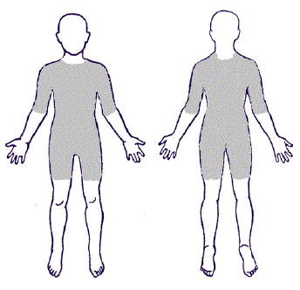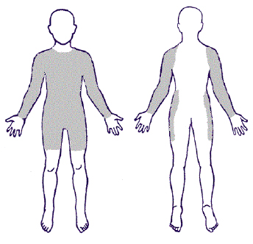

7.2 Arms: Any block using the arm from the elbow to the shoulder.
7.3 Elbow: Any block using the elbow, with the arm bent.
7.4 Whip: An assist given using any part of the body, including legs, arms, elbows, hands, and hips. Skaters may also grasp their own teammates' clothing or equipment to execute whips.
7.5 Arm whips: A skater holds her arm behind her back, while another skater grabs her arm and is propelled forward. No hand holding is allowed when taking whips. A jammer may legally take an arm whip from an opposing blocker if the blocker is not paying attention to whom she is offering the whip. Other types of whips may not be taken from an opposing team member.
7.6 Shoulders: Any block using the shoulder in a backwards or sideways motion.
7.7 Body: Any block using the torso.
7.8 Multi-player Block: One or more skaters hold a teammate, her clothing, or equipment to form a wall. Skaters may not hold hands or hook elbows.
7.9 Rail Block: a skater takes another skater to the rail using her shoulder, torso and/or hips. The blocker must disengage after the block is complete and may not hold the opposing skater at the rail. Primary use of the forearm is not legal in taking a skater to the rail.
7.10 Players may use teammates as objects to stop opposing players. i.e. pushing a teammate into a member of the opposing team to block them.
7.10.1 If a skater is pushed into an opponent by a teammate, the pushed skater is still responsible for any illegal contact she may make.
7.11 Players must keep one skate on the ground in order to maintain control of their bodies when executing blocks so as to not endanger other skaters.
7.12 Players may block while facing forward or backward.
7.13 Players are allowed to block up to 20 feet ahead of or behind the pack (see 8.8 “Illegal Engagement”).

8 PENALTIES:

8.1 Advancement: When a skater re-enters the track ahead of her original position in, or in relation to, the pack. A skater who reenters from out of bounds ahead of her place in the pack can get out of the way, wait for the pack to pass her, and enter from the back of the pack to avoid a penalty.
8.2 Delay of Game: Any activity that consists of an individual or multiple individuals deliberately stalling game play, either during or between jams.
8.3 Failure to Yield: If a blocker is “running” from the opposing jammer, once she is more than 20' away from the pack, she must yield to the jammer when the jammer becomes within 5' of her. To show that she is yielding, she must yield high, allowing enough room for the jammer to pass easily on the inside line. If, in this process, this blocker "runs" to where she is within 20' of the rearmost member of the pack, she is again able to block and does not have to yield to this jammer.
8.4 Forearms: Blocking with a forearm.
8.5 High Blocking: Blocking above the collar bone.
8.6 Holding: Use of the hands or body to pin a skater to the track, ground, or rail.
8.7 Illegal Blocking: Blocking using illegal giving or receiving zones.
8.8 Illegal Engagement:
8.8.1 Blocking an opposing jammer more than 20 feet away from the pack. If a blocker is in front of the pack, 20' will be measured from the front-most member of the pack. If the blocker is behind the pack, 20' will be measured from the rear-most member of the pack. In the event that there is not a clear majority of skaters in a pack, 20' may be measured from the nearest opposing blocker. A jammer may engage the opposing jammer at any point on the track.
8.8.2 Blocking while out of bounds.
8.8.3 Blocking a skater who is out of bounds.
8.8.4 Blocking after returning to the track from out of bounds without first skating a stroke.
8.9 Illegal Procedure: Called when procedural violations occur:
8.9.1 An illegal star pass including a skater who is not the jammer or pivot handing or throwing the star to another skater.
8.9.2 Any attempt or action committed by a jammer’s or pivot’s own team member or an opposing team member with the intent to hold, remove, or retrieve a jammer’s or pivot’s helmet panty.
8.9.3 Any action performed with the intent to hide the jammer panty at any time
8.9.4 Failure by the pivot to put on the jammer panty before attempting to improve her position in the pack.
8.9.5 An illegal block performed on an opposing jammer or pivot as the star is being passed.
8.9.6 Too many skaters on the track after the pack starting whistle has been blown.
8.9.7 Entering the track after the pack starting whistle has been blown.
8.9.8 Fielding an incorrect lineup following a major penalty.
8.9.9 Not fulfilling uniform and safety equipment requirements while on the track (per section 3, “Uniforms”).
    - An illegal whip taken off an opposing skater.
8.9.11 Skating, defined as purposeful and continual forward movement, in a clockwise direction on the track.
8.10 Obstruction: Any activity that impedes the forward progress of the pack during a jam. Remaining on the track while fighting or repairing an equipment malfunction, causing the jam to be called off when the pack approaches, are examples of obstruction.
8.11 Pushing: Any movement of the hands or arms used to propel an opposing skater. Also, movement of the body into the back of a skater, propelling her forward or sideways.
8.12 Tripping: Contact with a skater below her upper thighs, resulting in a fall or significant loss of position in or in relation to the pack. If a skater trips another skater but has “fallen small” by pulling in her arms and legs, no penalty will be given. However, if a skater is involved in multiple tripping incidents even while falling small, a penalty may be given.
8.13 Unnecessary Roughness: Called when a skater uses excessive or unnecessary force. Late hits (after the jam-ending whistle), blocking a skater while stopped, and slide tackles are examples of unnecessary roughness.
8.14 Unsportswomanlike Conduct: Called when a skater is being disrespectful to the referees or opposing team.
8.15 If it cannot be determined which skater is at fault, the penalty is assigned to either the skating Captain, skating Co-Captain, or pivot of the jam in question, in that order. If the Captain, Co-Captain, and pivot already have 2 major penalties, the offending team must skate down a player in the following jam, but a major penalty is not assigned to any one skater.

9 FIGHTING:

9.1 Fighting is an acceptable element of roller derby.
9.2 The rules regarding roughness and conduct still apply.
9.3 Actions which are considered legal while fighting include punching or slapping the helmet, and taking a skater down from behind.
9.4 Actions which are considered illegal while fighting include punching above the collar bone, choking with hands or helmet strap, biting, any type of penetration, pulling hair, and kicking a downed skater.
9.5 Although fighting is an acceptable element of roller derby, skaters may be penalized or ejected from the game for unnecessary roughness or unsportswomanlike conduct per 8.13 and 8.14. For example, a skater taking another skater down from behind with a headlock may be penalized for either unsportswomanlike conduct or unnecessary roughness, depending on the specific situation.

10 MINOR PENALTIES:

10.1 Minor penalties are called if an illegal action has a minor effect on gameplay.
10.2 If a skater has acquired 2 minor penalties during a bout, her third minor penalty will be escalated to a major penalty.
10.3 When a skater is called for a minor penalty, she must complete the penalty face-off selected by the penalty mistress.
10.4 The penalty mistress may not stop the penalty wheel. If the wheel is spun and lands on a penalty face-off that has been completed twice in the bout, the penalty mistress may re-spin the wheel.
10.5 The penalized skater must go first in the penalty challenge.
10.6 If the penalized team loses the penalty challenge, her team will lose one point. If both skaters/teams disqualify themselves during a penalty challenge, no points are taken from either team.
10.7 If 2 or more skaters on the same team receive a minor penalty during a single jam, all skaters should go to the penalty wheel. In the event that tug of war is selected, 2 skaters will compete in the penalty (per 10.11.5.1). In the event the penalty challenge can only be completed by one person, one of the skaters will compete.
10.7.1 The number of skaters at the wheel will equal the number of points which can be lost in a faceoff.
10.7.2 Tag-outs will double the number of points lost.
10.8 Skaters/teams may be disqualified if any other teammates interfere in any way in a penalty face-off, if a skater cuts the track during races, or if a skater violates the safety rules while fighting; the rules regarding 8.13 Unnecessary Roughness, 8.14 Unsportswomanlike Conduct and 9 Fighting still apply.
10.9 Spank Alley (selected from raffle ticket holders) will act as judges for the audience participation penalties. The head referee still has the final say on who wins a penalty dispute, regardless of audience participation and/or judge’s choice.

10.10 Refusing Penalties
10.10.1 No player is allowed to refuse penalties. Following the determination of the penalty face-off, each team has 30 seconds to field a skater who will participate in the face-off. If a team fails to present a player within 30 seconds, they will automatically lose the penalty face-off.
10.10.2 If the player feels she is unable to perform the penalty assigned, she may “tag out” to another team member. If that skater loses the challenge, her team will lose 2 points (refer to 10.7 for multiple skater tag-out situations). Each team may only “tag out” players once every quarter for a total of four times per team per game.
10.11 Possible minor penalty challenges to be given by the Penalty Mistress:
10.11.1 Long Jump
10.11.1.1 One skater from each team skates 1 lap and jumps before hitting the rear pack line. The player who jumps the farthest wins.
10.11.1.2 Both skates must leave the track before hitting the rear pack line.
10.11.1.3 The first part of the skater’s body to touch the track will be judged as the distance jumped.
10.11.2 Pillow Fight
10.11.2.1 The pillow fight begins at the whistle and lasts up to 30 seconds.
10.11.2.2 The rules regarding roughness and conduct still apply.
10.11.2.3 The Judges in Spank Alley decide the winner of the pillow fight.
10.11.2.4 The head referee has the final say, to account for skater disqualification during the challenge, and denotes the winner.
10.11.3 Arm wrestling
10.11.3.1 Arm wrestling begins at the whistle.
10.11.3.2 Skaters must remove their wrist guards while arm wrestling.
10.11.3.3 Each player must remain seated for the duration of the wrestling match.
10.11.3.4 Elbows cannot lift off the elbow pad.
10.11.3.5 Players' non-wrestling arm may rest on the table or hold the arm wrestling grip while arm wrestling or, if no grip is present, they may grip the end of the table.
10.11.3.6 If skaters cannot agree on whether to use their right arm or left arm, a coin will be flipped to decide.
10.11.3.7 Referees may call rematch for false starts.
10.11.4 Two-Lap Duel
10.11.4.1 The two-lap-duel is not just a race; skaters must engage with one another by fighting or other physical contact. If players simply race each other, they may be disqualified.
10.11.4.2 Laps begin at the whistle, and skaters begin and finish at the rear pack line. The winner is the skater who crosses the finish line first without being disqualified.
10.11.4.3 If a skater crosses the finish line without making contact with her opponent, she will be disqualified. Skater to skater contact must result in at least one of the skaters touching at least one knee to the track.
10.11.4.4 If fighting continues for an extended amount of time, the referees may blow the whistle to separate the skaters. At this point, the skaters must stand up and complete the race.
10.11.5 Tug of war
10.11.5.1 Tug of war may be between two or four skaters, depending on how many minor penalties a team has in a single jam (see 10.7).
10.11.5.2 Each skater will hold one end of the rope and line up with the mid-line marker of the rope over the designated line on the track.
10.11.5.3 The rope must be held taut by both skaters before the whistle is blown to start the tug of war.
10.11.5.4 If any part of the skater’s body crosses the designated line or if the skater lets go of the rope, the skater will lose the challenge.
10.11.5.5 Skaters who hold on to or use any part of the track for leverage will be disqualified.
10.11.6 Push Cart
10.11.6.1 Push cart is a race between two teams and consists of two laps around the track.
10.11.6.2 The race begins and ends at the rear pack line, and the first skater to pass the finish line wins.
10.11.6.3 The skater who committed the penalty must do the pushing while another team mate becomes the “cart.” The skater acting as the cart must crouch while being pushed, and must not stride, slalom, or otherwise propel herself during the race.
10.11.6.4 No blocking is allowed during the race, but benign side to side contact between carts is expected and allowed.
10.11.6.5 The pusher and the cart are not required to maintain contact during the race.
10.11.7 Relay Race
10.11.7.1 The relay race is a race between two teams of 3 people each. The first team to finish the relay wins the race.
10.11.7.2 The relay begins and ends at the jammer start line. Skater one starts at the jammer start line and skaters two and three line up in the infield. Skaters enter the track and take her position at the jammer start line once the skater in front of them takes off. Each skater skates one lap in bounds around the track, passes the baton to the next skater in the exchange zone and exits the track while the next skater skates one lap until all skaters have completed one lap.
10.11.7.3 The penalized skater must skate on the relay team. The other two skaters must be from the team’s active skating line up for the game.
10.11.7.4 The exchange zone stretches from the jammer start line to the front pack line. The skaters must pass the baton within the exchange zone or their team will be disqualified.
10.11.7.5 Once a skater passes the baton, she must leave the track immediately, without interfering in the race in any way.
10.11.7.6 If the baton is dropped, the receiving skater must retrieve it and continue the race.
10.11.7.7 Normal giving and receiving zones while blocking apply during the relay race.
10.11.7.8 Blocking is not allowed during the baton pass, in the exchange zone.
10.11.7.9 Referees will announce any disqualification after the relay race is complete.
10.11.8 Judges’ Choice
10.11.8.1 At the beginning of each half, a panel of “judges” will be chosen via random selection. When the “Judges’ Choice” category is selected on the penalty wheel, the judges must choose one of the penalties for the penalized skater, using a simple majority vote.
10.11.8.2 The penalty mistress will coordinate the voting and announce the penalty decided.

11 MAJOR PENALTIES:

11.1 A referee may elevate any minor infraction to a major if the skater’s actions:
11.1.1 Significantly affect the point scoring capabilities of either jammer
11.1.2 Are considered intentional
11.1.3 Are perceived to jeopardize the safety of any skater
11.2 Three major penalties by any one skater will result in ejection from the game (per section 12, “Ejections”).
11.3 Major penalties result in a repeat of the jam with the penalized skater sitting in the penalty box.
11.3.1 If a skater cannot re-skate a jam due to injury, she may be substituted. The injured skater must then sit out 3 jams.
11.4 If 4 or 5 skaters on a team receive a major penalty in a single jam, all major penalties will be documented, but only 3 skaters will sit in the penalty box, and the game will move on to the next jam.
11.5 If the jammer received the major penalty, the team may field a replacement jammer. The replacement must be a skater from that jam’s original line-up.
11.6 In the re-skated jam, jammers score one point for the skater in the penalty box if any opposing skater is scored upon in that jam (see 5.6 “Scoring”).
11.7 If a skater commits a major penalty against a jammer, the jam may be called off immediately. If a skater commits a major penalty against a blocker, the penalty will not be called until the jam is over.
11.8 No single jam will be repeated more than once due to a major penalty.
11.8.1 In the event of a major penalty in a jam that is being re-skated due to a previous major penalty, the penalized team will skate one player down in the next jam.
11.9 Any one team that receives one or more major penalties in three successive jams will lose one point in that jam and every immediately succeeding jam in which the team commits another major penalty. Re-skate policies apply per rule 11.8.
11.10 If a major penalty is committed in the final jam of the 4th quarter or overtime period, the offending team’s jammer forfeits any and all points scored in that jam and the jam will be re-skated with the penalized skater sitting in the penalty box.

12 EJECTIONS:

Referees can eject a skater at any time during the game, regardless of her penalty situation, depending on the skater’s behavior or severity of the infraction.
12.1 Referees may eject a skater from the bout if the skater’s behavior is perceived to be unsafe.
12.2 Three major penalties by any one skater will result in ejection from the game (per 11.2).
12.3 If a skater has the jam called off for an injury three times in any single bout, she will be ejected from the game (per section 5.10, “Injuries”).
12.4 Referees may eject a team manager or coach from the game if he/she is deemed to be
acting in an unsafe manner, or if he/she does not heed warnings about appropriate behavior in
the infield. When a manager or coach is ejected, no further penalty will be assigned to the team
as a result of the incident.
12.5 An ejected skater, manager, or coach must leave the track before the next jam starts.

Appendix II - Skater Membership Forms

All the following are copies of forms all members have signed and submitted to Human Resources upon entry into TXRD. Some are obviously only applicable to skaters, and there are other forms that skaters signed during New Girl training which are not included. If you want copies of these New Girl forms, please email hr@txrd.com.

All members signed a “Member’s Signature Page” from our Regulations, and it’s attached as page 29 in Appendix I.

All forms are confidential and not for reproduction.

WAIVER AND RELEASE OF LIABILITY

In consideration of being allowed participating in any way in TXRD Lonestar Rollergirls athletic/competitive program, and related events and activities, the undersigned:

1. Agree that prior to participating, they will inspect the facilities and equipment to be used, and if they believe anything to be unsafe, they will immediately advise a representative or board member of such condition(s) and refuse to participate.

2. Acknowledge and fully understand that each participant will be engaging in activities that involve risk of serious injury, including permanent disability or even death, which might result not only from their own actions, inactions or negligence, but the actions, inactions or negligence of others, the rules of play, or the condition of the premises or of any equipment used. Further, that there may be other risks not known to us or not reasonably foreseeable at this time.

3. Assume all the foregoing risks and accept personal responsibility for the damages following such injury, permanent disability or death.

4. Hereby release, waive, discharge and covenant not to sue TXRD Lonestar Rollergirls, its affiliate clubs, their respective administrators, board officers, agents, other members, sponsoring agencies, sponsors, advertisers and if applicable, owners and leasers of the premises used to conduct practices and/or events, all of which are herein referred as "releases" from any and all liability to each of the undersigned, for any and all loss, claims, demands, injury, damage, cost or expenses therefore which the undersigned may occur.

The undersigned has read the above waiver and release, and understand that they have given up substantial rights by signing below and have done so voluntarily.

Printed Name: ________________________ Date: __________________

Signature: ______________________________ Date: __________________

TXRD EQUIPMENT AGREEMENT

By signing this agreement you understand that TXRD Lonestar Rollergirls will not be held responsible for injuries that are obtained when not wearing the required safety equipment.

Required Skater Safety Equipment:

Helmet
Kneepads (2)
Elbow Pads (2)
Wrist Guards (2)

You also understand that TXRD is not responsible for injuries obtained outside of scheduled practices when there is not a TXRD trainer present. Injuries received during practice must be reported to a trainer and release to skate after receiving an injury is up to the discretion of the Training Team.

TXRD is not responsible for injuries that occur because of a preexisting condition.

SIGNATURE: _______________________________________________

PRINTED NAME: ____________________________________________

TXRD LONESTAR ROLLERGIRLS
CONFIDENTIALITY AND NON-DISCLOSURE AGREEMENT

THIS AGREEMENT, made this ____ day of __________ (month), _____ (year), between __TXRD Lonestar Rollergirls___, (hereinafter “Disclosing Party”), and _________________________________ (hereinafter “Receiving Party”).

BACKGROUND
The Disclosing Party and Receiving Party wish to discuss and exchange certain items and information related to business programs, products, plans, structure, economics strategy and business topics (the “Invention”) which the parties hereto consider highly confidential and proprietary.
NOW THEREFORE, the parties hereto, intending to be legally bound in consideration of the mutual covenants and agreements set forth herein, hereby agree as follows:
1. DEFINITIONS
1.1. “Invention” shall mean all information relating to business programs, products, plans, structure, economics, strategy and business topics.
1.2. “Confidential Information” shall mean all information provided by Disclosing Party with respect to the Invention regardless of whether it is written, oral, audio tapes, video tapes, computer discs, machines, prototypes, designs, specifications, articles of manufacture, drawings, human or machine readable documents. Confidential Information shall also include all information related to the Invention provided by Disclosing Party to Receiving Party prior to the signing of this agreement. Confidential Information shall not include any of the following:
(a) such information in the public domain at the time of the disclosure, or subsequently comes within the public domain without fault of the Receiving Party;
(b) such information which was in the possession of Receiving Party at the time of disclosure that may be demonstrated by business records of Receiving Party and was not acquired, directly or indirectly, from Disclosing Party; or
(c) such information which Receiving Party acquired after the time of disclosure from a third party who did not require Receiving Party to hold the same in confidence and who did not acquire such technical information from Disclosing Party.
1.3. “Disclosing Party” shall mean the party disclosing information to the other relating to the Invention.
1.4. “Receiving Party” shall mean the party receiving information from the other relating to the Invention.
2. USE OF CONFIDENTIAL INFORMATION
The Receiving Party agrees to:
(a) receive and maintain the Confidential Information in confidence;
(b) examine the Confidential Information at its own expense;
(c) not reproduce the Confidential Information or any part thereof without the express written consent of Disclosing Party;
(d) not, directly or indirectly, make known, divulge, publish or communicate the Confidential Information to any person, firm or corporation without the express written consent of Disclosing Party;
(e) limit the dissemination of the Confidential Information and the disclosure of the Confidential Information received from the Disclosing Party to those persons, if any, related to or associated with the Receiving Party who have a need to know and an obligation to protect it;
(f) not use or utilize the Confidential Information without the express written consent of Disclosing Party;
(g) not use the Confidential Information or any part thereof as a basis for the design or creation of any business or activity similar to any business or activity in the Confidential Information unless expressly authorized in writing by Disclosing Party; and
(h) utilize the best efforts possible to protect and safeguard the Confidential Information from loss, theft, destruction, or the like.
3. RETURN OF CONFIDENTIAL INFORMATION
All information provided by the Disclosing Party shall remain the property of the Disclosing Party. Receiving Party agrees to return all Confidential Information to Disclosing Party within 15 days of written demand by Disclosing Party. When the Receiving Party has finished reviewing the information provided by the Disclosing Party and has made a decision as to whether or not to work with the Disclosing Party, Receiving Party shall return all information to the Disclosing Party without retaining any copies.
4. NON-ASSIGNABLE
This agreement shall be non-assignable by the Receiving Party unless prior written consent of the Disclosing Party is received. If this Agreement is assigned or otherwise transferred, it shall be binding on all successors and assigns.

5. GOVERNING LAW
This Agreement and all questions relating to its validity, interpretation, performance and enforcement (including, without limitation, provisions concerning limitations of actions), shall be governed by and construed in accordance with the laws of the State of Texas, notwithstanding any conflict-of-laws doctrines of such state or other jurisdiction to the contrary, and without the aid of any canon, custom or rule of law requiring construction against the draftsman.
6. No License
Neither party does, by virtue of disclosure of the Confidential Information, either expressly or by implication, grant any right or license to any patent, trade secret, invention, trademark, copyright, or other intellectual property right.
7. Binding Nature of Agreement
This Agreement shall be binding upon and inure to the benefit of the parties hereto and their respective heirs, personal representatives, successors and assigns.
8. Provisions Separable
The provisions of this Agreement are independent of and separable from each other, and no provision shall be affected or rendered invalid or unenforceable by virtue of the fact that for any reason any other or others of them may be invalid or unenforceable in whole or in part.
9. ENTIRE AGREEMENT
This Agreement sets forth all of the covenants, promises, agreements, conditions and understandings between the parties and there are no covenants, promises, agreements or conditions, either oral or written, between them other than herein set forth. No subsequent alteration, amendment, change or addition to this Agreement shall be binding upon either party unless reduced in writing and signed by them.
10. Arbitration
Any controversy or claim arising out of or relating to this Agreement, or the breach thereof, shall be resolved by arbitration conducted by J.A.M.S. and in accordance with the rules thereof, conducted in Austin, Texas, or in any other convenient forum agreed to in writing by the parties. Any arbitration award shall be final and binding, and judgment upon the award rendered pursuant to such arbitration may be entered in any court of proper jurisdiction. Notwithstanding the foregoing, either party may seek and obtain temporary injunctive relief from any court of competent jurisdiction against any improper disclosure of the Confidential Information.

IN WITNESS OF THEIR AGREEMENT, the parties have agreed to it below effective the day and year first written above.
Disclosing Party Receiving Party

By: __________________________ By: __________________________

Name and Likeness Release

I authorize Four on the Floor, LLC; DBA TXRD Lonestar Rollergirls, hereafter referred to as the “Company”, and its assignees, heirs, and representatives, to record, publish, display, sell, grant use, and print my name, likeness; image, and voice (including but not limited to my own or fictional name or identity), for promotional and/or advertising purposes, and at the discretion of the Company. I grant this permission in perpetuity.

This document covers any and all Uses and Purposes (all uses in all current and future media the Company chooses, including but not limited to illustration, advertising, art, publication, trade, collections, reproductions, promotion, editorial, broadcast, products, and sale).

In the event that any action is brought by me or any third parties on my behalf concerning the use of my Likeness, I agree to pay the costs and expenses of the Company for any such legal action, whether or not such action proceeds in judgment.

______________________________________________________________
Name (please print) Signature Date

INNOVATIONS AND PROPRIETARY RIGHTS
ASSIGNMENT AGREEMENT

This Agreement is intended to formalize in writing certain understandings and procedures which have been in effect since the time I was initially involved with Four on the Floor, LLC, DBA Bad Girl, Good Woman Productions, and/or TXRD Lonestar Rollergirls (the “Company”). In return for my new or continued involvement by Company and other good and valuable consideration, the receipt and sufficiency of which I hereby acknowledge, I acknowledge and agree that:

1. Duties; Time Frame; No Conflict. I will perform for Company such duties as may be designated by Company from time to time. I agree that my involvement with Company is for no specified term, and may be terminated by Company at any time, with or without cause, with two weeks notice.. Similarly, I may terminate my involvement with Company at any time, with or without cause, with two weeks notice. During my period of involvement with the Company, I will devote my best efforts to the interests of Company and will not engage in other involvement or in any activities determined by Company to be detrimental to the best interests of Company without the prior written consent of Company.

2. Prior Work. All previous work done by me for Company relating in any way to the conception, reduction to practice, creation, derivation, design, development, manufacture, sale or support of products or services for Company is the property of Company, and I hereby assign to Company all of my right, title and interest in and to such previous work.

3. Proprietary Information. My involvement creates a relationship of confidence and trust between Company and me with respect to any information:
(a) Applicable to the business of Company; or
(b) Applicable to the business of any client or customer of Company, which may be made known to me by Company or by any client or customer of Company, or learned by me in such context during the period of my involvement.

All such information has commercial value in the business in which Company is engaged and is hereinafter called “Proprietary Information.” By way of illustration, but not limitation, Proprietary Information includes any and all technical and non-technical information including patent, copyright, trade secret, and proprietary information, techniques, sketches, drawings, models, inventions, know-how, processes, apparatus, equipment, plans, structures, economics, strategy and business topics related to the current, future, and proposed products and services of Company, and includes, without limitation, respective information concerning research, experimental work, development, design details and specifications, engineering, financial information, procurement requirements, purchasing manufacturing, customer lists, business forecasts, sales and merchandising and marketing plans and information. “Proprietary Information" also includes proprietary or confidential information of any third party who may disclose such information to Company or to me in the course of Company's business.

4. Ownership and Nondisclosure of Proprietary Information. All Proprietary Information is the sole property of Company, Company's assigns, and Company's customers, and Company, Company's assigns and Company's customers shall be the sole and exclusive owner of all patents, copyrights, mask works, trade secrets and other rights in the Proprietary Information. I hereby do and will assign to Company all rights, title and interest I may have or acquire in the Proprietary Information. At all times, both during my involvement by Company and after termination of such involvement, I will keep in confidence and trust all Proprietary Information, and I will not use or disclose any Proprietary Information or anything directly relating to Proprietary Information without the written consent of Company, except as may be necessary in the ordinary course of performing my duties as an employee of Company.

5. Ownership and Return of Materials. All materials (including, without limitation, documents, drawings, models, apparatus, sketches, designs, lists, and all other tangible media of expression) furnished to me by Company shall remain the property of Company. Upon termination of my involvement, or at any time on the request of Company before termination, I will promptly (but no later than five (5) days after the earlier of my involvement's termination or Company's request) destroy or deliver to Company, at Company's option, (a) all materials furnished to me by Company, (b) all tangible media of expression which are in my possession and which incorporate any Proprietary Information or otherwise relate to Company's business, and (c) written certification of my compliance with my obligations under this sentence.

6. Innovations. As used in this Agreement, the term "Innovations" means all processes, machines, manufactures, compositions of matter, improvements, inventions (whether or not protectable under patent laws), works of authorship, information fixed in any tangible medium of expression (whether or not protectable under copyright laws), moral rights, mask works, trademarks, trade names, trade dress, trade secrets, know-how, ideas (whether or not protectable under trade secret laws), and all other subject matter protectable under patent, copyright, moral right, mask work, trademark, trade secret or other laws, and includes without limitation all new or useful art, combinations, discoveries, furmulae, manufacturing techniques, technical developments, discoveries, artwork, software, and designs. "Innovations" includes "Inventions," which is defined to mean any inventions protected under patent laws.

7. Assignment of Innovations: License of Prior Innovations. I hereby agree promptly to disclose and describe to Company, and I hereby do and will assign to Company or Company's designee my entire right, title, and interest in and to, (a) each of the Innovations (including Inventions), and any associated intellectual property rights, which I may solely or jointly conceive, reduce to practice, create, derive, develop or make during the period of my involvement with Company, which either (i) relate, at the time of conception, reduction to practice, creation, derivation, development, or making of such Innovation, to Company's business or actual or demonstrably anticipated research or development, or (ii) were developed on any amount of Company's time or with the use of any of Company's equipment, supplies, facilities or trade secret information, or (iii) resulted from any work I performed for Company, and (b) each of the Innovations which is not an Invention (as demonstrated by me by evidence meeting: the clear and convincing standard of proof), and any associated intellectual property rights, which I may solely or jointly conceive, develop, reduce to practice, create, derive, develop, or make during the period of my involvement with Company, which are applicable to the business of Company (collectively, the Innovations identified in clauses (s) and (b) are hereinafter the “Company Innovations”). To the extent any of the rights, title and interest in and to Company Innovations cannot be assigned by me to Company, I hereby grant to Company an exclusive, royalty free, transferable, irrevocable, worldwide license (with rights to sublicense through multiple tiers of sublicensees) to practice such non-assignable rights, title and interest. To the extent any of the rights, title and interest in and to Company Innovations can be neither assigned nor licensed by me to Company, I hereby irrevocably waive and agree never to assert such non-assignable and non-licensable rights, title and interest against Company or any of Company's successors in interest to such non-assignable and non-licensable rights. I hereby grant to Company or Company's designees a royalty free, irrevocable, worldwide license (with rights to sublicense through multiple tiers of sublicensees) to practice all applicable patent, copyright, moral right, mask work, trade secret and other intellectual property rights relating to any Innovations, applicable to tile business of Company or relating in any way to Company's business or demonstrably anticipated research and development or business, which were conceived, reduced to practice, created, derived, developed, or made by me prior to my involvement with Company (collectively, the “Prior Innovations”) which I incorporate, or permit to be incorporated, in any Company Innovations. Notwithstanding the foregoing, I agree that I will not incorporate, or permit to be incorporated, any Prior Innovations in any Company Innovations without Company’s prior written consent.

8. Future Innovations. I recognize that Innovations or Proprietary Information relating to my activities while involved with the Company and conceived, reduced to practice, created, derived, developed, or made by me, alone or with others, within. three (3) months after termination of my involvement may have been conceived, reduced to practice, created, derived, developed, or made, as applicable, in significant part while employed by Company. Accordingly, I agree that such Innovations and Proprietary Information shall be presumd to have been conceived, reduced to practice, created, derived, developed, or made, as applicable, during my involvement with Company and are to be promptly assigned to Company unless and until I have established the contrary by written evidence satisfying the clear and convincing standard of proof.

9. Cooperation in Perfecting Rights to Proprietary Information and Innovations.

(a) I agree to perform, during and after my involvement, all acts deemed necessary or desirable by Company to permit and assist Company, at Company's expense, in obtaining and enforcing the full benefits, enjoyment, rights and title throughout the world in the Proprietary Information and Innovations assigned or licensed to, or whose rights are irrevocably waived and shall not be asserted against, Company under this Agreement. Such acts may include, but are not limited to, execution of documents and assistance or cooperation (i) in the filing, prosecution, registration, and memorialization of assignment of any applicable patents, copyrights, mask work, or other applications, (ii) in the enforcement of any applicable patents, copyrights, mask work, moral rights, trade secrets, or other proprietary rights, and (iii) in other legal proceedings related to the Proprietary Information or Innovations.

(b) In the event that Company is unable for any reason to secure my signature to any document required to file, prosecute, register, or memorialize the assignment of any patent, copyright, mask work or other applications or to enforce any patent, copyright, mask work, moral right, trade secret or other proprietary right under any Proprietary Information (including improvements thereof) or any Innovations (including derivative works, improvements, renewals, extensions, continuations. divisionals. continuations in part, continuing patent applications, reissues, and reexaminations thereof), I hereby irrevocably designate and appoint Company and Company's duly authorized officers and agents as my agents and attorneys-in-fact to act for and on my behalf and instead of me, (i) to execute, file, prosecute, register and memorialize the assignment of any such application, (ii) to execute and file any documentation required for such enforcement, and (iii) to do all other lawfully permitted acts to further the filing, prosecution, registration, memorialization of assignment, issuance, and enforcement of patents, copyrights. mask works, moral rights, trade secrets or other rights under the Proprietary Information, or Innovations, all with the same legal force and effect as if executed by me.

10. No Violation of Rights of Third Parties. My performance of all the terms of this Agreement and as an employee of Company does not and will not breach any agreement to keep in confidence proprietary information, knowledge or data acquired by me prior to my involvement with Company, and I will not disclose to Company, or induce Company to use, any confidential or proprietary information or material belonging to any previous employer or others. I am not a party to any other agreement which will interfere with my full compliance with this Agreement. I agree not to enter into any agreement, whether written or oral, in conflict with the provisions of this Agreement.

11. No Solicitation. During the term of my involvement with Company and for a period of two (2) years thereafter, I will not solicit, encourage, or cause others to solicit or encourage any employees, contractors, consultants or volunteers of Company to terminate their involvement with Company.

12. Survival. This Agreement (a) shall survive my involvement with the Company; (b) does not in any way restrict my right or the right of the Company to terminate my involvement at any time, for any reason or for no reason; (c) inures to the benefit of successors and assigns of Company; and (d) is binding upon my heirs and legal representatives.

13. Injuctive Relief. A breach of any of the promises or agreements contained herein will result in irreparable and continuing damage to Company for which there will be no adequate remedy at law, and Company shall be entitled to injunctive relief and/or a decree for specific performance, and such other relief as maybe proper (including monetary damages if appropriate).

14. Notices. Any notice required or permitted by this Agreement shall be in writing and shall be delivered as follows, with notice deemed given as indicated: (a) by personal delivery, when delivered personally; (b) by overnight courier, upon written verification of receipt; (c) by telecopy or facsimile transmission, upon acknowledgment of receipt of electronic transmission; or (d) by certified or registered mail, return receipt requested, upon verification of receipt. Notices to me shall be sent to any address in Company's records or such other address as I may specify in writing. Notices to Company shall be sent to to such address as Company may specify in writing.

15. Governing Law. This Agreement shall be governed in all respects by the laws of the United States of America and by the laws of the State of Texas. Each of the parties irrevocably consents to the exclusive personal jurisdiction of the federal and state courts located in Texas, as applicable, for any matter arising out of or relating to this Agreement, except that in actions seeking to enforce any order or any judgment of such federal or state courts located in Travis County Texas, such personal jurisdiction shall be nonexclusive.

16. Severability. If any provision of this Agreement is held by a court of law to be illegal, invalid or unenforcable, (i) that provision shall be deemed amended to achieve as nearly as possible the same economic effect as the original provision, and (ii) the legality, validity and enforceability of the remaining provisions of this Agreement shall not be affected or impaired thereby

17. Waiver; Amendment; Modification. The waiver by Company of a term or provision of this Agreement, or of a breach of any provision of this Agreement by me, shall not be effective unless such waiver is in writing signed by Company. No waiver by Company of, or consent by Company to, a breach by me, will constitute a waiver of, consent to or excuse of any other or subsequent breach by me. This Agreement may be amended or modified only with the written consent of both me and Company. No oral waiver, amendment or modification shall be effective under any circumstances whatsoever.

18. Entire Agreement. This Agreement represents my entire understanding with Company with respect to the subject matter of this Agreement and supersedes all previous understandings, written or oral.

I certify and acknowledge that I have carefully read all of the provisions of this Agreement and that I understand and will fully and faithfully comply with such provisions.

COMPANY: INDIVIDUAL:

Four on the Floor, LLC _____________________________________

By: ___________________________________ Name : __________________________________

Date: __________________________________ Date: ________________________________

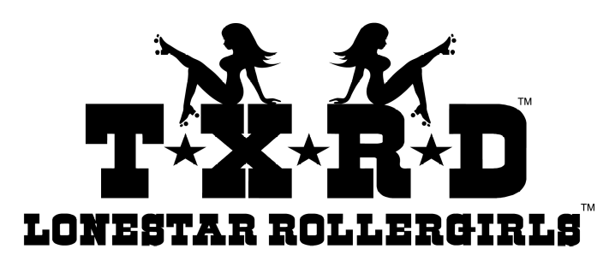

Exclusive Membership Agreement

While retaining membership in TXRD, skaters may not participate with another roller derby league, except with the expressed permission of Human Resources and the Training Team. While the league encourages members to contact and visit outside leagues, any participation with an outside roller derby league must be disclosed to TXRD Human Resources. Utilizing the Inter-League Liaison Manager does not constitute Human Resources communication. Examples of inter-league participation include but are not limited to: visiting other leagues while on vacation, invitational bouting, bouting for a team in which a skater had previous membership, etc. Any promotional use of TXRD skater images or names falls under the Innovations & Endorsement Agreement and Name & Likeness Release guidelines, and all policies therein apply. Permission must be requested no later than 48 hours in advance of any outside league participation.

Any injury incurred while participating with an outside roller derby league must be reported to the Training Team Injury Coordinator within 48 hours of the occurrence.

In order to receive practice credit for any training undertaken with another league, credit must be requested and approved through the Training Team before said training has occurred. Standards for practice credit within TXRD as determined by the Training Team also apply to practices in other leagues. Approval is at the discretion of the Training Team manager. It is the responsibility of the requesting party both to ensure that the Training Team Manager is in touch with the outside training party regarding the details of any practice and to follow-up on their attendance record.

I verify that I have read the above information and agree to conduct myself within these standards. Failure to comply may subject me to disciplinary action.

Signed: ______________________________________Date: _________________

Skate Name: _______________________________________

TXRD Member Information Sheet

In order for TXRD to comply with tax regulations, we must have all Members’ names, Social Security Numbers, and home addresses on file. The first part of this form is for those purposes. The second half is contact information for league purposes. You may have given this information already, and possibly recently, but we are attempting to keep records current by having one of these in each Member’s file. Please fill this out and return to HR. This form will be kept confidential.

Full, legal name: ____________________________________________________

SSN: _____________________________________________________________

Full Address with Zip: ________________________________________________

__________________________________________________________________

Phone Numbers - OK to use for derby:

Home: ______________________________________________________

Cell: ________________________________________________________

Work: ________________________________________________________

Non-TXRD email address: _________________________________________

TXRD Rules/Policies of the Game

I have read and fully understand the Training Team Rules. I have received a personal copy for my reference.

I agree to follow the rules/policies stated.

Name: __________________________________________

Date: _________________________________________
Appendix III
TXRD
Strategic
Plan
November 1, 2011
Prepared by
Sindra Dee / Molly Wofford

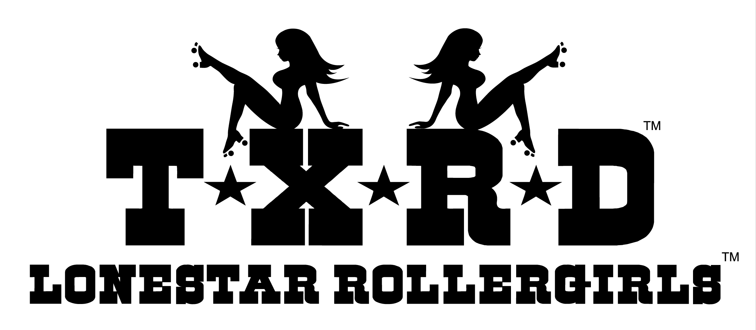
Strategic Business Plan
2012 - 2015
CONFIDENTIAL: FOR TXRD MEMBERS ONLY

Table of Contents
Situational Analysis 69
SWOT: Strengths, Weaknesses, Opportunities and Threats 69
Financial Summary 67
Mission & Vision 69
Mission Statement 69
Vision Statement 69
Goals, Strategies and Measurements 70
Goal 1: Be financially stable. 715
Goal 2: Foster the growth of roller derby communities, both TXRD and worldwide. 748
Goal 3: Maintain excellent internal communications & interdepartmental cooperation. 79
Goal 4: Keep a high profile for TXRD in the Austin community. 76
Goal 5: Perpetuate TXRD as entertainment; leverage our fame as “Rollergirls” to generate awareness of and interest in the sport of roller derby. 77
Goal 6: Secure a home as both practice and performance space. 77
Goal 7: Develop the athletic and performance skills of our skaters while ensuring their safety. 78
Goal 8: Foster positive, healthy relationships between TXRD league members. Keep TXRD membership fun! 79
Revised Organizational Chart 80
Financial Projections (2012-2014) 84
Board of Directors: Next Steps 87
Appendix I. Methodology and Research Results 882
League Member Survey 88
Response Rate/Sample Profile 88
Results Summary 88
Full Survey Results 89
Manager Interviews 102
Interview List – names, dates 102
Questions / Discussion Topics 102
Appendix II. Financial Statements (2008-2011 to date) 103

Situational Analysis

SWOT: Strengths, Weaknesses, Opportunities and Threats
Every organization has Strengths, Weaknesses, Opportunities and Threats that, combined, help describe the current condition of the business and its competitive situation. A ‘SWOT’ analysis for TXRD is outlined below.
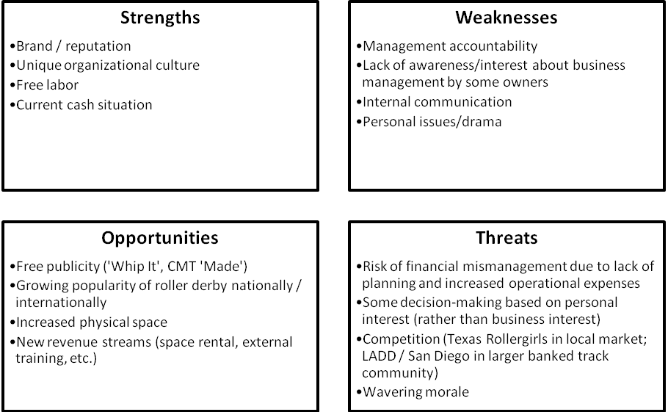

Strengths
TXRD’s most enduring strengths – its brand, culture and cadre of dedicated free laborers - have sustained it over the years, even when times were tough. Currently, TXRD is also in a strong cash position which allows it the luxury of deciding how to invest its resources – hopefully towards the long-term sustainability of business operations.
The brand of TXRD Lonestar Rollergirls associated with themes of female independence, strength, rebellion and sexiness. It incorporates everything that a fan experiences when they come to a bout or check out the website. Similarly, TXRD helped make roller derby a pop culture phenomenon - its reputation as the league that started the roller derby revival is one of the reasons why the league is featured in television, film, books, etc.
TXRD’s unique organizational culture of a DIY business unrestrained by convention and owned co-operatively by its members creates a kind of (albeit sometimes dysfunctional) ‘family’ that people want to be a part of. The league’s rich history, democratic decision-making and party atmosphere attract league members and die-hard fans.
The difference between the league’s brand and culture is subtle, but distinct. TXRD’s brand is the reason why people join the league; the unique organizational culture is what makes them stick around and work so hard to make it a success.
Additionally, TXRD benefits from the skills, experience and time contributed at no cost by a workforce of 100+ business owners and volunteers. Free labor is what keeps TXRD’s day-to-day operations functioning. If the league had to compensate its entire workforce financially, it would not exist as the TXRD we know and love.
TXRD’s brand is the reason why people join the league; the unique organizational culture is what makes them stick around and work so hard to make it a success.
Finally, TXRD is currently in a strong cash position that many veteran skaters and owners, in particular, appreciate because it certainly has not always been the case. For many years, the league collected dues from members and held fundraisers to keep the lights on and doors open. The current cash-rich situation is due in part to increased sales resulting from the publicity of the film ‘Whip It’, but also in part due to the fiscally conservative mentality ingrained from years of hardship. However, it may be time for the league to transition carefully from a ‘scrimp and save’ mindset to an ‘invest in the future’ approach to financial management.

Weaknesses
One of the weaknesses that comes with having a volunteer workforce is lack of management accountability. TXRD currently has difficulty recruiting competent managers who have time to dedicate to league operations, and no realistic recourse to reprimand or remove ineffective managers. This has resulted in problems in several key areas of the business.
The heightened level of constant interpersonal conflict is the biggest barrier to progress that TXRD currently faces.
Furthermore, the leagues’ cooperative ownership structure means that anyone who wants to skate has to be a league member/owner. (Non-skating members have to demonstrate their dedication and interest in the business in other ways.) But not all members have equal interest in business operations. Some people got involved because they want to skate – not because they want to ensure the financial solvency of the company.
The sheer number of owners and contributors makes internal communication a challenge that the league has struggled with for years. Over the years, the league has increasingly used technology to facilitate the flow of information; however, not all league members have regular access to a computer.
But it seems the most frustrating issue facing the league is personal issues and drama among league members/owners. This problem was mentioned most often in both survey results and in manager interviews. Tensions between league members pop up on the Yahoo group regularly (despite constant reminders from mediators), interfere in day-to-day operations, affect all levels of management, and adversely affect league morale. It seems natural that a roller derby league attracts members with aggressive personalities, but the heightened level of constant interpersonal conflict is the biggest barrier to progress that TXRD currently faces. If league members found ways to cooperate and work together, they may find more time and energy to devote to business operations and collectively address the other challenges the league is dealing with.

Opportunities
TXRD must leverage these (publicity) opportunities over the long-term, so that new fans are continually developed beyond the specific publicity event.
In the last five years, TXRD has gained the attention of Hollywood creating free publicity opportunities through the A&E Documentary ‘Rollergirls’, Drew Barrymore’s film ‘Whip It’, CMT’s episode of ‘Made’, etc. – all featuring the league. These opportunities create a flux of public attention to the league that has pushed ticket sales to maximum capacity. TXRD must leverage these opportunities over the long-term so that new fans are continually developed beyond the specific publicity event.
Roller derby is growing in popularity both in the U.S. and globally. TXRD has the opportunity to promote its unique style of the sport among new leagues and fans. One way the league is seeking to do this is through the promotion of TXRD’s style as the brand of ‘Texas Rollerderby’, much like ‘Texas Hold ‘Em’ is a specific style of poker.
TXRD recently signed a 5-year lease for a larger facility in north Austin. This increased physical space may allow for easier internal training, but is also an asset which can (and should) be leveraged through new revenue streams such as space rental for external trainers or leagues and hosting external training events (boot camps, conferences, etc.)

Threats
Some business decisions are made based on the best interests of the personnel involved rather than the most efficient use of resources.
Prior to this study, TXRD had not undertaken any in-depth financial or business planning to support the long-term sustainability of the league. Combined with the increased operational expenses due to the new lease, this creates a threat of potential financial mismanagement. However, the current Board of Directors has expressed clear interest in developing and implementing strategies which will prevent this threat from becoming a reality.
One alarming discovery that emerged in the manager interviews (and some anecdotal stories) conducted for this research is that some business decisions are made based on the best interests of the personnel involved in terms of time available, convenience, personal preferences, etc. rather than the most efficient use of resources (human, financial, etc.). The recent global economic crisis is a great example of how this dangerous practice has the potential to increase costs, create delays, and make short-sighted management decisions that affect the business as a whole, not just the individuals involved. Managers must be incentivized to prioritize the league’s long-term interests in all business decisions.
TXRD is the only banked-track roller derby league in Austin and has ‘first-mover advantage’ in the roller derby revival; thus, competition isn’t as much of a concern as in most other businesses. However, the league’s complex history and relationship to Texas Rollergirls, the local flat-track league, has caused confusion with branding and competition for fans (and potentially sponsors) among the general public. Within the banked-track roller derby community, TXRD’s main competition as the leading league is likely the L.A. Derby Dolls. Although LADD operates under a different business model (NOT skater-owned), some TXRD skaters and fans envy the ‘Dollhouse’ as a practice/performance space. Additionally, TXRD has not performed as well as expected in the recent banked-track tournaments, though this has had minimal (if any) effects on the league’s financial performance.
TXRD must continue to find creative ways to incentivize membership and keep managers motivated and cooperative for the organization to grow and thrive.
Finally, the league struggles constantly to maintain the morale of its members. Echoing themes from multiple management interviews were overwork and under-appreciation. Of course, when everyone is focusing on his/her own tasks, there is minimal time to acknowledge the hard work of others. Decline in league morale appears to be exasperated by personal conflicts among members. TXRD must continue to find creative ways to incentivize membership and keep managers motivated and cooperative for the organization to grow and thrive.

Financial Summary
TXRD’s Accounting Manager, Varuca Assault, has recently prepared a comprehensive analysis of the league’s current financial situation, which will not be repeated here. However, financial highlights from the most recent financial statements available (Jul 29, 2011) include:
- Current (cash) assets of over $122,000, with fixed and other assets around $9,000.
- Liabilities include almost $25,000 in payables to members, with almost $2,500 in the Tulsa Fund.
TXRD is currently in a strong cash position, but… will need to strategically maximize revenue over the long-term to sustain and secure its financial success.
- Retained earnings (past years’ profits) of over $100,000.
According to Varuca, current monthly expenses run roughly $10-12,000. The league has enough cash to cover 3-months of expenses in a cash reserve, and should determine appropriate spending/savings for the remainder. Immediate cash needs that emerged during the research conducted for this report include:
- Replacement of the practice track (ASAP)
- Market research/publicity strategy and/or implementation
- Re-design and purchase of new merch inventory
- Potential compensation contracts for HR needs which cannot be filled internally by league members
The BOD should work closely with the managers of relevant departments to ensure that all expenditures contribute to the achievement of the league’s long-term goals.
Once immediate cash expenditures are determined, the league should contract a certified financial advisor who can provide guidance on short- and long-term savings and investment vehicles which will meet the league’s financial goals while ensuring sufficient liquidity to cover any business emergencies which may arise.
In summary, TXRD is currently in a strong cash position, but also faces increased liabilities due to its new lease. The league will need to strategically maximize revenue over the long-term to sustain and secure its financial success.

Mission & Vision
Overall, the current league Mission and Vision Statements were re-affirmed with over a majority of responses to the survey conducted in June 2011.

Mission Statement
71% of respondents felt that the following statement fully reflects the current mission of TXRD:
‘Mission Statement: TXRD—Lonestar Rollergirls, or our legal partnership of Four on the Floor, LLC, exists and operates to:
- Ensure the safety of the skaters
- Promote the sport of roller derby in Austin and beyond
- Generate enough income to sustain and perpetuate TXRD bouts’
In response to specific survey response suggestions about wording and order, I propose the following revised version be put to a league vote:
‘Mission Statement: TXRD—Lonestar Rollergirls, or our legal partnership of Four on the Floor, LLC, exists and operates to:
- Provide unique and quality entertainment which generates sufficient income to sustain and perpetuate TXRD bouts
- Promote the sport of roller derby in Austin and beyond
- Ensure the safety and continued skill development of the skaters
- Support the empowerment of girls and young women.’

Vision Statement
A majority (60%) of respondents felt that the following statement accurately reflects the current vision of TXRD, although with slightly less support of this verbiage than that of the Mission Statement.
‘Vision Statement: Ensure a spirit of cooperation and volunteerism is retained in our community while fostering the development of other roller derby communities.’
In response to specific suggestions about wording and themes for the vision statement, I propose the following revised version be put to a league vote:
‘Vision Statement: To be a strong, self-sustaining organization that enriches the lives of its members and enhances the spirit of its community through our shared passion for the sport of roller derby, our dedication to the empowerment of women and our unyielding commitment to having fun!’

Goals, Strategies and Measurements
A survey of current league membership re-affirmed the goals set in 2008. The existing goals are as follows:
League Goals: These may change periodically, and may be altered by the Board, and/or a league vote to reflect new knowledge, opportunities or directions. Goals are really part of the Mission Statement, and it may be altered from time to time.
From league vote, May 2008:
- Be financially stable.
- Foster roller derby communities, both in TXRD and worldwide.
- Maintain excellent intra-league communications & interdepartmental cooperation.
- Keep a high profile for TXRD in Austin community
- Perpetuate TXRD as an entertainment, use fame as “Rollergirls” to leverage awareness and interest
- Maintain interest in the community with marketing/PR opportunities (keep up ticket sales, participate with local charities).
- Secure a home as both practice and performance space.
- Develop athletic and performance skills of our skaters, while maintaining their safety.
- Foster positive relationships between TXRD league members (platonic—Don’t Do Derby). Keep TXRD membership fun!
In response to the TXRD board’s request for minor adjustments for grammar and clarification, proposed revisions are underlined as follows:
Each goal should have strategies designed to support its achievement, tactics which provide specific steps to take, measurements/deliverables established to determine success, and ownership by a Director to lead/monitor progress.
League Goals: Goals may be altered periodically by the Board and/or a league vote to reflect new knowledge, opportunities or directions.
From league vote, May 2008 and re-affirmed in June 2011:
- Be financially stable.
- Foster the growth of roller derby communities, both TXRD and worldwide.
- Maintain excellent internal communications & interdepartmental cooperation.
- Keep a high profile for TXRD in the Austin community by participating in charitable events and other marketing/PR opportunities. (Combine with goal 6)
- Perpetuate TXRD as entertainment; leverage our fame as “Rollergirls” to generate awareness of and interest in the sport of roller derby.
- Maintain a strong presence in the Austin community by participating in charitable events and other marketing/PR opportunities. (Recommend combining with goal 4 – wording is unclear, but seems to overlap in purpose.)
- Secure a home as both practice and performance space.
- Develop the athletic and performance skills of our skaters while ensuring their safety.
- Foster positive, healthy relationships between TXRD league members. Keep TXRD membership fun!

Each goal should have strategies designed to support its achievement, tactics which provide specific steps to take, measurements/deliverables established to determine success, and ownership by a Director to lead/monitor progress. (Directors’ performance in the role could easily be gauged by progress toward assigned goals and deliverables.)

Suggestions for strategies, tactics and measurements/deliverables for each goal are described in the section below. Discussion/adjustments will be needed by the Board of Directors, along with assignment of each goal to a specific Director for oversight. (Note: New proposed verbiage for each goal was used to increase clarity.)

Goal 1: Be financially stable.

The league has done a great job of building its cash reserves significantly, resulting in the elimination of member dues and more ‘breathing room’ to cover operational expenses. However, being financially stable means much more than having money in the bank. It also involves:
TXRD must increase revenue to meet financial obligations over the next three to five years.
- Leveraging assets (cash, investments, facilities, etc.) to ensure maximum possible income
- Carefully monitoring expenses
- Having security against financial and other business risks
- Ensuring accurate financial record-keeping and compliance with legal tax requirements
- Investing in the long-term sustainability of league operations

Additionally, TXRD must increase revenue to meet its financial obligations over the next three to five years.

(Note: In typical businesses, financial management is all about maximizing value for the shareholder. However, in TXRD’s case, few members expect to derive financial benefits from their investment in the league and thus, it has not historically been a priority to ensure dividends are taken regularly.)

Strategy | Tactic | Measurement/Deliverable
- Maximize existing revenue: Ticket Sales for 2012 season at Palmer Auditorium | - Get butts in seats for the 2012 season. Currently planning for 85% capacity at ALL bouts. Sell out as much as possible.  - Hire a professional marketing firm with the specific objective of achieving 85%+ capacity, even in the summer months.  - Invest in strategic marketing that will guarantee a reasonable return on the cost of media placement, etc. | - Increased expense line item for marketing/PR investment  - Written bids from marketing/PR firms  - Contract with selected marketing/PR firm  - 85% capacity reached in 2012 season, resulting in ticket sales of at least $262,000.
- Maximize existing revenue: Ticket Sales for 2013 and beyond | - Move back to the Convention Center for 2013 OR immediately explore alternatives that will hold additional capacity. (NOTE: Personal issues between TXRD management and City facility managers is NOT a good enough reason to pass up an extra 50% of potential capacity per bout.)  - Make the facility contract negotiation and relationship at the BOD level. It is one of the most significant financial commitments made by the league.) | - Detailed cost-benefit analysis of venue options for 2013.  - Contract with venue for 2013.  - Revision of job descriptions to include facility contract negotiations at BOD level.
- Maximize existing revenue: Merch - New designs | - Add a position to the org chart with responsibility for getting new designs and products ASAP. If position isn’t filled immediately, outsource the responsibility.  - Set Merch sales goal of $62,000 for 2012 and purchasing budget of $18,000 (or revised figures as appropriate).  - BOD should check in monthly to monitor progress toward sales goals. | - New organizational chart OR merchandising company  - Written sales goals and purchasing budget agreed with Merch Manager.  - Meeting notes from monthly BOD/Merch Manager meetings.
- Maximize existing revenue: Online Merch (Note: Outsource if necessary – this is a money-maker and currently a HUGE missed opportunity when considering the league’s interest in building the brand beyond Austin, TX.) | - Keep the online merch portal updated, attractive and functional AT ALL TIMES.  - Update site immediately to reflect current inventory.  - Make sure orders are being filled and shipped in a timely manner. | - BOD review online merch portal monthly  - Develop an online merch order/shipping log to document processing time.
- Maximize existing revenue: Merch - League Member Discount | - Conduct a detailed financial analysis to consider a possible re-structuring of league member discount. (Note: Currently skaters are the first to get any new team-specific gear, sometimes at the risk of depleting inventory for full-price customers. Make the necessary adjustments so that skaters can still afford to buy the stuff, and TXRD can still make a profit. Or just order more inventory! League members wearing TXRD is ‘free’ marketing.) | - Cost analysis of league member merch sales.
- Maximize existing revenue: Sponsorship | - Put a cap and specific requirements on any in-kind sponsorships (non-cash).  - Consider adding a sponsorship requirement to league membership to increase the accountability of each league member for some tangible ($$) component of league revenue.  - Make sure the Sponsorship Team Liaisons are strong, active and providing actual support needed to drive CASH sponsorship revenue.  - Set cash Sponsorship goal of $25,000 for 2012, with 10% increase annually. | - Edited Sponsorship structure and written goals, agreed with Sponsorship Manager  - Possible addition to league member requirements in SOTU.
- Develop new revenue streams: Space Rental | - Assign a new position responsible for managing negotiations, contracts and relationships with external trainers who rent space at the warehouse. Lease space as appropriate to maximize use of warehouse capacity at all times. | - Space rental revenue of $18,000 in 2012  - Contracts with external trainers/space rental tenants
- Develop new revenue streams: External Training | - Assign a new position responsible for bringing in external training revenue by organizing and selling three (3) boot camps per year, 20 participants each, for $195 per person. | - Training event revenue of $11,700 in 2012
- Develop new revenue streams: Private Parties/Bouts | - Assign a new position responsible for bringing in external revenue for hosting private parties/bouts at the warehouse (check lease/permitting/logistics feasibility prior to implementation). | - Private party/bout revenue of $8,000 in 2012.
- Ensure financial security against any loss of income. (Short-term) | - Continue to maintain cash reserve to cover a minimum of 3 months’ operating expenses (possibly more). Specific cash savings amount to be determined by Accounting Manager upon review of monthly operating expenses. (Currently $10-$12,000 per month – total of $30-36,000 cash reserve). | - Monthly bank account statements showing minimum cash reserve amount
- Ensure financial security maximizing return on assets. (Long-term) | - Determine specific long-term financial goals (purchase $30,000 performance track every five years and $25,000 practice track every ten years, for example), and work with a certified financial planner to invest appropriately in CDs, mutual funds, etc. | - Notes from quarterly meetings with financial planner.  - Quarterly financial report published to league members.
- Monitor and plan for upcoming expenditures. (Short-term) | - Conduct department planning session with each manager semiannually, including thorough financial review. | - Meeting notes from semiannual planning sessions.
- Keep long-term projections updated and make informed financial decisions. | - Update financial projections and annual budget at least once a year. | - Quarterly financial report published to league members.  - Updated Annual Projections every offseason.
- Ensure appropriate management organization and accountability. | - Re-organize the business management structure to focus the most significant resources (both human and financial) on the most important and high-growth revenue areas. Prioritize designing an effective structure that makes sense for the long-term rather than re-shuffling current individuals due to skills/abilities or personal relationships. | - New organizational chart and job descriptions
- Ensure accountability and transparency at every level of management. | - Ensure that all board members have a firm grasp of the league’s financial situation AT ALL TIMES, as their primary responsibility is to ensure the sustainability of league operations.  - Consider adding a financial update to each board meeting.  - Consider re-designing skater ticket sales process to ensure that all tickets and revenue are accounted for AT ALL TIMES.  - Track the number of tickets sold for each bout. | - Accurate financial records at all times  - Accurate count of tickets sold for each bout, broken down by type (door/vendor/skater)  - Zero outstanding skater ticket balance after each bout.  - Quarterly financial report published to league members.
- Incentivize effective management performance; improve or remove ineffective managers | - Offer a $50 gift card at each League Meeting awarded to an outstanding manager (BOD or league member can nominate, BOD votes for recipient)  - Provide refreshments at all manager meetings  - Develop formal procedure to improve or remove ineffective managers | - Retention line item in financial projections  - Written procedure to improve/remove ineffective managers in Ops Manual

Goal 2: Foster the growth of roller derby communities, both TXRD and worldwide.
TXRD has been actively involved in the growth of other leagues through the Interleague Department. TXRD skaters have trained leagues across the globe and helped other leagues by providing advice and guidance on various aspects of operations, especially with regard to banked-track derby specifically. However, TXRD’s investment of time and energy in interleague activity is in need of specific direction. Interviews conducted for this study found that:
- Participation in the W.O.R.D. organization over the last 4 years has not yielded and financial or other tangible gains for TXRD, seems to lack league support and may not be an optimum strategy to engage with other leagues
- TXRD is not respected in the banked track community and is sometimes the ‘odd woman out’ due to the distinctive rules setAlternative suggestions to engaging the growth of the larger roller derby community are below.
Strategy | Tactics | Measurement/Deliverable
- Become more active in the annual RollerCon event | - Offer stipend for TXRD member participation in return for proven benefit to the league (skills, knowledge, relationships, etc.)  - Sponsor TXRD trainers to attend and/or host workshops  - Help with event organization in order to learn how to host similar conferences /training events | - RollerCon investment as a set line item in annual budget
- Focus interleague efforts on ‘friendly’ leagues with similar/open rules sets, are interested in going banked, or are newly-developing. | - Conduct skater/ref exchanges for trainings  - Host/participate in expo bouts (set specific revenue goal) | - Host exchange skaters/reps quarterly or as requested  - Specific revenue amount sought for expo bouts reached
- Provide strategic direction for the TXRD Travel Team. | - Define the purpose of the TXRD Travel Team.  - Make a decision on the level of the league’s support and participation eligibility based on the purpose.  - Set goals for the desired return on investment (financial or otherwise).  (Suggestion: If its purpose is to provide an opportunity for TXRD skaters to travel, interact with other leagues and build the brand of TXRD, then participation should be open to any league member and the league should NOT subsidize travel costs beyond what the Travel Team brings in through fundraising. However, if its purpose is to compete against other leagues, demonstrate TXRD skaters’ exceptional abilities in the interest of generating external training revenue (promoting boot camps), then participation should be competitive and the league SHOULD subsidize travel costs.) | - Travel team line items in budget (revenue and expenses).  - Travel Team purpose and specific goals outlined in SOTU. Semi-annual review with Travel Team Captain to determine progress on goals (return on investment).
- Formalize TXRD’s relationships with related leagues (Junior Derby, Texas Rollergirls, Rec League, for example) | - Develop Memorandums of Understanding (MOUs) which outline each leagues’ commitments and expected benefits | - Memorandums of Understanding with related leagues

Goal 3: Maintain excellent internal communications & interdepartmental cooperation.

One Director noted that ‘people not reading things’ was the biggest challenge TXRD faces. Communication is a challenge that may always plague TXRD; it is only natural in an organization with so many people heavily involved in the daily operations who also have other full-time obligations. The league does its best to provide appropriate avenues for different types of communication (Yahoo group, SOS to league emails, Skater Reps, League Meetings, Manager Meetings, etc.) and the league survey showed relative approval/progress in this area.

However, a significant problem cited in multiple interviews is the current tension between the Production Manager and the Production Director which has resulted in complete lack of communication. Evidence of further frustrations with the Production crew was observed at a recent league meeting, while league members were trying to get details on options for track replacement. This situation adversely affects the progress of the league on many levels and should be addressed immediately.

Strategy | Tactics | Measurement/Deliverable
- Remedy the dysfunctional working relationship between management and BOD in the Production Department, exploring all possible options to get the job done and picking the choice that is in the best long-term interest of the league. | - Host a mediation/ negotiation session between Production and BOD. Personally invite each member of the Production Crew to attend, along with other members who may provide helpful historical input, without further aggravating the situation (Dirty Blonde and Kate or Dye were suggested participants). Set agenda, start time and end time in advance and make sure all participants are aware.  - If mediation fails with one or more members of the current Production Crew, seek new Production Crew members to be compensated financially on a contract basis (NOT league members – can be hired/fired). | - Signed Memorandum of Understanding with each member of Production Crew (existing or new), outlining expectations for effort and anticipated benefits of participation.
- Ensure managers are informed of related departments’ work | - Each Director to host monthly meetings with department managers to discuss progress and provide feedback/guidance. | - Agendas/Meeting notes from monthly department meetings.

Goal 4: Keep a high profile for TXRD in the Austin community.

Keeping TXRD top-of-mind in the Austin community is vital to boost ticket sales. Additionally, community service was referenced several times in league survey responses and appears to be a priority for several league members. Suggestions to achieve this goal are below.

Strategy | Tactics | Measurement/Deliverable
- Ensure maximum exposure of TXRD to potential audience. | - Hire PR/marketing firm to provide:  - Media buying  - Market research  - Publicity  - Marketing strategy | - Increased marketing expense budget.  - Contract with PR firm to dictate expected return on investment (minimum 75% capacity at 2012 bouts).
- Demonstrate TXRD’s commitment to community service | - Add a role to the org chart with responsibility for relationships with local non-profits  - Commit financial resources to charity; ask for volunteers to form committee to determine philanthropic priorities  - Participate in at least 3 non-profit fundraisers each year, ensuring TXRD is featured in event coverage | - New organizational chart  - Percentage of net annual revenue to go to local charity.  - Media coverage of TXRD participation in charity events.

Goal 5: Perpetuate TXRD as entertainment; leverage our fame as “Rollergirls” to generate awareness of and interest in the sport of roller derby.

This goal received divergent responses, indicating lack of clarity in initial wording, lack of current relevance or simply lack of progress. Further research may be needed to determine relevance, clarity and a plan to achieve this goal.

Goal 6: Secure a home as both practice and performance space.

This goal is the one which the majority of league survey respondents felt was most lacking in progress. However, the current BOD reports that securing a physical space in which both practice and performance can be facilitated is impossible due to financial restraints. The current BOD is pleased to have found homes for practice (new United facility) and for performance (Palmer Auditorium, mostly). There is a clear and striking communication disconnect on the feasibility of this goal between the BOD and the league which, though not urgent, is certainly pressing.

Strategy | Tactics | Measurement/Deliverable
- Publish research into finding practice/performance space among league members. | - Document existing research done to-date and complete any additional research needed.  - Conduct thorough cost/benefit analysis of leasing vs. ownership.  - Develop clear and effective communications piece to explain the research to league members.  - Publish and keep available at all times. | - Documented research, cost/benefit analysis and report to league.

Goal 7: Develop the athletic and performance skills of our skaters while ensuring their safety.

Interview results showed that the athletic and performance skills of TXRD skaters have improved significantly and continually over the years. Generally, the survey results showed approval of progress in this area, and emphasis on training should continue. But safety is also significant concern of ALL league members and some improvements could still be made.

The most pressing issue in this area is the immediate need to replace ‘Grandma’ – the practice track.

Strategy | Tactics | Measurement/Deliverable
- Further formalize the importance of safety as a priority for TXRD. | - Include a position on the organizational chart with responsibility for checking equipment, organizing bout security, track safety, rules compliance, etc. | - New organizational chart  - Safety coordinator job description in Ops Manual
- Replace ‘Grandma’ – the practice track. | - Seek bids and time estimates for completion from all possible sources to replace the track (see Appendix for quote from current Production Crew).  - Conduct cost/benefit analysis for each and hold a league vote to make a decision on which option is best (this will be a MAJOR financial commitment for the league – board or management approval won’t be enough). | - Contract for design and build of a new practice track to be completed as soon as possible, including:  - Cost quote  - Timeline for completion  - Task assignments (who’s doing what)
- Repair the performance or ‘travel track’ and begin plans to replace when it is required. | - Get list of needed repairs from Production Manager, along with time estimate for completion and list of resources needed.  - Plan to purchase/build new travel track in the next 5-7 years. | - Travel track repairs completed.  - Savings for new travel track in long-term financial plans.

Goal 8: Foster positive, healthy relationships between TXRD league members. Keep TXRD membership fun!
This goal is a HUGE challenge for TXRD, according to survey and interview results.
The relevance of platonic relationships seems to be a moot point based on the reality of personal relationships among today’s TXRD membership. Instead, focus should be on developing and maintaining positive relationships and keeping participation fun.
The establishment of skater reps and the C4 has helped with building positive relationships, but the Yahoo group is still an all-too-common means of expressing frustration and anger.
There also seems to be chronic discontent with the workload among league members – almost everyone I talked to emphasized the amount of work they have to do; some cited that minimal work is done by some members of the league (‘80% of the work done by 20% of the people’). The establishment of the points system in an effort to relieve this pressure may help – it is still too new to determine whether progress has been made. Although, not all managers agree that this is an effective way to manager league member efforts.
Many vets get burned out after a few years, though some take longer. The loss of this valuable knowledge and experience base through member churn is something the league may wish to address formally. The establishment of the Non-Skating Member status seems to be a step in the right direction.
It seems that there are rules and infrastructure set up to help guide interpersonal relationships within the league, although the consequences are not always enforced. (Has anyone ever been forcibly removed from the Yahoo group for posting inflammatory comments? Is this an effective deterrent?)
The positivity of relationships is difficult to measure, and honestly I’m not sure what the league can do to achieve it.

Fun, however, is another story. The league currently hosts a league retreat and an annual Rollerball ceremony each year as an opportunity to thank league members (and sponsors) for their contributions. However, there is always room for more FUN!
The league’s business is based on creating a fun environment for its fans. Thus, I would not presume to tell TXRD how to have fun, but I would encourage that this remain a formal priority of the league in order to retain the league’s unique culture. Perhaps league input would be helpful on this one!
Strategy | Tactics | Measurement/Deliverable
- Have fun | - Host league-sponsored parties as often as possible  - Get league input on ideas to keep having fun | - Expense line item for league member appreciation in the budget  - League survey on what makes TXRD fun

Revised Organizational Chart
In order to reach the league’s long-term goals and provide the human resources needed to support the growth of existing and additional revenue streams, a re-organization of the league’s organizational structure is recommended. After an initial review with the BOD, the proposed revised structure is below.
Boxes in BLUE have been discussed/approved by the BOD; boxes in RED have not yet been examined and require further discussion. Certain departments have been eliminated from the new proposed structure, either because their responsibilities have been divided among other departments or because they were not actively contributing to the league’s operations.
Note: A Microsoft Powerpoint Presentation of these slides will be made available to the BOD for further editing.

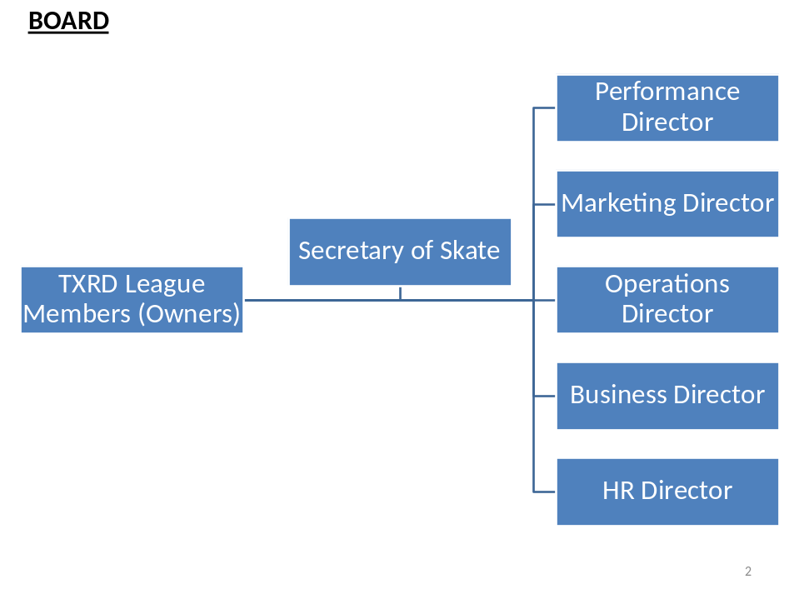

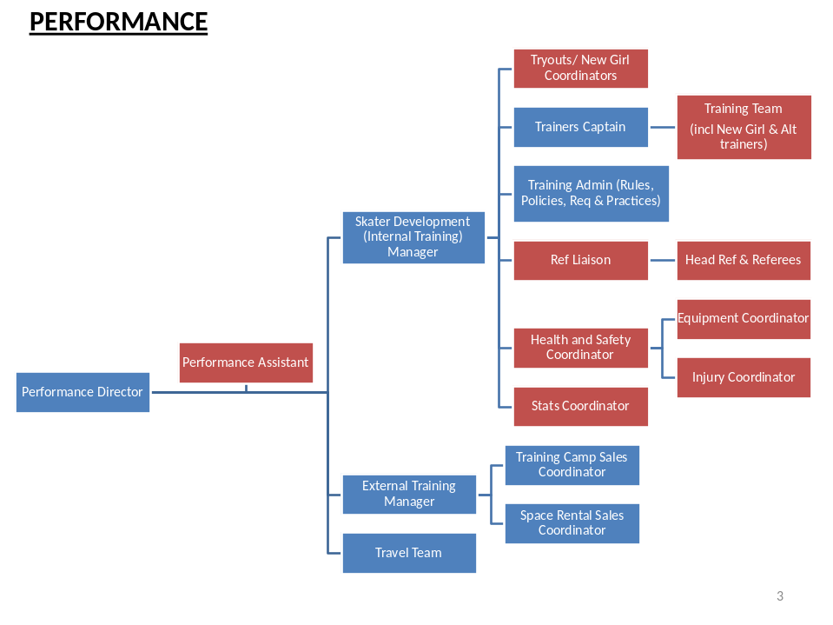

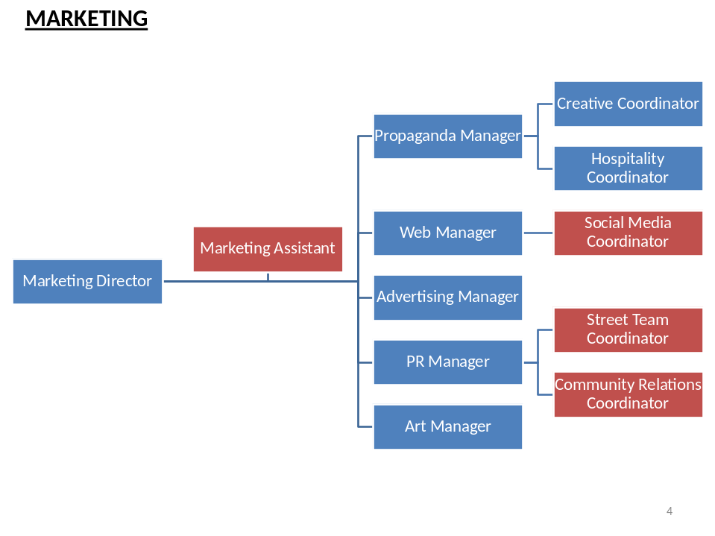

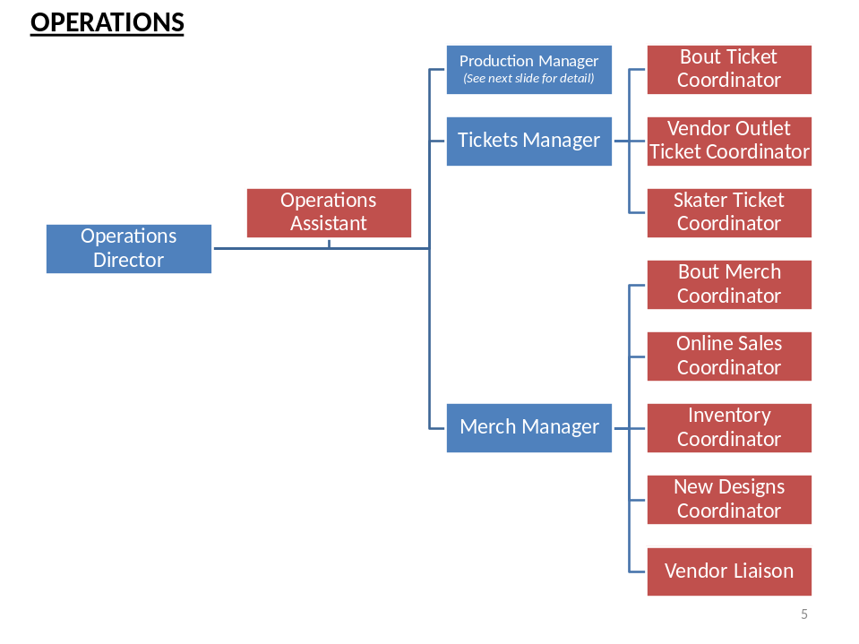

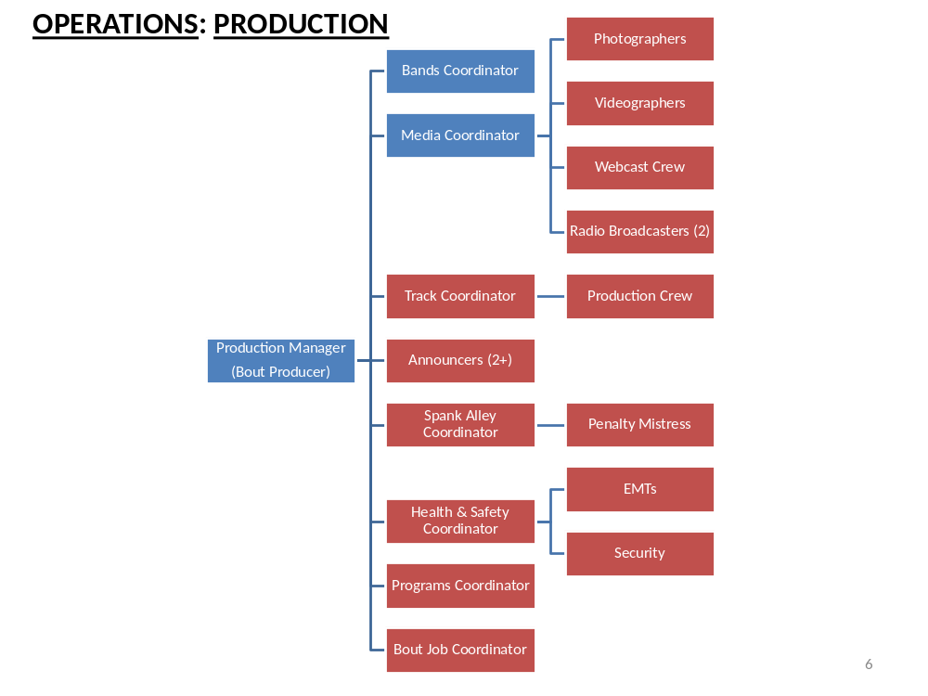

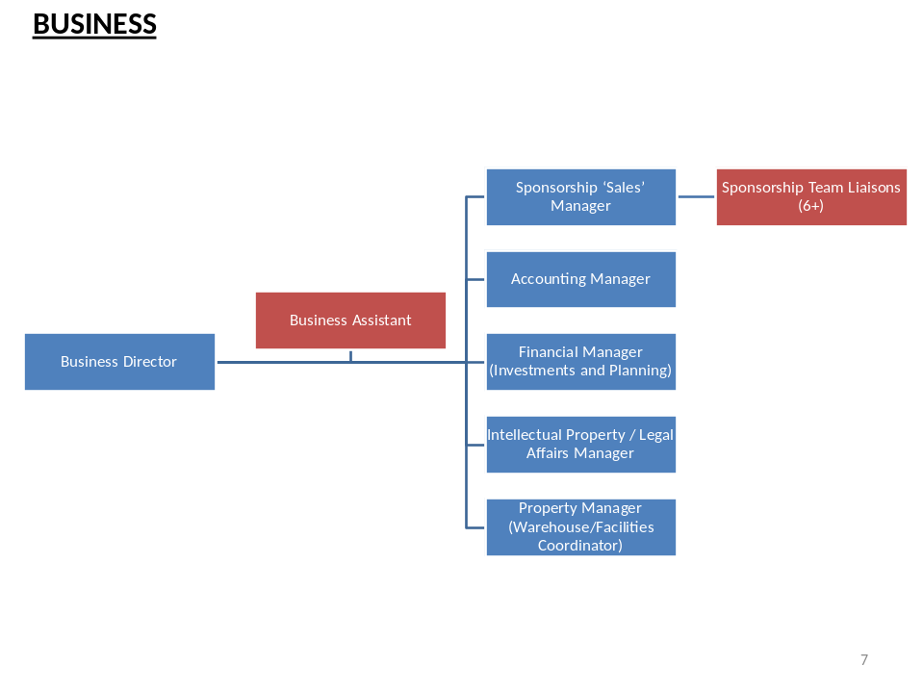

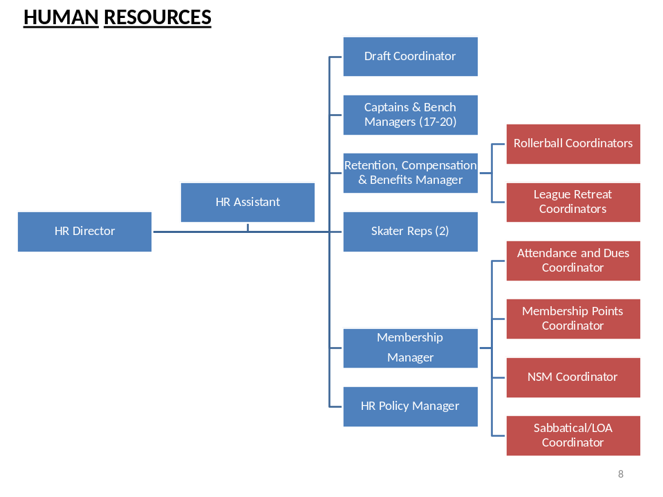

Financial Projections (2012-2014)
The financial projections below are based on the best information available at the time of the analysis. They will need to be reviewed and updated regularly in order to reflect changes in the organization over time.
Many assumptions were made to compile the following calculations, all of which are notated in the ‘Comments’ or on referenced sheets. A Microsoft Excel spreadsheet will be made available to the BOD to make adjustments and update as appropriate.
Items highlighted in yellow indicate areas of particular change which may require attention/decisions from the BOD.
(Note: Several changes to the arrangement of the Chart of Accounts and organization of the P&L statements are recommended. I would be happy to work with the league’s Accounting Department to review and make adjustments, if requested.)
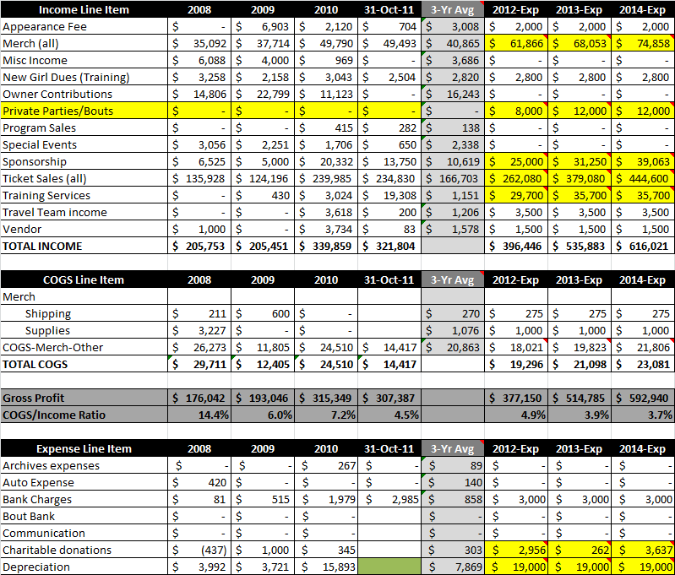

(Expenses – continued)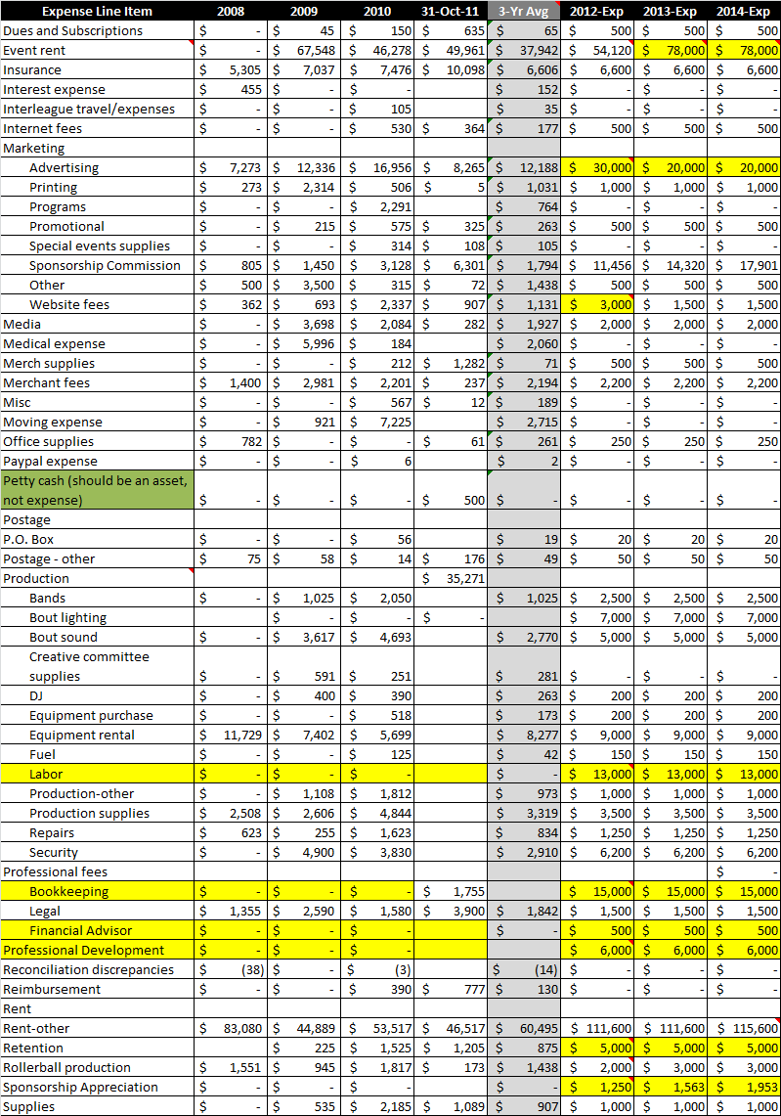
(Expenses – continued)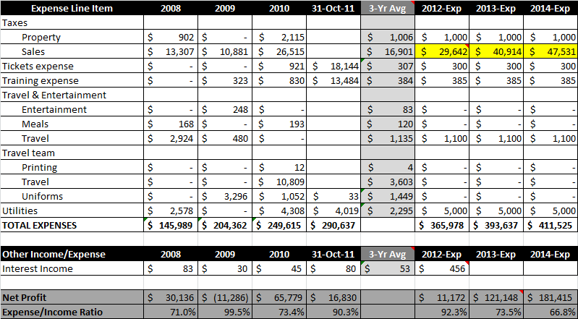

Board of Directors: Next Steps
- Determine immediate cash priorities, make choices and proceed accordingly.
  - Determine most efficient method to build a new practice track:
    - Current Production crew – bid $25,000 with time frame unknown
    - Seek additional bids for labor
    - Seek Bitchy Kitten specs/quote
  - Pursue bids from market research/PR firms for:
    - Conducting market research
    - Media buying services
    - Publicity services
    - Marketing strategy consultation
  - Meet with a financial advisor who can help to:
    - Invest appropriate amount of cash in long-term savings/investment vehicles
    - Set-up and invest the Tulsa Fund in an appropriate long-term investment vehicle

- Discuss/finalize proposed changes to mission/vision/goals and present to league.

- Discuss/finalize revised organizational chart and present to league.
  - Re-organize existing staff to fill new structure.
  - Consider compensation contracts for any positions which cannot currently be filled internally. (Note: This is a last resort and should be used for staffing departments with significant revenue potential.)

- Agree on strategies, tactics and measurements/deliverables for each goal (potentially a time-consuming process, but necessary to [provide sufficient strategic direction for league managment).
  - Assign each goal to a Director for leadership/monitoring (although specific tasks can and should be delegated) according to the new organizational structure.
  - Report on the progress of each measurement/deliverable quarterly at board meetings to stay focused.

Appendix I. Methodology and Research Results
Research conducted in preparation for this report included a survey of all TXRD League members about the mission, vision and goals of the league and interviews with managers and directors in strategic positions within the league. Details about the research results are found in subsequent sections.

League Member Survey
The purpose of the survey was to collect feedback from TXRD members for the purposes of developing a new business plan for the league. It is important that we periodically assess where we have been, where we are and where we’re going to make sure our daily activities are aligned with the legacy of the league and the perspectives of the current owners and members.

Response Rate/Sample Profile
- Survey 1: Mission/Vision – 51 started, 44 completed
- Survey 2: Goals – 38 started, 38 completed

Respondents represented a pretty even distribution of league membership between rookies and old veterans. Most respondents have been a manager/board member at some point, but are not currently holding positions.

Results Summary
Results ranged from helpful/insightful to bitter/sarcastic, which indicates that there are some great ideas out there, as well as some room to improve – which is why we’re doing the business plan! One theme that came up in the responses to a number of questions was drama. It seems that folks have had enough of the conflict and want to actively work towards a stronger sense of unity and cooperation. There are growing feelings of resentment for folks who don’t actively contribute, focus on negativity or openly/publicly demonstrate hostility towards the league. Summarized results for each question are as follows:

- What is your favorite part about being a member of TXRD?
- Friendship/camaraderie/TXRD family/Sisterhood
- Atmosphere of women-empowerment
- Competition/sport/athleticism
- Skating!!!
- Learning how to own and run a business
- Discovering and building personal strength – both mental/physical
- If you could change one thing about TXRD, what would it be?
- Very diverse answers relating to league structure, management, culture, communication, work distribution, facilities, etc.
- Do the current mission/vision statements accurately reflect TXRD?
- Majority said yes, made some suggestions for adjustment, which will be considered and incorporated.
- Some themes were women empowerment, interleague activity, athleticism and entertainment.
- Several responses questioned the relevance of the word ‘volunteerism’.

- Goals Responses
- Most goals came back with the majority saying we’ve made progress, but aren’t there yet.
- Seems that we have made the most progress on our financial stability, fostering rollerderby communities as a whole and our cooperation with other leagues, promoting ourselves in the Austin community, as well as in developing our skills as skaters.
- Still have work to do on internal league member relationships and practice/performance space.
- Suggestions for new goals included branding concepts, business ideas, training suggestions, track repair/acquisition, fiscal accountability, presence/image in the larger derby community.

Full Survey Results
For those who love the nitty-gritty, full survey results are as follows. Please note that write-in responses have NOT been edited for proper spelling/grammar/sense.

Section I: General Questions
- How long have you been a member of TXRD?

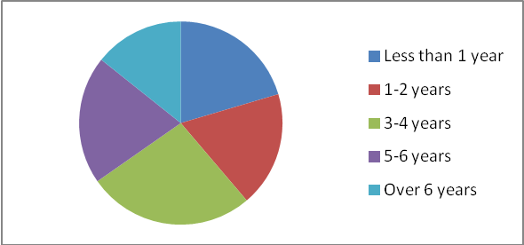

- Have you ever held a position as a manager or board member?

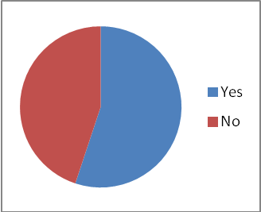
- Are you currently serving as a manager or board member?

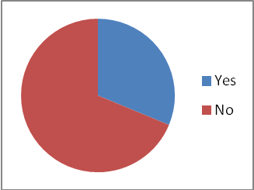

- What is your favorite part about being a member of TXRD?
- Being around other people that share a passion for skating.
- Friendships with other TXRD members
- The fun and love. I get to be mentally stimulated, I get to hang with the coolest girls I could have ever imagined, and I have gotten to make life-long friends. I also get to be part of something bigger than me and get rid of my ego issues at the same time.
- I am inspired by the strong women in this leage.
- Competitive bouting- season games
- Being able to spend time with strong and empowered women, while also being able to be athletic and maintain fitness...and skating of course.
- the comradery, the social family, the learning experience
- Having somebody to skate with me.
- The skating.
- skatin
- Our big weird dysfunctional family.
- Getting to skate regularly. Being able to set a personal athletic goal and accomplish it. Working with those who are genuinely interested in furthering our business.
- the community, and learning how a DIY business works
- Kicking ass and taken names
- The sisterhood and learning how strong I really am, physically and emotionally.
- skating!!!
- skating (the performance and the workout), having awesome friends
- Hanging out with a bunch of wonderful ladies, becoming a better skater, pushing myself and making new friends.
- Being part of a group of diverse women who work hard to make our league amazing. I love practicing, bouting, and creating with my league members. Skating is fun too...
- Being close to my fellow league members - the family atmosphere.
- The camaraderie -- the fact that we are all in this together and work hard to make the league run, practices happen, and the bouts go off without a hitch.
- skating, the family/friendship connection, being apart of something amazing
- playing the game and the people
- Having an active input rowards the organization.
- The community/comraderie/relationships of a bunch of people that all love to skate.
- Ownership: being able to improve, develop, enhance a department with new concepts ideas.
- Being part of a team.
- The sport is awesome, The friendships aré priceless!
- Being involved in a competitive sport with a bunch of amazing women.
- League comradery. We strive to have fun and make money at the same time.
- Being part of a "family"
- The friends I have made.
- Support system
- After going to rollercon, just about everything! We have a really great time with derby and keep it fun. Its a fucking hobby people! I think we get more organized and stable every year and thats reduced a lot of my frustrations. I am happy to be a part of all the progress we have made in the last 5 years that I have been an owner.
- Being a part of txrd is like being a part of another universe, its like having a second home
- Playing Roller Derby, our way.
- Feeling a sense of inclusion and seeing the fruits of my labors.
- Having fun!
- The family I've gained and the social interaction. My favorite part has changed over the years, but the reason I joined to begin with and what I love about it today have become one.
- it used to be the sense of community.. the fun.. now it seems like it is just some lesbian club bent on exclusion or conversion of non-lesbians.
- Being apart of the family that is TXRD.
- camaraderie
- If you could change one thing about TXRD, what would it be?
- Team practices should count for more than just 2 of the 8 required monthly practices. While it does encourage skaters to attend open practices and skate with other league members, it also encourages them to skip the other 2 (or 3, depending on the month) team practices since they don't count as practice credits.
- Less of a bureaucracy
- I wouldn't change a thing. :) I think with the correct focus we can do anything we want!
- Realistically: It is difficult to navigate and understand the league organization and jobs. It seems to take more than a year to understand everyone's roles. A better organizational chart and more structured league meetings with updates provided by each BOD and manager would be helpful. A 30 sec blurb to let people know what's going on and if you want to know more you then know who to talk with. Pie in the sky: A super derby facility set up for bouting (permanent track with seating and stages etc); if there is space for an extra track can rent space to rec league or TXRG; or hold more classes during the week; locker rooms with showers (make it like a gym so people would pay higher memberships for more classes); could have pro shop up front either a league store or rent spaces to multiple vendors; possibly even space for other rec sports; a bar to sell beverages and concessions during bouts. I'd like to know more about our possibilities at our new lease space but I'd also like to know more about the business to consider creating an investment group to pursue this.
- I would change our business structure. It's outdated. There are many options that the company can explore. There is no reason that this company should be a burden on it's owners. That was never the intention when we created the structure in the beginning. In the beginning there were less people who all agreed to wanting to own an equal piece. Now we require it when it's not necessary. We have more people than we do work available yet we still try to spread the jobs out and give everyone work to meet their "requirements" that we impose upon them. We continue to spread ourselves thin which delays business progression. We don't need 100+ owners... What benefit do we see in this?
- I promise I thought about this very hard, but I really don't know.
- The drama.
- communication
- Less bitching
- I would change the fact that 20% of the people do 80% of the work.
- we need our own space that we can practice and hold our bouts in. i think that would eliminate a lot of stress we currently have, and allow us to generate more revenue.
- Then cattines but then we are women.
- To rule the world!!!!! and go back to being a more united and strong league rather than strong teams with acquaintances on other teams. More support towards each other. We are a family.
- air conditioning....
- More unity between teams. I've heard really amazing things about TXRD being league first, instead of team first. That sounds amazing.
- I think our current goal is to own our own space so we can practice and have bouts to not only bring in cash flow but to offer better facilities to our league members, etc... But I don't know what to do specifically to get to this goal - besides ticket sales. I would like more info on what needs to be done to acquire a space, how much money we need, what licencing we need, what are the major drawbacks??? Just more info on this specific goal - which I think is an important one.
- Since none of us get paid to do this, I believe there needs to be more emphasis put on the joy of TXRD - that we do this because we love it. All too often, I feel skaters lose sight of that, and things become dramatized.
- Probably communication/organization. I think that is something that can always be improved. We have a lot of processes that rely on spreadsheets for organization, I think it would be great to streamline many of these processes with some software solutions, but of course, this would take a lot of effort! Maybe a new practice track as well :D
- its starting to feel more like a job than a hobbie,( i know it is a job, but sometimes it seems the fun level is dying down.) i like to think i do it for the fun that is involved, i would like that to stay existing. id like to change the drama level too!, lol, if thats possible.
- finding a place to have games that would allow our own sponsors to sell food/drinks.
- Being a more active member in the roller drby community outside of Austin.
- We would have our own facility that we could bout and practice in and it would have climate control.
- We need to empower our leadership to make executive decisions with minimal assistance from the league members that aren't aware of the business side. We need to trust that our leadership is acting in the best interest of the league.
- More events where the focus is not at a bar/alcohol
- Air conditioned workout space.
- I don't feel like I've been a member long enough to have to much to say about change. Maybe follow through with things better. (Mainly speaking of travel team.)
- stricter recruitment...we need a better system to weed out the crazies...
- More people participate in the business and take on manager or board positions
- That people criticize others opinions entirely too much. Just because it is not the way you want it or the way you want things to be ran, does not make it wrong. Also, people talk too much shit about each other. It's far worse than high school because we are adults and should know better by now. We are also owners of a company together. We will get nowhere without helping each other. Trash talked is energy spent in the wrong direction.
- I'd like to change how people take manager and board positions to do ajob, but when asked to solve a problem or do their job, then ask of a sudden it's not their job or theres nothing they can do, or they pass it to someone else. It just seems the system does not work, it's hit or miss whether or not anything ever gets solved.
- Lack of replacing people that suck. If a skater obvi doesnt seem to care about their team and league duties- kick them out. If someone sucks and consistantly pisses skaters or the crowd off (announcers, penalty mistress) kick them out. If a ticket person cant run the front door in an organized manner, kick them out. I dont know how to make it happen but I have heard complaints for years about the same things (from both our attendees and our skaters) and there seems no process to reevaluate if someone is good for the position. Voting in front of everyone else doesnt help either so nothing changes.
- air-conditioning
- Make it easier for shitty, deadweight people to be removed from the business and be more proactive about making sure that everyone involved with us, not just skaters, are trustworthy reliable people without criminal records.
- Winning the lotto! Seriously though, I want to have a facility like LADD's one day where we're a self-contained unit, not dependent upon the city or Aramark, just our fans and our product.
- I'd like to see the people who bitch about how things work actually step up and do the work--as in, if you bitch about the rules, go to the rules meetings, and if you bitch about the way the managers are managing, be a manager or join the comittee in question. Or, if you don't want to do either of those things, at least be supportive to those who ARE working instead of trashing them all the time.
- I would separate the company from the game. Give the owners stock in the company instead of distribution promises. Then derby practice wouldn't have to be limited by being an owner and only those interested in running a high profiting company would be owners... because there would be a choice.
- the way people are placed in charge of the decision making positions.. the bs glad handing.. the way no issues are ever fully solved by skater reps.. the lack of respect ppl are given.. the way board members are dismissive to issues.. the politics.. how people dont think discrimination of fellow members is inappropriate or will lead to us being sued.. being told when you bring these issues up that if you dont like it to leave.. the fact that we havent had a special event in 2 seasons.. oh oh oh and the fact that there are skaters in this league who have never passed their evaluations.. but thats ok lets make them board members huh?? and let them run their mouths and not be punished.. i could go on..
- All teams have a bout job and the point system is done away with.
- work ethic

Section II: Mission
A mission statement is meant to define the purpose of an organization. It should answer the question, ‘Why do we exist?’ TXRD’s current mission statement is below for your reference. Please use it to answer the questions below.
‘Mission Statement: TXRD—Lonestar Rollergirls, or our legal partnership of Four on the Floor, LLC, exists and operates to:
- Ensure the safety of the skaters
- Promote the sport of roller derby in Austin and beyond
- Generate enough income to sustain and perpetuate TXRD bouts’

- Does this statement fully reflect the mission of TXRD?

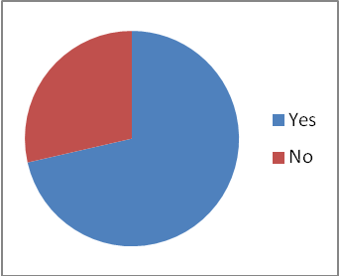
- If not, how would you describe TXRD’s mission? (Even if you can’t think of exactly how you would put it, feel free to mention words, phrases or concepts that you think should be included.)
- I would put bullet point two first.
- We exist to bring passion and enrichment to the lives of our members. We exist to bring Texas Roller Derby to our audience and to the world at large. We exist to perform feats of sporting strength and share the joy we feel in our performance. We exist as a company to ensure the next generation can have the same privileges of membership in a fiscally viable company.
- As a skater I see our primary mission as: Generate enough income to sustain and perpetuate TXRD bouts’. TXRD is there to ensure the organization framework to accomplish that. The safety item is rolled into that framework but is not exclusive and doesn't seem to help define us any better to make that a separate item. We don't need to promote derby but I think we need to assess if we want to have a larger presence in the derby world. Do we want to make travel team a real team supported and funded by the league with the goal of competing to establish TXRD as a serious and competitive force. I like the idea but don't know the implications of that decision.
- Provide quality training and ensure safety for our skaters and the public we train Provide quality entertainment and expert sportsmanship to our audience and our community. Promote and perpetuate rollerderby in our community and beyond Generate substantial profit to sustain the company, allow for touring or other business prospects, and provide training.
- I think esteem building of young women should be included. So many people have said that this league is their first time to feel empowered, confident, included, supported etc. Now that there is Junior Derby, we can begin to instill this confidence at a young age. Athletic success is key to confidence in the future. It promotes health and fitness, good muscle tone, it fosters relationships when team mates have to work together. It also exposes people to personality dynamics and teaches skills of dealing with conflict.
- i think it represents where txrd currently is, however i dont think it reflects our future. i feel txrd is always lagging behind in the derby world, and not paving the way, or advancing like the rest of the derby community. in terms of business, and the sport itself.....but i am not saying that is bad....i am just saying.
- To breed forever bonds.
- I think that statement is accurate, but not complete. There is more to TXRD than just keeping itself around.
- I think we are more than the current mission. Same as previously mentioned and.... Promote sisterhood, individualism and creative thinking. Ensure we work hard both in training and administrating. Something about promoting all derby (junior, flat, men's, co-ed, etc) in Austin and in the world. Not my best thoughts translated into words but maybe you get the idea??? :)
- improve as skaters -- maybe "Ensure the safety and (skills) growth of skaters" ?
- I feel like this might be good in a discussion because we feed off of each other. Right now I'm drawing a blank.
- The current statement covers everything that we need to continue moving in the right direction: safety, promoting, perpetuating ...
- Something about growth and women's empowerment
- "safety". Really? It's skate at your own risk. When someone is hurt they are forgotten, pushed under a rug. Everyone wants to move on because for some fucked up reason, people don't matter to certain people, points do. The thought of injuries scare most girls so they aren't talked about often enough. People matter to themselves until they are the ones hurt then all of a sudden, "we should be concerned about safety" So, hahahahahaah... "Safety".
- Take care of the popular members because that's who matters the most make sure they get what they want and do what they need to do because that's who matters most.
- I would add in something about providing unique entertainment and recreation for the people of Austin Texas and beyond.
- Our mission is to keep our business wealthy and our skaters healthy so that we can continue to have a fucking awesome time for years to come.
- dont forget ride the coattails of others hard work and dedication.. change deals and undermine our own members

Section III: Vision
A vision statement describes the organization as if it were perfect – in its ideal form. It should answer the question, ‘What does the perfect TXRD look like?’ (Note: A good vision statement can’t be achieved – it is meant to be visionary. If you achieve your vision, you need to get a new one in order to ensure the continued progress of the organization.)
TXRD’s current vision statement is below for your reference. Please use it to answer the questions below.

‘Vision Statement: Ensure a spirit of cooperation and volunteerism is retained in our community while fostering the development of other roller derby communities.’
- Does this statement fully reflect the vision of TXRD?

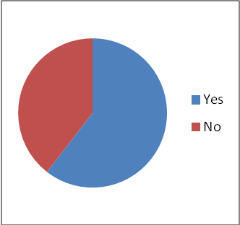
- If not, how would you describe TXRD’s vision? (Even if you can’t think of exactly how you would put it, feel free to mention words, phrases or concepts that you think should be included.)
- It's got a lot of good elements in it, but it's so vague as to be less than inspiring. The perfect TXRD employs all its members, plays internationally, and continues to lead the path of modern roller derby, through training of junior, amateur, professional, mens and women's leagues, and Olympic training, and provides the 'home base' for growing leagues to come and learn the sport and business.
- I think our vision needs to be more TXRD centric, derby as a sport has it's own momentum now. TXRD doesn't need to foster development. Foster greater interaction and support; cross promotion with other leagues may be good for us. Can the vision statement relate to building the business to a super derby facility or is it intended to be more person related?
- This vision statement is so off base to me - We have not fostered the development of other roller derby communities in some time, over 4 years. & We are owners who repeatedly tell each other that we are NOT volunteering, we are working for our company's future. What I'd like to see: provide an outlet for expression, empowerment, and health w/in the female community and roller derby community while perpetuating the company to continue to provide the roller derby experience for years to come.
- It should probably say something about being self-sufficient, owning a spot, having our bouts in house, keeping all of our profits, flourishing and becoming a fixture in the city. I think that's most people's ultimate dream.
- i dont have any suggstions, i just dont know if i agree with our current system of volunteerism, or if we need to continue fostering derby communities...
- Ensure a spirit of cooperation, athleticism and volunteerism is retained in our community while fostering the development of the roller derby communities.
- I love this!
- We need to continue to develop our own derby community.
- Again, I think a discussion would be helpful. Not convenient, I know, but definitely helpful.
- This is where our challenges lie , i agree.
- friendly competition passing roller derby to the next generation
- Hahahaha. "cooperation". More like, "these girls cooperate with these girls and but not those girls" it's like a sorority but divided within, not against other leagues. We are real nice to everyone else, just not each other. And we volunteer sometimes. I really dont see that as our vision though. Everyone is more concerned with winning a pointless championship versus helping out the community. It's nice to think that and it sounds good in the vision, I just don't believe we are sincere about that actually BEING OUR vision.
- How do you ensure the spirit of cooperation and volunteerism? I don't see it. What it has become is nothing is ever enough. If you're not spending 40 hours a week doing derby then you're a nobody. Also how can you foster development to anybody else when our own league needs to be?
- Self sustaining.
- I think our vision should be about profitably entertaining the masses with a unique style of roller derby and supporting one another in our mission to do so.
- TXRD's vision should be to enrich the lives of our league members and our community through our attitude and our amazing product.

Section IV: Goals
An organization’s goals should align with its mission (purpose) and help it to achieve its vision. They also provide an overarching direction that can be used to develop strategies within various departments to keep the whole organization moving forward in a coordinated manner. Goals are usually fairly broad in scope – it is typically left up to managers to determine how to best meet organizational goals.
TXRD’s current goals are listed below for your reference. Please review them carefully and use them to answer the questions below.
‘League Goals: These may change periodically, and may be altered by the Board, and/or a league vote to reflect new knowledge, opportunities or directions. Goals are really part of the Mission Statement, and it may be altered from time to time.
From league vote, May 2008:
- Be financially stable.
- Foster roller derby communities, both in TXRD and worldwide.
- Maintain excellent intra-league communications & interdepartmental cooperation.
- Keep a high profile for TXRD in Austin community
- Perpetuate TXRD as an entertainment, use fame as “Rollergirls” to leverage awareness and interest
- Maintain interest in the community with marketing/PR opportunities (keep up ticket sales, participate with local charities).
- Secure a home as both practice and performance space.
- Develop athletic and performance skills of our skaters, while maintaining their safety.
- Foster positive relationships between TXRD league members (platonic—Don’t Do Derby). Keep TXRD membership fun!’

Please indicate where you think TXRD is in achieving each goal:

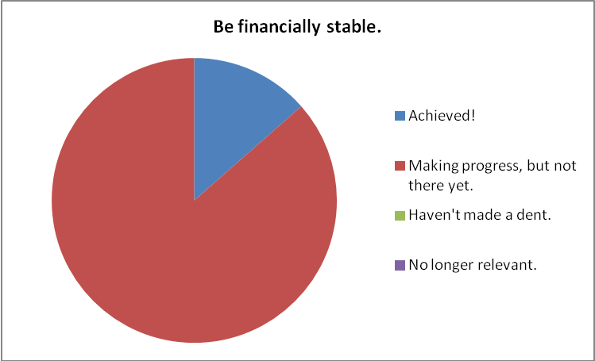

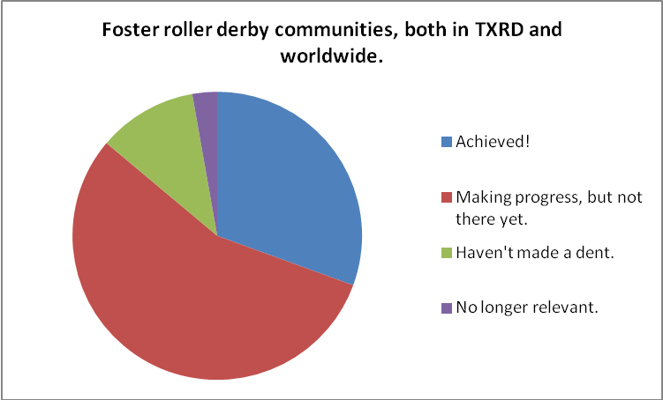

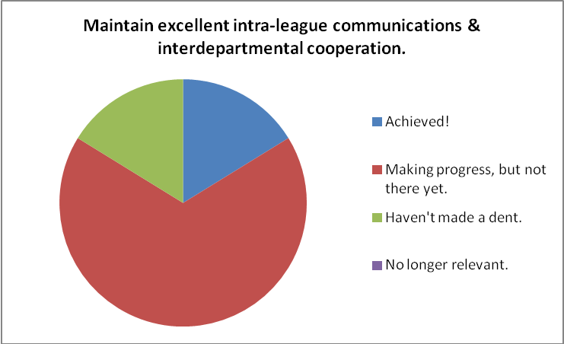

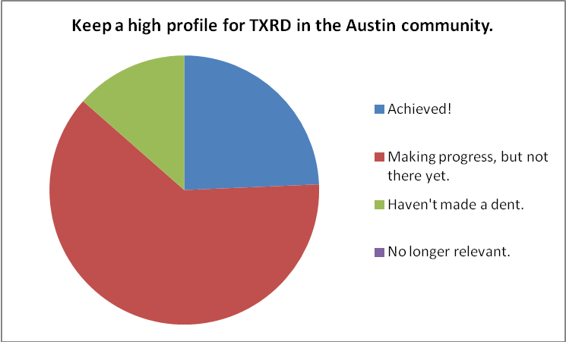

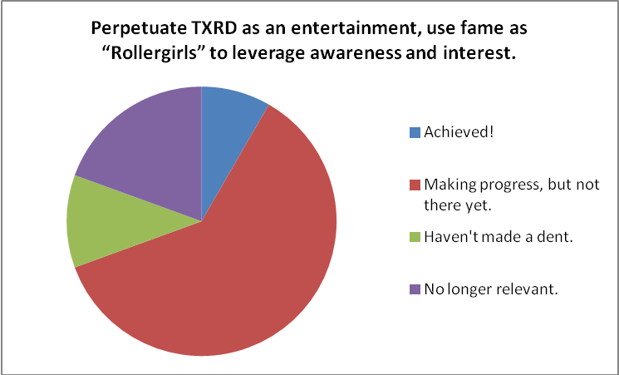

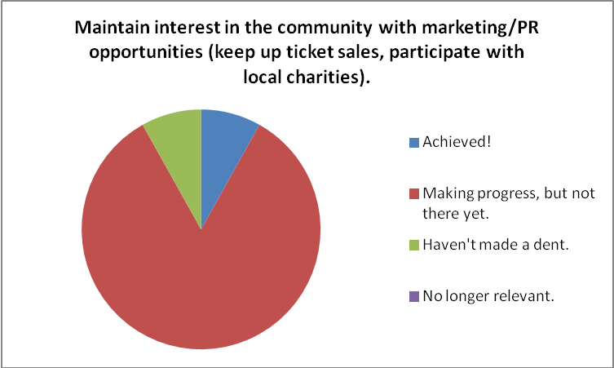

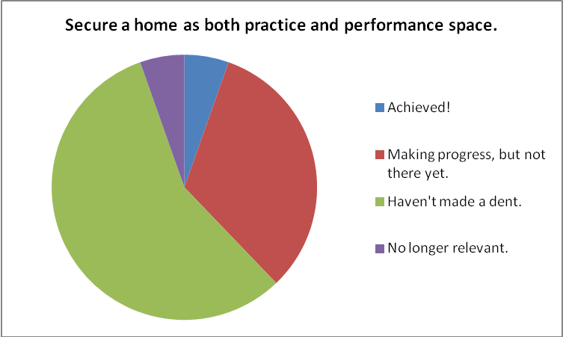

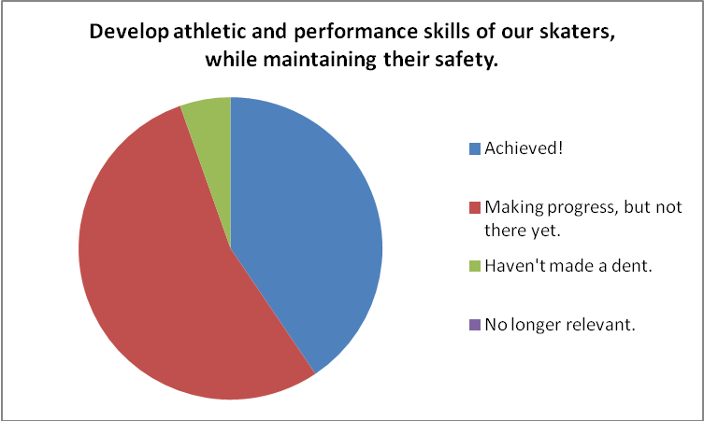

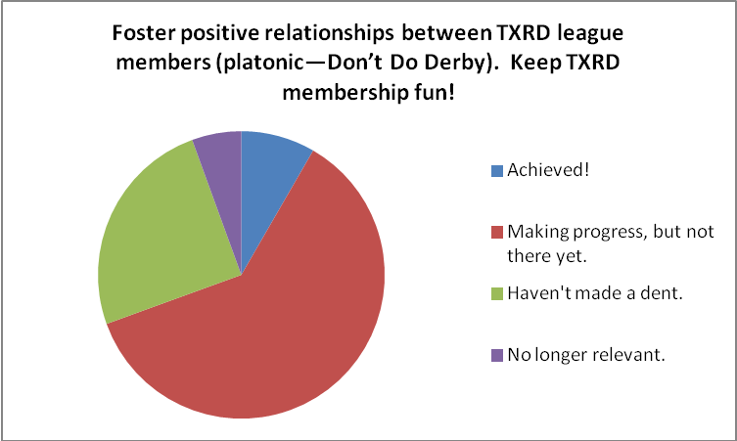

- Are there other goals that the league should strive towards? Think financially, internally, externally, etc. Please include any other thoughts or comments relating to TXRD goals for the future.
- bleh
- I think we should use our brand, TXRD, as our rule set - aka "I'm a Lonestar Rollergirl and I play Texas Roller Derby." We can give out our ruleset for free with a signed licensing deal and then other leagues can play also say "I play Texas Roller Derby." We need to be the premiere training facility in the country, if not world. We should jump on the Olympic bandwagon if it's started. We should train juniors, men, rec, women, flat, banked, etc. No ruleset left behind, but our performance will always be TXRD. We need to let go of the negative qualifiers like "Don't Date Derby." You can't work towards a negative! :) Also, anything that is impossible needs to be let go of as a goal, i.e. having a space to practice and perform in. We have both now and living in that dream is impossible and is making it seem like we are full of empty promises. We should pay trainers and administrators of training negotiated fees. Eventually we should have paid management. Also, stipends for equipment and production. Production could work it's way into a professional track building team that could sell its services. The NSM's could be a think tank or consultants for trainings - business or skating. Shall I go on? :)
- I began with TXRD as a favor to a friend and hung around for a time because of the fun and parties. I have stayed for the long run because of the overall strength of character of the women in this organization. As we continue to foster league growth, interleage development and publicity/public image of TXRD, the collective strength of this group of women from all backgrounds should always remain at the forefront. ....and as a male in this group its something I am proud to be a part of. Thanks for letting me in!
- I wasn't in the league in 08 some of these goal don't seem like good goals. And the other I have nothing to compare progress to. I am not clear what #5 means. Ones I felt I had no context to assess I didn't respond to. The training seems great with careful attention to safety and fitness. BOD is making steps on better spaces with more possibilities which is good. I for one have not participated in special events. I am not sure if the dominant answer is that I am tapped out for time commitment or I am not interested in the special events organized. Do we have any marketing data that the time and effort for those events benefits the league? or is the purpose just for fun? This seems a good step to update the business plan but beside sharing the results of the survey it seems more important to outline the steps and purpose of the process you all are working on. Thank you all- you probably don't hear that enough!
- Create long term goals and stick to them Create goals based on the needs of the company not on personal or unmeasurable topics Reinvest profits into side projects that generate regular vs. seasonal income Brand our logo- actually focus on it for an entire year Update our Merch line and seek professional assistance Increase merch profits by 25% Hire externally for our weakest departments.
- A new practice space and opportunities to bring in more outside trainers.
- We should do more, (I don't know what) to distinguish ourselves from the competition. We try to stress "banked track" but roller derby is roller derby to most of the potential fans who haven't been to a bout before. Many show up here looking for txrg, and vice-versa. I think our advertising should make the differences more obvious...the track and the penalties and we're cooler and they're boring.
- n/a
- na
- We still need to work on the existing goals
- not sure
- As far as intera-league, I would love for the new leagues and even old leagues to know without a doubt who gave them this opportunity...us... and that with that opportunity we have given, we will also be more of a league that they can come to for anything anytime. Be the REAL godmothers of rollerderby and not just have it be a marketing phrase. If we can no longer be the best league in placement at tournaments and standings, we can and always will be the BEST league as a whole for derby and everyone no matter how large or small that love the sport! We are wise and not in competition with the world (although, I am in favor of world domination) because we are unique and irreplaceable. No other league will EVER be able to hold our title and with that knowledge and power, I would love us to be the "Don" Vito Corleone's of modern derby. "...... "The business of the family is just like the head of the family, kind and benevolent to those who give respect, but given to ruthless violence whenever anything stands against the good of the family.". Well maybe not the ruthless violence part ;)
- We should develop a 6th team. We should strive to have a practice track that is not full of holes and left unrepaired for months. The lack of regular maintenance has led to the current state of affairs. Production should be accountable to hold regular maintenance times and regimes. Just because Grandma is old does not mean that she can't be in good shape. Order the second set of Pads. Sell the forklift. Make sure that the warehouse cleaning coordinator comes at least once a week to check on the state of things. Clean towels should be present at all times. There were no large size towels in the warehouse when one was needed. People who check out skater tickets should have to turn them in at the game that the tickets were sold for. I heard someone say a few weeks ago that she had to get more skater tickets to sell so she could pay off the previous money she owed for tickets to a past bout. Our rules should reflect they way we want to play. I think we should focus less on implementing rules used by other leagues in national tournaments that seem to be driving our rule set and focus on what we want as a league. National tournaments do not entertain our paying customers and I think some of our current rules are not understood by our fans and detract from the exciting nature of our game.
- Na
- We need to better police ourselves to keep the warehouse a more drug free zone. Drugs are fine for those that partake, but blatant drug use (cleaning pot in the warehouse?) is not fine for any of us. We are put at too much risk. We need to better treat each other with respect no matter how high emotions run. Recently a skater has given the finger to the league in public as well as at a bout. Another league member threatens lawsuits. These demonstrations of inner league conflict show that we are no where close to where we want to be in fostering good feelings inside txrd.
- I would like to work on increasing our presence more through volunteerism and charity.
- Things are great but they can always run more smoothly. There's nothing in particular I could say but I think we are constantly making progress to make our business run more efficiently.
- To cultivate a common sense of pride in the league and in one another.
- Looks good
- Not that I can think of.
- I think we've got everything covered
- n/a
- I think a super awesome goal would be to have our own facility -- not one that we rent, but one that is ours to make our home. I know this would be a very difficult goal to achieve, though.
- Goal- if it's not already brought up. To build another track. Have a safer track for practice.
- Be a bigger presence in the international roller derby community.
- I'd like us to be more fiscally accountable. Not turning in ticket money for months is not ok.
- We just need to be reminded of these on a regular basis. We are making progress on all the current ones.
- I think good progress has been made regarding the Hired Gun$ in terms of skater development. With Purr gone, we really need someone to take on leadership as far as booking outside trainers.
- We have great goals to keep striving for. All are well on their way!
- Our league hates each other. All I hear is bickering, wherever I go. "fuck this and fuck that". It's no longer fun. It's pretty much fun for the rookies for about a year or two until they are drug into drama. Then, like all of us vets, they either leave with a broken heart and madder than hell or they stay just because they have some weird hope that TXRD will one day return to it's former glory. No one listens to each other. Everyone thinks their opinion is the only one worth hearing or acting upon. We bash each other constantly and feed into this negative energy destroying our league. Andddddd we continue to hide this problem As if it does not exist. Sport vs entertainment is what we have labeled it but its way more than that. Tradition vs future or change is more like it.
- Interleague department goals need to be revisited, and a clear focus for the department needs to be formed based on input from the league. (This is Dee )
- Develop processes and procedures to ensure every job can be done correctly and smoothly.
- I'd be interested to see how our merch sales online (not at bouts) stack up against other leagues. I don't think this is data we could get, but we could improve our secondary product sales and endorsements. Also, could we return to radio spots? If our crowd is waining at all it might be worth it, especially Poilin for Putas bouts and Kase, etc. for Rhinestones.
- We should expand our presence in the derby community as the alternative to WFTDA-type shit that's so tired and boring as opposed to simply expanding the derby community (which has arguably been done). We should make ties with Renegade and OSDA leagues and whoever else is out there who will play a fun game instead of getting bogged down with that boring WORD stuff.
- how about actually working on the goals.. other than making more money i dont see anything that has improved off that list

Manager Interviews
Interviews were conducted with individuals in key decision-making or financially-relevant roles to gain insights on best strategies for the league’s sustainability. To protect the comments of individual respondents, detailed notes of the interviews are not provided here, but names, dates and question topics are listed below. The results of the interviews have been analyzed and compiled with survey results to comprise the recommendations contained in this report. Many of the ideas and suggestions contained in this report came straight from TXRD Managers and Directors, with a few metrics or numeric goals added in.

Interview List – names, dates
- Dixie Sanchez, Production Director – September 15, 2011
- La Muerta, She-E-O and Internal Operations Director – September 20, 2011
- Guera, Retired skater and the league’s current CPA – September 22, 2011
- Varuca Assault, Accounting Manager – September 28, 2011
- Kate or Dye, Merch Manager – October 4, 2011
- Honey Homicide, Promotions Director – October 4, 2011
- Dee Toxin, League Mediation Director – October 12, 2011
- Fishnet Stalker, Sponsorship Manager – October 13, 2011
- Lil Chris, Production Manager – October 19, 2011

Questions / Discussion Topics

I informed each interviewee about the strategic plan and purpose: to ensure the sustainability of TXRD in the future. For most interviews, I shared that TXRD’s current biggest revenue streams are Ticket Sales and Merch; there has been significant growth recently in Training Services and Sponsorship; and the survey shows ideas for new revenue streams, including Space Rental and Licensing/Branding. Each interview varied a bit to dig deeper into specific topics that came up, but generally I asked these questions:
- What could your department use to contribute to one or more of TXRD’s revenue streams? (financial or human resources? policy/procedure changes?)

- If you had $10,000 to spend to improve the league, what would you spend it on and why?

- What is the biggest challenge the league is currently facing? Ideas for solutions?

Appendix II. Financial Statements (2008-2011 to date)
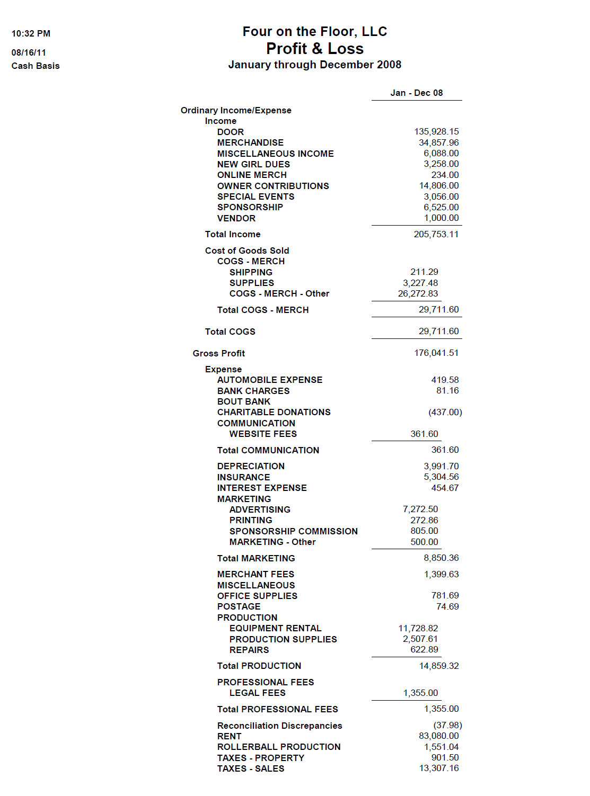
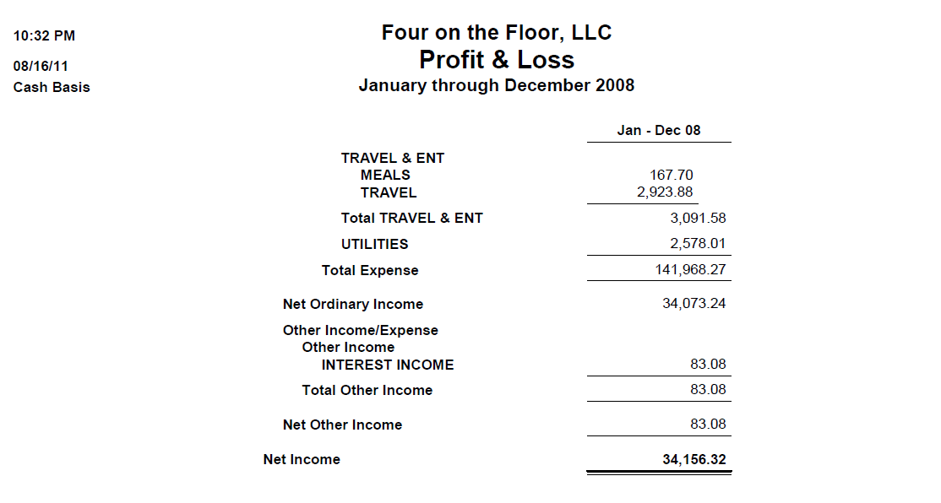

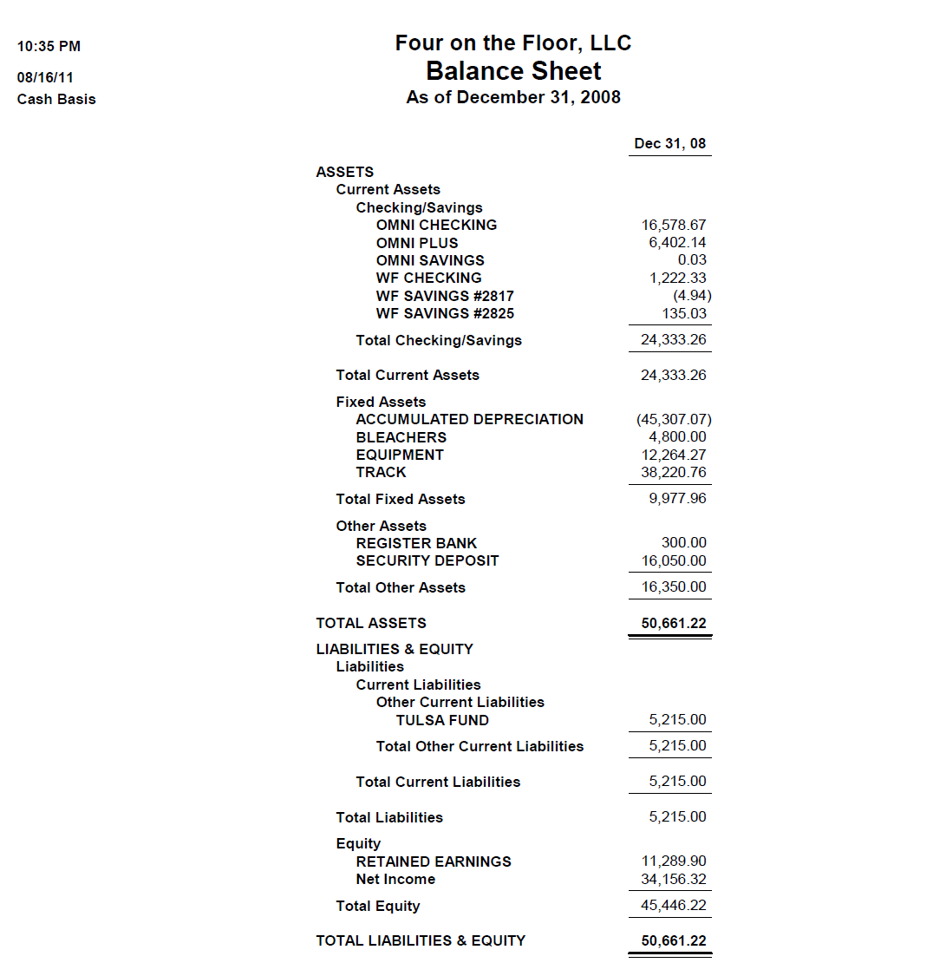

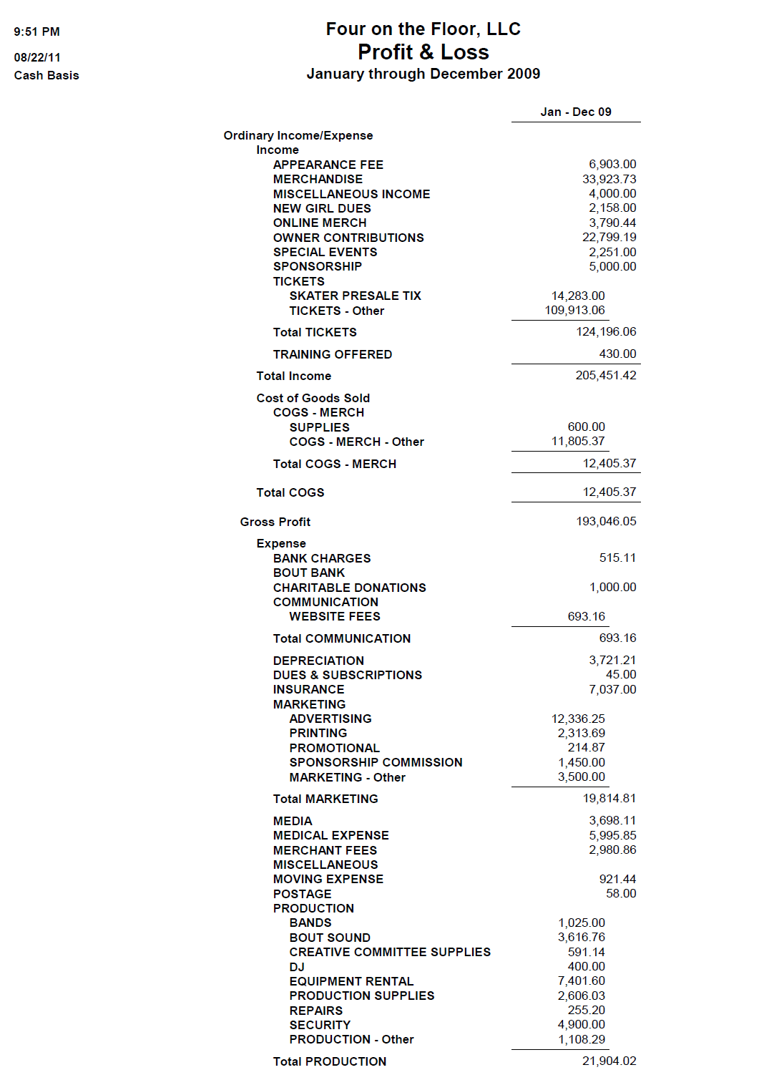
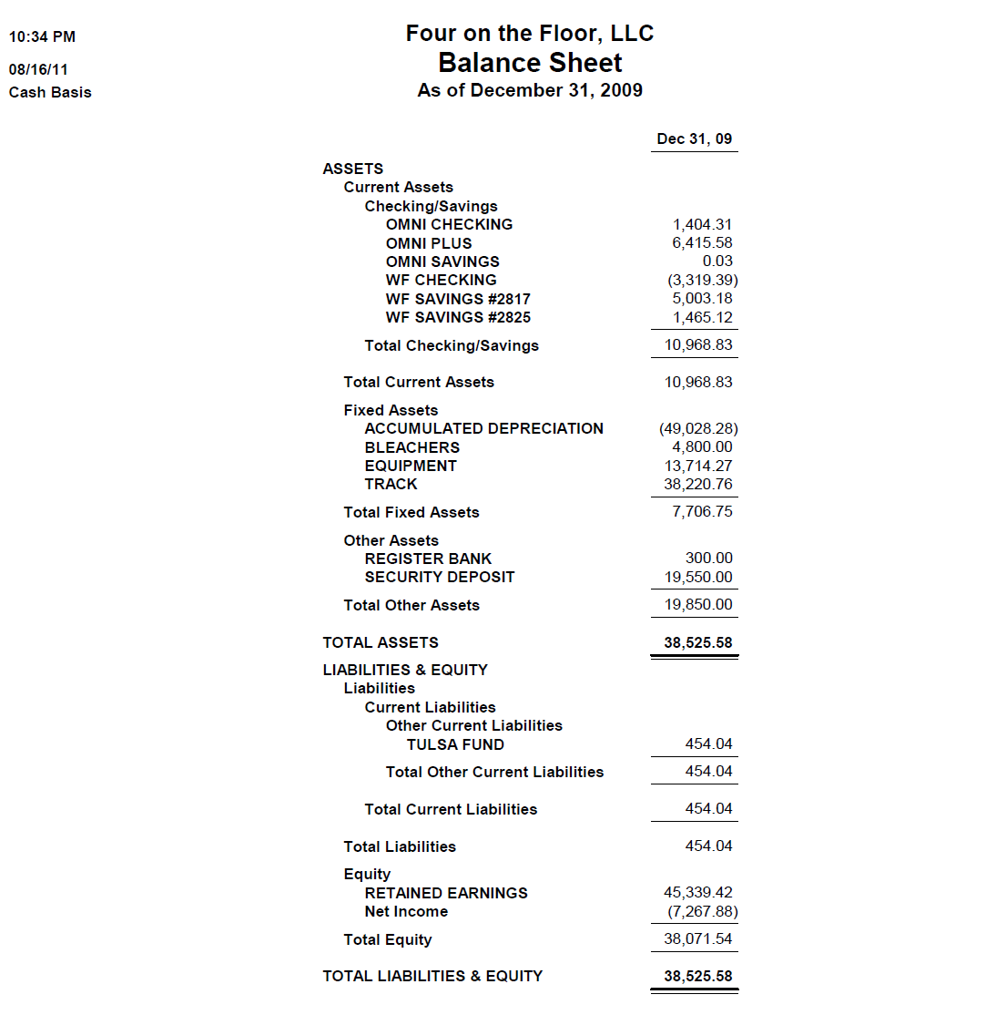

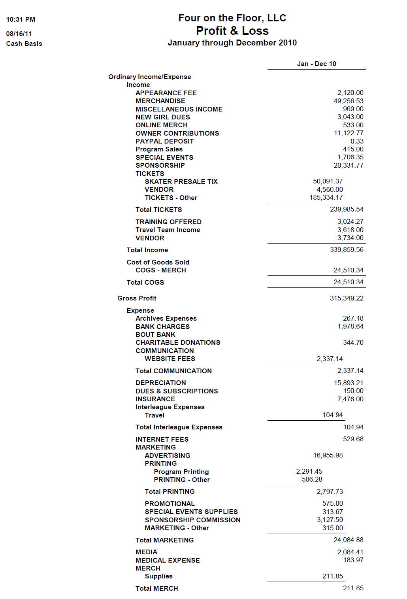
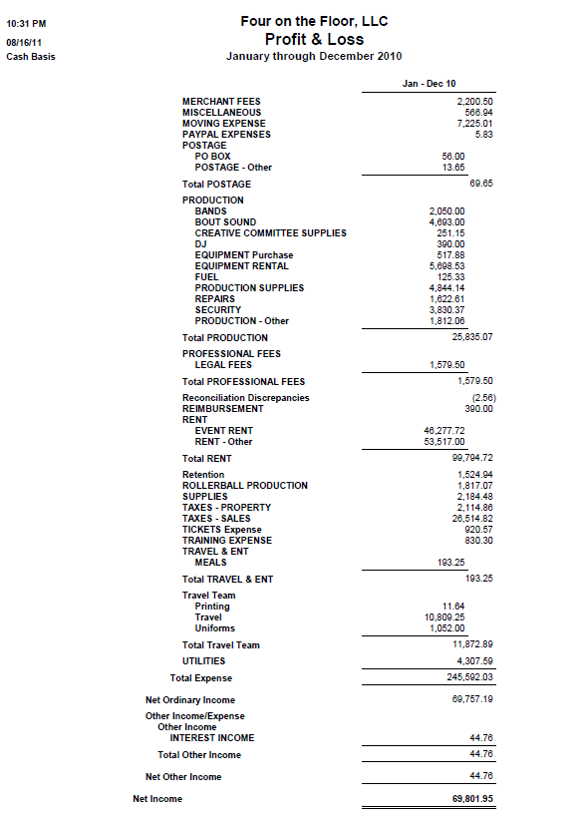

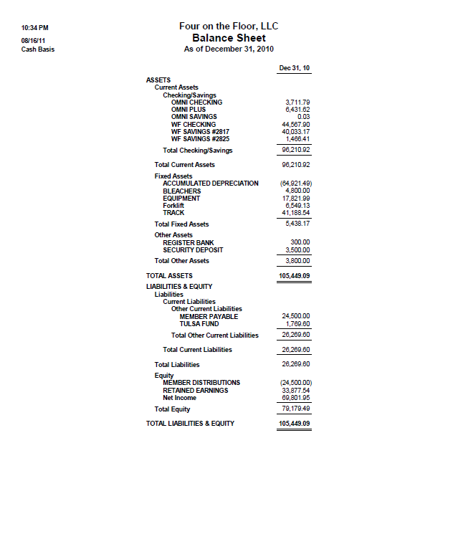
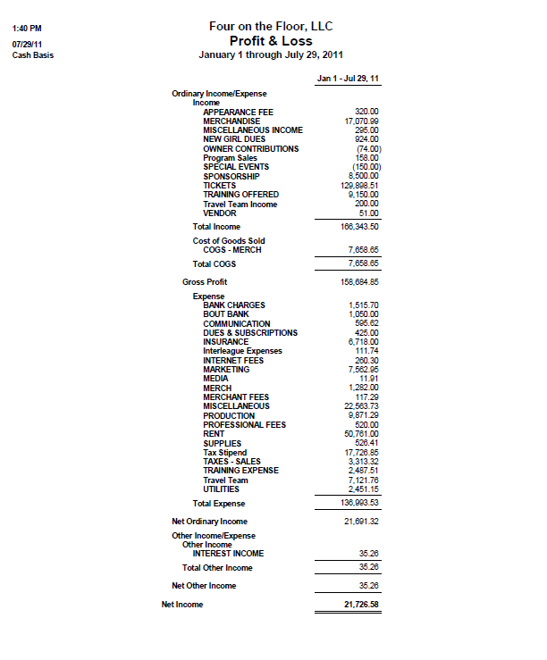

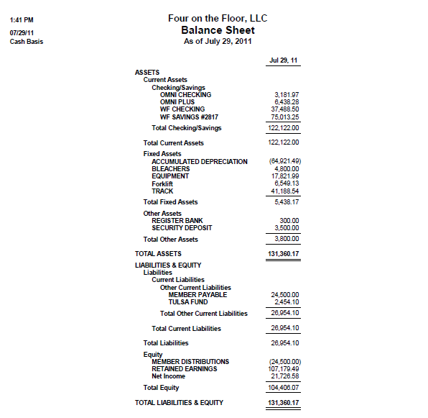

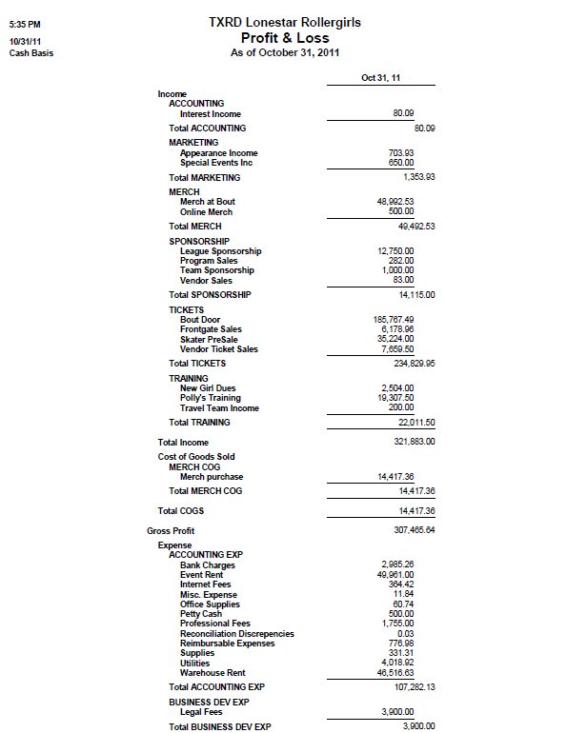

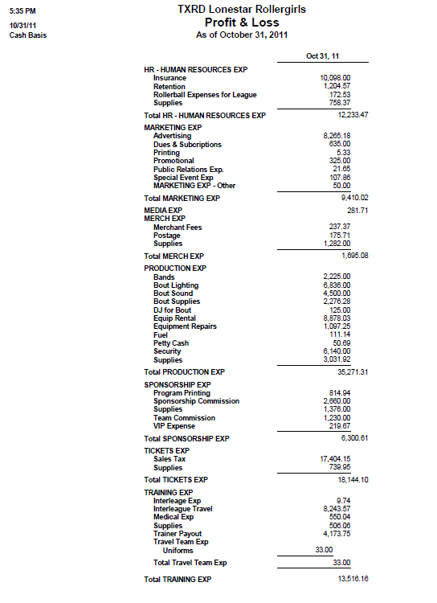

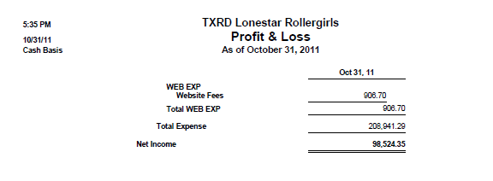

Appendix IV - Regulations

The Amended and Restated Regulations of Four on the Floor, LLC, are attached as its own document, with it’s own numbering. The Regulations themselves are unlikely to be amended, and cannot be without legal advice and every member’s signature. The Schedules attached to it may be amended at will, and the 2011 changes are noted below.

All Members must sign the Member Signature Page (pg 29) of the Regulations and, if married, have their spouse sign the Spouse Signature Page to become legal Member/Owners of TXRD. If you do not agree to these Regulations through signature, you will not be admitted into membership! The signed copies are held by HR.

Schedule A to the Regulations is amended by HR’s current Membership Roster, with all Members besides Nancy, Heather and Anya holding $10 Membership Interest in Four on the Floor, LLC.

Schedule B to the Regulations is explained and slightly amended (Effort hours are now tracked by Membership Points) in No. 17 of the SOTU.

Schedule C of the Regulations is hereby amended by No. 6 of the SOTU.

