REQUIREMENTS SPECIFICATION

**RemindMe**

(An App for Abuse Victims)

**Written By:**

Julia Navarro

Karina Hernandez

Audrey Simpson

Isaiah Beaudry

Daniel Rincón

Fei Hoffman

CECS 491A Section 01

September 27, 2022

Table of Contents

**Executive Summary** **3**

**Stakeholder Model** **4**

Stakeholders Roles 5

Developers 5

Project Manager 5

Software Developer 5

UI & UX Designer 6

Quality Assurance Engineer 6

End Users 7

Customer/Users 7

Competitors 7

Competitor 7

**Goal Model** **8**

**System Vision** **9**

**Usage Model** **10**

**Use Cases** **11**

Disguised App Name 11

Disguised App Display 12

Store videos 13

Store Photos 15

Store Text 17

Store Audio 18

Secretly Dial 911 20

Obtain Device Location 21

System Time-Out 23

Survey to Determine Abuse Type/Severity 24

User Login to Access Private Information 26

Disguised Check-In Notifications 27

User Profile Information 29

Quick User Guide 30

Storing Location History 32

Provide Locations of Nearest Help Centers, Shelters, and Police Departments 33

Calendar Logs of Stored Information 35

Sharing Documented Information Privately 36

Dummy Display with Incorrect Logins 38

Backing up information 39

**Functional & non-functional Requirements** **41**

Functional (Features) 41

Quality (Qualities) 42

Constraints (OS, languages) 42

Development Process 42

# Executive Summary

RemindMe is an Android mobile application that is meant to be disguised as a way to organize the user’s life by creating a list of items and/or tasks that need to be completed in the the form of a checklist. The true meaning and function of this Android mobile application, is to serve as a tool for victims of abuse to take control of their own lives and begin their journey towards becoming survivors of abuse.

According to [*Reach, Beyond Domestic Violence*](https://reachma.org/blog/6-different-types-of-abuse/), there are six different types of abuse: physical abuse, sexual abuse, verbal/emotional abuse, mental/psychological abuse, financial/economic abuse, and cultural/identity abuse. Each type of abuse can come with many behaviors that are often escalated over time. As the abuse escalates over time, the abuser gains more control over the victim, causing the victim to feel trapped and helpless. According to [*Shelter House’s Domestic Violence Statistics*](http://www.shelterhousenwfl.org/resources/domestic-violence-statistics/), the majority of domestic violence cases have not/will never be reported to the police. Some reasons may be due to the fact that the abuser can become more violent, there is a lack of a support system, the fear of losing financial support or possibly facing homelessness, the lack of knowledge of existing support systems outside of family and friends, etc. RemindMe’s goal is to give abuse victims the power, knowledge, and confidence by providing external resources to get support nearby, understanding the severity of their abuse, the ability to document abusive events, and plan their path to survival.

This document is meant to serve as an overview of this entire Android mobile application where we will discuss the stakeholders and their functions, the goals and expectations we have set in order for the application to be successful, the application’s expected usage, and the use cases that go along with the features. The goals and expectations of this application are set to ensure that when the application is released into a testing environment, there will be little to no issues and/or changes which will also lead to a more successful launch of the application in a real world environment.

As a victim of abuse, it is not always easy to reach out for help or report an abuser to the authorities. RemindMe will provide support and education to victims by giving them the power to document their own abuse undetected and gain access to external support systems that surround them. This application is expected to aid in the attempt to increase the number of survivors by giving them the power and privacy that they need.

# 

# Stakeholder Model

A stakeholder is any internal or external person of interest, whose role will have an affect on the outcome of our project. Internal stakeholders, such as developers, have a direct association to the project. While external stakeholders, like end users and competitors, do not have a direct association but are affected by the outcomes of the project. Our requirements describe the stakeholders by providing a model that categorizes them by specific roles and contributions. Developers are responsible for implementing the required features to bring the concept into an accessible application. This includes a project manager, software developers, UI/UX designers, and quality assurance engineers. End users will be using our application and be able to give feedback through comments and reviews. This will allow us to improve our product and meet the exact needs of the end users. Competitors are applications that have similar services that will be examined as a marketing strategy to help our product stand out.

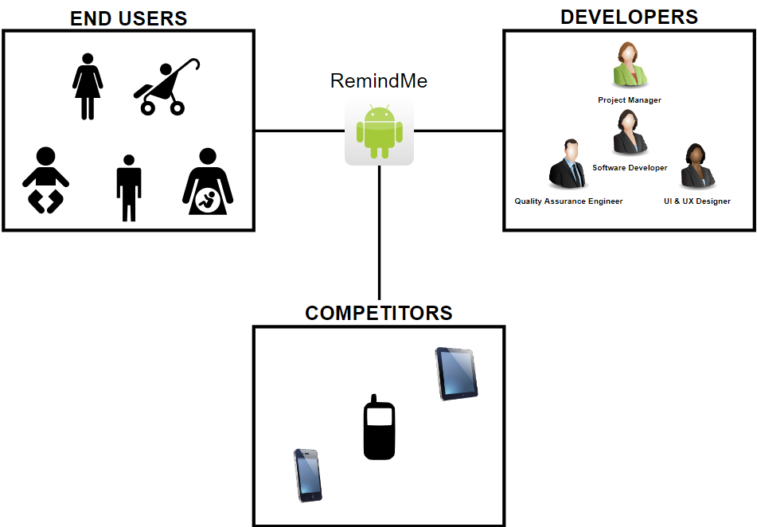

## **Stakeholders Roles**

### Developers

| Role | **Project Manager** |
| --- | --- |
| Role description | The project manager foresees the completion of set tasks needed to complete the project effectively. |
| Expertise | Planning, organization, delegation, supervision, and motivation. |
| Responsibilities | Planning and directing through every step of the project to ensure tasks are completed on time. |
| Deliverables | These are the internal deliverables that are submitted to the team members: initial design, time-tracking report, project budget report, and progress report. The external deliverables that are delivered to stakeholders outside the company include: progress report, initial design, final design, and the final product. |

| **Role** | **Software Developer** |
| --- | --- |
| Role description | Software developers identify user needs, build programs, test out new software, and make improvements. |
| Expertise | Some develop new applications for mobile or desktop use, while others build underlying operating systems. |
| Responsibilities | Design, program, build, deploy, and maintain software using a variety of tools and skills. They also help build software systems that power networks and devices, and ensure that those systems remain functional. |
| Deliverables | Deliverables could be a report, document, software product, server upgrade, or any other building block of an overall project. A deliverable might consist of many smaller deliverables. |

| **Role** | **UI & UX Designer** |
| --- | --- |
| Role description | The UI & UX Designer is responsible for making the product's interface effective in its interactions between the user and application while providing a positive and convenient experience. |
| Expertise | Artistic, innovative, visual design, behavior analysis, and prototyping. |
| Responsibilities | Understand how the aspects in the design affect the users demands and expectations of the product. Create dynamic and interactive prototyping based on user behavior. |
| Deliverables | Ideation: Sketching, UX/UI: Wireframing, UI design: Visualization (Mockups), Pre-development stage: Slicing  **SOURCE LINK:**  <https://mobidev.biz/blog/ui-ux-design-stages-deliverables-checklist> |

| **Role** | **Quality Assurance Engineer** |
| --- | --- |
| Role description | The Quality Assurance Engineer is responsible for testing the program to find and fix bugs before the program’s launch. |
| Expertise | Problem-solving and attention to detail |
| Responsibilities | Ensuring that the program runs smoothly by running tests and fixing bugs. Finding any problems with the User Interface. Overall, ensure the program is ready to launch, and the user will have a good experience. |
| Deliverables | Solutions to any bugs to ensure that the development team has the resources they need to make the program and the user experience better. |

### End Users

| **Role** | **Customer/Users** |
| --- | --- |
| Role description | Users are people who are experiencing any level of abuse and are seeking help. |
| Responsibilities | Use the application as a means of receiving help or documenting abuse. |
| Deliverables | Feedback from the user will help developers make any necessary changes to the application in order to better the user’s experience. |

### Competitors

| **Role** | **Competitor** |
| --- | --- |
| Description | Apps that have similar functionalities and services, such as Docusafe and MyPlan. |
| Responsibilities | Offer resources and features for the end users to document abuse. |
| Deliverables | Improve upon some of their key functionality |

# 

# Goal Model

This diagram is intended to help us plan and execute our goals for this application. Visualizing our goals will provide us with a path to our end goal and will help us plan accordingly along the way. Showing the connections between them will ensure that we stay on track and can be used as a reference at a later time. Establishing goals is a necessary and important part of developing and designing our application. Our primary goal is to design a software that will provide support for victims of abuse by allowing them to document abusive events as well as give them access to external resources. Part of our primary goal is to disguise the application to look like a reminder app in order to make the app discrete and ensure the safety of the user. Our primary goal can be divided into three different categories: Usage, Business, and System goals. For each category, we define below what it means for our application.

1. Usage: Goals related to how the program will function and how the user will be interacting with it
2. Business: Goals related to strategy as developers that directly impact the application
3. System: Goals related to characteristics of the software and the design of the system

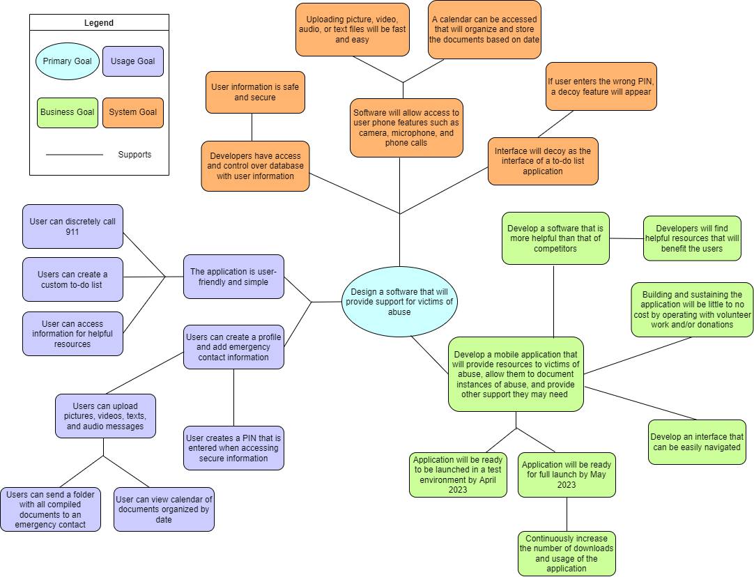

# System Vision

The System Vision diagram represents how all of the stakeholders will be involved with the system and how the system will respond in return. It is the developer’s responsibility to establish and maintain the whole system. Our system will provide a user-friendly interface that is disguised as a “To-do List” for all users and customers. The system will provide a quick user-guide for first-time users, and also display disguised check-in notifications as “Reminders” of support. Users will be able to use the system to document logs, share documented information one-time privately, and have immediate access to resources they might need. Users will also have the option to allow the system to track their current location and/or store their last location. The system will have a dummy to-do list display if someone other than the user attempts to login with an incorrect password, and it will have an automatic system time-out if there is no interaction from the user within 30 seconds.

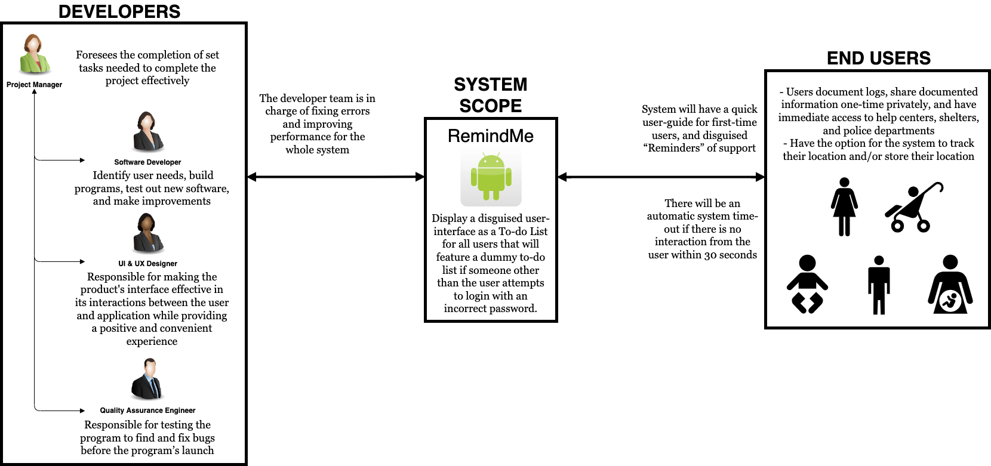

# 

# Usage Model

The usage model represents data about the user (victim) goals, and the conditions in which they use the software and how they use it. The model also includes all relevant qualities of the software usage factors, to an extent that recognizes the software benefits to the user. The usage model below will illustrate how the end user, software, and developers interact with one another. The first interaction between the victim and our application occurs upon signing up. The software will provide the victim with a user guide that walks them through the steps of how to use the app beneficially. The victim can use the Disguised App layer to create a custom to-do list and receive corresponding reminder notifications. In order to access the hidden Abuse Victims App layer, the victim must create a secure PIN that will be linked to their profile information. This will give them permission to the rest of the usage factors modeled within the Abuse Victims App. In the case of a user inputting an invalid PIN, a trigger sets off the decoy interface. The developers will be responsible for managing the users, database, fixing errors, and making updates while improving the performance of the system.

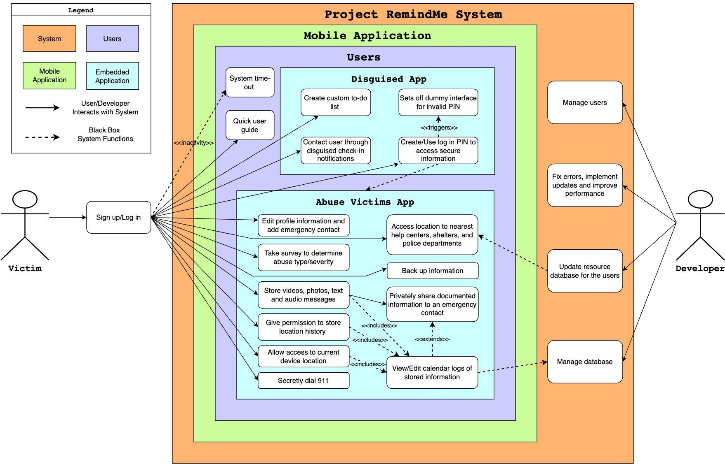

# Use Cases

| **Use Case #1** | Disguised App Name | | | |
| --- | --- | --- | --- | --- |
| **Goal in Context** | The application’s name will not raise alarms to an abuser who checks the user’s downloading history | | | |
| **Scope and level** | Strategic & Primary Task | | | |
| **Preconditions** | User will need an android phone with Google Play Store | | | |
| **Success End Condition** | Anyone that is not the user will not question the application’s name based off of the Google Play Store history download | | | |
| **Failed End Condition** | Low download numbers due to the application’s name being too unrecognizable | | | |
| **Primary, Secondary Actors** | Primary: Users  Secondary: Google Play Store | | | |
| **Trigger** | The user can search for the application on Google Play Store by it’s name | | | |
| **Description** | | | **Step** | **Action** |
|  | | | 1 | User opens Google Play Store |
|  | | | 2 | User searches for the application name |
|  | | | 3 | User downloads the application |
|  | | | 4 | User’s Google Play Store download and search history does not raise suspicions towards the abuser |
| **Extension** | | | **Step** | **Branching Action** |
|  | | | 2a | The name of the application will have to be known by word of mouth or by searching keywords that are in the applications description |
| **Sub-Variations** | | |  | **Branching Action** |
|  | | |  | None |
| **Related Information** | | | *RemindMe* | |
| **Priority** | | | The name of the application is critical, as the entire purpose of the application is to be disguised | |
| **Performance** | | | 2 to 3 minutes for the user to search for and download the application. | |
| **Frequency** | | | Name of the application will remain the same throughout its lifetime | |
| **Channels to Actors** | | | N/A | |
| **Open Issues** | | | None | |
| **Due Date** | | | Process already completed | |
| ..**.any other**  **management info** | | | None | |
| **Superordinates** | | | None | |
| **Subordinates** | | | None | |

| **Use Case #2** | Disguised App Display | | | |
| --- | --- | --- | --- | --- |
| **Goal in Context** | The application’s home screen will be disguised as a regular To-Do List/Task Manager and require a password to have access | | | |
| **Scope and level** | Strategic & Primary Task | | | |
| **Preconditions** | User will need to search for the app on their device | | | |
| **Success End Condition** | Visibly, the app will be displayed and perceived as an application used to create and manage To-Do lists and does not raise suspicions of the abuser | | | |
| **Failed End Condition** | The app is easily recognized as an app used to help abuse victims | | | |
| **Primary, Secondary Actors** | Primary: Users  Secondary: Front end developers | | | |
| **Trigger** | The user will recognize the app on their device based off the app’s display | | | |
| **Description** | | | **Step** | **Action** |
|  | | | 1 | User opens Google Play Store |
|  | | | 2 | User searches for the app and is able to confirm the application based off of the display |
|  | | | 3 | Once the app is downloaded, the user will interact with the app that visibly perceived as an app to create and manage tasks |
| **Extension** | | | **Step** | **Branching Action** |
|  | | |  | None |
| **Sub-Variations** | | |  | **Branching Action** |
|  | | |  | None |
| **Related Information** | | | Visual design | |
| **Priority** | | | The display of the application is critical, as the entire purpose of the application is to be disguised | |
| **Performance** | | | 2 to 3 minutes for the user to search for and download the application. | |
| **Frequency** | | | The application display will only change depending on necessity, such as visual updates or app theme changing entirely | |
| **Channels to Actors** | | | N/A | |
| **Open Issues** | | | None | |
| **Due Date** | | | April 2023 | |
| **...any other**  **management info** | | | None | |
| **Superordinates** | | | None | |
| **Subordinates** | | | None | |

| **Use Case #3** | Store videos | | | |
| --- | --- | --- | --- | --- |
| **Goal in Context** | Allow the user to upload videos to document proof of abuse | | | |
| **Scope and level** | Strategic & Primary Task | | | |
| **Preconditions** | The application will require access to the user’s files and camera to take/upload the videos | | | |
| **Success End Condition** | The app will display confirmation that the video has been saved. | | | |
| **Failed End Condition** | Any issues during the video recording or uploading process will prevent the videos from being properly stored | | | |
| **Primary, Secondary Actors** | Primary: Users  Secondary: Storage system outside of the user’s device | | | |
| **Trigger** | The user will be given an option to record video and prompted with a camera interface when selected. | | | |
| **Description** | | | **Step** | **Action** |
|  | | | 1 | User opens the app: RemindMe |
|  | | | 2 | User goes through the login process listed in the previous use cases |
|  | | | 3 | User taps on the camera option |
|  | | | 4 | User is prompted with a camera interface and selects the option to record a video |
|  | | | 5 | User records and hits stop button |
|  | | | 6 | Video files are safely and privately stored outside of the user’s device/local storage |
| **Extension** | | | **Step** | **Branching Action** |
|  | | |  | None |
| **Sub-Variations** | | |  | **Branching Action** |
|  | | | 1 | User opens the app: RemindMe |
|  | | | 2 | User goes through the login process |
|  | | | 3 | User accesses items stored in the app and selects the option to upload new items |
|  | | | 4 | User will upload the desired videos |
|  | | | 5 | Video files are safely and privately stored outside of the user’s device/local storage |
| **Related Information** | | | Video-Upload | |
| **Priority** | | | Recording & uploading videos is critical, as documenting abuse can be extremely helpful when reporting abusive events | |
| **Performance** | | | Video footage will be recorded at 780p quality to minimize battery consumption and storage constraints | |
| **Frequency** | | | This process will repeat each time the user would like to record a new video or upload an already existing video from their device | |
| **Channels to Actors** | | | Database, interactive, timeouts | |
| **Open Issues** | | | None | |
| **Due Date** | | | April 2023 | |
| **...any other**  **management info** | | | None | |
| **Superordinates** | | | None | |
| **Subordinates** | | | None | |

| **Use Case #4** | Store Photos | | | |
| --- | --- | --- | --- | --- |
| **Goal in Context** | Allow the user to take photos or upload and store photo documents to assist in logging abusive events | | | |
| **Scope and level** | Strategic & Primary Task | | | |
| **Preconditions** | The application will require access to the user’s files and camera to take/upload the photos | | | |
| **Success End Condition** | The application will notify the user that the photo has been successfully saved/uploaded | | | |
| **Failed End Condition** | The photos will not be properly stored | | | |
| **Primary, Secondary Actors** | Primary: Users  Secondary: Storage system outside of the user’s device | | | |
| **Trigger** | When selected, the user will be given an option to take a photo and prompted with a camera interface. | | | |
| **Description** | | | **Step** | **Action** |
|  | | | 1 | User opens the app: RemindMe |
|  | | | 2 | User goes through the login process listed in the previous Use Cases |
|  | | | 3 | User selects the camera choice |
|  | | | 4 | User is prompted with a camera interface and selects the option to take a photo |
|  | | | 5 | User takes picture(s) |
|  | | | 6 | Photo files are safely and privately stored outside of the user’s device/local storage |
| **Extension** | | | **Step** | **Branching Action** |
|  | | |  | None |
| **Sub-Variations** | | |  | **Branching Action** |
|  | | | 1 | User opens the app: RemindMe |
|  | | | 2 | User goes through the login process |
|  | | | 3 | User accesses previous logs stored in the app and selects the option to upload new items |
|  | | | 4 | User will upload the desired photos |
|  | | | 5 | Photo files are safely and privately stored outside of the user’s device/local storage |
| **Related Information** | | | Photo-Upload | |
| **Priority** | | | The ability to take photos is essential to help the user with documenting and reporting abusive events | |
| **Performance** | | | Photos will be taken with 780p quality to minimize storage constraints | |
| **Frequency** | | | This process will repeat each time the user would like to take a new photo or upload an already existing photo from their device | |
| **Channels to Actors** | | | Database, interactive, timeouts | |
| **Open Issues** | | | None | |
| **Due Date** | | | April 2023 | |
| **...any other**  **management info** | | | None | |
| **Superordinates** | | | None | |
| **Subordinates** | | | None | |

| **Use Case #5** | Store Text | | | |
| --- | --- | --- | --- | --- |
| **Goal in Context** | Allow the user to type up or upload and store text documents to assist in logging abusive events | | | |
| **Scope and level** | Strategic & Primary task | | | |
| **Preconditions** | The application will require access to the user’s local storage to upload already existing text files | | | |
| **Success End Condition** | The application will notify the user that the text file(s) has been successfully saved/uploaded | | | |
| **Failed End Condition** | The text file(s) will not be properly stored | | | |
| **Primary, Secondary Actors** | Primary: Users  Secondary: Storage system outside of the user’s device | | | |
| **Trigger** | The user will be given an option to create or upload a text file | | | |
| **Description** | | | **Step** | **Action** |
|  | | | 1 | User opens the RemindMe app |
|  | | | 2 | User goes through the login process |
|  | | | 3 | User will select option to create new text file |
|  | | | 4 | User will create text file with desired information |
|  | | | 5 | User will save the text file which will then be stored in a safe and private location that is not their device’s local storage |
| **Extension** | | | **Step** | **Branching Action** |
|  | | |  | None |
| **Sub-Variations** | | |  | **Branching Action** |
|  | | | 1 | User will open the RemindMe app |
|  | | | 2 | User goes through the login process |
|  | | | 3 | User will select the option to upload a text document and upload their desired text document |
|  | | | 4 | The text file will then be uploaded to a safe and private location that is not their device’s local storage |
| **Related Information** | | | Text- Upload | |
| **Priority** | | | Creating & uploading text files with information regarding abusive events is critical as it can be used when reporting abusive events | |
| **Performance** | | | .txt, .dox, and .pdf files will be supported to make uploading easier and more convenient | |
| **Frequency** | | | This process will repeat each time the user would like to create a new text file or upload an existing text file from their device | |
| **Channels to Actors** | | | Database, interactive, timeouts | |
| **Open Issues** | | | None | |
| **Due Date** | | | April 2023 | |
| **...any other**  **management info** | | | None | |
| **Superordinates** | | | None | |
| **Subordinates** | | | None | |

| **Use Case #6** | Store Audio | | | |
| --- | --- | --- | --- | --- |
| **Goal in Context** | Allow the user to record or upload and store audio files to help log abusive events | | | |
| **Scope and level** | Strategic & Primary task | | | |
| **Preconditions** | The application will require access to the user’s local storage in order to upload pre-existing audio files | | | |
| **Success End Condition** | The application will notify the user that the audio file(s) has been successfully saved/uploaded | | | |
| **Failed End Condition** | The audio file(s) will not be properly stored | | | |
| **Primary, Secondary Actors** | Primary: Users  Secondary: Storage system outside of the user’s device | | | |
| **Trigger** | The user will have the option to record or upload an audio file | | | |
| **Description** | | | **Step** | **Action** |
|  | | | 1 | User opens the RemindMe app |
|  | | | 2 | User goes through the login process |
|  | | | 3 | User will select option to record new audio file |
|  | | | 4 | User will record their audio file with desired information |
|  | | | 5 | User will save the audio file which will then be stored in a safe and private location that is not their device’s local storage |
| **Extension** | | | **Step** | **Branching Action** |
|  | | |  | None |
| **Sub-Variations** | | |  | **Branching Action** |
|  | | | 1 | User will open the RemindMe app |
|  | | | 2 | User goes through the login process |
|  | | | 3 | User will select the option to upload an audio file and upload their desired audio file |
|  | | | 4 | The audio file will then be uploaded to a safe and private location that is not their device’s local storage |
| **Related Information** | | | Audio-Upload | |
| **Priority** | | | Recording & uploading audio files with information regarding abusive events is essential to help the user with documenting and reporting abusive events | |
| **Performance** | | | .mp3 and .amr files will be supported to make uploading easier and more convenient | |
| **Frequency** | | | This process will repeat each time the user would like to record a new audio file or upload an existing audio file from their device | |
| **Channels to Actors** | | | Database, interactive, timeouts | |
| **Open Issues** | | | None | |
| **Due Date** | | | April 2023 | |
| **...any other**  **management info** | | | None | |
| **Superordinates** | | | None | |
| **Subordinates** | | | None | |

| **Use Case #7** | Secretly Dial 911 | | | |
| --- | --- | --- | --- | --- |
| **Goal in Context** | Allow the user to dial 911 at the push of a button but not have their phone display that they are in a current call | | | |
| **Scope and level** | Strategic & Primary Task | | | |
| **Preconditions** | * The user must give the app permission to have access to make phone calls. * The user’s device must have cellular service connection | | | |
| **Success End Condition** | The user is successfully connected to the emergency services in a discrete manner | | | |
| **Failed End Condition** | The user is not connected to emergency services in a discrete manner (for example, it is obvious that the user is making a phone call) | | | |
| **Primary, Secondary Actors** | Primary: User  Secondary: The user’s device used to make a phone call | | | |
| **Trigger** | A visible emergency button that clarifies it will call 911 | | | |
| **Description** | | | **Step** | **Action** |
|  | | | 1 | The user will open the RemindMe App |
|  | | | 2 | The user will navigate to the password protected portion of the app and enter their pin |
|  | | | 3 | The user will navigate to the option that will request emergency services |
|  | | | 4 | The user will be prompted to confirm that they want to contact emergency services through the app |
|  | | | 5 | After confirming, Emergency services will be contacted while the display on the user’s phone does not show the action of a phone call being completed |
| **Extension** | | | **Step** | **Branching Action** |
|  | | |  | None |
| **Sub-Variations** | | |  | **Branching Action** |
|  | | |  | None |
| **Related Information** | | | Call 911 | |
| **Priority** | | | Being able to discreetly dial 911 is critical as it can be used in the middle of an abusive event where emergency services can listen to (and record) the event and attempt to dispatch emergency services to the phone call’s location. The user can leave the phone near-by without it appearing as if emergency services have been contacted | |
| **Performance** | | | This feature will require control of the user’s screen display to ensure that the device’s display does not indicate a phone call. It will take approximately 30 seconds to log into the app and press the emergency services button. | |
| **Frequency** | | | This process will only be repeated based off the user’s necessity to contact emergency services | |
| **Channels to Actors** | | | Interactive, timeouts, screen display | |
| **Open Issues** | | | None | |
| **Due Date** | | | April 2023 | |
| **...any other**  **management info** | | | None | |
| **Superordinates** | | | None | |
| **Subordinates** | | | None | |

| **Use Case #8** | Obtain Device Location | | | |
| --- | --- | --- | --- | --- |
| **Goal in Context** | Gain access to the user’s current device location | | | |
| **Scope and level** | Strategic & Primary Task | | | |
| **Preconditions** | The user must give the app permission to have access to obtain the device’s location | | | |
| **Success End Condition** | The application is able to properly obtain the user’s device location | | | |
| **Failed End Condition** | The application is unable to obtain the device’s location | | | |
| **Primary, Secondary Actors** | Primary: User’s who allow the application to retrieve the device’s location  Secondary: The device’s GPS location | | | |
| **Trigger** | The user selects the “allow” button when the app requests permission to access the current device location. | | | |
| **Description** | | | **Step** | **Action** |
|  | | | 1 | If the user wishes to access features that require the device’s location, the user will be prompted to allow access to the device’s GPS location |
|  | | | 2 | The user will allow or deny the application access of their device’s location |
|  | | | 3 | The application will then be able to obtain the device’s location when needed immediately after confirmation has been received |
| **Extension** | | | **Step** | **Branching Action** |
|  | | |  | None |
| **Sub-Variations** | | |  | **Branching Action** |
|  | | |  | None |
| **Related Information** | | | GPS Location | |
| **Priority** | | | Obtaining the user’s device location is not critical, but it can be helpful by supporting other features that may require GPS location | |
| **Performance** | | | The GPS location will only be obtained when prompted by the user, depending on the feature being used. This will help prevent constant draining of the device’s battery | |
| **Frequency** | | | This process will be repeated when there are features using the GPS location of the user’s device | |
| **Channels to Actors** | | | Permissions, GPS location | |
| **Open Issues** | | | None | |
| **Due Date** | | | April 2023 | |
| **...any other**  **management info** | | | None | |
| **Superordinates** | | | None | |
| **Subordinates** | | | None | |

| **Use Case #9** | System Time-Out | | | |
| --- | --- | --- | --- | --- |
| **Goal in Context** | If the user is not interactive with the application within a certain amount of time, the RemindMe application will close entirely on the device | | | |
| **Scope and level** | System & Primary function | | | |
| **Preconditions** | The user must have the RemindMe application downloaded | | | |
| **Success End Condition** | After a certain amount of time has passed where the user was inactive on the open RemindMe application, it will close entirely and will require reopening if the user wants access to the application again | | | |
| **Failed End Condition** | The application does not close entirely on the device if the maximum time of inactivity has been reached | | | |
| **Primary, Secondary Actors** | Primary: The user  Secondary: The application’s timeout system | | | |
| **Trigger** | No activity on the application from the user | | | |
| **Description** | | | **Step** | **Action** |
|  | | | 1 | The user does not interact with the RemindMe application |
|  | | | 2 | The application closes on the user’s device |
| **Extension** | | | **Step** | **Branching Action** |
|  | | |  | None |
| **Sub-Variations** | | |  | **Branching Action** |
|  | | |  | None |
| **Related Information** | | | Application Timeout | |
| **Priority** | | | This is a critical feature as it gives the user the ability to maintain privacy if their device is left unoccupied with sensitive information regarding abusive events. | |
| **Performance** | | | A window of 15 - 30 seconds for the system to verify that the application is inactive before closing the application out | |
| **Frequency** | | | This process will occur each time the user interacts or doesn’t interact with the application | |
| **Channels to Actors** | | | Time outs | |
| **Open Issues** | | | Deciding a safe window / time-frame for the application to time out | |
| **Due Date** | | | April 2023 | |
| **...any other**  **management info** | | | None | |
| **Superordinates** | | | None | |
| **Subordinates** | | | None | |

| **Use Case #10** | Survey to Determine Abuse Type/Severity | | | |
| --- | --- | --- | --- | --- |
| **Goal in Context** | This feature is meant to help users who are abuse victims, or know of an abuse victim, determine the type and/or the severity of the victim’s abuse | | | |
| **Scope and level** | Strategic & Summary | | | |
| **Preconditions** | The user must have the RemindMe application downloaded | | | |
| **Success End Condition** | The user receives results that indicate the victim’s type and/or the severity of their abuse | | | |
| **Failed End Condition** | * The user is unable to take the survey when prompted * The user does not receive the results that were determined from the survey | | | |
| **Primary, Secondary Actors** | Primary: The user  Secondary: Database system that keeps track of the user’s results | | | |
| **Trigger** | * The user will be prompted to take the survey when first downloading the RemindMe application * The user will also be able to decide to retake the survey any time they would like | | | |
| **Description** | | | **Step** | **Action** |
|  | | | 1 | The user downloads the RemindMe app |
|  | | | 2 | The user is prompted to take the survey |
|  | | | 3 | The user opts to take the survey and proceeds with answering the survey questions |
|  | | | 4 | The user is then presented with the results of the survey, which are also stored outside of the device’s local storage to access for future reference |
| **Extension** | | | **Step** | **Branching Action** |
|  | | |  | None |
| **Sub-Variations** | | |  | **Branching Action** |
|  | | | 1 | The user already has the RemindMe app downloaded |
|  | | | 2 | The user selects the feature that allows them to take the survey |
|  | | | 3 | The user proceeds with answering the survey questions |
|  | | | 4 | The user is then presented with the results of the survey, which are also stored outside of the device’s local storage to access for future reference |
| **Related Information** | | | Victim Survey | |
| **Priority** | | | This feature is critical, as some abuse victims are not entirely aware of how severe their abuse is until it is too late. This survey is meant to help victims become more aware of the types of abuse they are experiencing | |
| **Performance** | | | Survey results will be saved and then presented to the user immediately | |
| **Frequency** | | | This feature process will be repeated each time the user decides to take the surveys | |
| **Channels to Actors** | | | Database system, timeout | |
| **Open Issues** | | | Which existing surveys from experts will be used to create and conduct these surveys | |
| **Due Date** | | | April 2023 | |
| **...any other**  **management info** | | | None | |
| **Superordinates** | | | None | |
| **Subordinates** | | | None | |

| **Use Case #11** | User Login to Access Private Information | | | |
| --- | --- | --- | --- | --- |
| **Goal in Context** | This feature is to provide the user with privacy in regards to accessing their stored documents and/or information of their abusive events | | | |
| **Scope and level** | Strategic & Primary Task | | | |
| **Preconditions** | The user will need to create a pin code to access the information | | | |
| **Success End Condition** | The user will be able to access their privately stored information using the pin code they set | | | |
| **Failed End Condition** | The user is unable to set a pin code for their private information | | | |
| **Primary, Secondary Actors** | Primary: The user  Secondary: Database | | | |
| **Trigger** | The user will select the option to access their private information | | | |
| **Description** | | | **Step** | **Action** |
|  | | | 1 | The user will open the RemindMe application |
|  | | | 2 | They will then navigate to the location of where their private information is stored |
|  | | | 3 | The user will then be prompted to enter a pin |
|  | | | 4 | If the correct pin is used, the user will then have access to their private information that is stored in the database |
| **Extension** | | | **Step** | **Branching Action** |
|  | | | 4a | If incorrect pin is used/dummy pin is used then the user will not be allowed to access the information, but will be brought to a different page in the app |
| **Sub-Variations** | | |  | **Branching Action** |
|  | | |  | None |
| **Related Information** | | | User login | |
| **Priority** | | | This feature is critical as it is a safety feature to help the user hide their information that may include documented items from abusive events | |
| **Performance** | | | This feature should process in a quick and timely manner as any delays can possibly cause the application to time out as the user is waiting for their information | |
| **Frequency** | | | This feature will be used each time the user is attempting to access their private information | |
| **Channels to Actors** | | | Database, timeout | |
| **Open Issues** | | | Should this be a pin with numbers or a password that includes letters and symbols? | |
| **Due Date** | | | March 2023 | |
| **...any other**  **management info** | | | None | |
| **Superordinates** | | | Dummy Display with incorrect logins | |
| **Subordinates** | | | System time-out | |

| **Use Case #12** | Disguised Check-In Notifications | | | |
| --- | --- | --- | --- | --- |
| **Goal in Context** | The application will display disguised check-in notifications as regular “To-Do List" notifications to remind the user that they have support from the app | | | |
| **Scope and level** | System & Primary Function | | | |
| **Preconditions** | The user must have the RemindMe app downloaded | | | |
| **Success End Condition** | A reminder check-in notification will display and prompt the user to log-in if they attempt to access the app, and it does not raise suspicions of the abuser | | | |
| **Failed End Condition** | The notification is easily recognized as an app used to help abuse victims | | | |
| **Primary, Secondary Actors** | Primary: the User  Secondary: Front end developers | | | |
| **Trigger** | The user will receive a notification on their device from RemindMe | | | |
| **Description** | | | **Step** | **Action** |
|  | | | 1 | The user downloads the RemindMe app |
|  | | | 2 | The user receives a disguised check-in notification from RemindMe |
|  | | | 3 | The user proceeds to interact with the notification |
|  | | | 4 | The user is presented with the app’s log-in screen |
|  | | | 5 | The user enters the correct password and is able access the apps features and their information |
| **Extension** | | | **Step** | **Branching Action** |
|  | | |  | None |
| **Sub-Variations** | | |  | **Branching Action** |
|  | | | 1 | The RemindMe app is already downloaded |
|  | | | 2 | The user’s device receives a disguised notification from RemindMe |
|  | | | 3 | Someone other than the user interacts with the notification |
|  | | | 4 | This person is presented with the app’s log-in screen |
|  | | | 5 | They enter the wrong password and are shown the app’s dummy to-do list |
| **Related Information** | | | Visual design | |
| **Priority** | | | The display of the notifications are critical, as the entire purpose of the application is to be disguised | |
| **Performance** | | | 10 to 15 seconds to display as a quick notification | |
| **Frequency** | | | A reminder check-in notification will be displayed at least once a week to the user | |
| **Channels to Actors** | | | N/A | |
| **Open Issues** | | | None | |
| **Due Date** | | | April 2023 | |
| **...any other**  **management info** | | | None | |
| **Superordinates** | | | None | |
| **Subordinates** | | | None | |

| **Use Case #13** | User Profile Information | | | |
| --- | --- | --- | --- | --- |
| **Goal in Context** | The user will create a profile that will contain necessary information about the user including name, cell phone number, and emergency contact information. | | | |
| **Scope and level** | Strategic & Primary | | | |
| **Preconditions** | The user must have the RemindMe app downloaded | | | |
| **Success End Condition** | The user will have all necessary information saved on their profile | | | |
| **Failed End Condition** | The system does not store all information and some is lost | | | |
| **Primary, Secondary Actors** | Primary: The user  Secondary: Database | | | |
| **Trigger** | Upon downloading and opening app, user will be prompted to create a profile | | | |
| **Description** | | | **Step** | **Action** |
|  | | | 1 | The user downloads the RemindMe app |
|  | | | 2 | The user is prompted to create a profile |
|  | | | 3 | The user enters their information |
|  | | | 4 | The user now has created a profile |
| **Extension** | | | **Step** | **Branching Action** |
|  | | |  | None |
| **Sub-Variations** | | |  | **Branching Action** |
|  | | | 1 | The user downloads the RemindMe app |
|  | | | 2 | The user is prompted to create a profile |
|  | | | 3 | The user chooses to not create a profile at that moment |
|  | | | 4 | The user is directed to the home screen |
| **Related Information** | | | Create Profile | |
| **Priority** | | | This feature is critical because it is essential the users information is stored in the database, especially the users name and emergency contacts | |
| **Performance** | | | 2 to 3 minutes | |
| **Frequency** | | | Once | |
| **Channels to Actors** | | | Interactive | |
| **Open Issues** | | | None | |
| **Due Date** | | | April 2023 | |
| **...any other**  **management info** | | | None | |
| **Superordinates** | | | None | |
| **Subordinates** | | | None | |

| **Use Case #14** | Quick User Guide | | | |
| --- | --- | --- | --- | --- |
| **Goal in Context** | Give a quick rundown of how to use the app so the user understands how to best utilize our features. | | | |
| **Scope and level** | System & Primary | | | |
| **Preconditions** | The user must have the RemindMe app downloaded | | | |
| **Success End Condition** | The user learns everything they need to know about the app through the quick user guide and are set up to successfully use the app and its features | | | |
| **Failed End Condition** | The quick user guide is unclear and the user is still unsure of how to use the app | | | |
| **Trigger** | Upon downloading and opening the app for the first time, the quick user guide will appear. After the first time, the user will be able to access the quick user guide again when necessary | | | |
| **Description** | | | **Step** | **Action** |
|  | | | 1 | The user downloads the RemindMe app |
|  | | | 2 | The user opens the app and the quick user guide appears |
|  | | | 3 | The user clicks next to go through each step of the guide |
|  | | | 4 | Once the guide is finished, the home screen is displayed |
| **Extension** | | | **Step** | **Branching Action** |
|  | | |  | None |
| **Sub-Variations** | | | **Step** | **Branching Action** |
|  | | | 1 | The user will open the RemindMe app |
|  | | | 2 | Navigate to the settings options |
|  | | | 3 | Select the “Quick-Guide” option to be show how the application functions |
| **Related Information** | | | Quick User Guide | |
| **Priority** | | | Although this feature is not critical, it can become helpful to the users who need guidance on how the application operates or need a quick reminder | |
| **Performance** | | | The quick user guide will be displayed on the application until the user either prompts out of the user guide or the application times out and closes | |
| **Frequency** | | | The quick user guide will be displayed at minimum one time upon downloading the application, then it will be displayed if and only if the user decides to view it | |
| **Channels to Actors** | | | Database | |
| **Open Issues** | | | None | |
| **Due Date** | | | February 2023 | |
| **...any other**  **management info** | | | None | |
| **Superordinates** | | | None | |
| **Subordinates** | | | None | |

| **Use Case #15** | Storing Location History | | | |
| --- | --- | --- | --- | --- |
| **Goal in Context** | The app will give the user the ability to store the most recent location in the calendars history log. | | | |
| **Scope and level** | System & Primary Task | | | |
| **Preconditions** | The user must give the app permission to have access to obtain the device’s location | | | |
| **Success End Condition** | The application is able to properly store and upload the user’s most recent device location | | | |
| **Failed End Condition** | The application is unable to obtain the device’s location | | | |
| **Primary, Secondary Actors** | Primary: User’s that allow the application to retrieve their device’s location  Secondary: The device’s GPS location | | | |
| **Trigger** | The user chooses to store their most recent location on RemindMe | | | |
| **Description** | | | **Step** | **Action** |
|  | | | 1 | If the user wishes to access features that require the device’s location, the user will be prompted to allow access to the device’s GPS location |
|  | | | 2 | The user will allow or deny the application access of their device’s location |
|  | | | 3 | The application will then be able to obtain the device’s location when needed immediately after confirmation has been received |
|  | | | 4 | The user can select the option to store their last location |
| **Extension** | | | **Step** | **Branching Action** |
|  | | |  | None |
| **Sub-Variations** | | |  | **Branching Action** |
|  | | |  | None |
| **Related Information** | | | GPS Location | |
| **Priority** | | | Although obtaining the user’s device location is not critical, it is useful for features such as this one that requires GPS location | |
| **Performance** | | | The GPS location will only be obtained when prompted by the user to help prevent constant draining of the device’s battery | |
| **Frequency** | | | This process will be repeated when the user selects to store their last location | |
| **Channels to Actors** | | | Permissions, GPS location | |
| **Open Issues** | | | None | |
| **Due Date** | | | April 2023 | |
| **...any other**  **management info** | | | None | |
| **Superordinates** | | | Provide locations of nearest help/support, storing location history | |
| **Subordinates** | | | None | |

| **Use Case #16** | Provide Locations of Nearest Help Centers, Shelters, and Police Departments | | | |
| --- | --- | --- | --- | --- |
| **Goal in Context** | This feature will display a map of pins to the nearest help centers, shelters and police departments. Along with contact information and a brief description of services in an effort to provide helpful resources to the users. | | | |
| **Scope and level** | Strategic & Primary task | | | |
| **Preconditions** | The user must give the app permission to obtain device location in order to find the nearest resource centers. | | | |
| **Success End Condition** | The app displays an accurate map with resource locations based on device location. | | | |
| **Failed End Condition** | * The user does not allow the app to obtain device location. * App cannot accurately locate and display map pinning the nearest resources | | | |
| **Primary, Secondary Actors** | Primary: Users that are seeking helpful resources  Secondary: Resource centers that are being located | | | |
| **Trigger** | User selects the helpful resources button in the RemindMe App | | | |
| **Description** | | | **Step** | **Action** |
|  | | | 1 | The user opens the RemindMe App. |
|  | | | 2 | The user will navigate to the option that provides helpful resources. |
|  | | | 3 | The app displays a request to obtain device location, where the user can make a selection. |
|  | | | 4 | Upon allowing the device to obtain its current location, a map with pins to the nearest resources will be displayed. |
| **Extension** | | | **Step** | **Branching Action** |
|  | | |  | None |
| **Sub-Variations** | | |  | **Branching Action** |
|  | | |  | None |
| **Related Information** | | | Helpful - Resources | |
| **Priority** | | | This is a critical feature, as it is meant to give the users the power to research where they can receive support without leaving behind a search history online | |
| **Performance** | | | This feature will have to operate in a quick and timely manner as it can be crucial for users to seek support | |
| **Frequency** | | | This feature will be repeated each time the user decides to search for support nearest to their current location | |
| **Channels to Actors** | | | GPS location | |
| **Open Issues** | | | Will a map or the locations be more useful vs a list? | |
| **Due Date** | | | March 2023 | |
| **...any other**  **management info** | | | None | |
| **Superordinates** | | | None | |
| **Subordinates** | | | Accessing current GPS location | |

| **Use Case #17** | Calendar Logs of Stored Information | | | |
| --- | --- | --- | --- | --- |
| **Goal in Context** | The app will provide an integrated calendar that links the documented information to a desired or recorded date. The user can easily organize, search and view a history log of all documented data through the calendar. | | | |
| **Scope and level** | Strategic & Primary Task | | | |
| **Preconditions** | The user must have the RemindMe app downloaded. | | | |
| **Success End Condition** | The user can conveniently locate all their documented information that is linked by date on the calendar. | | | |
| **Failed End Condition** | The system failed to link the documents to the calendar, so the user is unable to view recorded data in an organized fashion. | | | |
| **Primary, Secondary Actors** | Primary: User who wants to easily locate their documents by date  Secondary: Front end developers and storage system outside of users device. | | | |
| **Trigger** | The user uploads or records information onto the app. | | | |
| **Description** | | | **Step** | **Action** |
|  | | | 1 | User opens the app: RemindMe |
|  | | | 2 | User goes through the login process listed in the previous use cases |
|  | | | 3 | User taps on calendar option |
|  | | | 4 | The calendar interface appears and the user selects a date to view attached logs. |
| **Extension** | | | **Step** | **Branching Action** |
|  | | |  | None |
| **Sub-Variations** | | |  | **Branching Action** |
|  | | |  | None |
| **Related Information** | | | Calendar Event Logs | |
| **Priority** | | | Having a calendar to log abuse is critical to users so they are able to reference their own history of records of the abusive events that took place whenever needed. | |
| **Performance** | | | The user will be able to store their events by date to keep it in an organized manner that is easy to navigate. | |
| **Frequency** | | | Whenever the user needs to recall an abusive event, they will have the option to view or select the date from their calendar log. | |
| **Channels to Actors** | | | Database | |
| **Open Issues** | | | How the users will be able to categorize the events other than just by date | |
| **Due Date** | | | April 2023 | |
| **...any other**  **management info** | | | None | |
| **Superordinates** | | | None | |
| **Subordinates** | | | Store videos, store pictures, store text, and store audio | |

| **Use Case #18** | Sharing Documented Information Privately | | | |
| --- | --- | --- | --- | --- |
| **Goal in Context** | If the user feels confident enough to share their documented information in regards to their abuse, they will be able to send the information to another individual via email | | | |
| **Scope and level** | Strategic & Summary | | | |
| **Preconditions** | The user must have the RemindMe app downloaded and know the email address of the individual they wish to sent the information to | | | |
| **Success End Condition** | The individual successfully receives the email with all the information the user decided to share | | | |
| **Failed End Condition** | The individual does not receive the files | | | |
| **Primary, Secondary Actors** | Primary: The user  Secondary: database & individual receiving the information | | | |
| **Trigger** | The user selects the option to send documented information to certain individuals | | | |
| **Description** | | | **Step** | **Action** |
|  | | | 1 | The user will have the RemindMe app downloaded |
|  | | | 2 | The user will navigate to the feature where all of their private information will be stored on the app |
|  | | | 3 | The user will be prompted to enter their pin to access the information |
|  | | | 4 | The user will select the option to share their information to an email address of their choice |
| **Extension** | | | **Step** | **Branching Action** |
|  | | |  | None |
| **Sub-Variations** | | |  | **Branching Action** |
|  | | |  | None |
| **Related Information** | | | Securely sharing information | |
| **Priority** | | | Sharing documents privately is critical as it can benefit users who need an easy way to share their logged abuse information with someone they trust | |
| **Performance** | | | The user will have the option to create a zip file of all their logged history and privately share it to an email address of their choice. It will take 30 seconds to zip files and email them. | |
| **Frequency** | | | This option will always be available to users whenever they feel the need to share their logs/information | |
| **Channels to Actors** | | | Interactive | |
| **Open Issues** | | | None | |
| **Due Date** | | | April 2023 | |
| **...any other**  **management info** | | | None | |
| **Superordinates** | | | Store videos, store photos, store texts, and store audio | |
| **Subordinates** | | | None | |

| **Use Case #19** | Dummy Display with Incorrect Logins | | | |
| --- | --- | --- | --- | --- |
| **Goal in Context** | The application will require a password in order to access the user’s information; if an incorrect password is entered, then the app will display a made-up “To-Do List” to make the abuser believe they have successfully accessed the apps information | | | |
| **Scope and level** | Strategic & Primary Task | | | |
| **Preconditions** | User will need to have the app installed on their device and set up their custom To-do list if they do not want one auto-generated | | | |
| **Success End Condition** | The app will display the dummy To-do List if an incorrect password is entered and it does not raise suspicions of the abuser | | | |
| **Failed End Condition** | The app is easily recognized as an app used to help abuse victims | | | |
| **Primary, Secondary Actors** | Primary: Users  Secondary: Front end developers | | | |
| **Trigger** | An incorrect password is entered into RemindMe’s log-in screen | | | |
| **Description** | | | **Step** | **Action** |
|  | | | 1 | Someone other than the user attempts to access their RemindMe app |
|  | | | 2 | The app prompts the abuser to log-in |
|  | | | 3 | The abuser enters an incorrect password |
|  | | | 4 | The app displays a dummy to-do list |
|  | | | 5 | The abuser is prompted to sign-in again |
| **Extension** | | | **Step** | **Branching Action** |
|  | | |  | None |
| **Sub-Variations** | | |  | **Branching Action** |
|  | | | 1 | The user open their RemindMe app |
|  | | | 2 | The app prompts for the user to log-in |
|  | | | 3 | The user enters an incorrect password |
|  | | | 4 | The app displays a dummy to-do list to the user |
|  | | | 5 | The user is prompted to sign-in again |
| **Related Information** | | | Visual design | |
| **Priority** | | | The dummy To-do List is critical, as the entire purpose of the application is to be disguised | |
| **Performance** | | | The made-up tasks will be either be a simple auto-generated To-do List or it will be custom-made by the user | |
| **Frequency** | | | The list will appear whenever an incorrect password is entered on the RemindMe log-in screen | |
| **Channels to Actors** | | | N/A | |
| **Open Issues** | | | How to auto-generate a believable list that will trick people every time someone other than the user attempts to access RemindMe | |
| **Due Date** | | | April 2023 | |
| **...any other**  **management info** | | | None | |
| **Superordinates** | | | User login | |
| **Subordinates** | | | None | |

| **Use Case #20** | Backing up information | | | |
| --- | --- | --- | --- | --- |
| **Goal in Context** | The user will be able to send their information to themselves as a backup file via email | | | |
| **Scope and level** | Strategic & Summary | | | |
| **Preconditions** | The user must have the RemindMe app downloaded and know which one of their own email addresses that they are going to send the file to | | | |
| **Success End Condition** | The user successfully receives the email with all the information that they decided to share | | | |
| **Failed End Condition** | The user does not receive the files | | | |
| **Primary, Secondary Actors** | Primary: The user  Secondary: database & the user email receiving the information | | | |
| **Trigger** | The user selects the option to send documented information to certain email addresses | | | |
| **Description** | | | **Step** | **Action** |
|  | | | 1 | The user will have the RemindMe app downloaded |
|  | | | 2 | The user will navigate to the feature where all of their private information will be stored on the app |
|  | | | 3 | The user will be prompted to enter their pin to access the information |
|  | | | 4 | The user will select the option to share their information to one of their own email addresses |
| **Extension** | | | **Step** | **Branching Action** |
|  | | |  | None |
| **Sub-Variations** | | |  | **Branching Action** |
|  | | |  | None |
| **Related Information** | | | Securely backing up/sharing information | |
| **Priority** | | | Backing up information is critical because it allows users to share their logged abuse information with themselves in order to keep their records in a secure place outside of their device | |
| **Performance** | | | The user will have the option to create a zip file of all their logged history and privately share it to an email address of their choice | |
| **Frequency** | | | This option will always be available to users whenever they feel the need to share their logs/information | |
| **Channels to Actors** | | | Interactive | |
| **Open Issues** | | | None | |
| **Due Date** | | | April 2023 | |
| **...any other**  **management info** | | | None | |
| **Superordinates** | | | Store videos, store pictures, store texts, and store audio | |
| **Subordinates** | | | None | |

# Functional & non-functional Requirements

## Functional (Features)

* Sign in/Login
  + Allows users to access and hide documented information regarding abusive events
  + Prevents others from accessing the user’s private information
* Searching support nearby
  + Allows users to privately research support centers near their current location
  + Nearby support centers will be listed on a map or in a list with some filter options
    - Filter by distance amount
    - Sort by distance
    - Filter by type of support
* Dummy pins and displays
  + Prevents others that are not the user from accessing private information and/or becoming suspicious of the app’s intended use
  + When an dummy pin is entered, then the app will display and interact as a To-Do application and the private information cannot be accessed
* Privately sharing documentation
  + Documented information can be shared by email through the application
  + The user will not have to provide any email information and their information can be sent anonymously
* User profile information
  + The user can create a profile with no mandatory information to be provided. They will be able to document as much private information as they wish
  + Emergency contact can be used if the device is obtained by authorities and they are able to go through the app (and are familiar with its intent)
* Privately storing media (texts, photos, videos, & audio recordings)
  + Documenting abusive events and keeping them safe and away from the abuser is difficult. These features will allow the user to store them with a lower risk of grabbing the abuser’s attention

## 

## Quality (Qualities)

* Make sure that the app can be easily navigated while also operating discreetly
  + It should not be difficult to find or access features in the app, but the features should not be displayed in a obvious fashion
* Ensure that any external links open a browser window in an “incognito” mode to prevent an online history/trail
* The application must be functional during all hours and days of the week
  + If any updates need to be made to the app, the updates will be made in a test environment while the current version is still live

## Constraints (OS, languages)

* Each team member will have to set time aside to learn and understand the Kotlin coding language to ensure too much time is not wasted on unnecessary troubleshooting due to syntax
* Developing a secure database that will protect any and all users
* As beginning software engineers and developers, this project will require a lot of time and dedication. This means possibly sacrificing time for other work and activities to complete the application thoroughly

## Development Process

* Complete all documentation necessary
* Research and confirm all the technology needed to have the application operate
* Become familiar with Android SDK, coding languages, frontend, and backend
* Begin app development
* Deploy the application in a testing environment complete release
* Create a release and distribute the application in a real world environment
* Continuously maintain the application’s software