**Kary S. Sutariya**

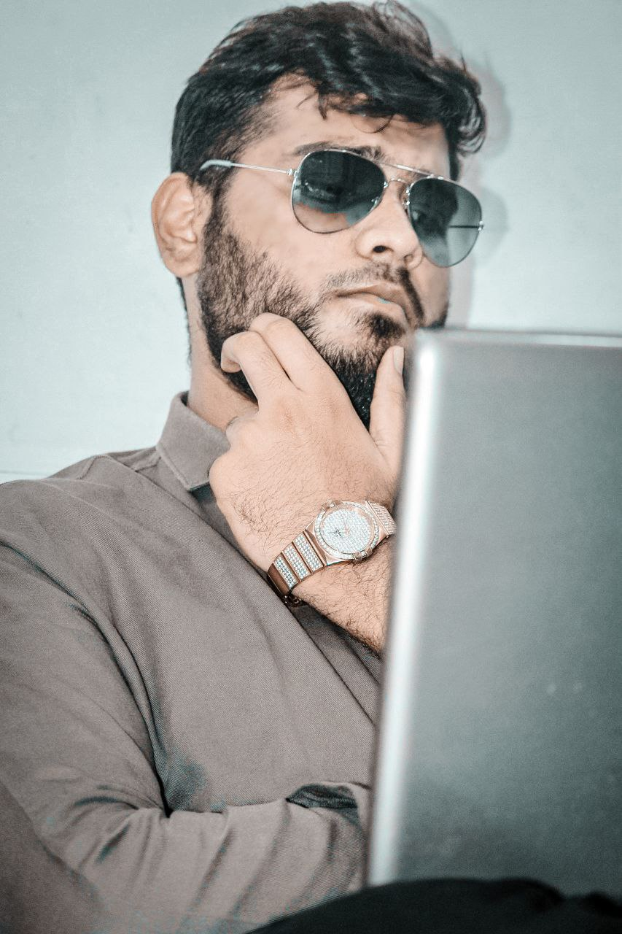

Master of Applied Computer Science

https://skarys.herokuapp.com/





PERSONALITY & Objectives

Many people say that they have experience but I don’t think experience matters a lot (By the way, I have an experience). According to me, it’s a will which matters the most. After working for nearly 1 year for a good organization. I learned one thing that is every project has different requirements compared all your past projects. Indeed, experience can guide us to opt best path. Moreover, 21st century is an era of rapid developments so whatever we know today will be old tomorrow. So, tackled this problem I have developed myself in a way to learn new technologies rapidly in the last year. I take challenges and put everything on the line for the success.

CONTACT

* +91 98252 93615

 [Karysutariya1234@gmail.com](mailto:Karysutariya1234@gmail.com)

 K-402, Melaanio Residency, near Yogi Chowk, Surat-395010.

SOCIAL

* KARY SUTARIYA

### @KARYSUTARIYA1234



 KARY SUTARIYA

 KARY S.

SKILLS

* Proficient in Python for back-end development.
* On front-end side fluent with React-Js, HTML, FLEX-BOX CSS, JavaScript. And others.
* Familiar with frameworks python and JavaScript namely Django, Django-rest, Reactjs, and Selenium.
* Server Deployment of projects on Linux servers, Pythonanywhere, AWS, DigitalOcean and others.
* SSL certificate integration and domain integration have done by me.
* Database designing and integration with python.
* Thorough understanding of computer hardware. As I had taken internship at small organization where that company makes assembled computers as per clients’ requirements.

Nonetheless, if I don’t know something, I’ll say directly that I need time to find out solution of problem. As I don’t accept failure, success will under your feet for sure. As an employer if you are good with above terms, we are good to go. I will wait for your kind reply.

 INCULCATION

**Master in Applied Computer Science** CLASS OF 2021 ***Concordia University – Montreal, Canada***

**B. E. in Computer Engineering** Class OF 2020

Gujarat Technological University – Ahmedabad, India

As an Undergraduate Student, my academic accomplishments include:

* + **8.74 CGPA**
  + Certified in **Programming, Data Structure and Algorithm using Python** by IIT-Madras (ranking at country: 1st)
  + Published a paper at RIHET’18, presented in National level conference held by ISTE and ISBN no. 978-93-5346-457-8.
  + Completed Course of **Machine Learning** from the **Coursera** with **96%.**
  + Got scholarship for further education from Gujarat state Government (around $ 2167)

**H. S. C**. Class OF 2016 Ashadeep Higher Secondary School, Surat

Percentage- 78.15%

**S. S. C**. Class OF 2014 Mangaldeep High School, Surat

Percentage- 85.17% Rank at school level – 4th

Projects

* FFMeasure
* In this project I was making PowerPoint presentation for a company using CSV data of students.
* I had written script which makes slides using python code and ffmpeg library.
* Share market
* Currently, I am working on this project. This is a website which shows information about share market of India.
* We are gathering data using Web scraping.
* Android apps with back-end in python.

<https://play.google.com/store/apps/details?id=com.ninetynineapps.teluguactress.wallpapers>

<https://play.google.com/store/apps/details?id=com.bollywoodwallpapers.hollywoodwallpapers>

<https://play.google.com/store/apps/details?id=com.ninetynineapps.southactress.wallpapers>

<https://play.google.com/store/apps/details?id=com.ninetynineapps.tamilactress.wallpapers>

<https://play.google.com/store/apps/details?id=com.bollywood.actress.wallpapers>

* Web scraping and Datamining
* Image mining from Instagram
* Data mining of social groups from Instagram
* iOS app
* AWS SMS micro services
* Back-end API and data models

<https://apps.apple.com/in/app/dentist-on-demand/id1488297899>



# AWARD

Awarded Scholarship from Saint Louis University (U.S.A.) for doing masters there in computer Science field. The amount of scholarship was approximately $10,000.



 WORK Experience

**Python Developer** August 2020

Benzatine Infotech (<https://www.benzatine.com/> ), Surat

As a full-time Software Engineer, my responsibilities included:

* Writing, testing and altering code to meet client requirements.
* Work with technologies like Django and Machine Learning.
* Handling clients directly and present updates on the projects.



KEY ACHIEVEMENT

Youngest and the only undergraduate author who presented paper on Smart Database System; titled “A REVIEW DBMS WITH NATURAL LANGUAGE PROCESSING IN SANSKRIT” at RIHET’18, presented in National level conference held by ISTE and ISBN no.978-93-5346-457-8.



REFERENCE

Ms. Nikita

NPTEL,

IIT Madras,

employment@nptel.iitm.ac.in

RESEARCH WORK



* + Author: “**A REVIEW DBMS WITH NATURAL LANGUAGE PROCESSING IN SANSKRIT**”
  + Published a paper at RIHET’18
  + Presented in National level conference held by ISTE
  + ISBN no. 978-93-5346-457-8.

 CERTIFICATION

* + Achieved **96%** in **Machine Learning** course of **Coursera**.
  + Completed course of **CLP: Advance Programing in c** from **CISCO**.
  + Learned **Programming, Data Structure and Algorithm using Python** by IIT-Madras (NPTEL).
  + Completed **CYBER SECURITY (**Ethical Hacking) training program from SkillYou.

 COMPETITION

* + Secured 5th position (more than 1000 participants from entire Gujarat State) in Ingenious Hunt ’19 organized by Softices.

Link of result: <https://ingenioushunt.com/2019/ig/phase-2/result>

* + Achieved 11th rank in State Level Quiz competition ‘12 (held by Sardar Patel Education Trust).
  + Got Third place in Teacher’s day competition ‘11 (at school level)

VOLUTAREEN EXPERINECE



* Planned and Organized Technical Quiz at Technical Festival of ‘18.
  + Student member of The Indian Society for Technical Education.
  + Worked as corona warrior in India during Covid-19 pandemic.

*Your faithfully,*



Kary Sutariya