Assignment 4
R for Data Visualization: Fundamentals & First EDA

Team Number | 2
Project Title | Historical Stock Analysis
Dataset (name & source/link) | data/stock_data.csv - https://www.kaggle.com/datasets/ibrahimshahrukh/top-50-companies-dataset (note: this Kaggle dataset has since been removed/taken down by its uploader)
Team Members | Karthikeyan M (26120004), Mirthula M (26120121), Lakshmi Mayuri Kavya N (26120161)
Date | [team: confirm submission date]

This report redoes our Assignment 2 python eda (eda.ipynb) in r, same dataset, same questions, a different language, per the assignment's own instructions. Part C figure numbers below are r figures 1 through 8, separate from the python eda's own figure numbering. The full r script is assignment4_eda.R at the repo root.

Part A: Installation & Setup
R and RStudio were installed via Homebrew (brew install --cask r rstudio), which is equivalent to the CRAN/Posit installers. Console output is pasted below in place of screenshots, which the worksheet explicitly allows ("paste screenshots or console output").
Packages installed and loaded:
> library(tidyverse)
-- Attaching core tidyverse packages -------------------- tidyverse 2.0.0 --
v dplyr 1.2.1 v readr 2.2.0
v forcats 1.0.1 v stringr 1.6.0
v ggplot2 4.0.3 v tibble 3.3.1
v lubridate 1.9.5 v tidyr 1.3.2
v purrr 1.2.2
-- Conflicts ------------------------------------- tidyverse_conflicts() --
x dplyr::filter() masks stats::filter()
x dplyr::lag() masks stats::lag()
> library(data.table)
data.table 1.18.4 using 5 threads (see ?getDTthreads).
> library(lubridate)
> library(reshape2)
(all four load cleanly, no error text - the lines above are the standard
"masking" notices every tidyverse session prints, not failures)
Dataset loaded and checked:
> df <- read.csv('data/stock_data.csv')
> dim(df)
[1] 230111 8
> names(df)
[1] "Date" "Ticker" "Open" "High" "Low" "Close"
[7] "Adj.Close" "Volume"
> str(df)
'data.frame': 230111 obs. of 8 variables:
$ Date : chr "2006-01-02" "2006-01-03" "2006-01-04" ...
$ Ticker : chr "000660.KS" "000660.KS" "000660.KS" ...
$ Open : num 36100 38100 38250 35900 34950 ...
$ High : num 37650 38400 39050 36000 35850 ...
$ Low : num 35850 36850 35300 33600 34850 ...
$ Close : num 37600 38200 35400 34750 35100 ...
$ Adj.Close: num 27358 27795 25758 25285 25539 ...
$ Volume : num 13334311 13815168 23064896 21043236 12557226 ...
> head(df)
Date Ticker Open High Low Close Adj.Close Volume
1 2006-01-02 000660.KS 36100 37650 35850 37600 27358.40 13334311
2 2006-01-03 000660.KS 38100 38400 36850 38200 27794.97 13815168
3 2006-01-04 000660.KS 38250 39050 35300 35400 25757.65 23064896
4 2006-01-05 000660.KS 35900 36000 33600 34750 25284.69 21043236
5 2006-01-06 000660.KS 34950 35850 34850 35100 25539.36 12557226
6 2006-01-09 000660.KS 35600 36750 35450 36750 26739.93 13524015
- 230,111 rows and 8 columns, matching what we expected and what the python eda found. R renamed Adj Close to Adj.Close automatically, since read.csv does not allow spaces in column names, and Date loaded as plain text rather than a date type, both just how r's base reader works rather than anything wrong with the data.

Part B: Concept Check
B.1 In your own words, distinguish descriptive statistics from inferential statistics. Give one example of each using your own project dataset.
- Descriptive statistics summarize and describe the main characteristics of a dataset using measures such as the mean, median, standard deviation, and graphs. Inferential statistics use sample data to make conclusions about a larger population.
- Descriptive example: in our stock market dataset, we calculated the mean daily return and median trading volume to summarize the data.
- Inferential example: we performed a hypothesis test to check whether the average daily returns of two markets were significantly different.

B.2 Suppose your key numeric variable has a few extreme outliers. Which measure of central tendency would you trust more - the mean or the median - and why? Name one measure of spread that is similarly robust to outliers.
- We would choose the median, since it is resistant to outliers, whereas the mean is heavily affected by extreme values.
team to add: a robust measure of spread (e.g. the interquartile range, IQR) still needs to be named to fully answer this question.

B.3 What two parameters define a normal distribution, and what does each one control?
- A normal distribution is defined by two parameters: the mean, which determines the central location of the distribution, and the standard deviation, which controls the spread of the data away from the mean, expressed in the original data's units.

B.4 Name one sampling method other than simple random sampling, and describe a situation from your project domain where it would be the better choice.
- One sampling method is stratified sampling, where the population is divided into homogeneous groups and samples are drawn from each group.
- In our stock market dataset, the data contains companies from different countries, so we would divide the data into groups based on country and randomly sample from each group. This ensures every country is properly represented.

B.5 Explain, in a sentence or two, what a p-value below your chosen significance level (alpha) tells you about the null hypothesis.
- A p-value below the chosen significance level (alpha) means there is enough evidence to reject the null hypothesis. It suggests that the observed result is statistically significant and is unlikely to have happened by chance.

B.6 What is the difference between base R, the tidyverse, and data.table as approaches to working with data? Name one advantage of each.
- Base R uses built-in R functions for data analysis. Advantage: no extra packages are required.
- tidyverse is a collection of packages that make data manipulation and visualization simple and readable. Advantage: easy-to-read syntax and an efficient workflow.
- data.table is a package designed for fast data manipulation, especially with large datasets. Advantage: very fast and memory-efficient.

B.7 Which single dplyr verb would you use to (a) keep only the rows meeting a condition, and (b) collapse many rows into one summary row per group?
- (a) To keep only rows that meet a condition, use filter().
- (b) To create one summary row per group, use summarise(), paired with group_by() to define the groups.

B.8 Explain the difference between wide and long data format. Name one function - from reshape2 or tidyr - that converts data from wide to long.
- Wide format stores each variable in a separate column. Long format stores values from multiple columns in a single column, with another column indicating the variable name.
- One function that converts data from wide to long is pivot_longer() from tidyr.

B.9 List the seven layers of ggplot2's Grammar of Graphics, in order.
- Data
- Aesthetics (aes)
- Geometries (geom)
- Statistics (stat)
- Scales
- Coordinate system (coord)
- Facets

B.10 Your scatter plot has hundreds of points overlapping in one corner. Name two techniques you could use in ggplot2 to make the underlying pattern more visible.
- Use transparency by setting the alpha value, so overlapping points become visible rather than solid.
- Use geom_jitter() to slightly spread overlapping points and reveal the underlying pattern.

Part C: First EDA in R

C0: Setup & Data Overview
C0.1 shape and column types
- The dataset has 230,111 rows and 8 columns: Date (character), Ticker (character), Open, High, Low, Close, Adj.Close, and Volume (all numeric). This matches what we expected, one row per ticker per trading day across 49 tickers, no surprises in row count, and it matches the python eda's own dtypes exactly aside from R's automatic Adj Close -> Adj.Close renaming and Date loading as text instead of a date type.
C0.2 summary statistics
- Volume has the widest range by far, 0 to about 18.8 billion, but that is a share count, not a price, so it is not really comparable to the price columns.

- Among the price columns, High has the widest range, about 955,000, stretched by Korean won prices sitting at a completely different scale from dollar prices.

- Volume also has the largest mean minus median gap, about 44 million, and every price column shows the same roughly 40x mean-to-median gap for the same reason: mixed currencies pulling the average up, not genuine skew in any single stock. All of this matches the python eda's C0.2 numbers exactly.
C0.3 missing data
- colSums(is.na(df)) shows zero missing values in every column, identical to the python eda. Nothing needs to be dropped or imputed for missingness; the real quirks in this data (mixed currencies, staggered start dates) do not show up as missing values.

C1: Univariate Exploration
C1.1 distribution of the key numeric variable
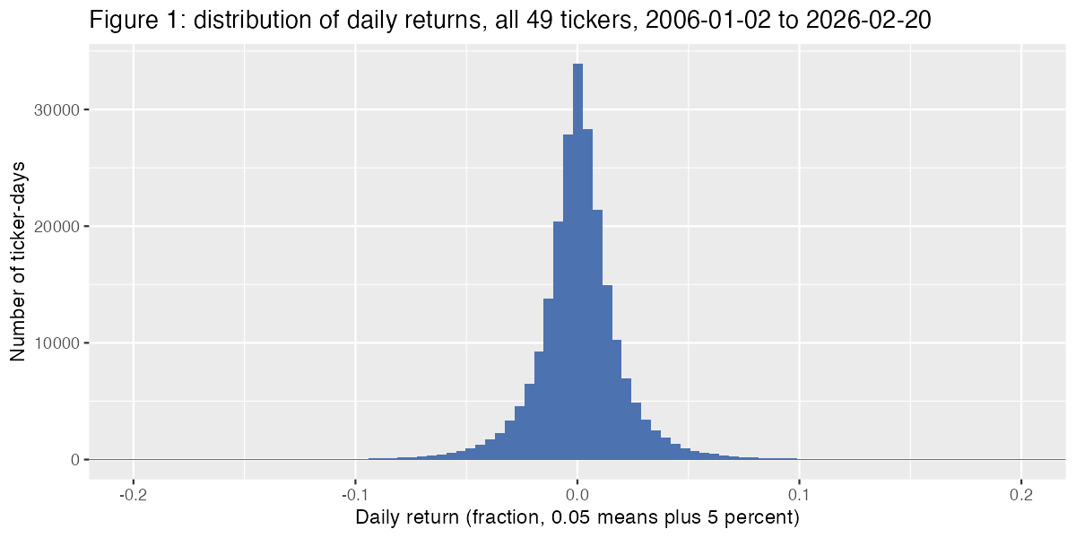
- Daily return is the numeric variable most central to the project, the same choice as the python eda, since raw price cannot be compared across the 49 tickers once currency is mixed in.

- Figure 1 is roughly symmetric and centered near zero, mean about 0.08 percent and median about 0.04 percent a day, which makes sense since most days a stock does not move much either way.

- The shape is not a clean bell curve: a sharp narrow peak right at zero, with long thin tails stretching to about minus 35 percent and plus 52 percent in a single day. Those extreme days are rare but far more common than a normal distribution would predict, the same read the python eda reached.
C1.2 category counts for a key categorical variable
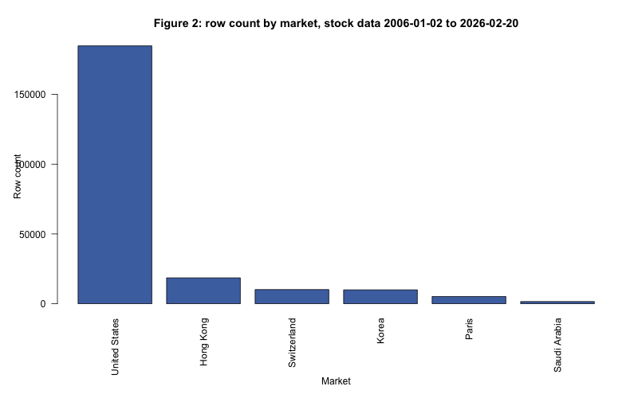
- Market, derived from ticker suffix, is the categorical variable again. Figure 2 shows the same heavy skew as the python eda: United States rows are 184,793 of 230,111 total, about 80 percent, while Saudi Arabia has only 1,550 and Paris only 5,152.

- This is mostly a ticker-count imbalance (39 of 49 tickers are US-listed), not a market trading more often, which means the Paris and Saudi Arabia labels are really single company statistics.
C1.3 box plot for outliers (optional / bonus)
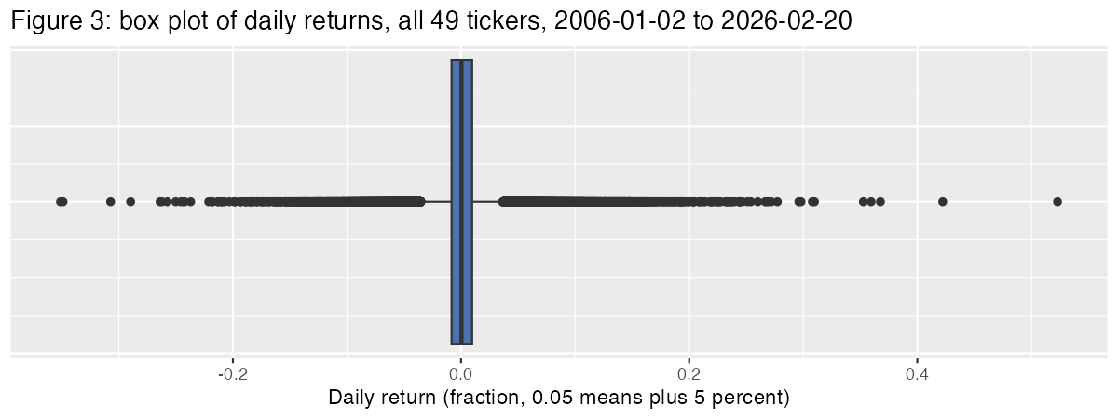
- Figure 3's box sits tightly between about minus 3.5 percent and plus 3.7 percent, with a dense scatter of points beyond both whiskers, about 7.24 percent of all ticker-days, identical to the python eda's outlier fence and share.

- The most extreme days on record are the same real events found in python: Netflix's two roughly 35 percent single-day drops (2022-04-20 and 2011-10-25), Nvidia's 31 percent drop during the 2008 crisis, Bank of America's swings in 2008-2009, Meta's 26 percent drop in 2022, and AMD's 52 percent jump in 2016. These read as genuine extreme trading days tied to real news, not data errors, so they should stay in the dataset.

C2: Relationships Between Variables
C2.1 scatter plot of two related numeric variables
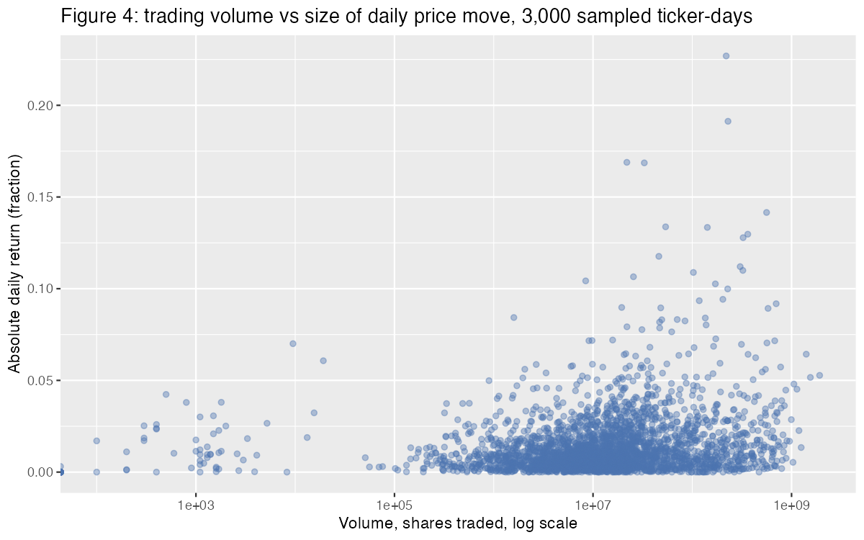
- Same question as the python eda: does bigger trading volume come with bigger price moves. The Pearson correlation between volume and the size of the daily move is 0.207, identical to the python result.

- Figure 4 shows a widening funnel, not a tight line: low volume days are almost always small moves, but high volume days can be small or huge. Volume raises the ceiling on how big a move can get without guaranteeing a big move happens, a weak relationship at best, the same conclusion the python eda reached.
C2.2 correlation heatmap
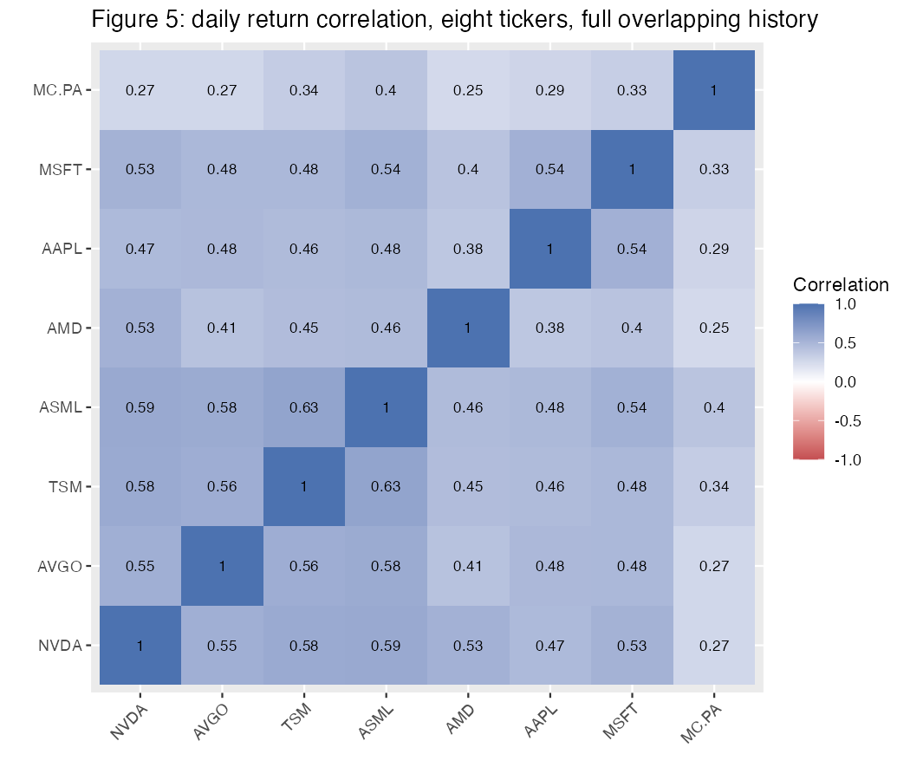
- Same eight tickers as the python eda: five chip names (NVDA, AVGO, TSM, ASML, AMD), Apple, Microsoft, and one non-US name outside tech, LVMH (MC.PA).

- Figure 5 shows the same clustering: ASML-TSM is the strongest pair at 0.63, and the five chip names sit together at 0.53-0.63, noticeably tighter than their correlation with Apple or Microsoft (0.38-0.54).

- LVMH is the weakest-correlated name against everything else, 0.25-0.40, well below any tech-to-tech pair. Same caveat as the python eda: this cannot separate sector from region since LVMH is both non-tech and the only non-US name here, and it is a full history average, not a check on crisis periods specifically.
C2.3 recreate one plot above using a second R graphics system
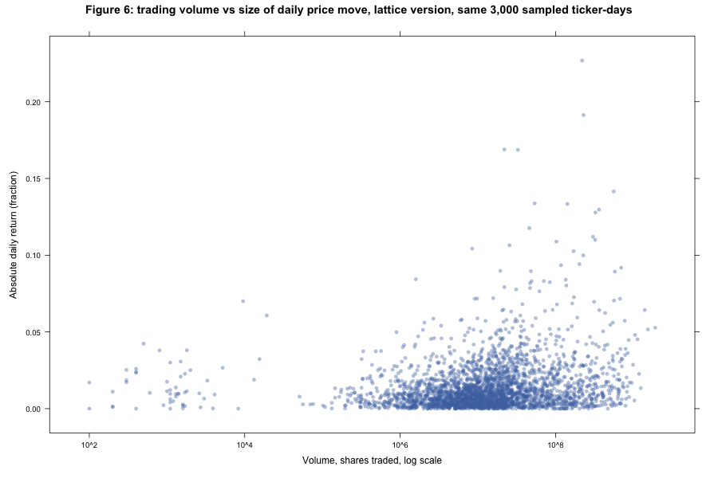
- Figure 6 recreates Figure 4 (volume vs. size of move) using Lattice's xyplot(), a different graphics system from the ggplot2 used above, on the same sampled 3,000 points.

- The shape reads the same in both. Lattice's default styling is plainer and its log axis prints as powers of ten (10^2, 10^4) rather than ggplot2's 1e+03 style, a small but real difference in how the two systems format the same information. ggplot2 was quicker to get labeled and styled the way we wanted; Lattice needed less code for a quick default plot but less control over the details.

C3: Group & Categorical Comparisons
C3.1 group by a key categorical variable, compare a numeric outcome
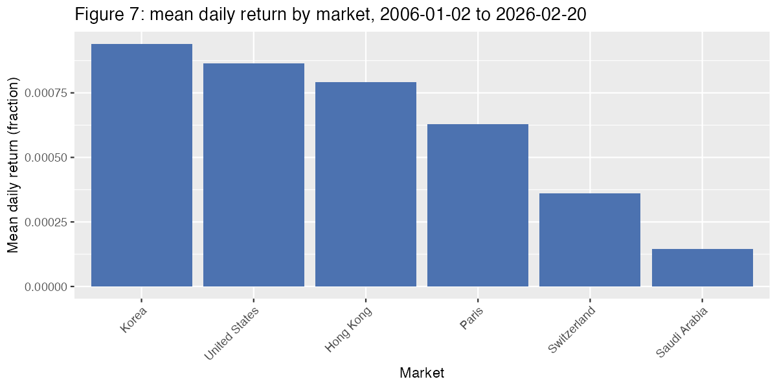
- Grouping by market again, Figure 7 shows the same order the python eda found: Korea has the highest mean daily return (0.094 percent), then United States (0.086 percent), Hong Kong, Paris, Switzerland, and Saudi Arabia lowest (0.015 percent).

- Korea is also the most volatile market by standard deviation (2.37 percent daily) and Saudi Arabia the calmest (1.05 percent), so higher average return and higher volatility travel together here, same as the python eda found.

- Same caveat carried over from C1.2: Saudi Arabia, Paris, and Switzerland are one or two tickers each, so this is not really a market-wide statistic, it is a statistic about a handful of individual companies wearing a market label.
C3.2 key variable over time
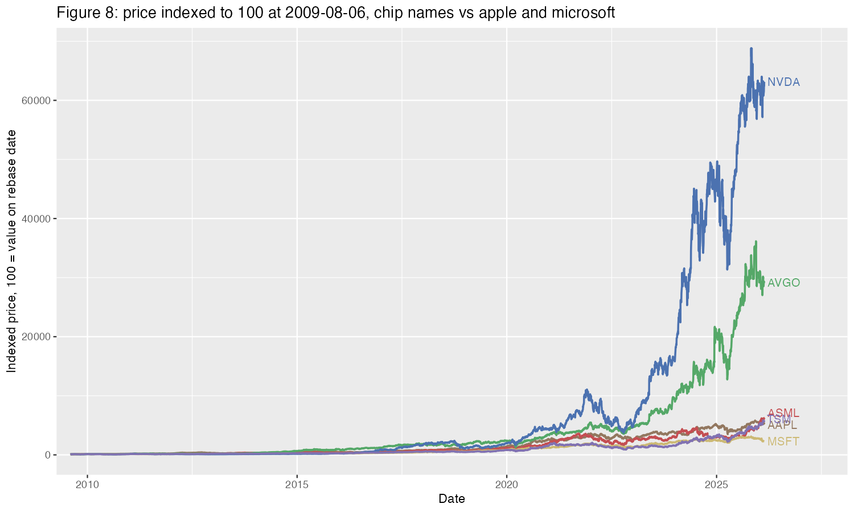
- Figure 8 indexes NVDA, AVGO, TSM, ASML, AAPL, and MSFT to 100 at 2009-08-06, Broadcom's start date and the latest starter of the six, the same rebase logic as the python eda.

- NVDA reaches about 63,100 by 2026-02-20 and AVGO about 29,200, both far ahead of ASML and TSM (about 58-62x) and AAPL (about 54x), with MSFT trailing at about 23x, matching the python eda's Figure 8 numbers.

- This supports the AI rally narrowness idea but complicates the simple version of it: AVGO alone would still justify a chip-outperformance story without NVDA, but ASML and TSM end up closer to AAPL's growth than to NVDA or AVGO's.

C4: Data Quality Notes
- Mixed currencies across tickers - revealed in C0.2's summary table, the roughly 40x gap between mean and median in every price column is currency mixing, not real skew, since Korean won prices sit at a totally different scale from dollar prices. Every chart that combines tickers in this script works around it with returns or indexing instead of raw price.

- Heavy market imbalance - revealed in Figure 2, United States is about 80 percent of all rows, and two of six market labels (Paris, Saudi Arabia) are backed by a single company each, so any market-level statistic in Figure 7 is really a statement about one or two companies.

- A small number of zero-volume days concentrated in one ticker - this one came out of building Figure 4/6 in R specifically. R's scale_x_log10() threw a warning about infinite values from the log transform, which led to checking sum(df$Volume == 0). 1,706 rows (0.74 percent of the dataset) have Volume recorded as exactly zero, and 1,459 of those, about 85 percent, belong to a single ticker, AZN, spread mostly across 2009-2019 with a smaller cluster in 2024-2025. That is not spread evenly across all 49 tickers, so it looks like a data recording gap specific to AZN rather than genuinely zero trading on those days for a large pharmaceutical stock.

C5: Synthesis & Reflection
C5.1 three key findings
- Figure 8 shows the AI rally narrowness idea is real but uneven within the chip group: NVDA and AVGO pulled dramatically ahead (631x and 292x their 2009 value) while ASML and TSM only reached about 58-62x, barely ahead of AAPL's 54x. The finding should probably be about specific standout names rather than the whole chip sector as a block.

- Figure 5 shows the five chip names correlate more tightly with each other (0.53-0.63) than with AAPL or MSFT (0.38-0.54), and far more than with LVMH (0.25-0.40). That is independent evidence for the same narrowness story from a different angle, not just growth, but day-to-day correlation too.

- Figures 1 and 3 together show daily returns sharply peaked near zero with fat tails, about 7.2 percent of ticker-days sitting outside the box plot fence, and the most extreme days lining up with specific known events like the 2008 crisis or company earnings shocks rather than being spread evenly through time.
C5.2 which R graphics system felt most natural
- ggplot2 felt the most natural for this dataset. Its grammar-of-graphics approach, mapping columns directly to x, y, color, and building up labs() and geoms as layers, was the closest match to how we already think about a chart after doing the python eda in matplotlib and seaborn.

- Base R's barplot() (Figure 2) was fine for one simple bar chart but needed more manual margin adjustment (par(mar = ...)) than ggplot2 to stop axis labels from clipping.

- Lattice (Figure 6) worked well for a quick recreation but felt the least flexible of the three beyond its built-in plot types; its default styling was plainer and harder to customize to match the rest of the figures.
C5.3 comparison to the original python EDA
- Almost nothing looked different. Every number recomputed in R matched the python eda to the same precision shown: the same 0.207 volume-return correlation, the same 0.63 ASML-TSM correlation, the same 7.24 percent outlier share, the same rebase date and indexed values in Figure 8. That is reassuring rather than surprising, since both notebooks read the same csv file and just perform the same operations in a different language.

- One genuine difference: R's ggplot2 explicitly warned about the log-10 transform producing infinite values while building Figure 4, which led directly to finding the 1,706 zero-volume rows concentrated in AZN (see C4). The python matplotlib version of the same chart did not surface an equivalent warning in the notebook output, so this specific data quality issue was easier to catch in R.

- A smaller mechanical difference: R renamed Adj Close to Adj.Close on load, and dates came in as plain text rather than a date type until explicitly converted with lubridate, both things python's pandas read_csv handled automatically with parse_dates.
C5.4 one open question
- The same open question from the python eda carries over unresolved here too: Figure 5's correlation heatmap is a full 2006-2026 average, so we still do not know whether the chip cluster's tight correlation, or LVMH's low correlation with everyone, actually holds up specifically during 2008, 2020, and 2022, or whether it only looks stable because it is averaged over many calm years alongside the volatile ones. That is still the open thread from Assignment 3's H2 hypothesis work, not something this R pass answers on its own.

Deliverables
Filename: 26120004_Team2_Assignment4.docx
R script: assignment4_eda.R (repo root, contains all code from Parts A and C)
Submit via: Digiicampus

