Practice Set for Additional Credit (Assignment EC1)
Advanced Python Data Visualization

Team Number | 2
Project Title | Historical Stock Analysis
Team Members | [add team member names here]
Date | 2026-07-30

This report works through exercises A to F of the EC1 practice set, applied to our own project (data/stock_data.csv, 49 tickers, 2006-01-02 to 2026-02-20) rather than a textbook example. It builds on eda.ipynb (Assignment 2) and assignment3_analysis.ipynb (Assignment 3), reusing the same tickers, groupings, and hypotheses. The full working notebook is assignment_ec1.ipynb; this document summarizes it in report form.

Exercise A: Redesign for Clarity
Chosen chart: eda.ipynb Figure 8, six tickers (NVDA, AVGO, TSM, ASML, AAPL, MSFT) indexed to 100 since 2009-08-06.
- Wrong scale for the data's range: NVDA ends 27 times above MSFT, so a linear y-axis leaves four of six tickers flat near zero for most of the chart.
- Poor pre-attentive encoding of change: a linear axis encodes equal absolute change, not equal percent change, which is the wrong read for an indexed growth chart.
- Label collision: ASML, TSM, and AAPL end within 15% of each other, so their direct end labels overlap.
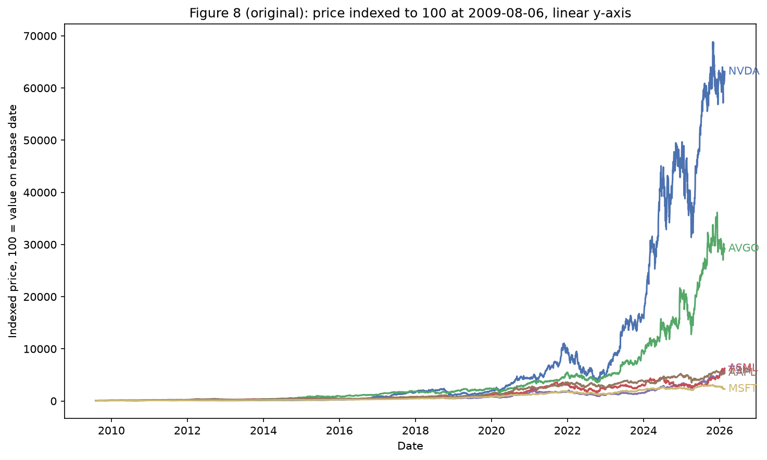 | 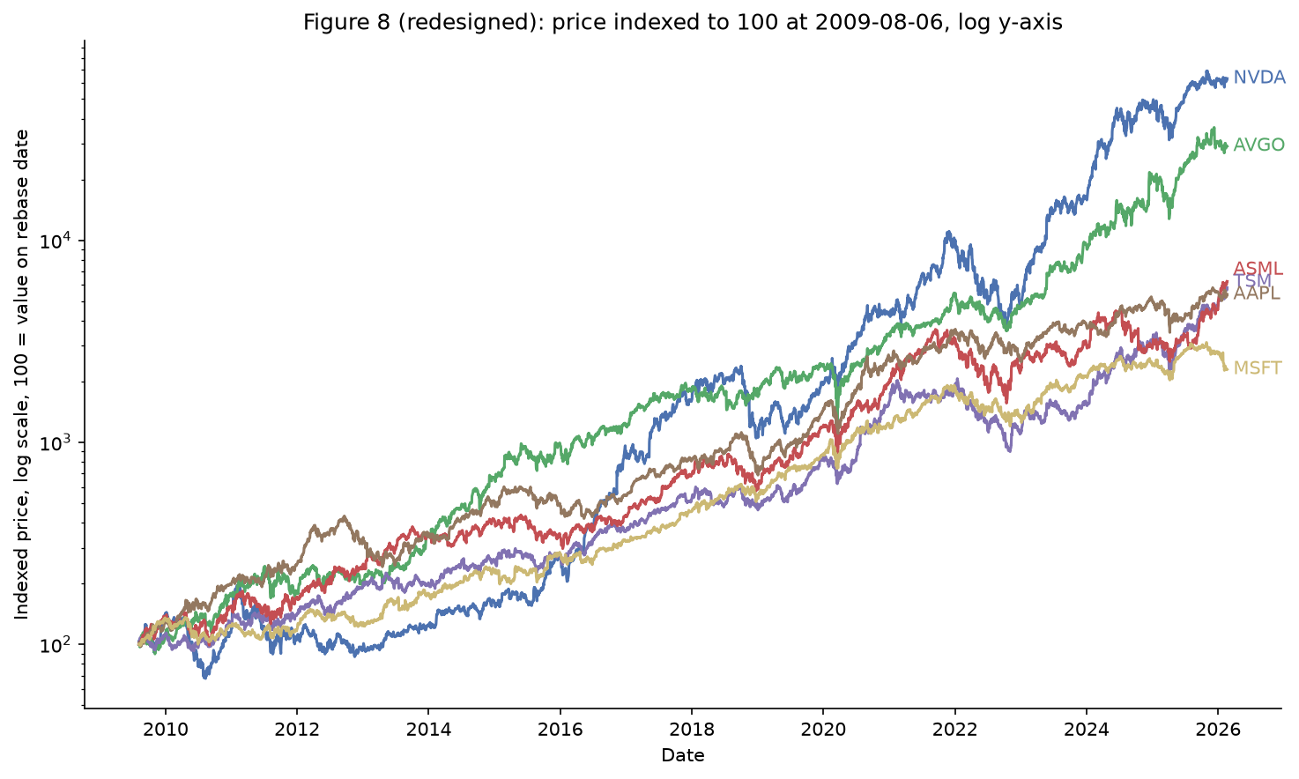
Before: linear y-axis | After: log y-axis, nudged labels
- Switching to a log y-axis makes equal vertical space mean equal percent change, so all six tickers show a visible growth curve across the full 16 years, not just the two winners.
- Nudging the three closest end labels apart by a small fixed amount keeps all six names readable instead of stacking three of them illegibly.

Exercise B: Small Multiples Storytelling
Categorical variable: region (US, Korea, Hong Kong, Switzerland, Paris; same one ticker per region as Assignment 3). Relationship shown: trading volume vs. each ticker's own 2015-2017 calm baseline, across the four periods, one subplot per region on a shared y-axis.
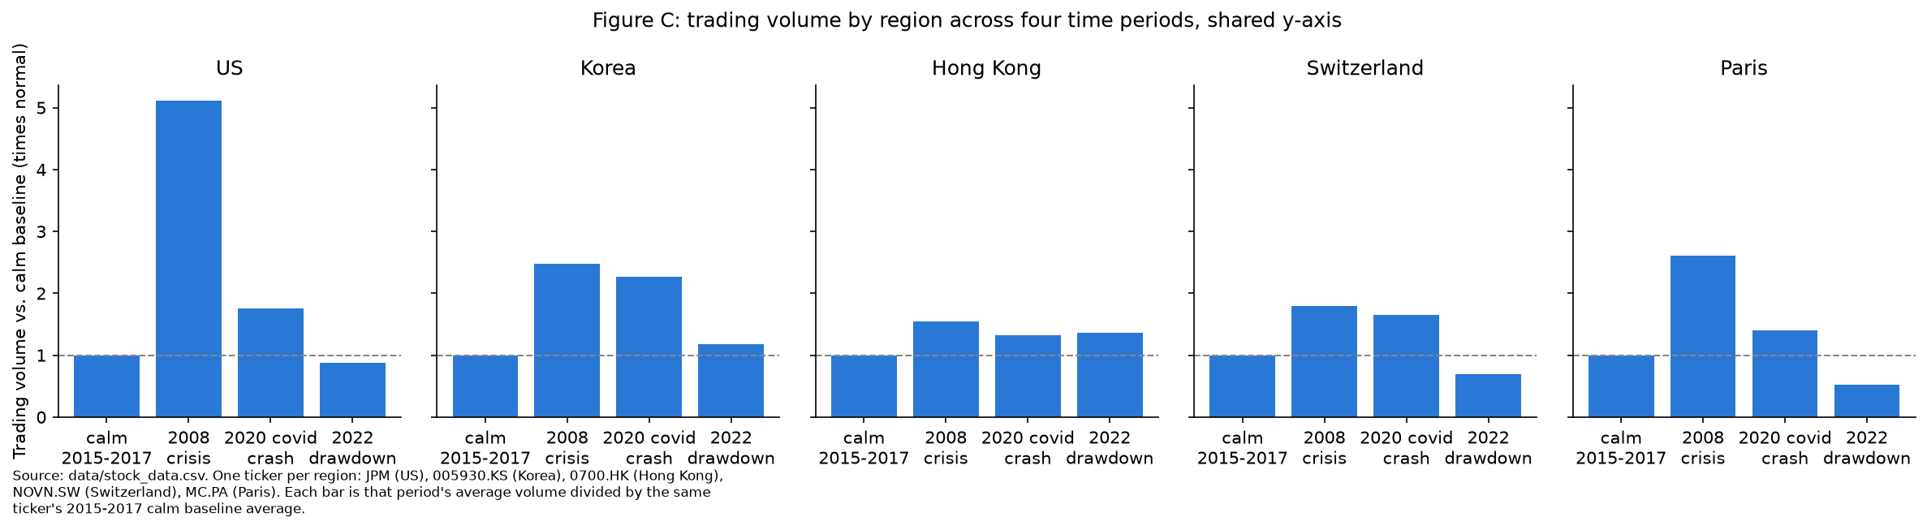
- Assignment 3's combined chart averaged all five regions into one 2008 bar (about 2.7x normal volume), which looked like a broad, even panic.
- Split by region, the US panel (JPM) spikes to about 5.1x normal in 2008, clearly the highest bar in the whole figure, while the other four regions sit at 1.5-2.6x, closer to their own 2020 numbers. Averaging JPM in with four calmer regions hid how much of an outlier the US region was that period, matching Assignment 3's own caveat about JPM's Bear Stearns acquisition news.

Exercise C: Interactive Linked Views
Two linked Altair views on the H1 tickers (chip/AI vs. rest of tech, since 2023-01-03): a scatter of daily return over time, and a bar chart of average daily return per ticker. A selection_interval brush on the scatter's date axis filters the bar chart via transform_filter; a bind_radio dropdown isolates either group.
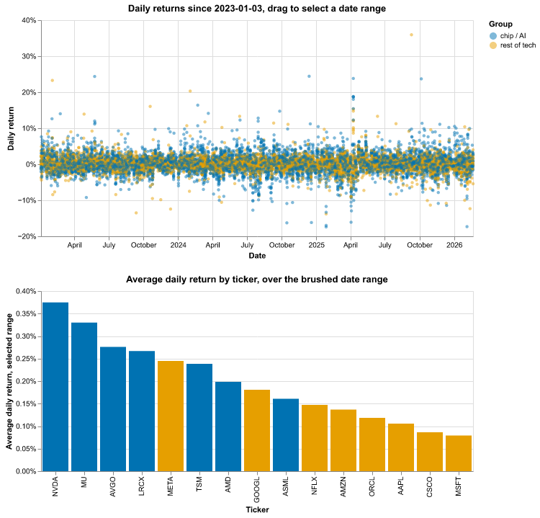
Default (unfiltered) state; brushing and the dropdown only work in the live HTML export
- A static chart only answers one question: which group did better over the whole period (chip/AI names take 4 of the top 5 spots). The brush turns that into 'did the chip group also win during this specific window,' recomputed instantly instead of redrawn by hand.
- The group dropdown answers whether one group's result is carried by a single name or spread across it, by hiding the other group instead of asking the reader to filter by color.
- assignments/ec1_c_linked_views.html is the interactive version; a static PNG cannot show dragging or clicking.

Exercise D: Statistical Rigor
Hypothesis: H1, the chip/AI rally is narrower than the rest of tech. Mean daily return per group since 2023-01-03, with 95% confidence intervals, plus a Welch's t-test.
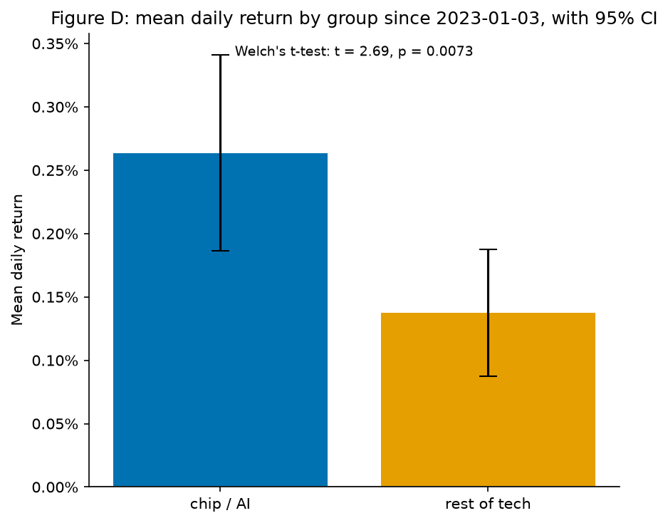
- Chip/AI group: 0.26% mean daily return, 95% CI [0.19%, 0.34%]. Rest of tech: 0.14%, 95% CI [0.09%, 0.19%]. Welch's t-test: t = 2.69, p = 0.0073.
- Verdict: this supports H1. The gap survives a test of the average ordinary day, not just a handful of large days compounding in the indexed price chart, and p = 0.0073 is well under the usual 0.05 cutoff.
- Honest complication: the daily gap is small and the two groups' confidence intervals almost touch. It only becomes the dramatic split seen in Assignment 3's Figure A because it compounds over three years of trading days.

Exercise E: Reusable Style Module
Style module: scripts/chart_style.py. A fixed six-color Okabe-Ito palette (validated with the course's colorblind-safety checker), the same two colors for the chip/AI and rest of tech groups everywhere they appear, standard font sizes, and a standard figure size.
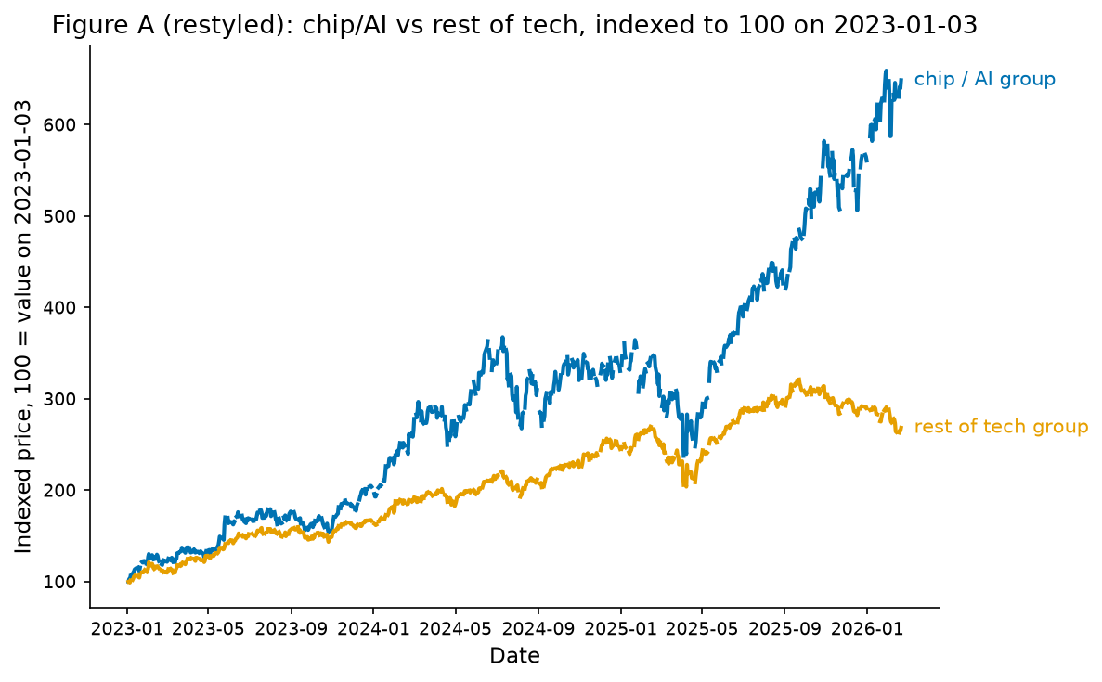 | 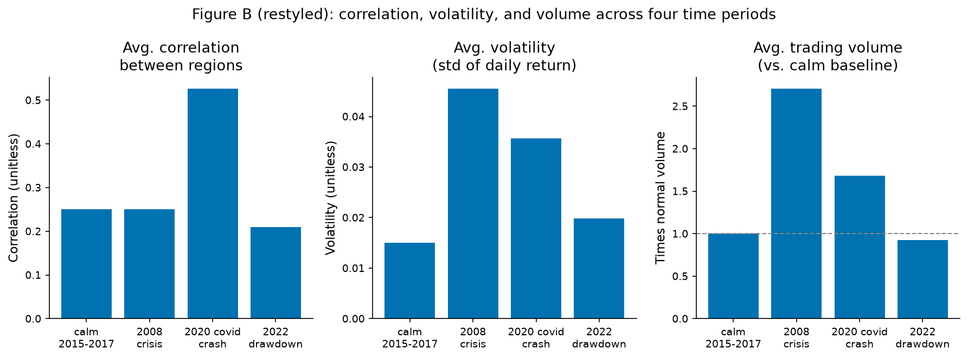
Figure A, restyled | Figure B, restyled
- The palette passed the colorblind separation checks for every pair used, rather than being picked by eye.
- Blue and orange are reserved for the same two groups everywhere in the project, so color follows the entity instead of being re-picked per chart.
- These are categorical groups, not a magnitude, so a categorical palette is the right encoding rather than a single-hue gradient.

Exercise F: Widening the Region Basket (H2/H3 Follow-Up)
Assignment 3 flagged widening the region basket from one stock to two or three as its next step, since JPM's own Bear Stearns news looked like it was drowning out the regional signal in 2008. Widened baskets, keeping only full-history tickers: US (JPM, AAPL, XOM), Korea (005930.KS, 000660.KS), Hong Kong (0700.HK, 0939.HK, 1398.HK), Switzerland (NOVN.SW, ROG.SW), Paris (MC.PA only, the sole Paris-listed ticker in the dataset).
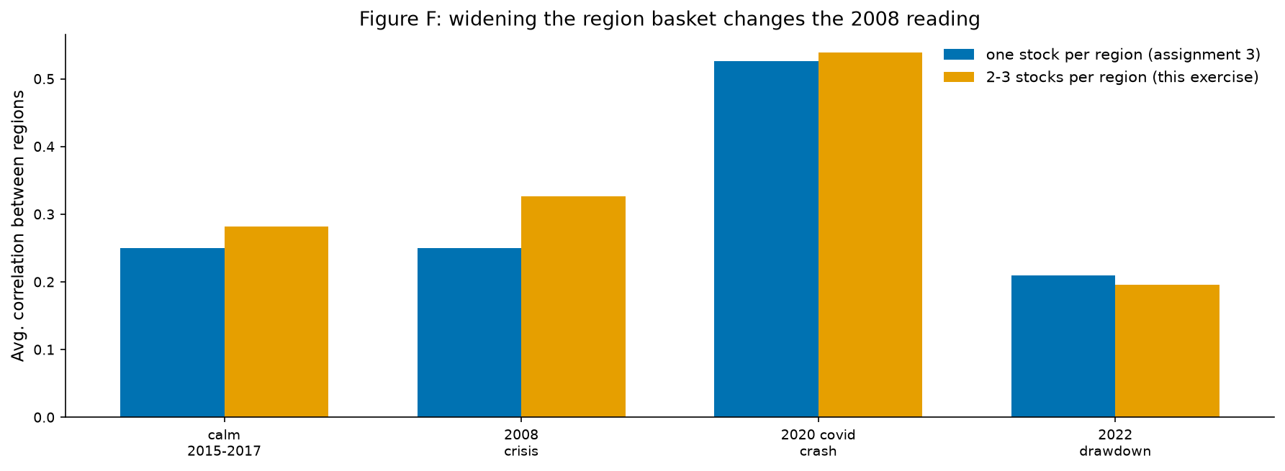
- One stock per region: 2008 correlation (0.250) was almost identical to the calm baseline (0.250). Two to three stocks per region: 2008 moves to 0.326 vs. a calm baseline of 0.282, now clearly above baseline instead of sitting on top of it.
- 2020 and 2022 barely move under the widened basket, so the single-stock approach was not wrong everywhere, it specifically undersold 2008, the one period where JPM had its own large company-specific news on top of the broader crisis.
- Limitation: Korea and Switzerland baskets are still sector-narrow (tech, pharma), and Paris cannot be widened at all with this dataset, so 2008 for those regions still rests on thinner ground than the US and Hong Kong baskets.

Peer Critique Checklist
Self-review of Figure F (Exercise F), completed ahead of the peer exchange:
Question | Rating / Answer | One Improvement
Is the chart type appropriate for this data and question? | Yes, 5/5 | None needed; grouped bars fit comparing two methods across four discrete periods.
Is there unnecessary chart junk (gridlines, borders, 3D, redundant color)? | No, 5/5 | Period labels could carry a shared date subtitle instead of repeating years.
Are axes, labels, and legends clear without needing explanation? | Yes, 4/5 | Y-axis label should say correlation of daily returns, not just 'correlation'.
Is color used meaningfully, not just decoratively? | Yes, 5/5 | None needed; blue/orange separate the two methods, consistent with every other figure.
Does the written interpretation match what the chart actually shows? | Yes, 5/5 | None needed; the write-up also reports that 2020 and 2022 barely moved.

The peer half of this exercise, exchanging Figure F with another team and receiving their checklist in return, is left for that in-person/async exchange and is not filled in here.

Filename & Submission
Filename: 26120004_Team2_Assignment-EC1.pdf
Submit via: Digiicampus
Due: 31st July, 2026 11:59 PM

