Assignment 5 - Part 2
Data Wrangling with R
Team Number | 2
Project Title | Historical Stock Analysis
Dataset | data/stock_data.csv - https://www.kaggle.com/datasets/ibrahimshahrukh/top-50-companies-dataset (the source page has since been removed by its uploader)
Team Members | Karthikeyan M (26120004), Mirthula M (26120121), Lakshmi Mayuri Kavya N (26120161)
Date | 19 August 2026
This is the same stock dataset we used in Assignment 4, with 230,111 rows. For this part, we used tidyr to switch between wide and long data, lubridate to work with the Date column, and dplyr and data.table to calculate the same grouped summary in two ways. Since the stocks trade in different currencies, we compare indexed prices or returns instead of comparing raw prices directly.

B.1 Reshape your data
We used AAPL, MSFT, NVDA, and AVGO for 2025 and kept the last trading day in each month. We then indexed every stock to 100 in January. All four stocks are listed in the US, and indexing them makes the change over time comparable even though their starting prices are different.

Wide and long forms
Table 1. Wide form (first four months; January 2025 = 100)
Month | AAPL | AVGO | MSFT | NVDA
Jan 2025 | 100.0 | 100.0 | 100.0 | 100.0
Feb 2025 | 102.6 | 90.1 | 95.8 | 104.0
Mar 2025 | 94.2 | 75.9 | 90.6 | 90.3
Apr 2025 | 90.1 | 87.2 | 95.4 | 90.7
Table 2. Long form (first eight rows)
Month | Ticker | Indexed Price
Jan 2025 | AAPL | 100.0
Jan 2025 | AVGO | 100.0
Jan 2025 | MSFT | 100.0
Jan 2025 | NVDA | 100.0
Feb 2025 | AAPL | 102.6
Feb 2025 | AVGO | 90.1
Feb 2025 | MSFT | 95.8
Feb 2025 | NVDA | 104.0
monthly_wide <- monthly_long_source %>%
pivot_wider(names_from = Ticker, values_from = Indexed.Price)
monthly_long <- monthly_wide %>%
pivot_longer(cols = all_of(selected_tickers),
names_to = "Ticker", values_to = "Indexed.Price")
Figure 1. Monthly adjusted prices in 2025, indexed to 100 in January.
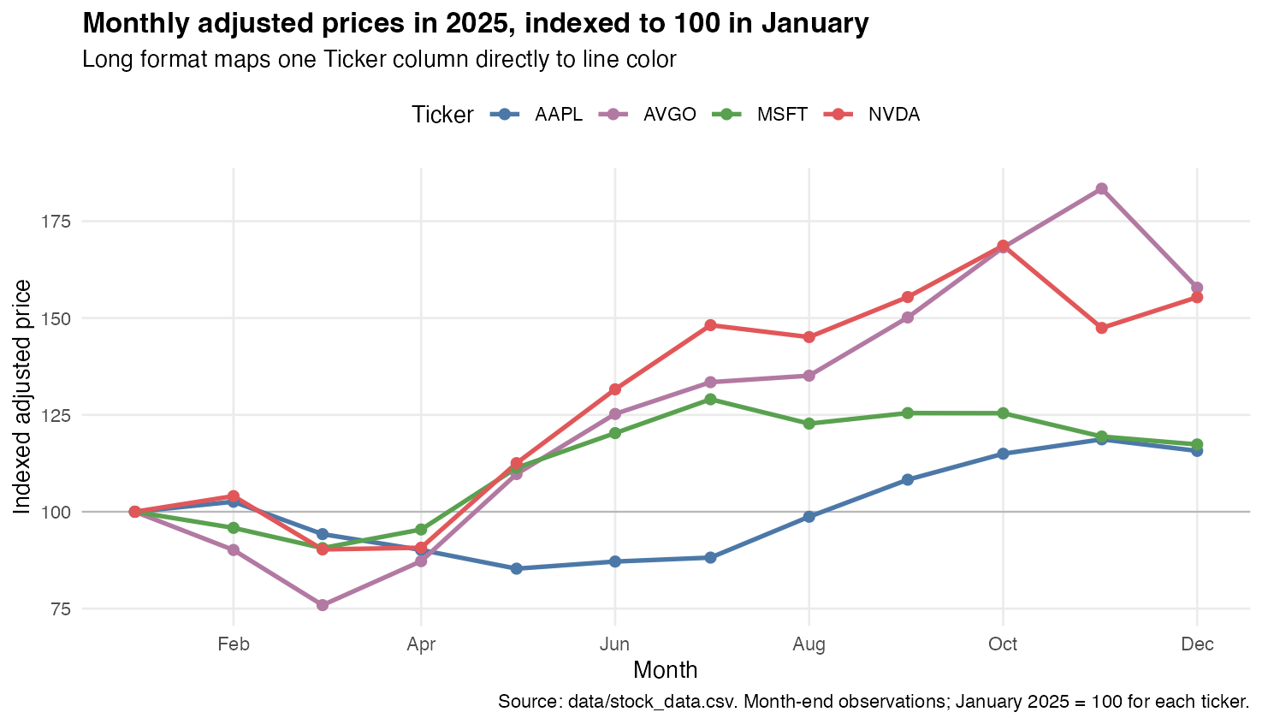
The long form was easier to plot. ggplot2 could use the Ticker column for the line colour and draw all four stocks with one geom_line() layer. In the wide form, every ticker is a separate column, which is useful for reading the table but less convenient for this chart. Figure 1 also shows the difference clearly: AVGO and NVDA finished 2025 near 158 and 155, while AAPL and MSFT finished near 116 and 117.

B.2 Parse and use a date/time field
The Date column came into R as plain text, which was the same issue we saw in Assignment 4. We converted it with ymd(), pulled out the year, month, and weekday, and used floor_date() to put the daily rows into monthly groups.
Table 3. Parsed date fields (sample)
Date | Ticker | Year | Month | Weekday
2006-01-02 | 000660.KS | 2006 | January | Monday
2006-01-03 | 000660.KS | 2006 | January | Tuesday
2006-01-04 | 000660.KS | 2006 | January | Wednesday
Table 4. Five months with the highest mean absolute daily return
Month | Mean Absolute Return | Tickers
October 2008 | 4.82% | 40
March 2020 | 4.67% | 48
November 2008 | 4.38% | 40
March 2009 | 3.25% | 41
January 2009 | 3.16% | 40
stocks <- stocks %>%
mutate(Date = lubridate::ymd(Date),
Year = lubridate::year(Date),
Month.Name = lubridate::month(Date, label = TRUE),
Weekday = lubridate::wday(Date, label = TRUE),
Month = lubridate::floor_date(Date, "month"))
monthly_volatility <- stocks %>%
filter(!is.na(Daily.Return)) %>%
group_by(Ticker, Month) %>%
summarise(Mean.Abs.Return = mean(abs(Daily.Return)), .groups = "drop") %>%
group_by(Month) %>%
summarise(Mean.Abs.Return = mean(Mean.Abs.Return),
Tickers = n(), .groups = "drop")
Figure 2. Average absolute daily return by month, equal-weighted across available tickers.
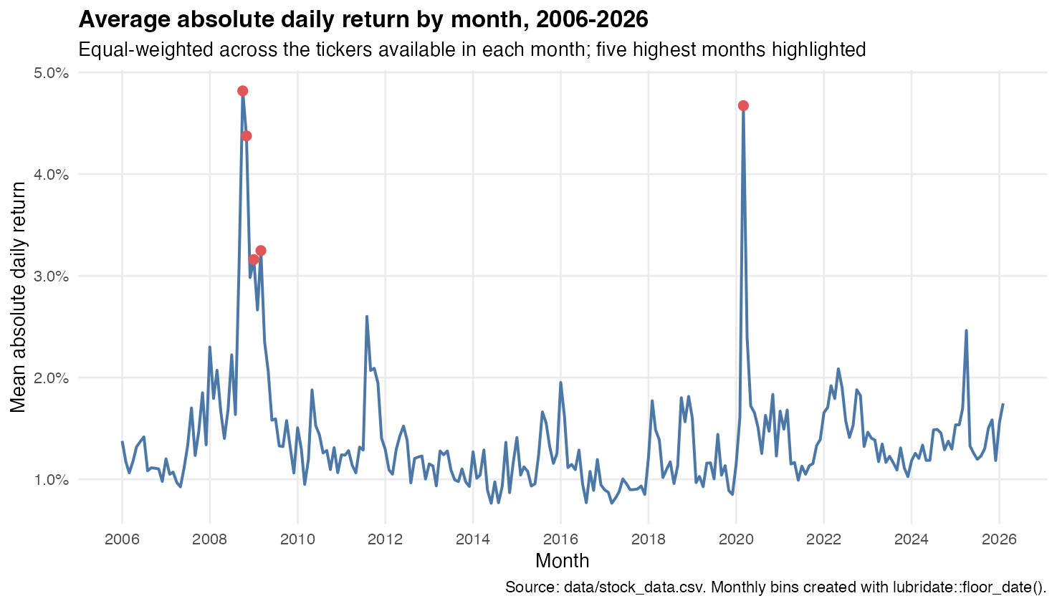
Grouping the dates by month makes the high-volatility periods much easier to see. October 2008 is the highest month at 4.82%, followed by March 2020 at 4.67% and November 2008 at 4.38%. We first calculated the average inside each ticker-month and then averaged across tickers. This stops a market with more companies in the dataset from receiving extra weight automatically.

B.3 data.table vs. dplyr
We repeated Assignment 4 C3.1 by grouping daily returns by market and finding the mean return, standard deviation, and number of ticker-day observations.
Code comparison. The same grouped summary in two syntaxes
dplyr | data.table
market_stats_dplyr <-  returns_by_market %>%  group_by(Market) %>%  summarise(  mean_return =  mean(Daily.Return),  sd_return =  sd(Daily.Return),  observations = n(),  .groups = "drop"  ) %>%  arrange(desc(mean_return)) | market_stats_dt <-  returns_dt[  , .(  mean_return =  mean(Daily.Return),  sd_return =  sd(Daily.Return),  observations = .N  ),  by = Market  ][order(-mean_return)]
Table 5. Result from both dplyr and data.table
Market | Mean Return | SD Return | Observations
Korea | 0.094% | 2.37% | 9,942
United States | 0.086% | 2.19% | 184,754
Hong Kong | 0.079% | 1.99% | 18,528
Paris | 0.063% | 1.82% | 5,151
Switzerland | 0.036% | 1.27% | 10,138
Saudi Arabia | 0.015% | 1.05% | 1,549
Both versions give exactly the same result. We found dplyr easier to read because group_by() and summarise() show the steps in the order we think about them. The data.table version is shorter, and we would expect it to be faster and more memory-efficient on a much larger dataset. With 230,111 rows, both worked without a practical problem, so readability mattered more here.

B.4 Reflection
Yes. Reshaping the data let us draw several stock lines from one ggplot mapping, while grouping the Date column by month showed exactly when the major volatility spikes happened; the values were already in the dataset, but changing the shape and time grouping made the pattern visible.
We used ChatGPT for help with wording and formatting.

