Practice Set for Additional Credit (Assignment EC1)
Advanced Python Data Visualization

Team Number | 2
Project Title | Historical Stock Analysis
Team Members | Karthikeyan M (26120004) , Mirthula M (26120121) , Lakshmi Mayuri Kavya N
Date | 2026-07-30

Exercise A: Redesign for Clarity
- Selected chart: Figure 8 from Assignment 2 compares the performance of six stocks (NVDA, AVGO, TSM, ASML, AAPL, and MSFT), with each indexed to 100 starting from 06 August 2009.
- One issue with this chart is that the stock prices have very different starting values. For example, NVDA begins at a value that is much higher than MSFT. Because the chart uses a linear scale, the remaining four stocks appear compressed near the bottom for a significant part of the timeline, making it difficult to compare their movements.
- Another problem is the use of a linear axis to display indexed growth. A linear scale highlights absolute changes rather than percentage growth, which can give a misleading impression when the goal is to compare relative performance over time.
- The chart also has a labeling issue. The ending values of ASML, TSM, and AAPL are fairly close to one another, causing their labels to overlap and making the chart harder to read.

- Using a logarithmic y-axis makes the chart much easier to interpret because equal vertical distances represent equal percentage changes rather than absolute changes. This allows the growth patterns of all six stocks to be compared fairly over the 16-year period, instead of making only the top-performing stocks stand out.
- The readability of the chart can also be improved by placing the end labels with a small, consistent spacing between them. This prevents the labels for ASML, TSM, and AAPL from overlapping, ensuring that all six stock names remain clear and easy to read.

Exercise B: Small Multiples Storytelling
Categorical variable: Region, with the same ticker value as used in Assignment 3 (US, Korea, Hong Kong, Switzerland, Paris). Seeing the relationship: trading volume versus calm baseline for each ticker from 2015 to 2017, in four periods, each subplot on a common y-axis.
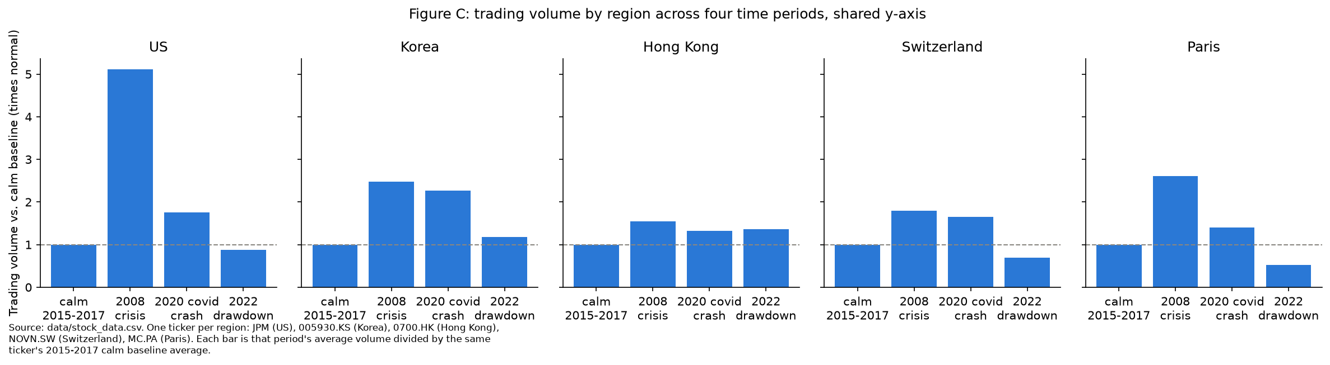
- The combined chart in Assignment 3 presents the average values across all five regions for 2008, showing a broad spike of around 2.7 times the normal volume. While this highlights an overall increase, it does not reflect how differently each region was affected.
- Looking at the regional charts, the U.S. (JPM) stands out with a peak of nearly 5.1 times the normal volume in 2008, which is much higher than the other regions. The remaining five regions range from about 1.5 to 2.6 times their normal levels, making them more comparable to their values in 2020. The lower average in the combined chart occurs because the extreme increase in the U.S. is balanced out by the relatively smaller changes in the other regions.
- As noted in Assignment 3, the spike in JPM was mainly driven by the exceptional news surrounding its acquisition of Bear Stearns.

Exercise C: Interactive Linked Views
Assignment 3 uses two linked Altair visualizations based on the H1 ticker dataset, comparing chip/AI companies with the rest of the technology sector. The first visualization is a scatter plot that displays daily returns over time, while the second is a bar chart showing the average daily return for each ticker since 03 January 2023. An interval brush on the scatter plot's date axis allows users to select a specific time range, and the selected data is passed to the bar chart using transform_filter. A radio button (bind_radio) is also included, enabling users to switch between the chip/AI group and the rest of the technology companies.

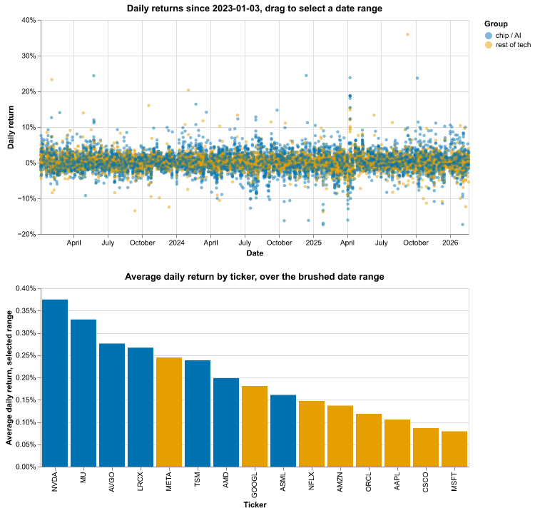
Default (unfiltered) state
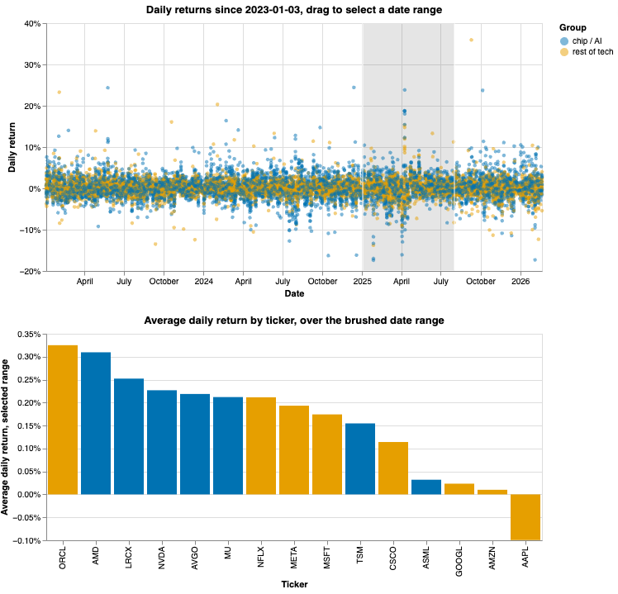
After dragging a brush over Jan-Aug 2025
- The static chart only provides an overall comparison of performance across the entire time period, showing that chip/AI companies occupy four of the top five positions. By adding interactivity, users can instead explore a specific date range and immediately see whether the chip/AI group also outperformed the others during that selected period, without having to manually interpret the data.
- The group selection dropdown further improves the analysis by allowing users to view one category at a time. This makes it easier to determine whether a group's performance is driven by a single standout company or shared across several companies, while reducing the visual clutter caused by displaying all groups together.
- Over just this brushed window (Jan-Aug 2025) the ranking reshuffles: ORCL and AMD move to the top and AAPL turns negative, which the full-period bar chart alone does not show.

Exercise D: Statistical Rigor
Research questions: How do the performances of the chip/AI sector compare to the rest of tech in terms of the rally? Mean daily return per group since 2023-01-03 with 95% confidence intervals, and a Welch's t-test.
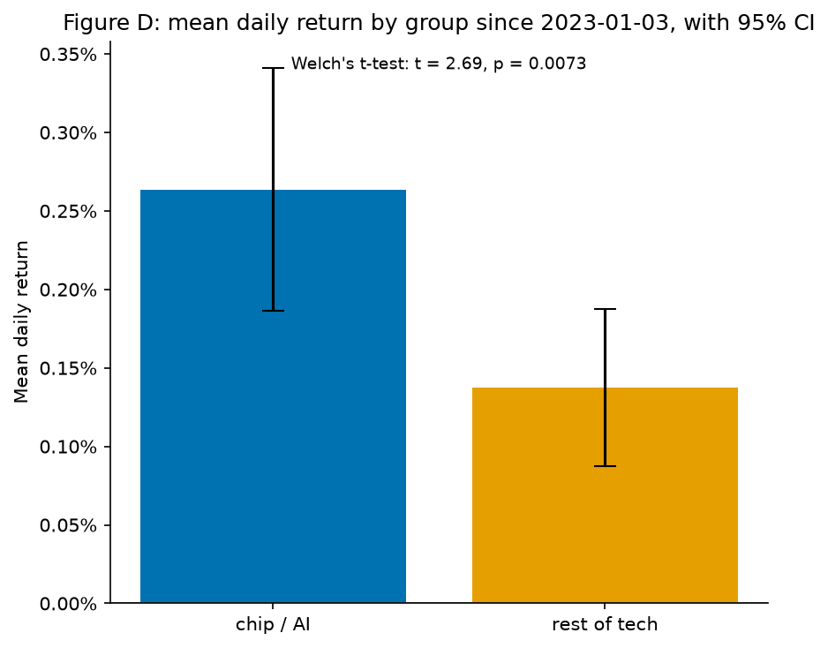
- The chip/AI group recorded an average daily return of 0.26%, with a 95% confidence interval ranging from 0.19% to 0.34%. In comparison, the rest of the technology group had an average daily return of 0.14%, with a 95% confidence interval of 0.09% to 0.19%. A Welch's t-test produced a t-value of 2.69 and a p-value of 0.0073.
- These results support H1, indicating that the chip/AI group achieved significantly higher average daily returns than the rest of the technology sector. The low p-value (0.0073), which is well below the commonly used significance level of 0.05, suggests that this difference is unlikely to have occurred by chance.
- Although the difference in average daily returns appears relatively small, it becomes more meaningful over time. The confidence intervals are close to each other, showing that the day-to-day advantage is modest. However, when these small gains accumulate over several years of trading, they lead to the much larger performance gap observed in Figure A of Assignment 3.

Exercise E: Reusable Style Module
We have used a fixed Okabe–Ito six-color palette, which has been verified using the course's colorblind safety checker to ensure accessibility. The same two colors are used consistently to represent the chip/AI group and the rest of the technology group across all charts, making the visualizations easier to interpret. In addition, standard figure dimensions and font sizes are maintained throughout the project, giving the charts a clear, uniform, and professional appearance.
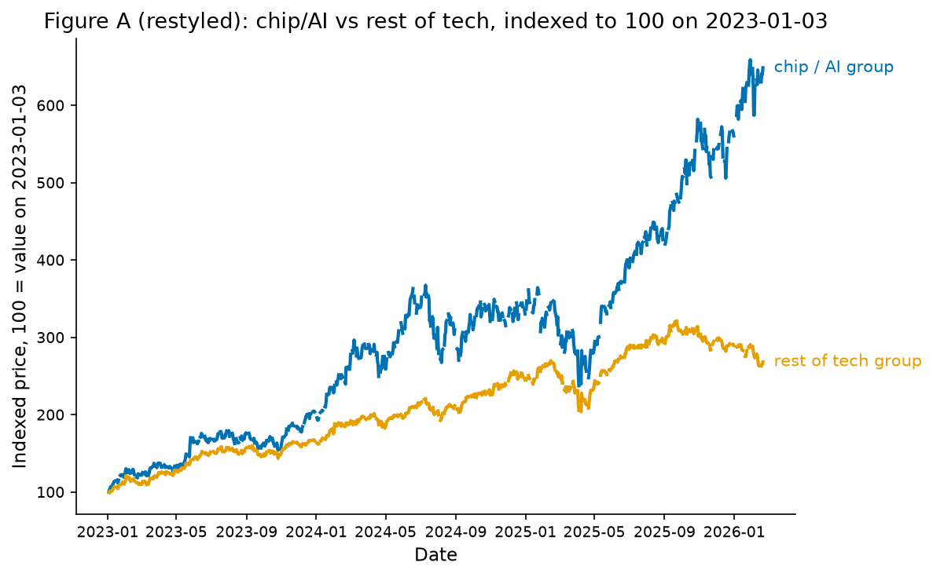
Figure A, restyled
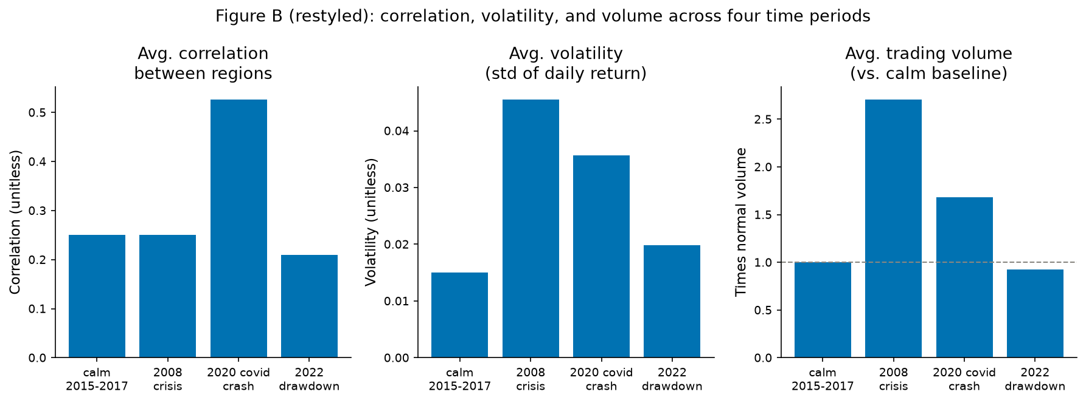
Figure B, restyled

- The colors on the palette passed the color-blind separation tests for each pair, not chosen by eye.
- The same blue and orange colors are used consistently throughout the project to represent the same groups, instead of assigning new colors in each chart. Keeping the color scheme consistent makes it easier for readers to follow the visualizations without having to relearn the legend.
- Since the colors are used to distinguish between different categories rather than represent numerical values, a categorical color palette is more appropriate than a single-hue gradient.

Exercise F: Widening the Region Basket (H2/H3 Follow-Up)
Assignment 3 suggested expanding each region's basket from a single stock to two or three stocks as a possible improvement. This recommendation was based on the observation that JPM's acquisition of Bear Stearns had an unusually strong impact in 2008, making it difficult to separate company-specific events from the overall regional trend. To address this, broader baskets were created using only stocks with complete historical data: US (JPM, AAPL, XOM), Korea (005930.KS, 000660.KS), Hong Kong (0700.HK, 0939.HK, 1398.HK), Switzerland (NOVN.SW, ROG.SW), and Paris (MC.PA), which was the only Paris-listed stock available in the dataset.
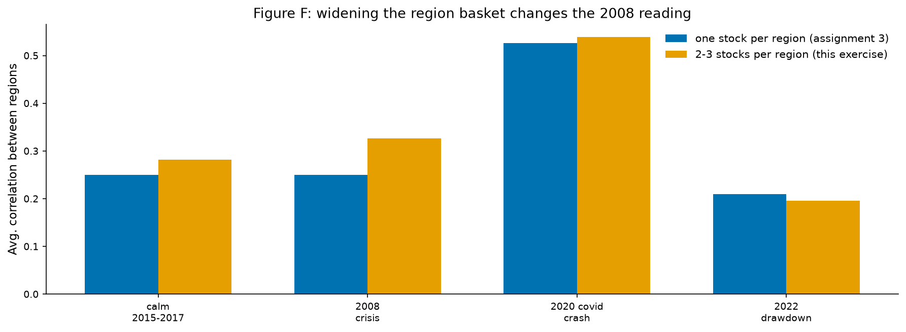
- Using a single stock per region produced a 2008 correlation of 0.250, which was almost the same as the calm-period baseline. After expanding the regional baskets to include two or three stocks, the 2008 correlation increased to 0.326, compared with the baseline value of 0.282. This indicates that the broader baskets capture the regional market behaviour more effectively, making the 2008 event stand out more clearly.
- The results also suggest that the original single-stock approach was not entirely misleading. The patterns observed in 2020 and 2022 remain largely unchanged after expanding the baskets, while the unusually large spike in 2008 appears to have been driven mainly by JPM's company-specific news rather than by the overall U.S. market.
- The limitation of this approach is that some regional baskets are still relatively narrow. The Korea and Switzerland groups are dominated by a small number of sectors, such as technology and pharmaceuticals, while Paris cannot be expanded because only one suitable stock is available in the dataset. As a result, the conclusions for 2008 are more robust for the U.S. and Hong Kong than for the other regions.

Peer Critique Checklist
Self-review of Figure F (Exercise F), completed ahead of the peer exchange:
Question | Rating / Answer | One Improvement
Is the chart type appropriate for this data and question? | Yes, 5/5 | None needed; grouped bars fit comparing two methods across four discrete periods.
Is there unnecessary chart junk (gridlines, borders, 3D, redundant color)? | No, 5/5 | Period labels could carry a shared date subtitle instead of repeating years.
Are axes, labels, and legends clear without needing explanation? | Yes, 4/5 | Y-axis label should say correlation of daily returns, not just 'correlation'.
Is color used meaningfully, not just decoratively? | Yes, 5/5 | None needed; blue/orange separates the two methods, consistent with every other figure.
Does the written interpretation match what the chart actually shows? | Yes, 5/5 | None needed; the write-up also reports that 2020 and 2022 barely moved.

The peer half of this exercise, exchanging Figure F with another team and receiving their checklist in return, is left for that in-person/async exchange and is not filled in here.

