Assignment 3: Hypotheses, Related Work & Proposed Analysis
Team Number: Team 2
Project Title: Historical Stock Analysis
Dataset: stock_data.csv, source: [ADD DATASET SOURCE LINK HERE]
Team Members: [ADD TEAM MEMBER NAMES HERE]
Date: 2026-07-29

1. Team & Project Info
Team 2. Project title: Historical Stock Analysis. Dataset: stock_data.csv, 230,111 rows, 49 tickers, 2006-01-02 to 2026-02-20. Source: [ADD DATASET SOURCE LINK HERE]. Team members: [ADD TEAM MEMBER NAMES HERE].

2. Recap of EDA from Assignment 2
- We had to use daily returns instead of raw price everywhere, since the 49 tickers trade in six different currencies. Comparing raw prices across tickers directly would not mean anything.
- The AI rally narrowness idea is real, but not evenly true across the group. Indexed to 100 from 2009-08-06, NVDA grew to about 631 times its starting value and AVGO to about 292 times, while ASML and TSM only reached about 58 to 62 times, barely ahead of Apple's 54 times. Microsoft trailed the whole group at about 23 times. So the story is really about NVDA and AVGO, not the whole chip sector as one block.
- The five chip names' daily returns move more closely with each other, 0.53 to 0.63, than with Apple or Microsoft, 0.38 to 0.54, and much more than with LVMH in Paris, 0.25 to 0.40. Another sign pointing the same direction as the growth chart, just using correlation instead of price.
- Daily returns are sharply peaked near zero with long tails. About 7.2 percent of ticker days sit outside the normal box plot range, and the most extreme days line up with known events like the 2008 crisis instead of being spread out evenly.
- The correlation heatmap in Assignment 2 was only ever one single average over the full 2006 to 2026 history. The worksheet itself asked whether that pattern actually holds up during 2008, 2020, and 2022 specifically, or whether it just looks that way because calm and rough years got blended into one number. Section 5 of this report answers that question directly.
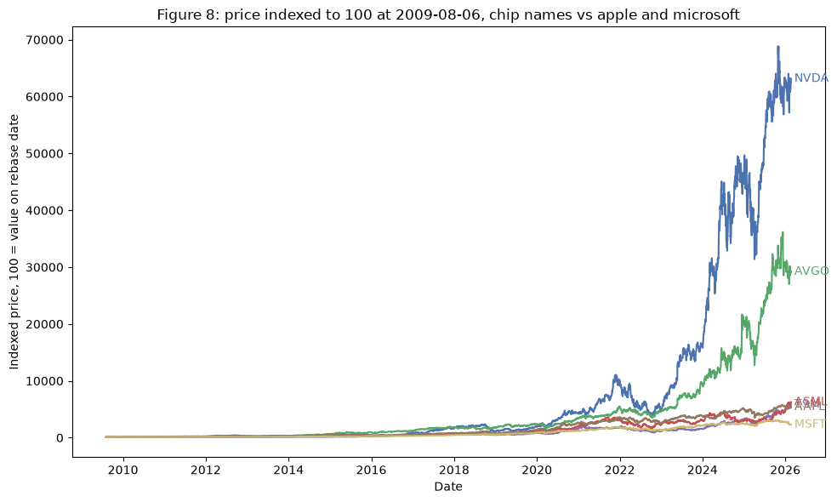
Figure 1 (carried over from Assignment 2, originally Figure 8). Price indexed to 100 at 2009-08-06 for NVDA, AVGO, TSM, and ASML versus Apple and Microsoft. Source: data/stock_data.csv, 2009-08-06 to 2026-02-20.

3. Hypotheses
Central thread: the diversification this portfolio seems to offer, whether across technology sub-sectors or across world regions, is thinner than it looks. H1 checks this at the sector level, H2 and H3 check it at the region and crisis level.

H1
We hypothesize that the post-2023 rally in large-cap technology stocks is concentrated in a small group of semiconductor and AI-linked names (NVDA, AVGO, TSM, ASML, AMD, MU, LRCX), not spread across large-cap tech broadly, because these seven stocks grew by 549 percent on average since January 2023, while eight other big tech names (AAPL, MSFT, GOOGL, AMZN, META, NFLX, ORCL, CSCO) only grew by 168 percent on average over the same stretch.
Reasoning: the news makes it sound like all of tech is booming because of AI, but our own numbers show the chip group grew roughly three to four times as much as the rest of big tech, which is not a small gap. Figure A below shows this directly, the average of the chip group indexed to 100 against the average of the rest of tech group, both starting January 2023. The two lines sit close together for the first few months and then just keep separating, so this is not a one-time jump, the chip group kept pulling further ahead the whole way. Assignment 2's Figure 1 (above) already hinted at this using four individual stocks since 2009; Figure A extends it to a full seven-stock group compared against eight other tech names, specifically since 2023. Related work [2] backs this up independently using market cap data, while [3] pushes back a little on how narrow the story really is (see Section 4).
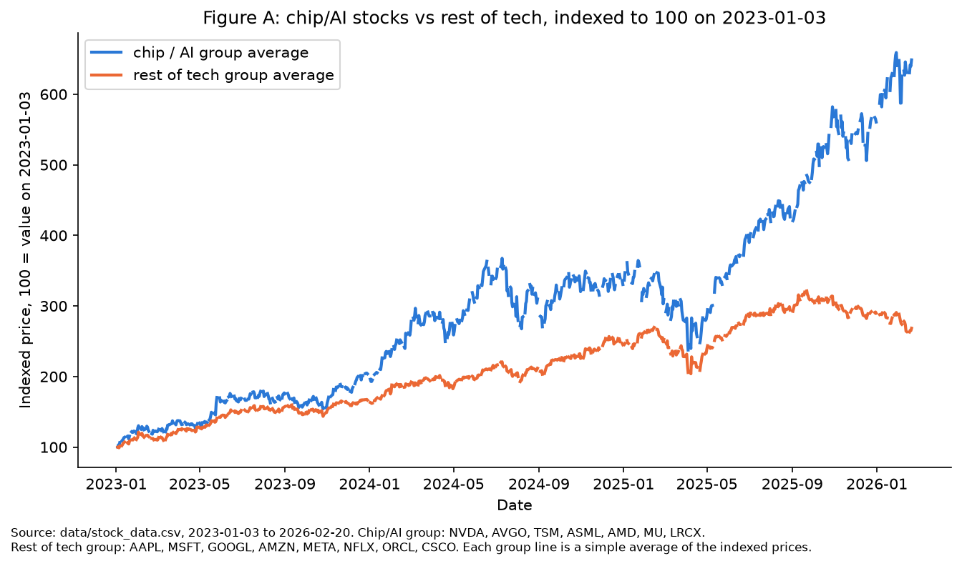
Figure A. Chip/AI group (NVDA, AVGO, TSM, ASML, AMD, MU, LRCX) versus rest-of-tech group (AAPL, MSFT, GOOGL, AMZN, META, NFLX, ORCL, CSCO), each indexed to 100 on 2023-01-03 and averaged into one line per group. Source: data/stock_data.csv, 2023-01-03 to 2026-02-20.

H2
We hypothesize that stocks from different world regions move more like each other specifically during sudden, panic-driven crashes (2008, 2020), but not during slower, macro-driven drawdowns (2022), because a sudden panic makes people sell everything at once no matter the region, while a slower downturn caused by something specific, like 2022's interest rate hikes, hits different regions and sectors unevenly.
Reasoning: using one stock per region (JPM for the US, 005930.KS for Korea, 0700.HK for Hong Kong, NOVN.SW for Switzerland, MC.PA for Paris), average correlation between regions was about 0.25 in a calm 2015-2017 stretch, jumped to 0.53 in the 2020 COVID crash, but only reached about 0.21 in 2022, actually below the calm number. 2008 came out close to the calm baseline too, about 0.25, which is a more complicated result than we expected, see Section 5 for why. This mirrors Assignment 2's own open question about whether its correlation heatmap holds up during a real crisis. Related work [1], the classic result that diversification melts away under market stress, backs up the general idea using 72 years of Dow Jones data, but treats it as a smooth relationship with stress. Our numbers look more like an on-or-off pattern tied to the type of crisis, which is the narrower version of H2 used here. Figure B in Section 5 is the supporting chart.

H3
We hypothesize that trading volume and short-term volatility spike specifically during the panic-driven crashes of 2008 and 2020, but stay close to normal during the 2022 drawdown, because volume and volatility are symptoms of the same panic-selling that drives the correlation spikes in H2, so a period without a correlation spike should not have a volume or volatility spike either.
Reasoning: average volatility was 0.015 in the calm baseline, rose to 0.046 in 2008 and 0.036 in 2020, and only reached 0.020 in 2022. Average trading volume followed a similar shape, 2.7 times normal in 2008, partly driven by JPM itself, whose own volume was over 5 times normal that year since JPMorgan acquired Bear Stearns in March 2008, right in the middle of the crisis, 1.7 times normal in 2020, and slightly below normal, 0.9 times, in 2022. This tracks H2's pattern closely for 2020 and 2022, which is why H2 and H3 are shown together as one figure instead of two separate claims. Figure B in Section 5 is the supporting chart.

4. Related Work

Preis, Kenett, Stanley, Helbing, and Ben-Jacob (2012), "Quantifying the Behavior of Stock Correlations Under Market Stress" [1]
The researchers looked at 72 years of daily closing prices for the 30 Dow Jones Industrial Average stocks, from 1939 to 2010, to study how correlation between stocks changes when the market is under stress. They measured average correlation and compared it to how stressed the market was overall, using normalized index returns across different time windows. They found correlation rises roughly in step with stress, so the protection people expect from spreading their money across different stocks gets weaker exactly when the market is falling, right when it is needed most. This backs up the basic idea behind our H2, crisis periods make stocks move together more. But their model treats it as one smooth relationship, more stress always means more correlation, while our own numbers look more like specific events (2020 clearly, 2008 less clearly with our one-stock-per-region method) rather than a constant sliding scale. That difference is the angle our narrower H2 adds to their finding.

Morningstar (2026), "3 Years of the AI Stock Market Boom in Charts" [2]
This article tracks semiconductor and broader tech stock performance since May 2023, the month Nvidia's earnings surprise is treated as the start of the AI rally. Using market capitalization and index-return numbers, it reports the Morningstar US Semiconductors Index grew 423.9 percent since then, versus 85.6 percent for the overall US Market Index, while software companies like Salesforce and Adobe grew only 17.6 percent over the same stretch. This backs up our H1 clearly, the AI rally is not lifting tech broadly, it is mostly the chip names, with even other parts of tech left behind. It lines up closely with what our own chip-group-versus-rest-of-tech chart (Figure A) shows.

Harlap, J.P. Morgan (2026), "Is It All One Big AI Trade?" [3]
This piece looks at a much wider group, 148 companies across the whole AI ecosystem, not just chip makers, including data centers, cooling, software, and cloud companies. It finds 70 percent of these names are up year to date, across 8 of 11 market sectors, and argues the AI trade is bigger than the "just a handful of chip stocks" story suggests. This complicates our H1 rather than confirming or denying it, it comes down to how wide you draw the circle around "AI stocks." Our comparison of seven specific chip names against eight other specific big tech names still holds up as a real gap, but this source is a useful reminder not to treat those seven stocks as the whole AI story.
Put together, these sources support our hypotheses more than they fully settle them. [1] confirms that diversification breaking down under stress is a real, well-known pattern, but our own numbers suggest it is not a smooth, constant relationship, it looks more like specific crisis events turning it on or off, which is a gap we are in a good position to explore further. [2] and [3] mostly agree that AI-linked stocks did better than the rest of the market, but disagree on how narrow that story really is depending on how wide you define "AI stocks," which is something our own H1 needs to state clearly rather than assume.

5. Proposed Additional Analysis / Experiment
This analysis targets H2 and H3 together, since they are really the same event, correlation breaking down during a crisis, looked at from two angles: how much regions move together, and how much volume and volatility change. It directly follows up on Assignment 2, which asked whether its full-history correlation numbers actually hold up during a real crisis, or just look that way from averaging calm and rough years together.
Data and method: using daily returns (Adj Close percent change), we picked one representative stock per region, JPM for the US, 005930.KS for Korea, 0700.HK for Hong Kong, NOVN.SW for Switzerland, and MC.PA for Paris, the same one-stock-per-region approach Assignment 2 already used for LVMH. We compared four time periods, a calm stretch (2015-2017), the 2008 crisis, the 2020 COVID crash, and the 2022 drawdown, and for each one worked out the average correlation between the five regions, the average volatility, and the average trading volume compared to the calm baseline. A chart is the right way to show this because the point is about a pattern across different time periods, something a single number cannot show as clearly as four bars side by side.
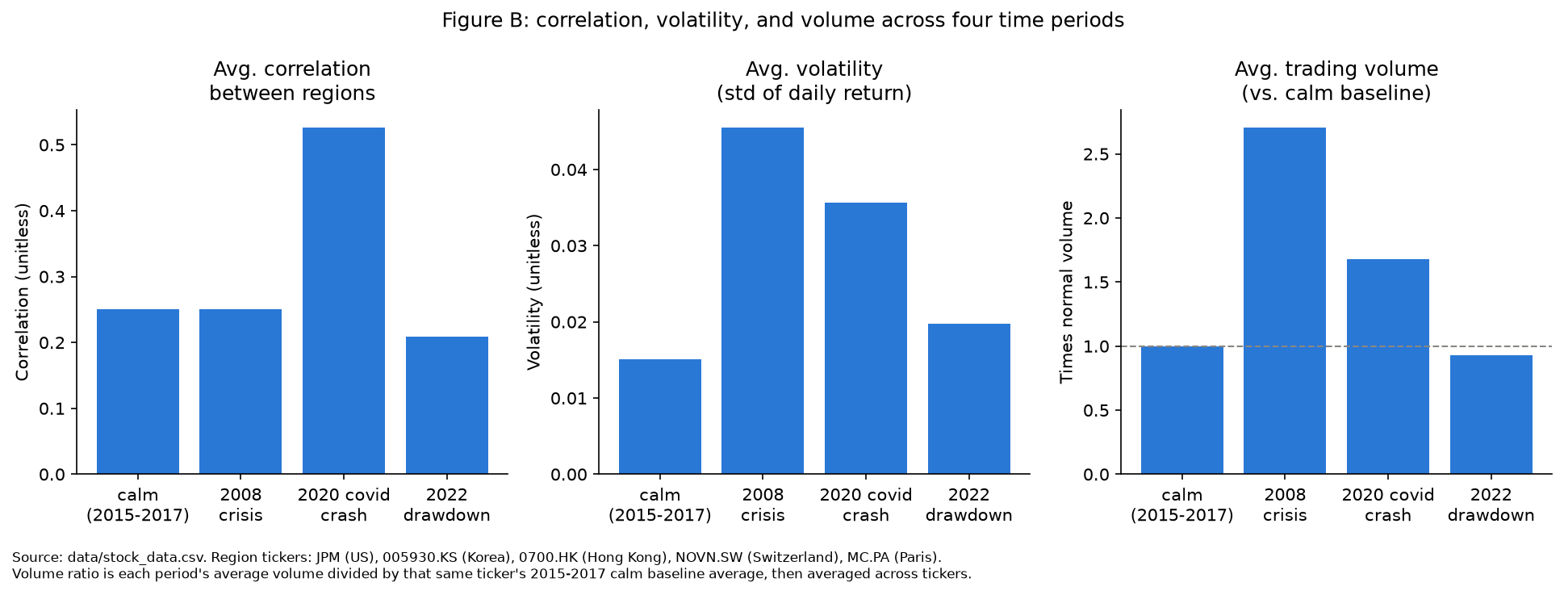
Figure B. Average correlation, volatility, and trading volume across four time periods, using one representative stock per region (JPM, 005930.KS, 0700.HK, NOVN.SW, MC.PA). Correlation is close to the calm baseline in 2008 (0.25 versus 0.25) but jumps clearly in 2020 (0.53) and dips in 2022 (0.21). Volatility and volume both spike clearly in 2008 and 2020 and stay close to normal in 2022: volume was 2.7 times normal in 2008 (helped along by JPM's own volume being over 5 times normal that year, since JPMorgan acquired Bear Stearns that March) and 1.7 times in 2020, versus 0.9 times in 2022. This version of the chart still supports H3 clearly, but shows H2 is noisier for 2008 than expected, most likely because using just one stock per region lets a single company's own news, like JPM's, drown out the regional story. Source: data/stock_data.csv. Not yet finalized: using two or three stocks per region instead of one would likely make the 2008 correlation result cleaner, which is the next step.

6. Plan & Next Steps
This analysis sets the direction for the rest of the project's charts around one thread, concentration and correlation breaking down, instead of a list of separate findings. The very next step is to redo Section 5's check with two or three stocks per region instead of one, especially for the US where JPM's own Bear Stearns story may be drowning out the regional signal for 2008, before locking in the final chart set for the semester report.

7. References
[1] T. Preis, D. Y. Kenett, H. E. Stanley, D. Helbing, and E. Ben-Jacob, "Quantifying the behavior of stock correlations under market stress," Scientific Reports, vol. 2, art. 752, 2012. [Online]. Available: https://www.nature.com/articles/srep00752
[2] Morningstar, "3 Years of the AI Stock Market Boom in Charts," Morningstar.com, May 2026. [Online]. Available: https://www.morningstar.com/stocks/three-years-ai-stock-market-boom-charts
[3] D. Harlap, "Is It All One Big AI Trade?" J.P. Morgan Insights, Jul. 24, 2026. [Online]. Available: https://www.jpmorgan.com/insights/markets-and-economy/top-market-takeaways/tmt-is-it-all-one-big-ai-trade

