Introduction to Information Technology - W5 Tutorial - Semester 2, 2025
Week 5 — Loops, Lists & Tuples (Exercises)
Source adapted from Textbook. Please see bibliography in your reading list (Canvas).
3-Output:
Atlantic, Pacific, Antarctic
2-Output:
18
1-Output:
20
Introduction
This tutorial continues your Python foundations with a focus on
loops
(
while
and
for
)
,
lists
, and
dictionaries
.
What you'll practice
Using
while
loops with counters, sentinels, and
break
/
continue
.
Iterating with
for
and
range()
(start, stop, step).
Working with
lists
(indexing, slicing,
insert
,
del
,
len
,
sum
,
max
).
Building and updating
dictionaries
for counting and aggregation.
Using basic string methods and membership tests.
Translating problem statements into step‑by‑step algorithms.
How to use this page
1
.
Open
IDLE

→

File
→
New File

→
save as
week5_exercises.py
.
2
.
Copy each snippet into the editor, run with
F5
, and predict the output
before
you look.
3
.
Experiment: change values, add prints, and observe how loops behave.
4
.
Finish with the
Case Study — Movie Theatre Ticket Sales
to integrate loops, lists, and dictionaries.
Prerequisites:
variables, arithmetic,
print()
/
input()
, and basic
if/elif/else
.
Exercises 1–8 — determine the output displayed
1
.
num = 5
while True:
num = 2 * num
if num % 4 == 0:
break
print(num)
2
.
num = 3
while num < 15:
num += 5
print(num)
3
.
oceans = ["Atlantic", "Pacific", "Indian", "Arctic", "Antarctic"]
i = len(oceans) - 1
while i >= 0:
if len(oceans[i]) < 7:
del oceans[i]
num = 0
total = 0
while num < 3:
total = total + int(input(“enter a number:”))
print(total)
for num in range(1, 10, 2):
print(num)
7-Output
3 20
5-Output:
5 6 7

4-Output:
6 8 10 12

6-Output:
10 9 8 7 6 5 4 3 2 1

8-Output
4

Out
i = i - 1
print(", ".join(oceans))
4
.
for i in range(3, 7):
print(2 * i)
5
.
num = 5
for i in range(num, 2 * num - 2):
print(i)
6
.
for countdown in range(10, 0, -1):
print(countdown)
7
.
numEvens = 0
sumOfEvens = 0
list1 = [2, 9, 6, 7, 12]
for num in list1:
if num % 2 == 0:
numEvens += 1
sumOfEvens += num
print(numEvens, sumOfEvens)
8
.
numOfNumbers = 0
list1 = ["three", 4, 5.7, "six", "seven", 8, 3.1416]
for item in list1:
if isinstance(item, str):
continue
numOfNumbers += 1
print(numOfNumbers)
Exercises 9–10 — rewrite the code
9
.
Rewrite using a
for
loop:
num = 1
while num <= 9:
print(num)
num += 2
# your for-loop version here
10
.
Rewrite using a
while
loop:
total = int(input("Enter a number: "))
num = int(input("Enter a number: "))
total = total + num
num = int(input("Enter a number: "))
Missing : after while True
num = 1 is inside the loop, so it keeps resetting to 1
while True has no stopping condition, so it would run forever.
The question says to display 1 through 5.

13-Output
Largest Number: 8
Length: 4
Total: 17
- virtues[0] = wisdom
- virtues[1] = courage
- virtues[2] = temperance
- virtues[3] = justice
So virtues[4] does not exist and causes an IndexError.

join() requires the items to be strings, but 1 and 4 are integers.
14-Output
When in the course of human events
11-Output
This sentence contains five words
This sentence contains six different words
12-Output
Hearth, Damith
total = total + num
print(total)
# your while-loop version here
Exercises 11–14 — determine the output displayed
11
.
L = ["sentence", "contains", "five", "words."]
L.insert(0, "This")
print(" ".join(L))
del L[3]
L.insert(3, "six")
L.insert(4, "different")
print(" ".join(L))
12
.
# Assume the name entered is: Damith Hearth
name = input("Enter name with two parts: ")
L = name.split()
print("{0:s}, {1:s}".format(L[1], L[0]))
13
.
nums = [6, 2, 8, 1]
print("Largest Number:", max(nums))
print("Length:", len(nums))
print("Total:", sum(nums))
14
.
tuple1 = ("course", "of", "human", "events", "When", "in", "the")
tuple2 = tuple1[4:] + tuple1[:4]
print(" ".join(tuple2))
Exercises 15–17 — identify all errors
15
.
# Four virtues presented by Plato
virtues = ("wisdom", "courage", "temperance", "justice")
print(virtues[4])
16
.
list1 = [1, "two", "three", 4]
print(" ".join(list1))
17
.
## Display the numbers from 1 through 5.
num = 0
while True
num = 1
print (num)
num += 1
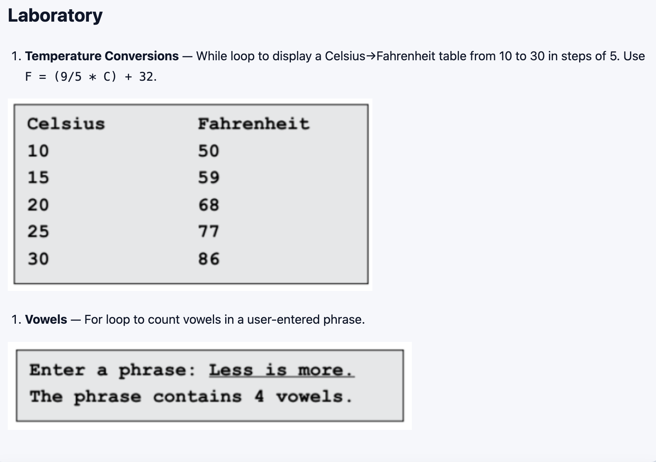
phrase = input("Enter a phrase: ")
phrase = phrase.lower()
count = 0
for ch in phrase:
if ch in "aeiou":
count = count + 1

print("The phrase contains", count, "vowels")
print("Celsius \t\t Fahrenheit")
for c in range(10, 31,5):
f=(9/5) * c + 32
print(c, "\t\t",f)

total = 0

for title, qty, price_each in purchases:
line_total = qty * price_each
print(title, qty, "x $", price_each, "= $", line_total)
total = total + line_total

print("Total: $", total)
movies = {
"Dune": 12.5,
"Barbie": 11.0,
"Oppenheimer": 13.0,
"Spirited Away": 10.0
}

purchases = []

while True:
title = input("Enter movie title or 'done': ")

if title == "done":
break

if title not in movies:
print("Available movies:", list(movies.keys()))
continue

qty = int(input("Enter quantity: "))

purchases.append((title, qty, movies[title]))

print(purchases)

.

Case Study — Movie Theatre Ticket Sales
Practice
while
/
for
loops,
lists
, and
dictionaries
by building a tiny point‑of‑sale simulator.
Part A — Input loop (while) & list of purchases
Keep asking for a movie and quantity until the user types
done
. Store each purchase as a
tuple

(
title, qty,
price_each)
in a list.
# Starter
movies = {
"Dune": 12.5,
"Barbie": 11.0,
"Oppenheimer": 13.0,
"Spirited Away": 10.0
}
purchases = [] # list of (title, qty, price_each)
# TODO: use a while loop that continues until the user enters 'done'
# 1) ask for movie title (case sensitive is fine)
# 2) if title not in movies, print the available keys and continue
# 3) ask for quantity (int)
# 4) append (title, qty, movies[title]) to purchases
# 5) optional: track running subtotal
Part B — Receipt (for loop over list)
After input ends, print a receipt with one line per item and a grand total.
# TODO: iterate over purchases and compute line totals
# for title, qty, price_each in purchases:
# line_total = ...
# print(...)
# print("Total:", ...)
# Calculate average tickets per purchase

total_tickets = 0

for title, qty, price_each in purchases:
total_tickets = total_tickets + qty

average = total_tickets / len(purchases)

print("Average tickets per purchase:", average)

# Sort Movies by revenue

Sorted_by_rev = sorted(revenue_by_movie.items(), key=lamda kv: kv[1]), reverse=True)

print(“Movies sorted by revenue:”, sorted_by_rev)

# Find top-selling movie

top_title = None
top_qty = -1

for title, qty in tickets_by_movie.items():
if qty > top_qty:
top_title = title
top_qty = qty

print("Top seller:", top_title, top_qty)

def apply_member_discount(total, is_member):
if is_member == "y":
total = total * 0.95

return total

member = input("Do you have a member code? (y/n): ")

total = apply_member_discount(total, member)

print("Grand Total: $", total)

tickets_by_movie = {}
revenue_by_movie = {}

for title, qty, price_each in purchases:

if title in tickets_by_movie:
tickets_by_movie[title] = tickets_by_movie[title] + qty
revenue_by_movie[title] = revenue_by_movie[title] + (qty * price_each)
else:
tickets_by_movie[title] = qty
revenue_by_movie[title] = qty * price_each

for title in tickets_by_movie:
print(title, "- Tickets:", tickets_by_movie[title],
"Revenue: $", revenue_by_movie[title])

Part C — Sales summary (dictionaries)
Build two dictionaries:
tickets_by_movie
(total tickets per title) and
revenue_by_movie
(revenue per title).
Then print a summary table.
tickets_by_movie = {}
revenue_by_movie = {}
# TODO: for each (title, qty, price_each) in purchases:
# update tickets_by_movie[title]
# update revenue_by_movie[title]
# TODO: print each movie with tickets and revenue
Part D — Discounts & validation (challenge)
If the user buys
4+
tickets in a single line, apply a
% group discount
10
to that line.
Ask if the customer has a
member code
; if yes, apply an extra
5
% o
ff
the
grand total
.
Use
try/except
to guard against non‑numeric quantities.
# Hints
# def apply_group_discount(qty, price_each):
# ...
# def apply_member_discount(total, is_member):
# ...
Part E — Analytics (stretch)
Find the
top‑selling
movie by tickets (loop over
tickets_by_movie
).
Sort titles by
revenue
(create a list of tuples from the dict and sort).
Compute the
average tickets per purchase
using the
purchases
list.
# Example sketches (fill in the logic)
# top_title = None
# top_qty = -1
# for title, qty in tickets_by_movie.items():
# if qty > top_qty:
# top_title, top_qty = title, qty
# print("Top seller:", top_title, top_qty)
# sorted_by_rev = sorted(revenue_by_movie.items(), key=lambda kv: kv[1], reverse=True)
# print(sorted_by_rev)
# Calculate average tickets per purchase total_tickets = 0 for title, qty, price_each in purchases: total_tickets = total_tickets + qty average = total_tickets / len(purchases) print("Average tickets per purchase:", average)
On this page
Introduction
Exercises 1–8
Exercises 9–10
Exercises 11–14
Exercises 15–17
Laboratory
Case stud
y
— ticket sales

