Katie Stanley

Evolution Final Project

**Phenotypic Variation of Hip Dysplasia in Dog Breeds**

**Introduction**

The domestic dog, *Canis familiaris* has been subject to directional selection for thousands of years. This dog can be classified based on breed types. Dog breeds have been selected for favorable phenotypic or behavioral traits for many years (Honeycutt 2010). Thus, the canine genome has been shaped by rapid short-term evolution (Akey 2010). Unfortunately, the diversification of dog breeds has led to the development of increased prevalence in genetic disorders (Sutter 2004).

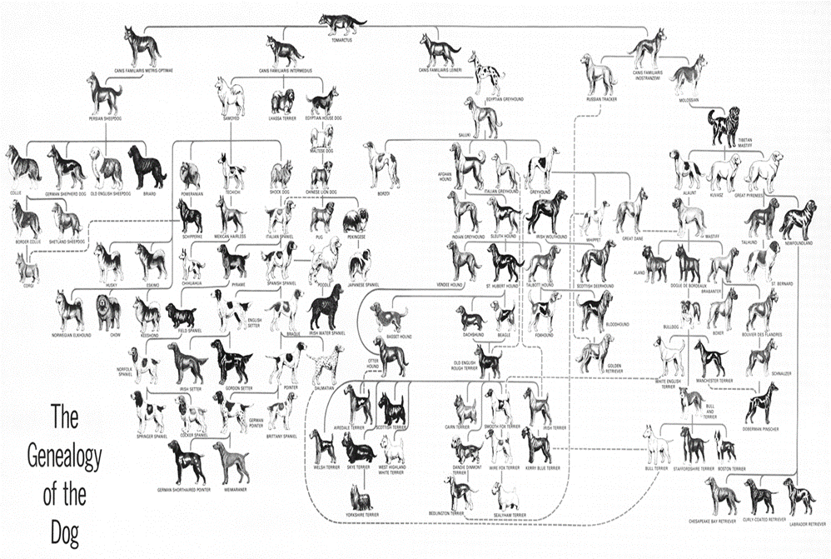

Figure 1. The Genealogy of the Domesticated dog. The genealogy of dogs can demonstrate the breeding events that have produced a morphologically different breed (Moore 1962).

Canine hip dysplasia (HD) is a genetic condition that involves a lack of veracity between the femoral head and acetabulum (Lust 1997). It is a polygenic pathology (Brass 1989). This means that Hip Dysplasia can be influenced by both environmental and genetic factors. Environmental factors proven to influence the phenotype can occur during hip development and stress during examination (Hedhammar 2007). At the same time, dysplastic parents tend to pass on mild to severe cases of HD to their progeny (Hedhammar et al 1979). While the presence of Canine HD differs by breed (Loder 2017), it is one of the most prevalent diseases in dogs (Kaminaris 2012), and it often causes severe pain and various symptoms. In fact, HD often plays a major role in the decision to euthanize dogs. Tragically, HD is found to constitute greater than 50 percent occurrence in most large breeds according to information from breeders and veterinarians (Riser 1963).[D2] The Veterinary Medical Database during the year 1964 and 2003, reported an increase in the prevalence of Canine HD (Witsberger 2008).

One approach to ameliorate this issue is selective breeding. Selective breeding tries to optimize good genes by breeding individuals that are not as susceptible to Canine hip dysplasia. This process attempts to select for phenotypic traits to reduce the impact of canine HD. Selecting for reduced radiographic evidence of Canine HD pathology in a wide variety of phenotypes constituents selective breeding (Wilson 2011). Selective changes emitted on the genotype of *Canis familiaris* can be useful based on the theory of natural selection. Natural selection states that individuals who are better fit to the environment will pass those traits to their progeny (Darwin 1859). Two important definitions need to be considered before proceeding: heritability and inheritability. Inheritability can be defined as traits being passed directly from parent to offspring; inheritability refers to traits that are entirely genetics based (Kapatkin 2002). On the other hand, heritability involves variation between the phenotypic traits. The following study considers only phenotypic outcomes; because it does not involve any genetic sampling, only heritability can be considered. In this case, this study is referring to HD observations by the use of hip scores among breeds. A high heritability shows phenotypic variation can be explained by genes and there is no environmental contributions and sampling error into the occurrence of HD. A low heritability can account for some genes that make HD prevalent but also, nongenetic factors, such as diet. The degree of heritability of the hip will largely determine the success in removing HD from a certain breed of dogs.

HD is a major problem in dog breeds! It’s prevalence still exists in the breeding pool of pure breeds. While information exists on the prevalence of HD in different dog breeds at the Orthopedic Foundation for Animals and American Kennel Club, research on genetic variation of this disease in dog breeds that constitutes selective breeding is still underway. The purpose of this study was to identify dog breeds with an increased heritability of hip dysplasia and selective pressures to maintain pure-breed status. The author believes that the study of HD among certain dog breeds will empower scientists to better understand heritability of HD. This study hypothesized that phenotypic variation of HD in 128 dog breeds have different occurrences of HD, over a short time period of 45 years and is evolutionarily conserved.

**Materials and Methods**

*Literature review:*

The author used high-quality and reliable sources of literature to reproduce viable data within this study. All journal articles included for the bases of data have been peer-reviewed. The key terms in this paper include: phenotype variation, trait grouping system, and heritability models. Primary data bases explored were google scholar and BMC Biol among others. The references are relevant to the study. Finally, additional databases include the Orthopedic Foundation for Animals and Pet Place Staff, and the American Kennel Club collective data. The OFA data was evaluated based upon a Veterinary expert before submission. The American Kennel Club grouping data was evaluated based upon highly skilled and professional members of society. In total, 3 peer-reviewed articles were used as the primary data contributions.

*Study Design and Data Selection*

This is a cross-sectional study that analyzes the prevalence of HD in and its distribution among dog breeds. The information for this study was obtained through public databases and other open access studies. The authors chose the OFA database to represent 128 breeds because of the accessibility and open domain of data statistics on hip dysplasia. As such, no IRB was required. This study was conducted with the oversight of Dr. Jonathan Mitchell, Professor at West Virginia University Institute of Technology for the Biology class Principles of Evolution.

*OFA and Prevalence*

The prevalence of HD among dog breeds data was obtained from the Orthopedic Foundation of Animals (OFA). 128 out of 194 listed breeds were randomly selected on the database to obtain approximately 130 samples to investigate for the clinical diagnosis of HD by pet health care professionals. The dog breeds included in this study were determined by visual characteristics unique to that breed. The data collected for each breed included the number of individuals evaluated for HD, the number that tested positive for HD and the percentage of individuals with HD if available. The OFA evaluated a minimum of fifty individuals from each breed category between the years 1974 and 2019. All data was collected by physical examination and radiographic diagnosis. Dog breeds being tested for hip dysplasia are often evaluated using a hip score estimate on a 1-18 scale from Normal to Severe HD but for this study all hip dysplastic individuals were characterized as testing positive or negative for HD based upon clinical diagnosis (Flückiger 2007). Three calculations were used to obtain the percentage, number of positive and genotype frequency of HD. The phenotype frequencies of this study were calculated based on the percentage of total individuals reported for having hip dysplasia using equation 1. The number of dysplastic individuals from the observed reported positive cases was calculated using equation 2.

Equation 1: ((% of HD cases in a specific breed)/100)=Phenotype of HD

Equation 2: (#Number of hip dysplasia positive individuals in a breed /total individuals of a specific breed)*100=% HP

*Oberbauer and Heritability*

Oberbauer et al obtained data for the OFA to calculate the genetic variation in hip dysplasia using heritability estimate hip scores. The heritability data used for analysis was obtained from this article. All 60 breeds evaluated in this study were evaluated by the American Kennel Club groups listed above. Data was obtained from American Kennel Club on the weight and height range within most, but not all 60, of those breeds and compared to heritability scores of hip (Pet Place Staff, 2019).

*Data Analysis*

In addition to gathering data and the calculations above. The data was analyzed using R Graphic programming platform (R Core Team, 2013) and Excel. The two variables, height and weight, were independently tested against the heritability score values using two linear regression models for each variable. A statistical summary of the slope was evaluated. The phenotypic variation among breeds was tested using the package ggplot to make a box plot. Three bar plots were developed to show breed group in the heritability data, low phenotypic variation and high phenotypic variation.

**Results**

*Prevalence of canine HD in dog breeds.*

Table 1. A summary of the 128 domesticated dog breeds used in this study. Breeds are shown in are in alphabetic order (Data Obtained: OFA 2019).



*Prevalence Discrepancies*

From the same data, forty-seven breeds were identified to encompass the largest number of HD cases among the cumulation of breeds. The other eighty-two breeds showed significantly less positive HD cases as the number of cases did not exceed 5,000. The breeds that were clinically evaluated are indicated above, using random samples sizes of each specific breed to test for HD (Table 1).

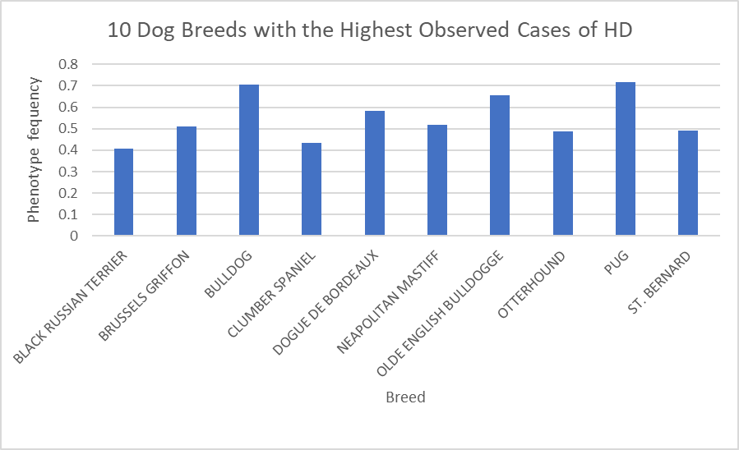

Figure 2. A bar graph for the clinical observation of HD, among ten breeds from the 128 breed population used in this study. The breeds listed from left to right are shown in alphabetic order (see Supporting Information Tables 1 for the complete lists of 128 domesticated breeds used in this study). Ten breeds that are shown present the highest observed disease frequency in the sample of 128 breeds. (Data Obtained: OFA 2019).

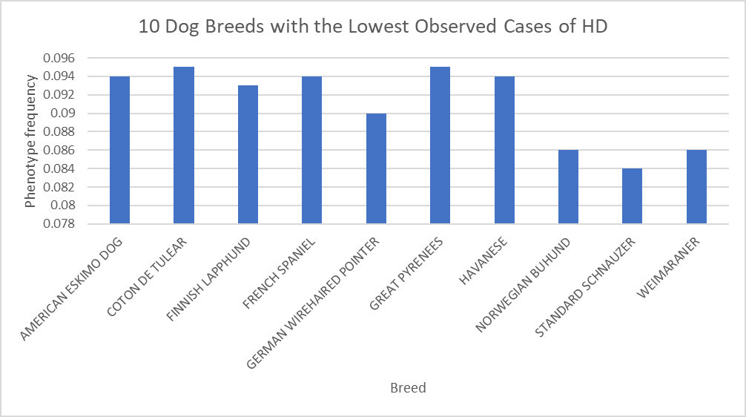

Figure 3. A bar graph for the clinical observation of HD, among ten breeds from the 128 breed population used in this study. The breeds listed from left to right are shown in alphabetic order (see Supporting Information Tables 1 for the complete lists of 128 domesticated breeds used in this study). Ten breeds that are shown present the lowest observed disease frequency in the sample of 128 breeds. (Data Obtained: OFA 2019).

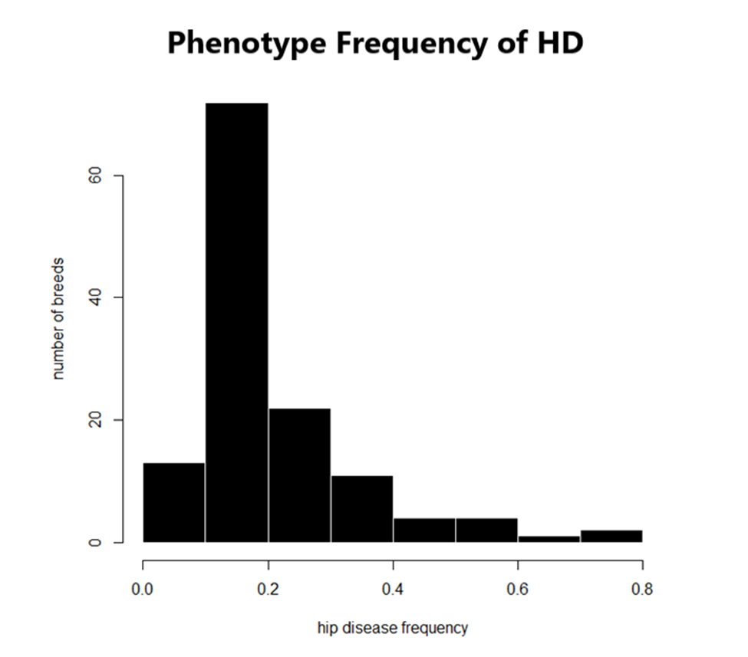

Figure 4. The phenotype frequencies of hip dysplasia among the 128 dog breeds. Each frequency was evaluated based upon the clinical examination for HD. The phenotype frequencies of HD, range between 0.0-0.8 (Data Obtained: OFA 2019).

*Phenotypic Frequencies*

The prevalence of certain dog breeds in one generation with the clinical diagnosis of HD can be calculated as the phenotype frequency. According to the data, the phenotype frequency ranges between 0.0-0.8; these are the chances that HD can be found in any one breed type. Over a hundred dog breeds show a low frequency of dysplasia (0.2). Frequencies above (0.5), have more than half of the breed specific sample exhibiting hip dysplasia. Frequencies that are high show an increased phenotypic association with HD and those that are low show a decreased phenotypic association of HD within each breed specific population size. Hip dysplasia is an observable characteristic among many breeds and can differ by breed specific high or low frequency (Figure 2).

*The Big Three*

This study identified the ten breeds with the most recorded cases of HD in the current OFA data of 128 breeds. The breeds include: Black Russian Terrier, Brussels Griffon, Bulldog, Clumber Spaniel, Dogue de Bordeaux, Neapolitan mastiff, Olde English bulldogge, Otterhound, Pug and Saint Bernard. The top three breeds with the highest occurrence of HD are listed from greatest to least: the pug, Bulldog and Old English bulldog. The largest amount of positive cases for the highest phenotype variation include, the Bulldog that had confirmed 757 cases. The pug has the second highest number of positive cases, 617. The Old English bulldog had the third highest number of positive cases, 93 (Figure 2). Each of the three breeds with the highest phenotype frequencies fall under the following American kennel Club classifications: Bulldog (non-sporting group), Pug (Toy group), and Old English Bulldog (not represented as a separate breed at AKC) ( American Kennel Club 2019). The toy group was not included in this study due to lack of availability of the heritability scores. The bulldog is also, a part of the largest heritable AKC group.

The ten breeds that showed the lowest occurrence of HD included: American Eskimo, Coton de Tulear, Finnish Lapphund, French Spaniel, German Wirehaired Pointer, Great Pyrnees, Havanese, Norwegian Behund, Standard Schnauzer and Weimaraner. The three breeds with the lowest occurrence of HD include: Standard Schnauzer, Norwegian Behund and Weimaraner. The three breeds are listed in descending order. The lowest amount of positive cases for the lowest phenotype variation include, the Standard Schnauzer that had confirmed 414 cases. The Norwegian Behund has the second lowest frequency with the number of positive cases, 25. The Weimaraner had the third lowest phenotype frequency, number of positive cases, 1165 (Figure 3). Each of the three breeds with the lowest phenotype frequencies fall under the American kennel Club classification: Standard Schnauzer (Working Breed), Norwegian Behund (Herding Group), and Weimaraner (Sporting) (American Kennel Club 2019). The three groups classification are the four lowest in heritability of hip score.

*Stratifying for Traits*

Table 2. A summary of the 60 domesticated dog breeds that have an estimated heritable hip score. Breeds are shown in are in alphabetic order from top to bottom. Groupings are listed as Shepherds/Herding, Terrier, Hounds, Sporting, Non-Sporting and Working Group (Data Obtained: , American Kennel Club 2019).

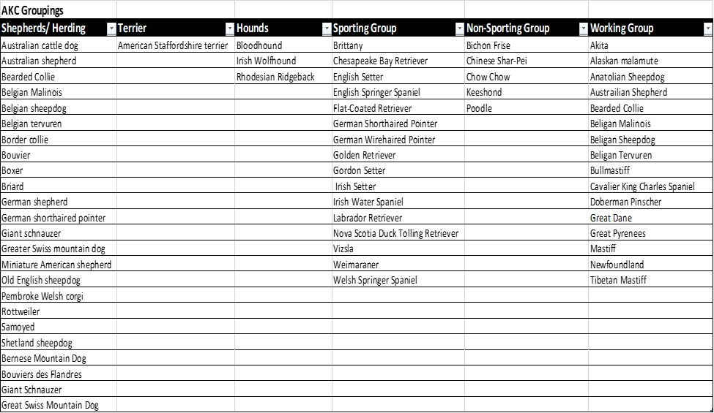

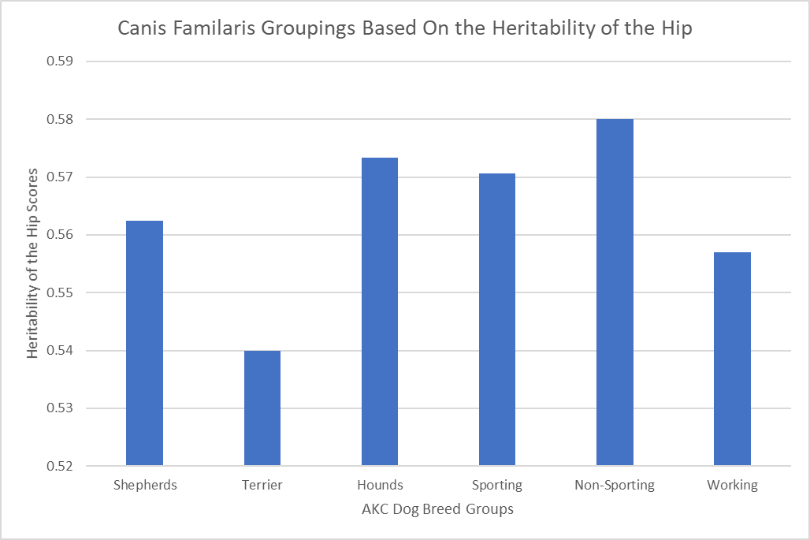

Figure 5: The heritability score of the hip using the data from OFA to estimate the degree of variation in the hip among 60 dog breeds. The breeds are grouped according to traits (see Supporting Information Tables 2 for the complete lists of 60 domesticated breeds used in this study) (Data Obtained from: Oberbauer et al. 2017, American Kennel Club 2019).

The heritability hip score between breed groupings was mapped according to six groups of the seven groups delineated by the AKC. The heritability data was limited to 60 breeds from the OFA data. The non-sporting dog group showed the most heritability of 58% heritability among the group classification. The second most heritability of the hip group includes the Hounds with 57% group heritability. All groups collectively demonstrated above 50% heritability of their hip scores. Heritability of hip showed no significant relationship with weight and height of hip dysplasia individuals included in Figure 6 and 7. Heritability of the hip score compared to the height values for the 60 breeds includes a R squared of 0.027. A weak positive linear relationship is made between heritability of the hip and height. Heritability of the hip score compared to the weight values for the 60 breeds includes a R squared of -0.00. There is no linear relationship between the variable heritability of the hip and weight. There is no significant relationship between heritability of the hip compared to weight or height. (Figure 6 and 7).

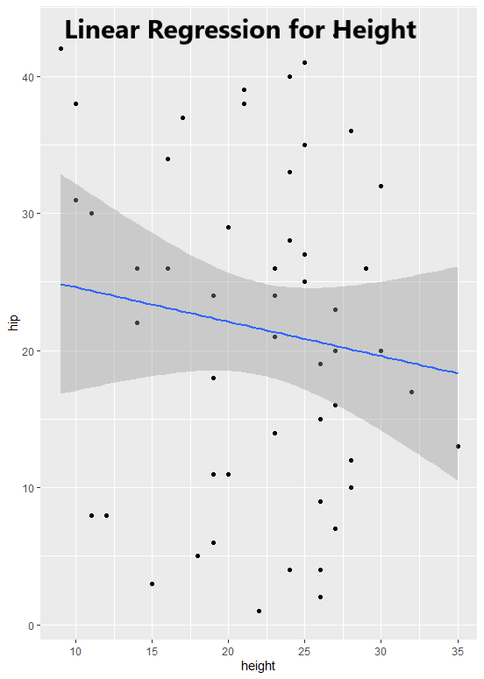

Figure 6: The heritability score of the hip checked for correlation to the height of the 60 dog breeds in table 2. The breeds names are in groups (see Supporting Information Tables 2 for the complete lists of 60 domesticated breeds used in this study) (Data Obtained from: Oberbauer et al. 2017, Pet Place Staff 2014).

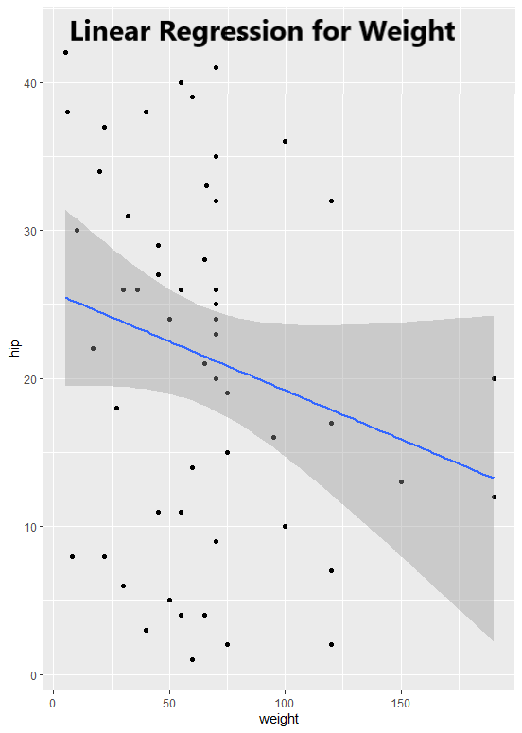

Figure 7: The heritability score of the hip was checked for correlation of the weight of the 60 breeds used in this study. The breeds names are under groups (see Supporting Information Tables 2 for the complete lists of 60 domesticated breeds used in this study) (Data Obtained from: Oberbauer et al. 2017, Pet Place Staff 2014).

**Discussion**

*Summary Paragraph*

The purpose of this study was to identify dog breeds with an increased phenotypic frequency within one generation and heritability of hip dysplasia in domesticated dog breeds that are affected by selective pressures to maintain pure-breed status. There is significant phenotype plasticity among the species. Selective pressures to keep pure-breed blood lines helps maintain genetic traits. There are phenotypic and heritability variations among different breeds. Genotypic variation could only tell if the trait is truly increasing in prevalence from one generation to the next. Since HD, is highly variable between the breeds, the author can conclude that that there is phenotypic variation based on artificial selected characteristics.

*Big-time prevalence discrepancies*

The breeds Black Russian Terrier, Brussels Griffon, Bulldog, Clumber Spaniel, Dogue de Bordeaux, Neapolitan mastiff, Olde English bulldogge, Otterhound, Pug and Saint Bernard has phenotypic frequencies at nearly 80% prevalence of obtaining hip dysplasia. These dogs are grouped in different groupings based on traits with all the breeds having more than 50% of there genetic information conserved. The breeds with the lowest phenotypic frequencies were less than 1%. Although, the grouping associated with the breeds showed less heritability among those ten breeds. The heritability values were still over fifty percent within those groups. In addition, the author explored the phenotypic characteristic of the dog body size and its role with the heritability of the hip. When controlling for height and weight, it was concluded that physical features such as weight and height show no significant association based on the 60 breeds used in this study.

*Groups and heritability*

A significant amount of heritability variation was found between AKC groupings. The American Kennel Association has confirmed 167 different varieties of *Canis familiaris* also called breeds. These differences between groupings are a result of domestication and artificial selection for desired traits in Canis familiaris. Selective pressure within breeds, such as personality traits, have been selected by humans for job-specific tasks (Jones 2008). Evidence concludes that the high heritability may have preserved the genetic susceptibility to obtain HD. Although, this study lacks the genetic evidence this can only be assumed. Further tests should be done to strengthen this information. Genotypic frequencies were not obtained and would be advised for further study into genetic relationship of hip dysplasia among the breeds.

*Selectively removing the trait*

There are rudimentary biological differences such as sex, gender specific disease research that could be compared to the current data, which may change the prevalence pattern among breeds. HD still plays a major role in the genetics of these breeds with evidence to support over-fifty percent evolutionarily conserved disease pathology in the heritability scores. Although breeders are attempting to selectively breed these dog breeds by individuals with less or no prevalence of HD, the genetic predisposition remains. Inbreeding may be the best option to decrease the risk of genetic disorders (KC 2020).

*Limitations and Future Directions*

This study supported the hypothesis that certain breeds are more prone to HD based on phenotypic evaluation, the heritability of the hip has a strong association with breed selection. Weight and height do not have an association on the heritability of the hip. Further investigation on other genotypic characteristics such as the heritability difference among the genders and breeds determined to be HD positive, could result in more accurate phenotypic frequencies of HD among the breeds. As prevalence of HD continues to increase among canines, the health of our canine friends can be greatly impacted by helping our dogs maintain a normal body weight in dogs as seen in clinical studies( Impellizeri, 2000).

Sources

Akey, Joshua M. et al. “Tracking footprints of artificial selection in the dog genome.” Proceedings of the National Academy of Sciences of the United States of America 107 3 (2010): 1160-5 .

American Kennel Club. List of Breeds by Group. (2019). <https://www.akc.org/public-> education/resources/general-tips-information/dog-breeds-sorted-groups/

Brass.W. “Hip dysplasia in dogs.” Journal of Small Animal Practice (1989)30, 166-170

Candine. Interesting facts about dog breeds in India. LinkedIn(2018).https://www.slideshare.net/canidine/breed-box

Darwin. On the origin of species by means of natural selection, or, The preservation of favoured races in the struggle for life . London: J. Murray, 1859.

Durmus et al. “Hip dysplasia in Labrador Retrievers in Turkey” Journal of Animal and Veterinary Advances.Vol.3; 385-386, (2005).

Flückiger, Mark. Scoring radiographs for canine Hip Dysplasia.The big three organisations in the world.The European Journal of Companion Animal Practice. VOL. 17 - (2) - OCTOBER 2007 ISSN 1018-2357

HEDHAMMAR, A., OLSSON, S.E., ANDERSSON, S.A. et al. Canine hip dysplasia: study of heritability in 401 litters of german shepherd dogs. J. Am. Vet. Med. Assoc., v.174, p.1012-1016, 1979.

Hedhammar, A.Canine Hip Dysplasia as influenced by genetic and environmental factors.The European Journal of Companion Animal Practice. VOL. 17 - (2) - OCTOBER 2007 ISSN 1018-2357

Honeycutt RL. Unraveling the mysteries of dog evolution. BMC Biol. 2010;8:20. Published 2010 Mar 9. doi:10.1186/1741-7007-8-20

Impellizeri, Joseph et al. Effect of weight reduction on clinical signs of lameness in dogs with hip osteoarthritis. Journal of the American Veterinary Medical Association. 2000, Vol. 216, No. 7, Pages 1089-1091. https://doi.org/10.2460/javma.2000.216.1089

J. Bouw (1982) Hip dysplasia and dog breeding, Veterinary Quarterly, 4:4,173-181, DOI: 10.1080/01652176.1982.9693859

Jones P., Chase K., Martin A., Davern P., Ostrander E. A., et al. , 2008.  Single-nucleotide- polymorphism-based association mapping of dog stereotypes. Genetics 179: 1033–1044.

Karbe GT, Biery DN, Gregor TP, Giger U, Smith GK. 2012. Radiographic Hip Joint Phenotype of the Pembroke Welsh Corgi. Veterinary Surgery. 41(1):34–41. doi:10.1111/j.1532- 950X.2011.00938.x.

KC. Gene pools and the impact of selection. 2020. <https://www.thekennelclub.org.uk/health/for-> breeders/understanding-canine-genetics/breeds-and-their-gene-pool/

Kaminaris, , Alexandros. “Canine hip displasia: PennHip compared to OFA, FCI and BVA/CK.” Hungarian Veterinary Archive.(2012): <http://hdl.handle.net/10832/417>

Kapatkin, A et al. Genetic Control of Canine Hip Dysplasia. University of Pennsylvania. Vol. 24, No. 9 September 2002

Loder RT, Todhunter RJ. The Demographics of Canine Hip Dysplasia in the United States and Canada. J Vet Med. 2017;2017:5723476. doi:10.1155/2017/5723476

Lust G. An overview of the pathogenesis of canine hip dysplasia. Journal of the American Veterinary Medical Association. 1997 May;210(10):1443-1445

Moore, Ruth. TIME LIFE: Nature Library; Evolution (1962). TextBook

Oberbauer AM, Keller GG, Famula TR (2017) Long-term genetic selection reduced prevalence of hip and elbow dysplasia in 60 dog breeds. PLoS ONE 12(2): e0172918. https://doi.org/10.1371/journal.pone.0172918

OFA. Hip displasia stastics. Orthopedic Foundation for Animals(2020).https://www.ofa.org/diseases/breed-statistics#detail

Pet Place Staff.”American Kennel Club (AKC) Breeds by Size.(2014)<https://www.petplace.com/article/dogs/pet-care/american-kennel-club-akc-> breeds-by-size/

R Core Team (2013). R: A language and environment for statistical computing. R Foundation for Statistical Computing, Vienna, Austria. URL http://www.R-project.org/.

Riser, Wayne. “A New Look at Developmental Subluxation and Dislocation: Hip Dysplasia in the Dog” School of Veterinary Medicine(1963) Vol.4, pp. 42 1 to 434.

Sutter NB, Ostrander EA (2004) Dog star rising: the canine genetic system. Nat Rev Genet 5:900–910

Witsberger TH et al. Prevalence of and risk factors for hip dysplasia and cranial cruciate ligament deficiency in dogs. J Am Vet Med Assoc. 2008 Jun 15;232(12):1818-24. doi: 10.2460/javma.232.12.1818.

Wilson, Bethany et al. Selection against canine hip dysplasia: Success or failure? The Veterinary Journal.Volume 189, Issue 2, August 2011, Pages 160- 168https://doi.org/10.1016/j.tvjl.2011.06.014