Does Network Structure Decide the Best Vaccination Strategy?
An SIR study on random, small-world and scale-free contact networks
Kasturi Sirmokadam and Varshitha Raparla — CITS4403 Computational Modelling, The University of Western Australia
Code, notebooks and results: https://github.com/kas1234/cits4403-disease-spread
Abstract: We use a stochastic SIR model on contact networks to ask whether the best way to use a limited supply of vaccine depends on how people are connected. We compare three network types, four vaccination strategies and seven transmission probabilities, with 30 simulations for each combination. With 10% of people vaccinated on a scale-free network, targeting the most connected people cuts the average final epidemic size from 0.84 to 0.22, compared with 0.68 for random vaccination. On the random network, targeting by degree gives no clear benefit at this coverage, while on the small-world network the best strategy is to target the people who connect different clusters. A second implementation, written independently, gave very similar results (correlation 0.995) and showed that targeting becomes more useful on random networks when a larger share of the population is vaccinated.

1. Background and aims
Vaccine supply is often limited, so who gets vaccinated first can matter. The classic SIR model of Kermack and McKendrick (1927) assumes that everyone mixes equally, so it only cares how many people are vaccinated, not who they are. Real populations are not like that. Some people have many more contacts than others, and people cluster in households, schools and workplaces. Network models (Keeling and Eames, 2005) can capture these differences, and they change both how a disease spreads and how it can be controlled.
One example is a scale-free network, where a few people have a very large number of connections and act as hubs. Earlier research has shown that epidemics behave differently on this type of network (Pastor-Satorras and Vespignani, 2001) and that vaccinating the most connected people can work much better than choosing people at random (Pastor-Satorras and Vespignani, 2002; Cohen et al., 2003). What is less obvious is whether the same approach works when contacts are spread more evenly, or when people are split into clusters.
This is the question we investigate: if the number of vaccines is fixed, does the best way to use them depend on the structure of the contact network? We compare random vaccination with two targeted approaches, vaccinating the people with the most contacts and vaccinating the people who often sit between other parts of the network. We test three hypotheses. H1: on a scale-free network, targeting the most connected people will be much better than random vaccination. H2: on a small-world network, targeting people who connect clusters will be at least as effective as targeting by degree. H3: on a random network, targeting will give little extra benefit, because there are fewer obviously important people. We also look at how the transmission probability changes the results, how often an outbreak becomes a major one, and how well the model matches a real outbreak.

2. Originality and contribution
The SIR model and the network types we use are well established, so we are not claiming that the methods themselves are new. They also differ from the models covered in the unit, such as Game of Life, Schelling, Sugarscape, traffic, flocking, evolution and the Prisoner's Dilemma. Our contribution is in how we combine them to investigate the vaccination question.
We compare four vaccination strategies on three network structures, keeping the network size and average degree similar. Within each repetition all strategies use the same network and random seed, which makes the comparison fairer. We also look separately at whether an outbreak takes off and how large it gets if it does, because the average final size alone can hide these two different outcomes. Another part of our contribution is the comparison with the 1978 influenza outbreak, where we report where the model does and does not fit instead of treating the calibration as a perfect prediction. The second author also wrote an independent version of the model. Comparing the two helped us explain an apparent difference in the random-network results and led to an extra experiment on vaccination coverage. Finally, we wrote automated tests for important edge cases, and they helped us find an early counting error in which vaccinated people were counted as infected, which had inflated the epidemic-size results by 0.10.

3. Model
Disease dynamics. Each person is a node, and each contact is an edge in a fixed, undirected network. A person is Susceptible (S), Infected (I) or Recovered/vaccinated (R). The simulation moves forward in discrete time steps, with all changes in a step happening together. If a susceptible person has k infected neighbours, the probability that they become infected during that step is
p = 1 − (1 − β)^{*k*},
An infected person recovers with probability γ and then becomes immune. Vaccinated people start in state R, so they can neither catch nor pass on the disease. This assumes a perfect vaccine that works immediately, which keeps the model simple but is also one of its limitations. Each run starts with one randomly chosen unvaccinated person infected and ends when nobody is infected. We use γ = 0.1, an average infectious period of ten time steps, and vary β. For the random network, Newman's (2002) result gives the epidemic threshold in terms of the transmissibility T = β/(β + γ). With an average degree of 6, this suggests a β of roughly 0.02. In our simulations, outbreaks start to take off at β = 0.04 on both the random and scale-free networks.
Networks. Each network has 300 people and an average of about six contacts (the mean degree is between 5.9 and 6.0), so overall contact levels are similar and we can focus on structure. The random network is an Erdős–Rényi graph (Erdős and Rényi, 1959), where most people have a similar number of contacts. The small-world network is a Watts–Strogatz graph (Watts and Strogatz, 1998): people are first linked to their nearby neighbours on a ring, which creates clusters, and then 10% of the links are rewired to random people, which creates shortcuts between clusters. The scale-free network is a Barabási–Albert graph (Barabási and Albert, 1999), where new people tend to connect to people who are already well connected, creating a few large hubs. In one example network the largest hub had 58 contacts, compared with 14 in the random network.
Vaccination strategies. We allow 10% of the population to be vaccinated, so 30 people receive a vaccine before the outbreak starts. We compare four situations: no vaccination, random vaccination, degree targeting and betweenness targeting. Degree targeting picks the 30 people with the most contacts. Betweenness targeting picks the 30 people with the highest betweenness centrality, meaning people who lie on many of the shortest paths between others and so link different parts of the network (Holme et al., 2002). The vaccinated people are fixed before the outbreak and do not change as it develops.
Outcome measures. For every simulation we record the final epidemic size (the fraction of people infected at some point, not counting vaccinated people), the largest number infected at the same time, when that peak happens, and how long the outbreak lasts. A simulation counts as a major outbreak if more than 10% of the population is infected. Runs below that level usually end quickly because the first infected person recovers before the disease reaches enough others.

4. Experimental design
We tested every combination of three network types, four vaccination strategies and seven transmission probabilities (β = 0.02, 0.04, 0.06, 0.08, 0.10, 0.15 and 0.20). Each combination was repeated 30 times, giving 2,520 simulations. The model is written in Python with NetworkX. For repetition r we used seed r for the network, the vaccinated set and the simulation, so within a repetition the four strategies are compared on the same underlying network and random setup.
We report the mean with a 95% confidence interval (1.96 standard errors). Outcomes often fall into two groups: an outbreak either dies out early or grows into a much larger one. Because of this, we also report the probability of a major outbreak and the average size of the major outbreaks. With 30 repetitions the intervals can still be wide, around ±0.1, so we are cautious about reading much into smaller differences.
We checked the implementation with 40 automated tests that have hand-worked answers on small networks. They cover cases such as no transmission, certain transmission, everyone vaccinated, disconnected networks and vaccinating the hub of a star network. We also compared the model with the real outbreak and with the independent second implementation (Section 5.4). Everything can be reproduced from the repository: python run_experiment.py runs the main experiment, python -m pytest runs the tests, and the notebooks produce the tables and figures.

5. Results

5.1 The best strategy depends on the network
Table 1 and Figure 1 show the mean final epidemic size at β = 0.10. The scale-free network gives the clearest result. Vaccinating the 30 most connected people cuts the final size from 0.84 to 0.22, a 74% reduction, whereas random vaccination only brings it down to 0.68, a 19% reduction. Betweenness targeting gives a very similar 0.25, because the hubs are also important bridges in this network. The confidence intervals for the targeted strategies and random vaccination do not overlap, which supports H1. Counting the contacts removed gives another explanation: degree targeting removes about 58% of all contacts, while random vaccination removes only about 19%.
The small-world network behaves differently. All three strategies reduce the epidemic, but betweenness targeting works best, with a final size of 0.44, compared with 0.58 for degree targeting and 0.59 for random vaccination. This supports H2. Here people have fairly similar numbers of contacts, so picking the highest-degree people does not help much (degree targeting removes only about 22% of contacts), whereas betweenness can pick out people who connect different clusters. This is encouraging, but we do not treat it as conclusive because the confidence intervals for betweenness and random vaccination overlap somewhat.
The random network shows a much smaller difference between strategies. Degree targeting gives a final size of 0.66, almost the same as random vaccination (0.67), and betweenness is actually worse at 0.77. At 10% coverage, this suggests there is little benefit in trying to pick particular people in a random network, which supports H3.
Network | None | Random | Degree | Betweenness
Random | 0.83 ± 0.12 | 0.67 ± 0.12 | 0.66 ± 0.11 | 0.77 ± 0.05
Small-world | 0.84 ± 0.12 | 0.59 ± 0.14 | 0.58 ± 0.11 | 0.44 ± 0.12
Scale-free | 0.84 ± 0.10 | 0.68 ± 0.11 | 0.22 ± 0.09 | 0.25 ± 0.09
Table 1. Mean final size (fraction infected) ± 95% confidence interval at β = 0.10 with 10% vaccinated, 30 repetitions. Bold: best strategy for each network where the difference from random vaccination is clear.
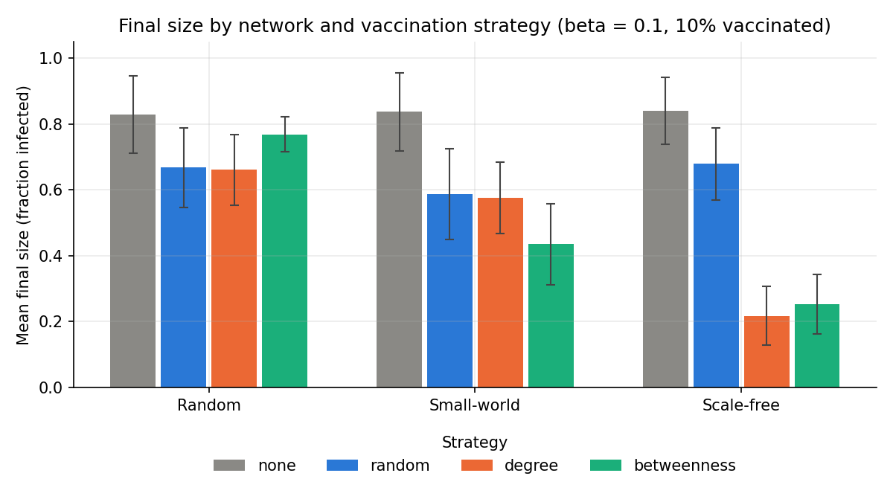
Figure 1. Final size by network and strategy at β = 0.10 (error bars: 95% confidence interval).

5.2 Effect of the transmission probability
Figure 2 shows how the final size changes as the transmission probability increases. Without vaccination, outbreaks start to take off at around β = 0.04 on the random and scale-free networks, but only at about β = 0.08 on the small-world network. This is consistent with clustering making it harder for the disease to jump from one group to another.
The scale-free network keeps showing a strong benefit from targeting even as β grows. At β = 0.20, targeted vaccination keeps the final size around 0.54–0.56, compared with 0.92 without vaccination and 0.82 with random vaccination. However, the advantage of vaccination generally shrinks as the disease becomes more infectious. On the random network at β = 0.20, for example, all strategies give final sizes between 0.76 and 0.87, and random vaccination is actually the best at 0.76. On the small-world network, betweenness is still the best strategy, with a final size of 0.80 compared with 0.97 without vaccination.
Targeting also changes the peak on the scale-free network. The peak falls from about 128 infected people to around 16–20 and happens later, moving from about step 16 to step 25. So targeting does not just reduce the final number of infections; it also spreads them over a longer period.
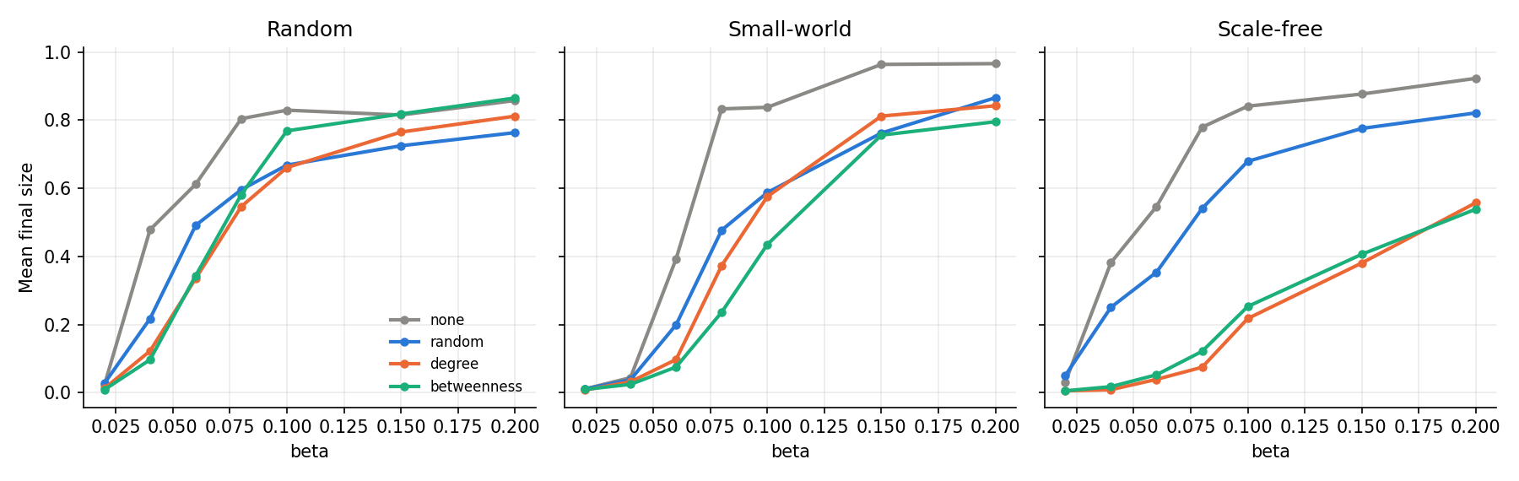
Figure 2. Mean final size against β for each network and strategy (30 repetitions per point).

5.3 Do outbreaks take off, and how large are they?
At β = 0.10, between 87% and 90% of the runs without vaccination became major outbreaks on all three networks. Targeting has the strongest effect on the scale-free network. Degree and betweenness vaccination reduce the chance of a major outbreak to around 43–50%, and the major outbreaks that still happen are smaller, falling from 0.93 without vaccination to 0.49. So targeting helps both by preventing some large outbreaks and by shrinking the ones that do occur.
The random network shows a different pattern. The probability of a major outbreak barely changes across strategies (about 0.80 to 0.97), so most of the benefit comes from making outbreaks smaller rather than stopping them from taking off. On the small-world network the probability of a major outbreak falls more moderately, from 0.87 to between 0.63 and 0.77. The fact that some runs die out quickly while others become large is also why the confidence intervals in Table 1 are fairly wide.

5.4 Calibration and cross-check
Calibration. We compared the model with an influenza outbreak at an English boarding school in 1978. It involved 763 boys, 512 of whom were confined to bed, which is a final size of 0.671, with a peak of 298 boys around day 6 (Anonymous, 1978). We searched over the mean degree, β and γ on random and small-world networks, and only scored simulations that developed into major outbreaks. The best fit used 12 contacts per person, β = 0.18 and γ = 0.5. It gave a peak of about 299 around day 8, which is reasonably close, but the final size was much too high at 0.97 instead of 0.67.
Our first calibration looked much better, with an error of 0.03 instead of 0.28. When we looked at the individual runs, we found why: it averaged together simulations that died out and simulations that became major outbreaks. In our model, once an outbreak takes off it usually reaches almost everyone, whereas in the real outbreak about a third of the boys were never ill. So we do not use the calibration to claim that the model can predict a real outbreak. It is more useful for showing where the simple model starts to differ from a real situation.
Cross-check. To make sure the main results were not caused by a mistake in our implementation, the second author independently wrote another SIRV model. It used 100 people, 20% vaccination coverage, four contacts per person and three strategies (no vaccination, random vaccination and degree targeting), with 100 repetitions. Run with the same settings, the two models gave very close results across 54 combinations, with a correlation of 0.995 and a mean absolute difference of only 2 people out of 100.
At first there was one important difference: on random networks, the second model showed a much bigger advantage for degree targeting. Rather than assuming one model was wrong, we checked whether vaccination coverage could explain it. In our random network, degree targeting is similar to random vaccination at 5–10% coverage. At 20% it starts to do better (a final size of 0.44 compared with 0.53 at β = 0.10), and at 30% the gap is much larger (0.10 compared with 0.40). The second model uses a smaller, sparser network and 20% coverage, a setting where targeting is more useful. When we ran our model with those settings we got a similar result: about 9 people infected with degree targeting compared with 28 with random vaccination.
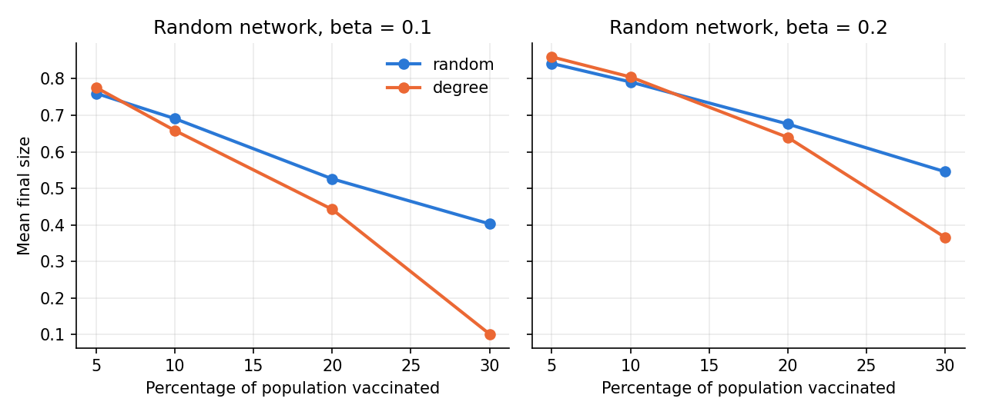
Figure 3. Effect of vaccination coverage on a random network (300 people, 6 contacts, 40 repetitions): targeting by degree only beats random vaccination once enough people are vaccinated.

6. Discussion and conclusions
Overall, no single vaccination strategy is best for every network. What works best depends on where the important connections are. In the scale-free network, a few hubs account for a large share of the contacts, so vaccinating them removes more than half of the network's contacts even though only 10% of people are vaccinated. That explains the large drop in the epidemic. Random vaccination cannot concentrate the vaccines in the same way.
The small-world network is different. Most people have similar numbers of contacts, so choosing by degree alone is not very useful, and the important people are those who connect different clusters. Betweenness targeting did best here, which fits this structure, but our experiments do not directly show that the shortcuts themselves are responsible for the improvement.
On the random network there is little advantage in targeting particular people when only 10% can be vaccinated, because nobody stands out much from the rest. The coverage experiment shows that this can change when more vaccine is available. Overall, knowing who the highly connected or bridging people are seems most valuable when contacts are uneven or clustered. When contacts are spread fairly evenly and vaccine is scarce, random vaccination can be just as useful. Targeting also becomes less effective when the disease is very infectious, since the infection can reach most of the population anyway.
There are some important limitations. The model assumes a perfect vaccine that works immediately, whereas real vaccines may not protect everyone and are rolled out gradually. It also assumes the contact network stays fixed and that we know all of it, which is unrealistic: people change their behaviour during an outbreak, and it would be hard to know every contact. The main experiments use a single recovery rate, population size and vaccination coverage. With only 30 repetitions per setting the confidence intervals are fairly wide, so differences smaller than about 0.1 should be treated carefully.
The comparison with the 1978 outbreak is also a clear limitation. The model could produce a similar peak but predicted a much larger final outbreak. One possible reason is that some boys may already have been immune. Another is that a boarding school has a dormitory and classroom structure that our simple networks do not capture. We did not test these explanations, so they remain possibilities.
The model could be extended in several ways, for example with vaccines that are only partially effective, a delay between vaccination and protection, and contact networks that change during an outbreak. Real contact data would make it more realistic. It would also help to test more coverage levels on each network, to find more clearly where targeted vaccination starts to beat random vaccination.

References
Anonymous (1978). Influenza in a boarding school. British Medical Journal, 1(6112), 586-587.
Barabási, A.-L. and Albert, R. (1999). Emergence of scaling in random networks. Science, 286, 509-512.
Cohen, R., Havlin, S. and ben-Avraham, D. (2003). Efficient immunization strategies for computer networks and populations. Physical Review Letters, 91, 247901.
Erdős, P. and Rényi, A. (1959). On random graphs I. Publicationes Mathematicae Debrecen, 6, 290-297.
Holme, P., Kim, B. J., Yoon, C. N. and Han, S. K. (2002). Attack vulnerability of complex networks. Physical Review E, 65, 056109.
Keeling, M. J. and Eames, K. T. D. (2005). Networks and epidemic models. Journal of the Royal Society Interface, 2, 295–307.
Kermack, W. O. and McKendrick, A. G. (1927). A contribution to the mathematical theory of epidemics. Proceedings of the Royal Society A, 115, 700–721.
Newman, M. E. J. (2002). Spread of epidemic disease on networks. Physical Review E, 66, 016128.
Pastor-Satorras, R. and Vespignani, A. (2001). Epidemic spreading in scale-free networks. Physical Review Letters, 86, 3200–3203.
Pastor-Satorras, R. and Vespignani, A. (2002). Immunization of complex networks. Physical Review E, 65, 036104.
Watts, D. J. and Strogatz, S. H. (1998). Collective dynamics of ‘small-world’ networks. Nature, 393, 440–442.

Appendix: supporting figures
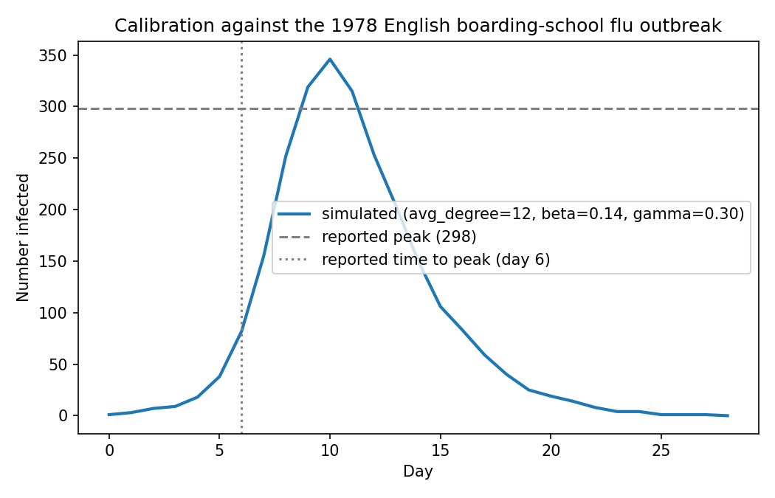
Figure A1. Best-fitting simulated outbreak (random network, 12 contacts, β = 0.18, γ = 0.5) against the reported peak and time to peak of the 1978 boarding-school outbreak.
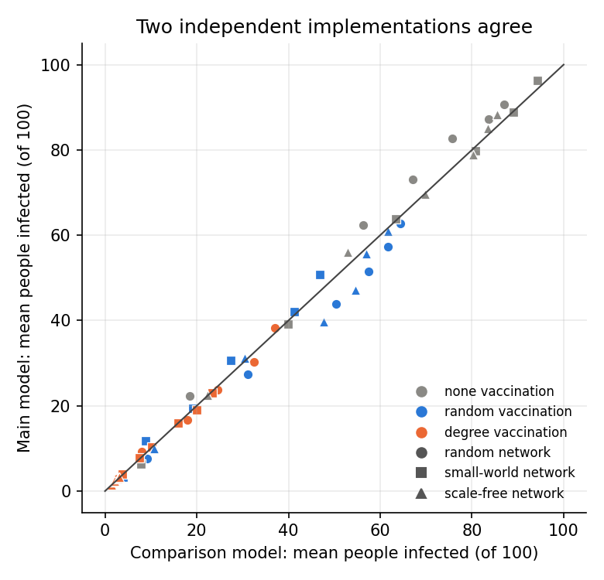
Figure A2. Agreement between the main model and the independently written comparison model run with the same settings (each point is one network × strategy × β combination).
Code and data. Repository: https://github.com/kas1234/cits4403-disease-spread. Key files: src/ (model), utils/ (statistics helpers), data/ (real outbreak numbers), tests/ (40 tests), notebooks/analysis.ipynb (tables and figures), notebooks/cross_check.ipynb (comparison with the second model), comparison_model/ (second model), README.md (setup and usage).

