Dapperly – High-Level & Low-Level Design Document

# High-Level Design (HLD)

## 1. Overview

The High-Level Design (HLD) outlines the system architecture and components of the Dapperly B2B eCommerce platform. It highlights the major modules, their interactions, and technology stack used to build the application.

## 2. Architecture Overview

Architecture is composed of three primary layers:

* - Presentation Layer: ReactJS, HTML5, CSS
* - Business Logic Layer: .NET Core Web API
* - Data Layer: SQL Server

## 3. Functional Modules

* - Product Management
* - Product Search & Filters
* - Product Details & Reviews
* - Cart and Checkout
* - Payment Processing (Dummy)
* - User Management and Authentication

## 4. Security

The platform enforces HTTPS for secure communication and uses JWT for user authentication.

## 5. System Architecture Diagram

Refer to the attached system architecture diagram for a visual representation.

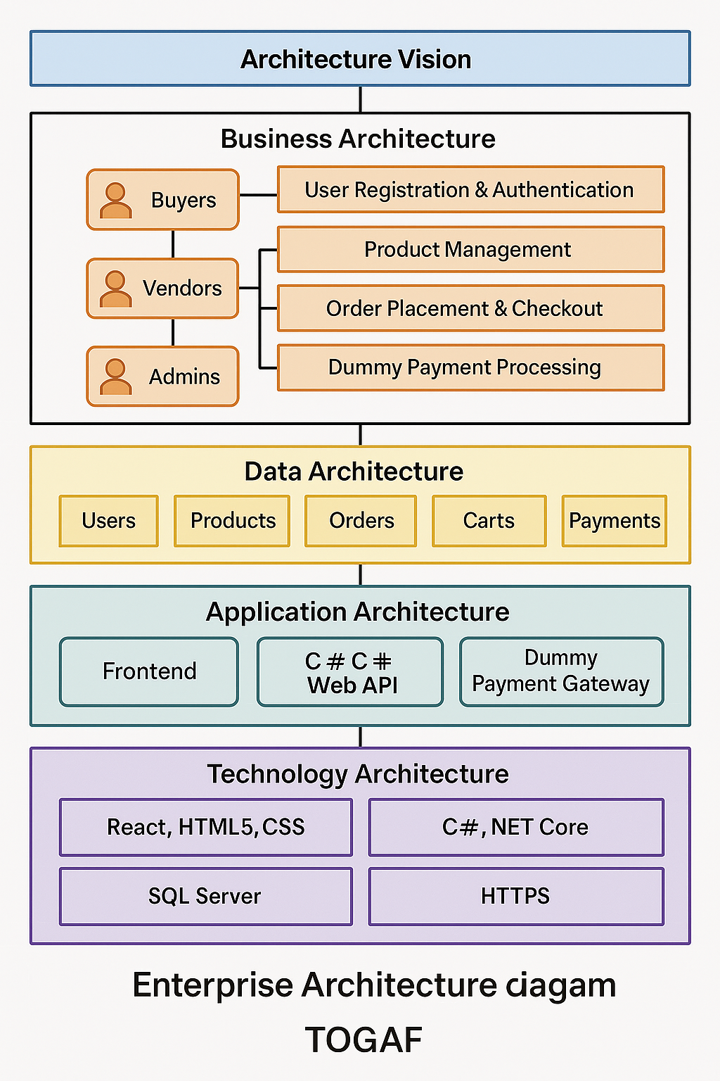

# Low-Level Design (LLD)

## 1. Module Breakdown

Each module includes the following components:

* - API Endpoints (RESTful)
* - UI Components
* - Database Entities

## 2. Sample API Endpoints

/api/products - GET/POST/PUT/DELETE

/api/users/register - POST

/api/cart - GET/POST/DELETE

/api/payment/process - POST

## 3. Database Design

Tables:

* - Users (user_id, name, email, password, role)
* - Products (product_id, vendor_id, name, price, stock, category)
* - Orders (order_id, user_id, total_price, status)
* - Cart (cart_id, user_id, product_id, quantity)
* - Payments (payment_id, order_id, status, timestamp)

## 4. UI Components

* - ProductList.jsx
* - ProductDetail.jsx
* - Cart.jsx
* - Checkout.jsx
* - Login/Register.jsx