

Assignment 1

Basic installation of MySQL



January 12, 2021

Kasahun tehone

msd@miu

W1D1 – LESSON1 ASSIGNMENT:

A. Answer the following questions:

a. Briefly discuss (i.e. in 2-4 statements/sentences) each of the following terms:

I. Data: is a row fact of information means any data which is not processed which may be gives meaning or just scrambled kind of data

ii. Database: is a collection of inter related data and files stored in a specific area.

iii. Database Management system: is a software to management our data base making all the necessary operation like CRUD

iv. Database application program: and computer program which interact with the database either through the command line or in GUI based.

b. Describe the main characteristics of the Data approach and contrast it with the File-based approach.

|  |  |  |
| --- | --- | --- |
| No | Data approach | File based approach |
| 1 | Centralization of data | Data isolation and separation |
| 2 | Sharing of data | Easy to start with it but nor efficient |
| 3 | Data security | Boring and time consuming to update single change of the files because it is not inherited |
| 4 | Consistency | No security to protect our data access by others |
| 5 | Lower cost of update and maintenance | Redundancy or dup lication |

c. What are the five components of the DBMS environment and how are they related to each other?

1. Hardware
2. Software
3. Data
4. Process
5. Person

This all are interact through one intermediate connecter which is data, because the main goal of DB is have highly purified data that makes a better achievement in our day to day activities.

d. Study the Dream Home case study introduced/presented in this Lesson

1. And answer the following questions:

I. What do you think are the main objects that need to be represented in the database?

* Property
* Client
* Owner
* Lease

ii. What relationships do you think exist between these main objects?

It depends on to which interacts to:-

For example : owner and client have one to many relationship, property and owner client 0 to 1 and property with owner n to 1 relationship are there

iii. For each of the objects, what details do you think need to be stored in the database?

|  |  |  |  |  |  |
| --- | --- | --- | --- | --- | --- |
| Property |  | Owner |  | Client |  |
| Id  Name  type  Price  duration |  | Id  Property |  | Id  Name  Prop-Id  Lease-length |  |

iv. Give at least 3 queries you think will be required.

**B. Perform the following tasks:**

a. Obtain and install the MySQL database (dbms) product, on your computer. Completed

b. Using the MySQL dbms which you have installed, complete the following sub-tasks:

i. Start the MySQL database server instance (if it is not already running) :done

ii. Launch open the MySQL Shell and execute the following shell commands (Note: For each command you successfully execute, take a screenshot of the output and add it to your Assignment1 answers document, which you will submit):

1. MySQL JS > \status (This command will display information about the current

global session. Since no connection has been made at this time, it will simply print the MySQL Shell version).

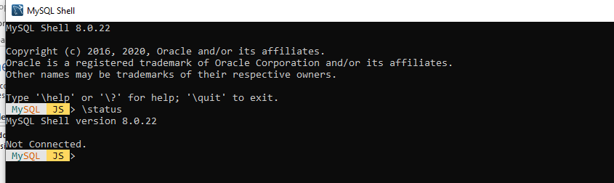

2. MySQL JS > \connect root@localhost (This command will open a connection to the database server as the super-user named, root. Note: You will be prompted to enter the correct password for “root”).

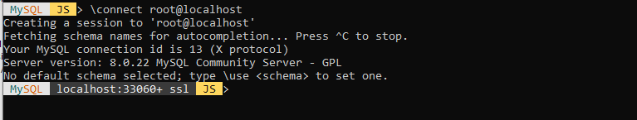

3. MySQL JS > \sql (This command will switch the Shell session from JavaScript processing mode to SQL processing mode).

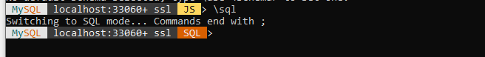

4. MySQL localhost:33060+ ssl SQL > show databases; (This will display a list of the Databases found in the MySQL DBMS instance).

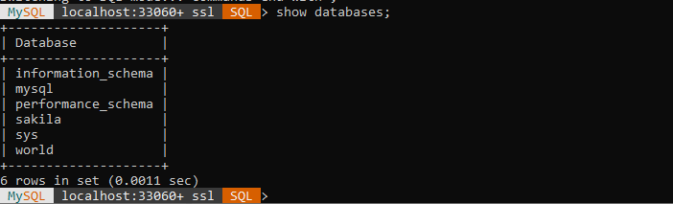

5. MySQL localhost:33060+ ssl SQL > show world; (This will set the default/active schema to “world”. Note: schema here means the database).

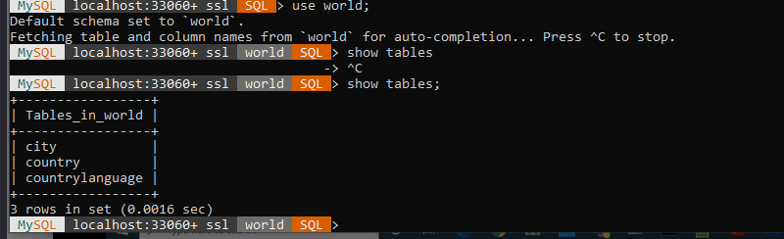

6. MySQL localhost:33060+ ssl SQL > show tables; (This will display a list of all the tables in the world schema (database)).



7. MySQL localhost:33060+ ssl SQL > desc country; (This will display the schema/specification for the table named, country).

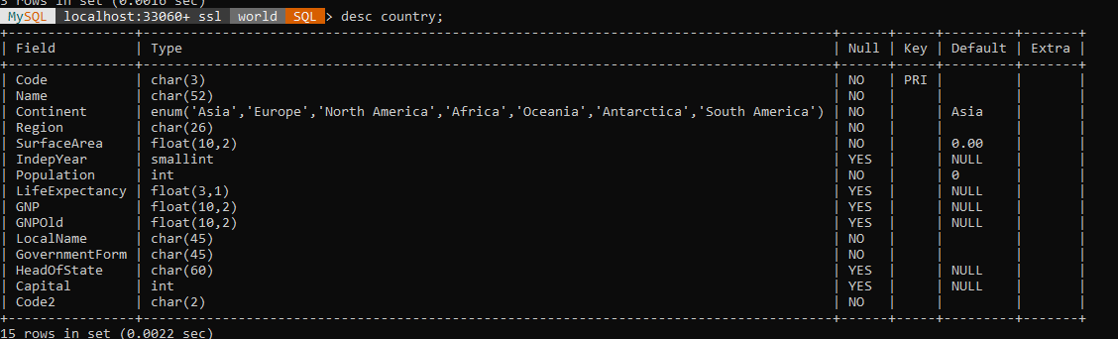

8. MySQL localhost:33060+ ssl SQL > desc city; (This will display the schema/specification for the table named, city).

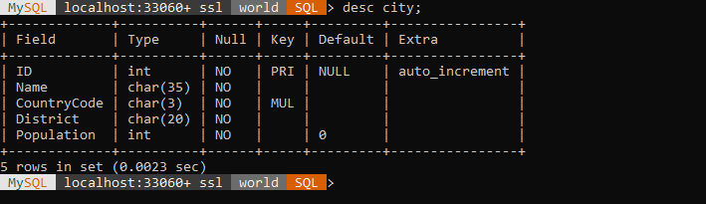

iii. Carefully examine the schema/specifications for both the table named, country and the one named, city. Is there any relationship(s) between the two tables? Yes or No? If yes, describe the relationship(s) which you can identify.

Yes : the code attribute under country table is also attribute for city but code under country but in case of city it act like foreign key to interact with the country table also they have one to many cardinality relationship

iv. Launch open the MySQL Workbench GUI tool and take a screenshot of it.

