|  |  |
| --- | --- |
| Spanish Republic of LettersSchool of Computer Science https://cs.uwindsor.ca | **Master of Applied Computing**  COMP-8347  Internet Applications and Distributed Systems |
|  |

**Project Description**

Your task is to create a website using Django, Python, and PyCharm which you will learn during your lectures and labs. Here are the details:

***Mandatory Features***

* Your website should contain all the **necessary things** you will learn during the labs/lectures such as creating and editing models, views, templates, forms, user sessions, cookies, authentication, and so on.
* Should be made using the **tools learned in the class** (ex. Python, Django, and PyCharm).
* The website idea must be based on the theme of **green/environment-friendly technologies**. Here is a link that showcases some similar ideas. <https://www.sepco-solarlighting.com/blog/10-amazing-environmentally-friendly-websites>
* Based on the group size, each student’s contribution should be justified. Ex. For each student, 2 forms, 2 models, 2 templates, 2 views, login page, and so forth. This can be further discussed during the lectures.
* Should contain different interfaces for **Registered/Unregistered** users. Many famous websites provide different options for registered and unregistered users. It is therefore up to you to decide what features must be accessible to registered users and what must not.
* **Login**, **logout**, and **forgot password** features.
* Should contain a **search bar**. Here a user must be able to search based on different strings while a top-down list should also be provided for searching.
* Should contain a **User History** section**:** You should use cookies and sessions to track users visits to your website. Ex. number of visits per day and so on. A sample example can be found here: <https://www.care2.com/>
* There must be an option for a user to **upload** something to your website. This could be anything (Ex. photo, document, ID, etc.)
* Should contain a **page bottom section** which can include similar features as shown in the figure below:

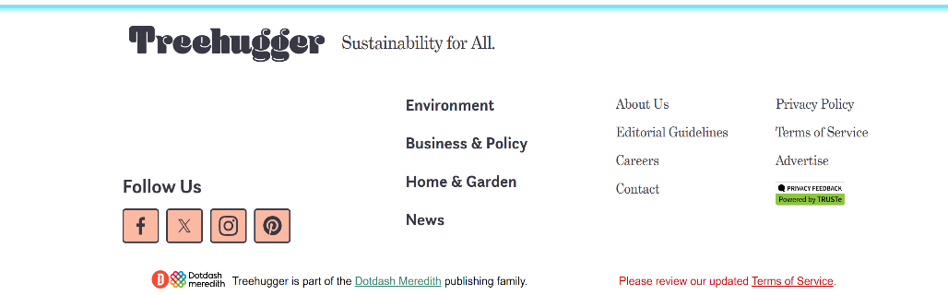

* The **design** and **color scheme** of the website must be good and eye-catching.
* **GITHUB** must be used to keep track of the project. Students progress with commits and dates will be checked while grading.
* The usage of APIs should be minimal (only use an API if no other option is available).

***Other Features***

* Save your database in JSON format. Load initial data using fixtures.
* Update index and detail view functions in **views.py** to use class-based views (<https://docs.djangoproject.com/en/3.1/topics/class-based-views/>).
* Use Bootstrap to style your pages.
* Any extra pages such as contact us, about us, team details, and so on.

***Groups, Submission, Due Dates, and Marking Criteria***

* **Group Size** = 4-5 members per group
* **Submission** = Only via Brightspace. Submit an MS Word document that should describe your project including the steps you performed to create your website, the motivation and reason for choosing your idea, the role of each team member (preferably a table or a graph), and the related screenshots. This document should have the links to your website and complete code files stored on GitHub. The word file should not be submitted as a part of any folder. You should also submit the main views.py, models.py, and forms.py files along with the word document. These files must not be submitted as a folder.
* **Due Date** = Monday of Week 11 (July 22, 2024), before midnight. Only one submission attempt is allowed. Project ideas must be discussed with and approved by the instructor before the end of Week 4 (May 31, 2024).
* **Total Marks** **= 20**. You will be judged on:
  + Individual oral exam/viva (maximum weightage)
  + Your progress on GitHub
  + Satisfaction of the mandatory features
  + Completion of the project
  + Running your website without errors
  + The overall look of your website
  + Your presentation
  + Additional features
  + The documents and files you submit on Brightspace.

**Note** **1:** As specified in the course outline, the above mark distribution/criteria may subject to change. For example, based on class’s performance, all the marks can be allocated for the project viva/oral examination and individual contribution.

**Note 2:** Every group member should have coding contribution using Python/Django/PyCharm especially in the “views”.

**Note 3:** Usage of ChatGPT or taking code from other sources will result in ‘0’ marks.

**Note 4:** Do not forget to add your GAs to your GitHub repository.

**Presentation Schedule and Details:**

* Presentations will be conducted in Week 11 during lectures (July 23-24, depending on your section).
* Presentation duration for each group (**subject to change**) = **15 Minutes** including Question/Answer session.
* You *must* i) prepare a PowerPoint presentation and ii) directly run the application demo.
* The order of presentations will be decided by the instructor during/before the class.
* All group members should be physically present during the presentation and take part in the presentation.
* Attending all other presentations in your section is mandatory.
* Further information will be added later Brightspace (if required).

**Viva/Oral Exam Schedule:**

During the lectures of Week 12 (July 30-31, depending on your section).