Name: Kasak Patel
Section-Batch: B-B1
Roll No.: 05
ML Practical 7
Date of Performance: 1/10/26

AIM
To implement the Naïve Bayes Classification algorithm using suitable dataset.
OBJECTIVES
- To load and inspect the Iris Dataset using Pandas and Scikit-learn.
- To check the dataset shape, features, target classes and basic information.
- To analyze the distribution of Iris flower species.
- To separate input features and the target class.
- To divide the dataset into training and testing sets.
- To build a Gaussian Naïve Bayes classification model.
- To train the model using the training dataset.
- To predict the species of Iris flowers using the trained model.
- To evaluate the model using accuracy, precision, recall and F1-score.
- To generate a confusion matrix and classification report.
- To analyze the performance of the Naïve Bayes classification algorithm.
- To understand the applications of Naïve Bayes in classification problems.

DATASET USED
Raisin.csv – Raisin Dataset
The dataset contains 900 records and 8 columns. It contains seven numerical input features related to raisin measurements and one target column, “Class (Kecimen, Besni)”, representing two raisin varieties.

Software/Tools Used:
- Python 3.x
- Jupyter Notebook / Anaconda
- Pandas
- NumPy
- Matplotlib
- Seaborn
- Scikit-learn

THEORY
Naive Bayes Classification
Naïve Bayes is a supervised machine learning algorithm based on Bayes' theorem. It assumes that all input features are conditionally independent given the target class. In this practical, the Gaussian Naïve Bayes algorithm is used to classify raisins into two varieties: Kecimen and Besni.
Bayes' Theorem
Bayes' theorem calculates the probability of a class based on the given input features. The model predicts the class with the highest probability.
Input and Output
The model uses seven numerical features: Area, MajorAxisLength, MinorAxisLength, Eccentricity, ConvexArea, Extent, and Perimeter. The output represents one of the two raisin classes: Kecimen or Besni.
Gaussian Naive Bayes
Gaussian Naïve Bayes assumes that numerical features follow a Gaussian (normal) distribution within each class. It estimates the probability of each class using the training data and predicts the most probable class for a given observation.
Data Preprocessing
The dataset is loaded using Pandas and checked for missing values and duplicate records. The input features are separated from the target column, and class labels are encoded if required by the implementation.
Training and Testing
The dataset is divided into training and testing sets. The training data is used to fit the Gaussian Naïve Bayes model, while the testing data is used to evaluate its performance on unseen observations.
Model Evaluation
The model is evaluated using accuracy, precision, recall, and F1-score. A confusion matrix and classification report are also generated to analyze the classification performance.
Applications
Naïve Bayes is widely used in text classification, spam detection, document categorization, and other classification tasks. It is simple, fast, and effective for many datasets.

MATERIALS / SOFTWARE REQUIRED
- Python 3
- Google Colab / Jupyter notebook
- Pandas and NumPy
- Scikit-learn
- Matplotlib and Seaborn
- Raisin dataset

PROCEDURE
- Import the required Python libraries, including NumPy, Pandas, Matplotlib, Seaborn, and Scikit-learn.
- Load the Raisin dataset using Pandas.
- Display the first and last records and inspect the dataset's shape, columns, and information.
- Check for missing values and duplicate records.
- Display the class distribution of Kecimen and Besni raisins.
- Separate the seven input features (X) and the target variable (y).
- Encode the target classes if required.
- Split the dataset into training and testing sets using an 80:20 split with random_state=42.
- Create a Gaussian Naïve Bayes classifier using GaussianNB().
- Train the model using the training dataset.
- Predict the raisin classes using the testing dataset.
- Evaluate the model using accuracy, precision, recall, and F1-score.
- Generate a confusion matrix and classification report to analyze the model's performance.
- Provide new input feature values to predict the raisin variety.
- Display the predicted class as Kecimen or Besni.

OUTPUT 1 – DATASET INSPECTION
The raisin dataset is loaded using Pandas and inspected to understand its structure and contents. Functions such as head(), tail(), info(), describe(), and shape are used to examine the first and last records, data types, statistical information, and dimensions of the dataset.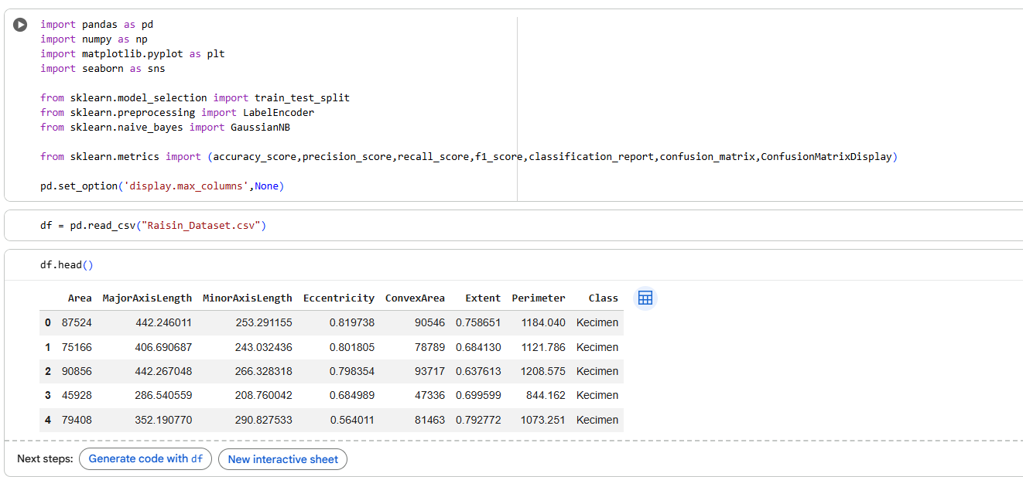 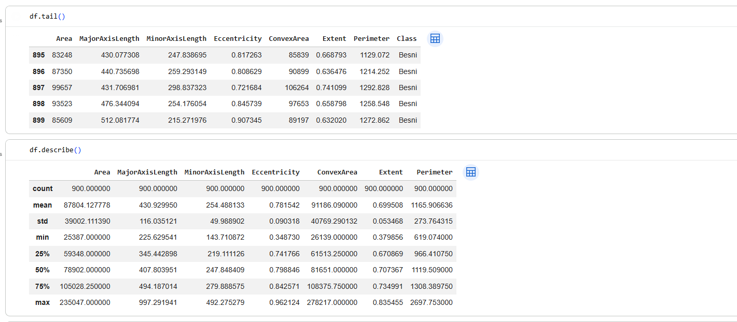 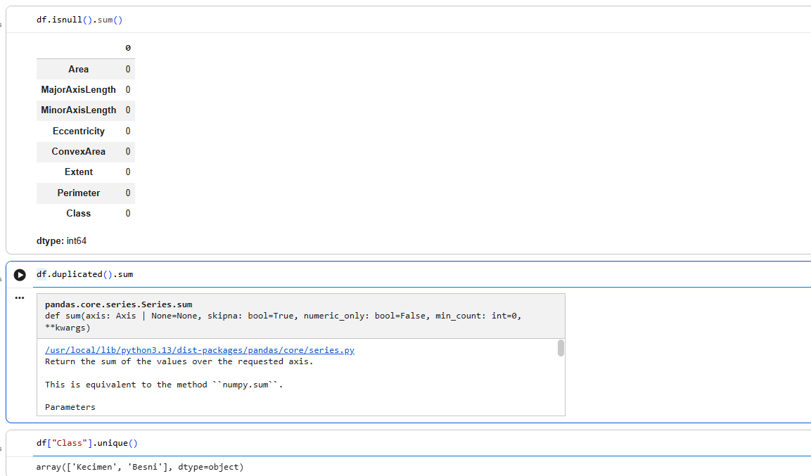
OUTPUT 2 – CLASS DISTRIBUTION
Class distribution analysis is performed to understand the number and proportion of samples belonging to each raisin class. Bar plots and pie charts are used to visualize the distribution of the target classes and compare the representation of each raisin variety in the dataset.
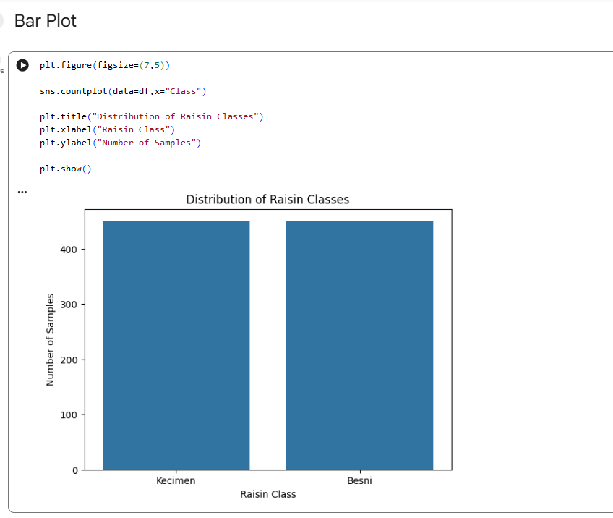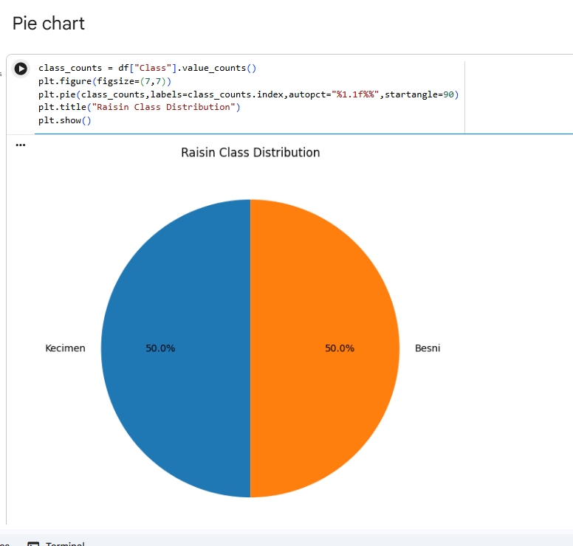

OUTPUT 3 – Univariate Analysis of Numerical Features:
Univariate analysis is performed to study the distribution and characteristics of individual numerical features in the raisin dataset. Histograms, KDE plots, and box plots are used to understand data distribution, identify patterns, and detect potential outliers in features such as Area, MajorAxisLength, MinorAxisLength, Eccentricity, ConvexArea, Extent, and Perimeter.
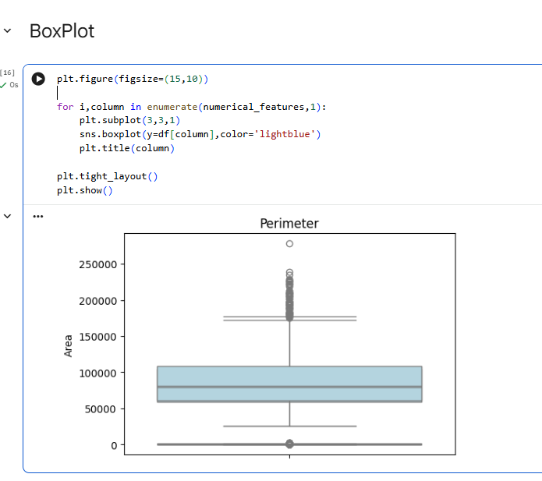
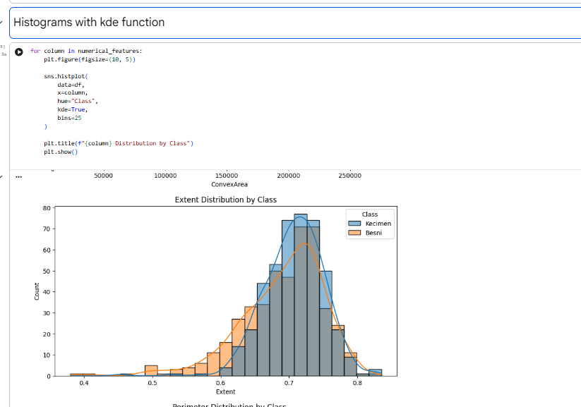

Output 4 – Correlation and Bivariate Analysis :
Correlation and bivariate analysis are performed to examine the relationships between numerical features in the raisin dataset. A correlation matrix and heatmap are used to identify the strength and direction of relationships between features, while scatter plots help visualize how two numerical features are related.
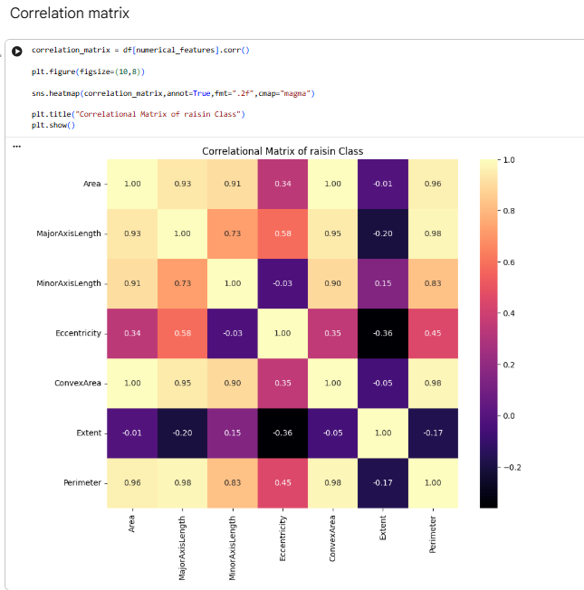
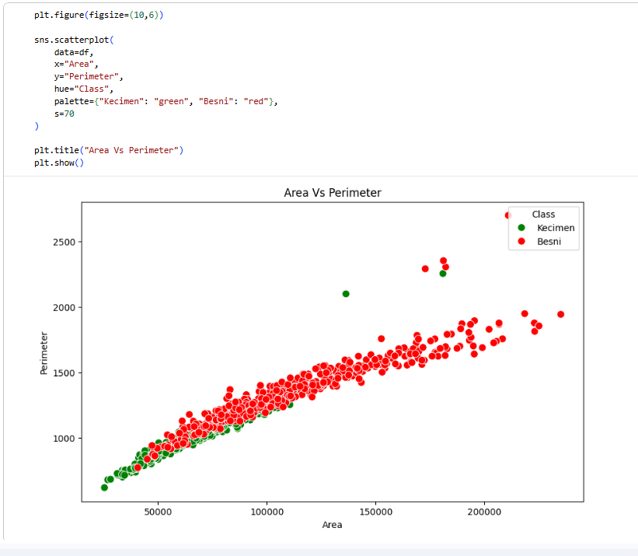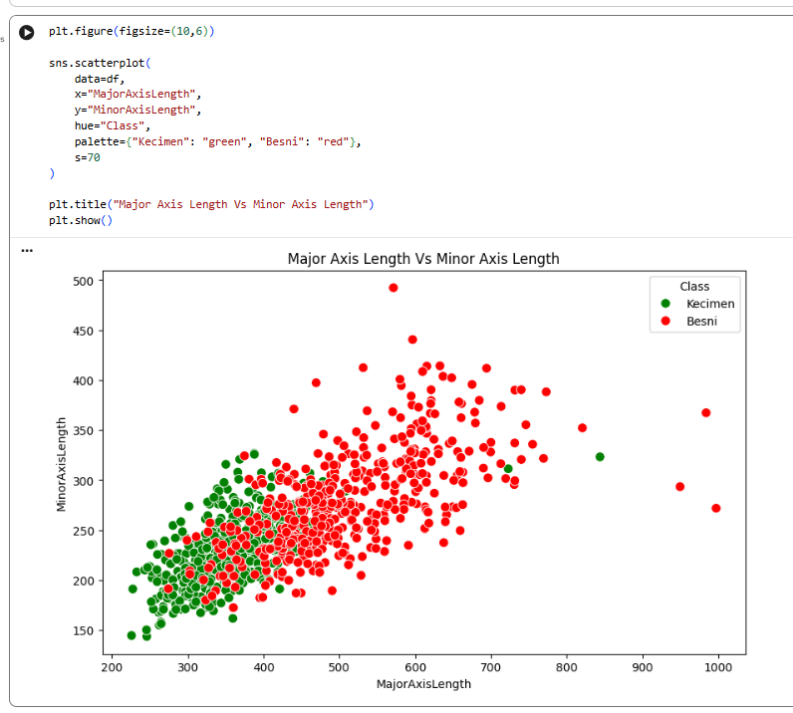
DATA PREPARATION :
Data preparation is performed to make the raisin dataset suitable for machine learning. The input features are separated from the target variable, and categorical class labels are encoded into numerical values using LabelEncoder. The dataset is then prepared for splitting into training and testing sets.

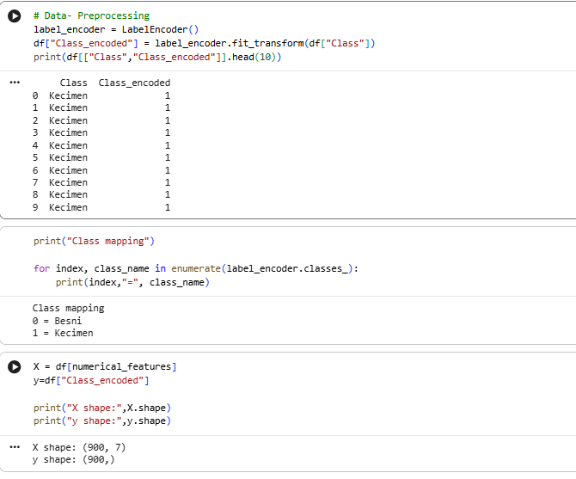
OUTPUT 5 : TRAIN–TEST SPLIT
The prepared dataset is divided into training and testing sets using train_test_split(). The training data is used to train the Gaussian Naïve Bayes model, while the testing data is used to evaluate its performance on unseen samples.
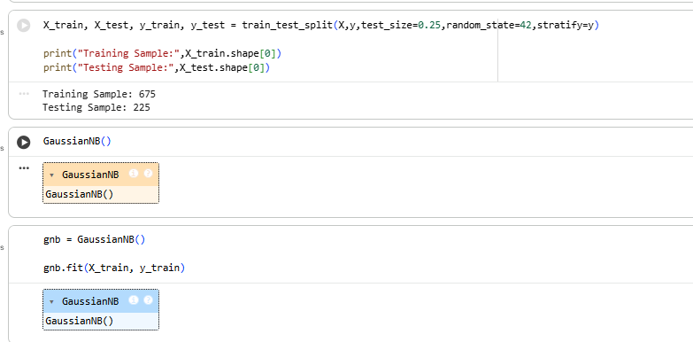

OUTPUT 6 : TEST PREDICTIONS
The trained Gaussian Naïve Bayes model predicts the class labels of the test dataset using the predict() method. The predicted values are compared with the actual class labels to evaluate how accurately the model classifies the raisin varieties.
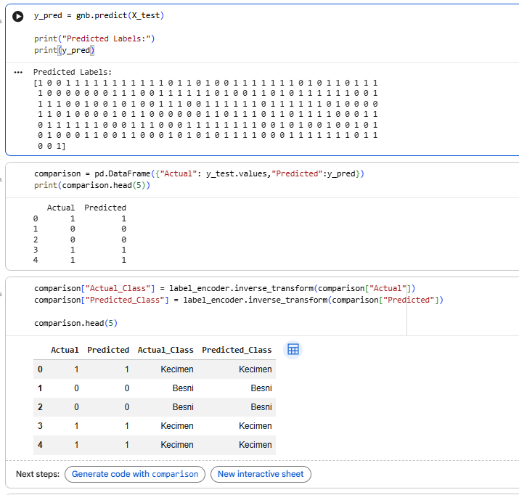

Output 7 : PERFORMANCE METRICS
The performance of the Gaussian Naïve Bayes model is evaluated using accuracy, precision, recall, and F1-score. These metrics measure the model's overall correctness and classification performance, helping assess how effectively it predicts the raisin varieties.
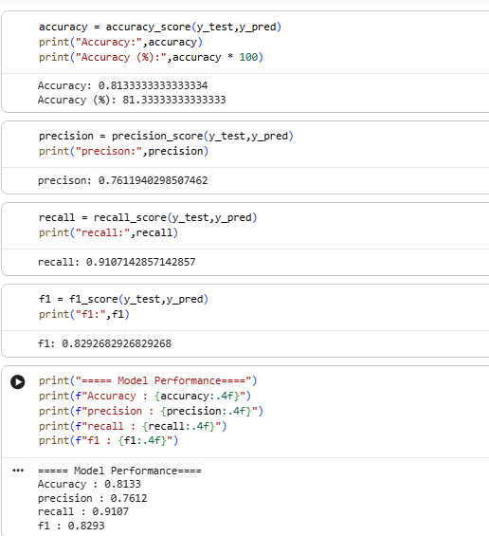

OUTPUT 8 : CONFUSION MATRIX
A confusion matrix is generated to compare the actual class labels with the predicted class labels of the Gaussian Naïve Bayes model. It displays the number of correct and incorrect predictions for each raisin variety, helping evaluate the model's classification performance and identify misclassified samples.

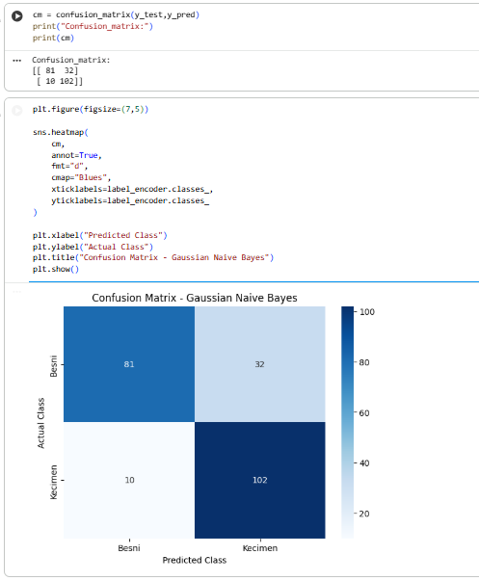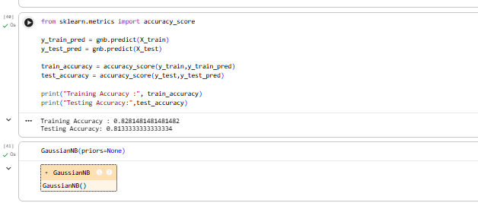

OUTPUT 9 : HYPERPARAMETER TUNING
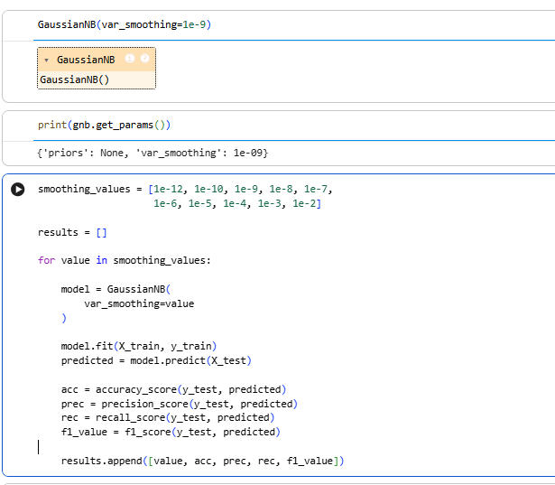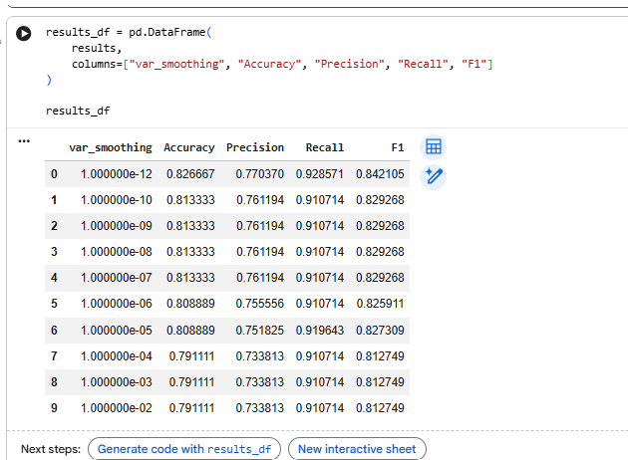

OUTPUT 10 : CLASSIFICATION REPORT AND NEW SAMPLE PREDICTION
The classification report summarizes the model's performance for each class. A new sample is used to predict its class using the trained model.
