News Zone

* [World](http://docs.google.com/home.html)
* Sport
* Economy
* Health
* Technology



Donald Trump sued for fraud over family business

Donald Trump and three of his children have been hit by a fraud lawsuit after a New York investigation into their family business.

Last updated 3 mins ago

[Read More](http://docs.google.com/cat-1.html)



Putin warning: What does Russian military call-up mean for Ukraine?

Russian President Vladimir Putin has ordered a partial mobilisation to reinforce his troops in Ukraine after major combat setbacks this month. In an address to the nation, he said Russia was directly threatened with "disintegration" by the Western powers backing the Kyiv government.

Last updated 9 mins ago

[Read More](http://docs.google.com/cat-2.html)



Iran protests: Mahsa Amini's death puts morality police under spotlight

The death of 22-year-old Mahsa Amini after she was detained by Iran's so-called morality police has sparked angry protests, with women burning their headscarves in a defiant act of resistance against the Islamic Republic's strict dress code and those enforcing it.

Last updated 15 mins ago

[Read More](http://docs.google.com/cat-3.html)



Eight interiors styles - as seen inside designers' own homes

From Scandi re-imagined to warm minimalist, each of these homes - located around the world - reflects a key style of décor. Dominic Lutyens takes a peek inside.

Last updated 20 mins ago

[Read More](http://docs.google.com/cat-4.html)



Floyd Mayweather: Retired undefeated boxer plots rematch with Conor McGregor in 2023

Floyd Mayweather says he wants to fight UFC star Conor McGregor in an exhibition bout next year.

Last updated 33 mins ago

[Read More](http://docs.google.com/cat-5.html)

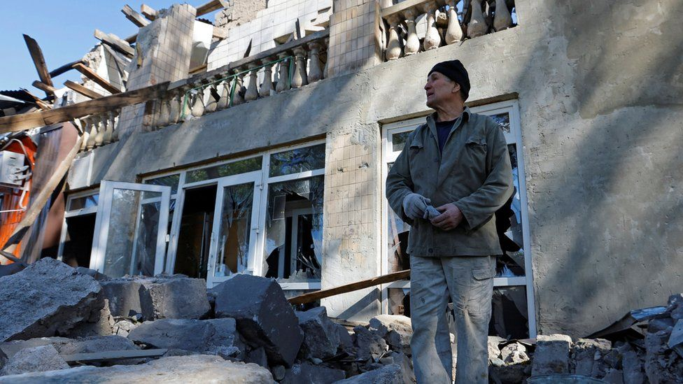

Ukraine war: Putin orders partial mobilisation after facing setbacks

Russian President Vladimir Putin is calling up thousands of extra troops to fight in Ukraine after suffering setbacks on the battlefield.

Last updated 47 mins ago

[Read More](http://docs.google.com/cat-6.html)

Copyright © 2019-2022 News Zone