- Project
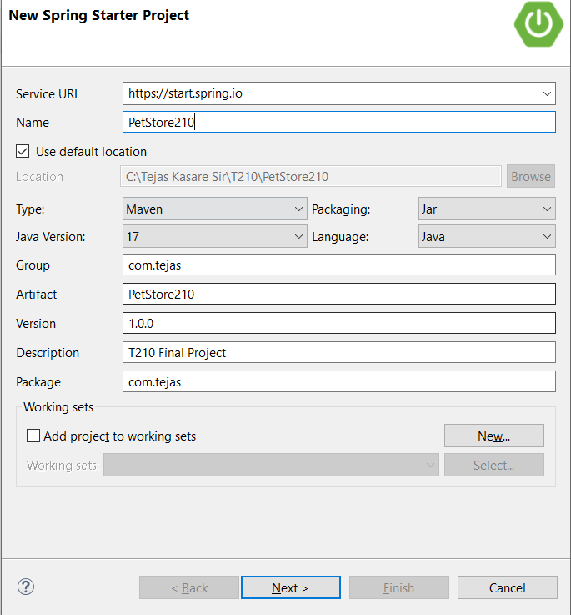
- Dependencies
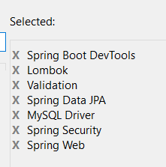

- Create database – petstore in mysql
Create database petstore;
- Add table details in spring application.properties
spring.application.name=PetStore210
spring.datasource.url=jdbc:mysql://localhost:3307/petstore
spring.datasource.username=root
spring.datasource.password=root
spring.jpa.hibernate.ddl-auto=update
spring.jpa.show-sql=true

- Add JWT dependencies in pom.xml (here I am sharing complete pom.xml file)
<?xml version="1.0" encoding="UTF-8"?>
<project xmlns="http://maven.apache.org/POM/4.0.0" xmlns:xsi="http://www.w3.org/2001/XMLSchema-instance"
xsi:schemaLocation="http://maven.apache.org/POM/4.0.0 https://maven.apache.org/xsd/maven-4.0.0.xsd">
<modelVersion>4.0.0</modelVersion>
<parent>
<groupId>org.springframework.boot</groupId>
<artifactId>spring-boot-starter-parent</artifactId>
<version>4.0.0</version>
<relativePath/> <!-- lookup parent from repository -->
</parent>
<groupId>com.tejas</groupId>
<artifactId>PetStore210</artifactId>
<version>1.0.0</version>
<name>PetStore210</name>
<description>T210 Final Project</description>
<url/>
<licenses>
<license/>
</licenses>
<developers>
<developer/>
</developers>
<scm>
<connection/>
<developerConnection/>
<tag/>
<url/>
</scm>
<properties>
<java.version>17</java.version>
</properties>
<dependencies>
<dependency>
<groupId>org.springframework.boot</groupId>
<artifactId>spring-boot-starter-data-jpa</artifactId>
</dependency>
<dependency>
<groupId>org.springframework.boot</groupId>
<artifactId>spring-boot-starter-security</artifactId>
</dependency>
<dependency>
<groupId>org.springframework.boot</groupId>
<artifactId>spring-boot-starter-validation</artifactId>
</dependency>
<dependency>
<groupId>org.springframework.boot</groupId>
<artifactId>spring-boot-starter-webmvc</artifactId>
</dependency>

<dependency>
<groupId>org.springframework.boot</groupId>
<artifactId>spring-boot-devtools</artifactId>
<scope>runtime</scope>
<optional>true</optional>
</dependency>
<dependency>
<groupId>com.mysql</groupId>
<artifactId>mysql-connector-j</artifactId>
<scope>runtime</scope>
</dependency>
<dependency>
<groupId>org.projectlombok</groupId>
<artifactId>lombok</artifactId>
<optional>true</optional>
</dependency>
<dependency>
<groupId>org.springframework.boot</groupId>
<artifactId>spring-boot-starter-data-jpa-test</artifactId>
<scope>test</scope>
</dependency>
<dependency>
<groupId>org.springframework.boot</groupId>
<artifactId>spring-boot-starter-security-test</artifactId>
<scope>test</scope>
</dependency>
<dependency>
<groupId>org.springframework.boot</groupId>
<artifactId>spring-boot-starter-validation-test</artifactId>
<scope>test</scope>
</dependency>
<dependency>
<groupId>org.springframework.boot</groupId>
<artifactId>spring-boot-starter-webmvc-test</artifactId>
<scope>test</scope>
</dependency>
<!-- JJWT API -->
<dependency>
<groupId>io.jsonwebtoken</groupId>
<artifactId>jjwt-api</artifactId>
<version>0.11.5</version>
</dependency>

<!-- JJWT Implementation -->
<dependency>
<groupId>io.jsonwebtoken</groupId>
<artifactId>jjwt-impl</artifactId>
<version>0.11.5</version>
<scope>runtime</scope>
</dependency>

<!-- JJWT Jackson JSON Parser -->
<dependency>
<groupId>io.jsonwebtoken</groupId>
<artifactId>jjwt-jackson</artifactId>
<version>0.11.5</version>
<scope>runtime</scope>
</dependency>
</dependencies>

<build>
<plugins>
<plugin>
<groupId>org.apache.maven.plugins</groupId>
<artifactId>maven-compiler-plugin</artifactId>
<configuration>
<annotationProcessorPaths>
<path>
<groupId>org.projectlombok</groupId>
<artifactId>lombok</artifactId>
</path>
</annotationProcessorPaths>
</configuration>
</plugin>
<plugin>
<groupId>org.springframework.boot</groupId>
<artifactId>spring-boot-maven-plugin</artifactId>
<configuration>
<excludes>
<exclude>
<groupId>org.projectlombok</groupId>
<artifactId>lombok</artifactId>
</exclude>
</excludes>
</configuration>
</plugin>
</plugins>
</build>

</project>

- Create following packages –
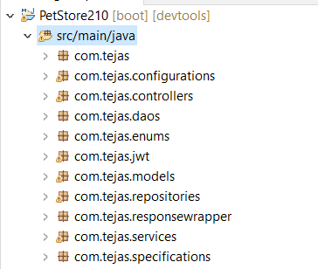

PetType 1 N PetBreed (create pet_type column in PetBreed)
Pet (create breed_id column in Pet)N 1 PetBreed

- Implementing user registration, login and Spring security
  - Create Role.java enum in enums package (right click on package > new > enum)
Role.java
public enum Role
{
CUSTOMER, ADMIN
}

  - Create User.java class in models package
User.java
@Data
@Entity
public class User {
@Id
@GeneratedValue(strategy = GenerationType.IDENTITY)
private long id;

private String fullName;

private String email;

private String password;

private String address;

private String pincode;

@Enumerated(EnumType.STRING)
private Role role;

}

  - Create UserRepository.java interface in repositories package
@Repository
public interface UserRepository extends JpaRepository<User, Long>
{
//to get user details by email while login
Optional<User> findByEmail(String email);
//to check if email already exist while registration
boolean existsByEmail(String email);
}

  - Create class MyUserDetailsService.java in services package
MyUserDetailsService.java
@Service
public class MyUserDetailsService implements UserDetailsService{
@Autowired
private UserRepository userRepository;

@Override
public UserDetails loadUserByUsername(String email) throws UsernameNotFoundException {
User user=userRepository.findByEmail(email) //here User is our model/entity
.orElseThrow(() ->
new UsernameNotFoundException("Email not found: " + email)
);

List<SimpleGrantedAuthority> authorities =
List.of(new SimpleGrantedAuthority(user.getRole().name()));

return new org.springframework.security.core.userdetails.User(
user.getEmail(),
user.getPassword(),
authorities
);
}

}

  - Create class JWTTokenGenerator.java in jwt package
@Component
public class JWTTokenGenerator
{
private final String SECRET = "GDF7acJj3fHj48U4/rtgWkSb31XKkqv0cHpP9yJJ2kU=";

// Extract EMAIL from JWT
public String extractEmail(String token) {
Claims claims = extractAllClaims(token);
return claims.get("email", String.class);
}

// Extract ROLE from JWT
public String extractRole(String token) {
Claims claims = extractAllClaims(token);
return claims.get("role", String.class);
}

// Extract all claims
private Claims extractAllClaims(String token) {
return Jwts.parserBuilder()
.setSigningKey(Keys.hmacShaKeyFor(SECRET.getBytes()))
.build()
.parseClaimsJws(token)
.getBody();
}

// Check if token expired
private Boolean isExpired(String token) {
Claims claims = extractAllClaims(token);
Date expiration = claims.getExpiration();
return expiration.before(new Date());
}

// Validate token
public Boolean validateToken(String token, UserDetails userDetails) {
String email = extractEmail(token);
return (email.equals(userDetails.getUsername()) && !isExpired(token));
}

public String generateToken(UserDetails userDetails, String role) {
System.out.println(role);
Map<String, Object> claims = new HashMap<>();
claims.put("email", userDetails.getUsername()); // username = email
claims.put("role", role);

return Jwts.builder()
.setClaims(claims)
.setSubject(userDetails.getUsername()) // optional
.setIssuedAt(new Date()) // below calculation is for 10 hrs
.setExpiration(new Date(System.currentTimeMillis() + 1000 * 60 * 60 * 10))
.signWith(Keys.hmacShaKeyFor(SECRET.getBytes()), SignatureAlgorithm.HS256)
.compact();
}
}

  - Create class JWTRequestValidator.java in jwt package
JWTRequestValidator.java
@Component
public class JWTRequestValidator extends OncePerRequestFilter {

@Autowired
JWTTokenGenerator jwtTokenGenerator;

@Autowired
MyUserDetailsService myUserDetailsService;

@Override
protected void doFilterInternal(
HttpServletRequest request,
HttpServletResponse response,
FilterChain filterChain)
throws ServletException, IOException {

final String header = request.getHeader("Authorization");
String jwtToken = null;
String email = null;
String role = null;

// Extract token
if (header != null && header.startsWith("Bearer "))
{
jwtToken = header.substring(7);

try
{
email = jwtTokenGenerator.extractEmail(jwtToken);
role = jwtTokenGenerator.extractRole(jwtToken);
} catch (Exception e)
{
System.out.println("Invalid Token: " + e.getMessage());
}
}

// Authenticate user if token is valid
if (email != null && SecurityContextHolder.getContext().getAuthentication() == null) {

UserDetails userDetails = myUserDetailsService.loadUserByUsername(email);

if (jwtTokenGenerator.validateToken(jwtToken, userDetails)) {

List<SimpleGrantedAuthority> authorities =
List.of(new SimpleGrantedAuthority(role));

System.out.println("ROLE FROM TOKEN = " + role);
System.out.println("AUTHORITIES SET = " + authorities);

UsernamePasswordAuthenticationToken authToken =
new UsernamePasswordAuthenticationToken(
userDetails,
null,
authorities
);

authToken.setDetails(
new WebAuthenticationDetailsSource().buildDetails(request)
);

SecurityContextHolder.getContext().setAuthentication(authToken);
}
}

filterChain.doFilter(request, response);

}
}

  - Create SecurityConfiguration.java class in configurations package
@Configuration
@EnableWebSecurity
public class SecurityConfiguration {

@Autowired
private MyUserDetailsService userDetailsService;

@Autowired
private JWTTokenGenerator jwtTokenGenerator;

@Autowired
private JWTRequestValidator jwtRequestValidator;

@Bean
PasswordEncoder myPasswordEncoder()
{
return new BCryptPasswordEncoder();
}

@Bean
public AuthenticationManager authenticationManager(AuthenticationConfiguration configuration) throws Exception {
return configuration.getAuthenticationManager();
}

@Bean
SecurityFilterChain securityFilterChain(HttpSecurity httpSecurity) throws Exception
{
httpSecurity
.cors(cors-> cors.configurationSource(corsConfigurationSource()))
.csrf(anyRequest -> anyRequest.disable()) // disable CSRF
.authorizeHttpRequests(request -> request
.requestMatchers("/api/v1/login", "/api/v1/register").permitAll()
.requestMatchers("/api/v1/get/**").permitAll()
.requestMatchers("/api/v1/filter").permitAll()
.requestMatchers("/images/**").permitAll()
.requestMatchers("/api/v1/admin/**").hasAuthority("ADMIN")
.anyRequest().authenticated())
.sessionManagement(session -> session
.sessionCreationPolicy(SessionCreationPolicy.STATELESS)
);
httpSecurity.addFilterBefore(jwtRequestValidator, UsernamePasswordAuthenticationFilter.class);
return httpSecurity.build();
}

//below must be imported as -
//import org.springframework.web.cors.CorsConfiguration; NOT FROM REACTIVE
//import org.springframework.web.cors.CorsConfigurationSource;
//import org.springframework.web.cors.UrlBasedCorsConfigurationSource;

@Bean
public CorsConfigurationSource corsConfigurationSource() {
CorsConfiguration config = new CorsConfiguration();
config.setAllowedOrigins(List.of("http://localhost:3000")); // React app
config.setAllowedMethods(List.of("GET", "POST", "PUT", "DELETE", "PATCH", "OPTIONS"));
config.setAllowedHeaders(List.of("*")); // allow Authorization header
config.setExposedHeaders(List.of("*"));
config.setAllowCredentials(true);

UrlBasedCorsConfigurationSource source = new UrlBasedCorsConfigurationSource();
source.registerCorsConfiguration("/**", config);
return source;
}
}

  - Create UserLogin.java class in daos package
@Data
public class UserLogin {
private String email;
private String password;

}

  - Create UserRegister.java class in daos pckage
@Data
public class UserRegister {
private String email;
private String password;
private Role role;
}

  - Create MyResponseWrapper.java class in responsewrapper package
@Component
@Data
public class MyResponseWrapper
{
private String message;
private Object data;
}

  - Create JwtResponseWrapper.java class in responsewrapper package
@Data
@Component
public class JwtResponseWrapper
{
private String token;
private String role;
private long userId;
}

  - Create UserService.java class in services package
@Service
public class UserService {
@Autowired
PasswordEncoder passwordEncoder;

@Autowired
MyResponseWrapper responseWrapper;

@Autowired
UserRepository userRepository;
private ResponseEntity<?> universalResponse(String message, Object data, HttpStatus httpStatus)
{
responseWrapper.setMessage(message);
responseWrapper.setData(data);
return new ResponseEntity<> (responseWrapper,httpStatus);
}

public ResponseEntity<?> register(UserRegister userRegister)
{
if(userRepository.existsByEmail(userRegister.getEmail()))
{
return universalResponse("Email Exists",null, HttpStatus.INTERNAL_SERVER_ERROR);
}
User newUser = new User();
newUser.setEmail(userRegister.getEmail());
newUser.setPassword(passwordEncoder.encode(userRegister.getPassword()));
newUser.setRole(userRegister.getRole());
User registeredUser=userRepository.save(newUser);
return universalResponse("Registration Success!",registeredUser, HttpStatus.CREATED);
}

@Autowired
private AuthenticationManager authenticationManager;

@Autowired
private JWTTokenGenerator jwtTokenGenerator;

@Autowired
private MyUserDetailsService myUserDetailsService;

public ResponseEntity<?> login(UserLogin userLogin)
{
try
{
authenticationManager.authenticate(
new UsernamePasswordAuthenticationToken(userLogin.getEmail(), userLogin.getPassword())
);
}
catch (BadCredentialsException e)
{
return universalResponse("Incorrect Username or password",null, HttpStatus.BAD_REQUEST);
}

User user =userRepository.findByEmail(userLogin.getEmail()).get();
UserDetails userDetails = myUserDetailsService.loadUserByUsername(userLogin.getEmail());
String jwtToken =jwtTokenGenerator.generateToken(userDetails, user.getRole().toString());

JwtResponseWrapper jwtResponseWrapper = new JwtResponseWrapper();
jwtResponseWrapper.setToken(jwtToken);
jwtResponseWrapper.setRole(user.getRole().name());
jwtResponseWrapper.setUserId(user.getId());
return universalResponse("Login Success",jwtResponseWrapper, HttpStatus.OK);
}

}

  - Create UserController.java class in controllers package
@RestController
@RequestMapping("/api/v1")
public class UserController
{

@Autowired
UserService userService;

@PostMapping("/register")
public ResponseEntity<?> register(@RequestBody UserRegister userRegister)
{
return userService.register(userRegister);
}

@PostMapping("/login")
public ResponseEntity<?> login(@RequestBody UserLogin userLogin)
{
return userService.login(userLogin);
}

}

  - Backend DONE!! - run spring server

- Create React project and add following dependencies –
  - >npx create-react-app pet-store
  - >cd pet-store
  - pet-store>
    - bootstrap
    - react hook form
    - bootstrap icons
    - react router dom
  - open project in VS code and create following project structure
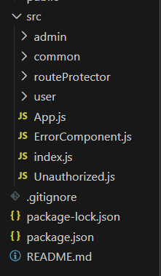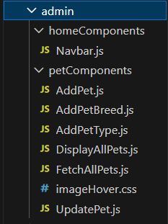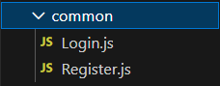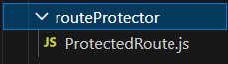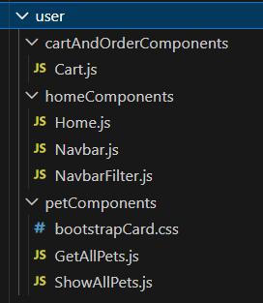
Add rfc code in all components
  - create protected routes (role based access in routeProtector/ProtectedRoute.js)
import { Navigate, Outlet } from "react-router-dom";

const ProtectedRoute = ({ roleRequired}) => {
// const token = localStorage.getItem("token");
// const role = localStorage.getItem("role");

const user = JSON.parse(localStorage.getItem("user")); // { role: "ADMIN" or "CUSTOMER" }

// not logged in
if (!user) {
return <Navigate to="/login" replace />;
}

// wrong role
if (user.role !== roleRequired) {
return <Navigate to="/unauthorized" replace />;
}

// render child routes
return <Outlet />;
};

export default ProtectedRoute;

  - code for src/ErrorComponent.js
import React from 'react'

export default function ErrorComponent() {
return (
<div>
<h1>404 This page not exists!</h1>
</div>
)
}

  - code for src/Unauthorized.js
import React from 'react'

export default function Unauthorized() {
return (
<div>
Unauthorized
</div>
)
}

  - create routes for all components in index.js
import '../node_modules/bootstrap/dist/css/bootstrap.min.css'
import '../node_modules/bootstrap/dist/js/bootstrap.min.js'
import '../node_modules/bootstrap-icons/font/bootstrap-icons.min.css'
import React from 'react';
import ReactDOM from 'react-dom/client';
import { createBrowserRouter, RouterProvider } from 'react-router-dom';
import App from './App';
import ErrorComponent from './ErrorComponent';
import AddPetType from './admin/petComponents/AddPetType';
import AddPetBreed from './admin/petComponents/AddPetBreed';

import AddPet from './admin/petComponents/AddPet.js';
import UpdatePet from './admin/petComponents/UpdatePet.js';
import FetchAllPets from './admin/petComponents/FetchAllPets.js';
import Home from './user/homeComponents/Home.js';
import Unauthorized from './Unauthorized.js';
import Login from './common/Login.js';
import Register from './common/Register.js';
import ProtectedRoute from './routeProtector/ProtectedRoute.js';
import GetAllPets from './user/petComponents/GetAllPets.js';
import Cart from './user/cartAndOrderComponents/Cart.js';

const allRoutes=createBrowserRouter([
//new routing after spring security
//ADMIN routes
{
path:'/admin',
element:<ProtectedRoute roleRequired="ADMIN"/>,
children:
[
{
path:"",
element:<App/>,
errorElement:<ErrorComponent/>,
children:[
{ path: "add-pet-type", element: <AddPetType /> },
{ path: "add-pet-breed", element: <AddPetBreed /> },
{ path: "add-pet", element: <AddPet /> },
{ path: "manage-pets", element: <FetchAllPets /> },
{ path: "update-pet/:petId", element: <UpdatePet /> }

]
}
]
},

// PUBLIC ROUTES
{
path: "/",
element: <Home />,
errorElement: <ErrorComponent />,
children:
[
{ path: "", element: <GetAllPets /> },
{ path: "login", element: <Login /> },
{ path: "register", element: <Register /> },
{ path: "unauthorized", element: <Unauthorized /> }, // Create a simple unauthorized page,
{
path: "my",
element: <ProtectedRoute roleRequired="CUSTOMER" />, // ⭐ Customer protected
children:
[
{ path: "cart", element: <Cart/> }
]
},
]
}
])

const root = ReactDOM.createRoot(document.getElementById('root'));
root.render(
<RouterProvider router={allRoutes}/>
);

- implementing login and register functionality
  - code for src/common/Login.js
import React from 'react'
import { useForm } from "react-hook-form";
import { useNavigate } from "react-router-dom";

export default function Login() {
let { register, handleSubmit, formState } = useForm();
const navigate = useNavigate();
async function handleLogin (formData)
{
console.log(formData);
let response = await fetch(
`http://localhost:8080/api/v1/login`,
{
method: "POST",
headers: { "Content-Type": "application/json" },
body: JSON.stringify(formData),
}
);
let responseObject = await response.json();
localStorage.setItem("user", JSON.stringify(responseObject.data));
//console.log(responseObject);
// Navigate based on role
const role = responseObject.data.role;

if (role === "ADMIN") {
navigate("/admin");
} else if (role === "CUSTOMER") {
navigate("/");
} else {
navigate("/");
}

};

return (
<div className='d-flex flex-column align-items-center'>
<h1>Login!</h1>
<form className='w-50' onSubmit={handleSubmit(handleLogin)}>

<table className="table table-hover table-bordered table-dark">
<tbody>
<tr>
<td> <label for="email" class="form-label">Email</label> </td>
<td> <input type="email" class="form-control" id="email"
{...register('email',{required:true,pattern:/^[^\s@]+@[^\s@]+\.[^\s@]+$/})}/></td>
</tr>
<tr>
<td> <label for="password" class="form-label">Password</label> </td>
<td> <input type="password" class="form-control" id="password"
{...register('password',{required:true})}/></td>
</tr>
<tr>
<td colSpan={2}> <button type="submit" className="btn btn-primary w-100">Submit</button></td>
</tr>
</tbody>

</table>
</form>
</div>
)
}

  - code for src/common/Register.js
import React from 'react'
import { useForm } from 'react-hook-form';
import { replace, useNavigate } from 'react-router-dom';

export default function Register() {
let { register, handleSubmit, formState } = useForm();
const navigate = useNavigate();
async function handleRegister (formData)
{
console.log(formData);
let response = await fetch(
`http://localhost:8080/api/v1/register`,
{
method: "POST",
headers: { "Content-Type": "application/json" },
body: JSON.stringify(formData),
}
);
let responseObject = await response.json();

navigate("/login",replace);

};

return (
<div className='d-flex flex-column align-items-center'>
<h1>Register!</h1>
<form className='w-50' onSubmit={handleSubmit(handleRegister)}>

<table className="table table-hover table-bordered table-dark">
<tbody>
<tr>
<td> <label for="email" class="form-label">Email</label> </td>
<td> <input type="email" class="form-control" id="email"
{...register('email',{required:true,pattern:/^[^\s@]+@[^\s@]+\.[^\s@]+$/})}/></td>
</tr>
<tr>
<td> <label for="password" class="form-label">Password</label> </td>
<td> <input type="password" class="form-control" id="password"
{...register('password',{required:true})}/></td>
</tr>
<tr>
<td> <label for="role" class="form-label">I am</label> </td>
<td>
<select id="role" className="form-select" {...register('role',{required:true})}>
<option value="ADMIN">Admin</option>
<option value="CUSTOMER">Customer</option>
</select>
</td>
</tr>
<tr>
<td colSpan={2}> <button type="submit" className="btn btn-primary w-100">Submit</button></td>
</tr>
</tbody>

</table>
</form>
</div>
)
}

  - code for user/homeComponents/Home.js
import Navbar from './Navbar'
import { Outlet } from 'react-router-dom'

export default function Home() {
return (
<div>
<Navbar/>
<Outlet/>
</div>
)
}

  - code for user/homeComponents/Navbar.js
import React from 'react'
import { Link, useNavigate } from 'react-router-dom'

export default function Navbar() {
const user = JSON.parse(localStorage.getItem("user"));
const navigate = useNavigate();

const handleLogout = () => {
localStorage.removeItem("user");
navigate("/");
};

return (
<div>
<nav className="navbar navbar-expand-lg bg-dark" data-bs-theme="dark">
<div className="container-fluid">
<Link className="navbar-brand" to={'/'}><i className="bi bi-shop"></i> &nbsp; Pet-Store</Link>
<button className="navbar-toggler" type="button" data-bs-toggle="collapse" data-bs-target="#navbarSupportedContent" aria-controls="navbarSupportedContent" aria-expanded="false" aria-label="Toggle navigation">
<span className="navbar-toggler-icon"></span>
</button>
<div className="collapse navbar-collapse" id="navbarSupportedContent">
<ul className="navbar-nav me-auto mb-2 mb-lg-0">
<li className="nav-item">
<Link className="nav-link active" aria-current="page" to={'/'}>Home</Link>
</li>
<li className="nav-item">
<Link className="nav-link active" aria-current="page" to={'/'}>Pets</Link>
</li>
{user && (
<>
<li className="nav-item">
<a className="nav-link active" aria-current="page" href="#">Cart</a>
</li>
<li className="nav-item">
<a className="nav-link active" aria-current="page" href="#">Orders</a>
</li>
</>
)}

</ul>
</div>
<div >
<ul className="navbar-nav me-auto mb-2 mb-lg-0">
{!user && (
<>
<li className="nav-item">
<Link className="nav-link active" aria-current="page" to={'/register'}>Register</Link>
</li>
<li className="nav-item">
<Link className="nav-link active" aria-current="page" to={'/login'}>Login</Link>
</li>
</>
)}

{user && (
<>
<li className="nav-item">
<button className="nav-link btn btn-link" onClick={handleLogout}>Logout</button>
</li>
</>
)}
</ul>
</div>
</div>
</nav>
</div>
)
}

  - after this, run react project and perform register and Login(TESTED! WORKING!!!!!)
  - DONEEE!!!!!!!!!

- Creating API to add PetType and get all pet types (Both backend and frontend code)
  - Create PetType.java class in models package
@Entity
@Data
public class PetType
{
@Id
@GeneratedValue(strategy = GenerationType.IDENTITY)
private long id;

@Column(unique = true, nullable = false)
private String typeName;
}

  - Create PetTypeRepository.java interface in repositories package
@Repository
public interface PetTypeRepository extends JpaRepository<PetType, Long>
{

}

  - Create PetTypeService.java class in services package
@Service
public class PetTypeService {

@Autowired
PetTypeRepository petTypeRepository;

@Autowired
MyResponseWrapper responseWrapper;

private ResponseEntity<?> universalResponse(String message, Object data, HttpStatus httpStatus)
{
responseWrapper.setMessage(message);
responseWrapper.setData(data);
return new ResponseEntity<> (responseWrapper,httpStatus);
}
public ResponseEntity<?> addPetType(PetType petType)
{
if(petType.getTypeName().length()<3 || petType == null)
{
return universalResponse("Please enter valid pet Type", null, HttpStatus.BAD_REQUEST);
}else {
PetType savedPetType = petTypeRepository.save(petType);
return universalResponse("Pet type added successfully", savedPetType, HttpStatus.OK);
}
}

public ResponseEntity<?> getAllPetTypes()
{
List<PetType> petTypes= petTypeRepository.findAll();
if(petTypes.size()==0)
{
return universalResponse("There are no pet types found", null, HttpStatus.NOT_FOUND);
}else {
return universalResponse("List of All pet types", petTypes, HttpStatus.FOUND);
}
}

}

  - Create PetTypeController.java class in controllers package
@RestController
@RequestMapping("/api/v1")
public class PetTypeController
{
@Autowired
PetTypeService petTypeService;

//only accessible by ADMIN
@PostMapping("/admin/add-pet-type")
public ResponseEntity<?> addPetType(@RequestBody PetType petType)
{
return petTypeService.addPetType(petType);
}

//public API
@GetMapping("/get/pet-types")
public ResponseEntity<?> getAllPetTypes()
{
return petTypeService.getAllPetTypes();
}
}

  - In react project, code for App.js in src/App.js
import React from 'react'
import Navbar from './admin/homeComponents/Navbar'
import { Outlet } from 'react-router-dom'

export default function App() {
return (
<div>
<Navbar/>
<Outlet/>
</div>
)
}

  - In react project, code Navbar.js in src/admin/homeComponents/Navbar.js
import React from 'react'
import { Link } from 'react-router-dom'

export default function Navbar() {
const handleLogout = () => {
localStorage.removeItem("user"); // remove token + role + userId
window.location.href = "/login"; // hard redirect to clean memory
};
return (
<div>
<nav className="navbar navbar-expand-lg bg-dark" data-bs-theme="dark">
<div className="container-fluid">
<Link className="navbar-brand" to={'/admin'}><i className="bi bi-shop"></i> &nbsp; Pet-Store</Link>
<button className="navbar-toggler" type="button" data-bs-toggle="collapse" data-bs-target="#navbarSupportedContent" aria-controls="navbarSupportedContent" aria-expanded="false" aria-label="Toggle navigation">
<span className="navbar-toggler-icon"></span>
</button>
<div className="collapse navbar-collapse" id="navbarSupportedContent">
<ul className="navbar-nav me-auto mb-2 mb-lg-0">
{/* <li className="nav-item">
<a className="nav-link active" aria-current="page" href="#">Home</a>
</li> */}
<li className="nav-item dropdown">
<a className="nav-link dropdown-toggle" href="#" role="button" data-bs-toggle="dropdown" aria-expanded="false">
Pets
</a>
<ul className="dropdown-menu">
<li><Link className="dropdown-item" to={'/admin/add-pet-type'}>Add Pet Type</Link></li>
<li><hr className="dropdown-divider"/></li>
<li><Link className="dropdown-item" to={'/admin/add-pet-breed'}>Add Pet Breed</Link></li>
<li><hr className="dropdown-divider"/></li>
<li><Link className="dropdown-item" to={'/admin/add-pet'}>Add Pet</Link></li>
<li><hr className="dropdown-divider"/></li>
<li><Link className="dropdown-item" to={'/admin/manage-pets'}>Manage Pets</Link></li>
</ul>
</li>
</ul>
</div>
<div >
<ul className="navbar-nav me-auto mb-2 mb-lg-0">

<li className="nav-item">
{/* <a className="nav-link active" aria-current="page" href="#">Logout</a> */}
<button className="nav-link btn btn-link" onClick={handleLogout}>
Logout
</button>
</li>

</ul>
</div>
</div>
</nav>
</div>
)}

  - In react project, code AddPetType.js in in src/admin/petComponents/AddPetType.js
import React, { useEffect, useState } from 'react'
import { useForm } from 'react-hook-form'

export default function AddPetType() {

let {register, handleSubmit, formState} = useForm();
let [pets, setPets] = useState(null);
let [isPetAdded, setIsPetAdded] = useState(false);
const user = JSON.parse(localStorage.getItem("user"));
const token = user?.token;

let submitForm = async (formData) => {
console.log(formData);
let response = await fetch('http://localhost:8080/api/v1/admin/add-pet-type',{
method:'POST',
headers:{'Content-Type':'application/json',"Authorization": `Bearer ${token}`},
body:JSON.stringify(formData)
})
let responseObject = await response.json();
console.log(responseObject);
setIsPetAdded(true); //to fecth all pets and display below
}

async function fetchAllPetTypes() {
setIsPetAdded(false)
let response = await fetch("http://localhost:8080/api/v1/get/pet-types")
let responseObject = await response.json()
let allPetTypes = responseObject.data
// console.log(allPetTypes)
setPets(allPetTypes)
}
// fetchAllPetTypes();
useEffect(()=>{fetchAllPetTypes()}, [isPetAdded])

return (
<div>
<h3 className='text-center mt-3'>Add Pet Type</h3>
<form className='d-flex justify-content-center mt-3 border-bottom border-primary border-3 rounded' onSubmit={handleSubmit(submitForm)}>
<div className="mb-3 me-3 w-25">
<input type="text" className="form-control" placeholder='Enter Pet Type here'
{...register('typeName',{required:true, minLength:3, maxLength:10})}/>
<div className='text-danger'>
{formState.errors.typeName && formState.errors.typeName.type=="required" && "Pet Type is Required"}
{formState.errors.typeName && formState.errors.typeName.type=="minLength" && "Pet Type must have min 3 characters"}
{formState.errors.typeName && formState.errors.typeName.type=="maxLength" && "Pet Type is not allowed more than 10 characters"}
</div>
</div>
<div>
<button type="submit" className="btn btn-primary">Submit</button>
</div>
</form>
<div className='mt-4 text-center d-flex justify-content-center'>
<table className="table table-hover table-bordered table-dark w-50">
<thead>
<tr>
<th scope="col">ID</th>
<th scope="col">Pet Type</th>
<th scope="col" colSpan={2}>Action</th>
</tr>
</thead>
<tbody>
{
pets && pets.map(pet => {
return <tr key={pet.id}>
<th scope="row">{pet.id}</th>
{/* <td>{pet.typeName.toLowerCase()}</td> */}
{/* <td>{pet.typeName[0].toUpperCase().concat(pet.typeName.slice(1))}</td> */}
<td>{pet.typeName[0].toUpperCase() + pet.typeName.slice(1)}</td>
<td>
<button type="button" className="btn btn-warning">Update</button>
</td>
<td>
<button type="button" className="btn btn-danger">Delete</button>
</td>
</tr>
})
}
{/* <tr>
<th scope="row">1</th>
<td>Cat</td>
<td>
<button type="button" class="btn btn-warning">Update</button>
</td>
<td>
<button type="button" class="btn btn-danger">Delete</button>
</td>
</tr> */}
</tbody>
</table>
</div>
</div>
)
}

  - Run spring and react project and check output
    - After running spring project, table : pet_type created (checked!!!)
    - Posting pet type from react also working file (I also checked table )
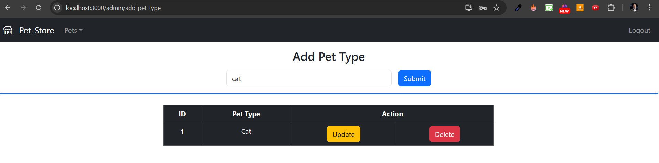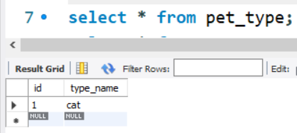 I also added dog after cat but not added in screenshot
- Creating API to add PetBreed and get All pet breeds (both in spring and angular)
  - Important :
    - Relationship between PetType 1 N PetBreed (one pet type has multiple pet breed)
    - We are going to some extra functionalities while adding a pet breed
      - Select pet type ( from drop down ) for which we are adding pet breed
      - Displaying added pet breed after adding
      - Filter option to filter pet breed according to pet type
  - Create PetBreed.java class in models package
@Entity
@Data
public class PetBreed
{
@Id
@GeneratedValue(strategy = GenerationType.IDENTITY)
private long id;

@Column(nullable = false, unique = true)
private String breedName;

@ManyToOne
@JoinColumn(name = "pet_type", nullable = false)
private PetType petType;
}

  - Create PetBreedRepository.java interface in repositories package
@Repository
public interface PetBreedRepository extends JpaRepository<PetBreed, Long>
{
//JPA method to get pet type based on pet type id
List<PetBreed> findByPetType_Id(long petTypeId);
}

  - Create PetBreedService.java class in services package
@Service
public class PetBreedService
{

@Autowired
PetBreedRepository petBreedRepository;

@Autowired
PetTypeRepository petTypeRepository;

@Autowired
MyResponseWrapper responseWrapper;

private ResponseEntity<?> universalResponse(String message, Object data, HttpStatus httpStatus)
{
responseWrapper.setMessage(message);
responseWrapper.setData(data);
return new ResponseEntity<> (responseWrapper,httpStatus);
}

public ResponseEntity<?> addBreedForPet(PetBreed petBreed, long petTypeId) {

Optional<PetType> petType = petTypeRepository.findById(petTypeId);
if(petType.isPresent()) {
petBreed.setPetType(petType.get());
PetBreed savedPetBreed = petBreedRepository.save(petBreed);
return universalResponse("Pet Breed added successfully", savedPetBreed, HttpStatus.OK);
} else {
return universalResponse("There is no pet found by given pet id", null, HttpStatus.NOT_FOUND);
}

}

public ResponseEntity<?> getAllPetBreeds() {
List<PetBreed> allBreeds = petBreedRepository.findAll();

if (allBreeds.isEmpty()) {
return universalResponse(
"No Pet Breeds found",
null,
HttpStatus.NOT_FOUND
);
} else {
return universalResponse(
"Following Pet Breeds found",
allBreeds,
HttpStatus.FOUND
);
}
}

public ResponseEntity<?> getPetBreedsByPetTypeId ( Long petTypeId ){

List<PetBreed> filteredPetBreeds = petBreedRepository.findByPetType_Id(petTypeId);

if(filteredPetBreeds.isEmpty()) {
return universalResponse("There are no Pet breeds found ", null, HttpStatus.NOT_FOUND);
}

else {

return universalResponse("Following breeds found", filteredPetBreeds, HttpStatus.FOUND);
}

}

}
  - Create PetBreedController.java class in controllers package
@RestController
@RequestMapping("/api/v1")
public class PetBreedController
{
@Autowired
PetBreedService petBreedService;

//only accessible by ADMIN
@PostMapping("/admin/add-pet-breed/{petTypeId}")
public ResponseEntity<?> addBreedForPet(@RequestBody PetBreed petBreed, @PathVariable("petTypeId") long petTypeId)
{
return petBreedService.addBreedForPet(petBreed, petTypeId);
}

//Public API
@GetMapping("/get/pet-breeds")
public ResponseEntity<?> getAllPetBreeds()
{
return petBreedService.getAllPetBreeds();
}

@GetMapping("/admin/findBreedByPetTypeId/{petTypeId}")
public ResponseEntity<?> getPetBreedsByPetTypeId(@PathVariable("petTypeId") long petTypeId)
{
return petBreedService.getPetBreedsByPetTypeId(petTypeId);
}

}

  - Code for AddPetBreed.js in src/admin/petComponents/AddPetBreed.js
import React, { useEffect, useState } from 'react'
import { useForm } from 'react-hook-form'

export default function AddPetBreed() {
let { register, handleSubmit, formState } = useForm();
let [pets, setPets] = useState(null); // list of pet types
let [breeds, setBreeds] = useState(null); // list of breeds
let [isPetBreedAdded, setIsPetBreedAdded] = useState(false);

const user = JSON.parse(localStorage.getItem("user"));
const token = user?.token;

let submitForm = async (formData) => {
console.log(token);

console.log(formData);
// formData = {petTypeId: '1', breedName: 'persian'}

let response = await fetch(
`http://localhost:8080/api/v1/admin/add-pet-breed/${formData.petTypeId}`,
{
method: "POST",
headers: { "Content-Type": "application/json","Authorization": `Bearer ${token}` },
body: JSON.stringify(formData),
}
);
let responseObject = await response.json();
console.log(responseObject);
setIsPetBreedAdded(true);
};

async function fetchAllPetBreeds() {
setIsPetBreedAdded(false);
let response = await fetch("http://localhost:8080/api/v1/get/pet-breeds");
let responseObject = await response.json();
let allBreeds = responseObject.data;
setBreeds(allBreeds);
}

async function fetchAllPetTypes() {
let response = await fetch(
"http://localhost:8080/api/v1/get/pet-types"
);
let responseObject = await response.json();
let allPettypes = responseObject.data;
setPets(allPettypes);
}

async function filterBreedByPetType(event) {
let petTypeId = event.target.value;
if (petTypeId == 0) {
fetchAllPetBreeds();
} else {
let response = await fetch(
`http://localhost:8080/api/v1/admin/findBreedByPetTypeId/${petTypeId}`,
{
headers:{"Authorization": `Bearer ${token}`}
}
);
let responseObject = await response.json();
let filteredBreeds = responseObject.data;
setBreeds(filteredBreeds);
}
}

useEffect(()=>{fetchAllPetTypes()},[])
useEffect(() => {
// fetchAllPetTypes();
fetchAllPetBreeds();
}, [isPetBreedAdded]);

return (
<div>
<h3 className="text-center mt-3">Add Pet Breed</h3>
<form
className="d-flex justify-content-center mt-3 border-bottom border-primary border-3 rounded"
onSubmit={handleSubmit(submitForm)}
>
<div className="mb-3 me-3">
<select
className="form-select"
{...register("petTypeId", { required: true })}
>
<option value={""}>Select Pet Type &nbsp;</option>
{pets &&
pets.map((pet) => (
<option value={pet.id} key={pet.id}>
{pet.typeName}
</option>
))}
</select>
<div className="text-danger">
{formState.errors.petTypeId?.type === "required" &&
"Pet Type is Required"}
</div>
</div>
<div className="mb-3 me-3">
<input
type="text"
className="form-control"
placeholder="Enter Pet Breed here"
{...register("breedName", {
required: true,
minLength: 3,
maxLength: 10,
})}
/>
<div className="text-danger">
{formState.errors.breedName?.type === "required" &&
"Pet Breed is Required"}
{formState.errors.breedName?.type === "minLength" &&
"Pet Breed must have min 3 characters"}
{formState.errors.breedName?.type === "maxLength" &&
"Pet Breed is not allowed more than 10 characters"}
</div>
</div>
<div>
<button type="submit" className="btn btn-primary">
Submit
</button>
</div>
</form>

<div className="mt-4 d-flex align-items-center flex-column ">
<div className="mb-3 d-flex justify-content-end w-50">
<h4>Select pet Type:</h4> &nbsp; &nbsp;
<select
className="form-select w-25"
onChange={filterBreedByPetType}
>
<option value={0}>All &nbsp;</option>
{pets &&
pets.map((pet) => (
<option value={pet.id} key={pet.id}>
{pet.typeName}
</option>
))}
</select>
</div>

<table className="table table-hover table-bordered table-dark w-50 text-center">
<thead>
<tr>
<th scope="col">ID</th>
<th scope="col">BREED</th>
<th scope="col" colSpan={2}>
Action
</th>
</tr>
</thead>
<tbody>
{breeds &&
breeds.map((breed) => (
<tr key={breed.id}>
<th scope="row">{breed.id}</th>
<td>{breed.breedName.toLowerCase()}</td>
<td>
<button type="button" className="btn btn-warning">
Update
</button>
</td>
<td>
<button type="button" className="btn btn-danger">
Delete
</button>
</td>
</tr>
))}
</tbody>
</table>
</div>
</div>
);
}

  - Run spring and react server and check output
    - After running spring server, I checked, pet_breed table is created!
    - After running react server I added pet breed –
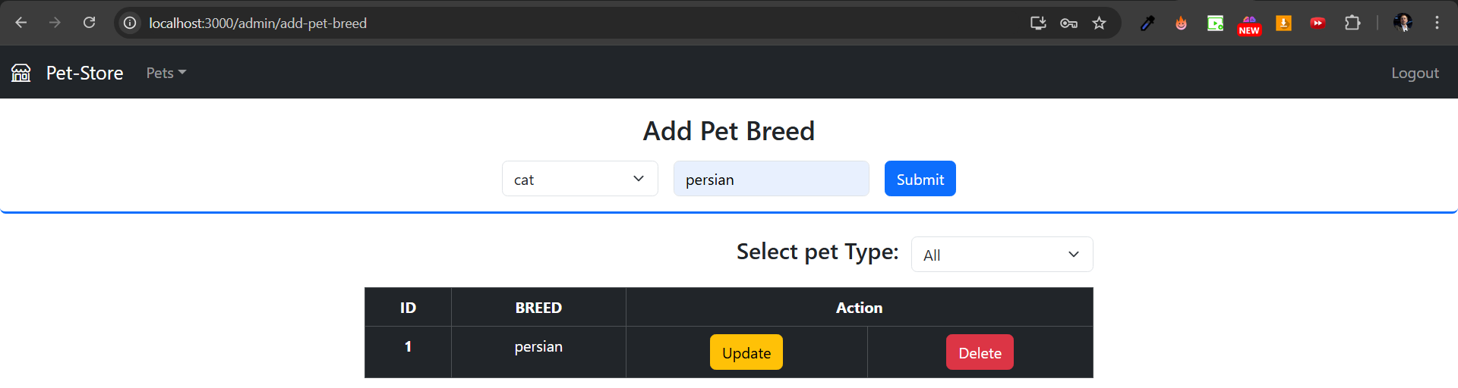

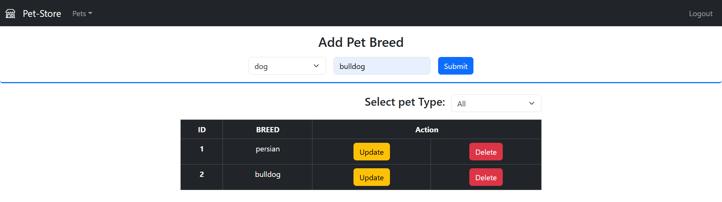
Filtration also working fine
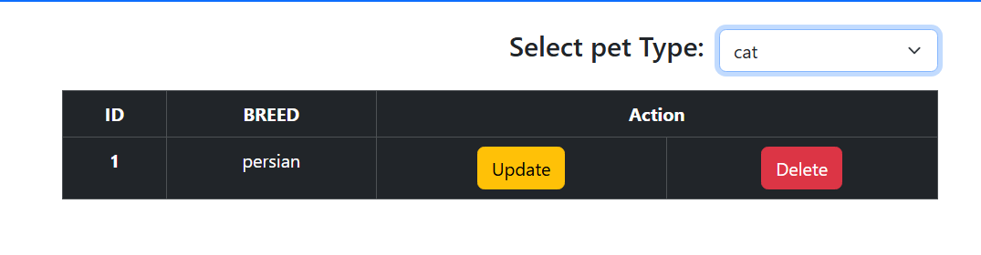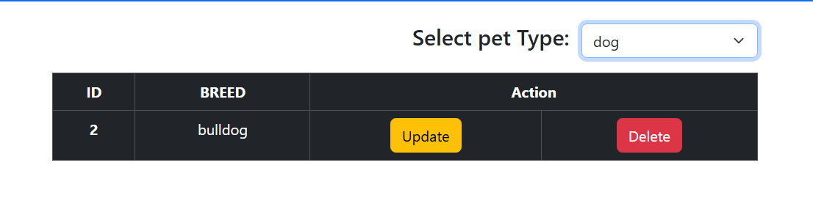
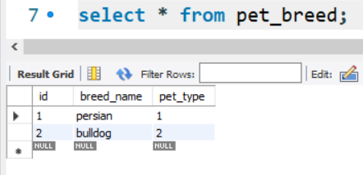
EVERYTHING WORKING FINE
    - DONE EEEEEEEEEEEEEEEEEEEE

