Title:
Project Report: Java Chatbot

👩‍💻 Student Details:
- Name: Sanika Kashinath Kasar
- Course: BCA
- College: COCSIT
- Internship: CodeAlpha Java Programming

🟢 1. Introduction
A chatbot is a software application that interacts with users through text or voice.
This project is a simple Java-based chatbot that responds to user inputs using predefined rules.

🟢 2. Objective
- To create a simple chatbot using Java
- To understand user input handling
- To generate responses using conditions

🟢 3. Tools & Technologies Used
- Java
- Scanner Class
- Conditional Statements (if-else)

🟢 4. Methodology
- The program starts and greets the user
- It takes user input using Scanner
- The input is checked using conditions
- Based on input, chatbot gives response
- Program runs until user types "exit"

🟢 5. Code Implementation
package code;

import java.util.Scanner;

public class Chatbot {
public static void main(String[] args) {
Scanner sc = new Scanner(System.in);
String input;

System.out.println("Chatbot: Hello! Type 'exit' to stop.");

while (true) {
System.out.print("You: ");
input = sc.nextLine().toLowerCase();

if (input.equals("exit")) {
System.out.println("Chatbot: Goodbye!");
break;
}
else if (input.contains("hello") || input.contains("hi")) {
System.out.println("Chatbot: Hi there!");
}
else if (input.contains("how are you")) {
System.out.println("Chatbot: I am fine!");
}
else if (input.contains("name")) {
System.out.println("Chatbot: I am a Java chatbot.");
}
else {
System.out.println("Chatbot: Sorry, I don't understand.");
}
}
}
}

🟢 6. Output
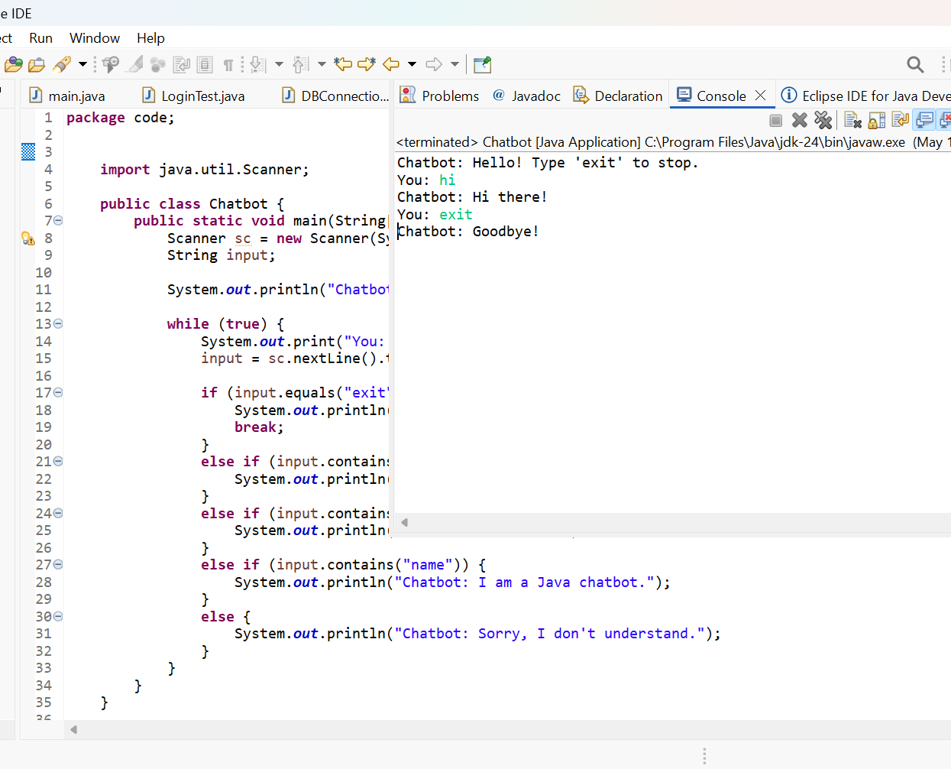

🟢 7. Advantages
- Easy to understand
- Beginner friendly
- Interactive program

🟢 8. Limitations
- Limited responses
- No real AI or NLP

🟢 9. Future Scope
- Add GUI interface
- Add database
- Improve responses using AI

🟢 10. Conclusion
This project demonstrates how a simple chatbot can be created using Java.
It helps in understanding basic programming concepts and user interaction.

