Pattern discovery for Malaria in Africa.

KASASA LIVINGSTONE TREVOR
2200722469 -22/U/22469
kasasatrevor25@gmail.com
0770820875/0704967769

Introduction:
Welcome to our report focusing on malaria-related services and population health indicators in African countries. Malaria continues to be a significant health concern across the continent, and this report aims to provide a concise overview of key metrics and trends in this context. By analyzing indicators such as basic sanitation, drinking water services, bed net utilization, and reported malaria cases, we seek to uncover insights into the state of malaria prevention and control efforts, as well as the overall health of populations in these regions. This report serves as a valuable resource for understanding the current landscape and challenges in addressing malaria in Africa.
Pattern Discovery Methods:
In our analysis of malaria-related data, we employed a suite of pattern discovery methods to extract valuable insights. Clustering, a powerful technique, allowed us to group data based on various dimensions, such as years, countries, and distinct prevention methods. This enabled the identification of trends and patterns within specific subsets of data, shedding light on how malaria-related variables interrelate over time and across different geographic regions. Additionally, we harnessed association rule mining, specifically the Apriori algorithm, to uncover hidden associations and correlations between different prevention methods. This method illuminated potential synergies or dependencies among interventions, contributing to a more nuanced understanding of effective malaria control strategies. Moreover, our application of anomaly detection pinpointed regions with unusually high malaria case counts, providing a geographical focus for targeted intervention efforts. Through these approaches, we not only revealed overarching patterns but also delved into intricate relationships, thereby advancing our comprehension of malaria dynamics and equipping stakeholders with actionable insights for informed decision-making. The subsequent sections delve into the specifics of each method's application and the impaction findings they unveiled.

Data Collection and Preprocessing:
Our analysis draws from a robust dataset curated by the World Bank, encompassing a spectrum of key indicators vital to understanding malaria dynamics across diverse countries. These indicators include urban and rural sanitation and drinking water services, population growth rates, utilization of preventive measures such as bed nets (% using IBNs), reported cases, and disease incidences per 1000 population at risk. Geographic attributes, latitude, and longitude provide the spatial context for our analysis. Prior to exploration, the dataset underwent rigorous preprocessing under the meticulous guidance of a colleague, who addressed missing values, rectified discrepancies, and ensured data integrity. This preparatory phase sets the stage for our subsequent pattern discovery methodologies, aimed at unearthing insights into the intricate interplay between these variables, ultimately informing effective strategies for malaria prevention and control.

Exploratory Data Analysis (EDA):
objective: Compare the burden of malaria across different African countries, helping prioritize regions for preventative measures and healthcare infrastructure.

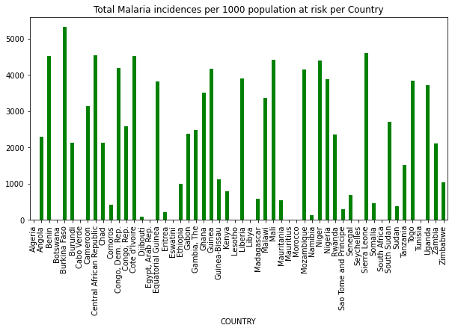

Conclusion: Data was grouped by country and we were able to determine different incidences of malaria in different countries of which we realized some countries had no cases while others had multiple incidences.

Objective: Identify countries with the highest and lowest number of Incidences, aiding in targeting interventions and allowing international organizations and donors prioritize resource allocation.

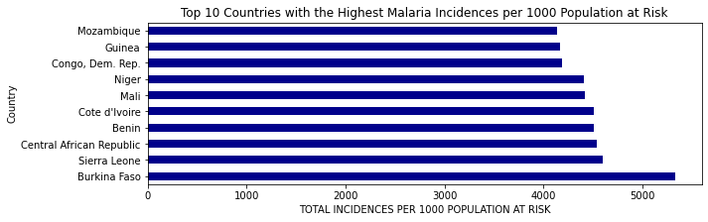
Observation: Data was sorted according to malaria incidences and we came up with a bar graph to visualize the out put where we realized Burkina Faso had the most incidences as shown above.
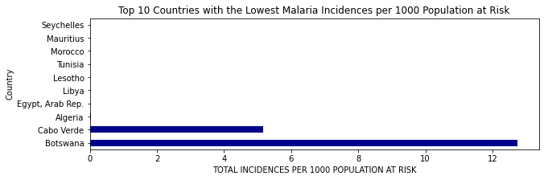
Observation:Data was sorted according to malaria incidences and we came up with a bar graph to visualize the out put where we realized countries like Algeria, Egypt, Libya, Lesotho, Tunisia, Morocco, Mauritius and Seychelles had zero incidences whereas cabo Verde and Botswana had very few incidences. This helped us archive our objectives.

Objective: Assess the impact of geographical location on malaria incidence.
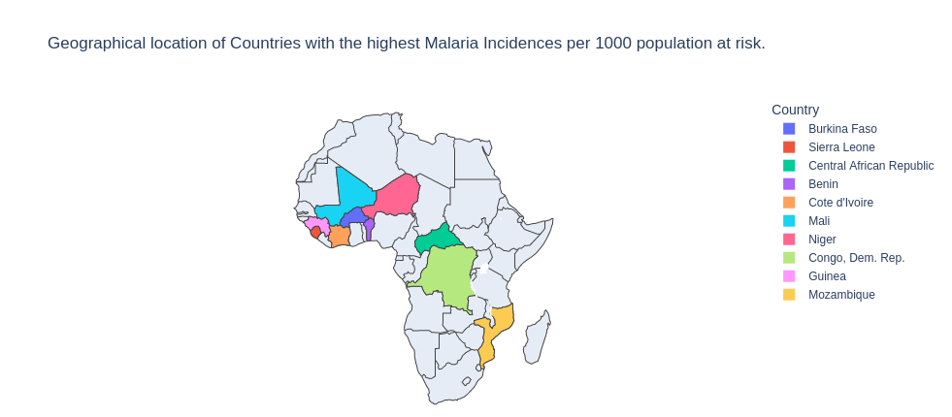
Observation: We observed that most of the countries with the highest malaria incidences per 1000 population at risk are located in the Equatorial region characterized by warm temperatures and heavy rainfall throughout the year which create ideal breeding places for mosquitoes, contributing to their high incidences of malaria.

Objective:To track and visualize the trend of malaria incidence over the years and evaluate the effectiveness of existing malaria control and prevention interventions.

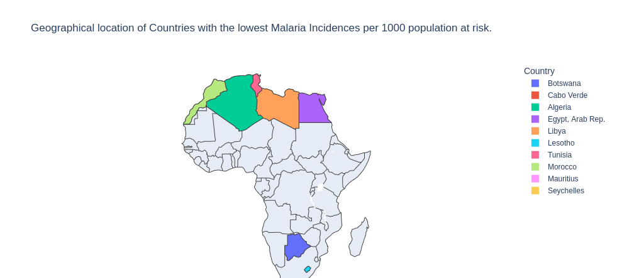
Observation:We observed that most of the countries with the lowest malaria incidences per 1000 population at risk are located in the Northern part of the African continent characterized by a predominantly arid or semi-arid climate with relatively low humidity. The combination of low humidity and limited precipitation in these regions creates less favorable conditions for sustained mosquito breeding, contributing to their low incidence of malaria.

Objective:To track and visualize the trend of malaria incidence over the years and evaluate the effectiveness of existing malaria control and prevention interventions.

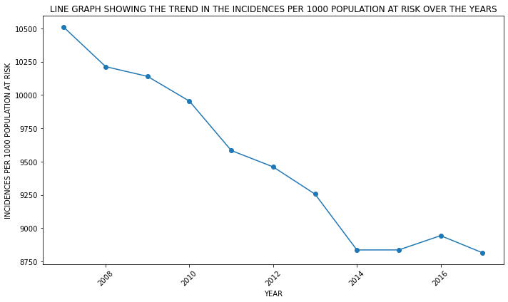
Observation: There is a clear down trend in the incidences which makes it clear that prevention interventions are effective.

Objective: Assess the effectiveness of malaria prevention campaigns and programs promoting bed net usage for children under the age of 5 years.

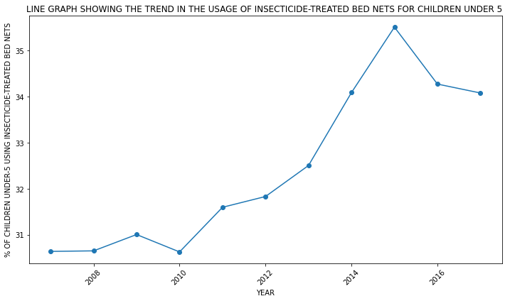

Observation: The trend increases over years this signifies that more children were put udder preventive measures which also explains the downtrend in the incidences recorded and from 2015 to 2016 numbers fr-actuated as the percentage decreased which also explains the trend in the graph before for incidences.

Objective: Identify countries with low bed net coverage targeting them for interventions to increase usage and reduce malaria transmission.

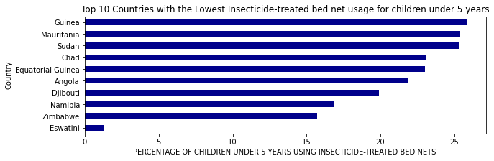
Observation: he top 10 countries with the lowest bed net coverage have one thing in common, that is, their climate(Arid Climate) does not favors mosquito breeding.
We therefore focused on countries whose climate favors mosquito breeding and also have low percentages if bed net usage for children under 5 years. The similar trend in incidences per 1000 and prevention on children under 5 also signifies that malaria affects more of children under age of 5.
Objective:

