**Solving lab 2 day 2 source control**

**1-Make a project deployment.**

<https://kasemsafwat.github.io/BootstrapProject/>

**2-what is pull request and request & differrent bettween them?**

**. pull request**: is a specific feature of version control systems like GitHub to merge changes into another branch.

**.Request:** can mean any generic request, such as an HTTP request.

**3-Make fork from your project and use it from anthor account**

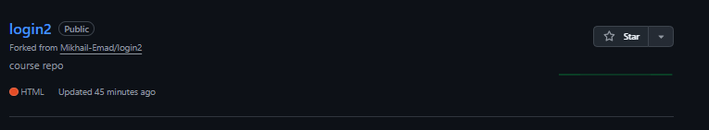

**4-What is the command to delete the branch "new-email"?**

git branch -D new-email

**5-What is the command to push the current repository to the remote origin?**

git push origin branch-name

or git push origin –all

**6-what is git Rebase and how to use it ?**

**Git Rebase** is a process to integrate changes from one branch into another by moving the base of the branch to the latest commit of another branch

7-**What is the command to get all the change history of the remote repository "origin"?**

git fetch origin

**8-What is the command to show the differences between the current branch and the branch "new-email"?**

git diff new-email

**9-what is tags and Make five tags and release two of them?**

**. Tags** are references that point to specific commits, typically used to mark release versions like

git tag v1.0

git tag v1.1

git tag v1.2

git tag v2.0

git tag v2.1

git push origin –tags

**release**

git push origin v1.0

git push origin v1.1