Kasey Hales

Project StockMeIn Design

# Background

VehicleSolutions has been the most innovative and exciting vehicle inventory solution software provider for many years, and I have no doubt it will be for years to come. VehicleSolutions’ current software solution is a desktop app that is installed on a local machine. To access this solution, the software must be installed on every machine that needs to use it. This presents challenges when trying to work from the road, from home, or from other devices. Today we need to be able to manage our vehicle inventory from anywhere and at any time.

StockMeIn is a proposed solution that can replace VehicleSolutions’ current legacy desktop application. StockMeIn is completely web based so it can be accessed from anywhere at any time. With StockMeIn, there is no software to install and can be accessed from any portable device. It offers the same current awesome functionality VehicleSolutions’ legacy application offers on a user-friendly website. With the StockMeIn web application you will be able to stock new vehicles into inventory and track vehicle information including make, model, year, type new or used, body, color, in inventory date, cost, and list price. A list of vehicles will be easily available with the ability to update, remove, or mark vehicle as sold and tie that sold vehicle to a customer. Customer information will also be tracked. Addition of customer contact information will be available and will store data including first, last and middle names, address, city, state, zip, and phone numbers. When searching customers, you will get a list of vehicles purchased, if any, and the application will provide the ability to update customer contact information and remove a vehicle tied to that customer. This will provide customer value and tracking information that will be valuable in marketing campaigns and customer evaluations. The accuracy and portability provided by StockMeIn will help drive sales and revenue in this every changing environment.

# Database or Data Store Design

StockMeIn will use a SQL server database to store vehicle, customer, and customer owner data. Below is a database diagram of the tables in this database:

|  |
| --- |
|  |

The vehicles table will contain all relevant vehicle information data. It will have a primary key, stockID, which will be unique for each vehicle. It will also contain a status. This status will dictate whether the vehicle is currently in inventory, ‘I’, or owned by a customer, ‘C’.

The customer table will contain all relevant customer information. It will have a primary key, custID, which will be unique for each customer.

The customerVehicle table will contain customer and vehicle relationships. It will have a primary key, custVehID, which will be unique for each relationship. It will also maintain relationships with the vehicle and customer table. The stockID and custID will be used to reference customer and vehicle information with each ownership. It will also contain a date when ownership started and a date when ownership ended.

# Screen Mockups

The application will utilize ASP.net and Razor pages to present StockMeIn’s web application. Below you will find mockups for each of the screens you will find in the application:

**Login Screen**

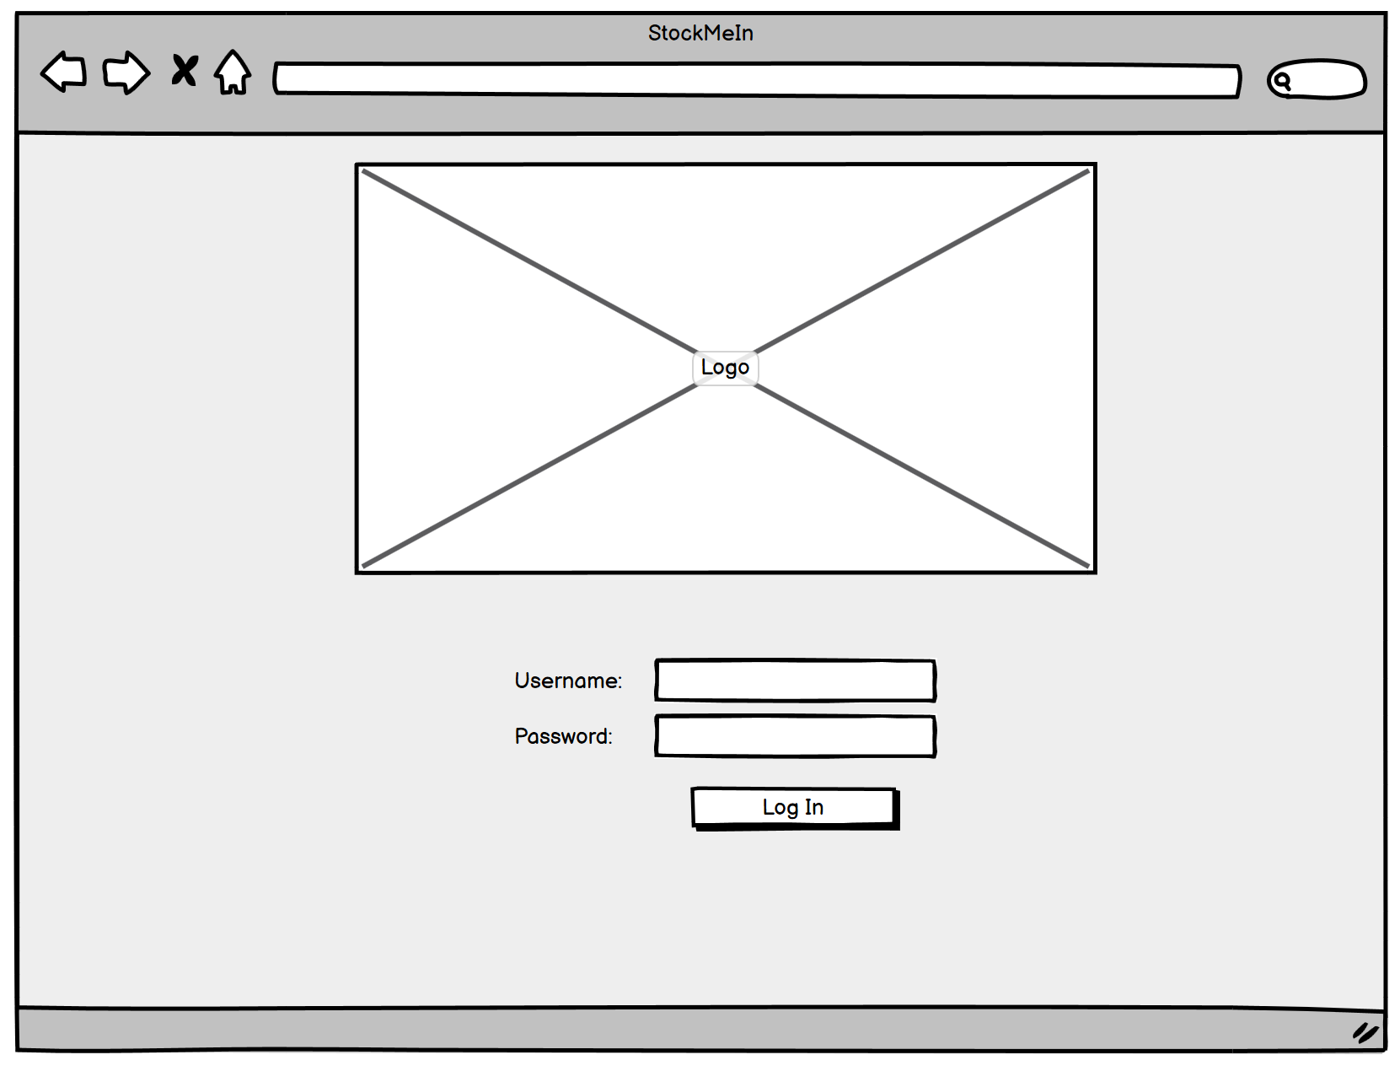

When navigating to the web application, the user will be directed to the login page. A valid username and password will be required to login.

**Inventory Screen**

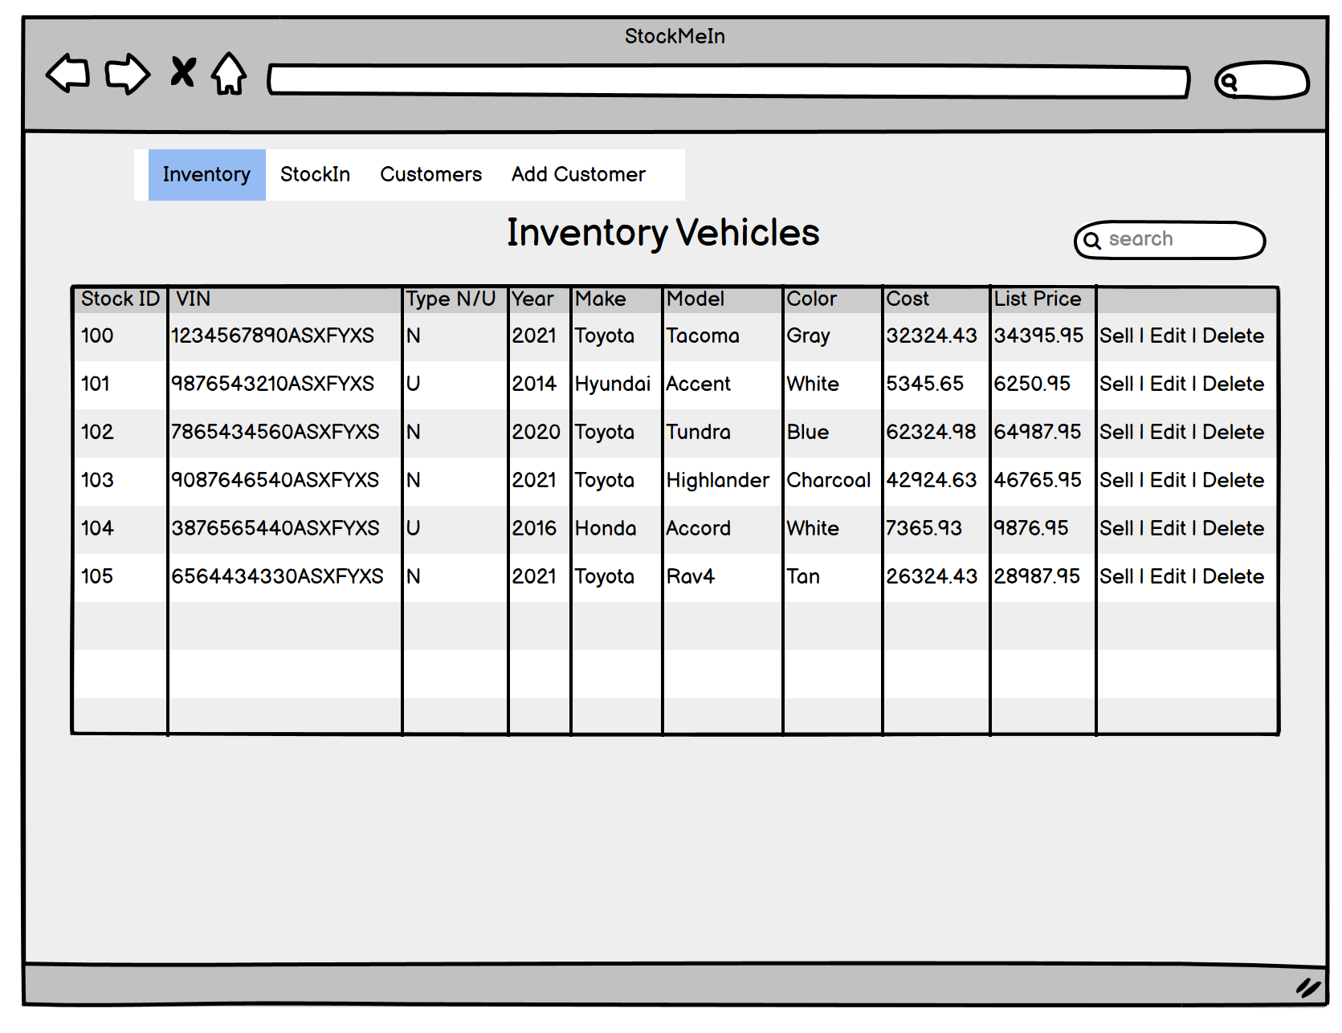

After login, the user will be presented with the vehicle inventory screen. The navigation bar at the top will allow the user to navigate to stock in vehicles, view customers, and add new customers. There will be links in the data table displaying vehicle inventory to sell the vehicle to a customer, edit vehicle information, or delete a vehicle. If the delete link is selected the vehicle will be removed from the inventory screen.

**Sell Vehicle**

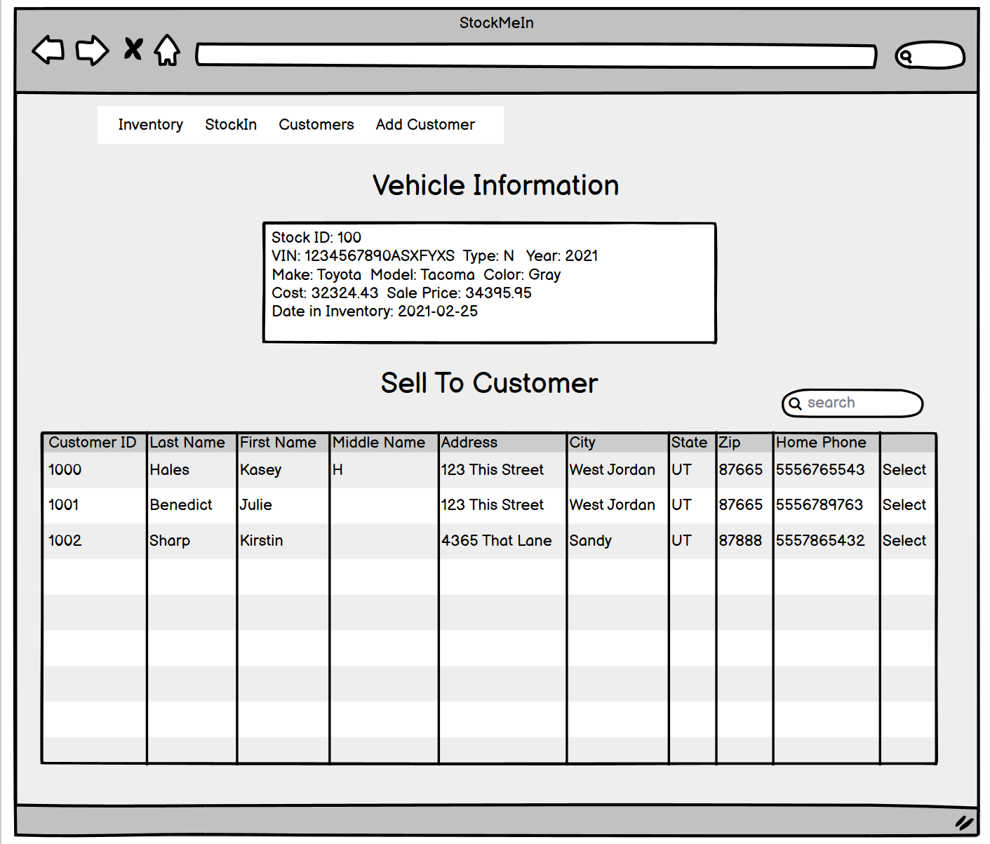

After clicking on the ‘Sell’ link in the vehicle inventory data table, the user will be directed to the sell vehicle page. Vehicle information will be displayed at the top and a customer data table will show below. The search box will allow a user to search for a customer. When the select link is selected, the vehicle will be removed from inventory by setting the status to ‘C’ and a record will be created for that customer and vehicle in the customerVehicle table creating ownership.

**Edit Vehicle**

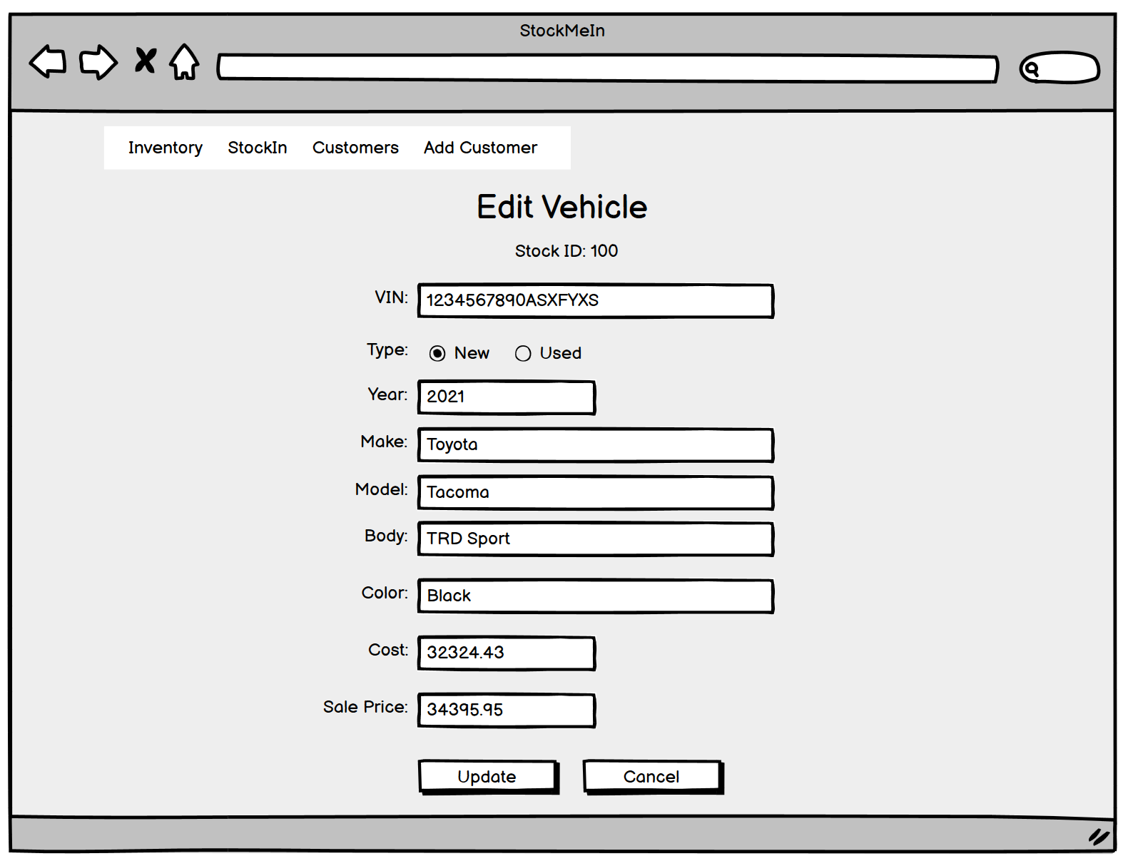

After clicking on the ‘Edit’ link in the vehicle inventory data table, the user will be directed to the edit vehicle page. The vehicle stockID will be displayed at top and the vehicle information will be displayed in the appropriate text boxes. The user will be allowed to update the vehicle information here. If update is selected, vehicle information will be updated in the vehicles table. If cancel is selected, no changes will occur.

**Stock In Page**

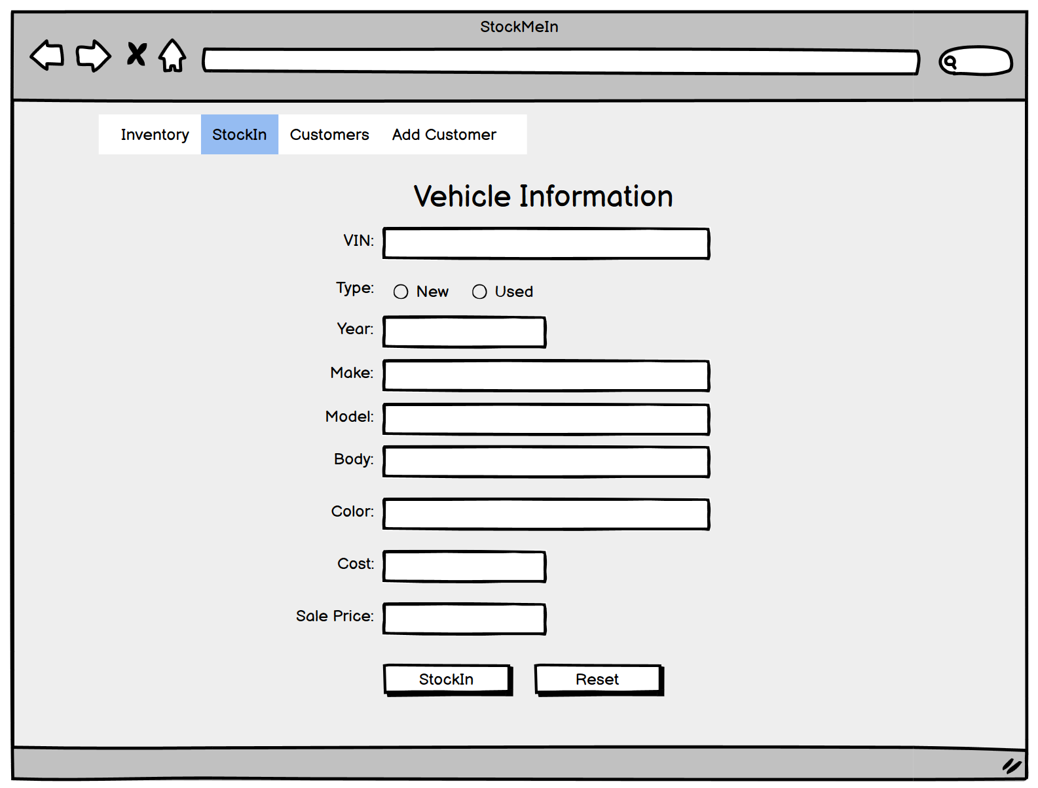

The Stock In page will allow the user to enter in the vehicle’s information to be stocked in. VIN, Year, Make, and Model will be required. When StockIn is selected a new record will be added to the vehicles table with a status of ‘I’.

**Customers Page**

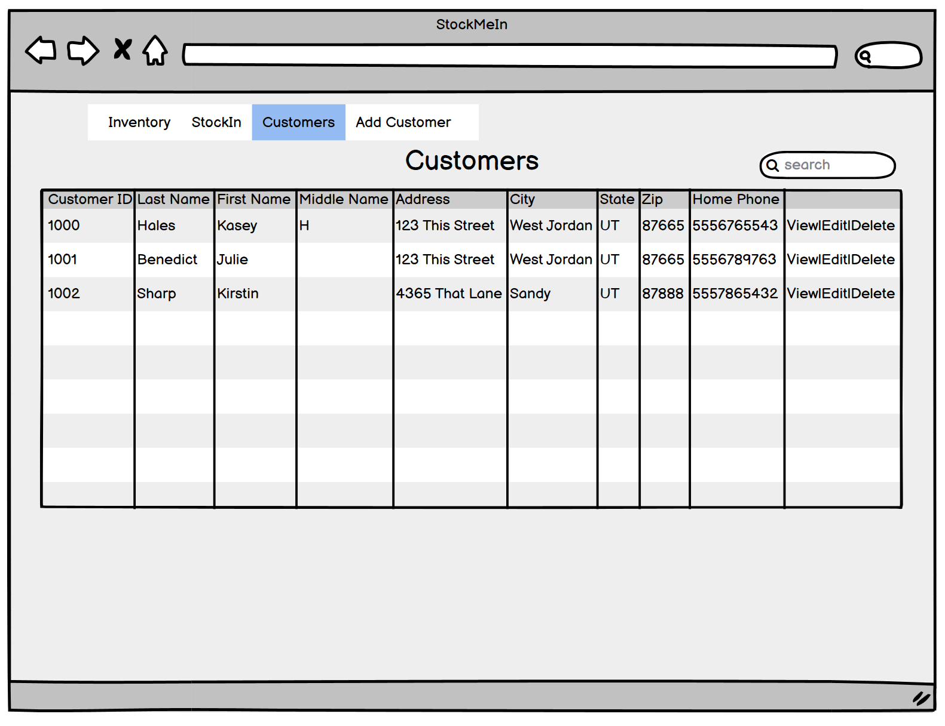

When the Customers tab is selected the user will be presented with a data table of existing customers. Each row will have links to View, Edit, and Delete a customer record. When the delete link is selected the customer will be removed from the customer screen.

**View Customer**

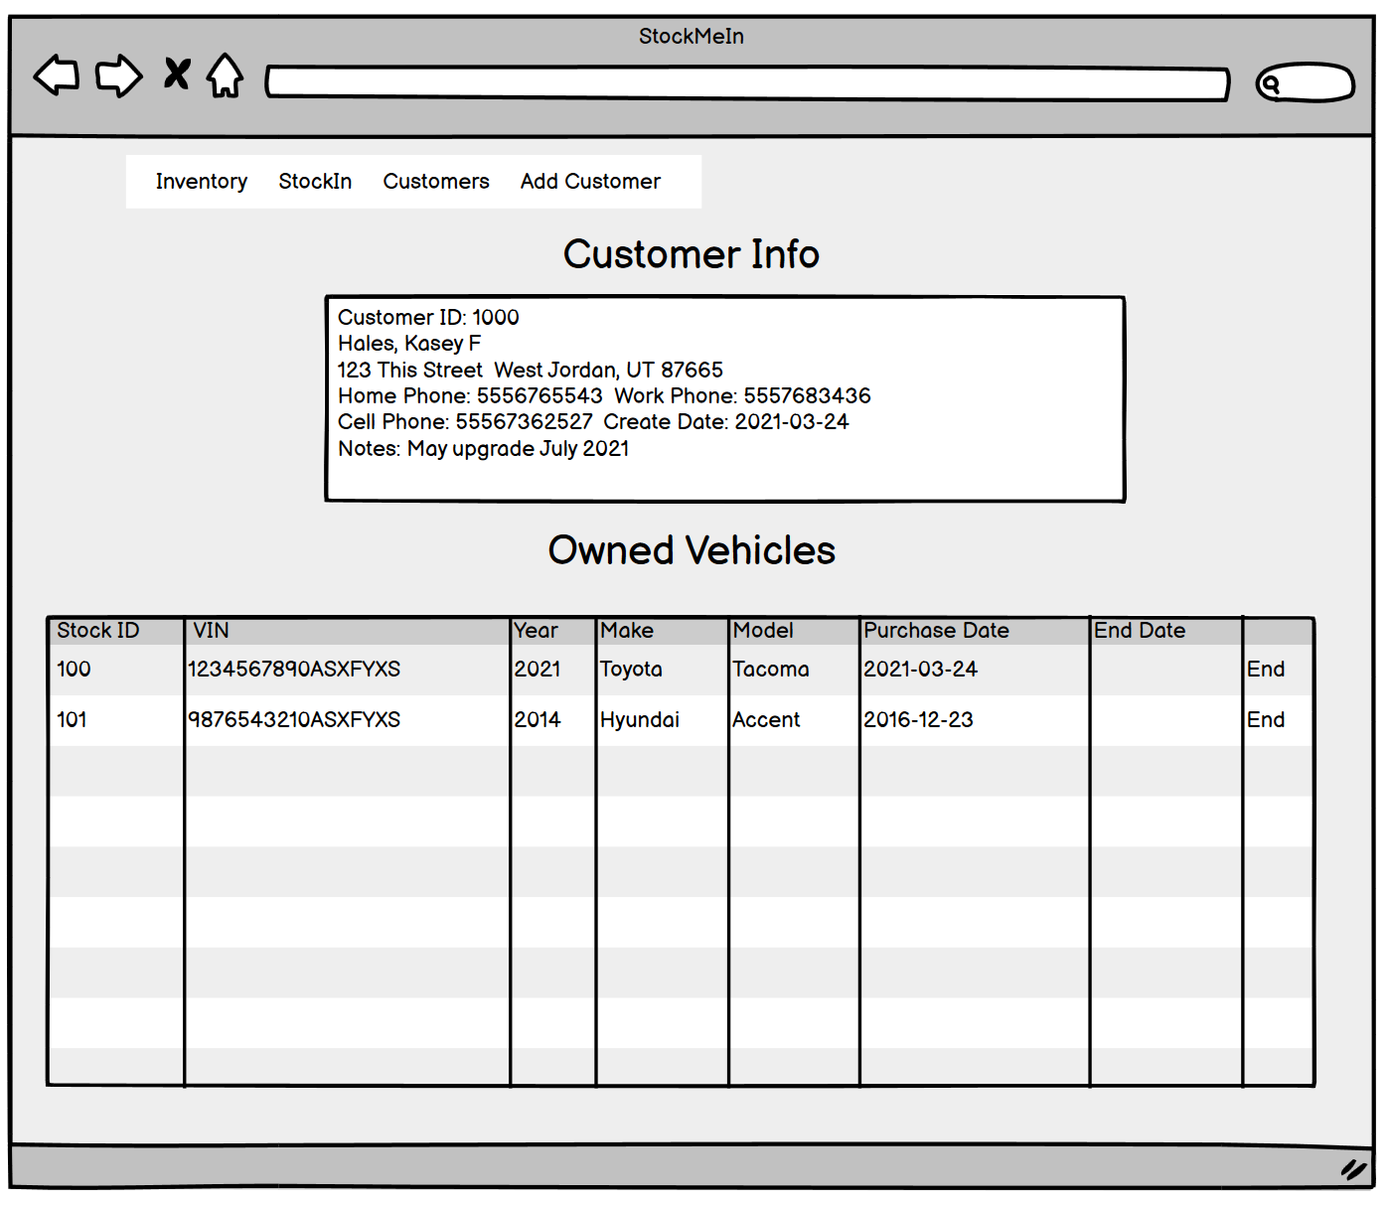

When the user selects View on the customer screen, the user will be directed to the customer information screen. The customer’s information will be displayed at the top of the page. Below, the user will be presented with the vehicles the customer owns or has owned. An End link will exist in each record on the Owned Vehicles data table. If selected, the end date will be updated in the customerVehicle table and the date will be displayed on the screen as current date.

**Edit Customer Screen**

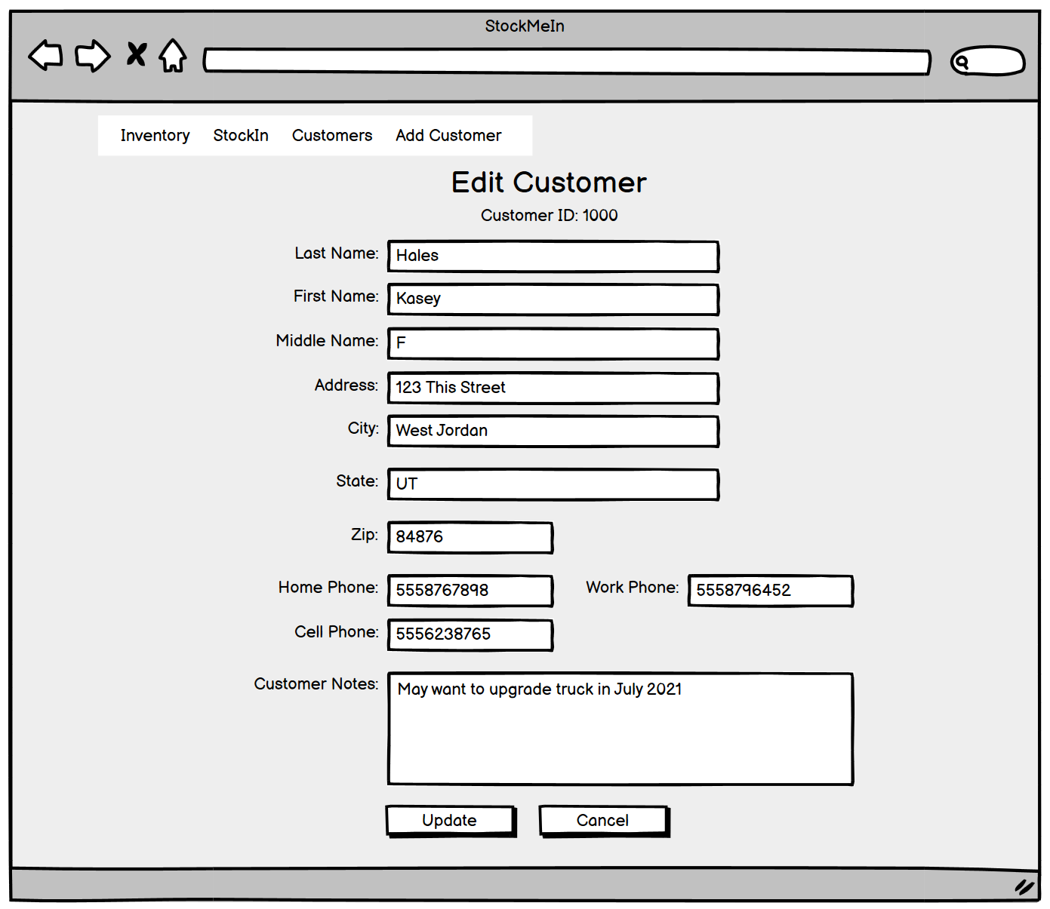

When the Edit link is select on a customer record the user will be presented with the above screen. The customer ID will be displayed at the top of the screen and the customer information will be displayed in the relevant text boxes. The user will be allowed to update the customer information. When update is selected the record in the customer table will be updated. If cancel is selected no changes will be made.

**Add Customer Screen**

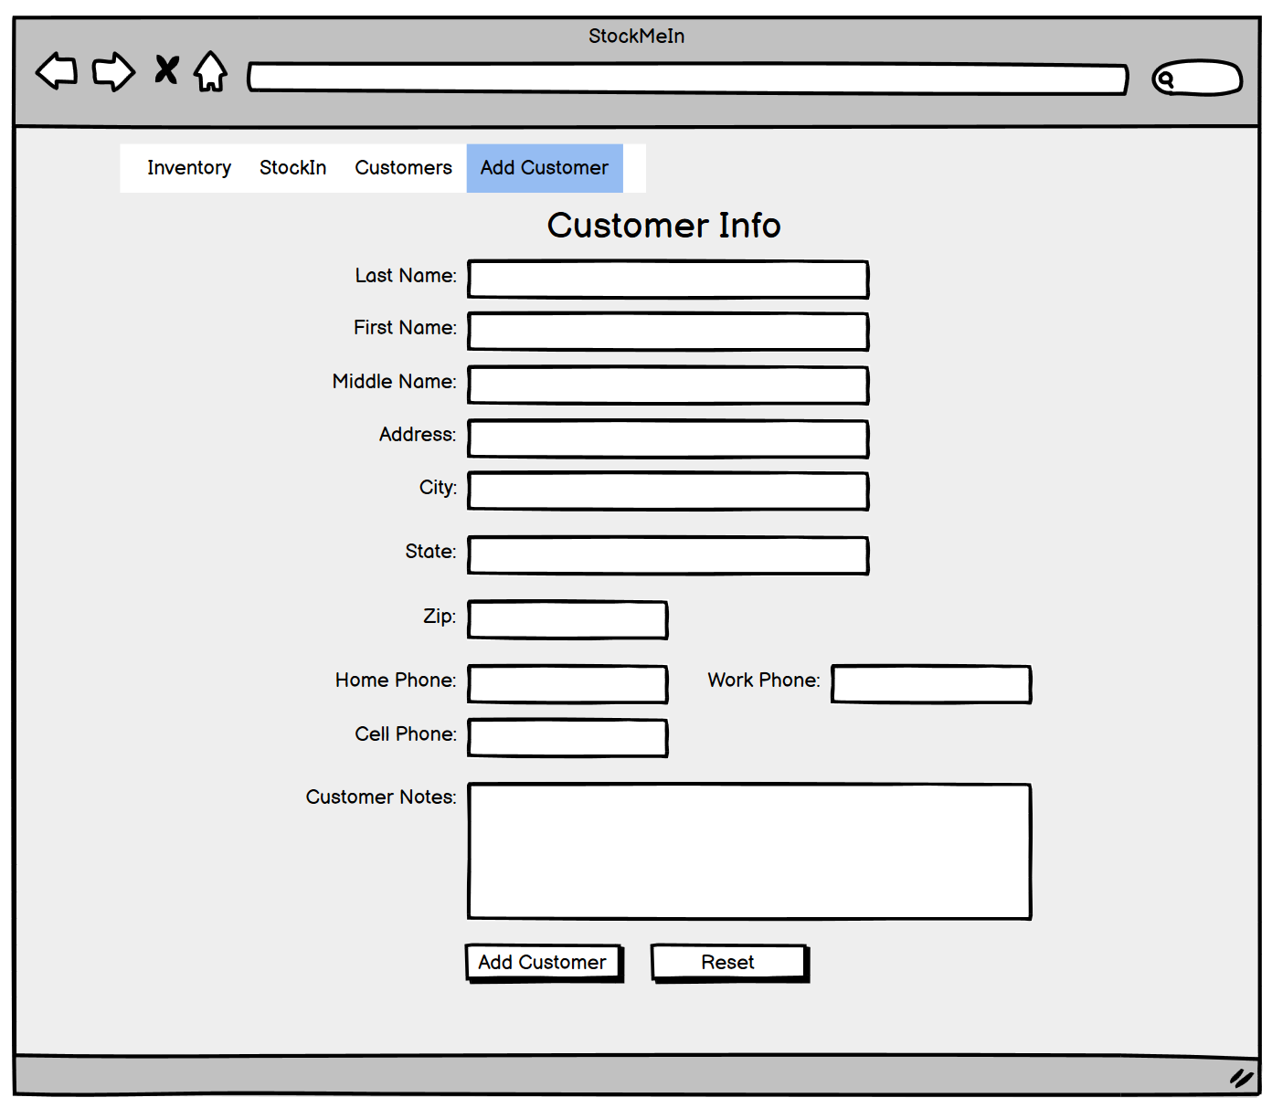

When the add customer tab is selected, the user will be directed to the add customer screen. Here the user will be able to fill in the relevant customer information. Last name will be a required field. When the Add Customer button is selected, a record will be added to the customers table. If Reset is selected the text boxes will be blanked out and no records will be added.

# Report Mockups

Reports may be added in a secondary project. Reports are out of scope for this project.

# Maintenance Features

If time permits, a function to mass delete vehicles in inventory will be added. This will allow the user to remove any vehicle that has been in inventory past a certain date or remove all vehicles in inventory. This will aid dealers in cases where vehicle inventory management has been neglected for a time or there is a need to start fresh.

# Work Breakdown Structure (WBS)

Below you will find the work breakdown for this project and timeline.

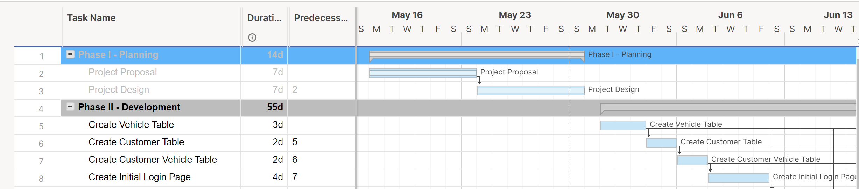

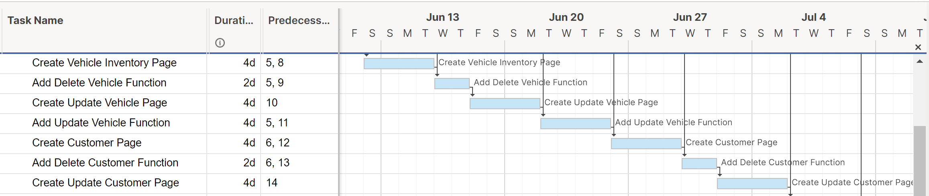

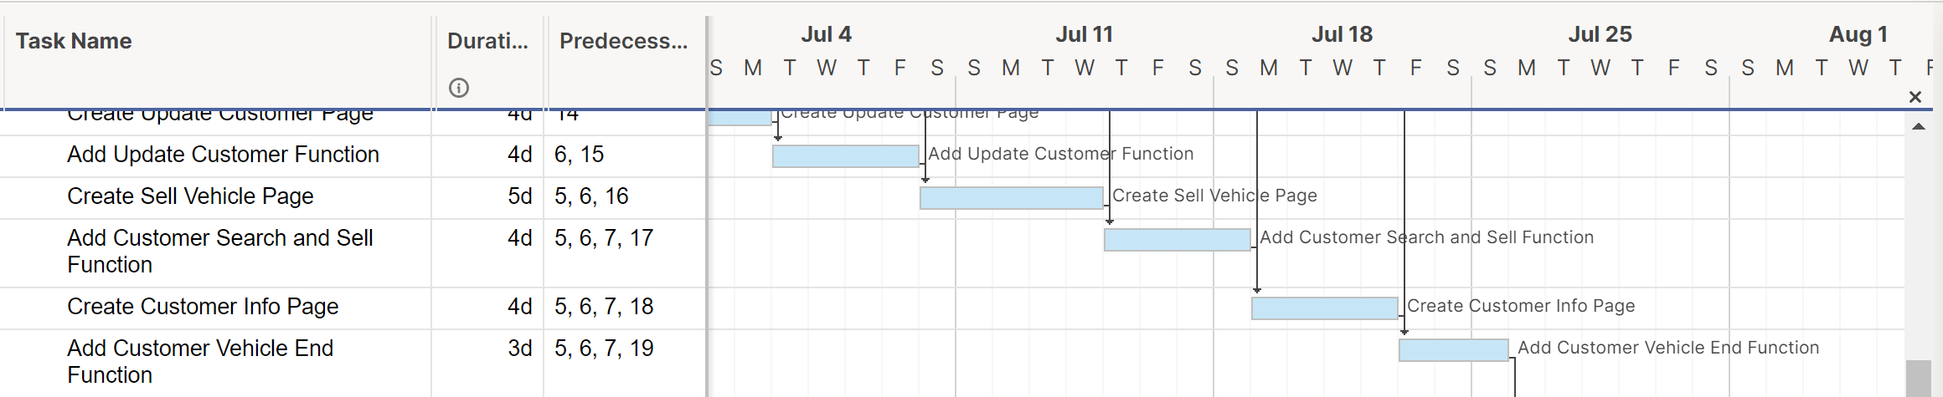

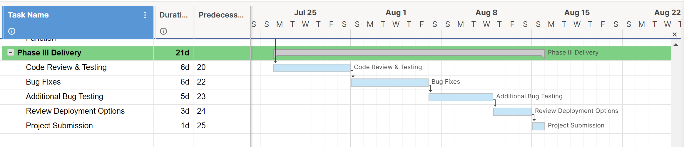

This Gantt chart also can track task completion and completion dates. This will aid in project tracking and timing and will guide me in project time estimates in future similar projects. This timeline will be adhered to as strictly as possible to ensure on time delivery of completed project.

# Summary

StockMeIn’s back end will be written in C# and will utilize a SQL server database to store vehicle, customer, and customer vehicle relationships. The front end of the application will utilize ASP.net and Razor pages to create a user-friendly design that promotes ease of use and a good workflow. The SQL database can easily be expanded upon to incorporate additional inventory fields and user defined optional field lookup tables and vehicle associations as well as customer and vehicle comment, and prospect tables to aid in sales marketing. Razor pages are also easily expanded upon to add new functionality for additional dealer features. The carefully laid out work breakdown structure will be strictly adhered to ensure on time delivery of a completed project. Any extra time in the testing and bug fix portion of the project will be utilized to create the maintenance functions laid out in the maintenance section to aid dealers in the inventory cleanup process if necessary.