How Long Do NEPA Reviews Take?
NEPA by the Numbers — Fact Sheet 1: Review Timelines
July 25, 2026

Key Findings
 Key Findings
- NEPA review duration climbs from days to months to years as review intensity increases. The median Categorical Exclusion (CE) is resolved in 20 days, the median Environmental Assessment (EA) in 117 days (~4 months), and the median Environmental Impact Statement (EIS) in 1,021 days (~2.8 years).
- Decarbonization and fossil energy projects take broadly similar time within each review process. The apparent fossil-EA speed advantage is a data artifact (administrative start dates recorded near the decision), not a real difference in review length.
- Post-FRA, EIS documents got shorter, but reviews have not yet gotten measurably faster. Mean EIS length fell from 318 to 269 regulatory pages after the Fiscal Responsibility Act of 2023, while median durations are statistically unchanged — though the post-FRA sample is still small.
- The longest reviews are real, and they are concentrated in EISs. Genuinely protracted reviews — SunZia Southwest Transmission (14.6 years), Grain Belt Express, Energia Sierra Juarez, Cushman Hydroelectric — are candidates for case-study investigation; multi-year CE “durations,” by contrast, are almost always extraction errors.
- Better federal timeline data would improve every finding in this fact sheet. No federal data source systematically records when NEPA reviews start and end; every date here was recovered from document text or agency registers. Agency adoption of the CEQ NEPA and Permitting Data and Technology Standard would make timeline analysis substantially more complete.

Introduction
Few questions in permitting policy attract more attention than how long NEPA reviews take. The Fiscal Responsibility Act of 2023 (FRA) wrote timeline targets directly into statute — one year for an EA, two years for an EIS — along with presumptive page limits. The regulatory ground has also shifted repeatedly: the Council on Environmental Quality (CEQ) rewrote its NEPA implementing regulations in 2020 and revised them again in 2022 and 2024, then rescinded them entirely in 2025 following Marin Audubon Society v. FAA and Executive Order 14154, returning procedural detail to individual agencies. Most recently, the Supreme Court’s decision in Seven County Infrastructure Coalition v. Eagle County (2025) narrowed the scope of judicial review of NEPA analyses, with implications for how much analysis agencies feel compelled to produce.
Against that backdrop, empirical evidence on NEPA timelines remains thin. Prior studies have documented multi-year EIS timelines [cite the Phase 1 report’s timelines literature — RFF et al.], but most rely on the small EIS population or hand-collected samples. Because roughly 95% of NEPA actions are resolved through CEs and EAs — for which no central timeline data exist — the full distribution of NEPA review durations has been largely unmeasured. Policymakers assessing the FRA’s reforms, CE expansion proposals, and further statutory changes need that baseline.
This fact sheet reports review timelines extracted from NEPATEC 2.0, the largest assembled corpus of NEPA documents, covering 61,881 projects across CEs, EAs, and EISs — with a focus on decarbonization technologies (solar, wind, transmission, geothermal, storage, nuclear, and related infrastructure) and comparisons to fossil energy projects.

Methodology

Scope
The timeline analysis covers the full NEPATEC 2.0 database. Energy-technology comparisons use the project technology classifications developed in this research program: roughly one-third of projects are decarbonization-related, with fossil energy and non-energy federal actions making up the rest. Full methodological detail is in the Phase 2 Deliverable 4 report.

How dates were extracted
No federal data source systematically records NEPA start and end dates, so we recovered them from the documents themselves. For every project we identify two milestones: the initiation (application received, Notice of Intent, or scoping start) and the decision (signature, Record of Decision, or Finding of No Significant Impact). A machine-learning pipeline extracts every candidate date from every document, classifies its role, ranks candidates, anchors on authoritative BLM/DOE register dates where available (~40,000 official dates), and sends only the hardest cases to a large language model for adjudication. A project’s timeline is complete when both dates are found.

Data completeness
Completeness varies sharply by review process, and the gaps are structural rather than fixable by better parsing:
- CE — 55% complete. Most CEs are single-signature determinations with no recorded start date.
- EA — 58% complete. The strongest of the three, but EAs have no Notice-of-Intent requirement, so start dates are often never documented.
- EIS — 36% complete. Initiations are well documented (an NOI is required), but Records of Decision are usually separate documents outside the corpus — only 42.3% of EISs have a recoverable decision date.
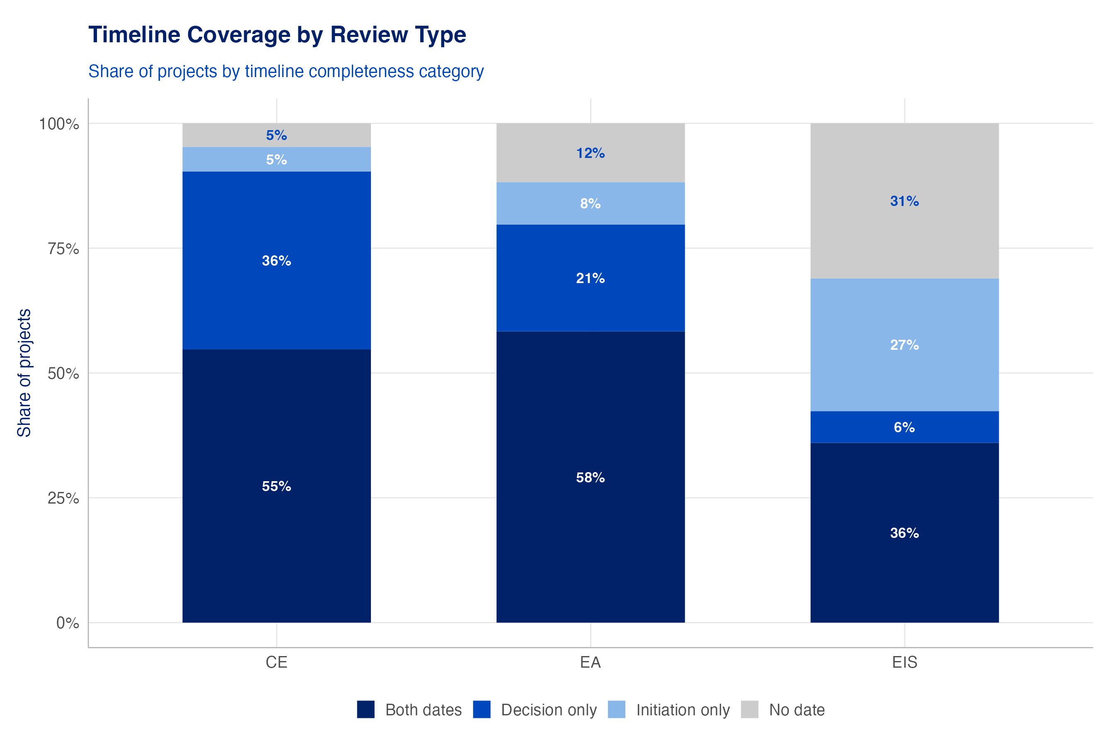
Figure 1: Note: Timeline coverage by review process — share of projects with both dates, decision only, initiation only, or neither.
All duration findings below use complete timelines only. Because incompleteness is driven by document availability rather than by project characteristics, medians are a reasonable estimate for each process — but readers should keep the completeness rates above in mind, particularly for EISs.

Results

Review duration by process
Durations track the expected complexity ladder. The median CE is resolved in 20 days; the median EA in 117 days (~4 months); the median EIS in 1,021 days (~2.8 years) (n = 27,275 / 1,736 / 1,329 complete timelines).
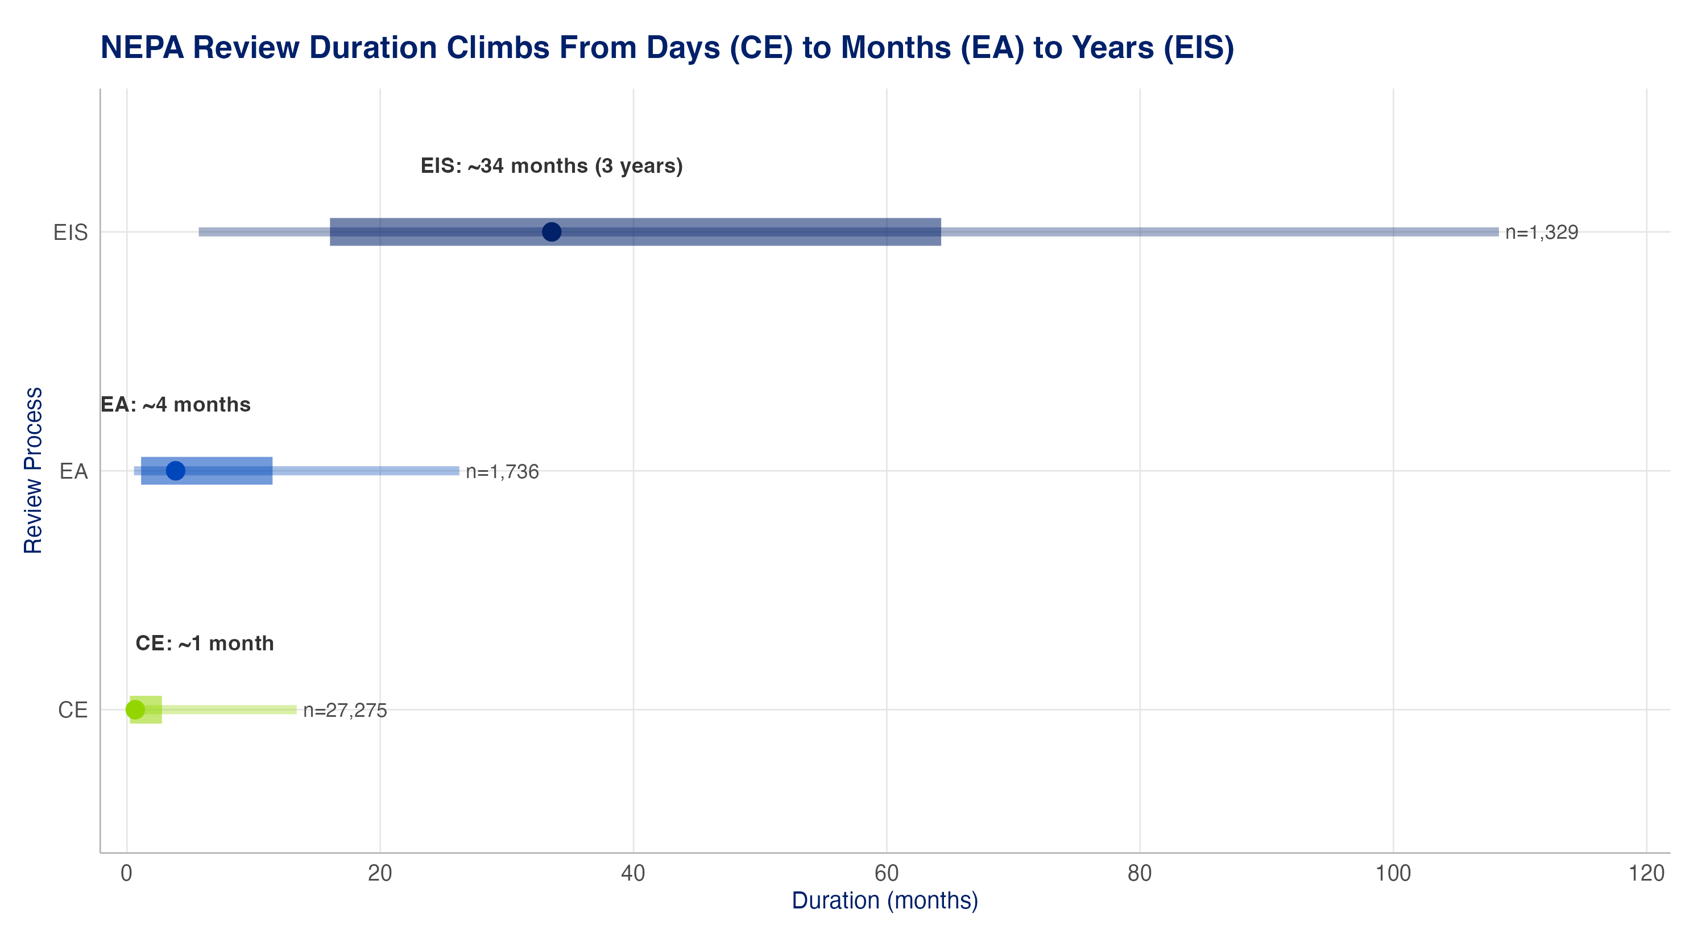
Figure 2: Note: Thin bar = 10th–90th percentile; thick bar = interquartile range (25th–75th); point = median. All complete timelines; month-only dates imputed to mid-month.
The full distributions show the same ladder as a shape, not just a median: CE durations pile up near zero, EAs spread out to a year or two, and the EIS distribution is broad and heavy-tailed — a meaningful share of EISs run 3–10+ years.
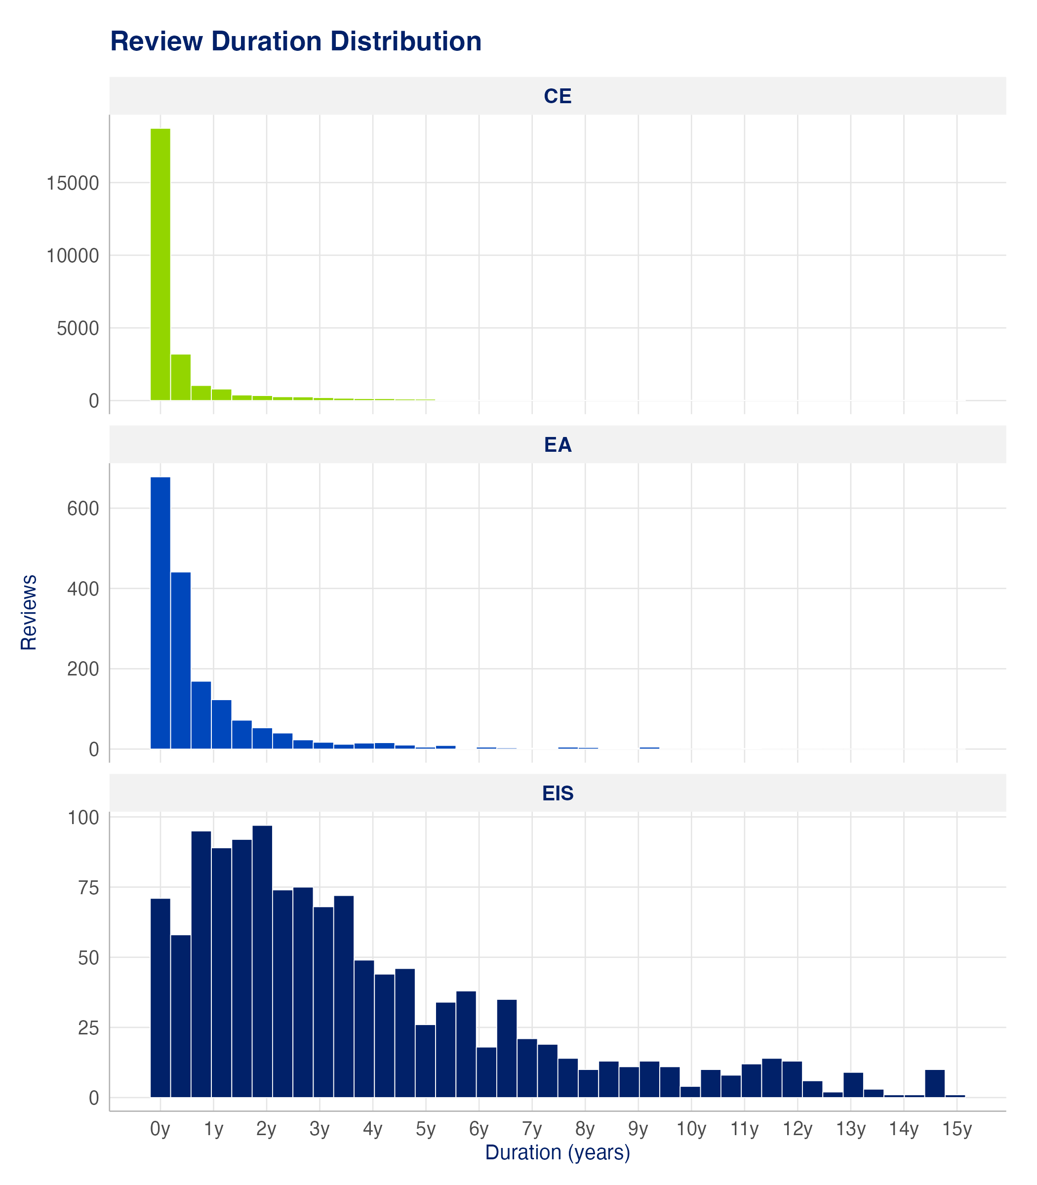
Figure 3: Note: Review duration distribution by process; all complete timelines.

Fossil and decarbonization projects take broadly similar time within each process
Within each review process, decarbonization and fossil projects take broadly similar time. Decarbonization and fossil EISs have similar median durations (~32 vs. ~35 months), and CE determinations are fast for everyone.
The one visible gap — fossil EAs appearing far faster (~1 month median vs. ~10 months for decarbonization) — is a data artifact rather than a real speed difference: 84% of fossil EAs take their start date from the BLM register, where the recorded “project start” is frequently a late administrative entry made within days of the decision. Restricting fossil EAs to document-stated start dates lifts their median to roughly five months, much closer to the decarbonization figure.
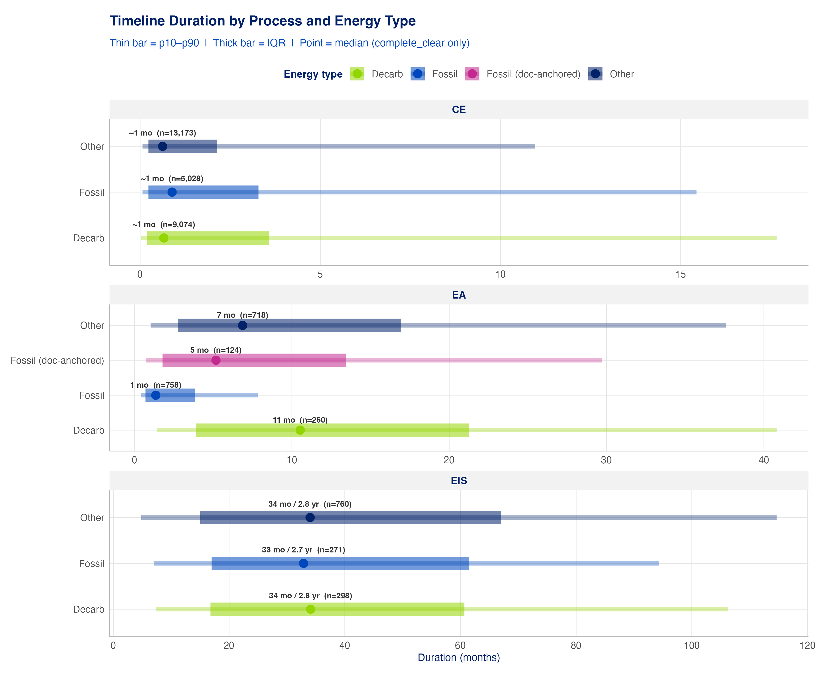
Figure 4: Note: Timeline duration by process and energy category. The magenta ‘Fossil (doc-anchored)’ row in the EA panel shows the corrected fossil-EA median using document-stated start dates only.

Duration by technology
Breaking durations down by technology (EA and EIS panels below; CE medians are under a month for every technology) shows the same conclusion at finer grain: no decarbonization technology faces systematically longer reviews than its fossil counterparts within the same process. Wind EISs sit at the high end with a long upper tail, coal EISs at a similar level; solar EISs conclude faster than the decarbonization average.
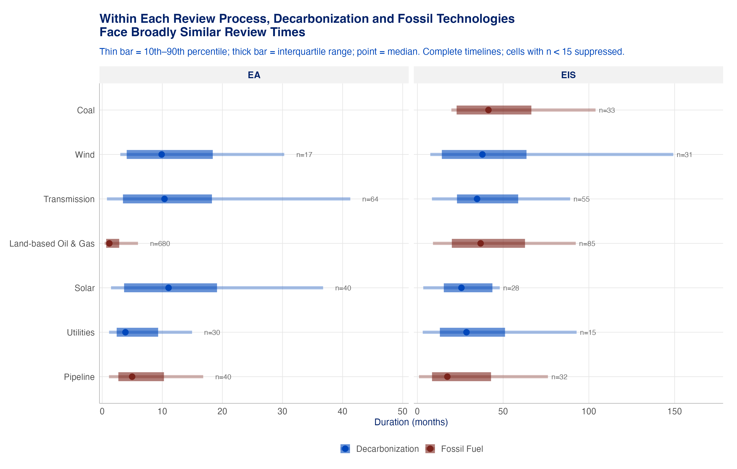
Figure 5: Note: Review duration by technology and energy category, EA and EIS panels. Thin bar = 10th–90th percentile; thick bar = interquartile range; point = median; cells with fewer than 15 complete timelines suppressed. Fossil EA durations are compressed by the register start-date artifact described above.

What Phase 1 found: programmatic reviews and solar
Two Phase 1 findings on decarbonization timelines carry forward:
- Programmatic and tiered reviews remain rare but promising. Tiered EISs — site-specific reviews that build on an umbrella programmatic review — were faster on median (593 days) than standard (1087 days) or programmatic (914 days) EISs, though samples are small. Tiered EAs took longer than standard EAs (734 vs. 421 days), suggesting the real efficiency gain from tiering comes when it lets an agency avoid a full EIS altogether.
- Solar reviews conclude faster than decarbonization reviews generally. On the rebuilt Phase 2 timeline, solar EISs conclude about a year faster than the all-decarbonization EIS median (~22 vs. ~34 months), replicating the Phase 1 finding on a larger sample; solar EAs run on par with decarbonization EAs (~12 months).
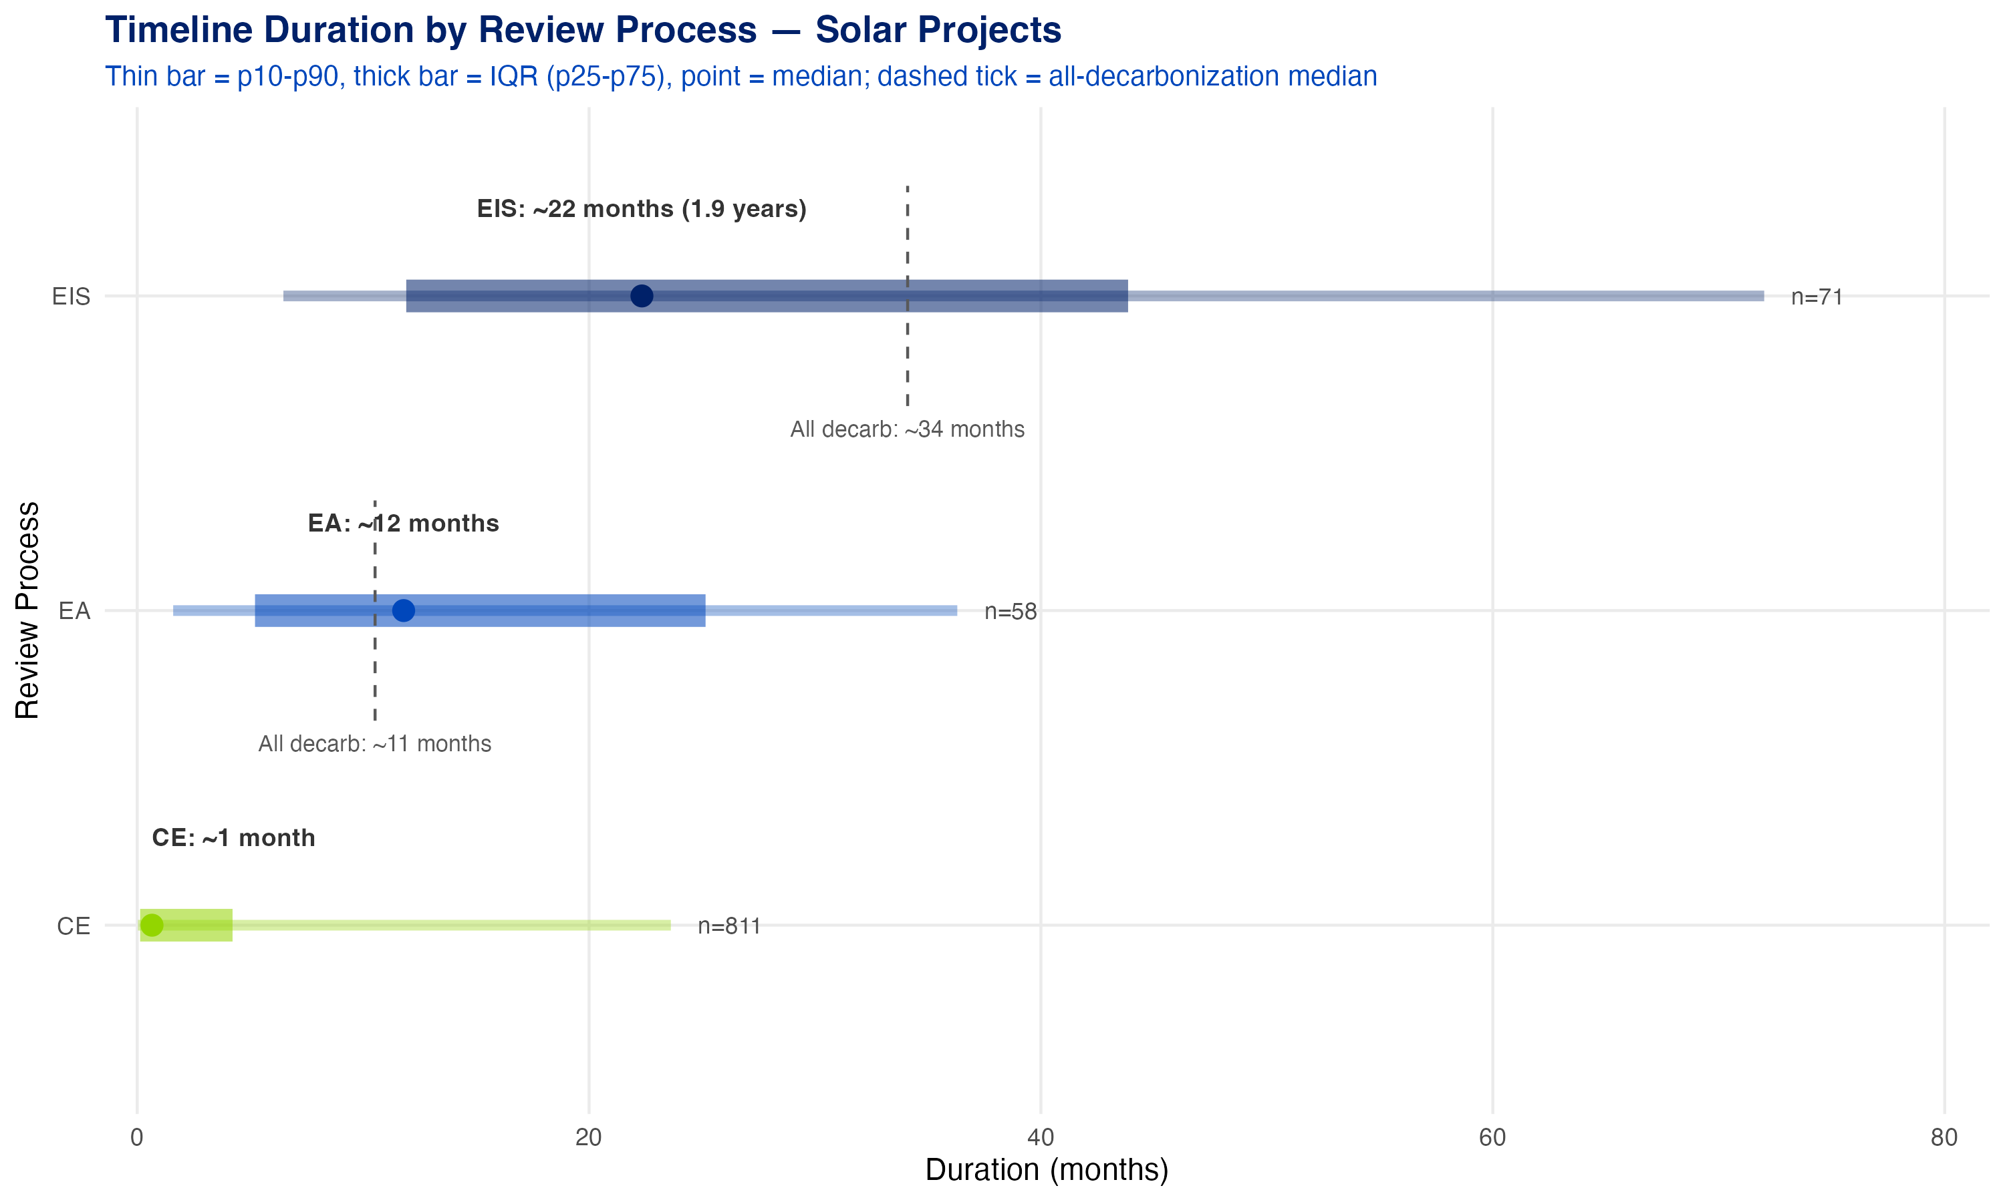
Figure 6: Note: Timeline duration for solar-tagged projects. Dashed tick = the all-decarbonization median for that process. Thin bar = 10th–90th percentile; thick bar = interquartile range; point = median.

Reviews by decision year
Review volume tracks federal funding cycles. CE volumes ramp up from the late 2000s (ARRA-era funding) with a second rise into the 2020s (BIL/IRA); EIS decisions lag CEs and EAs by several years, reflecting longer review cycles. The pattern is even sharper at the Department of Energy — the single largest agency in the dataset — where the ARRA and BIL/IRA grant-and-loan cycles dominate.
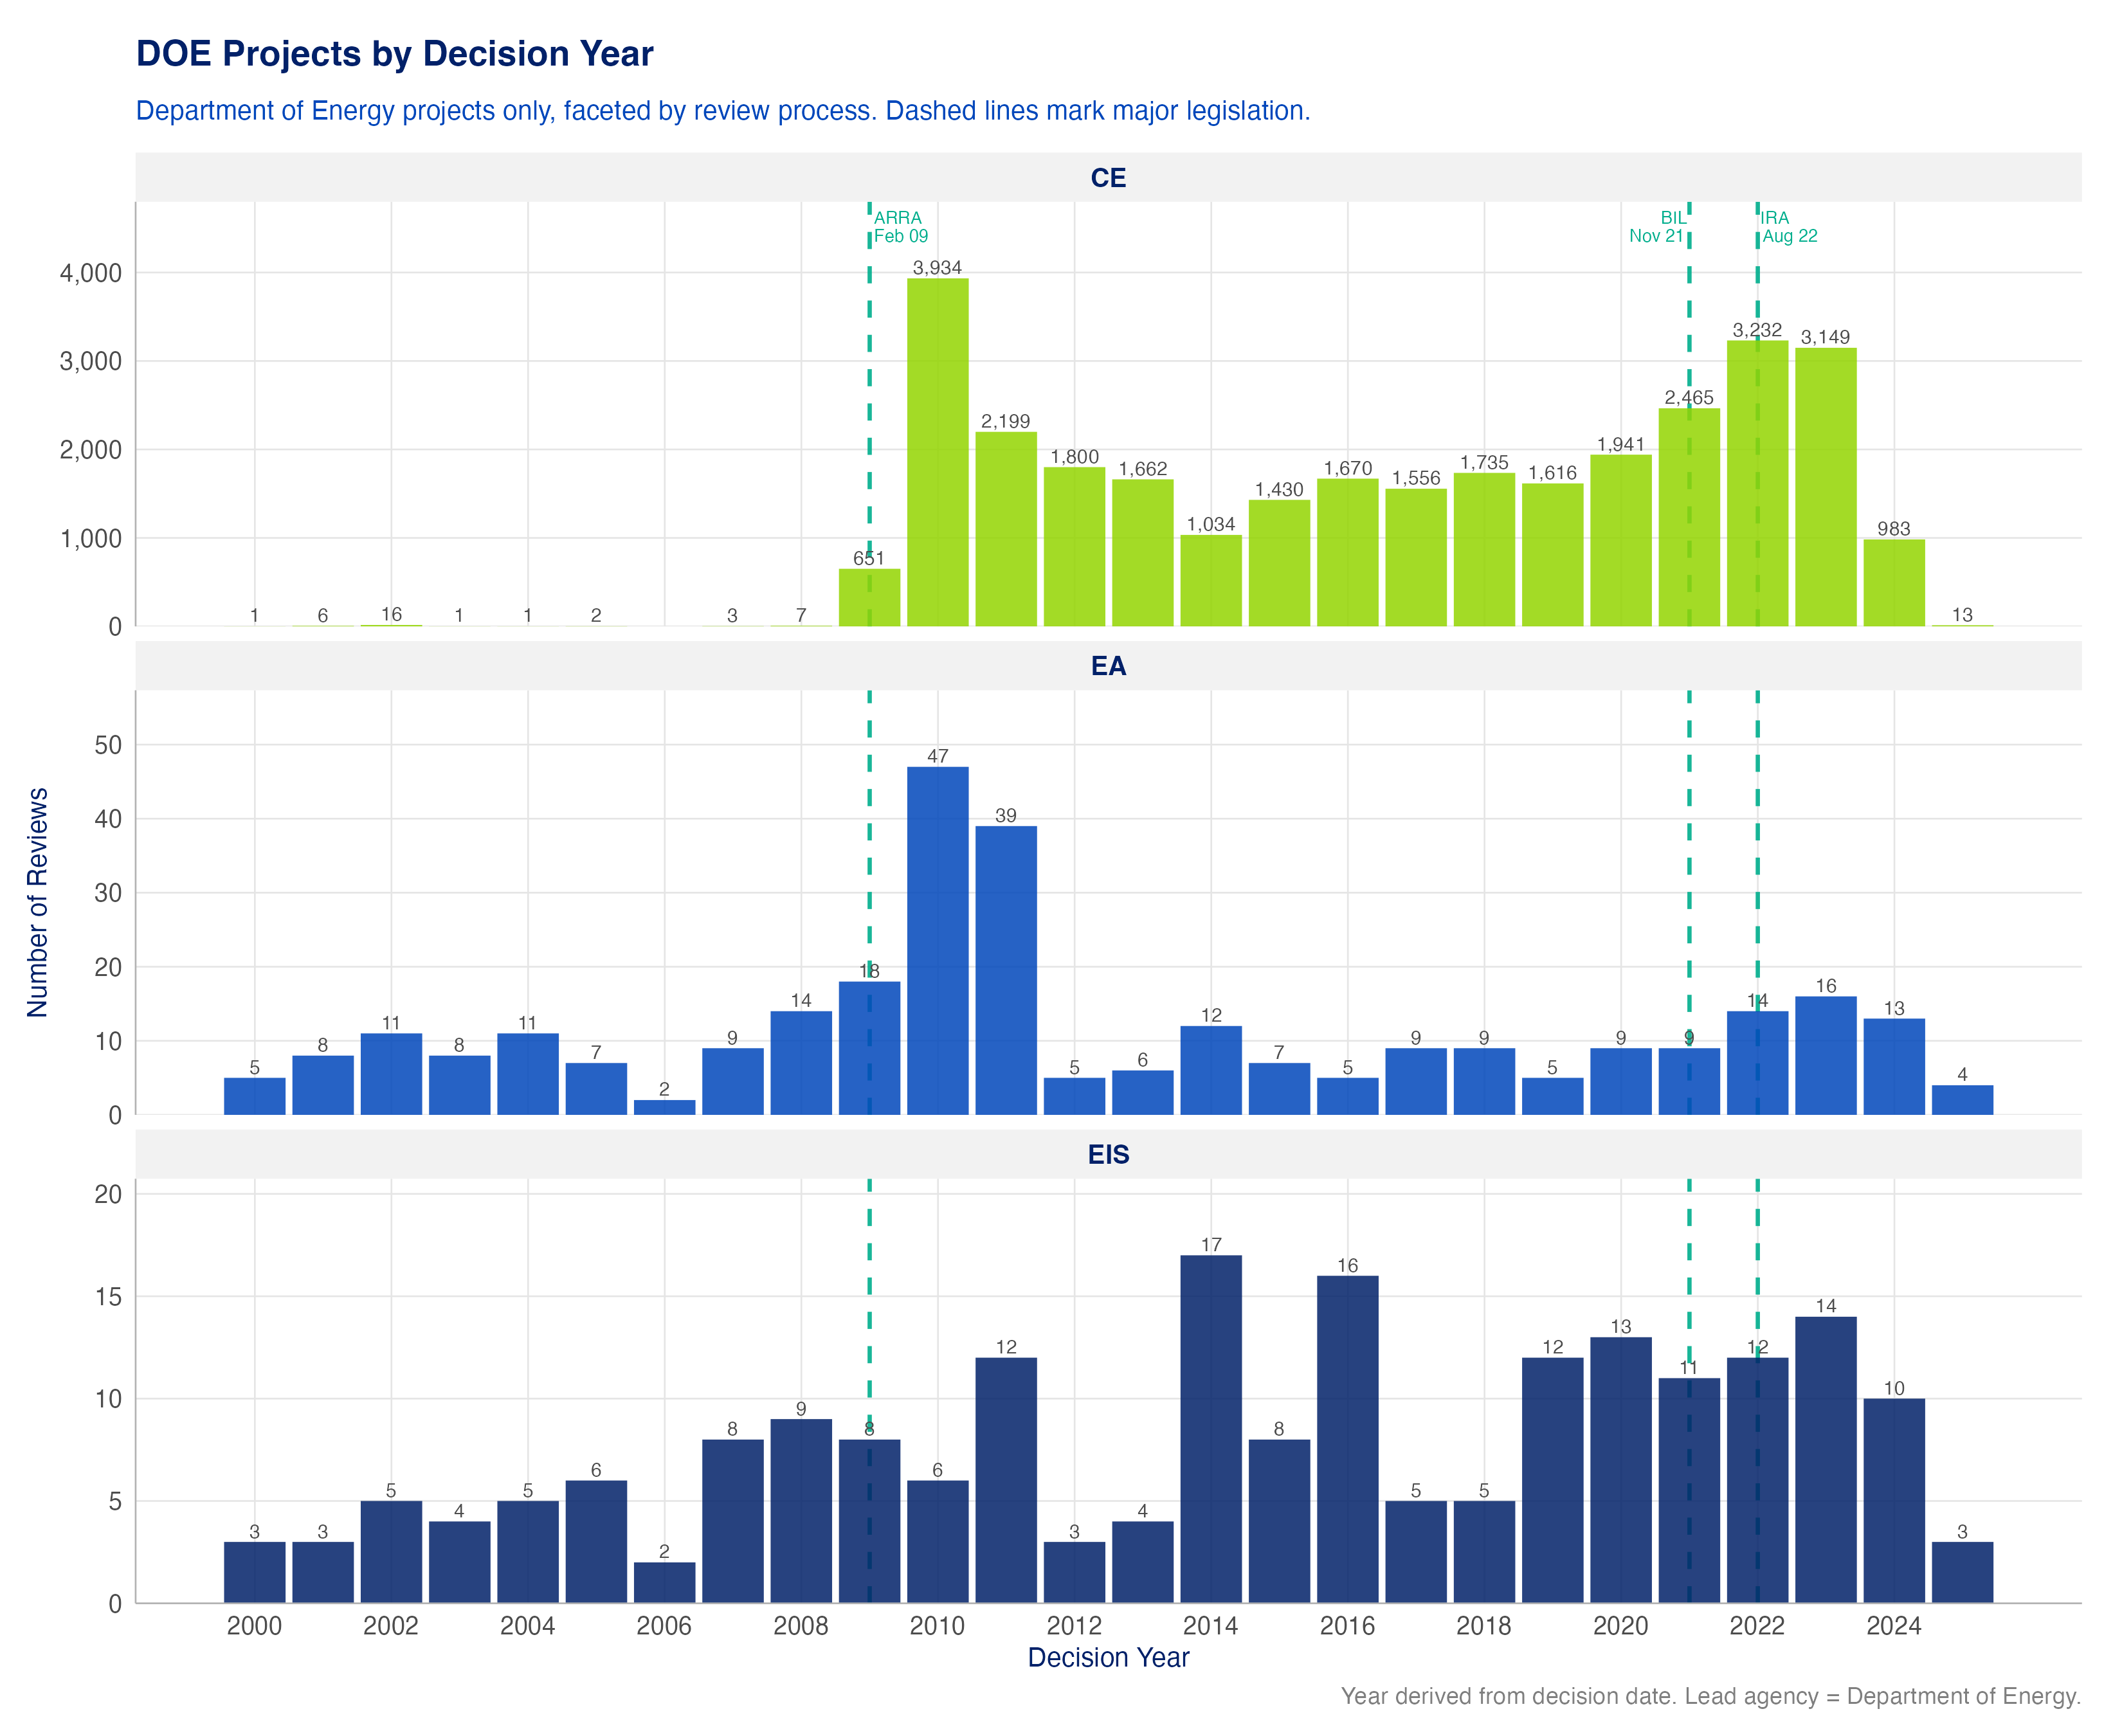
Figure 7: Note: Department of Energy projects by decision year, faceted by review process.

Before and after the Fiscal Responsibility Act
The FRA (enacted June 3, 2023) set statutory timeline targets and page limits. Two early findings, both provisional given the short post-FRA window:
Durations have not yet measurably fallen. Median EIS duration is essentially unchanged pre- vs. post-FRA (1,019 → 1,094 days; n = 106 post-FRA), and EA and CE medians are modestly higher post-FRA — though reviews decided shortly after enactment mostly ran under pre-FRA rules, and the post-FRA sample is confounded with data-coverage timing, so this should not yet be read as evidence the FRA failed.
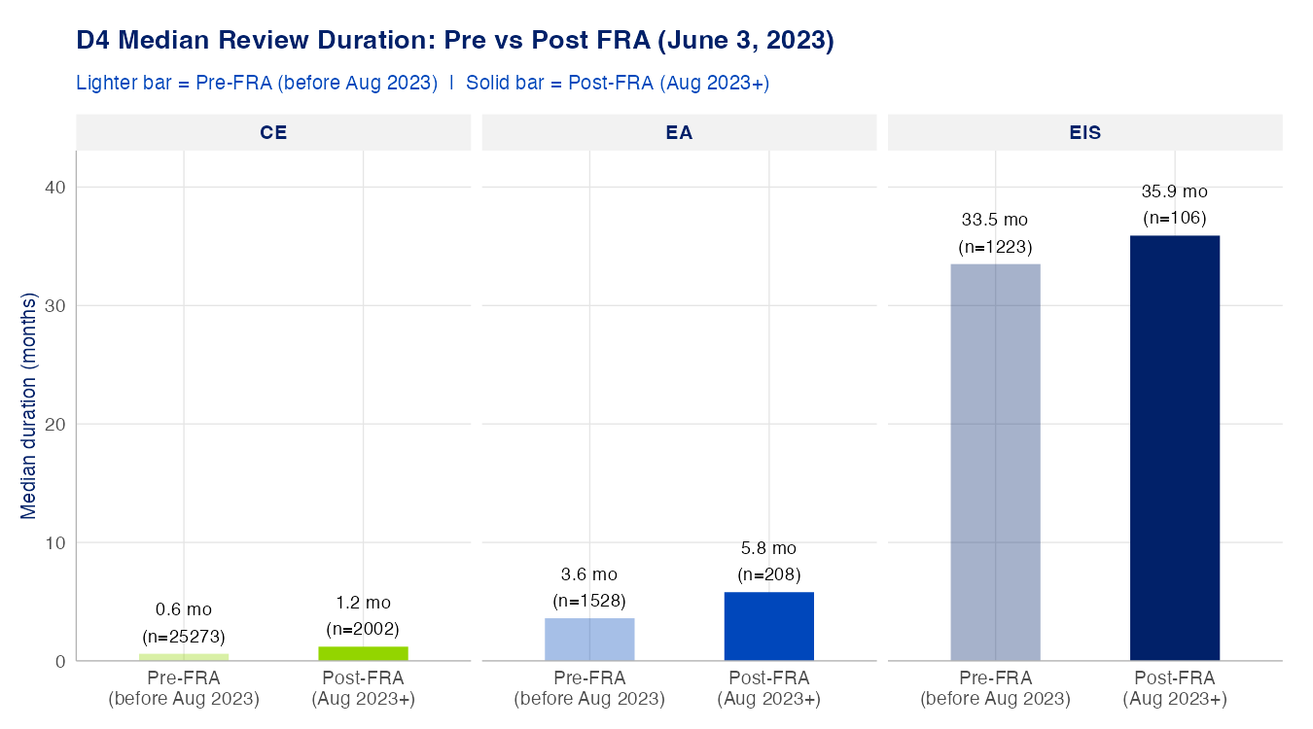
Figure 8: Note: Median review duration pre- vs. post-FRA (FRA enactment, June 3, 2023). Post-FRA samples are small and provisional.
Documents did get shorter — at least EISs. Mean EIS length fell from 318 to 269 regulatory pages (median 261 → 212), while EA length was essentially flat (33 → 39 pages) — EAs were already well under the 75-page limit. Against the FRA’s presumptive limits, 83% of post-FRA EAs comply with the 75-page limit; 32% of post-FRA EISs fall within the baseline 150-page limit, and 65% fall within the 300-page extraordinary-complexity ceiling.
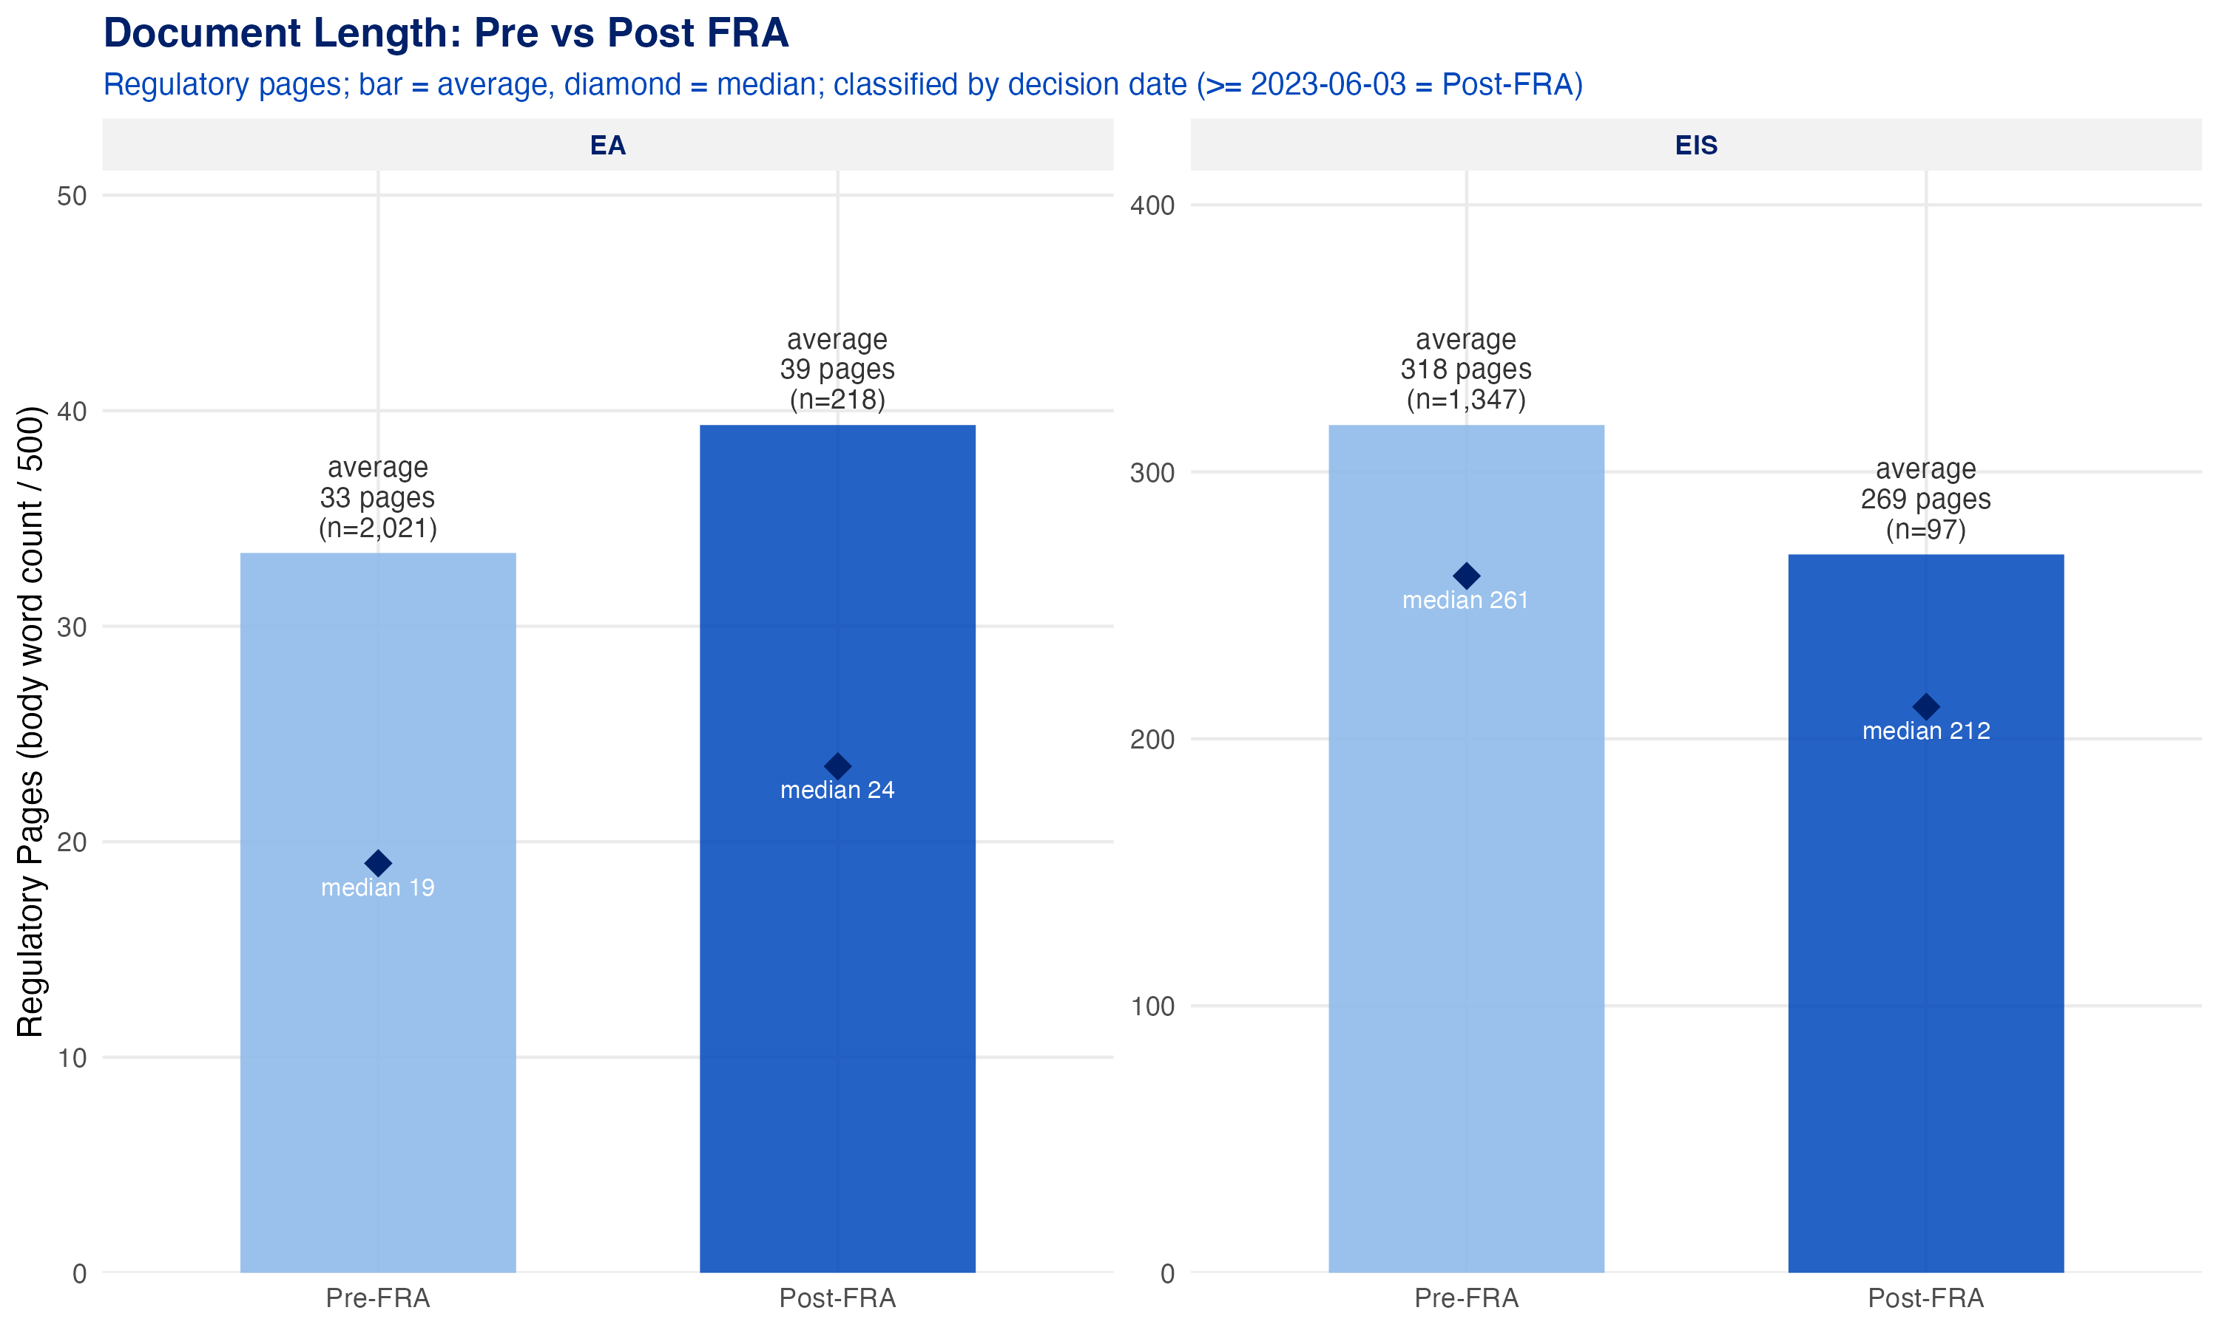
Figure 9: Note: Mean regulatory pages pre- vs. post-FRA (bar = mean; diamond = median). Regulatory pages = body word count ÷ 500, excluding appendices and low-content pages, per 40 C.F.R. § 1508.1(bb).
A parallel segmentation of durations by CEQ regulatory regime (1978 rules / 2020 rule / 2022–24 revisions / 2025 rescission) is in progress and will be added when complete.

Timeline outliers: the longest reviews
The right tail matters for policy: the highest-profile NEPA controversies involve reviews measured in decades. We flagged every review longer than ~13.7 years and read the evidence behind each. The distinction that matters is between genuinely long reviews and extraction errors:
- EIS outliers are mostly real. EIS median duration is already ~3 years; a 14–17-year EIS sits in the legitimate tail. Transmission, restoration, and resource-management EISs genuinely run that long.
- CE outliers are mostly errors. CEs are fast determinations, so a multi-year CE almost always reflects a mis-extracted start date (typically a decades-old citation — an original land grant, a covering programmatic review — selected as the initiation). These are flagged and excluded.
Table 1: Genuinely long EIS reviews — case-study candidates. Confirmed extraction errors, multi-year EA/CE spans, and pre-1990 initiations (a strong error signal) excluded.
Project | Process | Energy | Years | Initiation | Decision
Interstate Highway 35 Capital Express Central Project Fro… | EIS | Other | 29.8 | 1993-03-15 | 2023-01-05
Lower Cache Creek, Yolo County, Woodland and Vicinity, Ca… | EIS | Other | 23.6 | 1996-05-06 | 2019-12-27
2021 Land Management Plan Helena – Lewis and Clark Nation… | EIS | Other | 20.0 | 2001-10-26 | 2021-10-15
Rawlins Resource Management Plan | EIS | Other | 17.7 | 2002-02-25 | 2019-11-13
West Mojave Route Network Project | EIS | Other | 16.3 | 2003-06-07 | 2019-10-02
Clearwater National Forest Travel Planning | EIS | Other | 16.1 | 2007-11-28 | 2024-01-15
Pima County Multi-Species Conservation Plan | EIS | Other | 15.4 | 2000-09-07 | 2016-01-15
Placer County Conservation Program | EIS | Clean | 15.2 | 2005-03-15 | 2020-05-16
Proposed Roan Plateau Planning Area Resource Management P… | EIS | Fossil | 14.8 | 2000-11-16 | 2015-09-22
Malheur National Forest Site-Specific Invasive Plants Tre… | EIS | Other | 14.7 | 2000-06-26 | 2015-03-15
The table itself is dominated by land-management planning EISs (resource management plans, travel plans, conservation plans) rather than individual energy projects. Among energy projects, the strongest case-study candidates are SunZia Southwest Transmission (right-of-way application September 2008 → Record of Decision April 2023), Energia Sierra Juarez, Grain Belt Express, and Cushman Hydroelectric — exactly the protracted, multi-administration reviews that dominate the permitting-reform debate. Cushman’s 18.1-year span (a 1992 notice of intent through a 2010 record of decision for the same FERC relicensing action) was flagged by our automated date-triage and subsequently verified by hand against the final EIS’s own procedural history. [Short case studies on 1–2 of these to be added by CATF if timing allows; otherwise a follow-up research product.]

Conclusion and Policy Implications
Review duration scales as expected across CE, EA, and EIS — and decarbonization projects are not being singled out for slower treatment. The median CE takes weeks, the median EA months, and the median EIS about three years; within each process, fossil and decarbonization projects take broadly similar time. For decarbonization deployment, this reinforces a Phase 1 conclusion: because the overwhelming majority of decarbonization actions are resolved through fast CEs, reforms targeting EIS speed alone touch a small slice of the portfolio.
It is too early to see the FRA’s timeline reforms in the duration data — but document length is already responding. EIS page counts dropped meaningfully post-FRA while durations held steady. Whether shorter documents eventually translate into shorter reviews is a question the data can answer in another year or two of decisions. [Findings from the CEQ-regulatory-regime segmentation to be added once that analysis is complete.]
The single highest-value reform for understanding NEPA timelines is better data. Every date in this analysis had to be recovered from document text or agency registers because no federal system records when reviews begin and end — and structural gaps (missing Records of Decision, unrecorded CE/EA start dates) cap what any extraction method can achieve. Agency adoption of the CEQ NEPA and Permitting Data and Technology Standard — recording initiation, milestones, and decision dates as structured metadata — would make complete, real-time timeline accountability possible not just for researchers but for the agencies themselves.

Data: NEPATEC 2.0 (61,881 projects). Methods and full results: Phase 2 Deliverable 4.

