Where NEPA Draws the Line: Determinations of Significance
NEPA by the Numbers — Fact Sheet 5: Significance Across Resource Areas
July 25, 2026

Key Findings
 Key Findings
- One word — “significant” — sets a project’s whole review path. A not-significant finding puts a project on the fast track (a Finding of No Significant Impact, or FONSI); a significant finding triggers a full Environmental Impact Statement (EIS) that can add a year or more. This fact sheet is the first systematic look at how agencies draw that line for decarbonization projects.
- Most decarbonization FONSIs are mitigated. About 58% of analyzed FONSI decision documents reach “no significant impact” only because the developer commits to specific measures — the impact would have been significant otherwise. The mitigation burden concentrates in a handful of resources: biological (30%), soils / geology (28%), water (26%), cultural / historic (22%).
- On the EIS side, visual impacts cross the line most — judged significant more often than any other resource (visual (33%)), and most likely to be declared significant and unavoidable, because a changed landscape usually cannot be mitigated back.
- Resources split into two shapes. Some are reliably managed below the line (soils/geology, water, public health — mitigated in FONSIs, rarely crossing); others break through (visual, land use, air quality — judged significant more often than they are engineered under).
- Mitigation does much of the work — but is not always demonstrably enforceable. For the “softer” resources (visual, cultural, soils), the committed measures behind a not-significant finding are least often tied to an enforceable permit condition — a caveat for how much weight the “mitigated FONSI” label should bear.

Introduction
When a decarbonization project (a solar farm or a transmission line) needs federal approval, the lead agency studies its environmental impact and makes one judgment call: is that impact significant or not? That single determination decides the project’s review path. If the agency finds the impact not significant, the project moves ahead on a faster track, documented in a Finding of No Significant Impact (FONSI). If it finds the impact significant, the project requires a full Environmental Impact Statement (EIS), a longer and more demanding review that routinely adds a year or more to the timeline.
Often the agency lands in between: the impact would be significant unless the developer commits to specific measures to reduce it. That is a mitigated finding, and it is the most revealing case, because it shows the exact line the agency drew and what it required to stay on the safe side of it.
The diagram below is the vocabulary this fact sheet uses. Every determination lands in one of these outcomes, and “the line” is the significance threshold that separates the fast track from the full review:
Where it lands | Outcome | What it means
Above the line (EIS) | Significant & unavoidable | The impact is significant and no available measure can bring it below the threshold — the extreme case.
Above the line (EIS) | Significant adverse | The impact crosses the threshold, so the full EIS review applies.
— the significance line — |  | The threshold that separates the fast track from the full review.
Below the line (FONSI) | Less than significant with committed mitigation | The impact would cross the line, but required measures pull it under — the mitigated FONSI, this fact sheet’s central subject.
Below the line (FONSI) | Less than significant | A real but minor impact that stays under the line on its own.
Below the line (FONSI) | No significant impact | No meaningful impact on the resource — the below-the-line default.
Despite how much rides on this determination, there has been no prior research we are aware of showing the trends in significance calls: how often agencies stay below the line, the role mitigation plays, and which environmental factors push a project over the threshold. Answering those questions means reading a judgment call out of thousands of dense decision documents — far more than anyone could review by hand.

Methodology
We analyze two document tracks separately, because they record opposite outcomes. FONSIs are the below-the-line record, where agencies concluded the impact is not significant and where the mitigated cases live. EISs are the above-the-line record: impacts the agency judged significant, and at the extreme significant and unavoidable.
The workflow pairs the scale of automation with the reliability of human judgment. Software locates the specific passages where significance findings live; a language model (Claude) codes each one — outcome, resource area, threshold, mitigation. In parallel, two AI coders independently label a stratified 400-passage sample per track and a human adjudicator settles every disagreement, producing an answer key. The extraction is scored against that held-out key before any result counts. Every reported number traces back to a source passage.
The two tracks together span a larger EIS corpus and a smaller FONSI corpus, and both touch every major resource area:
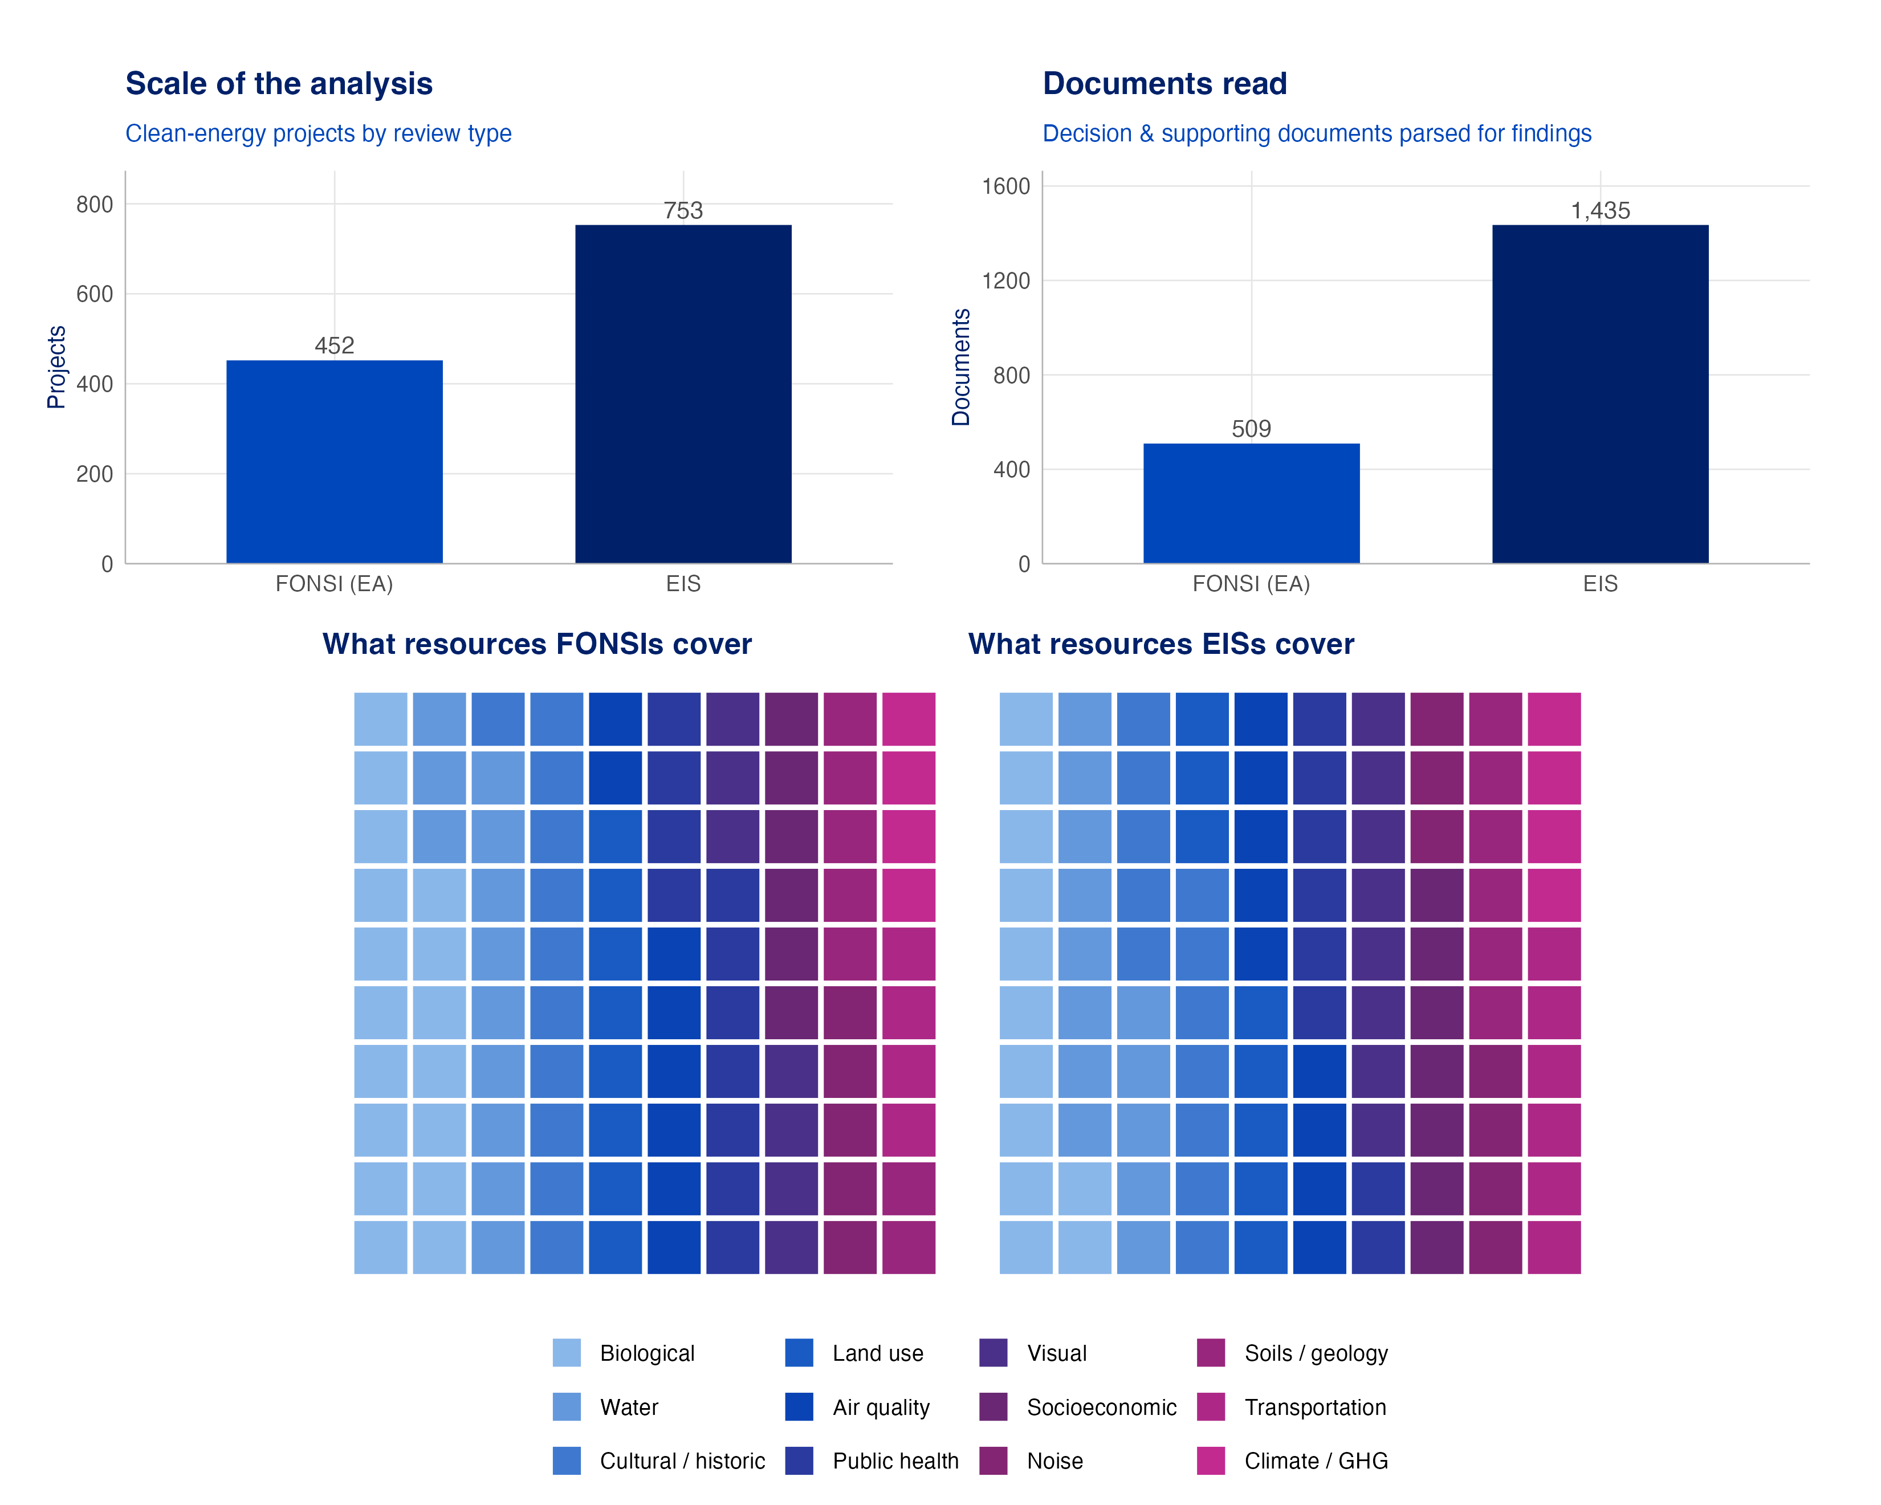
Figure 1: Note: The scale of analysis, by review type — projects and the documents actually parsed for findings (top; the EIS corpus is the larger one), and the mix of resource areas the determinations cover for FONSIs and EISs (bottom; each square ≈ 1% of that track’s determinations).

FONSI Analysis: How Agencies Stay Below the Line

Scope, coverage, and accuracy
The FONSI analysis rests on the decarbonization FONSIs that are led by BLM or the Department of Energy family and carry machine-extractable significance findings — 258 decision documents across 193 projects. Every rate below describes those documents, not the full corpus; the reduction is a coverage limitation (some documents phrase their finding in wording the extraction does not recognize), not a different finding.
Accuracy is measured against the AI-human answer key on a held-out test. The extraction almost never misses a determination, places it in the right resource area about 89% of the time, and agrees with the answer key on the significance class at 0.81, the standard bar for this kind of task. The three signals that carry the findings — finding the determination, placing the resource, and getting the class — all clear or approach that bar.

How agencies stay below the line
Within FONSIs the determinations sit, almost without exception, below the significance line: the agency either finds no significant impact outright or an impact that is less than significant, sometimes only with committed mitigation. The dominant outcome is no significant impact, as expected. But the resources agencies analyze most — biological, water, cultural/historic — are also where the close calls concentrate: the committed-mitigation band is widest for biological, soils/geology, and water.
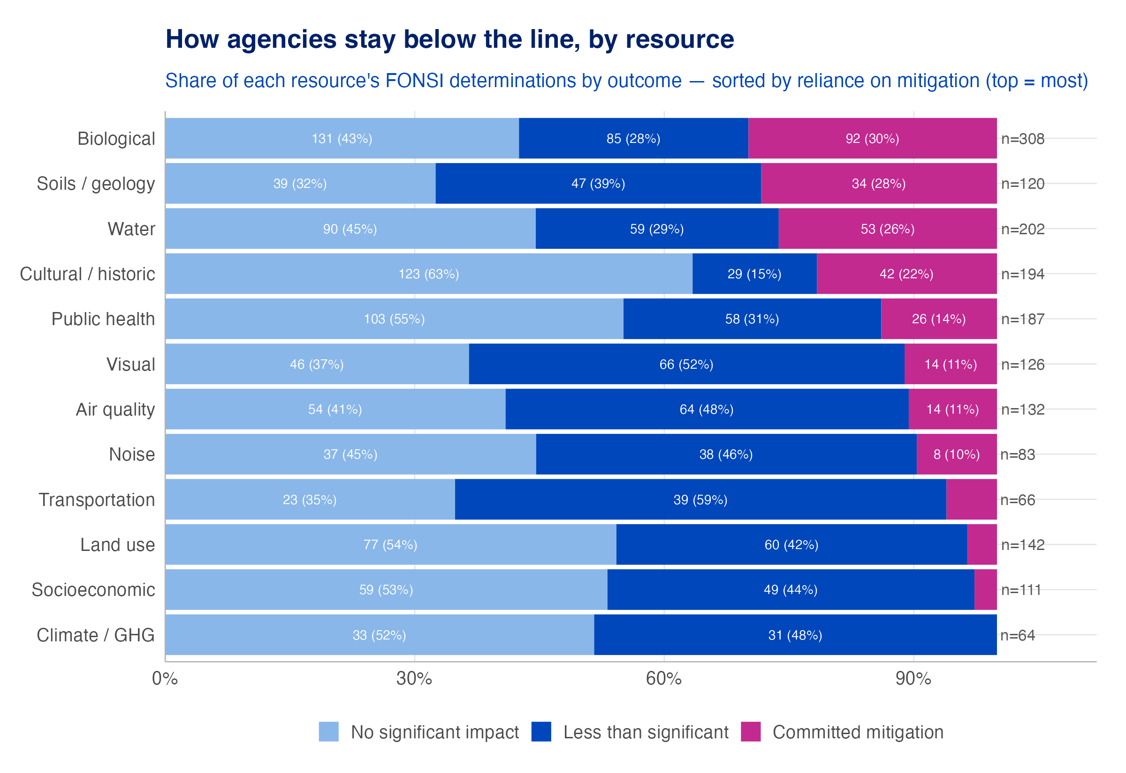
Figure 2: Note: Share of each resource’s FONSI determinations by outcome, sorted by reliance on mitigation. Resources with more committed-mitigation share lean harder on required measures to reach a not-significant finding.

Mitigated FONSIs — the line itself
The most revealing determinations are the mitigated ones: impacts the agency says would be significant, brought below the line only by required measures. They show exactly where the line sits and what it costs to stay under it, and they are the majority of FONSIs. About 58% of the analyzed FONSI documents are mitigated, with at least one resource whose not-significant conclusion depends explicitly on committed mitigation.
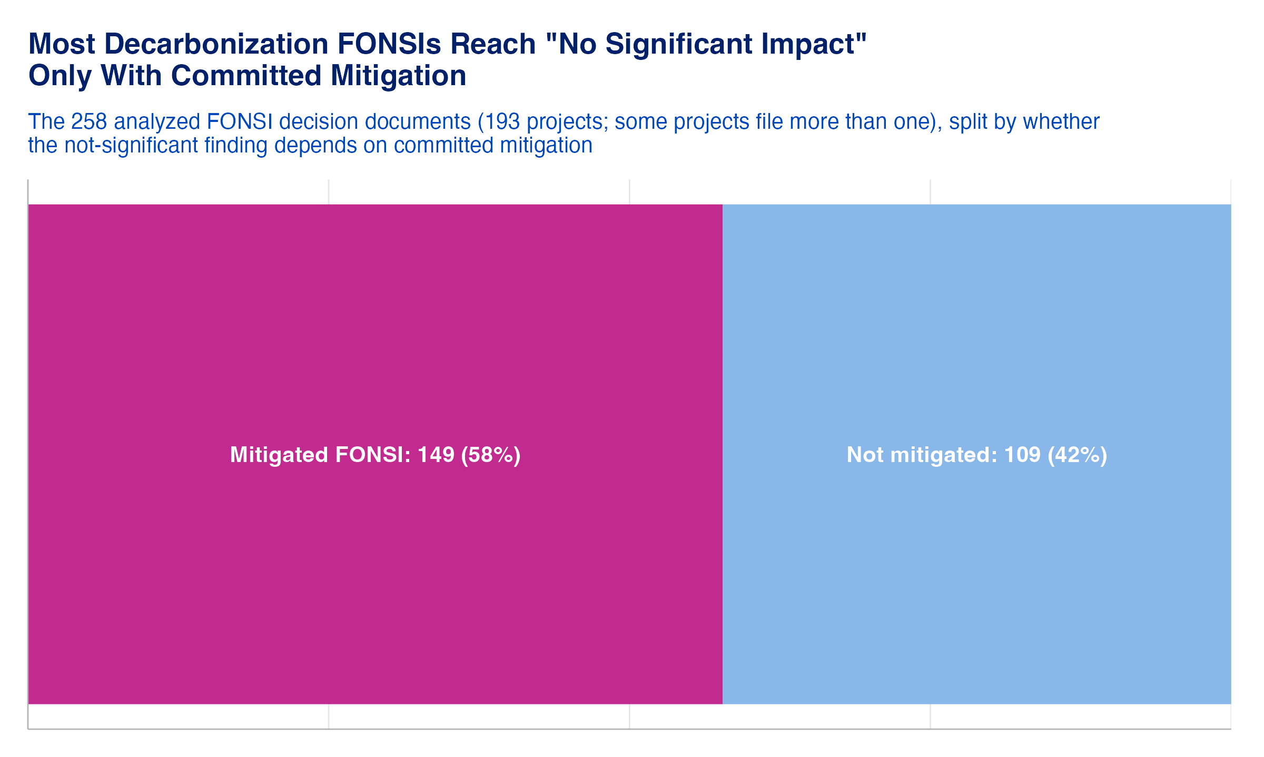
Figure 3: Note: Share of FONSI documents that reach a not-significant finding only with committed mitigation (per-resource class signal).
The mitigation burden is concentrated in a few resources — biological (30%), soils / geology (28%), water (26%), cultural / historic (22%) — the areas where decarbonization projects most frequently sit at the line and are pulled under it by mitigation. Reading volume and mitigation-intensity together sharpens the picture: biological resources dominate both axes (analyzed often and mitigated often), while soils/geology are mitigated intensively despite lower volume.
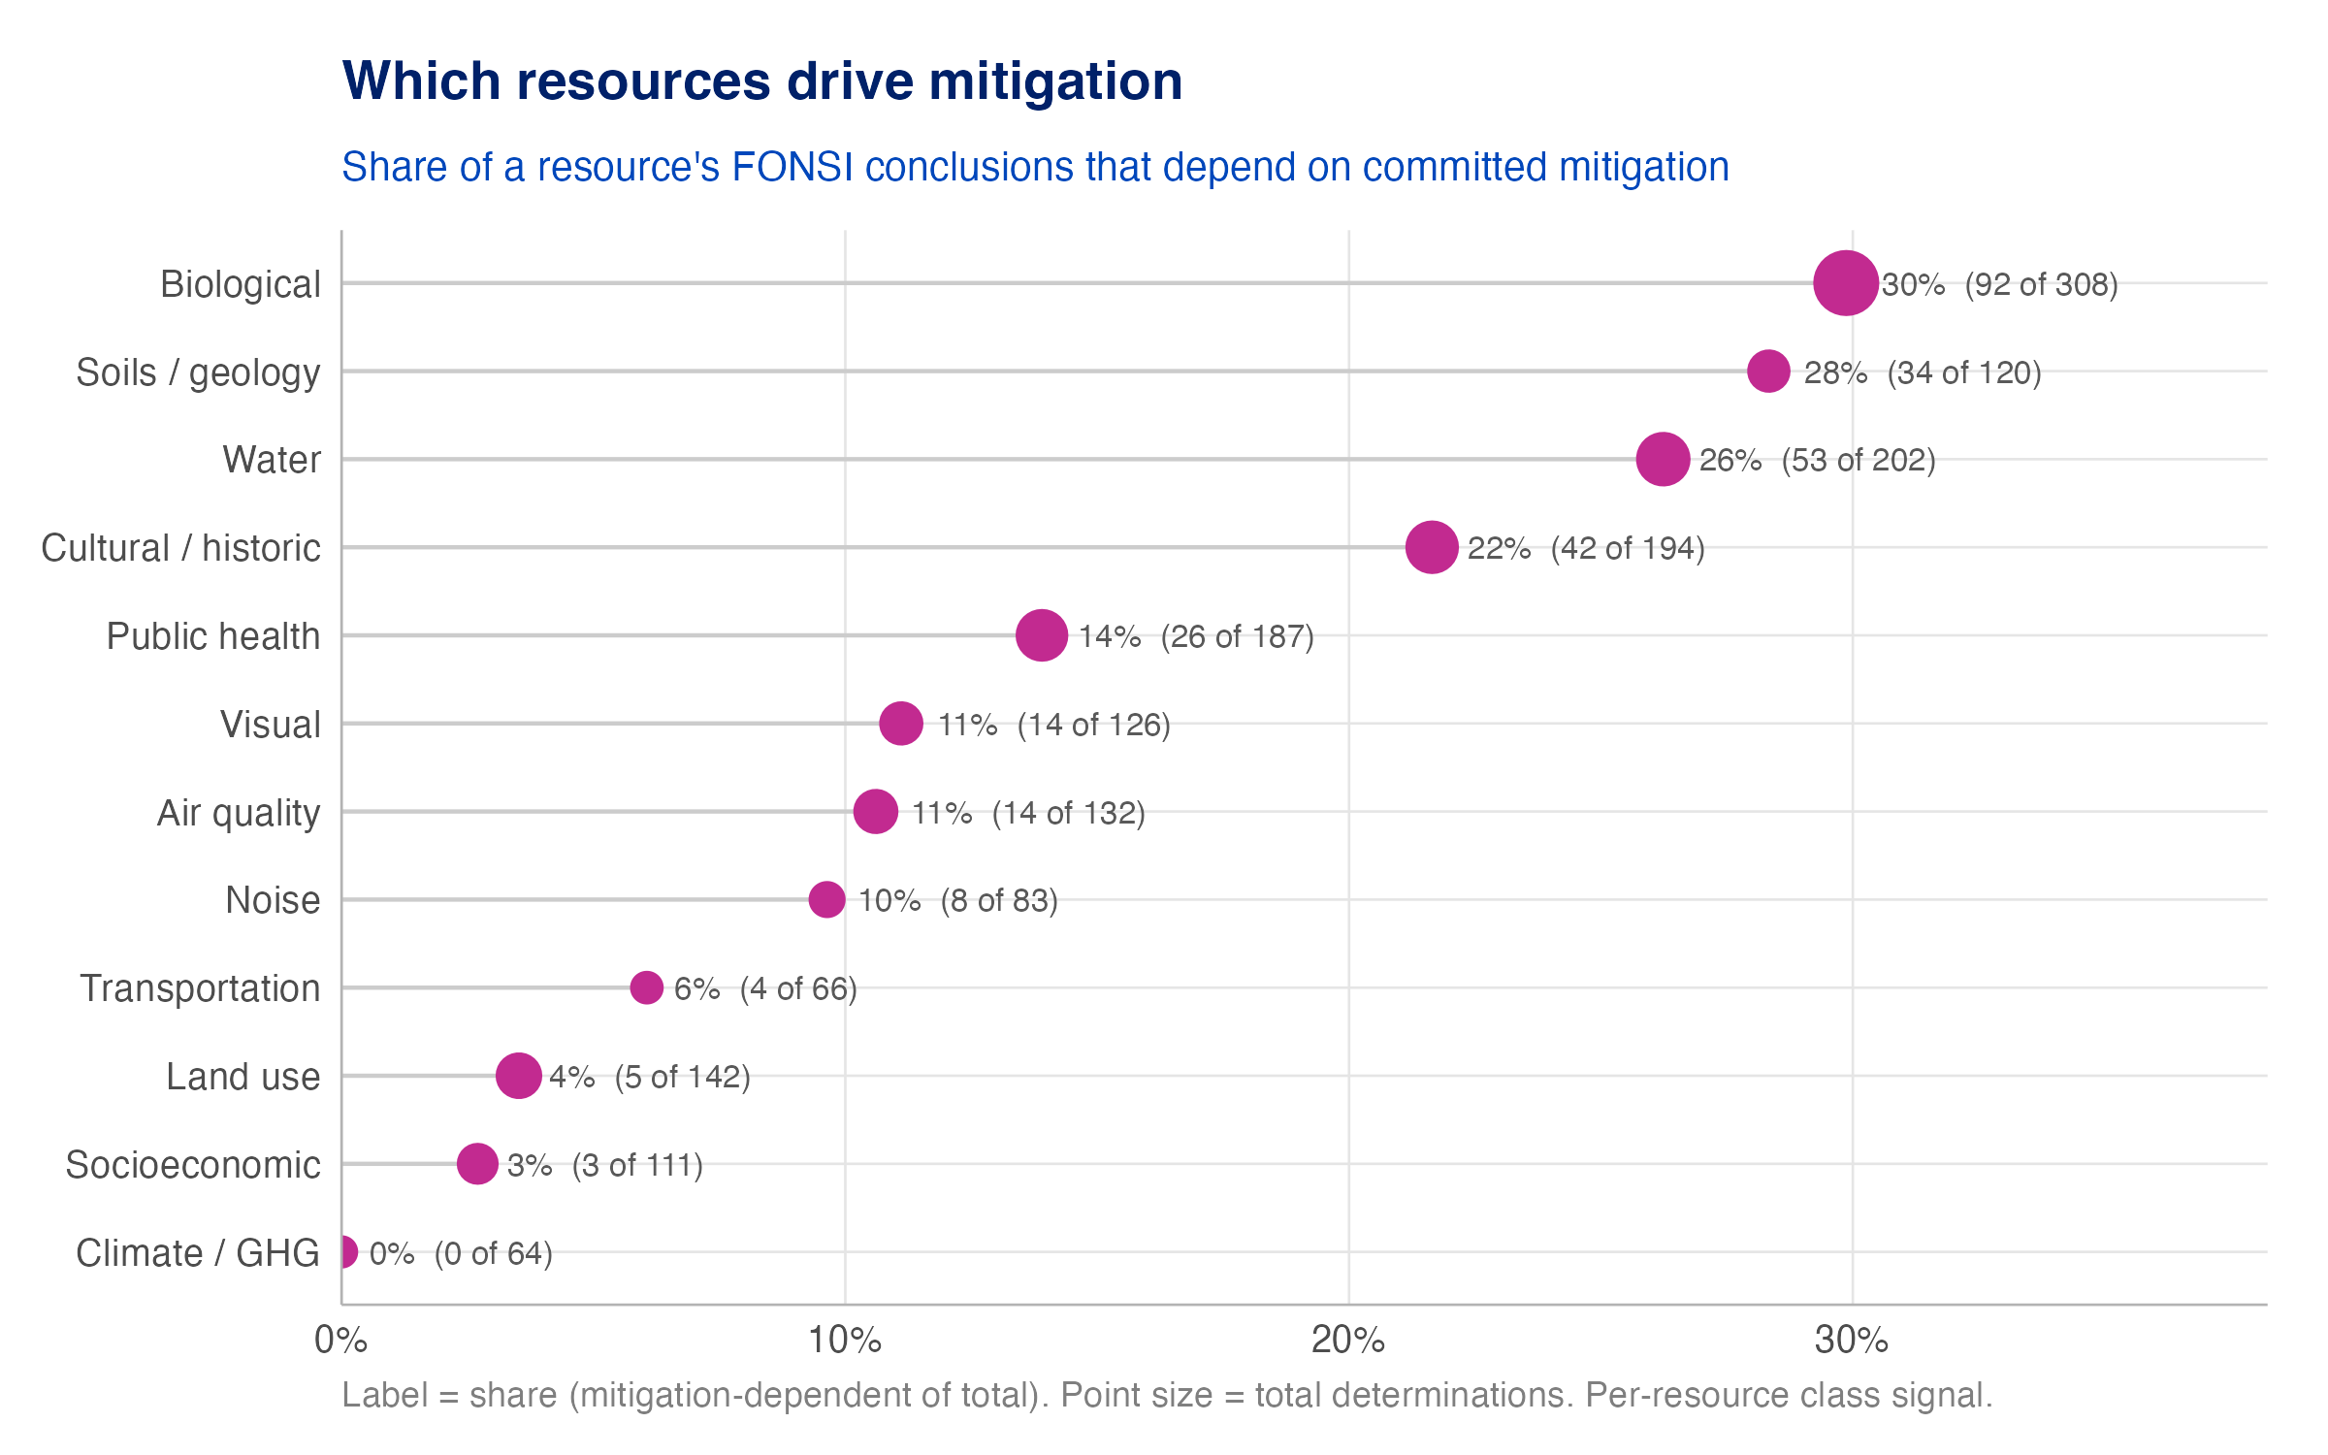
Figure 4: Note: Share of a resource’s FONSI conclusions that depend on committed mitigation. Point size scales with how often the resource is analyzed.

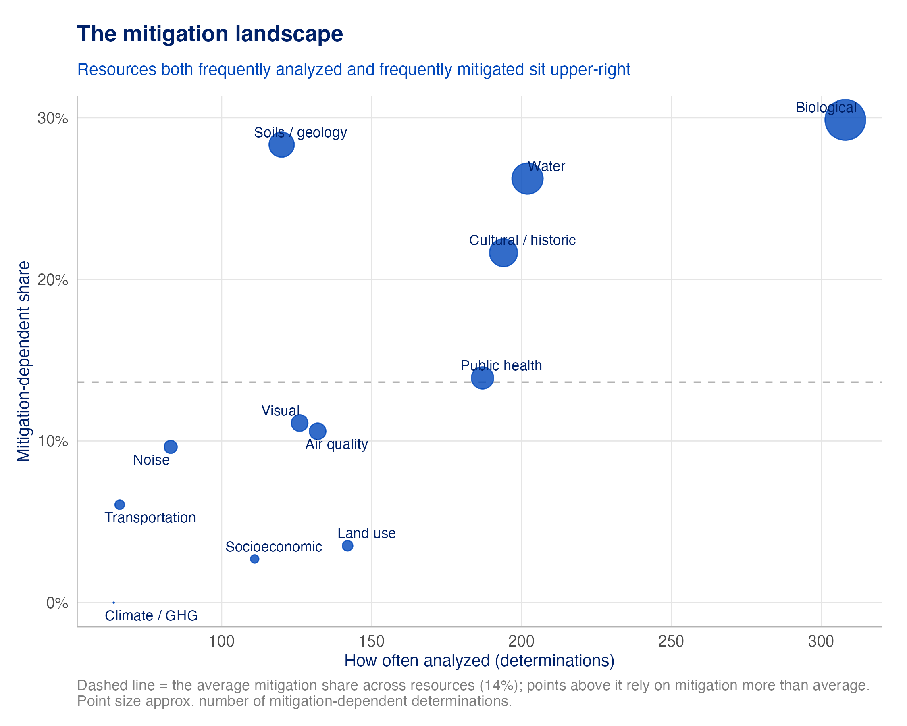
Figure 5: Note: Each resource by how often it is analyzed (x) and how often its conclusion depends on mitigation (y). Dashed line = overall average mitigation share. Resources in the upper right most shape whether a project can take the faster FONSI path.
A second, independent line of evidence confirms the pattern. For each flagged effect we can look at the committed mitigation conditions nearby and ask whether any addresses the same resource area — a direct join between an impact and a commitment. On that basis, 23% of flagged FONSI determinations are matched to at least one same-resource mitigation condition, concentrated in the same areas as the class signal. (The match rule is deliberately inclusive, so read this as an aggregate map of which resources recurringly attract same-resource mitigation, not a per-project ruling.)
What do these mitigations actually look like? A representative measure per resource, ordered from the most mitigation-heavy resources down:
Table 1: Representative mitigation measures behind less-than-significant-with-mitigation conclusions, by resource area (one example per resource; verbatim from the FONSI).
Resource | Example mitigation drawn from the FONSI
Air quality | Air quality impacts would be low, temporary, and would not violate air quality standards, with dust control mitigation minimizing construction impacts.
Biological | Restricting construction to August/September is intended to mitigate potential nest failure and displacement effects on Red-throated Loons.
Cultural / historic | KSU committed to minimize or avoid potential effects to cultural resources via protection measures detailed in section 2.5 of the EA.
Land use | KSU committed to implement protection measures to minimize or avoid potential effects to land uses as detailed in section 2.5 of the EA.
Noise | Construction noise would be discernable up to 2,000 feet but would be low to moderate and mitigated by limiting activities to daytime hours where feasible.
Public health | With mitigation measures and BMPs, fire-prevention measures and traffic management would prevent disruption to fire, police, and medical emergency services.
Socioeconomic | Agricultural land disturbance would be temporary and mitigated by revegetation, scheduling around fallow periods, compensating landowners for crop loss, and maintaining fences/gates.
Soils / geology | Use of BMPs and implementation of a construction SWPPP would ensure that short-term soil erosion and sediment transport impacts remain minor.
Transportation | KSU committed to minimize or avoid potential effects to transportation through the protection measures detailed in section 2.5 of the EA.
Visual | KSU committed to minimize or avoid potential effects to visual resources through protection measures in section 2.5 of the EA.
Water | Wetlands in the area were inventoried and potential impacts were mitigated in the design of the Proposed Action alternative.

Mitigation drivers differ by agency and technology
BLM and the DOE family run different kinds of projects, so the resources that push them to mitigate differ too. Biological, cultural/historic, air quality, and visual resources drive mitigation harder for BLM (land-facing impacts on habitat, historic sites, and viewsheds), while noise and water lean toward the DOE family (facility- and construction-driven effects).
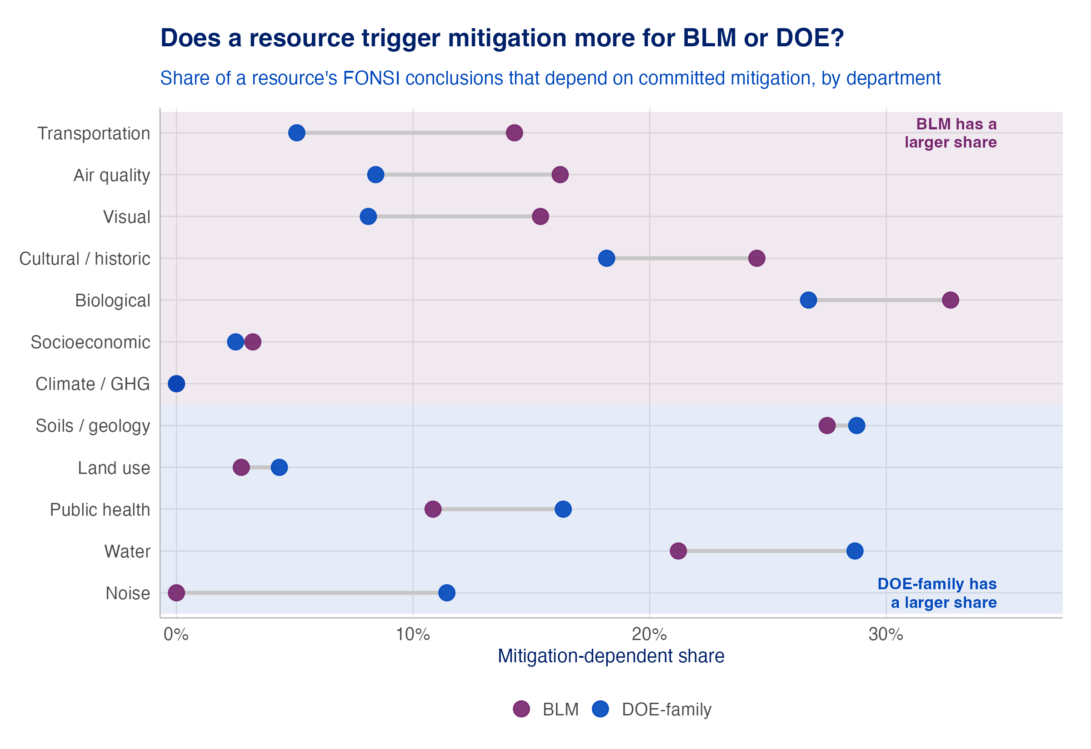
Figure 6: Note: Share of each resource’s FONSI conclusions that depend on committed mitigation, BLM versus the DOE family. A wider gap means the resource is a bigger mitigation driver for one department than the other.
The project type matters as much as the agency. Transmission and wind lean hardest on mitigation: linear corridors and turbine sites touch habitat, viewsheds, and cultural resources that repeatedly need committed measures to reach a not-significant finding. Solar and storage sit lower, closer to the corpus average.
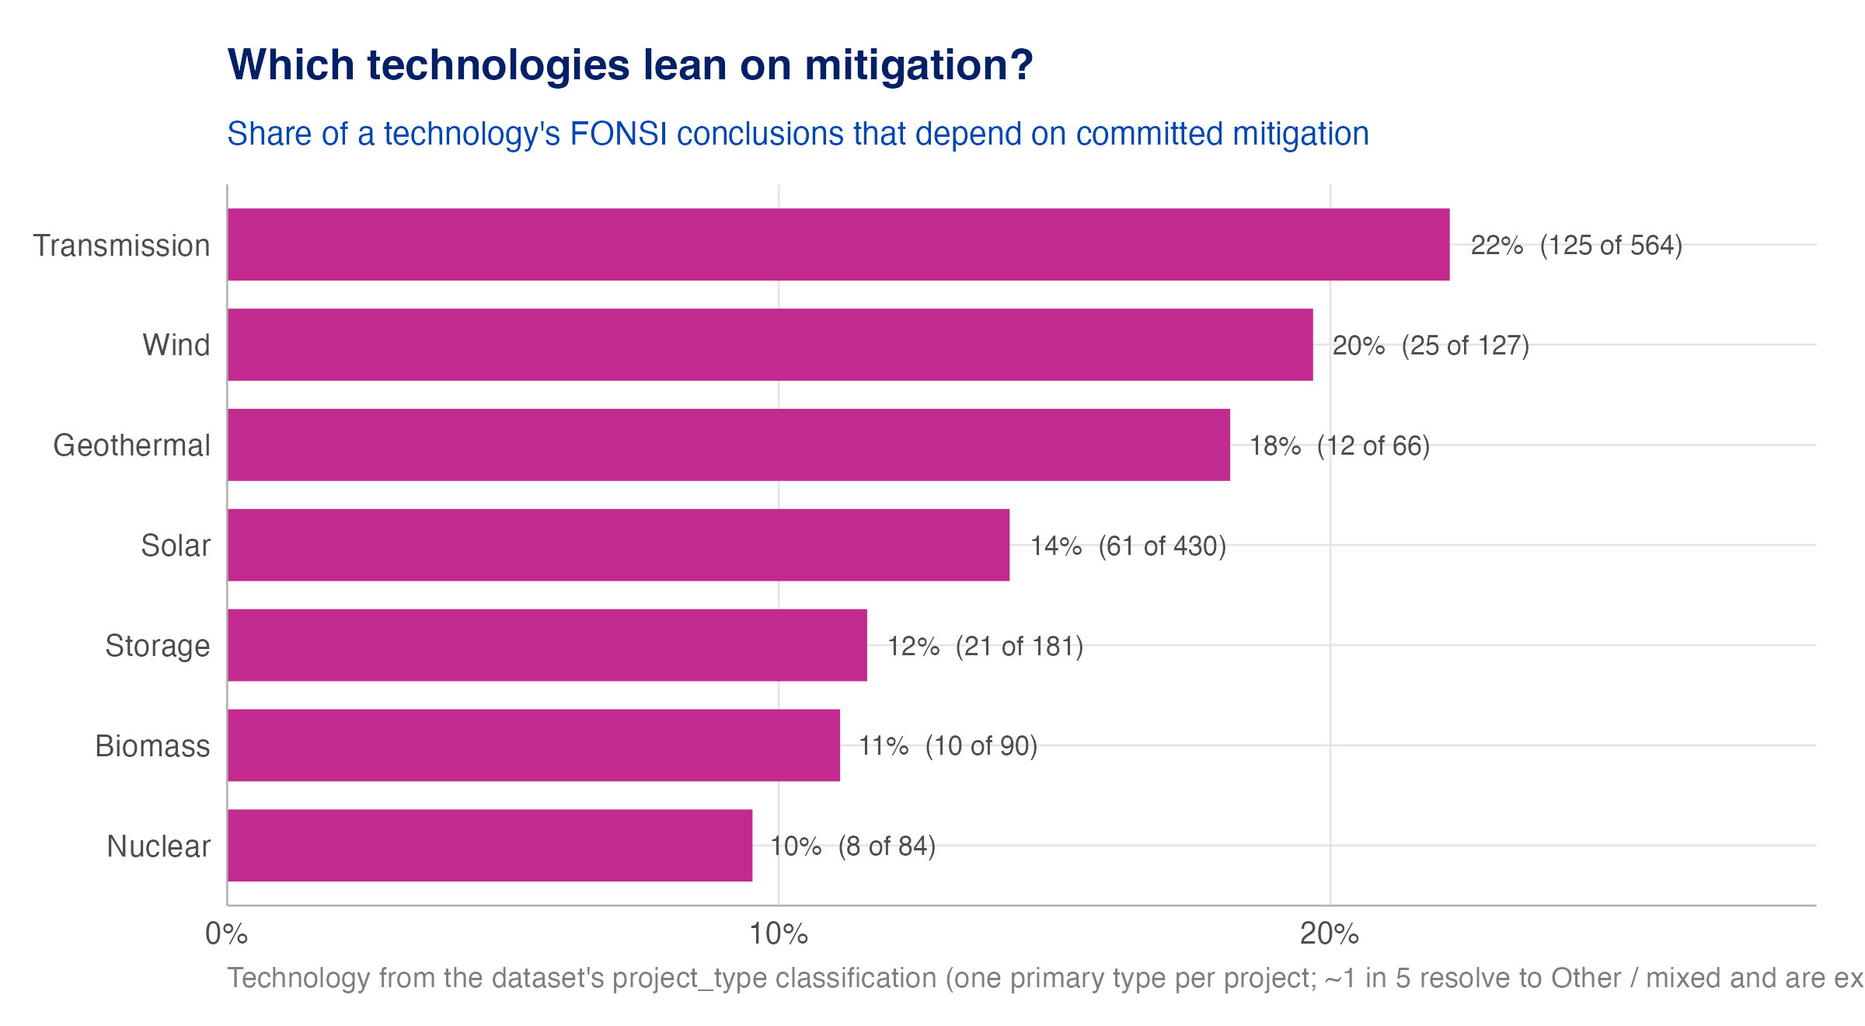
Figure 7: Note: Share of a technology’s FONSI conclusions that depend on committed mitigation. Technology is derived from the dataset’s project-type field; an ‘Other / mixed’ bucket is excluded, so read this for the named technologies.

Enforceability of committed mitigation
“Mitigated” only means something if the measures are actually required. The extraction flags whether each mitigated conclusion is tied to an enforceable permit condition or committed only in the document’s text. The pattern tracks regulatory leverage: biological, air-quality, and water conclusions — backed by the Endangered Species Act and the Clean Air and Water Acts — most often carry an enforceable condition. Visual, cultural, and soils measures are far less often tied to one.
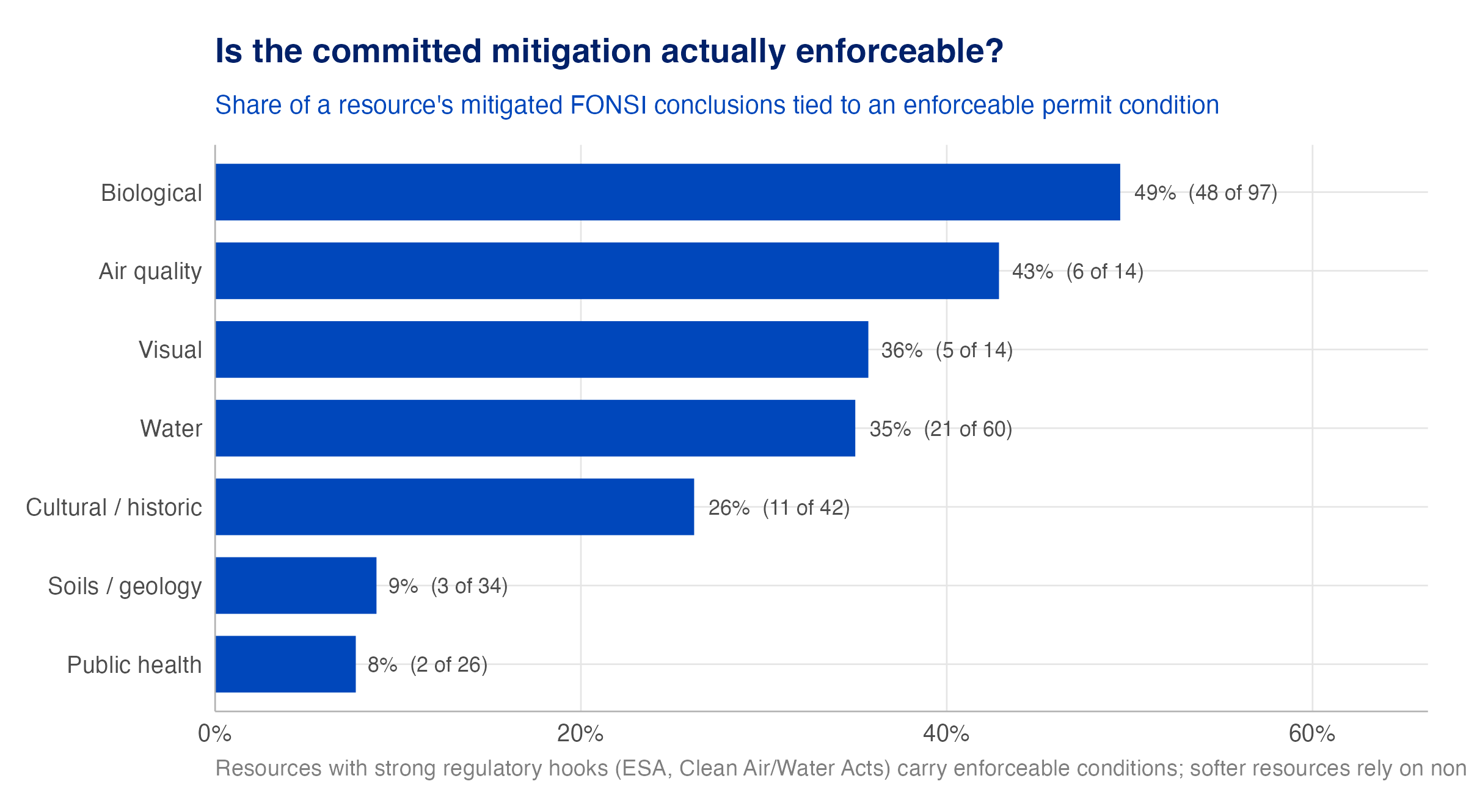
Figure 8: Note: Share of a resource’s mitigated FONSI conclusions tied to an enforceable permit condition (versus committed only in the document text). Reported descriptively — an unmatched conclusion may still be enforced through channels the extraction does not capture.
So for the softer resources, the mitigation behind a not-significant finding is the least demonstrably binding, a caveat worth carrying into how much weight the “mitigated FONSI” label should bear for those areas.

EIS Analysis: Which Resources Cross the Line

Scope, coverage, and accuracy
The EIS track is the mirror of the FONSI track — the above-the-line record of where impacts actually cross the significance line. It runs the identical extraction-and-validation machinery, but covers all lead agencies (not just BLM + DOE) because it is purely descriptive and never uses a project’s decision date. On that basis it rests on 506 projects (1,082 documents) carrying 13,240 distinct determinations, of which 2,198 land above the line, including 698 judged significant and unavoidable, impacts mitigation cannot erase.
The EIS scores run lower than the FONSI track across the board: the pipeline finds the determination reliably (0.84) and lands the significance class at 0.69. That is a real reflection of difficulty: separating “significant” from “significant and unavoidable” is a fine distinction the AI coders split on too. We therefore lead with the more reliable cut — which resources cross the line — and treat the adverse-vs-unavoidable split as directional.

Which resources cross the line
Ranking each resource by how often its EIS conclusions are judged significant, visual (33%) stands alone at the top, the clearest case of an impact that, once significant, tends to stay that way. cultural / historic (24%), biological (21%), and land use (18%) follow.
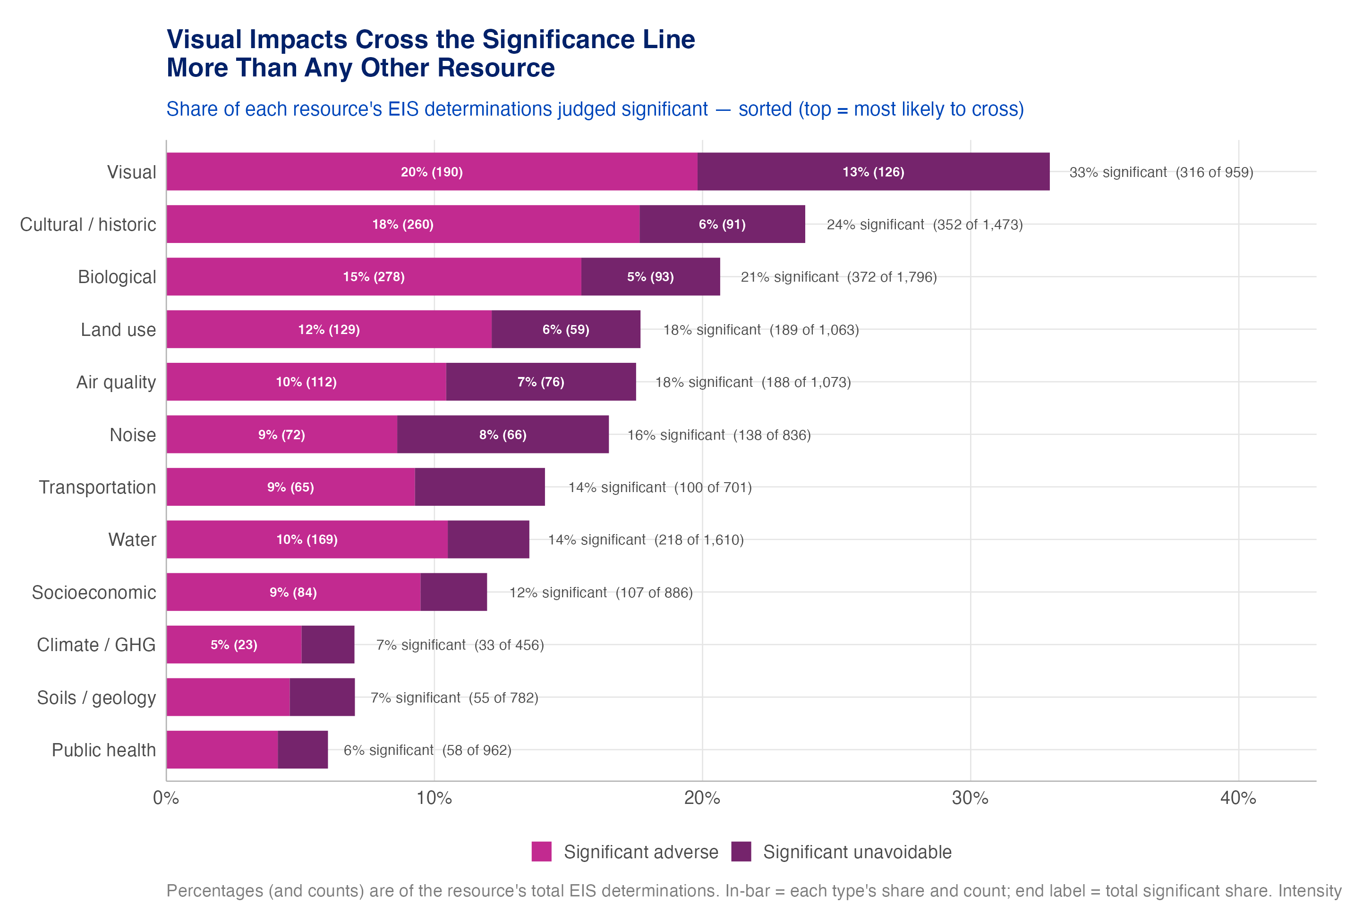
Figure 9: Note: Share of each resource’s EIS determinations judged significant (top = most likely to cross the line). In-bar labels split significant-adverse (lighter) from significant-unavoidable (darker); the end label gives the combined significant share and count.
The starkest determinations are the significant and unavoidable ones, where the agency concludes the impact is real, material, and cannot be mitigated below the line. These are the true limits on a decarbonization project. Visual impacts dominate this category: a wind farm on a ridgeline or a transmission corridor across open country changes a landscape in ways no mitigation fully undoes. Biological, cultural, and air-quality impacts follow.
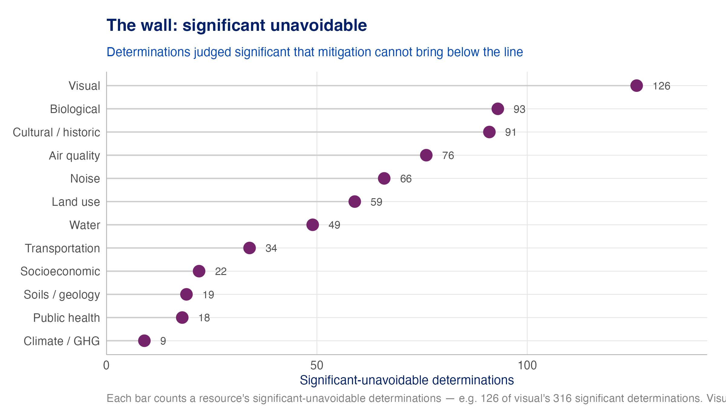
Figure 10: Note: Count of significant-unavoidable determinations by resource — the impacts that remain significant even after mitigation.

Table 2: Representative significant-and-unavoidable determinations, verbatim from the EIS, ordered from the resources that hit the wall most often (one example per resource).
Resource | Significant-unavoidable finding, in the agency’s words
Air quality | Unavoidable air quality impacts due to dust generated during site preparation and construction.
Biological | The proposed project would result in major unavoidable adverse effects on desert tortoise habitat.
Climate / GHG | Significant and unmitigable impacts from cumulative GHG emissions are identified for the Proposed CRS and all alternative sites.
Cultural / historic | The project would cause direct and indirect adverse change to the significance of historic properties.
Land use | Long-term loss of grazing allotments is identified as an unavoidable adverse impact.
Noise | Noise associated with Alternative 4 operations is identified as a long-term, unavoidable impact.
Public health | Worker injuries or death are considered unavoidable adverse impacts given the hazardous nature, complexity, and scale of the Project.
Socioeconomic | Potential short-term and long-term impacts on current land uses would produce associated social and economic impacts.
Soils / geology | Impacts to paleontological resources under this alternative are similar to the Proposed Action and would be significant under criterion P-1.
Transportation | Traffic associated with Alternative 4 operations is identified as a long-term, unavoidable impact.
Visual | With mitigation, impacts to scenic vistas would remain adverse and unavoidable (VIS-1).
Water | Cumulative impact on watersheds is identified as an unavoidable adverse water resources effect for all action alternatives.

How broadly an EIS crosses the line
At the document level a different question comes into view: when an EIS does cross the line, does it do so on one resource or many? Crossing is usually a focused event — over a third of EISs that cross do so on a single resource, and the median is two. But a meaningful minority cross on three or more resources, and a few span nearly the entire environmental slate.
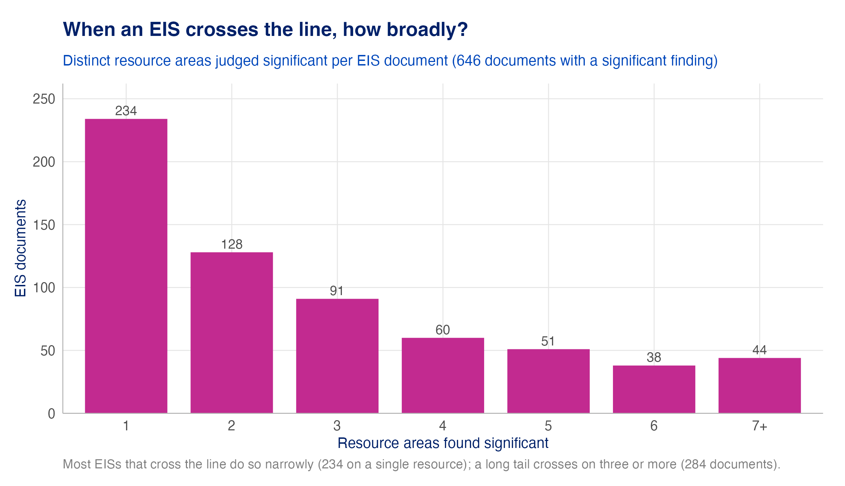
Figure 11: Note: Distinct resource areas judged significant per EIS document, among documents with at least one significant finding. Most cross narrowly; a long tail crosses on three or more.

Two ways a resource can be a problem
Analyzing the two tracks separately pays off in one picture, which plots each resource by how often it is mitigated below the line (FONSIs) against how often it crosses the line (EISs). Both tracks are restricted to BLM + DOE here, so the two are measured on the same footing. This split, mitigated below the line in FONSIs versus crossing above it in EISs, is one of the clearest structural patterns in the analysis:
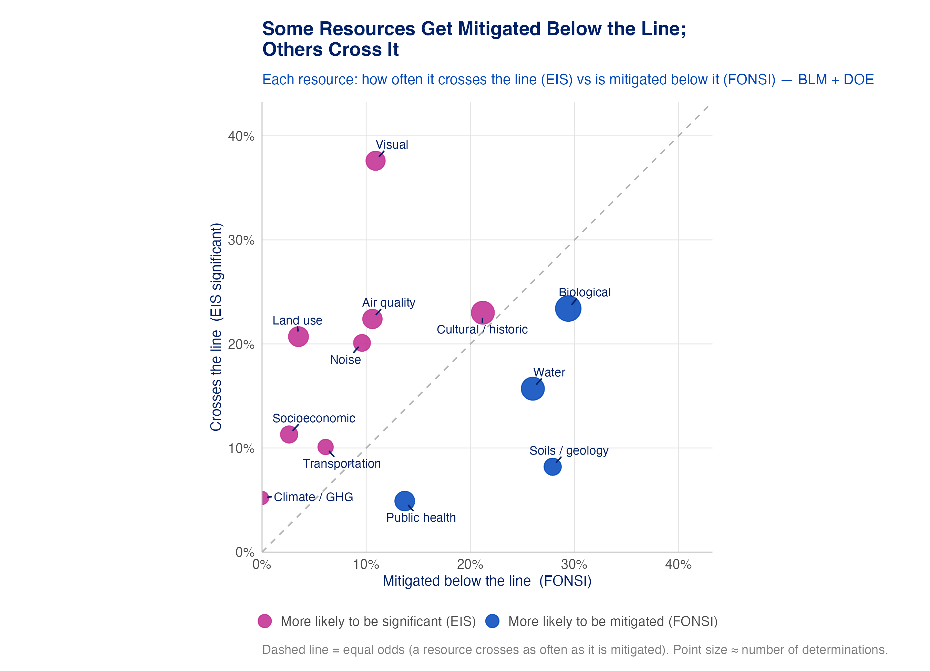
Figure 12: Note: Each resource (BLM + DOE) plotted by how often it is mitigated below the line in FONSIs (x) versus how often it crosses into significance in EISs (y). The dashed diagonal is equal odds; point size ≈ determinations.
Three shapes emerge. Visual, land use, and air quality break above the line more often than they are mitigated below it: when these become a problem, agencies more often accept a significant finding than engineer their way under it, with visual the extreme. Soils/geology, water, and public health show the opposite, frequently mitigated in FONSIs and rarely crossing into significance — the impacts the toolbox of committed measures reliably handles. Cultural/historic sits right on the line, crossing into significance about as often as it is mitigated below it, the one resource that genuinely straddles both sides.

Why an impact is significant
For every above-the-line determination the extraction also records why it is significant. The leading reasons are sheer magnitude, a protected resource, and cumulative effects — and they are not interchangeable: a protected resource drives significance mainly for cultural and biological resources (endangered species, historic properties), a regulatory threshold for air quality and noise (numeric standards), and cumulative effects for biological, visual, and water. That last one is notable for decarbonization siting — roughly one in four significant findings rests on impacts that build up across a landscape or airshed rather than on one project’s direct footprint.
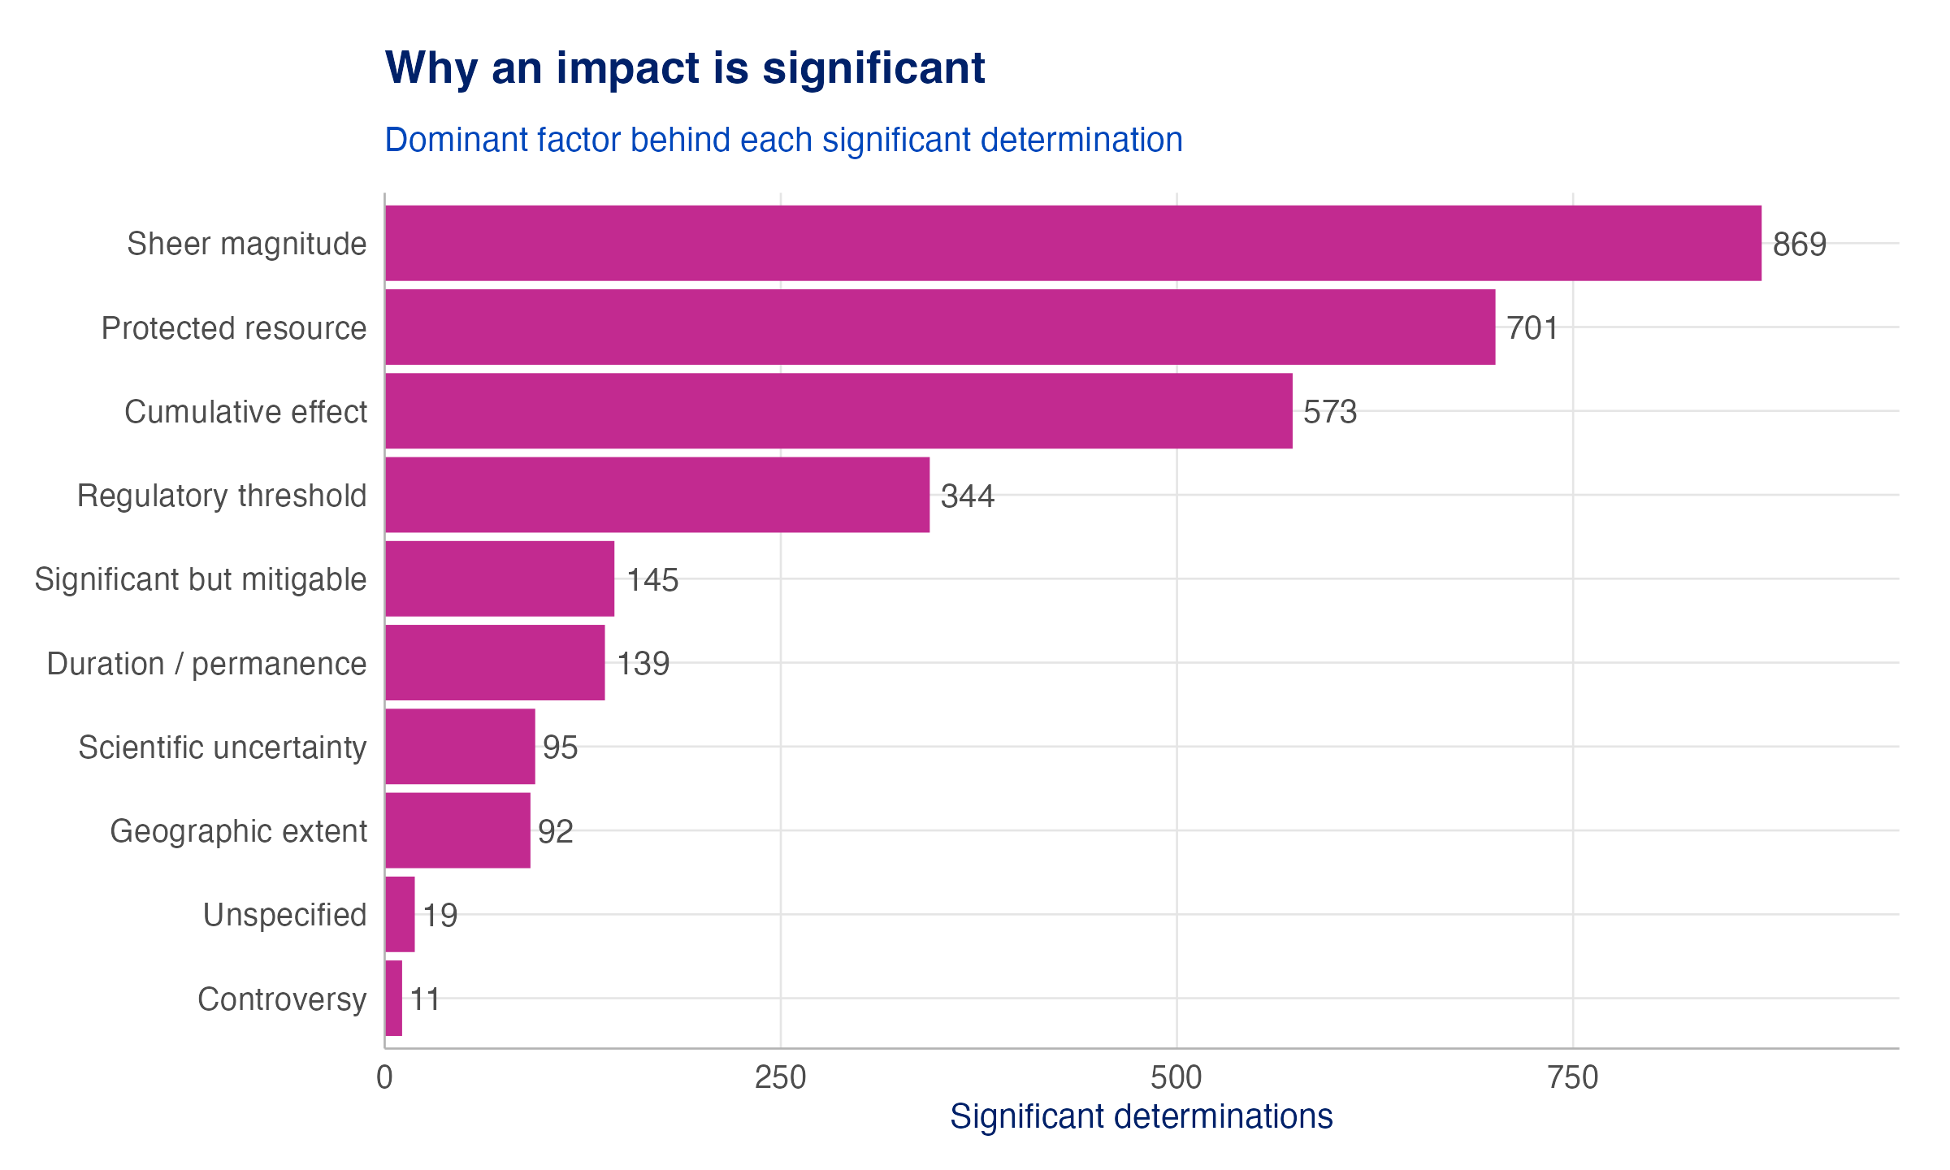
Figure 13: Note: The dominant factor behind each significant determination. Sheer magnitude, a protected resource, and cumulative effects lead.

Table 3: What each significance factor looks like in the EIS text — verbatim examples, ordered from the most common factor down (one example per factor).
Factor | Significant finding, in the agency’s words
Controversy | The proposed transmission line would conflict with the City of Yuma’s resolution opposing the line, resulting in an unavoidable significant impact on the city’s land planning policy.
Cumulative effect | The presence of the AEWP would add to a cumulative visual alteration, as discussed above.
Duration / permanence | Long-term loss of grazing allotments is identified as an unavoidable adverse impact.
Geographic extent | The Western Alternative would result in 14.5 miles of significant, long-term visual impacts.
Protected resource | Alternative E would result in significant impacts to cultural resources.
Regulatory threshold | VRM Class III objectives would not be met for this segment.
Scientific uncertainty | Population increase is possibly significant for Phase I, with impacts for future phases unknown.
Sheer magnitude | The Pier 41 Alternative could result in major socioeconomic impacts.
Significant but mitigable | Significant but mitigable impacts to parade-ground vegetation from irrigation with reclaimed water.

Significance rates differ by lead agency
Because the EIS track spans every lead agency, we can ask whether some cross the line more than others. They do — and the pattern tracks the kind of project each agency runs. The spread runs from Army Corps (27%) at the top down to TVA (3%). Land- and water-facing agencies — the Army Corps and BLM — cross into significance most often, fitting their portfolios (dredge-and-fill permits, public-land rights-of-way). Utility-service programs cross least, consistent with routine infrastructure on already-developed corridors.
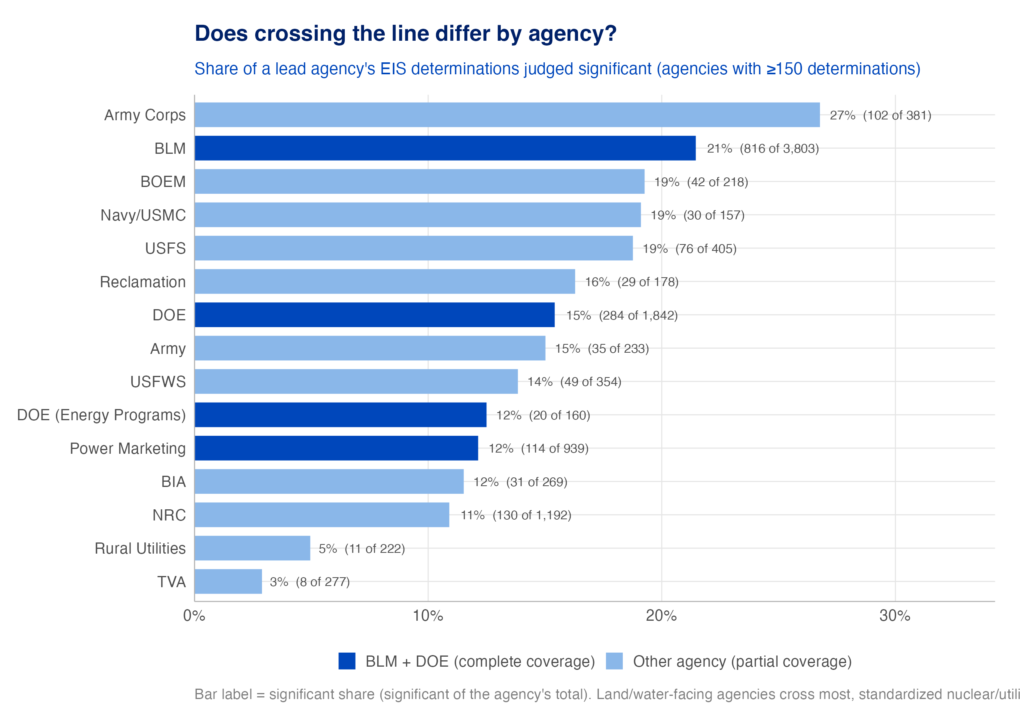
Figure 14: Note: Share of a lead agency’s EIS determinations judged significant, for agencies with enough determinations to report. Dark = the agencies with complete dataset coverage (BLM, DOE family); light = other agencies, shown for context with partial coverage. Point size ≈ determinations.

Significance by clean-energy technology
The most decision-relevant cut for a decarbonization portfolio is the technology. Hydro crosses the line most (28%), as dams carry aquatic and water impacts that are hard to avoid, followed by transmission and solar. Nuclear crosses least among the large technologies (6%), consistent with siting on already-industrial land under highly prescribed review. But the rate is only half the story; the resources each technology hits are distinct, and largely predictable: wind’s fight is about wildlife (avian and bat collision) and noise; solar’s is visual, cultural, and air quality; transmission spreads across biological, visual, and cultural along its corridor.
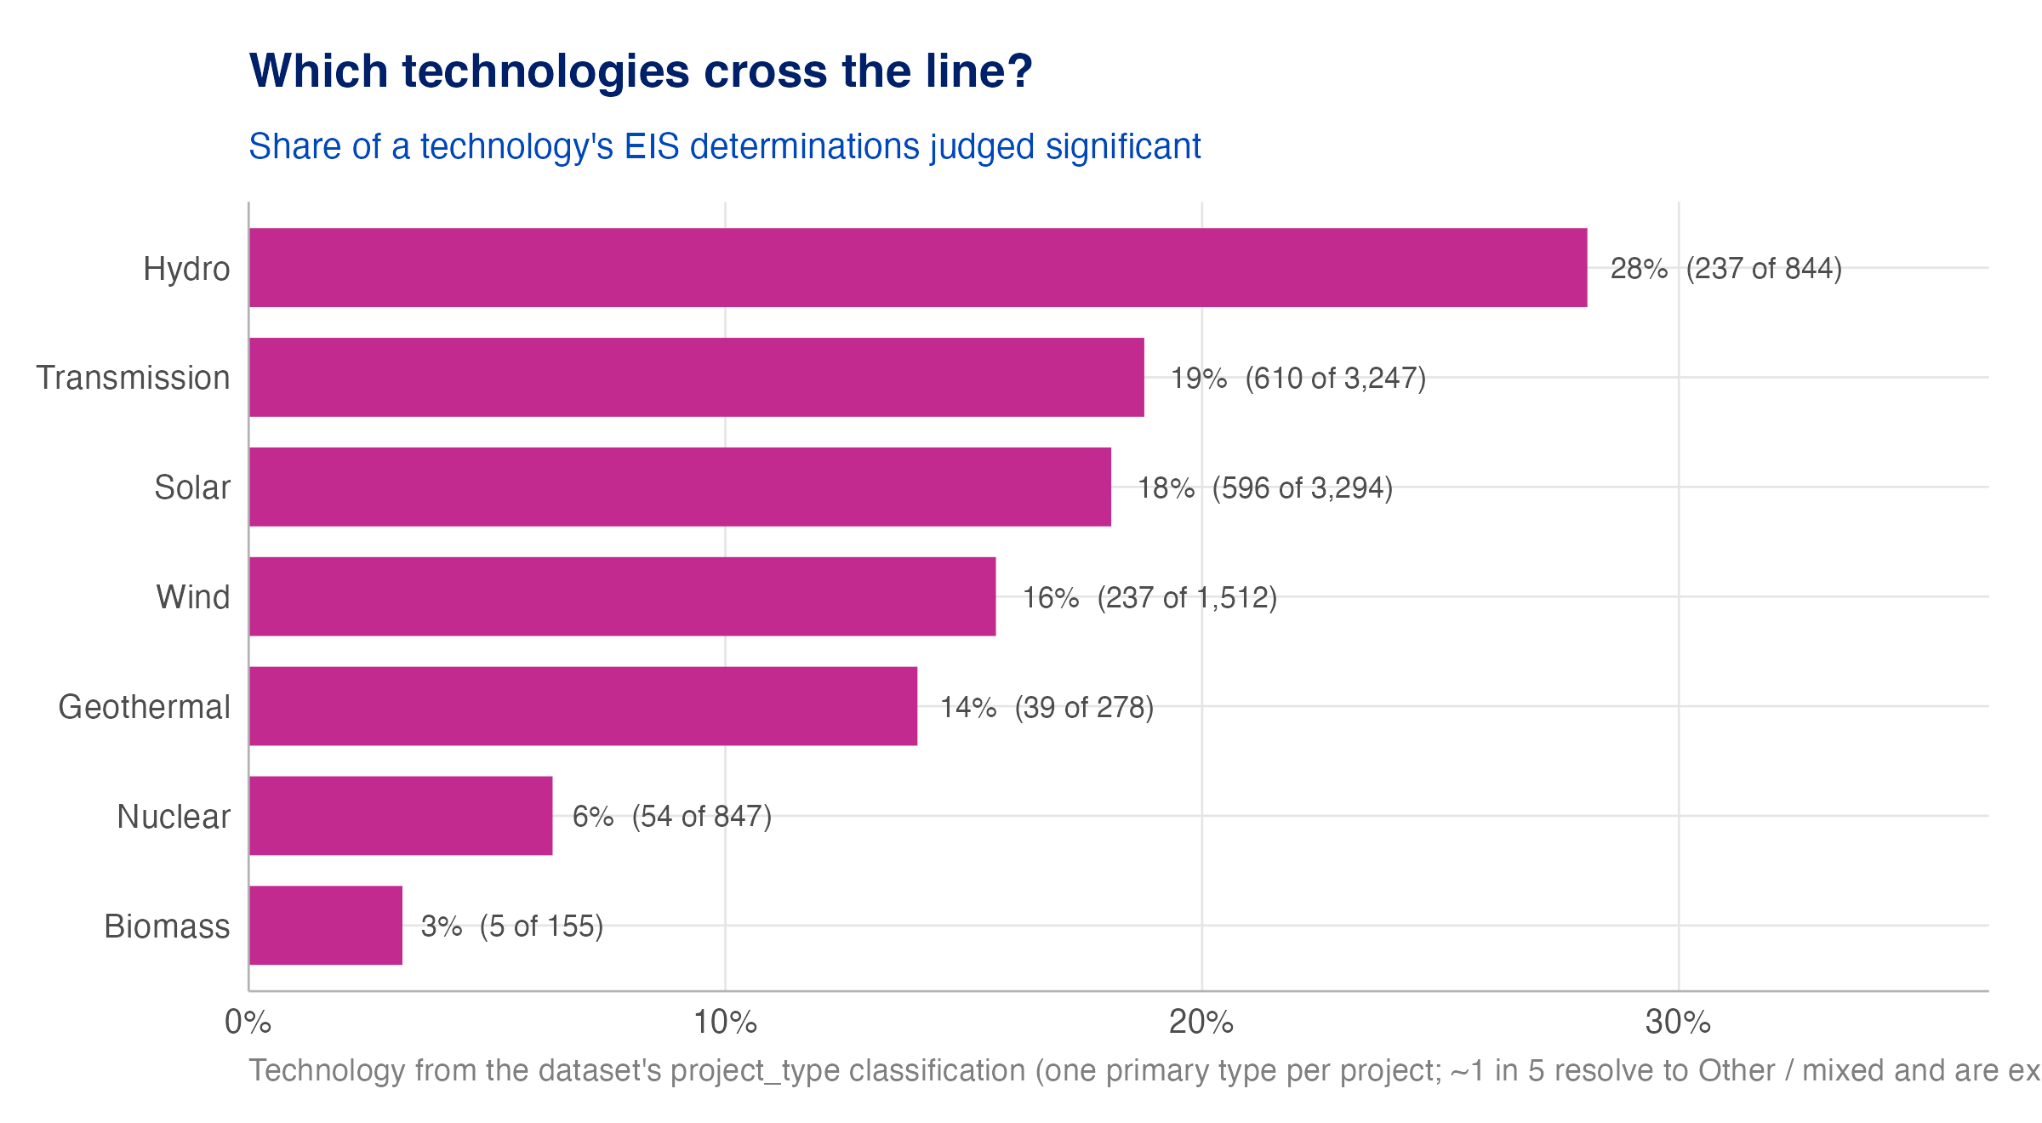
Figure 15: Note: Share of a technology’s EIS determinations judged significant. Technology is derived from the dataset’s project-type field; an ‘Other / mixed’ bucket is excluded, so read this for the named technologies.

Significant, but reducible
Not every above-the-line finding is a hard stop. One significance factor the extraction records is mitigable — the impact crosses the line, but the agency notes that measures can still lessen it. This is the EIS analog of a mitigated FONSI. Visual leads this list too: even the resource most likely to cross the line sometimes admits partial mitigation (screening, siting adjustments), just not enough to drop below it.
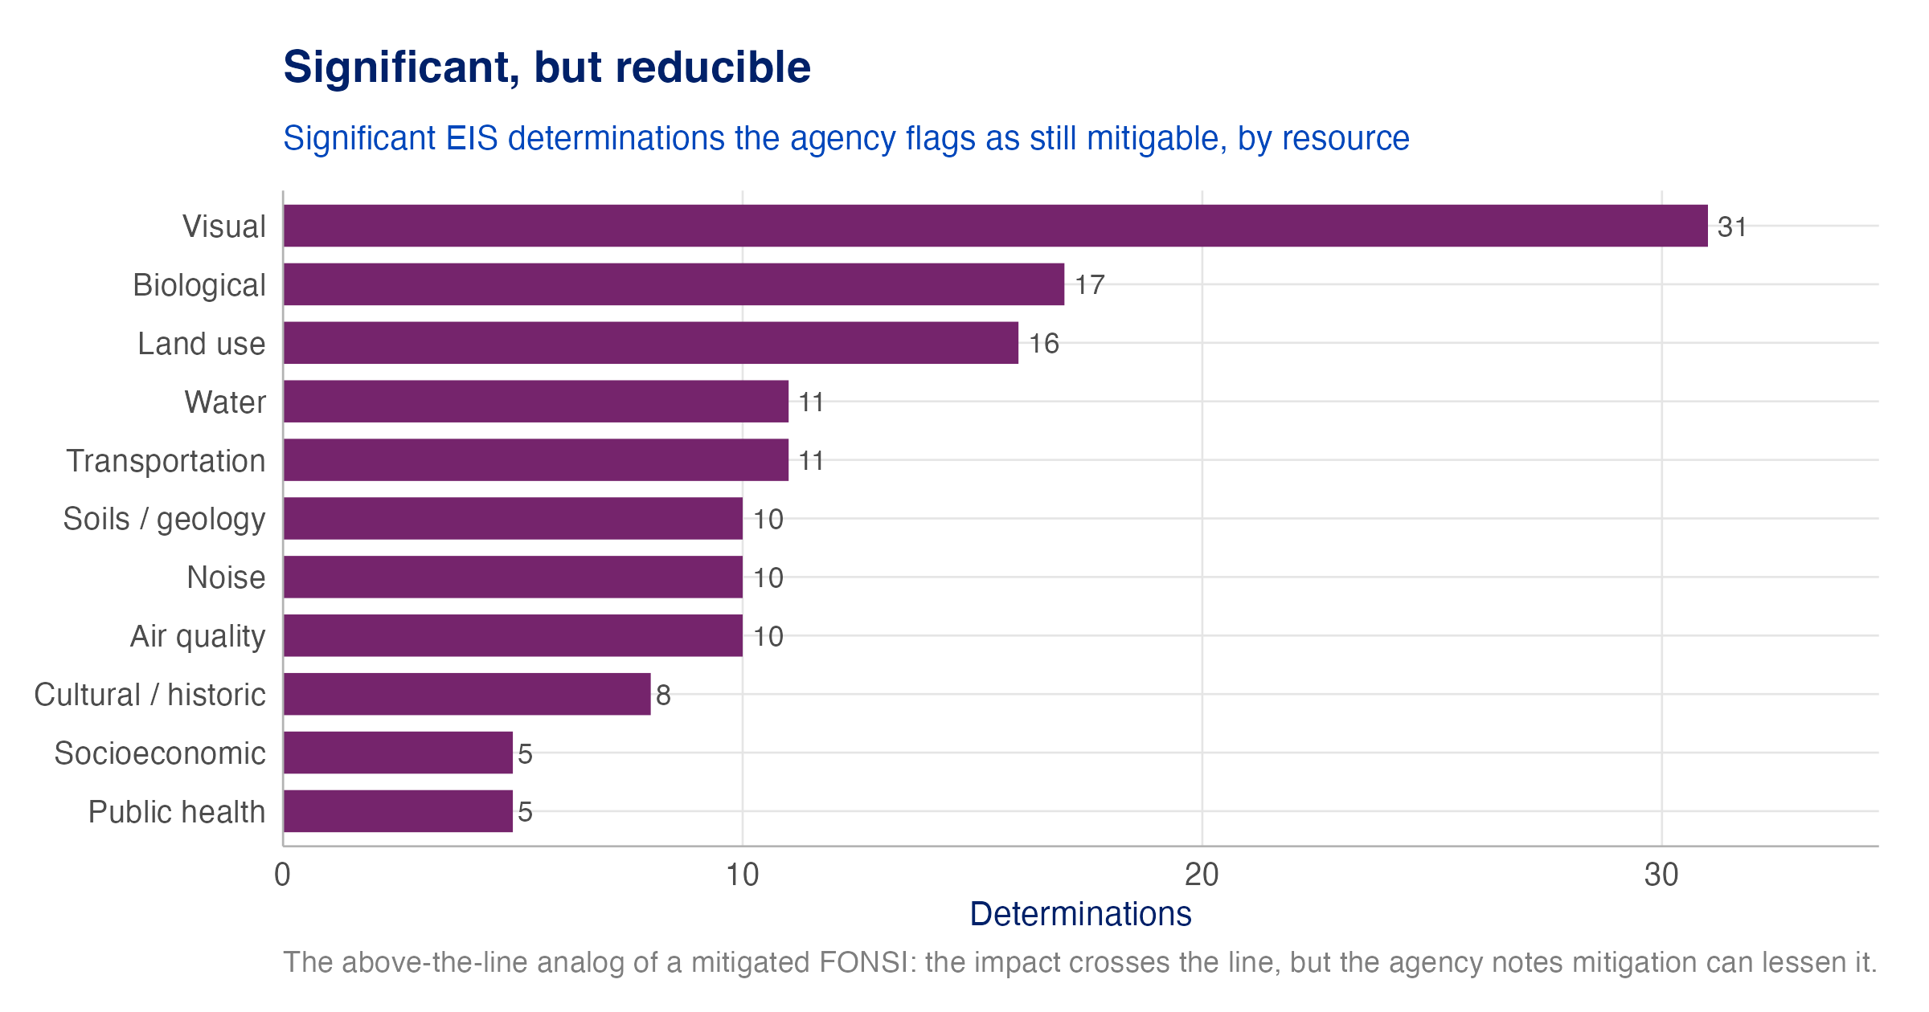
Figure 16: Note: Significant EIS determinations the agency flags as still mitigable, by resource — the above-the-line counterpart to a mitigated FONSI.

Conclusion and Policy Implications
Mitigation plays a central role in whether an impact is called significant. A majority of decarbonization FONSIs reach “no significant impact” only because the developer commits to specific measures — and that reliance is concentrated in a handful of resources (biological, soils, water, and cultural/historic sites), while others (notably visual) are mitigated far less often and, when significant, tend to stay that way. Two implications follow.
First, the uneven mitigation pattern is itself an opportunity. Where agencies have a deep, repeatable toolbox — habitat timing windows, wetland minimization, cultural-resource protection — impacts that would otherwise be significant are routinely brought under the line. The resources that cross most (visual above all) are precisely the ones where the mitigation toolbox is thinnest. Increased investment in, and standardization of, mitigation approaches for those harder resources could keep more projects on the faster FONSI track, provided the measures genuinely reduce impact rather than relabel it.
Second, a caveat that limits how far the “mitigated FONSI” label should be trusted. The committed mitigation behind a not-significant finding is, more often than not, not tied to a demonstrably enforceable permit condition — especially for the softer resources (visual, cultural, soils) that lean on commitments in the document text. This leaves open questions about the effectiveness of mitigation as a tool for avoiding in-depth environmental review: a finding is only as sound as the measures that support it are binding.
Data recommendation: standardize the terminology used for resource areas. The single largest friction in this analysis is that agencies name the same resource in many different ways, and significance language is written project by project. A shared, standardized resource-area vocabulary — of the kind contemplated by CEQ’s NEPA and Permitting Data and Technology Standard — would make significance determinations directly comparable across agencies and would sharpen every finding in this fact sheet.

Data: NEPATEC 2.0 — 193 decarbonization FONSI projects and 506 EIS projects. Methods and full results: Phase 2 Deliverable 2.

