Wine Recommendation Evaluation

White Wine Evaluation
User Input: I like white wine, especially Sauvignon Blanc. I enjoy wines that are fresh and fruity, with a hint of citrus. I prefer wines that are not too sweet and have a crisp finish.

Cosine Similarity Results
similarity index
0.817212 99802
0.798242 72361
0.778521 72102
0.763087 18782
0.744915 75505
0.742570 125764
0.740034 79796
0.737882 96697
0.732573 85022
0.728862 65274

Top Wines
Winery | Description | Variety | Province | Buyer | Price | Rating
Quady North | Bright, fresh, captivating white wine with crisp citrus and peachy flesh, extra spice, long clean crisp finish, stainless steel fermented. | Grenache Blanc | Oregon | Dinner party hosts, wine-lovers | 💲💲 Excellent quality, highly recommended | 🍷🍷🍷🍷
Columbia Crest | Sweetness underlying this crisp and fruity wine, 100% Sauvignon Blanc, fruit-forward, quaffable white. | Sauvignon Blanc | Washington | Casual drinkers, everyday wines | 💲 Very good quality, worth trying | 🍷🍷🍷
Bedell | Blend of 75% Chardonnay, 15% Viognier, 10% Sauvignon Blanc, toasty complexity, fragrant curviness, clean acidity, robust white. | White Blend | New York | Dinner party hosts, wine-lovers | 💲💲 Very good quality, worth trying | 🍷🍷🍷
Cosentino | White Meritage, 53% Sauvignon Blanc, remainder Sémillon, aged in neutral French oak, full body, balance of crispness and weight. | Meritage | California | Dinner party hosts, wine-lovers | 💲💲 Very good quality, worth trying | 🍷🍷🍷
De Loach | Dry, almost steely, aromas like cinnamon and lime, bone-dry flavors like lemon and Bosc pear, touch of tannin, cellar for mid-term. | Chardonnay | California | Wine enthusiasts seeking quality | 💲💲 Excellent quality, highly recommended | 🍷🍷🍷🍷
Chateau Ste. Michelle | Pure, single vineyard Sauvignon Blanc, 12.5% alcohol, European style, elegant, lively, fresh, cucumber, melon, green apple flavors. | Sauvignon Blanc | Washington | Budget-conscious enthusiasts | 💲💲 Very good quality, worth trying | 🍷🍷🍷
Salvestrin | 100% Sauvignon Blanc, fermented in stainless steel and neutral oak, floral, nutty, structured oak, medium to full-bodied, crisp finish. | Sauvignon Blanc | California | Dinner party hosts, wine-lovers | 💲💲 Excellent quality, highly recommended | 🍷🍷🍷🍷
Cascata | Aromas of white flowers, spice, citrus, flavors of white fruit, flowers, minerally spice, simply good white wine with a feminine touch. | Riesling | New York | Budget-conscious enthusiasts | 💲💲 Very good quality, worth trying | 🍷🍷🍷
Douglas Green | Fresh, tangy, little or no oak influence, refreshing, crisp white wine, citrus aromas, green apple flavors, tart finish. | Chardonnay | California | Budget-conscious enthusiasts | 💲💲 Very good quality, worth trying | 🍷🍷🍷
Ca' Momi | Blended from four white-grape varieties, subtle grassy, earthy aromas, neutral fruit flavors, touch of sweetness on the finish. | Sparkling Blend | California | Budget-conscious enthusiasts | 💲💲 Very good quality, worth trying | 🍷🍷🍷

The algorithm did well to pick out the subtleties, especially being able to pick out a “touch of sweetness on the finish” This means it understood the semantic meaning of “not too sweet”
It frequently matched based word for word like citrus. However, it did pick the De Loach with only the words lime, and lemon and pear
It also provided a variety of “Sémillon, aged in neutral French oak”
This phrase would be similar to that of semi
Every wine that was picked had a rating of very good quality and excellent. So the consumer is more than likely select a wine that they would enjoy.
The Ca' Momi is a sparkling blend. Not a white wine, however, it did match the description, not to fruity or sweet. Although it was not the intended
The algorithm performed well in identifying subtle nuances, particularly in detecting a “touch of sweetness on the finish.” This demonstrates its ability to comprehend the semantic meaning of “not too sweet.”
It frequently matched descriptions based on specific words, such as “citrus.” However, it also successfully identified De Loach using related terms like “lime,” “lemon,” and “pear.” Furthermore, it presented a variety, including “Sémillon, aged in neutral French oak,” which aligns with nuances associated with semi-dry wines.
Every wine selected by the algorithm had ratings of either “very good quality” or “excellent.” This suggests that consumers are likely to enjoy the recommended options.
The Ca' Momi, though a sparkling blend rather than a white wine, matched the description well. It was neither overly fruity nor excessively sweet, aligning closely with the intended profile, even if not the exact category expected. This offers the end-user to try something new based on their taste profile.
The algorithm performed well in identifying subtle nuances, particularly in detecting a **touch of sweetness on the finish.** This demonstrates its ability to comprehend the semantic meaning of **not too sweet.**
It frequently matched descriptions based on specific words, such as **citrus.** However, it also successfully identified De Loach using related terms like **lime,** **lemon,** and **pear.** Furthermore, it presented a variety, including **Sémillon, aged in neutral French oak,** which aligns with nuances associated with semi-dry wines.
Every wine selected by the algorithm had ratings of either **very good quality** or **excellent.** This suggests that consumers are likely to enjoy the recommended options.
The Ca' Momi, though a sparkling blend rather than a white wine, matched the description well. It was neither overly fruity nor excessively sweet, aligning closely with the intended profile, even if not the exact category expected. This offers the end-user to try something new based on their taste profile.

The original plan for the ML pipeline was to allow users to select the region and have a drop-down list of flavors. However, with the use of SentenceTransformer, this proved too challenging

The original project
Wine accuracy 9/10

Wordclouds
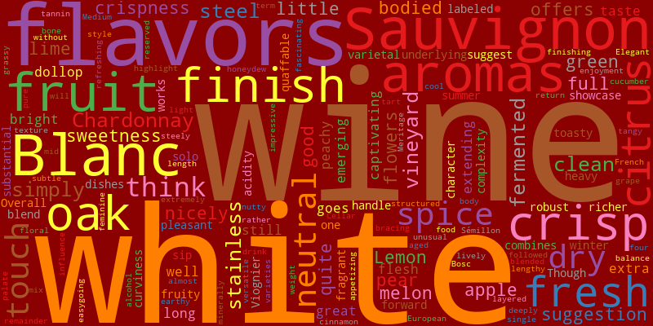
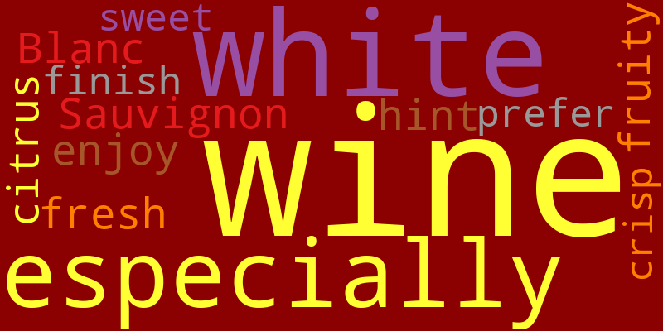

Red Wine Evaluation
User Input: I like dark fruit flavors that are full bodied and complex. it should have a long finish but not be too tannic. I enjoy wines that are rich and smooth, with a hint of oak and spice. I prefer wines that are well-balanced and have a good acidity.
The user is looking for
Positive: dark fruit flavors, full bodied, complex, long finish, rich, smooth, hint of oak, spice, well-balanced, good acidity
Negatives: not too tannic

The model overall did well at selecting the dark fruits and flavors being able to select “luxurious black cherry and dark chocolate flavors”
However, it consistently mismatched the tannic profile. In one instance it selected a wine that had “layer of fine tannins”
The algorithm performed well at understanding the positive semantic meaning being able to identify wine with “dark fruits” for instance, “luxurious black cherry and dark chocolate flavors”. As well as using "dark chocolate," "espresso," "roasted coffee" (for "complex," "rich").
However, as there was only one negative statement and it wasn’t to emotive this meant the other positive matches like spices, long finish and dark fruits. The overall similarity score appeared higher. This user statement simulates a person who is not familiar with wine. Having a bold," "full-bodied," "dark fruit," "complex," and "age-worthy" quite often are tannic.
The algorithm performed well at understanding the positive semantic meaning, accurately identifying wines with 'dark fruits,' for instance, as 'luxurious black cherry and dark chocolate flavors.' It also successfully recognised terms like 'dark chocolate,' 'espresso,' and 'roasted coffee' as indicators of 'complex' and 'rich' profiles.
However, a key challenge arose with the negative constraint. Because there was only one negative statement ('not too tannic') and it wasn't expressed with particularly strong negative emotion or specific weighting, the model tended to prioritise the numerous positive semantic matches (such as 'spices,' 'long finish,' and 'dark fruits'). This often led to an overall higher similarity score for wines that, despite matching the positive criteria, inherently possessed a tannic profile.
This user statement simulates a person who is not deeply familiar with wine. For such users, descriptions that are 'bold,' 'full-bodied,' 'dark fruit,' 'complex,' and 'age-worthy' often naturally co-occur with wines that are quite tannic.

The Model was unable to provide the user with the low or having too much tannin

Cosine Similarity Results
similarity index
0.805011 116591
0.794151 107428
0.792662 70192
0.788970 35431
0.784403 99461
0.783924 2182
0.782527 93004
0.776019 3528
0.772618 16388
0.770970 97310

Top Wines
Winery | Description | Variety | Province | Buyer | Price | Rating
Naggiar | Good balance, firm tannins and plenty of luxurious black cherry and dark chocolate flavors make this a complete and satisfying wine. It's medium to full bodied and has a rich but firm texture. The ample fruit flavors linger on the finish. | Bordeaux-style Red Blend | California | Dinner party hosts, wine-lovers | 💲💲 Excellent quality, highly recommended | 🍷🍷🍷🍷
Sierra Starr | Dark fruit aromas and flavors join with a generous texture and full body to make a complete and satisfying wine. This has just enough tannin to make it appetizing and well balanced. | Bordeaux-style Red Blend | California | Dinner party hosts, wine-lovers | 💲💲 Very good quality, worth trying | 🍷🍷🍷
Kendall-Jackson | A big, bold wine that also tastes precise and structured, it has deep, dense fruit flavors like black currant and black cherry, layers of fine tannins, hints of dark chocolate and espresso. This is a great wine to stash in the cellar, as it will taste best after 2020. | Red Blend | California | Budget-conscious enthusiasts | 💲💲 Excellent quality, highly recommended | 🍷🍷🍷🍷
Ruby Hill Winery | Intense concentration and firm structure make this an age-worthy, big and tannic wine. It boasts a deep, dark color, dense ripe blackberry and black cherry aromas and spicy, oaky nuances that add complexity. Best after 2019. | Cabernet Sauvignon | California | Wine enthusiasts seeking quality | 💲💲 Excellent quality, highly recommended | 🍷🍷🍷🍷
Noble Estate | Substantial and authoritative, this ripe and tannic wine turns quickly to the dark side. Dark fruits—black cherry and cassis—are joined to barrel flavors of roasted coffee and dark chocolate. Yet it's never too heavy, and stays balanced through a medium-long finish. | Pinot Noir | Oregon | Dinner party hosts, wine-lovers | 💲💲 Very good quality, worth trying | 🍷🍷🍷
Hart 2 Hart | Don't let the playful label fool you, this is an impressive, dry wine. Big, very ripe and fruity, it also has a good grippy texture due to firm tannins and acidity that make it appetizing. The color is quite dark, and the black cherry, blackberry and raspberry flavors run deep. | Bordeaux-style Red Blend | California | Dinner party hosts, wine-lovers | 💲💲 Excellent quality, highly recommended | 🍷🍷🍷🍷
Naggiar | Bold and substantial, this full-bodied and firmly tannic wine has a good core of ripe black berry and black cherry trimmed with lighter cinnamon and vanilla notes from oak. It's very attractive in a firm, palate-gripping way. | Cabernet Franc | California | Dinner party hosts, wine-lovers | 💲💲 Very good quality, worth trying | 🍷🍷🍷
Dark Horse | A good sense of concentration and depth make this medium-bodied wine taste big and satisfying without overdoing it. It has a very dark color, fruity and lightly spicy aromas, rich plum and black cherry flavors and rather mild tannins. | Red Blend | California | Budget-conscious enthusiasts | 💲💲 Very good quality, worth trying | 🍷🍷🍷
Concannon | A compelling spicy aroma and richly layered fruit give a lot of appeal to this full-bodied, fully tannic and nicely sculpted wine. It has a deep dark color, captivating oak and white-pepper aromas and a rich generous mouthfeel accompanied by an appropriately high level of fine-grained tannin. Best after 2020. | Petite Sirah | California | Dinner party hosts, wine-lovers | 💲💲 Excellent quality, highly recommended | 🍷🍷🍷🍷
Cedarville | This engaging, full-bodied and densely textured wine has a great bouquet and structured yet fine-grained tannins. It exudes an engaging mix of spices, smoke and cedar in the aroma, and serves equally layered and complex fruit and spice flavors. Best after 2018. | Cabernet Sauvignon | California | Dinner party hosts, wine-lovers | 💲💲 Excellent quality, highly recommended | 🍷🍷🍷🍷

Wordclouds
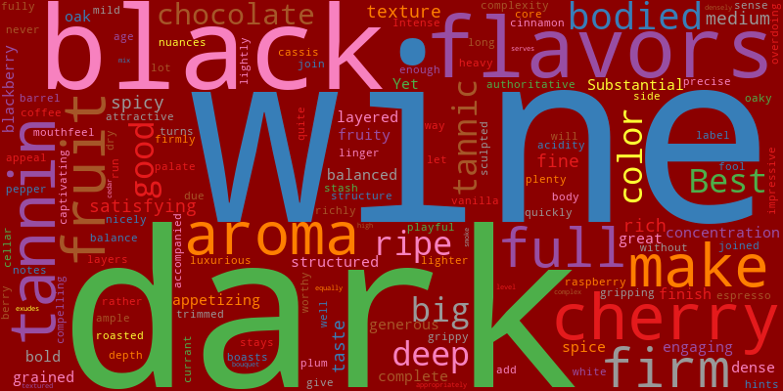
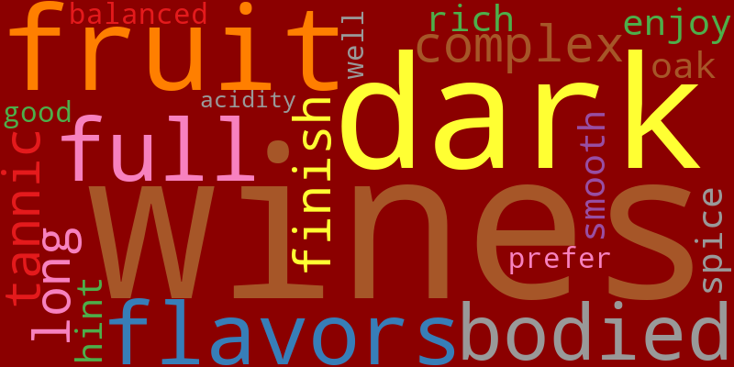

Sparkling Wine Evaluation
User Input: I am looking for a sparkling wine for a special occasion. I enjoy wines that are light and refreshing, with a hint of sweetness. I prefer wines that have a fine bubble and a crisp finish. I like wines that are not too dry and have a fruity aroma.

Cosine Similarity Results
similarity index
0.784459 58749
0.767109 96056
0.741827 110103
0.736923 67825
0.720789 96680
0.715957 53500
0.714558 61729
0.708004 33049
0.705251 119107
0.702901 81153

Top Wines

Conclusion: Evaluating the Content-Based Wine Recommendation System
The analysis of the content-based wine recommendation system, using SentenceTransformer for description similarity across red, white, and sparkling wine categories, reveals significant strengths in semantic understanding of both user and professional descriptions of wine.
Key Strengths Observed:
- Across all wine types, the algorithm demonstrated a strong ability to comprehend and match the positive semantic meaning of user input. It successfully identified wines with desired traits like dark fruits such as the luxurious black cherry and dark chocolate flavors, crisp fruit flavors, tangy, citrus finish, and light and refreshing.
- The system had a nuanced approach to selecting wine, demonstrating an ability to understand subtle user preferences, such as the white wine user's 'not too sweet' input, and effectively matched with wines having a hint of sweetness or being moderately sweet. This showcased its capacity to go beyond exact keyword matching.
- Although the dataset was already skewed towards good quality wine, the system was still able to consistently select wines with high ratings, which is a valuable outcome for user satisfaction.
- The system showed promise in recommending wines that semantically align with a user's taste profile, potentially leading to discoveries from regions or varieties not explicitly mentioned by the user, thereby expanding their exploration.
Identified Challenges and Areas for Refinement:
- The model struggled to select red wines, especially when it was handling negative constraints and co-occurrence bias, particularly when trying to find 'not too tannic' red wines. Due to the natural co-occurrence of terms like bold, full-bodied, and age-worthy often appearing with tannic, the algorithm tended to prioritize the abundance of positive semantic matches, sometimes overlooking the singular negative preference. This bias in the current semantic similarity model needs to be addressed.
- Categorical Type Purity: While generally good at identifying the correct wine type, instances like the Zinfandel appearing in sparkling wine recommendations (despite semantic taste alignment) highlighted a limitation. Relying solely on description embeddings can lead to mismatches in strict categorical filters (like "sparkling wine" only), which could reduce trust, especially from knowledgeable users or sommeliers. Rectifying dataset errors, such as the "American Champagne" clarification, is also vital for data integrity.
Recommendations for Improvement:
- A hybrid recommendation logic should be developed that integrates categorical features alongside the description embeddings. Incorporating pre-filtering features that would constrain its outputs to specific types like sparkling wine would significantly improve its reliability.
- The model has only been evaluated using pure analysis of its outputs and cosine similarity. For a more robust evaluation, ground truth data from real-users should be used to improve its ability to predict what wines people would enjoy.
Overall System Summary:
As the project aimed to not waste time drinking bad wine, the system has proven that it can recommend wines that are of good quality, will help the user expand their repertoire, and at the same time, provide predictability in its ability to match the user's tastes.
Varieties

There is a high average similarity to a cosine score 0.73. This suggests that, on average, the recommended wines are semantically close to the user input. This indicate s that the model is generally finding relevant matches.
The minimum suggests that even the least similar within the top 10 is still a strong semantic match as there are no dramatic drops in
The standard deviation is also low this indicates that it is tightly clustered. This shows a consistent performance of top recommendations without too much difference.

For the sparkling wines, the algorithm's performance in recommending sparkling wines for a **special occasion** user input **light and refreshing, hint of sweetness, fine bubble, crisp finish, not too dry, fruity aroma** demonstrated several key capabilities and one notable area for refinement.
All but one of the recommended wines were indeed sparkling, and the system even identified a Champagne, which aligns perfectly with a **special occasion** context. This confirms its strong ability to match wine type based on general context or implicit cues. Although references to Champagne were removed, as this would alienate sommeliers.
The system effectively identified wines with a **hint of sweetness** or that were **moderately sweet,** directly addressing the **not too dry'** preference. This again highlights its capacity to understand subtle semantic nuances beyond strict keyword matching, similar to its performance with **not too sweet** in the white wine analysis.
The recommendations consistently featured positive attributes like **crisp fruit flavors,** **tangy, citrus finish, fruity, lively, and fresh,** closely mirroring the user's explicit preferences.
The consistency of recommended wines having **very good quality** or **excellent** ratings (even when a Zinfandel appeared in the list) is a significant positive. This suggests that the semantic similarity derived from descriptions implicitly correlates with generally well-regarded wines, enhancing user satisfaction.
The majority of the recommended wines were sparkling, with one notable exception, and the system even included Champagne, an ideal choice for a **special occasion**. This demonstrates its ability to align wine types with general context and implicit cues. References to Champagne were omitted to ensure inclusiveness for sommeliers.
The system excelled in identifying wines with a **hint of sweetness** or those that were **moderately sweet**, directly addressing the preference for wines that are **not too dry**. This underscores its capacity to interpret subtle semantic nuances beyond straightforward keyword matching, akin to its performance with **not too sweet** in the white wine analysis.
The recommendations consistently highlighted positive attributes such as **crisp fruit flavors**, **tangy citrus finishes**, and **fruity, lively, and fresh profiles**, aligning perfectly with the user's explicit preferences.
Moreover, the recommended wines uniformly held **very good quality** or **excellent ratings**, even when a Zinfandel unexpectedly appeared on the list. This suggests that the semantic similarity derived from descriptions naturally correlates with well-regarded wines, significantly enhancing user satisfaction.
Winery | Description | Variety | Province | Buyer | Price | Rating
Schramsberg | Complex and well balanced, elegant dry, barrel-fermented sparkling wine with light white-cherry aromas, crisp fruit flavors with a touch of buttery richness, and a tangy, citrus finish. | Sparkling Blend | California | Wine enthusiasts seeking quality | 💲💲 | 🍷🍷🍷🍷
Willamette Valley Vineyards | A yeasty, toasty, rather thick 50-50 mix of Chardonnay and Pinot Noir. Pineapple and grapefruit are the dominant fruit flavors. | Sparkling Blend | Oregon | Wine enthusiasts seeking quality | 💲💲 | 🍷🍷🍷
The Winery SF | A nutty, pastry-like aroma and rather sweet fruit flavors. The sparkling texture is smooth and the body is rather light. | Sparkling Blend | California | Dinner party hosts, wine-lovers | 💲💲 | 🍷🍷
Argyle | A fine, fruity, yeasty sparkling wine from 100% Chardonnay grapes. Crisp and lively in the mouth, with medium bubbles and a fresh, citrusy finish. | Champagne Blend | Oregon | Dinner party hosts, wine-lovers | 💲💲 | 🍷🍷🍷
Wetzel Estate | A clean, simple and tasty sparkling wine, a Chardonnay/Pinot Noir cuvée, done in the traditional methode Champenoise. Pale straw in color, with flavors of green apple and pink grapefruit. | Sparkling Blend | Oregon | Dinner party hosts, wine-lovers | 💲💲 | 🍷🍷🍷
Gloria Ferrer | A soft richness that is both lush and creamy. The once-fresh bready scents have evolved into a toasty, nutty smoothness. | Champagne Blend | California | Dinner party hosts, wine-lovers | 💲💲 | 🍷🍷🍷🍷
Schramsberg | Moderately sweet, complex in aroma, elegant in texture and balance, rich in flavor and long on the finish. Fresh-bread aroma leads to rich poached-pear flavors. | Sparkling Blend | California | Dinner party hosts, wine-lovers | 💲💲 | 🍷🍷🍷🍷
Turkovich | Bright-colored, quite fruity wine with strong berry and cherry flavors, rich-feeling bubbles and a slightly sweet finish. | Sparkling Blend | California | Dinner party hosts, wine-lovers | 💲💲 | 🍷🍷🍷
Argyle | Rich, tawny gold color, vintage-dated sparkling wine fermented in the bottle and disgorged in small batches. Citrus flesh and rind flavors suggest grapefruit, lemon and lime. | Sparkling Blend | Oregon | Dinner party hosts, wine-lovers | 💲💲 | 🍷🍷🍷
Plungerhead | Fresh and lively like a cherry soda, medium-bodied wine with light, spicy, oaky aromas, lots of cherry and strawberry flavors and an easy-drinking texture. | Zinfandel | California | Budget-conscious enthusiasts | 💲💲 | 🍷🍷🍷

Wordclouds
